**1. Data Loading and Preprocessing**

Loading Data: You load the intents from a JSON file (intents.json) which contains patterns, tags, and responses for different intents.

Data Preparation: Iterate through intents to extract training sentences (patterns) and their corresponding labels (tag). You also collect responses for each intent.

Label Encoding: Use LabelEncoder from sklearn.preprocessing to convert textual labels into numeric format required by TensorFlow (sparse_categorical_crossentropy).

Tokenization: Use Tokenizer from tensorflow.keras.preprocessing.text to convert text into sequences of integers. This helps in converting sentences into a format suitable for neural network input.

Padding Sequences: Use pad_sequences to ensure all sequences have the same length (max_len). This is necessary for batch processing in neural networks.

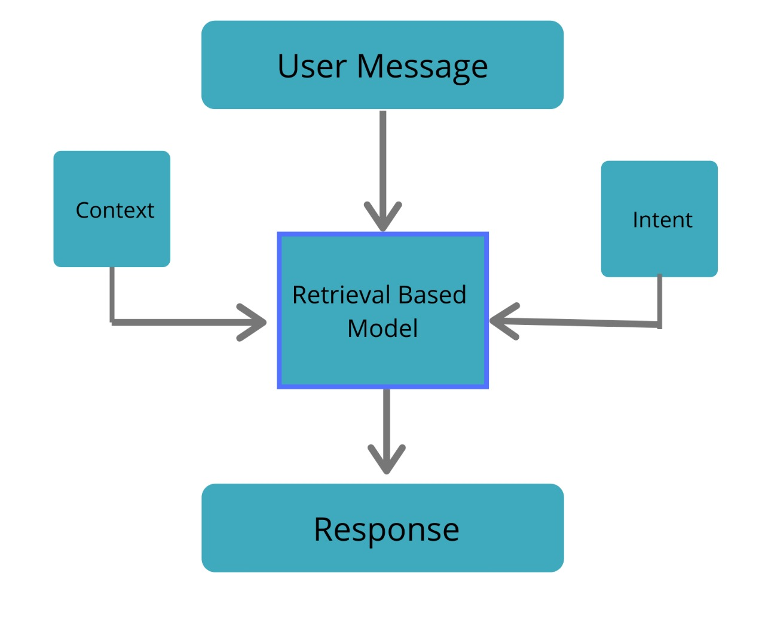

**2. Model Definition and Training**

Sequential Model: Define a sequential model in Keras.

Embedding Layer: Convert integer sequences into dense vectors of fixed size (embedding_dim). This layer is crucial for handling textual data.

GlobalAveragePooling1D: Reduce dimensionality after embedding to prepare for dense layers.

Dense Layers: Neural network layers for learning patterns in the data.

Compilation and Training: Compile the model with appropriate loss function (sparse_categorical_crossentropy), optimizer (adam), and metrics (accuracy). Train the model on padded sequences and encoded labels.

**3. Saving Model Artifacts**

Model Saving: Save the trained model using model.save() in HDF5 format (chat_model).

Saving Tokenizer and Label Encoder: Use pickle to save the fitted Tokenizer and LabelEncoder objects. These are needed during inference to preprocess user input.

4. Chatbot Implementation

Loading Saved Model: Load the trained model (chat_model), tokenizer, and label encoder during the chatbot session.

User Interaction: Continuously prompt the user for input. Process the input using the tokenizer and model for prediction.

Generating Responses: Use the loaded model to predict the intent tag for user input and select a response randomly from the corresponding intent's responses.

Exiting the Chatbot: Allow the user to type "quit" to terminate the chat session.