Figure 1. Workflow Visualization

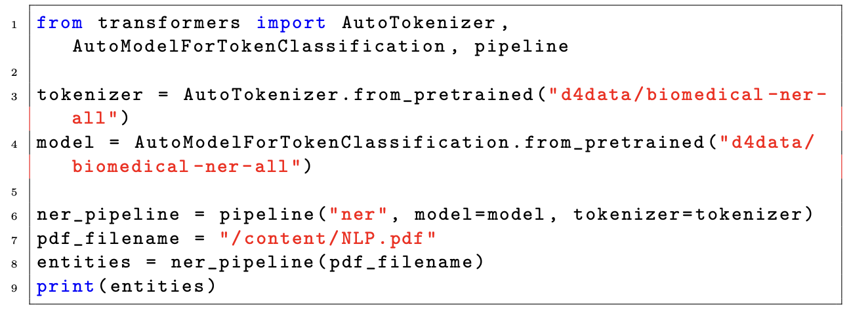
Figure 2. Code Snippet for NER

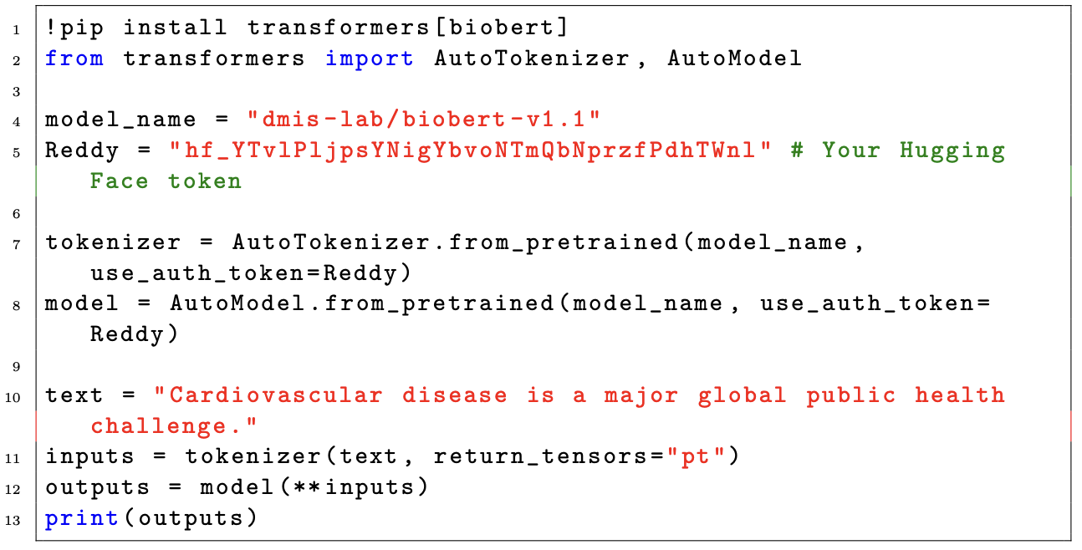
Figure 3. Code Snippet for BioBERT

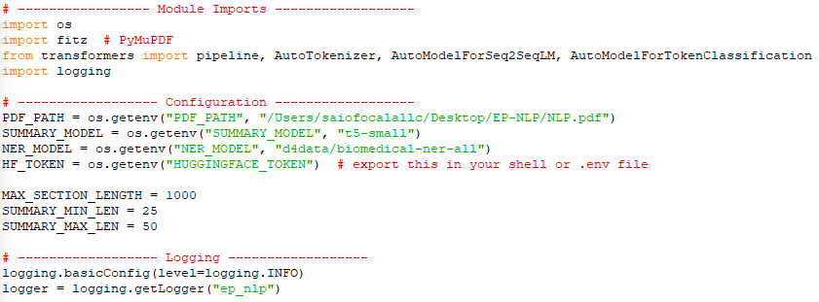
Figure 4. Initialization Code

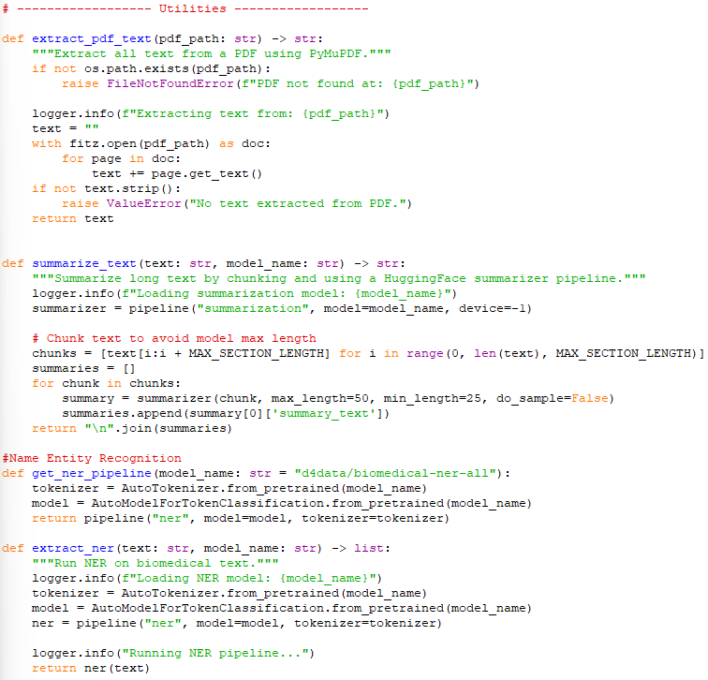
Figure 5. Utilities Code
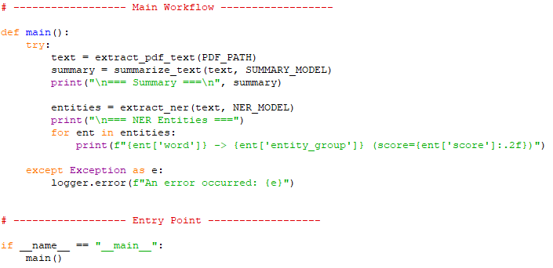
Figure 6. Main Workflow Code

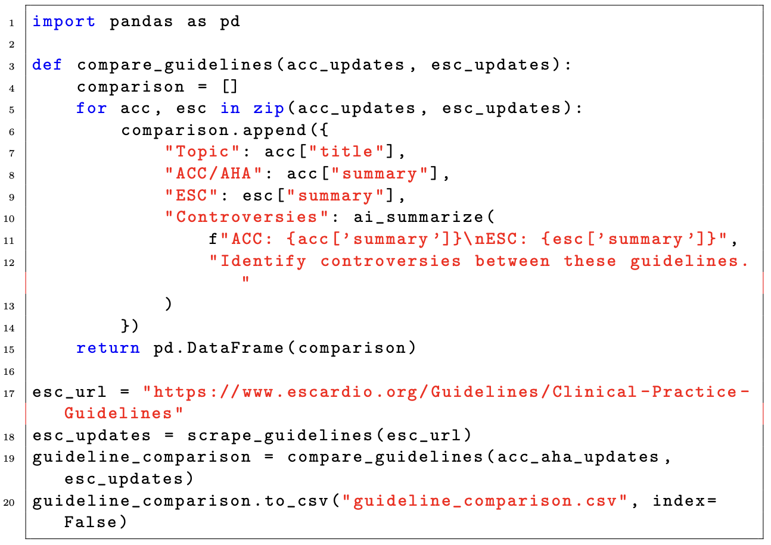
Figure 7. Code Snippet for Web Scraping Libraries

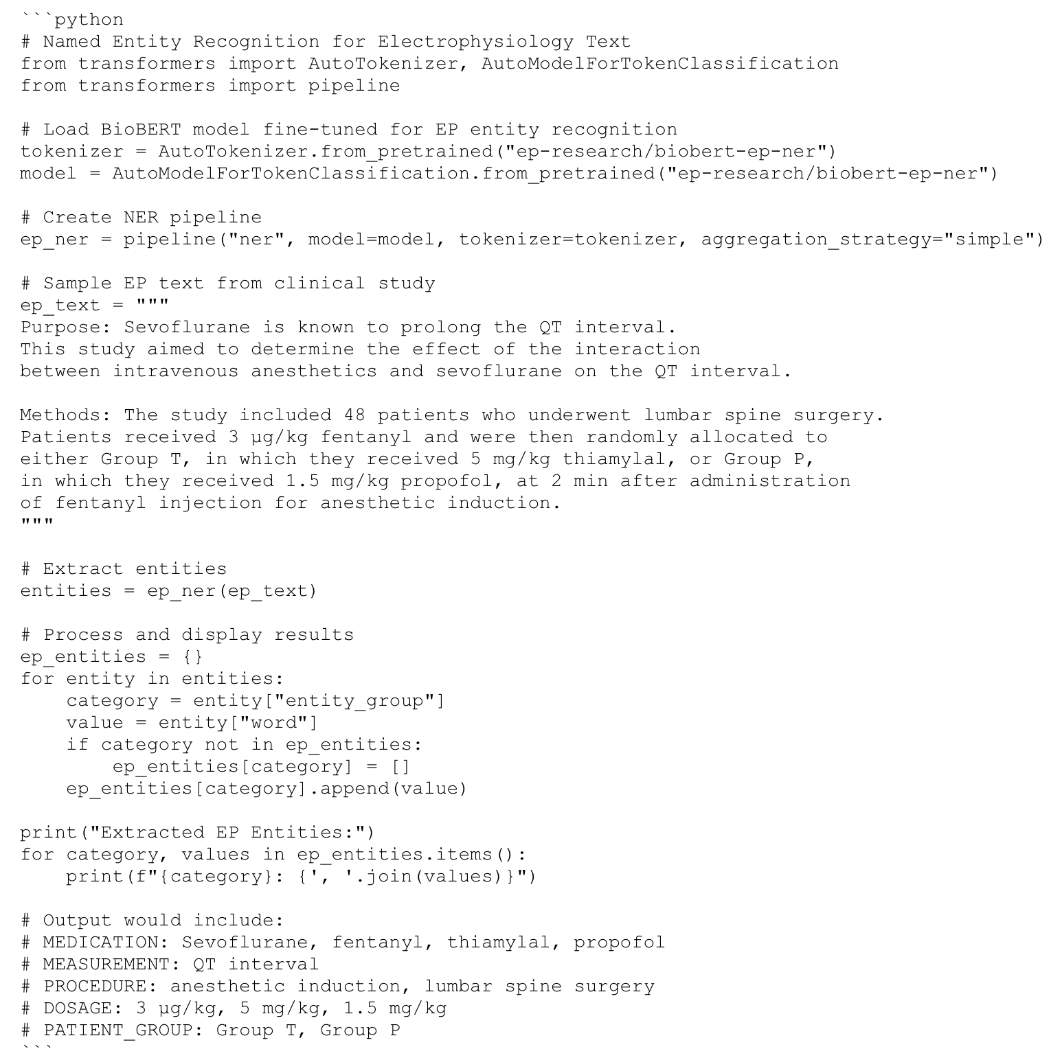
Figure 8. Sample Code Implementation for EP-NER

Figure 9. Agentic AI Implementation for EP Literature Monitoring

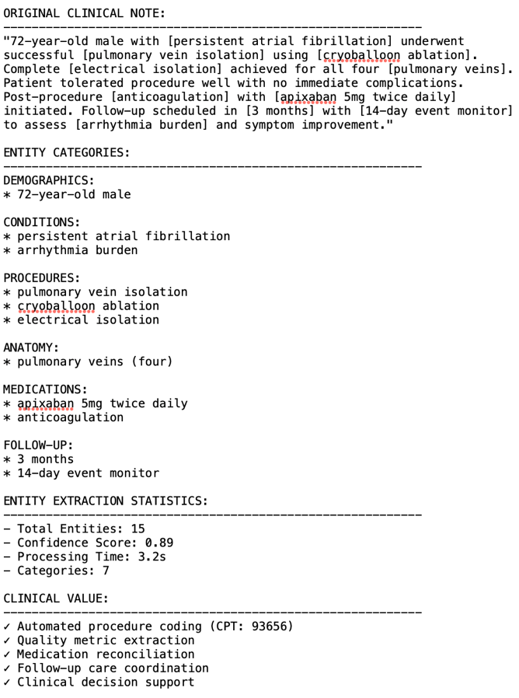
Figure 10. NER Visualization Output

