Week -2 Homework-3

Name: Himavanth reddy putta Id:18759

Q47)

Python code:

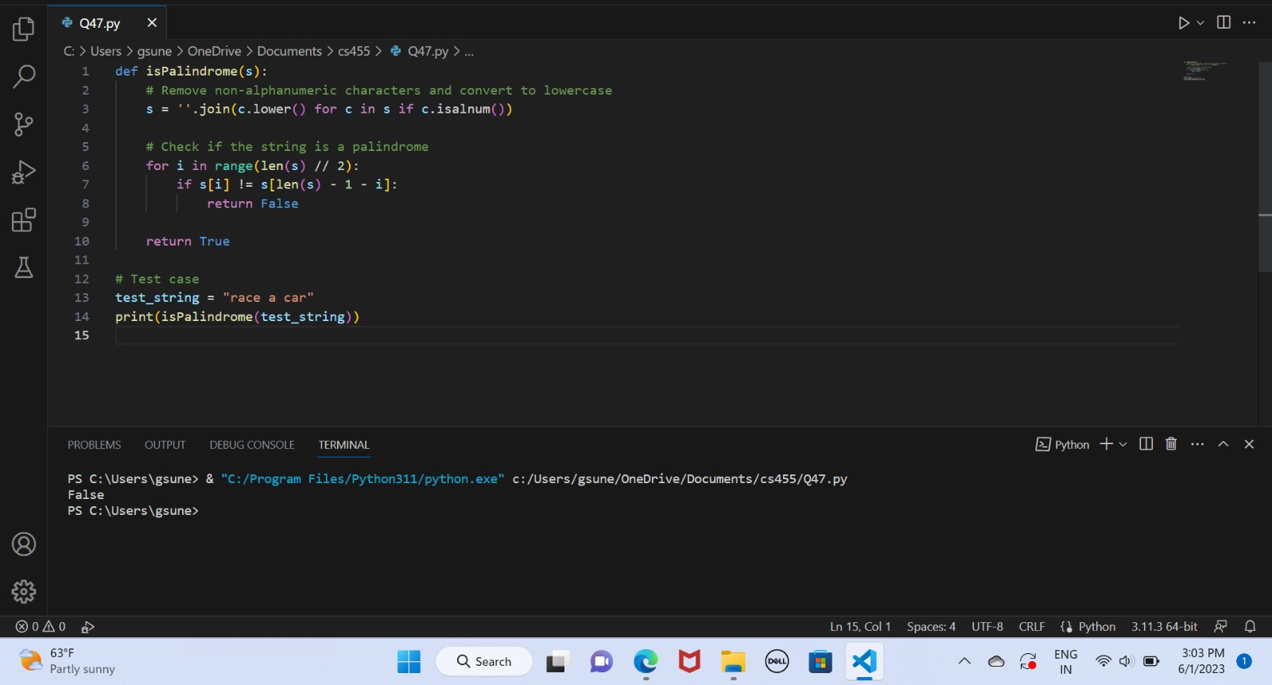

Flowchart:

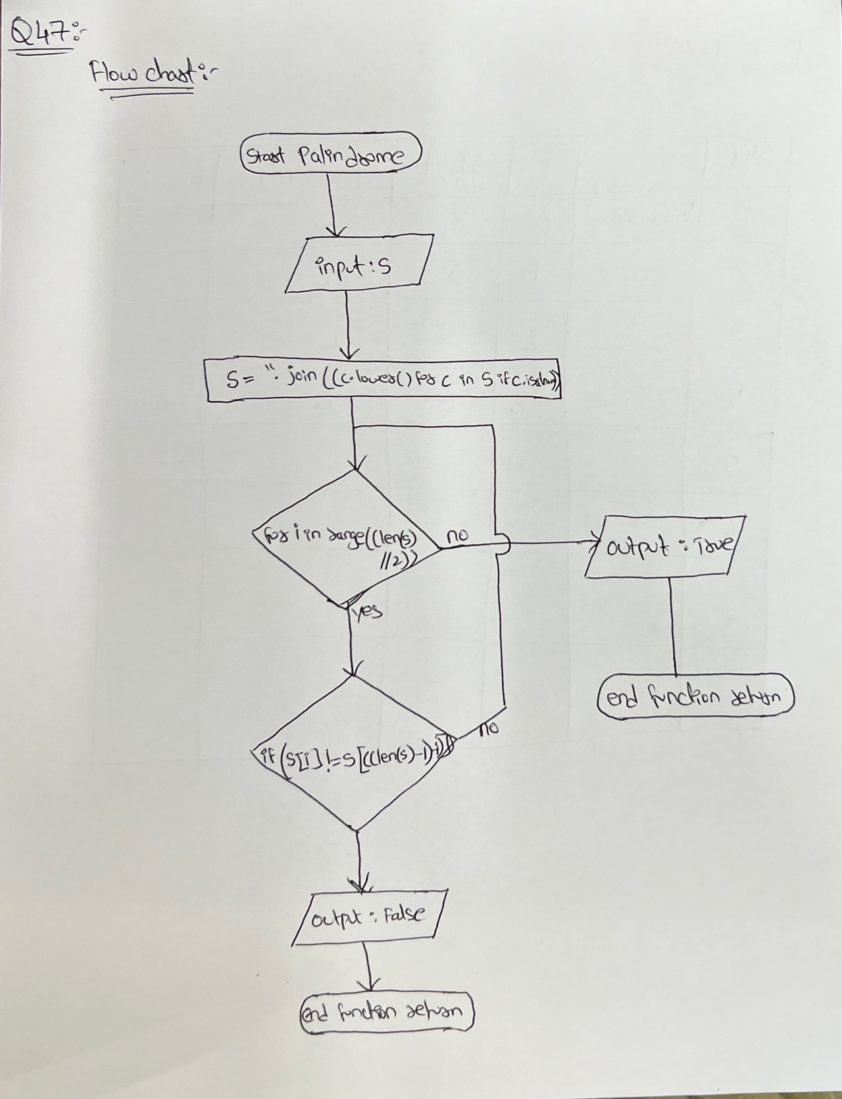

Trace Table:

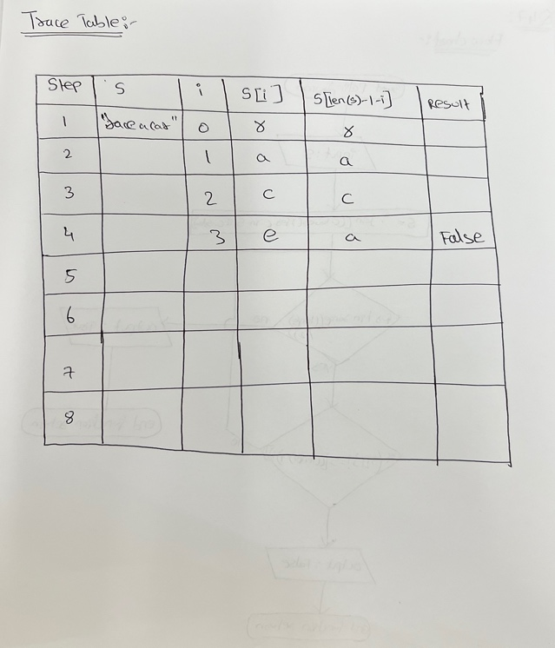

Examples output:

