A COMMUNITY SERVICE PROJECT REPORT
ON
"FREE ELECTRICITY FOR FARMERS"
Submitted to Jawaharlal Nehru Technological University, Anantapur, in partial fulfilment of the requirements for the award of the degree of
BACHELOR OF TECHNOLOGY
in
COMPUTER SCIENCE AND ENGINEERING
During the academic year 2026-2027
Submitted by
BUTHAPPA GARI BALAJI -- 249F1A0523
MURALI -- 249F1A0520
CHAITANYA -- 249F1A0534
SRINIVAS -- 249F1A0549
P. NIKHIL -- 249F1A05A0+++++
Under the esteemed guidance of
Dr. K. BALAJI SUNEEL
M.Tech, Ph.D.
Professor, Department of Computer Science and Engineering
SRI VENKATESWARA INSTITUTE OF TECHNOLOGY
(Affiliated to J.N.T. University, Anantapur)
NH-44, Hampapuram, Anantapuramu -- 515722
2025-2026

DEPARTMENT OF COMPUTER SCIENCE & ENGINEERING
CERTIFICATE
This is to certify that the project work entitled "FREE ELECTRICITY FOR FARMERS" is the bonafide work done by BUTHAPPA GARI BALAJI (249F1A0523), MURALI (249F1A0520), CHAITANYA (249F1A0534), SRINIVAS (249F1A0549), and P. NIKHIL (249F1A05A0), under my supervision and guidance, in partial fulfilment of the requirements for the award of the degree of "BACHELOR OF TECHNOLOGY in COMPUTER SCIENCE & ENGINEERING" from Jawaharlal Nehru Technological University, Anantapur, during the period 2024-2028.
This project was carried out as part of the Community Service Project (CSP) programme, involving structured field engagement with the residents of Penukonda village, Anantapuramu district, between 9th May 2026 and 8th July 2026, with the objective of spreading awareness on the Free Electricity Scheme for Farmers and safe, efficient use of agricultural power supply among the local community.

SIGNATURE OF GUIDE HEAD OF THE DEPARTMENT
Dr. K. Balaji Suneel Dr. K. Balaji Suneel
Department of CSE Department of CSE
Certified that the candidates were examined in the viva-voce examination held on ______________________.

SRI VENKATESWARA INSTITUTE OF TECHNOLOGY
(Affiliated to J.N.T. University, Anantapur)
NH-44, Hampapuram, Anantapuramu -- 515722
2025-2026

DEPARTMENT OF COMPUTER SCIENCE & ENGINEERING
CERTIFICATE FROM OFFICIAL OF THE COMMUNITY
This is to certify that the following students of Sri Venkateswara Institute of Technology, Anantapuramu, underwent Community Service in penukonda village, Anantapuramu District, from 09-05-2026 to 08-07-2026, as part of the Community Service Project titled "Free Electricity for Farmers".

S.No | Name of the Student | Register Number | Conduct / Performance
1 | BUTHAPPA GARI BALAJI | 249F1A0523 | Satisfactory / Good
2 | MURALI | 249F1A0520 | Satisfactory / Good
3 | CHAITANYA | 249F1A0534 | Satisfactory / Good
4 | SRINIVAS | 249F1A0549 | Satisfactory / Good
5 | P. NIKHIL | 249F1A05A0 | Satisfactory / Good

During this period, the students actively participated in household and field surveys, door-to-door awareness sessions, and interactive discussions with farmers on the Free Electricity Scheme, safe use of agricultural power connections, and efficient irrigation practices.
The overall conduct and performance of each Community Service Volunteer during the period of community service is found to be Satisfactory / Good.

Authorized Signatory with Date and Seal

ACKNOWLEDGEMENT
It is a great pleasure to express our deepest sense of gratitude and indebtedness to our guide and project coordinator, Dr. K. Balaji Suneel, M.Tech., Ph.D., Professor, Department of Computer Science & Engineering, Sri Venkateswara Institute of Technology, Anantapuramu, for having been a constant source of inspiration and for his precious guidance, patient supervision, and generous assistance throughout the course of this project work. We deem it a privilege to have worked under his able guidance.
We wish to express our sincere thanks to Dr. K. Balaji Suneel, M.Tech., Ph.D., Head of the Department of Computer Science & Engineering, for his valuable suggestions and for providing an eminent guide for the successful completion of this project.
We wish to express our sincere thanks to Dr.V.Venkateswara Reddy Principal, Sri Venkateswara Institute of Technology, Anantapuramu, for providing the necessary facilities on campus for the completion of this project, and for his constant encouragement towards community-oriented learning.
We are extremely thankful to the farmers and residents of penukonda village for their warmth, cooperation, patience, and willingness to participate in our surveys and awareness sessions. Their openness in sharing their experiences and concerns regarding electricity supply for agriculture made this study both meaningful and insightful.
We wish to express our heartfelt thanks to our parents for providing us with a good environment and encouragement to complete this work.
Finally, we thank all the Teaching and Non-Teaching Staff of the Department of Computer Science & Engineering, and our friends, for their valuable support and cooperation throughout the degree programme.

BUTHAPPA GARI BALAJI -- 249F1A0523
MURALI -- 249F1A0520
CHAITANYA -- 249F1A0534
SRINIVAS -- 249F1A0549
P. NIKHIL -- 249F1A05A0

ABSTRACT
This report presents the outcomes of the Community Service Project (CSP) titled "Free Electricity for Farmers," undertaken by students of the Department of Computer Science and Engineering, Sri Venkateswara Institute of Technology, Anantapuramu, as part of the academic curriculum prescribed by Jawaharlal Nehru Technological University, Anantapur. The project was carried out in Penukonda village, Anantapuramu district, over a nine-week period from 9th May 2026 to 8th July 2026.
Agriculture in Andhra Pradesh and much of rural India remains heavily dependent on electrically operated pump sets for irrigation. In recognition of this dependence, the State Government provides free, quality power supply to agricultural connections for a fixed number of hours each day, alongside national schemes such as PM-KUSUM that promote solarisation of agricultural feeders and pump sets. While these schemes have substantially reduced the input cost of irrigation for farmers, ground-level awareness of eligibility, application procedures, safe usage practices, and available grievance-redressal mechanisms remains uneven, particularly among small and marginal farmers.
With this context, the present project was designed with the dual objective of (a) educating the farmers of Penukonda on the provisions of the Free Electricity Scheme, safe and efficient use of agricultural power connections, and available complaint-redressal channels, through door-to-door interaction, printed awareness material, and group discussions, and (b) gathering first-hand data, through a structured survey, on the community's current level of awareness of the scheme, their experience with agricultural power supply, and their attitudes towards energy conservation.
The report documents the conceptual background of Community Service Projects, the objectives and methodology adopted, a detailed overview of agricultural electricity schemes, the causes of gaps in awareness, the impact of free electricity on farming households, illustrative statistics, safe-usage guidelines, an overview of Central and State Government initiatives, the relevant legal and regulatory framework, the survey instrument and consolidated responses, a profile of the study area, and a week-by-week record of the field activity. The report concludes with key findings, practical suggestions for strengthening awareness at the grassroots level, and an overall conclusion.
It is hoped that this report, and the awareness activities that underpin it, will contribute to a better-informed farming community in Penukonda and will serve as a useful reference for similar awareness initiatives undertaken in the future.

TABLE OF CONTENTS
Certificate 2
Certificate from Community Officials 3
Acknowledgement 4
Abstract 5
List of Tables 7
Chapter 1 : Introduction 8
Chapter 2 : Objectives of the Awareness Project 10
Chapter 3 : Methodology 12
Chapter 4 : Components of Agricultural Power Supply Schemes 14
Chapter 5 : Causes of Low Awareness and Challenges 16
Chapter 6 : Impact of the Free Electricity Scheme 18
Chapter 7 : Statistics on Free Electricity for Farmers 20
Chapter 8 : Safe and Efficient Use of Agricultural Electricity 21
Chapter 9 : Government Initiatives for Farmer Electricity Support 23
Chapter 10 : Legal and Regulatory Framework 25
Chapter 11 : Survey Questions and Responses 27
Chapter 12 : Profile of the Study Area -- Penukonda Village 29
Chapter 13 : Field Work -- Weekly Record 30
Chapter 14 : Findings, Suggestions and Conclusion 35
References 37
Annexure -- Community Service Project Declaration Form 38

LIST OF TABLES
Table 6.1 -- Summary of impacts of the Free Electricity Scheme by category
Table 7.1 -- Illustrative coverage of agricultural power schemes
Table 9.1 -- Government initiatives and their objectives
Table 10.1 -- Key provisions relevant to agricultural electricity supply
Table 11.1 -- Survey questions and consolidated responses (Q1--Q30)
Table 13.1 -- Week-wise summary of field activities

CHAPTER 1
INTRODUCTION

1.1 Community Service Projects -- An Overview
A Community Service Project (CSP) is an experiential learning strategy that integrates meaningful community service with structured instruction, guided participation, and reflective learning, with the overarching aim of contributing to community development. As a mandatory component of the undergraduate engineering curriculum prescribed by Jawaharlal Nehru Technological University, Anantapur, the CSP requires students to step outside the classroom and apply their knowledge, communication skills, and technical understanding towards addressing a real, identifiable need within a local community.
Community Service Projects differ from conventional academic assignments in that their success is measured not merely by the quality of the written report, but by the tangible value delivered to the community that is served. Students are expected to identify a relevant social issue, design an appropriate intervention, engage directly with community members over a sustained period, and document both the process and the outcomes achieved.

1.2 Benefits of Community Service Projects for Students

1.2.1 Psychological Benefits
Volunteering and community engagement have been widely observed to increase overall life satisfaction and to help students feel a stronger sense of purpose through the act of helping others. Structured community service has also been associated with reduced stress levels and improved emotional wellbeing, as students step out of purely academic routines and engage meaningfully with the world around them.

1.2.2 Social Benefits
Community Service Projects engage students directly with the community, helping to build bonds with the population being served and increasing social awareness and a sense of civic responsibility. Students learn to communicate across generational, linguistic, and educational differences, and develop empathy for the everyday challenges faced by people outside their immediate academic environment -- in this case, the practical realities of farming families dependent on agricultural power supply.

1.2.3 Academic and Professional Benefits
- Application of classroom knowledge to a real-world, non-technical, agrarian audience.
- Development of communication, planning, teamwork, and field-data collection skills.
- Exposure to survey design, data consolidation, and report writing.
- Enhanced employability through demonstrated initiative, leadership, and social responsibility.

1.3 Free Electricity for Farmers -- Introduction
Agriculture in India, and particularly in Andhra Pradesh, is heavily dependent on electrically operated pump sets for lifting groundwater and canal water for irrigation. Recognising the central role that reliable and affordable power supply plays in farm incomes, the State Government provides free, quality power supply to agricultural connections for a fixed number of hours each day, fully absorbing the tariff cost through budgetary subsidy to the power distribution companies (DISCOMs). This is complemented at the national level by schemes such as PM-KUSUM, which promote the solarisation of agricultural feeders and individual pump sets, reducing both the cost of power and the load on the conventional grid.
While the Free Electricity Scheme has meaningfully reduced the input cost of irrigation for lakhs of farming households, ground-level awareness of the scheme's provisions -- eligibility criteria, the process for obtaining a new agricultural connection, safe usage of electrical equipment in the field, and the correct channel for reporting supply faults or seeking redress -- remains uneven, particularly among small and marginal farmers and older residents with limited exposure to formal government communication channels.
Free electricity for agriculture is also not without its own set of practical challenges: farmers must still contend with issues such as unpredictable supply timings, voltage fluctuations that damage costly pump motors, and, in some cases, uncertainty about whether a given practice (such as an unauthorised additional connection) is within the bounds of the scheme. Awareness of both the entitlements and the responsibilities that come with the scheme is therefore essential for farmers to derive its full benefit safely and sustainably.

1.4 Rationale for Choosing This Theme
The choice of "Free Electricity for Farmers" as the theme for this Community Service Project was guided by several considerations. First, as students of Computer Science and Engineering with a general grounding in electrical and digital systems, the group possessed sufficient technical background to explain the scheme, metering, and safety concepts in a simple, accessible manner to a farming audience. Second, preliminary discussions with residents of Penukonda village revealed that, although virtually every farming household held an agricultural power connection, many respondents were unclear about the exact hours of free supply applicable to them, the process for reporting a fault, and the existence of newer schemes such as solar pump-set subsidies. Third, agricultural power supply is a subject of continuing public and policy interest in Andhra Pradesh, making the theme both timely and directly relevant to the livelihood of the community served.

1.5 Scope of the Report
This report is organised into fourteen chapters. It begins with the objectives and methodology adopted for the awareness campaign and the accompanying survey, followed by a detailed discussion of the components of agricultural electricity schemes, the causes of gaps in awareness, and the impact of free electricity on farming households. The report then presents illustrative statistics, a set of practical safety and efficiency guidelines for using agricultural power connections, an overview of Central and State Government initiatives, and a summary of the relevant legal and regulatory framework. Subsequent chapters present the survey instrument used during the fieldwork along with consolidated responses, a brief profile of the study area, a week-by-week record of the field activity, and finally the findings, suggestions, and conclusions drawn from the project as a whole.

CHAPTER 2
OBJECTIVES OF THE AWARENESS PROJECT
The awareness campaign and the accompanying household survey conducted in Penukonda village were guided by a clearly defined set of objectives. These objectives shaped both the content of the awareness material distributed to farmers and the structure of the survey instrument used to assess the community's existing level of awareness regarding the Free Electricity Scheme.

2.1 Primary Objectives
- To educate farmers about the Free Electricity Scheme, including eligibility, the number of free supply hours applicable, and the process for obtaining a new agricultural connection.
- To create awareness about safe handling of agricultural electrical equipment, including pump sets, starters, and field wiring.
- To promote efficient use of electricity in irrigation, including correct pump-set sizing and avoidance of overloading.
- To encourage timely reporting of supply faults, voltage fluctuations, and damaged transformers to the concerned DISCOM.
- To inform farmers about complementary schemes such as PM-KUSUM for solar pump sets and feeder solarisation.
- To reduce the incidence of electrical accidents and equipment damage on farms through preventive awareness.
- To inform residents about available grievance-redressal mechanisms, including the DISCOM toll-free helpline and Consumer Grievance Redressal Forums.
- To develop responsible and sustainable usage habits with respect to a subsidised public resource.
- To enhance overall awareness among farmers, farm labourers, and small shopkeepers dependent on the agricultural economy of the village.
- To build a channel of cooperation between farmers, local institutions, and the power distribution utility.

2.2 Secondary Objectives
- To gather first-hand, ground-level data on the community's awareness of and experience with the Free Electricity Scheme, through a structured 30-question survey.
- To identify specific gaps in awareness -- for example, around free-supply hours, safety practices, or grievance-redressal channels -- that can inform future awareness drives.
- To provide undergraduate engineering students with structured, supervised exposure to community engagement, field data collection, and applied technical communication.
- To create a documented, reusable awareness resource (this report, together with the printed material used during the campaign) that can support similar initiatives in neighbouring villages.

2.3 Target Audience
The awareness campaign was designed to be accessible to farmers and farming households across a wide range of ages and landholding sizes -- from young, tech-comfortable farmers who actively track supply schedules on their mobile phones, to older farmers and small and marginal landholders whose primary source of information about the scheme has historically been word of mouth. Awareness material and verbal explanations were adapted, where necessary, to suit the specific crop patterns, pump-set usage, and prior experience of each household encountered during the field visits.

CHAPTER 3
METHODOLOGY

3.1 What is the Free Electricity for Farmers Scheme?
The Free Electricity for Farmers Scheme refers to the State Government's policy of supplying quality electric power, free of tariff charge, to registered agricultural service connections for a defined number of hours each day, with the corresponding subsidy borne directly by the State budget and routed to the power distribution companies. The scheme is intended to reduce the recurring cost of irrigation for farming households and, in doing so, to support farm incomes and cropping intensity. It operates alongside complementary Central schemes, such as PM-KUSUM, which support the installation of solar-powered agricultural pump sets and the solarisation of agricultural feeders, further reducing both cost and grid dependence.

3.2 Research Design
The project adopted a descriptive, field-based research design combining two complementary components: (a) an awareness and outreach component, in which the project team visited farming households, fields, and common gathering points within Penukonda village to explain the provisions of the Free Electricity Scheme and safe usage practices in simple, conversational language; and (b) a survey-based data collection component, in which a structured questionnaire of thirty questions was administered to willing participants to assess their existing awareness levels, usage patterns, and prior experience with agricultural power supply.

3.3 Sampling and Participant Selection
Participants were selected through convenience sampling during door-to-door and field visits, ensuring representation across different age groups, landholding sizes (small, marginal, and medium farmers), and levels of prior exposure to the scheme's formal provisions. Participation in the survey was entirely voluntary, and respondents were informed of the purpose of the exercise before any data was collected, consistent with the declaration and consent process documented in the Annexure to this report.

3.4 Data Collection Tools
- A printed and verbally-administered questionnaire comprising thirty structured questions covering awareness of the scheme, usage patterns, safety practices, prior experience of supply faults, and attitudes towards energy conservation and grievance reporting.
- Printed awareness handouts covering free-supply hours, safe pump-set operation, and the DISCOM complaint helpline number.
- Verbal, conversational explanations tailored to the respondent's age, landholding, and existing familiarity with the scheme, delivered in the local language.
- A written field log maintained on a weekly basis to document the reach of the outreach activity (Chapter 13).

3.5 Duration and Location of Fieldwork
The fieldwork was carried out over a nine-week period, from 9th May 2026 to 8th July 2026, in Penukonda village, Anantapuramu district, Andhra Pradesh. Visits were organised on a weekly basis, with the project team covering different sections of the village -- including farming hamlets, field pump-house clusters, and the main village settlement -- in each successive week, so as to maximise the diversity and reach of households covered.

3.6 Data Analysis Approach
Responses collected through the survey were consolidated and tabulated question-by-question (see Chapter 11), and analysed descriptively to identify broad patterns -- such as the proportion of respondents aware of the exact free-supply hours applicable to them, common safety practices already in use, and gaps in awareness around topics such as fault reporting and solar pump-set subsidies. These patterns directly informed the findings and suggestions presented in Chapter 14.

3.7 Limitations of the Study
- The sample was drawn from a single village and cannot be assumed to be statistically representative of the wider district, state, or country.
- Convenience sampling, while practical for a time-bound field project, may under-represent farmers who were away at their fields or unavailable during the visit windows.
- Self-reported survey responses are subject to the usual limitations of self-report data, including the possibility of respondents over-stating their existing awareness or safety practices.
- The awareness sessions were delivered over a relatively short, nine-week period; the retention and long-term behavioural impact of the awareness messages was not independently measured after the conclusion of the project.

CHAPTER 4
COMPONENTS OF AGRICULTURAL POWER SUPPLY SCHEMES
Agricultural power supply in Andhra Pradesh today is supported through several complementary schemes and mechanisms, ranging from direct tariff subsidy to solar-based generation. This chapter presents a structured overview of the components most relevant to farmers, and which formed the core of the awareness material shared with residents of Penukonda village.

4.1 Free Power Supply to Agriculture (9-Hour Scheme)
Under this scheme, registered agricultural service connections receive quality, three-phase power supply, free of tariff charge, for a defined number of hours (generally around nine hours) each day, with supply timings communicated in advance so that farmers can plan irrigation accordingly. The subsidy is paid by the State Government directly to the distribution companies (DISCOMs) on behalf of the farmer.

4.2 PM-KUSUM Scheme
The Pradhan Mantri Kisan Urja Suraksha evam Utthaan Mahabhiyan (PM-KUSUM) is a Central Government scheme that supports the installation of standalone solar-powered agricultural pump sets, the solarisation of existing grid-connected pump sets, and the solarisation of agricultural feeders, with subsidy support shared between the Central and State Governments. The scheme reduces both the farmer's dependence on the conventional grid and the overall subsidy burden on the DISCOM.

4.3 New Agricultural Connections and Metering
Farmers seeking a new agricultural service connection are required to apply through the concerned DISCOM sub-division office, with supporting documents establishing land ownership or cultivation rights. Metered connections, even where power is supplied free of charge, allow the utility to monitor consumption patterns and plan feeder capacity.

4.4 Agricultural Feeder Segregation
Feeder segregation refers to the separation of agricultural feeders from domestic and other feeders at the distribution level, allowing agricultural supply to be scheduled independently of, and without disrupting, continuous domestic power supply to the same area.

4.5 Solar Agricultural Pump-Set Subsidy
Under the solar pump-set component of PM-KUSUM, eligible farmers can obtain a standalone solar pump set at a substantially subsidised cost, eliminating the recurring electricity cost of irrigation altogether for pump sets of the covered capacity.

4.6 Bill Waivers and One-Time Settlement Schemes
From time to time, the State Government has announced one-time settlement schemes for legacy agricultural power arrears, allowing farmers with old, unresolved dues (predating the free-power policy) to regularise their connections without penalty.

4.7 Chapter Summary
Together, these schemes and mechanisms are designed to make irrigation power both affordable and increasingly sustainable for farmers. Understanding which components apply to a given household -- and, in particular, the distinction between the free-supply entitlement and the newer solar subsidy schemes -- formed the core message of the awareness sessions conducted during this project.

CHAPTER 5
CAUSES OF LOW AWARENESS AND CHALLENGES IN THE SCHEME
Gaps in awareness of the Free Electricity Scheme, and the practical challenges farmers face in benefiting fully from it, arise from a combination of communication, infrastructural, and behavioural factors. Understanding these root causes is essential not only for improving scheme delivery, but also for shaping the kind of community-level awareness activity undertaken during this project.

5.1 Limited Formal Communication of Scheme Details
Many farmers learn about changes to supply hours, new subsidy components, or application procedures through informal word of mouth rather than official notices, leading to outdated or incomplete understanding of their entitlements.

5.2 Documentation and Application Complexity
The process of applying for a new agricultural connection or a solar pump-set subsidy requires supporting land and identity documents that some farmers, particularly older residents and those with informally-held land, find difficult to assemble.

5.3 Irregular or Unpredictable Supply Hours
Although free supply is nominally guaranteed for a fixed number of hours, farmers sometimes experience shifts in the scheduled timing, requiring them to adjust irrigation plans at short notice.

5.4 Voltage Fluctuations and Equipment Damage
Ageing distribution infrastructure can result in voltage fluctuations that damage pump motors and starters, a recurring practical concern raised by farmers during the survey.

5.5 Rebound Effect on Groundwater Extraction
Because irrigation power is free at the point of use, some farmers have limited economic incentive to moderate groundwater extraction, a concern noted in broader policy literature on free agricultural power schemes across India.

5.6 Limited Awareness of Fault-Reporting Channels
Several respondents indicated that they were unaware of the DISCOM's toll-free complaint helpline and instead relied on informal local contacts to report supply faults, resulting in delays.

5.7 Language and Literacy Barriers
Official scheme notifications and application forms are often issued in formats that are less accessible to residents with limited formal literacy, making verbal, conversational explanation an important complement to printed material.

5.8 Limited Access to Digital Application Portals
Newer schemes, including solar pump-set subsidy applications, are increasingly administered through online portals, which some farmers -- particularly older residents -- find difficult to navigate without assistance.

CHAPTER 6
IMPACT OF THE FREE ELECTRICITY SCHEME FOR FARMERS
The Free Electricity Scheme has had wide-ranging effects on farming households, the power sector, and the broader rural economy. This chapter summarises the major categories of impact, drawing on both general policy literature and the concerns and experiences expressed by residents during the household survey conducted as part of this project.

6.1 Reduced Input Cost of Irrigation
The most direct and widely acknowledged benefit is the elimination of the recurring electricity cost of running irrigation pump sets, meaningfully reducing the overall cost of cultivation for farming households.

6.2 Increased Cropping Intensity
Reduced irrigation cost has, in many areas, supported an increase in cropping intensity and a shift towards more water-intensive but higher-value crops.

6.3 Groundwater Depletion Concerns
Free power removes a natural economic check on groundwater extraction, and sustained heavy use of borewell irrigation without corresponding water-conservation practices can contribute to declining water tables over time.

6.4 Financial Burden on DISCOMs and the State Budget
The scheme represents a substantial and recurring subsidy commitment, met through State budgetary allocation to the distribution companies, with implications for the long-term financial health of the power sector.

6.5 Equity Considerations Among Farmers
Benefits of the scheme scale broadly with the number and capacity of pump-set connections held, meaning that farmers with larger landholdings and multiple connections may derive proportionately greater benefit than small and marginal farmers.

6.6 Reduced Dependence on Diesel Pump Sets
Reliable free grid power has reduced dependence on costlier and more polluting diesel-operated pump sets in many areas, with corresponding cost and environmental benefits.

6.7 Environmental Considerations
Where agricultural feeders are increasingly solarised under PM-KUSUM, the environmental footprint of irrigation power is further reduced, complementing the direct economic benefits of the scheme.

6.8 Reduced Farmer Financial Distress
By removing one significant recurring cost from the farm budget, the scheme contributes to reduced financial pressure on farming households, a point echoed by several respondents during the survey.

6.9 Summary Table
Category | Primary Effect | Typically Affected
Economic | Lower cost of irrigation, cultivation | Farming households
Agricultural | Higher cropping intensity | Farmers, local economy
Environmental | Groundwater stress; reduced diesel use | Community, ecosystem
Fiscal | Recurring subsidy burden | State Government, DISCOMs
Equity | Uneven benefit by landholding size | Small and marginal farmers
Social | Reduced farm financial distress | Farming households
Table 6.1 -- Summary of impacts of the Free Electricity Scheme by category

CHAPTER 7
STATISTICS ON FREE ELECTRICITY FOR FARMERS
Agricultural power supply and the associated subsidy represent one of the largest recurring line items in State power-sector finances, and coverage of agricultural connections continues to expand alongside rural electrification. The figures below are presented as an illustrative, general picture intended to give a broad sense of relative scale, rather than a precise, sourced statistic specific to Penukonda village or any particular financial year.

7.1 Illustrative Coverage of Agricultural Power Schemes
Category | Illustrative Share
Agricultural connections on standard free-power supply | Majority of connections
Connections solarised / under solar pump-set schemes | Small but growing share
Farmers aware of exact free-supply hours applicable to them | Roughly half
Farmers aware of the DISCOM complaint helpline | Minority
Table 7.1 -- Illustrative coverage of agricultural power schemes (general, not survey-specific)

7.2 Broad Observations
- Agricultural power subsidy remains one of the largest recurring components of DISCOM revenue shortfall in states operating free-power schemes.
- Solar pump-set adoption under PM-KUSUM, while still a minority of total agricultural connections nationally, is growing steadily as subsidy support expands.
- Awareness of fault-reporting channels tends to lag behind awareness of the core free-supply entitlement itself, a pattern broadly consistent with the findings of the present survey (Chapter 11).

7.3 Relevance to the Present Study
The survey responses gathered in Penukonda village (Chapter 11) broadly mirror these general patterns: nearly all respondents were aware that their agricultural connection received free power, but a smaller proportion could correctly state the exact number of free-supply hours applicable, and awareness of the formal complaint helpline was notably low. This alignment between the general picture and the ground-level survey findings reinforces the relevance of the awareness priorities adopted for this project.

CHAPTER 8
SAFE AND EFFICIENT USE OF AGRICULTURAL ELECTRICITY
This chapter summarises the core set of practical safety and efficiency measures that formed the backbone of the awareness sessions conducted during the field visits. These measures were deliberately kept simple and actionable, so that they could be readily adopted by farmers regardless of the size of their landholding or their prior exposure to formal electrical safety guidance.

8.1 Proper Earthing of Pump Sets
Farmers were encouraged to ensure that pump-set motors and starter panels are properly earthed, reducing the risk of electric shock in the event of an insulation fault, particularly in wet field conditions.

8.2 Use of Earth Leakage Circuit Breakers (ELCBs)
Installing an ELCB at the pump-house connection point provides an additional layer of protection by automatically disconnecting supply in the event of a current leakage to earth.

8.3 Correct Pump-Set Sizing
Selecting a pump motor of appropriate horsepower for the borewell depth and irrigation requirement avoids both under-performance and unnecessary energy wastage from an oversized motor.

8.4 Avoiding Overloading and Phase Imbalance
Farmers were advised to avoid running multiple heavy loads on a single phase simultaneously, which can trip protective devices or, over time, damage motor windings.

8.5 Timely Servicing of Motors and Starters
Regular inspection and servicing of pump motors, starters, and cabling reduces the likelihood of sudden breakdowns during critical irrigation periods.

8.6 Use of Capacitor Banks
Installing capacitor banks to improve the power factor of pump-set loads reduces line losses and can improve overall supply voltage stability at the feeder level.

8.7 Prompt Reporting of Faults
Farmers were encouraged to promptly report damaged transformers, sagging lines, or persistent voltage fluctuations to the DISCOM helpline rather than attempting unauthorised repairs themselves.

8.8 Safe Practice During the Rainy Season
Residents were advised to avoid touching pump-house switchboards, poles, or exposed wiring with wet hands or in standing water, and to keep children away from field-level electrical installations during heavy rain.

8.9 Basic Maintenance of Solar Pump Sets
For households with solar pump sets, farmers were advised on periodic cleaning of solar panels to maintain output efficiency, and on avoiding shading of panels by nearby structures or vegetation.

8.10 Protecting Children and Animals in the Field
- Keep pump-house doors and switch panels locked or otherwise inaccessible to children.
- Fence off exposed transformer and pole-mounted equipment where livestock movement is common.
- Avoid leaving live field wiring unattended between irrigation cycles.

CHAPTER 9
GOVERNMENT INITIATIVES FOR FARMER ELECTRICITY SUPPORT
The Central and State Governments have launched a range of initiatives to support affordable, reliable, and increasingly sustainable power supply for agriculture. Familiarity with these initiatives -- particularly the mechanisms available for reporting supply issues and applying for solar subsidy schemes -- formed an important part of the awareness material shared with residents during this project.

9.1 State Free Power Supply to Agriculture Scheme
The flagship State-level initiative under which registered agricultural connections receive quality power supply, free of tariff charge, for a defined number of hours daily, with the subsidy borne by the State budget.

9.2 PM-KUSUM Scheme
A Central Government scheme supporting solarisation of agricultural feeders, subsidised standalone solar pump sets, and solarisation of existing grid-connected pump sets, administered jointly with State nodal agencies.

9.3 Deendayal Upadhyaya Gram Jyoti Yojana (DDUGJY)
A rural electrification and feeder-segregation programme aimed at strengthening rural distribution infrastructure, including the separation of agricultural and domestic feeders to improve reliability of supply to both categories.

9.4 Agricultural Feeder Solarisation Programme
A component of PM-KUSUM specifically targeting the solarisation of existing agricultural feeders, allowing daytime irrigation supply to be sourced increasingly from solar generation.

9.5 DISCOM Toll-Free Complaint Helpline
Power distribution companies operate a toll-free consumer helpline for reporting supply interruptions, voltage complaints, and billing queries relating to agricultural and other connections, with field crews dispatched to address reported faults.

9.6 Consumer Grievance Redressal Forum and Ombudsman
Every DISCOM maintains a Consumer Grievance Redressal Forum for unresolved complaints, with further appeal available to the State Electricity Ombudsman under the regulatory framework established by the Electricity Act, 2003.

9.7 Farmer Training and Capacity-Building Programmes
The Department of Agriculture and the DISCOMs periodically conduct farmer training camps on safe pump-set operation, energy-efficient irrigation practices, and the application process for solar subsidy schemes -- initiatives that this Community Service Project sought to complement at the grassroots, village level.

9.8 Summary Table
Initiative | Nodal Focus | Primary Benefit to Farmers
Free Power to Agriculture Scheme | Tariff subsidy | Free daily irrigation power
PM-KUSUM | Solar pump / feeder subsidy | Lower long-term power cost
DDUGJY | Feeder segregation | Improved supply reliability
DISCOM Helpline | Fault / complaint reporting | Faster fault resolution
Grievance Redressal Forum / Ombudsman | Dispute resolution | Formal appeal mechanism
Table 9.1 -- Government initiatives and their objectives

CHAPTER 10
LEGAL AND REGULATORY FRAMEWORK
A basic understanding of the legal and regulatory framework governing electricity supply in India was included in the awareness sessions, so that farmers would know not only their entitlements under the Free Electricity Scheme, but also the correct legal channels available to them in case of disputes or supply issues. This chapter provides a general, non-exhaustive overview and does not constitute legal advice; residents seeking guidance on a specific issue should consult the concerned DISCOM office or a qualified professional.

10.1 The Electricity Act, 2003 -- Background and Purpose
The Electricity Act, 2003, consolidated the laws relating to generation, transmission, distribution, trading, and use of electricity in India, and established the regulatory framework -- including State Electricity Regulatory Commissions -- under which tariffs, including subsidised agricultural tariffs, are determined and administered.

10.2 Role of the State Electricity Regulatory Commission
The State Electricity Regulatory Commission approves the annual tariff structure for all consumer categories, including agriculture, and the extent to which agricultural tariff is subsidised by the State Government is reflected in the Commission's tariff orders.

10.3 Key Provisions Relevant to Agricultural Power Supply
Provision | General Subject Matter
Section 43 | Duty of the licensee to supply electricity on request, subject to prescribed conditions.
Section 55 | Requirement for consumer connections to be metered.
Section 135 | Theft of electricity, including unauthorised use or tampering with meters or lines.
Section 138 | Interference with meters or works of a licensee.
Section 42 | Establishment of Consumer Grievance Redressal Forums and the office of the Electricity Ombudsman.
Table 10.1 -- Key provisions relevant to agricultural electricity supply (general overview)

10.4 Reporting Mechanisms Under the Legal Framework
Farmers facing an unresolved supply issue may first approach the local DISCOM sub-division office or the toll-free helpline, escalate an unresolved complaint to the Consumer Grievance Redressal Forum, and, if still dissatisfied, appeal further to the State Electricity Ombudsman.

10.5 Relevance to the Community
During the awareness sessions, farmers were specifically informed that unauthorised tapping of agricultural lines or tampering with meters, even where supply is nominally free, can attract penal consequences under the Electricity Act, and that all supply and safety concerns should instead be routed through the formal complaint channels described above. This message was found to be particularly relevant given that several respondents indicated uncertainty about which practices were within the bounds of the scheme.

CHAPTER 11
SURVEY QUESTIONS AND RESPONSES
A structured thirty-question survey was administered during household and field visits to farmers of Penukonda village, covering awareness of the Free Electricity Scheme, usage patterns, safety practices, prior experience of supply faults, and attitudes towards energy conservation and grievance reporting. The consolidated responses are presented below, in question order, and represent the general pattern of responses gathered during the field survey.

11.1 Survey Instrument and Consolidated Responses
# | Question | Consolidated Response
1 | What is your age group? | 35–50 years — primary earning member of a farming household.
2 | What is your occupation? | Farmer — cultivates food crops on owned or leased agricultural land.
3 | What is your primary source of irrigation? | Borewell operated using an electric pump set.
4 | Do you hold a registered agricultural power connection? | Yes — holds a registered connection in own name.
5 | Are you aware that agricultural power supply is provided free of charge? | Yes — aware that supply is free of tariff.
6 | Do you know the exact number of free-supply hours applicable to your connection? | Only partially aware; unsure of the exact daily hours.
7 | How many hours of power supply do you typically receive daily for irrigation? | Around 7–9 hours, though the timing sometimes varies.
8 | Have you experienced frequent voltage fluctuations? | Yes — occasional fluctuations that affect equipment.
9 | Has your pump motor ever been damaged due to a voltage issue? | Yes — motor damaged once; repaired locally.
10 | Are you aware of the PM-KUSUM scheme for solar pump sets? | No — was not aware before this awareness campaign.
11 | Would you be interested in a solar pump set if subsidised? | Yes — interested if the cost is affordable.
12 | Do you know the toll-free helpline number to report a supply fault? | No — was unaware of the helpline number.
13 | Have you ever formally reported a supply fault to the DISCOM? | No — relied on informal local contacts instead.
14 | How satisfied are you with the current agricultural power supply? | Moderately satisfied; supply timing could improve.
15 | Do you have proper earthing or an ELCB at your pump house? | No — pump house lacks formal earthing.
16 | Are you aware of the risks of operating pump sets with wet hands? | Yes — generally cautious during the rainy season.
17 | Do you service your pump motor and starter regularly? | Occasionally — mainly when a problem arises.
18 | Have you applied for a new agricultural connection recently? | No — connection was inherited or pre-existing.
19 | Was the application process for your connection difficult? | Somewhat difficult, due to paperwork required.
20 | Do you think free power has increased groundwater usage in your area? | Yes — extraction has increased over the years.
21 | Are you concerned about declining groundwater levels? | Yes — noticeably concerned about the falling water table.
22 | Do you think the free electricity scheme has reduced your farming costs? | Yes — has significantly reduced irrigation expenses.
23 | Do you think all farmers benefit equally from the scheme? | No — larger farmers appear to benefit more.
24 | Would you support water-conservation measures alongside free power? | Yes — supportive, provided guidance is given.
25 | Have you heard of the Consumer Grievance Redressal Forum? | No — was unaware of this forum.
26 | What is your biggest concern regarding agricultural power supply? | Unpredictable timing and occasional voltage fluctuations.
27 | What role should the government play in improving the scheme? | Improve supply reliability and farmer communication.
28 | What role should the DISCOM play? | Faster fault resolution and regular awareness drives.
29 | Would you attend a follow-up session on solar pump subsidies? | Yes — expressed strong interest.
30 | What suggestions do you have for improving farmer awareness? | More frequent village-level awareness camps.
Table 11.1 -- Survey questions and consolidated responses (Q1–Q30)

11.2 Interpretation of Survey Results
The survey results reveal a farming community that is highly dependent on electric pump-set irrigation and broadly aware of the core free-supply entitlement, but with specific and actionable gaps in awareness of the scheme's finer provisions and available support channels.

11.2.1 Gap Between Core Awareness and Detailed Knowledge
Although nearly all respondents were aware that agricultural power supply is free, a smaller proportion could state the exact number of daily free-supply hours applicable to their connection, and awareness of newer schemes such as PM-KUSUM solar pump-set subsidies was notably low. This gap directly informed the emphasis placed on scheme details and solar subsidy information during the awareness sessions.

11.2.2 Under-Utilisation of Formal Fault-Reporting Channels
A majority of respondents had experienced voltage fluctuations or equipment damage, yet very few had ever formally reported a fault to the DISCOM helpline, relying instead on informal local contacts. This finding directly informed the emphasis placed on the toll-free helpline and formal grievance-redressal channels during the campaign.

11.2.3 Groundwater Sustainability as a Recurring Concern
A majority of respondents linked free power to increased groundwater extraction and expressed genuine concern about declining water tables, indicating an appetite for combined awareness on both power entitlements and water-conservation practices going forward.

CHAPTER 12
PROFILE OF THE STUDY AREA -- PENUKONDA VILLAGE

12.1 Location
Penukonda is a village situated in Anantapuramu district, Andhra Pradesh, within reasonable travelling distance of Sri Venkateswara Institute of Technology, Hampapuram. The village was selected for this Community Service Project on the basis of its accessibility for repeated weekly field visits and the willingness of local farmers and community officials to support and participate in the awareness campaign.

12.2 Community and Livelihood
Like many villages in the wider Anantapuramu region, Penukonda is home to a community predominantly engaged in agriculture, supported by borewell irrigation, alongside allied activities such as small retail trade and daily-wage farm labour. This agrarian character made the village a directly relevant and representative setting for an awareness campaign centred on agricultural electricity supply.

12.3 Agricultural Power Infrastructure in the Village
Field observations during the course of the project indicated that the great majority of farming households in Penukonda operate electric borewell pump sets under registered agricultural connections. At the same time, formal exposure to the finer provisions of the Free Electricity Scheme, safety practices, and newer solar subsidy schemes appeared limited prior to this campaign, consistent with the survey findings discussed in Chapter 11.

12.4 Community Support for the Project
Local farmers, household heads, and community members extended consistent cooperation throughout the nine-week field engagement, participating in survey interviews, welcoming the project team into their homes and fields, and, in several cases, signing the certificates of community engagement included with this report (see the Certificate pages at the beginning of this document). This cooperation was instrumental to the successful completion of both the awareness campaign and the accompanying survey.

CHAPTER 13
FIELD WORK -- WEEKLY RECORD
This chapter presents a week-by-week record of the field visits conducted in Penukonda village between 9th May 2026 and 8th July 2026. Each week's visit documents the team's direct engagement with farmers, farming households, and community members across the duration of the project.
Week | Dates (approx.) | Focus of Activity
1 | 09 -- 15 May 2026 | Introductory visits and initial household outreach
2 | 16 -- 22 May 2026 | Outreach to households with borewell pump-set connections
3 | 23 -- 29 May 2026 | Engagement with elderly farmers and household heads
4 | 30 May -- 05 Jun 2026 | Handout-based awareness sessions on free-supply hours and safety
5 | 06 -- 12 Jun 2026 | Distribution of printed material; individual queries addressed
6 | 13 -- 19 Jun 2026 | Pump-house safety and PM-KUSUM solar subsidy awareness sessions
7 | 20 -- 26 Jun 2026 | Continued household coverage and survey administration
8 | 27 Jun -- 03 Jul 2026 | Continued survey administration and follow-up queries
9 | 04 -- 08 Jul 2026 | Concluding visits and consolidation of survey data
Table 13.1 -- Week-wise summary of field activities

13.1 Week 1
Week 1 -- Introductory household visits: the team introduced the project to farmers along the main village road, explaining the purpose of the awareness campaign and beginning preliminary conversations about their agricultural power connections.

Field Photograph -- Week 1
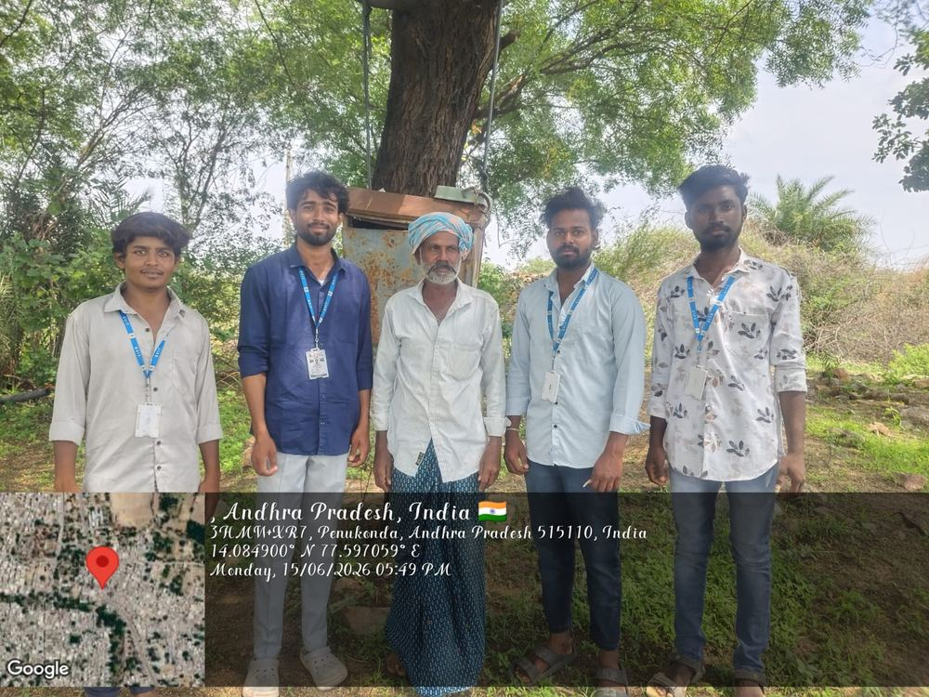
Week 1 -- 15 June 2026
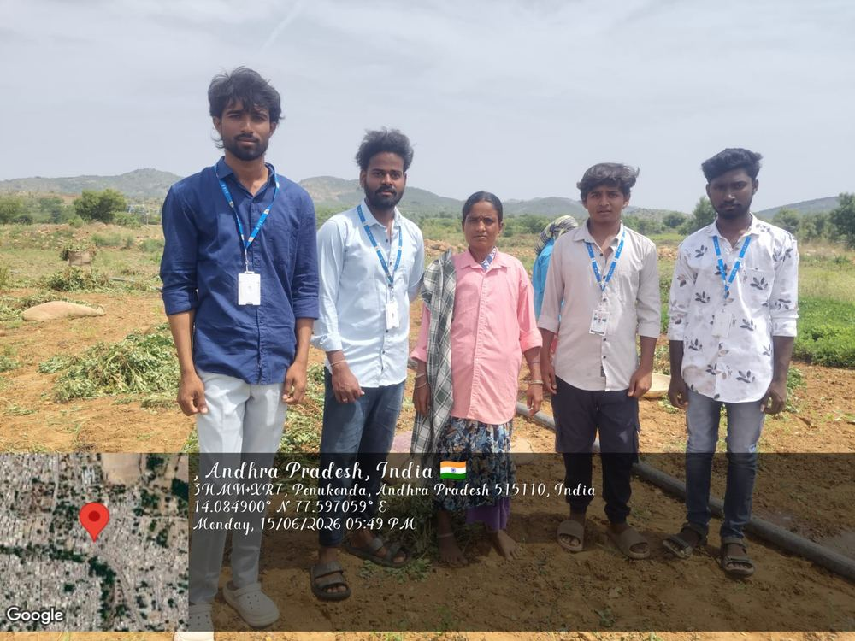
Field visit photograph, Week 1 -- 15 June 2026
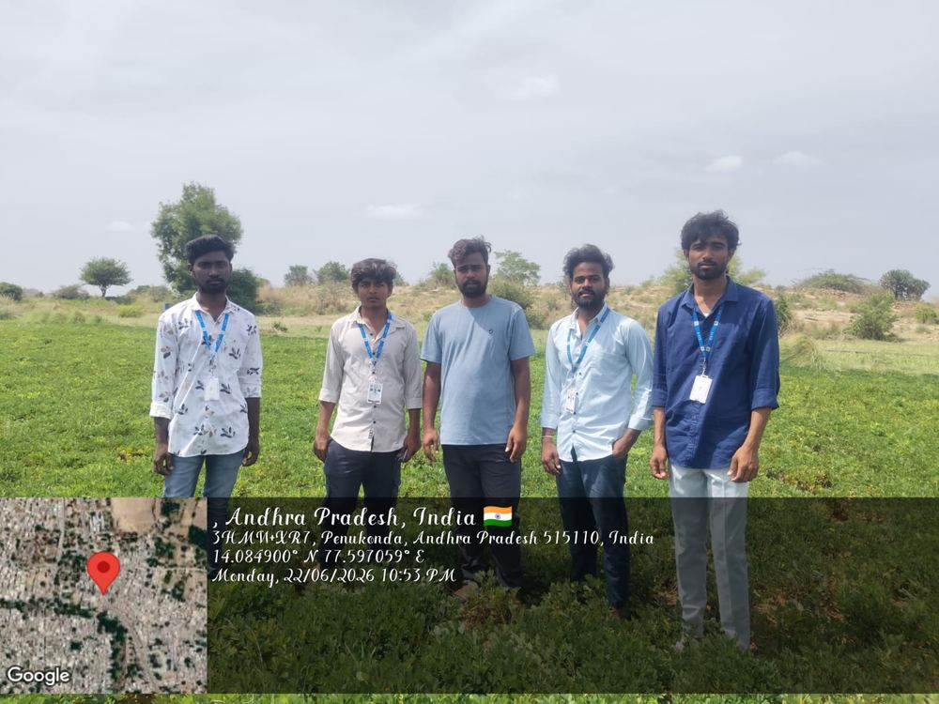
Field visit photograph, Week 1 -- 22 June 2026

Household Feedback Recorded -- Week 1
Question Asked | Respondent (Name / Phone No.) | Response Recorded
Do you have a registered agricultural power connection? | P. Narayana Reddy / 91234 61701 | Yes, has held a connection for over ten years.
Do you know how many hours of free power you get daily? | S. Rangamma / 91234 61702 | Not exactly sure; thought it varied by season.
Have you ever had your pump motor damaged by voltage issues? | M. Obulesu / 91234 61703 | Yes, once; had it repaired at his own cost.
Do you know the DISCOM helpline number? | K. Anjinamma / 91234 61704 | No, was not aware of any helpline.
Would you be interested in a short awareness session for your household? | T. Chinnappa / 91234 61705 | Yes, agreed to attend along with family members next week.

1. Do you have an agricultural electricity connection?
Answer: Yes, we have an agricultural electricity connection for our farm.

2. How long have you been using agricultural electricity?
Answer: We have been using agricultural electricity for more than 8 years.

3. Do you receive free electricity for farming?
Answer: Yes, free electricity is provided for our agricultural needs.

4. How does free electricity help you?
Answer: It helps us operate the water pump without spending much money on electricity bills.

5. Do you face power cuts during farming activities?
Answer: Yes, sometimes we face power cuts during irrigation.

6. Do you face low-voltage problems?
Answer: Yes, low voltage sometimes affects the working of our pump motor.

7. Has your pump motor ever been damaged because of voltage problems?
Answer: Yes, our pump motor was damaged once and we had to repair it.

8. Do you know about electricity safety precautions?
Answer: We know some basic safety precautions, but we need more awareness about electrical safety.

9. Do you know where to complain about electricity problems?
Answer: We know that we can contact the electricity department, but we do not know the exact helpline number.

10. Do you think awareness about free electricity is useful for farmers?
Answer: Yes, awareness is useful because it helps farmers understand the benefits and proper use of free electricity.

13.2 Week 2
Week 2 -- Expanded outreach to households with borewell pump-set connections, with a particular focus on safe earthing practices and correct pump-set sizing.

Field Photographs -- Week 2
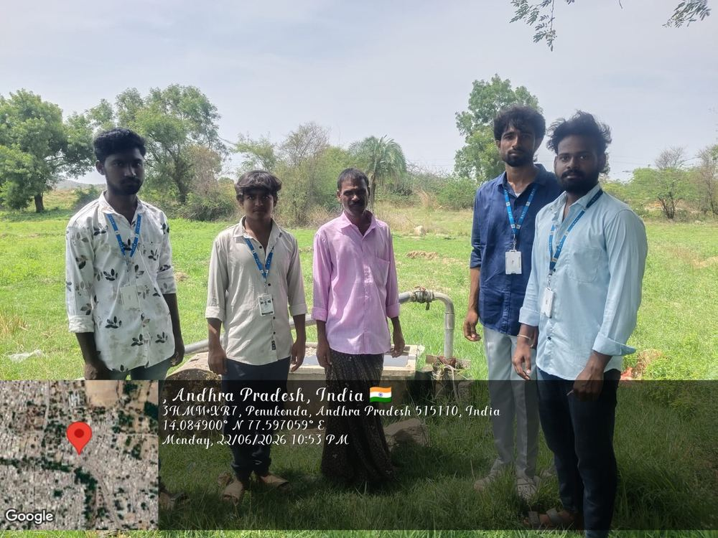
Field visit photograph, Week 2 -- 22 June 2026
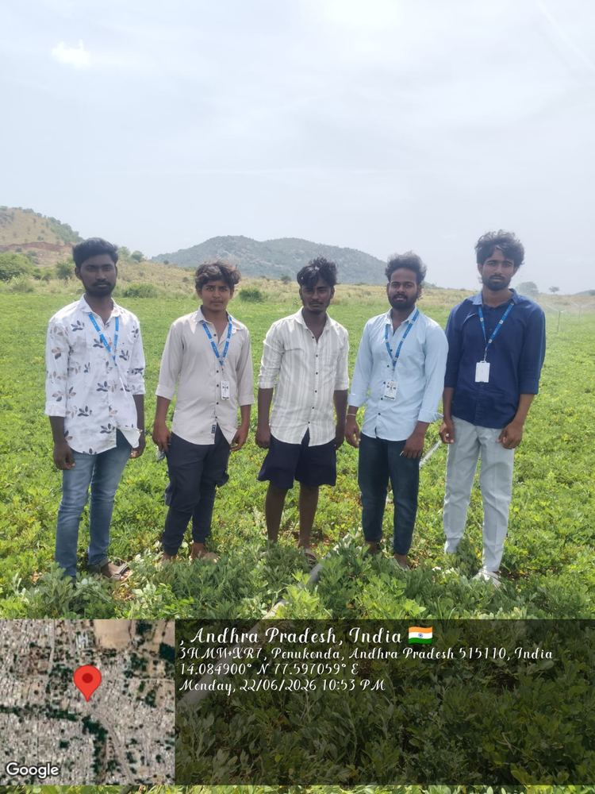
Field visit photograph, Week 2 -- 22 June 2026

Household Feedback Recorded -- Week 2
Question Asked | Respondent (Name / Phone No.) | Response Recorded
Is your pump house properly earthed? | R. Venkataramudu / 91234 61706 | Not formally; relies on a simple earth stake installed years ago.
Have you experienced any electric shocks near the pump house? | B. Saraswathi / 91234 61707 | No incident so far, but was unaware of the risk without proper earthing.
Do you check for damaged wiring before starting the pump? | N. Krishnappa / 91234 61708 | Occasionally checks, but not on a regular basis.
Is your pump-set motor the right size for your borewell? | V. Padmamma / 91234 61709 | Was unsure; motor was inherited along with the field.
Would you like simple guidance on pump-house safety? | C. Rameswar Rao / 91234 61710 | Yes, requested printed material to read at home.

1. Is your pump house properly earthed?
Answer: The pump house has basic earthing, but it needs to be checked and improved properly.

2. Do you know why earthing is important?
Answer: Yes, we learned that proper earthing helps protect people from electric shocks.

3. Have you ever experienced an electric shock near the pump house?
Answer: No, we have not experienced any electric shock so far.

4. Do you check the electrical wires before starting the pump?
Answer: We check the wires sometimes, but we do not check them regularly.

5. Have you noticed any damaged or loose wires near the pump?
Answer: Sometimes we notice loose wires and try to repair them before using the pump.

6. Is your pump-set motor suitable for your borewell?
Answer: We are not completely sure, because the motor was purchased several years ago.

7. Do you know that the correct pump size can save electricity?
Answer: Yes, we learned that using the correct pump size can improve efficiency and reduce unnecessary power usage.

8. Do you switch off the power supply before doing pump repairs?
Answer: Yes, we switch off the main power supply before checking or repairing the pump.

9. Do you know the basic electrical safety rules for a pump house?
Answer: We know a few rules, but we need more awareness about electrical safety.

10. Would you like to receive guidance about pump-house safety and proper pump usage?
Answer: Yes, we would like simple guidance so that we can use the pump safely and properly.

13.3 Week 3
Week 3 -- Door-to-door visits continued, with the team engaging directly with elderly farmers and household heads on the exact hours of free supply and on reporting supply faults.

Field Photographs -- Week 3
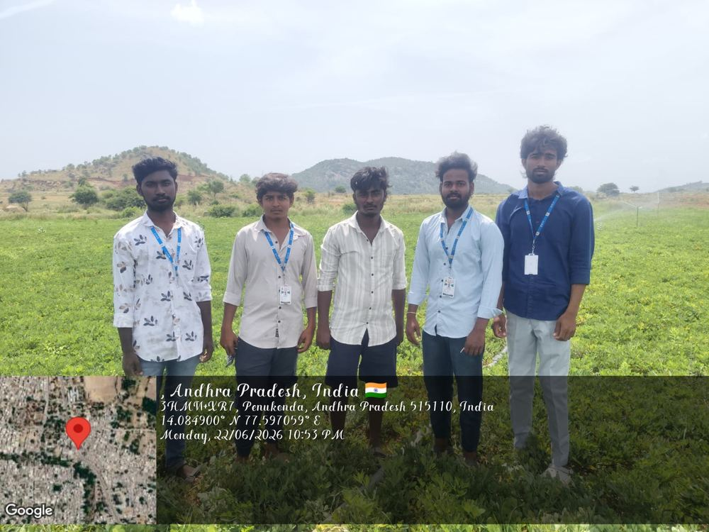
Field visit photograph, Week 3 -- 22 June 2026
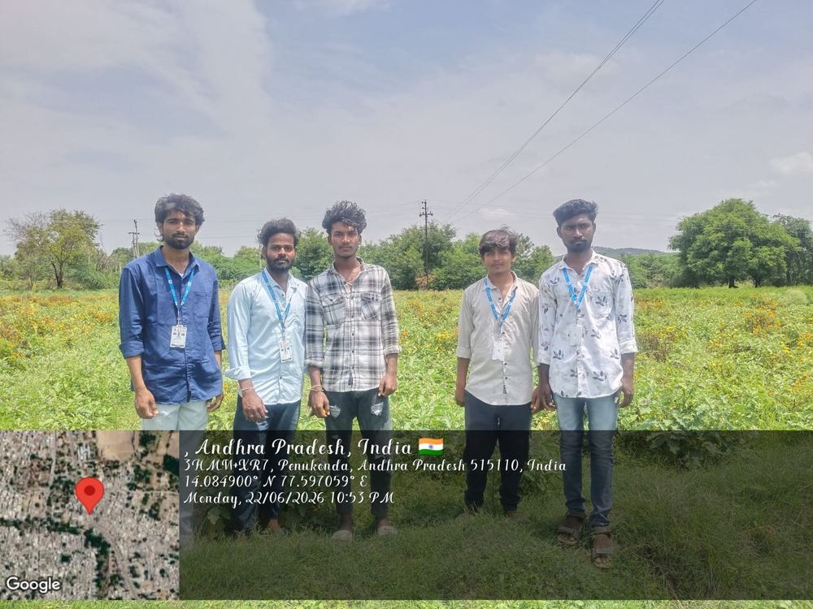
Field visit photograph, Week 3 -- 22 June 2026

Household Feedback Recorded -- Week 3
Question Asked | Respondent (Name / Phone No.) | Response Recorded
Do you know the exact daily hours of free power supply? | G. Subbaiah / 91234 61711 | Roughly aware, but timing sometimes shifts without notice.
Have you ever reported a supply fault to the DISCOM? | P. Narasimhulu / 91234 61712 | No, always relied on the local lineman informally.
Do you know that unauthorised tapping of lines can attract penalties? | K. Yellamma / 91234 61713 | Was not clearly aware; found this useful information.
Who would you contact if a transformer near your field failed? | S. Chennakesava Reddy / 91234 61714 | Was unaware of any formal number; noted down the helpline after the visit.
Would a printed safety checklist help at your pump house? | M. Lakshmamma / 91234 61715 | Yes, requested a checklist to keep at the pump house.

1. Do you know the exact daily hours of free power supply?
Answer: We have a general idea about the supply hours, but the timing sometimes changes.

2. Do you face any unexpected changes in the power supply timing?
Answer: Yes, sometimes the supply timing changes without prior information.

3. Have you ever reported an electricity supply fault?
Answer: No, usually we inform the local lineman when there is a problem.

4. Do you know the DISCOM complaint or helpline number?
Answer: We were not aware of the number, but we learned about it during the awareness visit.

5. What would you do if the transformer near your field stopped working?
Answer: We would inform the local electricity staff or lineman about the problem.

6. Do you know that unauthorized electricity connections or tapping can be unsafe?
Answer: Yes, we learned that unauthorized tapping is dangerous and can also lead to penalties.

7. Do you know the basic procedure for reporting electricity faults?
Answer: We know that we should report the problem to the electricity department, but we needed more information about the proper procedure.

8. Do you face problems due to low voltage during irrigation?
Answer: Yes, sometimes low voltage affects the operation of the pump.

9. Would a printed electrical safety checklist be useful at your pump house?
Answer: Yes, a simple checklist would help us remember important safety precautions.

10. Would you like more awareness about agricultural electricity and reporting faults?
Answer: Yes, we would like more awareness because it helps us understand the correct procedures and use electricity safely.

13.4 Week 4
Week 4 -- Awareness sessions extended to include family groups, with printed handouts used as visual aids to explain free-supply hours, safe pump-set operation, and the DISCOM helpline.

Field Photographs -- Week 4
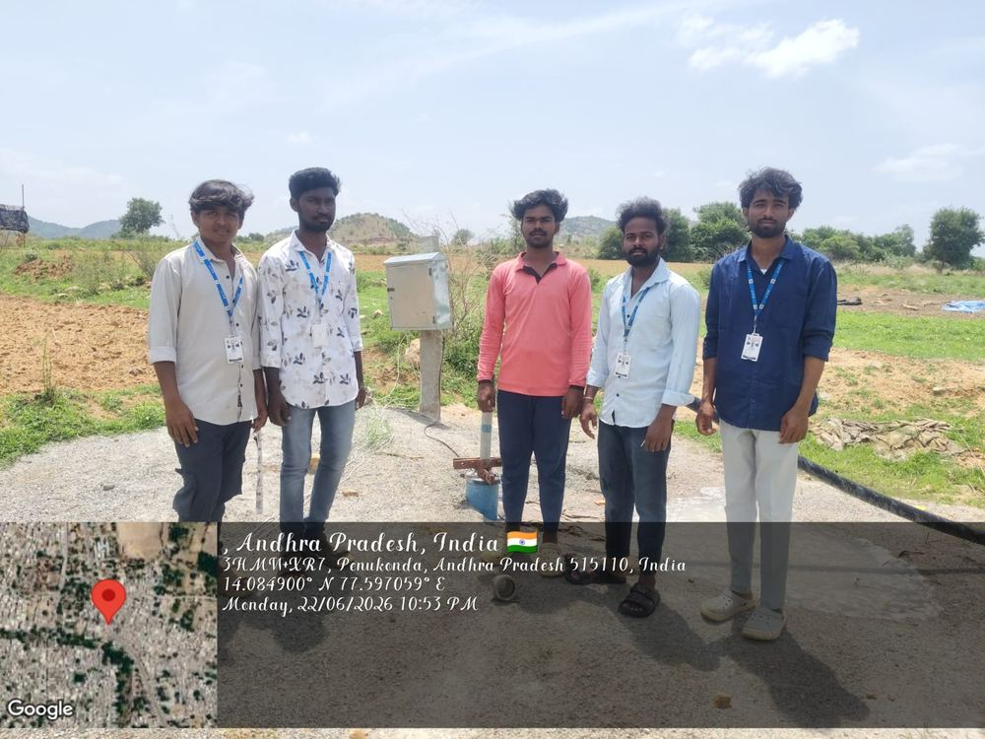
Field visit photograph, Week 4 -- 22 June 2026
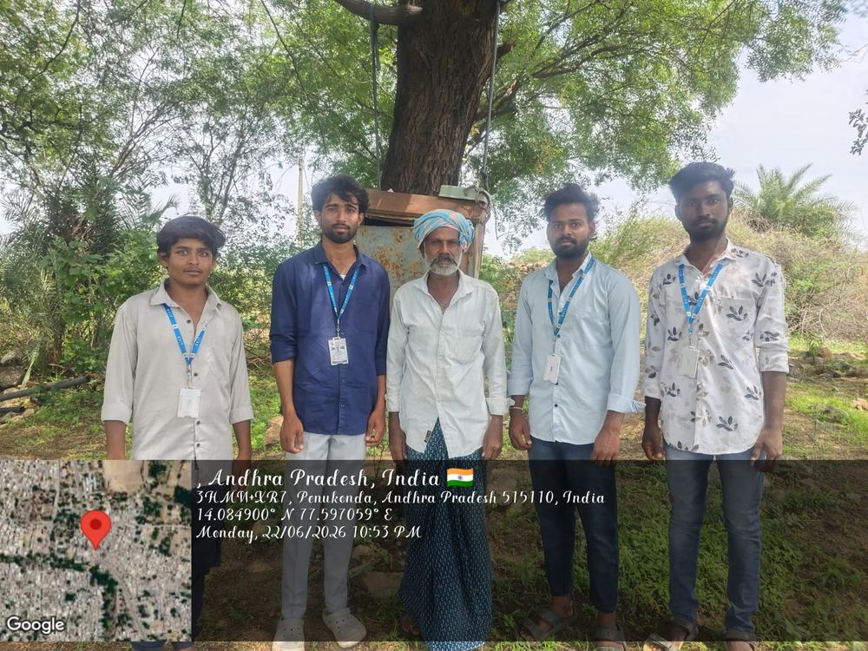
Field visit photograph, Week 4 -- 22 June 2026

Household Feedback Recorded -- Week 4
Question Asked | Respondent (Name / Phone No.) | Response Recorded
After seeing the handout, can you describe your free-supply hours? | D. Ravindra Reddy / 91234 61716 | Explained the general daily hours more confidently after the session.
Have you noticed any recent changes in supply timing? | A. Sujatha / 91234 61717 | Recalled a recent shift in timing; now checks the notice board regularly.
Do all family members know not to touch the pump switchboard with wet hands? | J. Basha / 91234 61718 | Discussed with family after the session; all agreed to be careful.
Did the handout help you understand the scheme better? | K. Rathnamma / 91234 61719 | Yes, found the simple points easier to understand than official notices.
Would you share this information with your neighbours? | P. Gangadhar / 91234 61720 | Agreed to pass on the printed handout to neighbouring farmers.

. After seeing the handout, can you describe the general free-supply hours?
Answer: Yes, the handout helped us understand the general daily supply hours more clearly.

2. Have you noticed any recent changes in the electricity supply timing?
Answer: Yes, we noticed that the timing sometimes changes, so we now check for updates regularly.

3. Do all family members know not to touch electrical switches with wet hands?
Answer: Yes, we discussed this with our family and everyone agreed to follow the safety rule.

4. Do you know why wet hands should not be used near electrical equipment?
Answer: Wet hands can increase the risk of electric shock, so we should always keep our hands dry.

5. Did the handout help you understand free electricity for farming better?
Answer: Yes, the simple points in the handout were easy to understand.

6. Do you know what to do if there is an electrical problem at your pump house?
Answer: We should switch off the power supply and contact the electricity department or a qualified electrician.

7. Do you know the importance of switching off the main supply before repairs?
Answer: Yes, switching off the main supply helps prevent electric shocks and accidents.

8. Do you know where to contact the electricity department for a supply problem?
Answer: Yes, we learned about the appropriate complaint and helpline options during the awareness session.

9. Would you share the information from the awareness session with your neighbours?
Answer: Yes, we would like to share the information with other farmers in our village.

10. Was the family awareness session useful to you?
Answer: Yes, it was useful because all family members learned about free electricity and electrical safety.

13.5 Week 5
Week 5 -- Continued household visits with an emphasis on distributing printed awareness material and answering farmers' individual questions about supply faults and equipment they had personally experienced.

Field Photographs -- Week 5
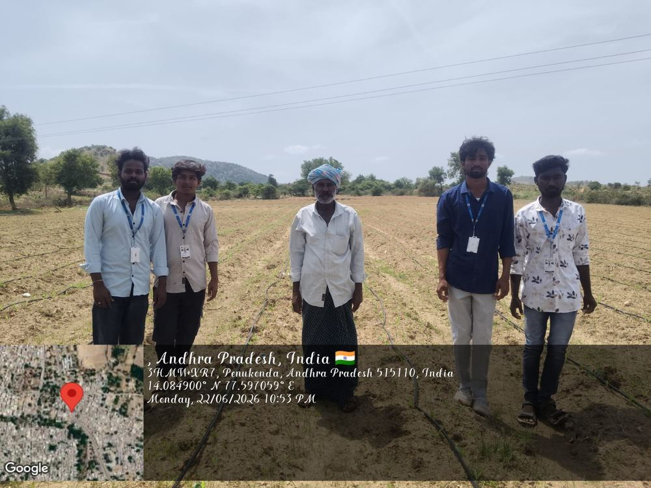
Field visit photograph, Week 5 -- 22 June 2026
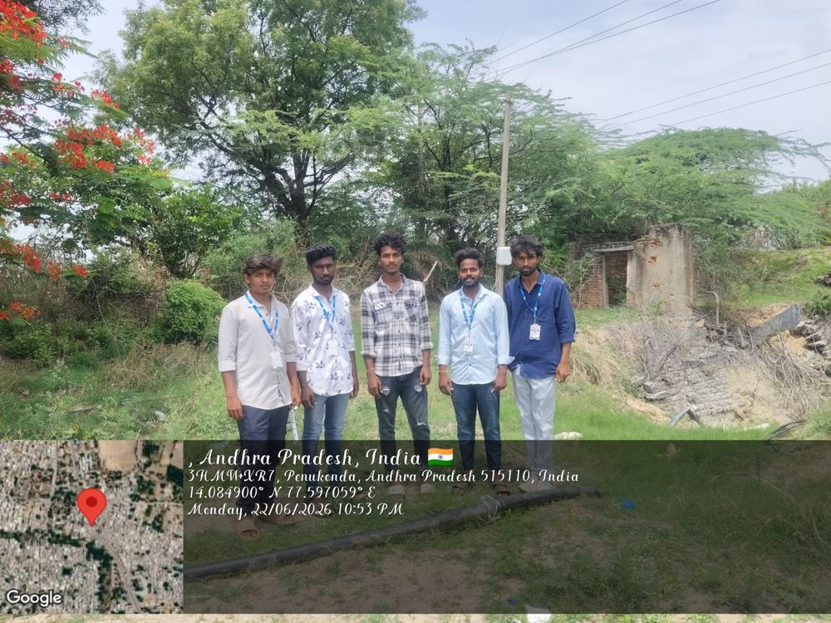
Field visit photograph, Week 5 -- 22 June 2026

Household Feedback Recorded -- Week 5
Question Asked | Respondent (Name / Phone No.) | Response Recorded
Have you personally faced a voltage-related equipment issue this month? | T. Anasuya / 91234 61721 | Yes, a starter unit malfunctioned; got it repaired locally.
What did you do after the starter malfunctioned? | R. Muniswamy / 91234 61722 | Repaired it through a local electrician without reporting it formally.
Do you have any specific questions about your connection? | S. Kondamma / 91234 61723 | Asked about applying for a second connection; was guided on the process.
Do you keep the printed material for future reference? | M. Eswaramma / 91234 61724 | Yes, kept the handout near the pump-house switchboard.
Is there any topic you would like explained in more detail? | K. Venkateswarlu / 91234 61725 | Requested more detail on the solar pump-set subsidy scheme.

1. Have you personally faced any voltage-related equipment problem this month?
Answer: Yes, we faced a problem with the starter unit and got it repaired locally.

2. What did you do after the starter stopped working?
Answer: We contacted a local electrician and repaired the starter.

3. Did you report the equipment problem to the electricity department?
Answer: No, we first tried to solve the problem through a local electrician.

4. Do you have any questions about your agricultural electricity connection?
Answer: Yes, we wanted to know more about the process for applying for another connection.

5. Do you understand the basic procedure for reporting supply faults?
Answer: We understand the basic procedure better after the awareness session.

6. Do you keep the printed awareness material for future reference?
Answer: Yes, we kept the handout near the pump-house switchboard for easy reference.

7. Did the printed material help you understand electrical safety?
Answer: Yes, the simple information helped us understand important safety precautions.

8. Do you know what to do when your pump equipment develops a fault?
Answer: We should switch off the power supply and contact a qualified electrician for repairs.

9. Would you like more information about government support for agricultural equipment?
Answer: Yes, we would like to know more about available schemes and subsidies for farmers.

10. Is there any topic you would like us to explain in more detail?
Answer: Yes, we would like more information about solar pump-set subsidy schemes and how farmers can apply.

13.6 Week 6
Week 6 -- The team focused on pump-house safety demonstrations and awareness of the PM-KUSUM solar pump-set subsidy scheme, given growing farmer interest in reducing dependence on grid supply timing.

Field Photographs -- Week 6
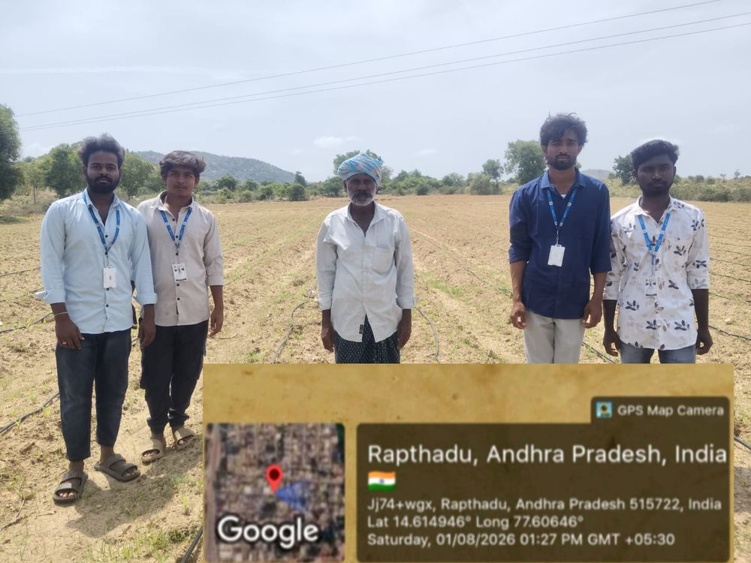
Field visit photograph, Week 6 -- 1 August 2026
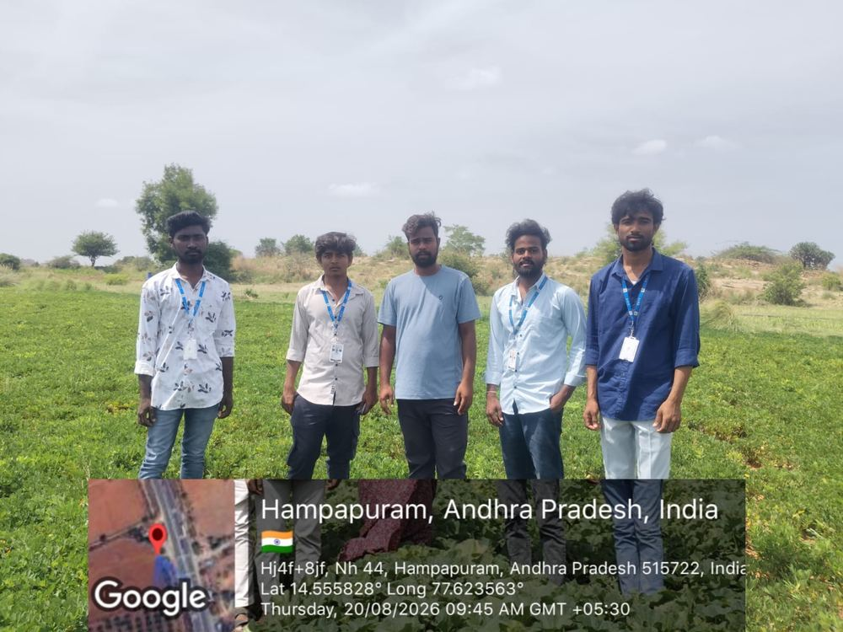
Field visit photograph, Week 6 -- 20 August 2026

Household Feedback Recorded -- Week 6
Question Asked | Respondent (Name / Phone No.) | Response Recorded
Are you aware of the PM-KUSUM solar pump-set scheme? | N. Hanumanthu / 91234 61726 | No, had not heard of it before this session.
Would you consider a solar pump set if subsidised? | V. Bhagyamma / 91234 61727 | Yes, interested, especially given recent voltage issues.
Do you use any protective device like an ELCB at your pump house? | C. Narayana Reddy / 91234 61728 | No, was not aware such a device existed.
Do you check your motor and starter periodically? | P. Kamalamma / 91234 61729 | Only when a problem is noticed, not on a fixed schedule.
Would a follow-up session on solar subsidies be useful? | S. Ramanjaneyulu / 91234 61730 | Yes, requested to be informed of any future session.

13.7 Week 7
Week 7 -- Awareness sessions and survey administration continued across additional households, with particular attention to farmers who had not yet been reached in earlier weeks.

Field Photographs -- Week 7
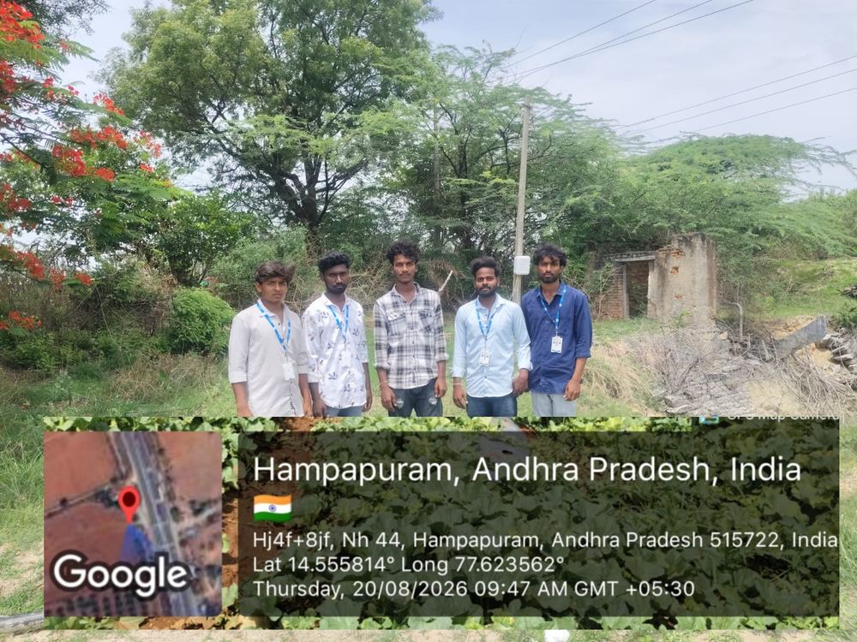
Field visit photograph, Week 7 -- 20 August 2026
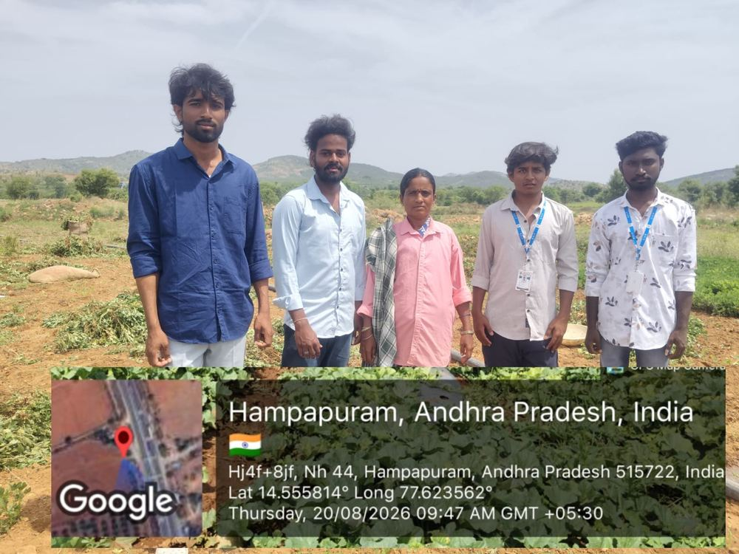
Field visit photograph, Week 7 -- 20 August 2026

Household Feedback Recorded -- Week 7
Question Asked | Respondent (Name / Phone No.) | Response Recorded
Have you ever reported a supply issue to any authority? | K. Subramanyam / 91234 61731 | No, was unaware of any formal reporting channel until this visit.
Do you now know the DISCOM toll-free helpline number? | M. Vijayalakshmi / 91234 61732 | Yes, noted the number after the explanation given.
Are you aware of the Consumer Grievance Redressal Forum? | R. Chandra Sekhar / 91234 61733 | Not aware earlier; found this useful for future reference.
Would you be willing to complete the household survey? | G. Parvathamma / 91234 61734 | Agreed and completed the thirty-question survey with the team.
Do you feel more confident about your power entitlements after this campaign? | B. Srinivasulu / 91234 61735 | Yes, felt noticeably more confident compared to the first visit.

Have you ever reported an electricity supply problem to any authority?
Answer: No, earlier we did not know about the formal complaint procedure.

Do you know the DISCOM toll-free helpline number now?
Answer: Yes, we learned the helpline number during the awareness session.

Do you know where to report a power supply fault?
Answer: Yes, we learned that supply problems can be reported to the electricity department through the proper complaint channel.

Are you aware of the Consumer Grievance Redressal Forum?
Answer: No, we were not aware of it earlier, but we learned about it during the visit.

Do you know why it is important to report electricity problems properly?
Answer: Proper reporting helps the concerned department understand and address the problem.

Did you understand the information provided during the awareness session?
Answer: Yes, the information was explained in simple language and was easy to understand.

Were you willing to participate in the household survey?
Answer: Yes, we agreed to participate and completed the survey with the team.

Did the awareness session improve your knowledge about agricultural electricity?
Answer: Yes, we learned more about electricity supply, safety, and complaint procedures.

Do you feel more confident about understanding your electricity-related rights and services?
Answer: Yes, we feel more confident compared with our first visit.

Would you share the information from the campaign with other farmers?
Answer: Yes, we would like to share the information with other farmers in our village.

13.8 Week 8
Week 8 -- Continued survey administration and follow-up conversations, with particular focus on groundwater-conservation awareness alongside power-scheme awareness.

Field Photographs -- Week 8
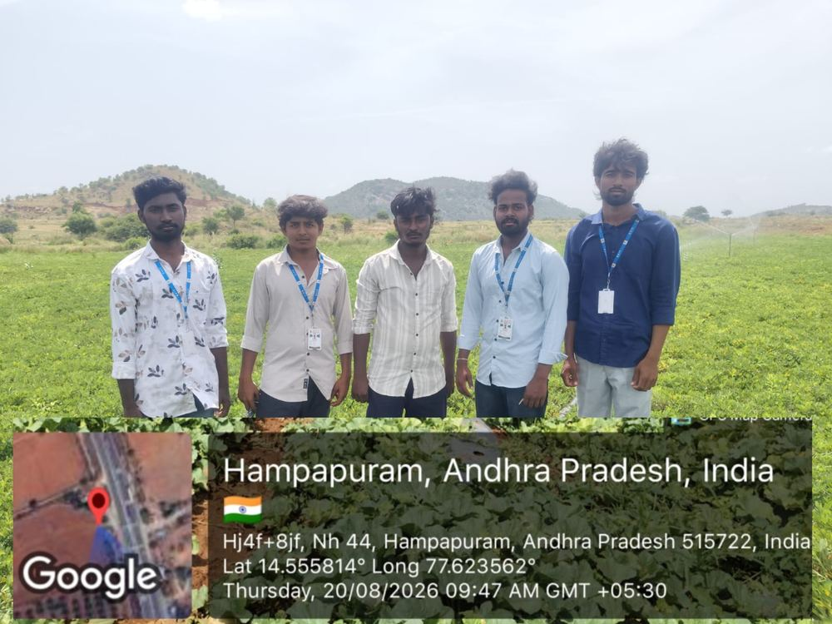
Field visit photograph, Week 8 -- 20 August 2026
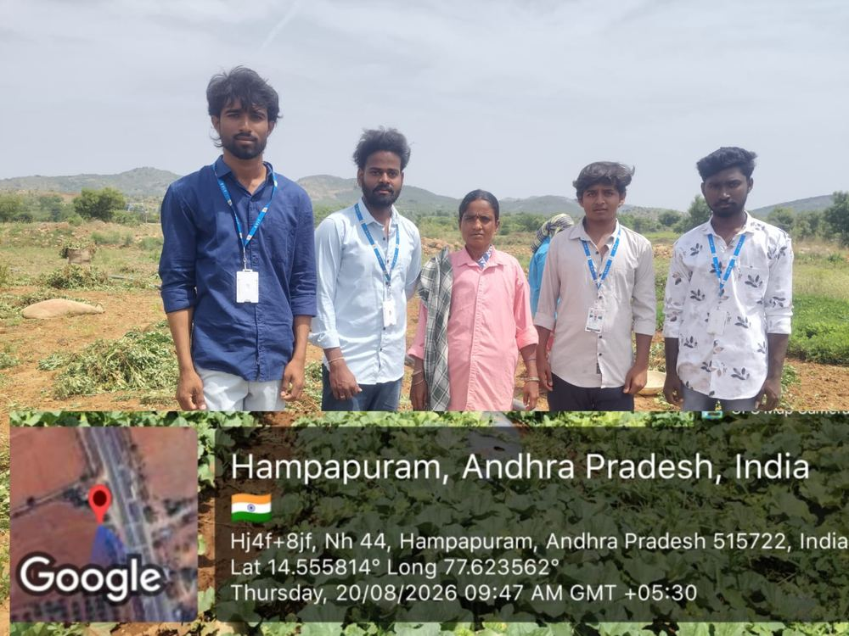
Field visit photograph, Week 8 -- 20 August 2026

Household Feedback Recorded -- Week 8
Question Asked | Respondent (Name / Phone No.) | Response Recorded
Do you think free power has affected groundwater levels in your area? | T. Manemma / 91234 61736 | Yes, believes extraction has increased noticeably over the years.
Would you support combining power awareness with water-conservation tips? | K. Ramaiah / 91234 61737 | Yes, felt this would be genuinely useful for the village.
Have you noticed the water table dropping in your own borewell? | S. Yellamma / 91234 61738 | Yes, borewell needed to be deepened in recent years.
Would you attend a session specifically on water conservation? | P. Nagendra / 91234 61739 | Yes, expressed willingness to attend such a session.
Any questions remaining about the free electricity scheme? | M. Rajeswari / 91234 61740 | Asked about applying for a solar pump set; was guided accordingly.

13.9 Week 9
Week 9 -- Concluding visits, consolidation of survey responses, and closing conversations with farmers and community officials to thank them for their participation and to gather the certification of community engagement.

Field Photographs -- Week 9
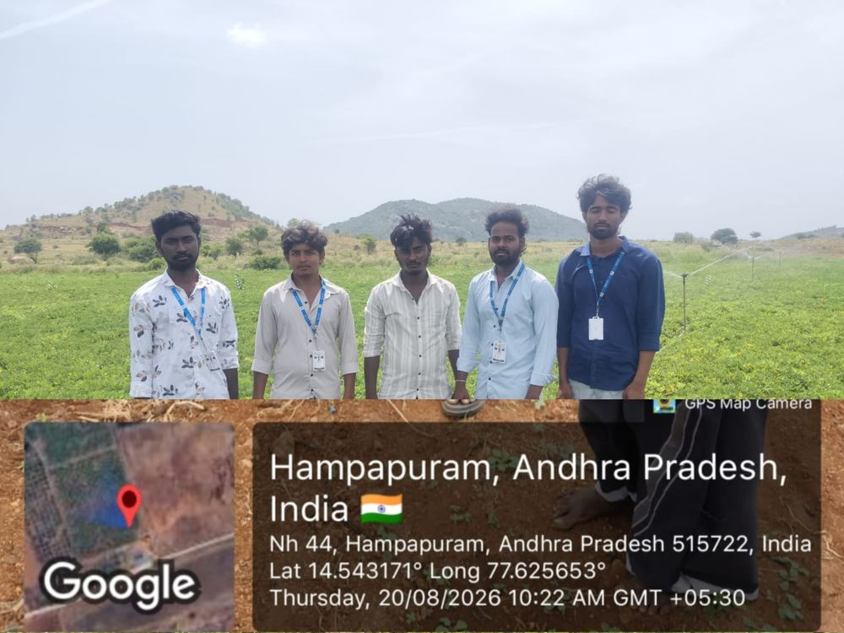
Field visit photograph, Week 9 -- 20 August 2026
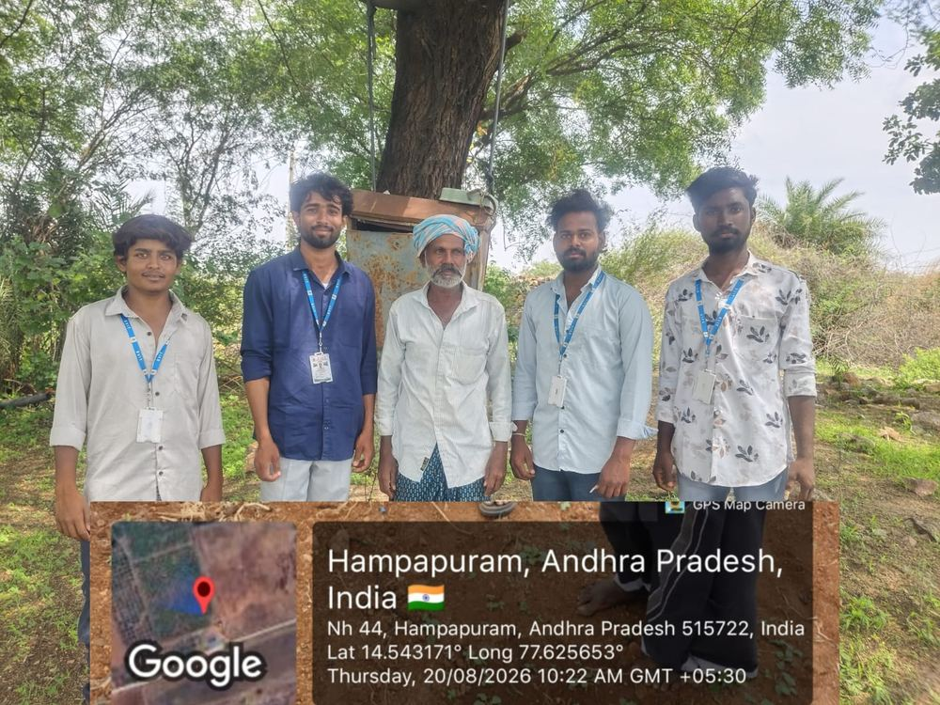
Field visit photograph, Week 9 -- 20 August 2026

Household Feedback Recorded -- Week 9
Question Asked | Respondent (Name / Phone No.) | Response Recorded
Overall, did you find the awareness sessions useful? | D. Lakshmi Narayana / 91234 61741 | Yes, found the sessions practical and easy to follow.
Which topic did you find most useful during the campaign? | A. Venkatalakshmamma / 91234 61742 | Found the guidance on pump-house safety the most useful.
Will you continue to follow the safety practices discussed? | B. Chinnaiah / 91234 61743 | Confirmed intention to continue safe pump-house practices.
Would you support similar awareness programmes in future? | K. Sujatamma / 91234 61744 | Yes, expressed willingness to support and participate again.
Any final suggestions for the project team? | M. Rangaswamy / 91234 61745 | Suggested more frequent visits, especially before each cropping season.

Conclusion
The Free Electricity Scheme has meaningfully reduced the cost of irrigation for farming households and supported the agrarian economy of villages such as Penukonda. As dependence on electric pump-set irrigation continues to grow, ensuring that farmers are fully aware of their entitlements, the safe operation of their equipment, and the channels available to them for reporting faults and seeking redress becomes increasingly important to realising the full and sustainable benefit of the scheme.
By understanding their exact free-supply hours, adopting basic pump-house safety practices, reporting faults through formal channels, and remaining mindful of groundwater sustainability, farmers can derive greater and more lasting value from the schemes available to them. The field survey conducted as part of this project confirmed that residents of Penukonda are engaged, dependent users of agricultural power supply, but that specific, addressable gaps remain -- particularly around detailed scheme awareness, pump-house safety, and formal fault reporting.
This Community Service Project sought to address these gaps directly, through sustained, door-to-door engagement over a nine-week period, combining simple, practical guidance with a structured survey that will hopefully be of continuing value to future awareness efforts in the region. Awareness of agricultural power schemes is not only the responsibility of governments and utilities, but of every farming household. A well-informed farming community, built one household and one conversation at a time, remains the surest foundation for a safer, more efficient, and more sustainable use of this vital resource.
"Awareness of one’s entitlements, and of the responsibility that comes with them, is the surest path to a safer and more sustainable farm."

REFERENCES
The following general sources informed the background material presented in this report. As an undergraduate Community Service Project report intended for educational and awareness purposes, this list reflects general, publicly available reference material rather than a formal academic literature review.
- Ministry of Power, Government of India -- general information on agricultural power supply and rural electrification.
- Ministry of New and Renewable Energy, Government of India -- PM-KUSUM Scheme.
- Andhra Pradesh Electricity Regulatory Commission (APERC) -- tariff orders relevant to agricultural power supply.
- Electricity Act, 2003, Government of India.
- General literature on agricultural power subsidy schemes, groundwater sustainability, and farm electricity safety practices.
- Primary data collected through the household survey and field observations conducted by the project team in Penukonda village (May–July 2026).

ANNEXURE
COMMUNITY SERVICE PROJECT DECLARATION FORM

Project Details
Project Name: Free Electricity for Farmers
Location: Penukonda Village, Anantapuramu District, Andhra Pradesh
Duration: 9th May 2026 to 8th July 2026

Group Information
Group Leader: SRINIVAS -- 249F1A0549
Participants:
- MURALI -- 249F1A0520
- CHAITANYA -- 249F1A0534
- BUTHAPPA GARI BALAJI -- 249F1A0523
- P. NIKHIL -- 249F1A05A0

Declaration
We hereby declare that we are residents of the village and participants in the Community Service Project conducted by Sri Venkateswara Institute of Technology. We understand the purpose and objective of the project and willingly provided our assistance, cooperation, and feedback for the successful implementation of the project. We further acknowledge that any information captured during the project may be used for educational purposes.
We understand that our participation in the project is voluntary and that we have the right to withdraw our consent or involvement at any time.
By signing this declaration, we confirm that the information provided above is true and accurate to the best of our knowledge.

Signature of Community Representative

THANK YOU
Free Electricity for Farmers -- Community Service Project, 2026-2027
Department of Computer Science & Engineering, Sri Venkateswara Institute of Technology

