PREDICTIVE MAINTENANCE AND PROCESS INTELLIGENCE
MILESTONE 2 REPORT
Monitoring Platform, Data Management and Operations Dashboard
Domain: Artificial Intelligence
Mentor: Selciya
Team: Team D
Milestone 2 Presentation Document
10 August 2026

TEAM MEMBERS
S. No. | Name
1 | Rajeswari Teppala
2 | Reddy Eswar Anush
3 | Sachin A S
4 | Sindhukay Ernapati
5 | Vabyasha Mohapatra
6 | Vaishnavi Kumari
7 | Vyshnavi Ganta
Document purpose
This is a standalone milestone 2 report. It documents only the monitoring, data-management and dashboard capabilities delivered for this milestone. It does not repeat milestone 1 planning material, and it intentionally contains no screenshots because the working application will be demonstrated separately.

CONTENTS
1. Milestone 2 at a glance
2. Objectives and scope
3. Delivered system architecture
4. Implemented modules
5. Data model and telemetry design
6. API design and data operations
7. Dashboard and monitoring experience
8. Health and anomaly decision support
9. Technology stack
10. Verification approach
11. Current limitations and risk controls
12. Next milestone plan
13. Conclusion
References

1. MILESTONE 2 AT A GLANCE
Milestone 2 turns the project into a usable operational monitoring platform. The delivered work provides a structured way to register factory assets, record multi-sensor telemetry, maintain operational records and present the current operating picture through a web dashboard. The emphasis is reliable data flow and visibilitythe necessary base for future predictive models and maintenance automation.
Area | Milestone 2 delivery
Milestone theme | Monitoring platform and operational visibility
Primary users | Operations staff, maintenance staff and project administrators
Main inputs | Machine, sensor and telemetry records; maintenance, incident, inventory and notification records
Main outputs | Live system status, fleet overview, telemetry cards, operating metrics and record summaries
Delivery boundary | Data capture, CRUD APIs, SQLite persistence and dashboard integration; advanced ML is intentionally a later milestone
2. OBJECTIVES AND SCOPE
2.1 Objectives
Create a persistent, API-driven data layer for factory operations.
Capture operational telemetry needed to assess machine condition.
Provide controlled create, read, update and delete operations for operational records.
Expose a concise dashboard that lets users interpret machine status without inspecting raw database records.
Lay a clean integration path for health scoring, anomaly detection and failure prediction in later work.
2.2 Scope boundary
Scope decision | Details
Included | FastAPI REST services, SQLAlchemy models, Pydantic validation schemas, SQLite persistence, Streamlit dashboard, Plotly trend indicators, operational record modules and basic rule helpers.
Not claimed as completed | A trained and evaluated machine-learning model, live IoT device ingestion, automated work-order scheduling, role-based access control, cloud deployment or production-scale alert delivery.
Reason for boundary | The milestone validates dependable data handling and monitoring before advanced intelligence is added. This keeps results demonstrable, traceable and technically honest.
3. DELIVERED SYSTEM ARCHITECTURE
The solution is organized as a layered application. Each layer has a distinct responsibility, which makes the platform easier to extend and test.
Layer | Implementation | Responsibility
Presentation layer | Streamlit application (app.py) | Renders operational overview, live system state, telemetry cards, sparklines and activity summaries.
API layer | FastAPI routers | Defines resource endpoints for machines, sensors, telemetry, predictions, maintenance, notifications, inventory and incidents.
Service layer | Backend service modules | Performs CRUD operations and isolates database access from HTTP route definitions.
Data layer | SQLAlchemy ORM + SQLite | Persists structured records, declares entities and uses foreign-key references to link machine-related records.
Decision-support layer | Health and anomaly helper functions | Provides initial, rule-based condition assessment logic that can later be replaced or enhanced by ML models.
Operational data flow
Operational records FastAPI request validation service operation SQLAlchemy ORM SQLite database REST response Streamlit dashboard operator interpretation
4. IMPLEMENTED MODULES
Module | Milestone 2 capability
Machine management | Stores the machine identifier, name, department, location and operating status. Enables a dashboard to identify where a reading originates.
Sensor management | Stores sensor identifier, sensor name, location and status, providing a registry for monitoring devices.
Telemetry management | Captures condition-related readings: temperature, pressure, vibration, voltage, current, power, RPM, humidity, oil level, health score and failure probability.
Prediction records | Stores machine-linked failure probability, health score and predicted days fields so model output can be persisted once introduced.
Maintenance records | Records maintenance type, assigned technician, cost, remarks and status for each machine.
Incident records | Records priority, description, assignee and status for issues requiring attention.
Inventory records | Tracks item name, quantity, supplier and status to support later spare-parts decisions.
Notification records | Stores title, message, notification type and delivery status for alerts and communications.
5. DATA MODEL AND TELEMETRY DESIGN
The data model uses a machine record as the operational anchor. Telemetry, prediction, maintenance and incident records include a machine identifier so events and condition data can be associated with a specific asset. The schema is deliberately broad enough to support both dashboard monitoring now and model feature engineering later.
Entity | Key field(s) | Purpose
machines | machine_id (PK) | Machine master data: name, department, location and status.
sensors | sensor_id (PK) | Sensor registry: name, location and status.
telemetry | id (PK), machine_id (FK) | Time-independent condition readings and supplied condition indicators.
predictions | id (PK), machine_id (FK) | Persisted prediction results for a machine.
maintenance | id (PK), machine_id (FK) | Maintenance work history and its operational status.
incidents | id (PK), machine_id (FK) | Issue records linked to a machine.
inventory | id (PK) | Parts and materials information.
notifications | id (PK) | System communication and alert records.
5.1 Telemetry parameters
Category | Fields | Monitoring purpose
Thermal | temperature | Machine heat condition; also used by the current anomaly helper.
Mechanical | vibration, rpm, oil_level | Signals that can indicate imbalance, wear, lubrication quality or abnormal operating speed.
Process | pressure, humidity | Environmental and process-state context for asset condition.
Electrical | voltage, current, power | Electrical load and consumption indicators.
Condition outputs | health_score, failure_probability | Fields reserved for reported or future model-derived condition estimates.
6. API DESIGN AND DATA OPERATIONS
FastAPI exposes resource-oriented endpoints. Each main module implements the familiar CRUD pattern: create a record, retrieve one or all records, edit it and delete it when appropriate. Pydantic request and response schemas keep payloads structured at the API boundary, while the service layer contains the persistence operations.
Base endpoint | Core methods | Purpose
/machines/ | GET, POST | List or register machines; also supports record lookup, update and deletion by machine ID.
/sensors/ | GET, POST | List or register sensors; also supports record lookup, update and deletion by sensor ID.
/telemetry/ | GET, POST | List or create telemetry readings; also supports record lookup, update and deletion by telemetry ID.
/predictions/ | GET, POST | List or create prediction records; also supports record lookup, update and deletion by prediction ID.
/maintenance/ | GET, POST | Manage maintenance records, including lookup, update and deletion by record ID.
/incidents/ | GET, POST | Manage incident records, including lookup, update and deletion by record ID.
/inventory/ | GET, POST | Manage inventory records, including lookup, update and deletion by record ID.
/notifications/ | GET, POST | Manage notification records, including lookup, update and deletion by record ID.
/health | GET | Returns backend health and database-connection status.
Note: individual resources use the conventional /{id} path for GET, PUT and DELETE. Machine services additionally provide location-oriented query helpers.
7. DASHBOARD AND MONITORING EXPERIENCE
The Streamlit dashboard converts REST data into an operator-facing overview. It is designed for quick scanning: the interface first confirms that the API is live, then summarizes fleet condition and finally presents telemetry per machine.
Dashboard element | Value to the user
API availability check | Calls /health before rendering the dashboard and gives a clear start-up instruction if the backend is unreachable.
Operational overview | Displays overall health, active-machine count, tracked output and average failure probability based on available records.
Power draw panel | Shows average power from telemetry and a compact trend indicator.
Telemetry cards | Shows machine name, location, RPM and temperature. Cards use normal, warning and critical visual states.
Telemetry refresh | Allows the user to request a fresh dashboard render after records are updated.
Operational summaries | Displays the number of recorded maintenance jobs and incident records.
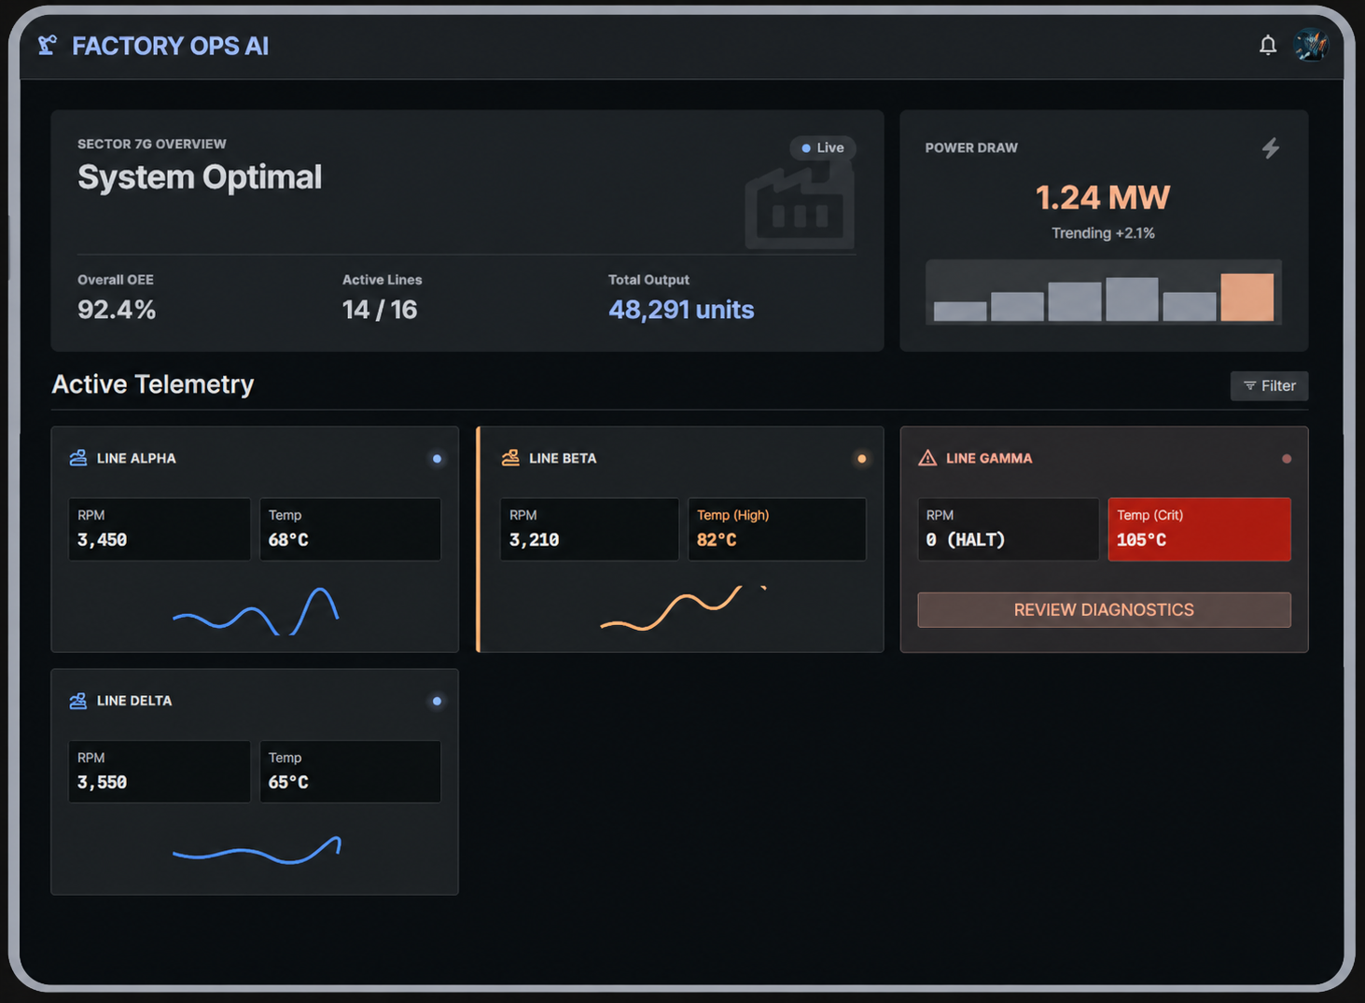
Figure 1. FactoryOps AI dashboard prototype: fleet overview, power draw and temperature-based telemetry states.
7.1 Dashboard state rules
State | Temperature rule | Dashboard treatment
Normal | Temperature below 80 | Blue indicator
Warning | Temperature from 80 up to 99.9 | Amber indicator
Critical | Temperature 100 or above | Red indicator
8. HEALTH AND ANOMALY DECISION SUPPORT
Milestone 2 includes simple, explainable rule helpers that demonstrate how raw sensor values can support condition awareness. These are not represented as a trained machine-learning model; they are transparent interim logic that can be validated by domain experts before later automation.
Component | Current behaviour
Anomaly helper | Temperature < 50: Normal; 50 to <100: Warning; 100 or more: Critical.
Health helper | Starts at 100. Deducts 20 when temperature exceeds 80, 20 when pressure exceeds 100 and 30 when vibration exceeds 8; floors the result at zero.
Dashboard classifier | Uses its own temperature thresholds: normal below 80, warning below 100, critical from 100 onward.
Interpretation | These rules create understandable visual cues. Thresholds should be calibrated with real equipment data and engineering input before operational use.
9. TECHNOLOGY STACK
Technology | Role in the delivered system
Python | Primary implementation language for backend services and dashboard.
FastAPI | High-performance REST API framework and automatic API documentation support.
Pydantic | Defines and validates request/response data schemas.
SQLAlchemy | ORM used to define database entities and execute persistence operations.
SQLite | Lightweight relational database for the milestone environment.
Streamlit | Rapid web interface for the operations dashboard.
Pandas | Tabular processing and dashboard aggregation of retrieved records.
Plotly | Compact interactive trend visualizations and sparklines.
Uvicorn | ASGI server used to run the FastAPI application.
10. VERIFICATION APPROACH
Verification for this milestone is based on component behaviour and data flow rather than predictive-model accuracy. The following checklist is suitable for the live demonstration and final internal testing.
Check | Method | Expected evidence
Backend start-up | Start the FastAPI app and request /health. | The response reports healthy status and database connectivity.
Machine CRUD | Create, retrieve, edit and delete a test machine through the REST API. | Changes are persisted and returned with a valid response schema.
Telemetry CRUD | Create a telemetry record associated with a machine and retrieve it. | All relevant measurements are stored and available to the dashboard API call.
Other operational modules | Exercise at least one create and list operation for sensors, predictions, maintenance, incidents, inventory and notifications. | Each module accepts a valid payload and returns the corresponding record.
Dashboard connection | Run the Streamlit app with the API available. | The live state is shown and records populate the overview/cards.
Dashboard failure handling | Stop or point the dashboard away from the API. | A clear API-unavailable instruction is displayed rather than a misleading empty dashboard.
Threshold display | Use telemetry records on either side of 80 and 100 temperature units. | Card colour/state changes according to the published dashboard rule.
Demonstration commands
Backend: uvicorn backend.api.main:app --reload
Dashboard: streamlit run app.py
11. CURRENT LIMITATIONS AND RISK CONTROLS
Limitation / risk | Control or next action
No trained ML model in current runtime | Avoid accuracy claims; treat prediction fields as a prepared data contract. Train and evaluate with a labelled data set in the next AI-focused milestone.
Rule thresholds are preliminary | Treat thresholds as demonstrative decision support. Validate thresholds against machine specifications and historical failures.
SQLite is a milestone database | Suitable for local development and demos. Plan a managed database and backups before multi-user or production use.
No authentication or authorization | Restrict the demo environment. Add identity, roles and audit logging before exposing write endpoints to users.
Telemetry has no timestamp field in the present schema | Add an event timestamp and ingestion metadata before time-series analysis, model training or historical trend reporting.
External sensor ingestion is not connected | Use validated API payloads for the demo; add an IoT gateway or message broker as a subsequent integration step.
12. NEXT MILESTONE PLAN
Priority | Planned outcome
1. Data readiness | Add timestamps, quality checks, unit conventions, sensor-to-machine mapping and representative historical data.
2. Feature engineering | Create reproducible feature pipelines for rolling statistics, trends, load conditions and health indicators.
3. Model development | Train baseline anomaly and failure-risk models; compare algorithms against agreed evaluation metrics.
4. Model integration | Expose prediction execution through a controlled backend service and store outputs in the prediction table.
5. Maintenance intelligence | Connect high-risk predictions with maintenance records, incidents, inventory availability and notification workflows.
6. Hardening | Add tests, error logging, authentication, documentation and deployment preparation.
13. CONCLUSION
Milestone 2 delivers the operational backbone of the Predictive Maintenance and Process Intelligence project. The system now has persistent factory data structures, API-driven data operations and a dashboard that turns stored data into a readable monitoring view. Its modular design supports the next stage: converting dependable telemetry and operational history into validated predictive intelligence. By separating what is already implemented from what remains to be trained and automated, the project presents a credible and technically responsible path toward predictive maintenance.
REFERENCES.
FastAPI Documentation. https://fastapi.tiangolo.com/
SQLAlchemy Documentation. https://docs.sqlalchemy.org/
Pydantic Documentation. https://docs.pydantic.dev/
Streamlit Documentation. https://docs.streamlit.io/
Plotly Python Documentation. https://plotly.com/python/
SQLite Documentation. https://www.sqlite.org/docs.html
Project source code: Predictive Maintenance and Process Intelligence, Team D, Milestone 2 implementation.

