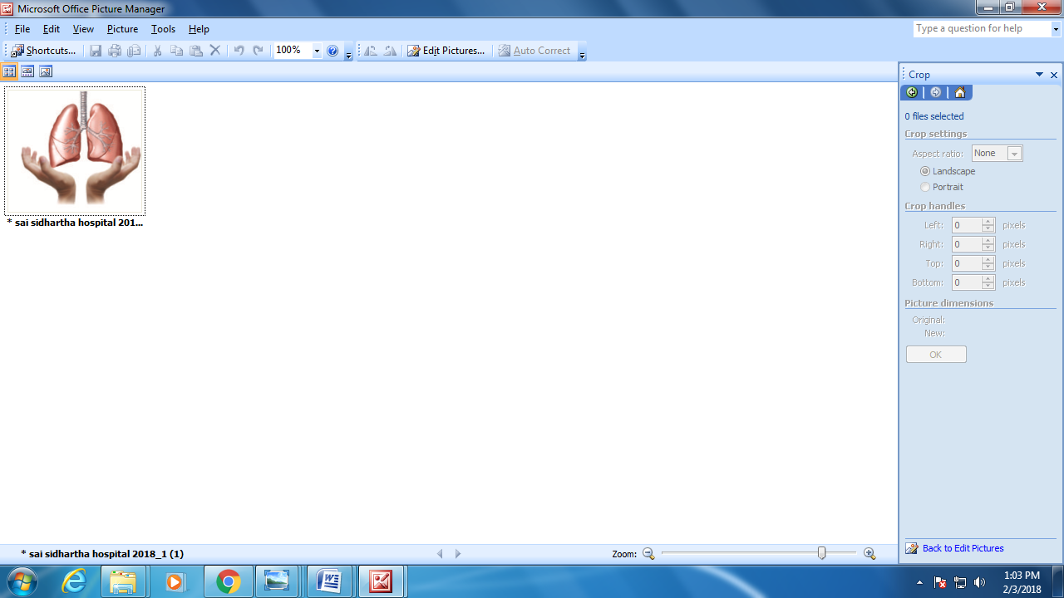

SAI SIDDHARTHA HOSPITAL  
 *“We treat, God Heals”*

*Website:* [*www.saisiddharthahospital.co.in*](http://www.saisiddharthahospital.co.in) *Email: info@saisiddharthahospita.co.in*

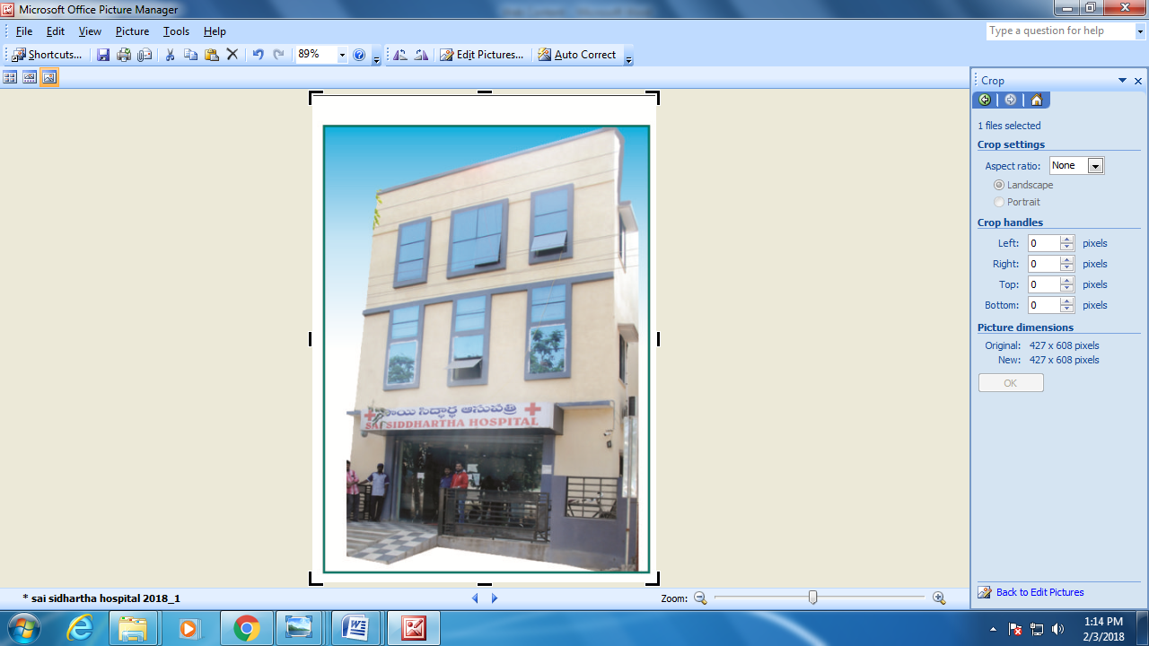

**About us**:

Sai Siddhartha Hospital is 50 Bedded State Govt. Recognized Hospital with OT and ICU facility located in Shapur nagar, IDA Jedimetla, Hyderabad,Telangana State was found in 2016 offers specialities like Pulmonology, Diabetology, Internal Medicine, general Surgery,ENT,Anaethesiology and Critical Care. It has Lung Surgery Unit, Video Bronchoscopy,Rigid Bronchoscopy, Thoracoscopy,Computerised Lung Function Testing,X-Ray and Lab facilities, Advanced Critical Care and Ventilatory management. Complicated Diabetes Management, Allergy skin testing for food Allergy,skin Allergy & Allergic Rhinitis and Asthma.

**DEPARTMENTS**  **DIAGNOSTIC SERVICES**

* Pulmonology - Biochemistry
* Diabetology - Clinical Pathology
* Internal Medicine - Microbiology
* Diabetology - Haemotology
* ENT - Digital X-Ray
* Anaesthesiology - PFT (Pulmonary Function Test)
* Critical Care

**24/7 SERVICES**

* Emergency
* Lab
* Pharmacy
* Digital X-Ray
* 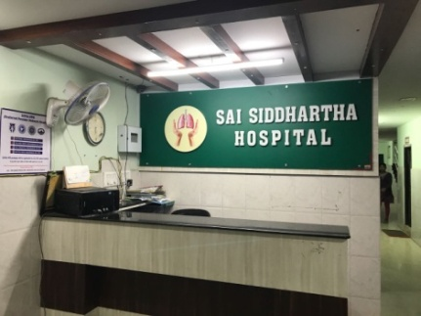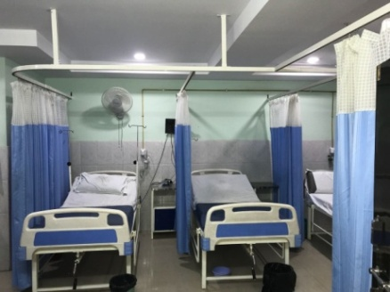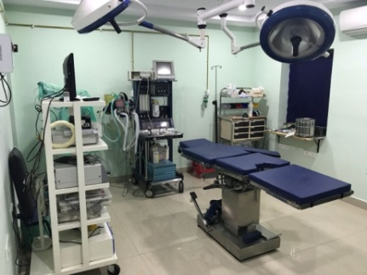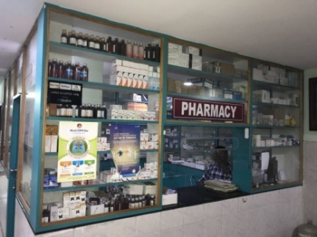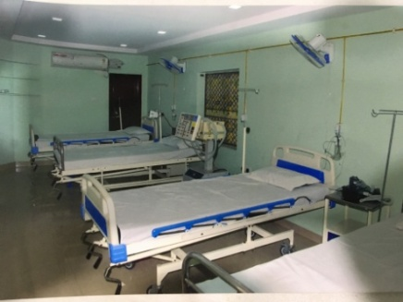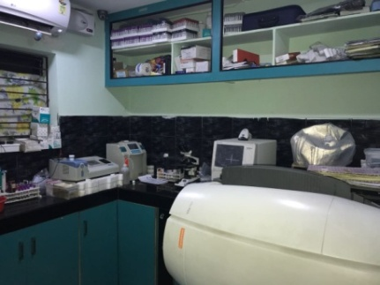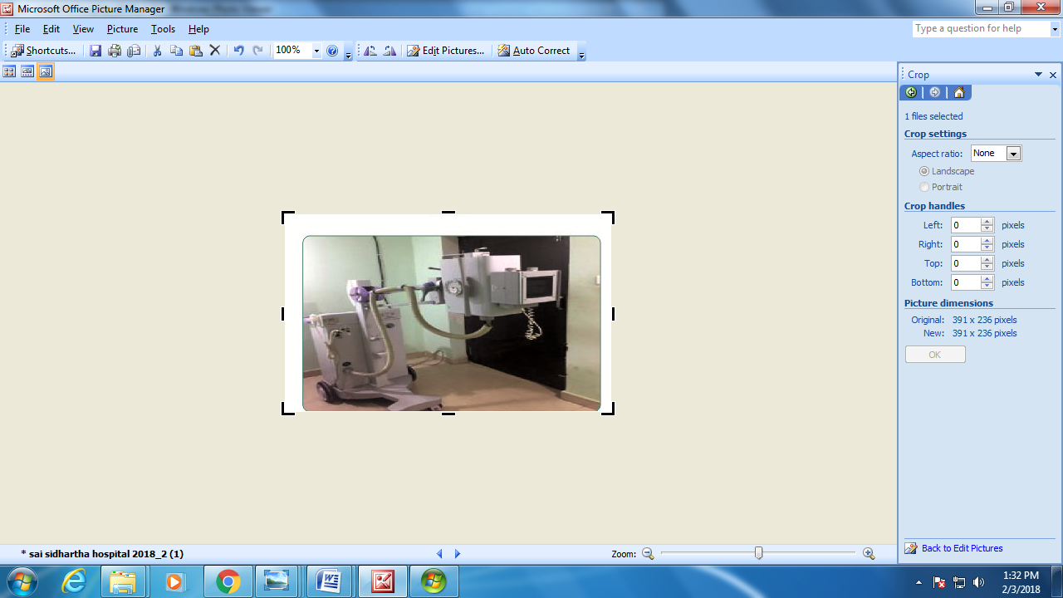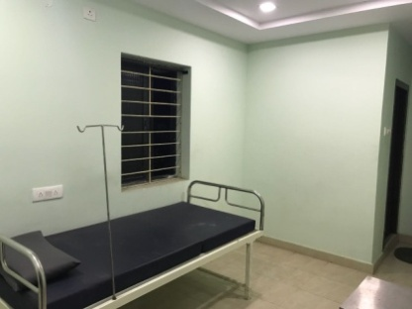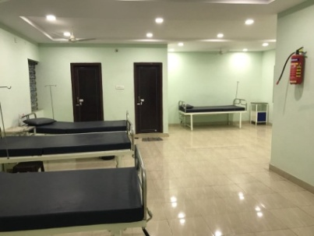
* 1.RECEPTION, 2.EMERGENCY,3. OT,4.PHARMACY, 5.ICU, 6.LAB,7. DIGITAL X-RAY, 8.SINGLE ROOM AND 9.GENERAL WARD.

Chairman Profile:

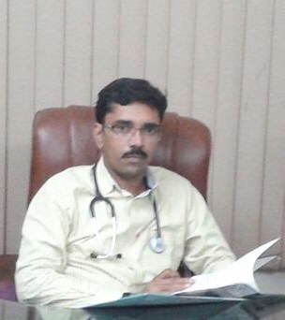

Dr.Kiran Grandhi owner of Sai Siddhartha Hoapital had completed MBBS in Guntur Medical College,MD Pulmonology in Osmania College, Hyderabad and DIP (Diabetology).He is Member of European Respiratory Society and a Member of American Thoracic Society.He took advance training in Interventional Pulmonology from Marsielle – France.

**Pulmonology:**

He specialises in treatment in the treatment of Chronic cough, difficulty in breathing,,reccuring Pneumonia,Asthma, Cystic Fibrosis,Chronic Lung Disease, Noisy breathing,Weezing and Bronchitis.He does basic bronchoscopic and Pleural procedures like Pleural Tapping, inter costal Drainage and Advanced diagnostic procedures like Medical Pleuroscopy for Inspection and Biopsy of Pleura, Thoracoscopy, Tracheoplasty and Air Stenting. (ADULT & PEDIATRIC)

**Diabetology**:

He specializes in the treatment of infectious disease, Diabetic Footcare, Rhematoiud Arthritis, Migarine treatment, Diabetes Management, Hypo & Hyper Throoidism, Leg Swelling, Obesity Issues, Insulin Treatment,Type 1 Diabetes treatment,Metabolic Disease, Osteoporosis, Hypertension, Thyroid Swelling, Gestational,Diabetic Management, Calcium Disorders,

  
SAI SIDDHARTHA HOSPITAL   
“We treat, God Heals”   
# 4/32 – 130,Shapur Nagar, Behind MJS Gardens, Indian Oil Petrol Bunk beside lane, Near Raitu Bazar,Hyderabad, T.S – 500055.

***(PULMONOLOGY – DIABETOLOGY – INTERNAL MEDICINE - ANAESTHESIOLOGY – GENERAL MEDICINE – ENT – CRITICAL CARE)***

Email: [info@saisiddharthahospital.co.in](mailto:info@saisiddharthahospital.co.in)  
Web Site: [www.saisiddharthahospital.co.in](http://www.saisiddharthahospital.co.in)

ROUTE MAP

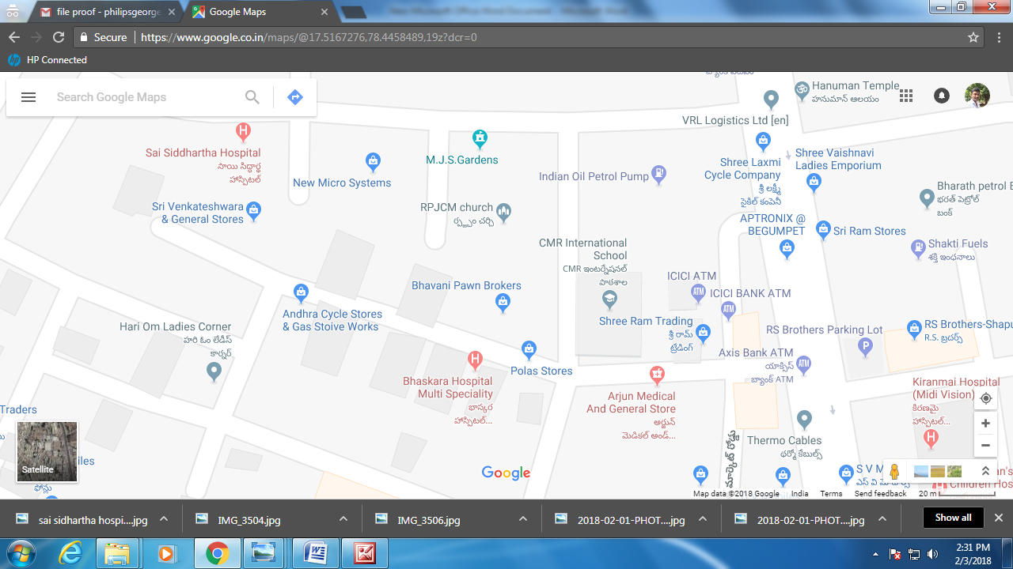

______________________________________________________________________________

**FOR APPOINTMENTS EMERGENCY**

**9550064751 040 – 23090409**

http://epaper.sakshi.com/1385583/Hyderabad-Constituencies/08-10-2017#page/33/1eHeaHhh kklkklhhhnouetv