**REPORT**

**M1__Customer-Billing-System-APP**

**Discription:**

Customer Billing System Project is a simple console application designed to demonstrate the practical use of C programming language and its features as wells as to generate an application which can be used in any departmental store, shops, cafes etc. for billing to the customer. We can use this application to keep the records such as name, address, mobile number, paid amount, due amount, payment date etc. of your regular costumer..

User Case Diagram :

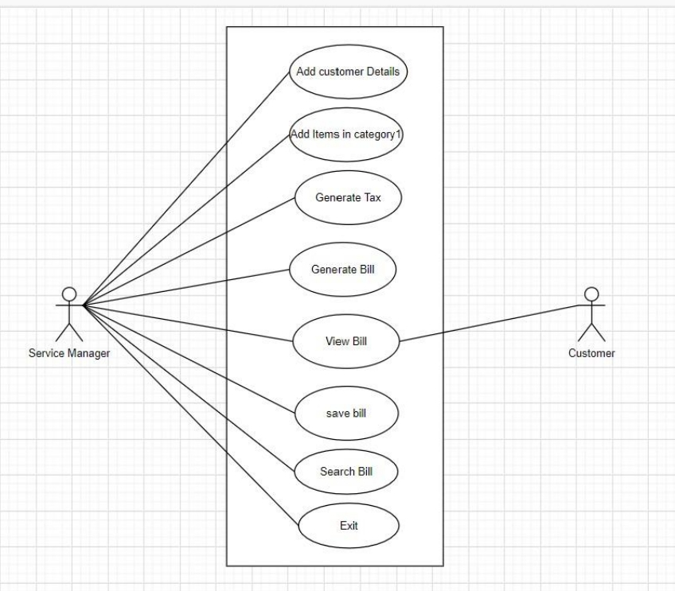

Flowchart :

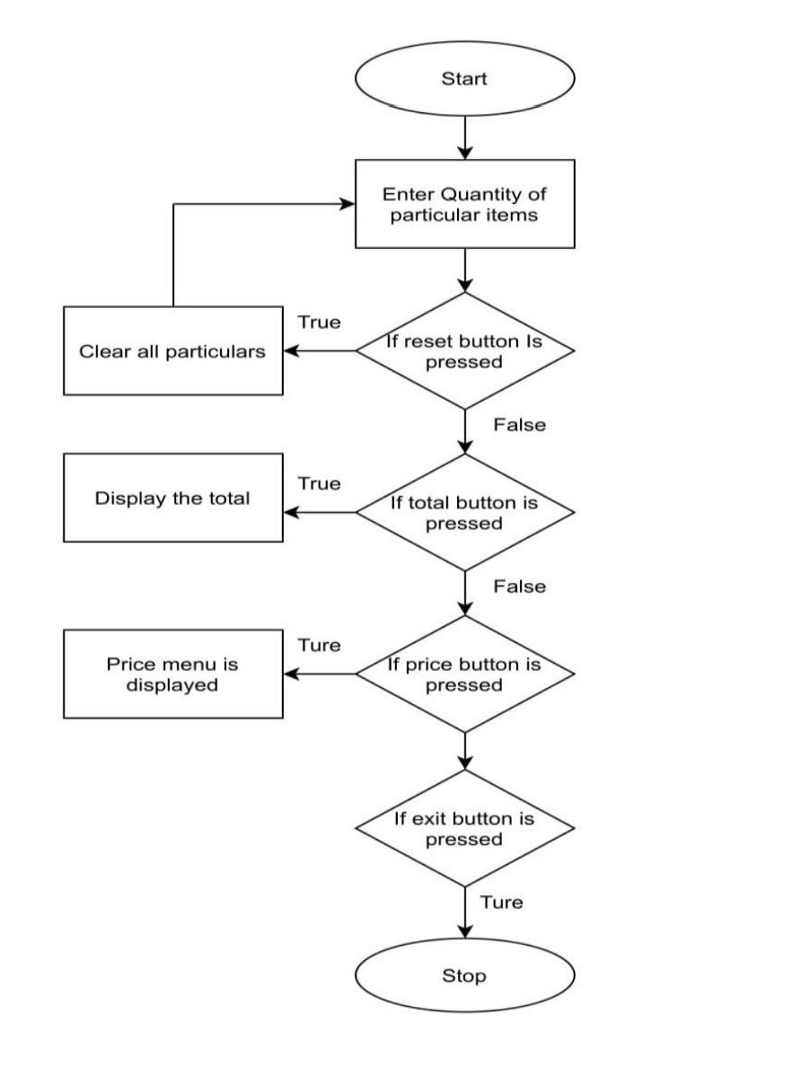

**Requirements**

# High Level Requirements:

# 1.To enter the purchases

# 2.To add and make a total

# 3.To make a bill

# Low Level Requirements:

# Tax calculation

# Date entry

# Admin name

# Customer name

## Advantages :

1. Time saving
2. Details of Tax
3. Even a Layman can understand
4. Affordable and Cost-effective

## DisAdvantages :

1. Fixed price
2. External Print Required

# SWOT Analysis:

STRENGTH: Easy to use Application Faster Process.

WEAKNESS: External Printing

OPPURTUNITY: Decrease labour

THREAT: Best applications are available using different technologies competition is high.

# 4 W's and 1 H:

WHO:

Anyone with a sysytem can use

What:

Designed to handle time and billing tracking as well as invoicing customer for services and products.

When:

It is available 24X7, 365 days.

Where:

It is available in any departmental store, shops, cafes etc. for billing to the customer.

How:

The program of this application was developed in C language to avoid the complexity and to keep it simple.

|  |  |
| --- | --- |
|  |  |

OUTPUT :-

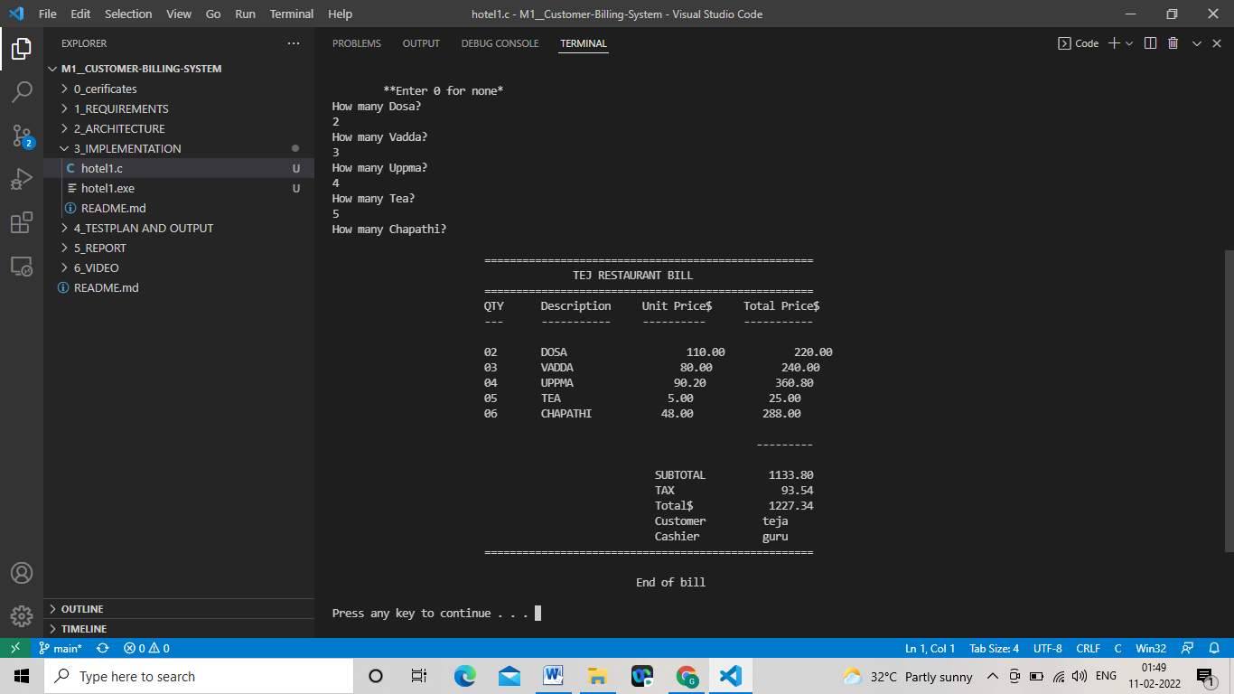

NAME :- P. GURU TEJA REDDY

PS.NO :- 99007900