DATA ANALYTICS AND FINANCIAL INTELLIGENCE
INDUSTRIAL INTERNSHIP REPORT
Data Analyst Internship at Bluestock Fintech
An Industrial Internship Report
submitted by
CHALAMKOTA REDDY HASINI
Reg. No.: 24BCA7967
in partial fulfilment for the award of the degree of
BACHELOR OF TECHNOLOGY
in
COMPUTER SCIENCE AND ENGINEERING
(AI & ML)

SCHOOL OF COMPUTER SCIENCE AND ENGINEERING
VIT-AP UNIVERSITY, AMARAVATI
October 2026

DECLARATION BY THE CANDIDATE
I hereby declare that the Industrial Internship Report entitled “Data Analytics and Financial Intelligence – Data Analyst Internship at Bluestock Fintech” submitted by me to VIT-AP University, Amaravati, in partial fulfilment of the requirements for the award of the degree of Bachelor of Technology in Computer Science and Engineering (AI & ML), is a record of bonafide industrial training undertaken by me at Bluestock Fintech Pvt. Ltd. from 24 July 2026 to 24 September 2026 under the supervision of Mr. Yash Kale, Project Manager.
I further declare that the work reported in this report has not been submitted, and will not be submitted, either in part or in full, for the award of any other degree or diploma at this or any other institute or university.

Signature of the Student
Name: Chalamkota Reddy Hasini
Reg. No.: 24BCA7967
INTERNSHIP CERTIFICATE
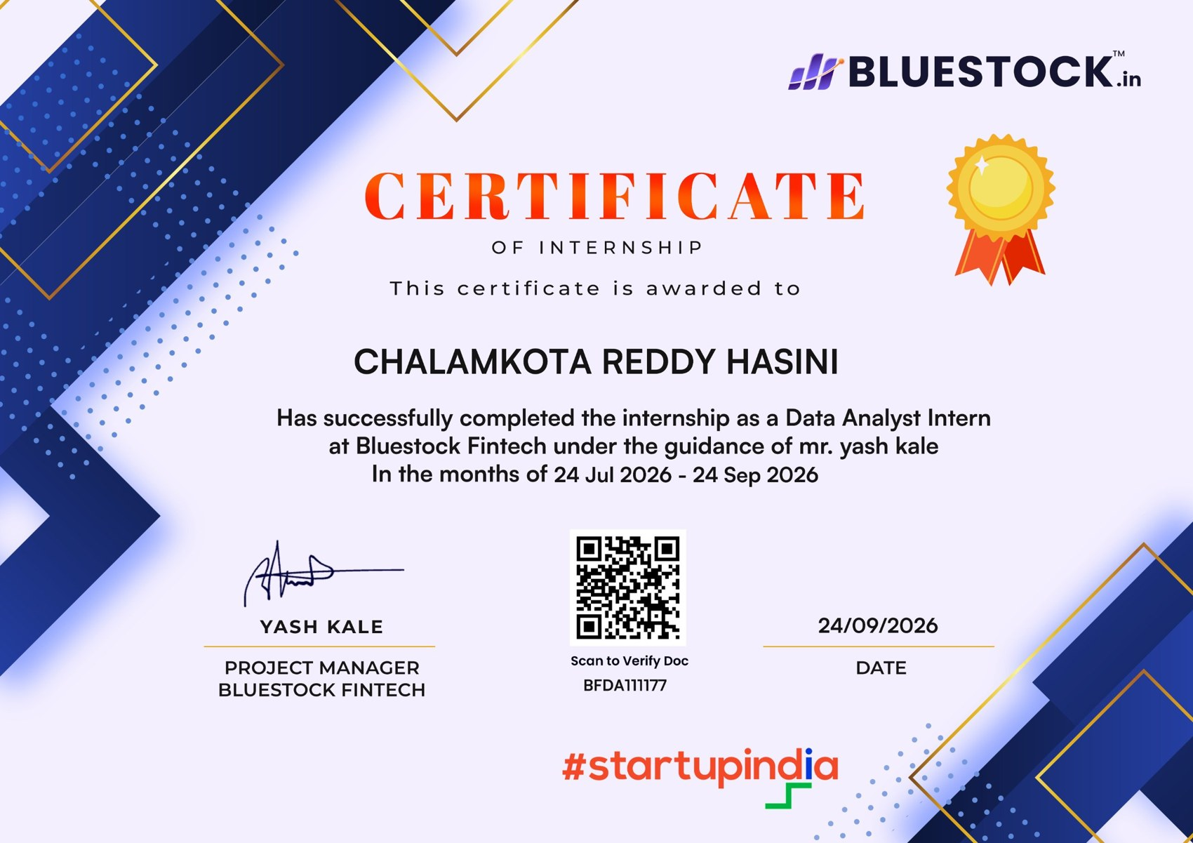
Internship completion certificate issued by Bluestock Fintech (Certificate ID: BFDA111177), dated 24 September 2026.
ACKNOWLEDGEMENT
I express my sincere gratitude to Bluestock Fintech for giving me the opportunity to undergo industrial training as a Data Analyst Intern and for exposing me to practical applications of data analytics in the FinTech domain.
I am especially thankful to Mr. Yash Kale, Project Manager, for his guidance and supervision during the internship. The structured tasks, project specifications and review-oriented workflow helped me understand how data analytics work is organised in an industry environment.
I also thank the faculty of the School of Computer Science and Engineering, VIT-AP University, for their academic guidance and support for industrial internship training.
Finally, I thank my family, friends and peers for their constant encouragement throughout the internship.

Place: Amaravati
Date: October 2026
Signature: ______________________
CHALAMKOTA REDDY HASINI
TABLE OF CONTENTS
Section | Page
Declaration by the Candidate | ii
Internship Certificate | iii
Acknowledgement | iv
Table of Contents | v
List of Tables | vi
List of Figures | vii
List of Abbreviations | viii
Chapter 1: Synopsis | 1
Chapter 2: About the Organization | 3
2.1 Organization Overview | 3
2.2 FinTech and Data Analytics Context | 3
2.3 Internship Programme Structure | 4
2.4 Technology Environment | 5
2.5 Work Culture and Communication | 5
2.6 Data Provenance and Responsible Use of Data | 5
Chapter 3: Student Skillset Before Training | 7
3.1 Academic Foundation | 7
3.2 Skill Readiness Before Training | 7
3.3 Areas Requiring Improvement | 7
3.4 Learning Goals Before the Internship | 8
Chapter 4: Knowledge Acquired from the In‑Plant Training | 9
4.1 Data Engineering and ETL | 9
4.2 SQL and Data Modelling | 10
4.3 EDA and Visualisation | 10
4.4 Financial Performance and Risk Analytics | 10
4.5 BI Dashboards | 12
4.6 Fundamental Analysis and Ratio Engineering | 12
4.7 Advanced Analytics and Professional Practices | 13
4.8 Statistical Foundations of the Metrics | 14
4.9 Understanding Financial Statements | 14
4.10 Version Control, Testing and Documentation | 15
Chapter 5: Application of the Gained Knowledge | 16
5.1 Project I: Mutual Fund Analytics Platform | 16
5.2 Project II: Nifty 100 Financial Intelligence Platform | 18
5.3 Challenges and Resolutions | 20
5.4 Worked Example: Computing the Core Metrics | 20
5.5 Testing and Quality Assurance | 21
5.6 Key Learnings from the Application | 21
Chapter 6: Comparison of Competency Levels and Self-Evaluation | 22
6.1 Before Training | 22
6.2 After Training | 22
6.3 Growth Areas | 23
6.4 Self-Evaluation | 23
6.5 Application of Learning and Future Learning Plan | 23
6.6 Conclusion | 24
Appendix 1: Internship Offer Letter | 25
Appendix 2: Sample Technical Workflow (Python) | 26
Appendix 3: Sample SQL Queries | 27
References | 27
LIST OF FIGURES
Figure | Title | Page
Figure 1 | Data Flow from User Action to Analytics Dashboard | 9
Figure 2 | Workflow from NAV History to Fund Scorecard | 11
Figure 3 | Mutual Fund Analytics Platform: Architecture | 16
Figure 4 | Star Schema of the Mutual Fund Database | 17
Figure 5 | Nifty 100 Platform: Seven-Layer Architecture | 18
Figure 6 | Competency Development During the Internship | 23
LIST OF ABBREVIATIONS
Abbreviation | Full Form
API | Application Programming Interface
AMC | Asset Management Company
AMFI | Association of Mutual Funds in India
AUM | Assets Under Management
BI | Business Intelligence
BSE | Bombay Stock Exchange
CAGR | Compound Annual Growth Rate
CFO | Cash Flow from Operations
CSV | Comma-Separated Values
CVaR | Conditional Value at Risk
D/E | Debt-to-Equity Ratio
EDA | Exploratory Data Analysis
EPS | Earnings Per Share
ETL | Extract, Transform, Load
HHI | Herfindahl-Hirschman Index
JSON | JavaScript Object Notation
KPI | Key Performance Indicator
NAV | Net Asset Value
NBFC | Non-Banking Financial Company
NLP | Natural Language Processing
NSE | National Stock Exchange of India
OLS | Ordinary Least Squares
PAT | Profit After Tax
P/E | Price-to-Earnings Ratio
REST | Representational State Transfer
ROCE | Return on Capital Employed
ROE | Return on Equity
SEBI | Securities and Exchange Board of India
SIP | Systematic Investment Plan
SQL | Structured Query Language
VaR | Value at Risk

CHAPTER 1: SYNOPSIS
The Data Analyst Internship at Bluestock Fintech was a two-month, part-time, remote programme undertaken from 24 July 2026 to 24 September 2026 under the guidance of Mr. Yash Kale, Project Manager. The training followed the complete workflow of financial data analytics: collecting public data and cleaning it, storing it in a relational database, analysing it with statistical and financial metrics, and presenting the results through dashboards and reports.
The programme began with a two-week foundation phase covering spreadsheets, SQL, Python, exploratory data analysis, visualisation, stock market basics, REST APIs and Git. It then moved to two projects. In the Mutual Fund Analytics Platform, I followed a seven-day workflow of ETL ingestion from AMFI-linked public sources and the mfapi.in API, data cleaning, a SQLite star schema, exploratory analysis, risk metrics (CAGR, Sharpe, Sortino, Alpha, Beta, Maximum Drawdown, VaR and CVaR) and a four-page Power BI dashboard. The Nifty 100 Financial Intelligence Platform, organised as six sprints, extended this to a ratio engine of more than fifty KPIs for 92 companies, an investment screener, scoring and peer comparison, rule-based NLP, clustering, a Streamlit dashboard, a FastAPI service and automated testing.
The training objectives were to understand an industry-oriented analytics workflow from data acquisition to presentation; to ingest, clean, validate and organise structured datasets; to strengthen SQL and relational database skills through SQLite-based modelling; to perform exploratory analysis and create clear visualisations; to learn financial performance and risk measures; to build familiarity with interactive dashboards and stakeholder-oriented reporting; and to apply version control, documentation and testing practices in project work.
Before the internship my knowledge was mainly academic. Through hands-on tasks, deadlines and mentor feedback, I learned to produce reproducible, documented and version-controlled analytical work, and gained confidence in Python-based data engineering, database design, financial metrics and dashboard storytelling. The internship strengthened both my technical and professional skills and gave me a clear direction towards a career in data analytics and financial technology.

CHAPTER 2: ABOUT THE ORGANIZATION

2.1 Organization Overview
Bluestock Fintech (Bluestock Fintech Pvt. Ltd., www.bluestock.in) is an Indian financial technology company focused on democratising investment analytics for retail and institutional investors. It builds data-driven products around mutual funds, equities and investor behaviour, and runs an internship programme in which students work on industry-style analytics projects using publicly available financial data. The offer letter dated 20 July 2026 (ID BFDA111177) described the role as a part-time, unpaid, remote Data Analyst Intern position with flexible hours and close collaboration with the leadership team. The completion certificate was issued on 24 September 2026 and signed by Mr. Yash Kale. Table 1 summarises the engagement.
Table 1: Internship Profile and Duration
Parameter | Details
Organization | Bluestock Fintech Pvt. Ltd.
Role | Data Analyst Intern (remote, part-time, flexible hours)
Internship period | 24 July 2026 to 24 September 2026
Training guide | Mr. Yash Kale, Project Manager
Domain | FinTech: mutual fund analytics and equity fundamental analysis
Projects | Mutual Fund Analytics Platform; Nifty 100 Financial Intelligence Platform

2.2 FinTech and Data Analytics Context
Financial technology combines finance with software and data engineering. Bluestock's capstone brief describes a platform that tracks the NAV of 40+ mutual fund schemes, monitors AUM growth of the ten largest fund houses, analyses investor behaviour, computes risk-adjusted metrics and benchmarks funds against indices such as Nifty 100. Table 2 lists the industry figures quoted in the brief, which show why automated analytics is valuable when schemes, folios and monthly flows are this large.
Table 2: Key Industry Figures Referenced in the Programme (December 2025)
Indicator | Value
Industry AUM | Rs. 81 lakh crore
Number of schemes | 1,908
Total mutual fund folios | 26.12 crore
Monthly SIP inflow (all-time high at the time) | Rs. 31,002 crore
Active SIP accounts | 9.35 crore
AUM of SBI / ICICI Prudential / HDFC Mutual Fund | Rs. 12.50 / 10.74 / 9.30 lakh crore

2.3 Internship Programme Structure
The internship followed a structured, deadline-driven model that mirrors a real analytics team:
- a task board with assignees, priorities and status for every task;
- a daily stand-up form for weekday progress reporting;
- defined deliverables with an evaluation rubric covering code quality, formula correctness, dashboard design and documentation; and
- clear labelling of simulated datasets (investor transactions, stock prices, valuation multiples) versus public AMFI, NSE and BSE data.
The training was organised into three blocks, summarised in Table 3.
Table 3: Training Structure
Block | Component | Focus
A | Foundation programme (2 weeks) | Spreadsheets, SQL, Python, EDA, visualisation, stock market basics, REST APIs, Git
B | Mutual Fund Analytics capstone (7 days) | ETL, cleaning, SQL schema, EDA, performance and risk metrics, dashboard, advanced analytics, report
C | Nifty 100 platform (6 sprints, 45 days) | ETL and data quality, ratio engine, screener, scoring, NLP, clustering, dashboard, API, testing

2.4 Technology Environment
Table 4: Technology Stack Used
Area | Tools | Use
Programming | Python 3.10+, SQL | ETL, analytics, queries
Data and statistics | Pandas, NumPy, SciPy | Cleaning, risk metrics, regression
Visualisation | Matplotlib, Seaborn, Plotly, Power BI | EDA charts and dashboards
Database | SQLite, SQLAlchemy | Schema design and loading
Applications | Streamlit, FastAPI, ReportLab, openpyxl | Dashboard, REST API, PDF/Excel reports
NLP and ML | NLTK, scikit-learn, regex | Text parsing, sentiment, clustering
Quality and collaboration | pytest, black, ruff, Git, GitHub | Testing, linting, version control

2.5 Work Culture and Communication
Because the internship was remote and part-time with flexible hours, communication had to be deliberate and documented. Work was assigned through a task board in which every task carried an assignee, a priority and a status; progress was reported through a daily stand-up form on weekdays; and questions, clarifications and feedback were handled through my mentor, Mr. Yash Kale. Finished work was reviewed against the evaluation rubric for code quality, formula correctness, dashboard design and documentation.
This working style differs from a university laboratory. Deadlines were tied to deliverables, a task was complete only when it met its acceptance criteria, and unclear requirements had to be raised early rather than guessed. Working this way taught me to plan my week, to break a large deliverable into small verifiable tasks and to write progress updates that another person can understand without a meeting.

2.6 Data Provenance and Responsible Use of Data
A distinctive feature of the programme was its transparency about data. Mutual fund and market data came from public sources such as AMFI, mfapi.in, NSE and BSE, whereas investor transactions, stock prices and valuation multiples were simulated for training and were clearly labelled as such. Every analysis therefore had to state which data was real and which was synthetic, so that a synthetic figure would never be mistaken for a market fact.
I also learned to keep raw files untouched, to record where each file came from and to avoid committing large database files or credentials to a public repository. These habits matter in finance, where a decision can rest on a single number.

CHAPTER 3: STUDENT SKILLSET BEFORE TRAINING

3.1 Academic Foundation
Before the internship, my technical base came from the B.Tech Computer Science and Engineering (AI & ML) curriculum at VIT-AP University. Coursework had given me programming, data structures, databases, statistics, probability and machine learning fundamentals, along with practical use of Python, Pandas, NumPy, Scikit-learn, SQL, Jupyter and Git/GitHub. Python was my strongest starting point, but I had used it for individual assignments and small projects rather than for a complete, repeatable ETL workflow. My SQL knowledge covered tables, keys and queries, and statistical concepts such as mean, standard deviation, correlation and regression were familiar, although I had not applied them to financial measures.

3.2 Skill Readiness Before Training
Table 5: Core Skills Before Training
Skill Area | Initial Level | Starting Position
Python / Pandas | Intermediate | Comfortable with data manipulation and basic analysis
SQL | Basic to Intermediate | Understood queries, tables and database concepts
Statistics | Basic to Intermediate | Academic knowledge of probability and regression
Data visualisation | Basic | Standard plots; no dashboard experience
Financial analytics | Basic | Limited exposure to NAV, SIP and risk measures
Power BI / Tableau | Basic | Limited practical dashboard experience
Git / GitHub | Basic | Familiar with repositories and basic workflow
Documentation | Basic to Intermediate | Academic reports; no industry-style documentation

3.3 Areas Requiring Improvement
The main gaps were building a complete ETL pipeline instead of isolated cleaning steps, handling data-quality rules and edge cases systematically, connecting analysis to a relational database, understanding financial terminology, designing dashboards for users rather than for academic evaluation, and following structured deliverables and timelines with reproducible scripts.

3.4 Learning Goals Before the Internship
My goals for the internship matched the training objectives described in Chapter 1. I wanted:
- to understand an analytics workflow from data acquisition to presentation instead of working on isolated notebooks;
- to learn the vocabulary and measures of mutual fund and equity analysis, which my curriculum had not covered;
- to design a relational database for analysis and query it confidently with SQL;
- to build an interactive dashboard that a non-technical user can explore; and
- to practise professional habits such as version control, documentation, testing and meeting deadlines.
These goals shaped how I approached each task: I tried to understand why a step was needed in the pipeline as well as how to implement it.

CHAPTER 4: KNOWLEDGE ACQUIRED FROM THE IN‑PLANT TRAINING

4.1 Data Engineering and ETL
The training introduced the Extract, Transform, Load pattern followed by Analyse and Visualise. In the extract stage I learned to read flat files, Excel workbooks and JSON from REST APIs such as mfapi.in, keeping untouched raw copies. In the transform stage I learned to parse dates, forward-fill NAVs on holidays, remove duplicates, normalise names and tickers, standardise financial-year labels, validate codes against a master list and derive fields such as daily returns. I also learned to use relative paths (pathlib) so that code runs on any machine. The foundation phase added stock market basics (NSE, BSE, SEBI, market capitalisation, EPS, P/E) and mutual fund vocabulary: AMFI code, NAV, AUM, SIP, folio, expense ratio, exit load, direct versus regular plans and risk grades. Table 6 lists the main terms. Figure 1 shows the data flow I documented during the foundation phase, from a user action in an application through the backend API and database to the analytics dashboard.
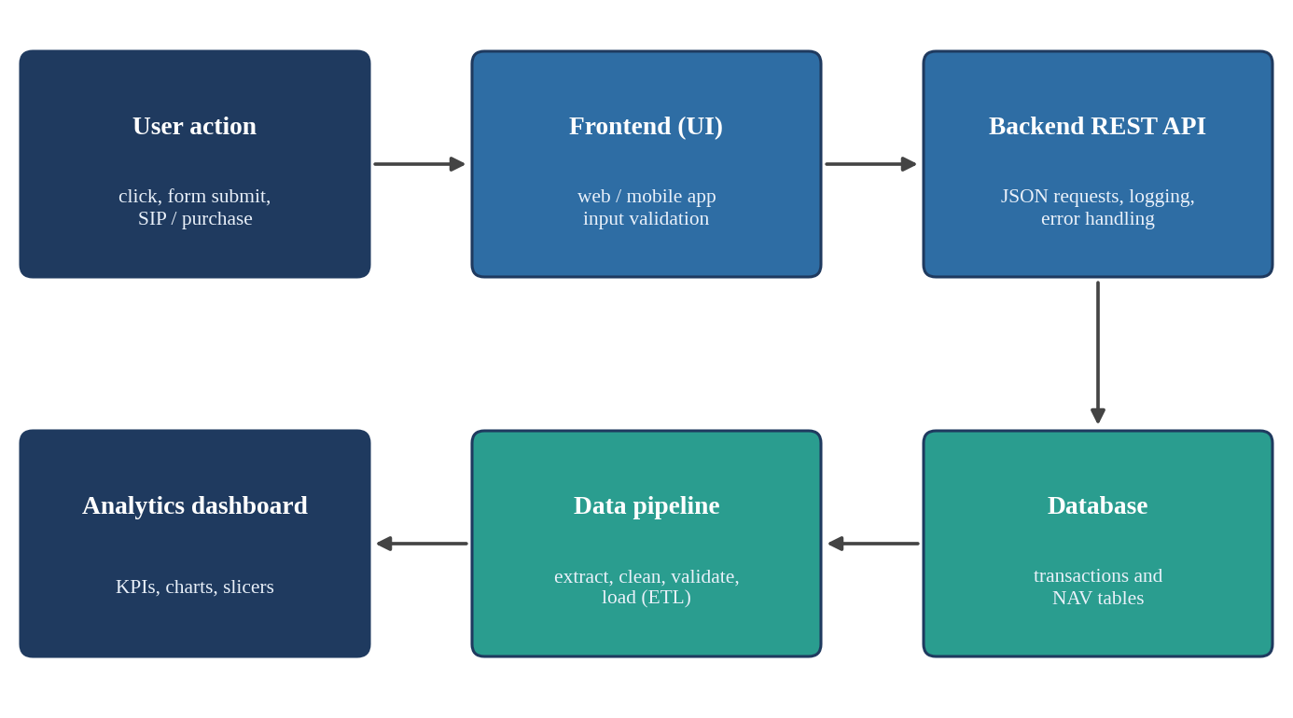
Figure 1: Data Flow from User Action to Analytics Dashboard
Table 6: Key Mutual Fund Concepts Learned
Term | Meaning
AMFI code | Unique scheme identifier; primary key across datasets
NAV | Net Asset Value per unit, declared on business days
AUM | Total market value of investments managed by a fund or fund house
SIP | Systematic Investment Plan; fixed periodic investment
Expense ratio | Annual fee as a percentage of assets; lower for Direct plans
Exit load | Fee on redemption within a specified period
Benchmark | Reference index (for example Nifty 100) for judging performance
T30 / B30 | AMFI classification of Top 30 and Beyond Top 30 cities

4.2 SQL and Data Modelling
I learned dimensional modelling: a star schema separates descriptive dimension tables (funds, dates) from numeric fact tables (NAV, transactions, performance, AUM), which keeps analytical queries simple and fast. I practised defining primary and foreign keys, indexing the AMFI code and date columns, loading data through SQLAlchemy and writing analytical SQL such as top funds by AUM, monthly average NAV, year-on-year SIP growth and transactions by state. I also learned not to commit large .db files to GitHub and to share the schema script instead.

4.3 EDA and Visualisation
Exploratory analysis taught me to examine distributions, trends and anomalies before drawing conclusions. I learned to match the chart to the question: line charts for NAV and SIP trends, grouped bars for AUM by fund house, heatmaps for category inflows, box plots for SIP amounts by age group, scatter plots for risk versus return and correlation matrices for fund returns. Every chart was expected to end in a written insight.

4.4 Financial Performance and Risk Analytics
This was the most demanding area. I learned how raw NAV history becomes measures that compare funds fairly (Table 7). A key lesson was to annualise with 252 trading days rather than calendar days. I also learned to build a composite fund scorecard (0 to 100) that weights 3-year return (30%), Sharpe ratio (25%), Alpha (20%), expense ratio (15%) and maximum drawdown (10%). Figure 2 shows how the metrics fit together, and Table 8 gives the scorecard weights.
Table 7: Performance and Risk Metrics Learned
Metric | Method | Meaning
CAGR | (NAV end / NAV start)^(1/n) - 1 | Smoothed annual growth
Sharpe ratio | (Rp - Rf) / Std(Rp) x sqrt(252); Rf = 6.5% | Return per unit of total risk
Sortino ratio | (Rp - Rf) / downside deviation | Return per unit of downside risk
Alpha and Beta | OLS regression on benchmark returns | Excess return; market sensitivity
Maximum drawdown | min(NAV / running max - 1) | Worst peak-to-trough fall
VaR and CVaR (95%) | 5th percentile; mean below it | Loss threshold and tail loss
Tracking error | Std(fund - benchmark) x sqrt(252) | Consistency with benchmark

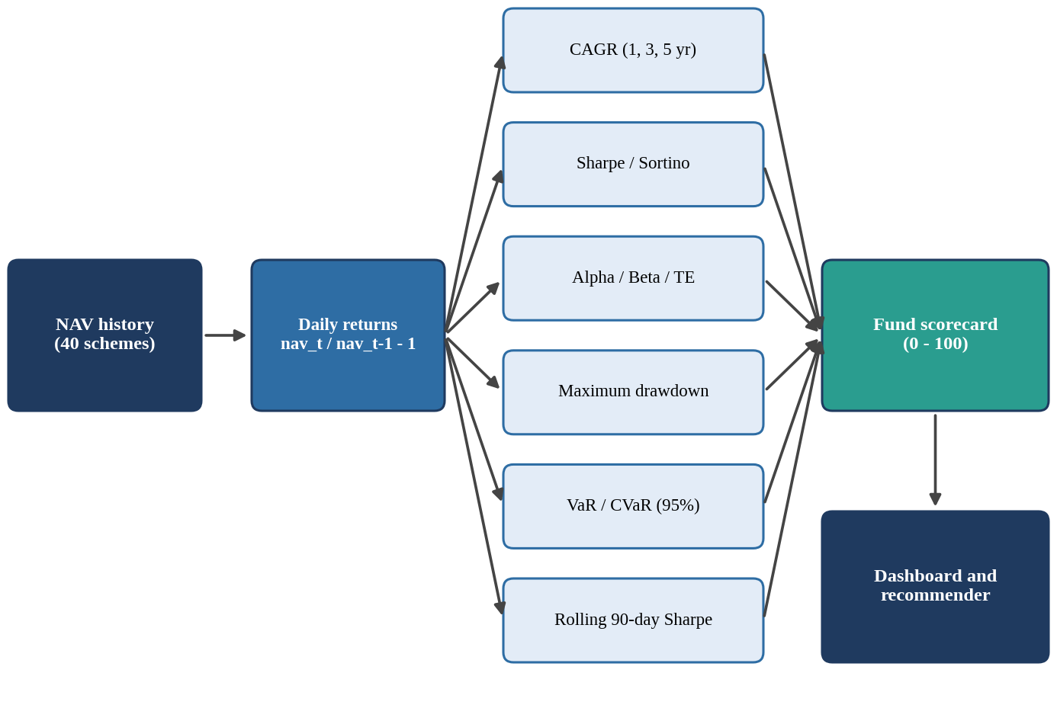
Figure 2: Workflow from NAV History to Fund Scorecard
Table 8: Fund Scorecard Weighting
Component | Weight | Direction
3-year return rank | 30% | Higher is better
Sharpe ratio rank | 25% | Higher is better
Alpha rank | 20% | Higher is better
Expense ratio rank | 15% | Lower is better (inverse)
Maximum drawdown rank | 10% | Smaller fall is better (inverse)

4.5 BI Dashboards
I learned how to design a multi-page Power BI dashboard on top of a database: KPI cards for headline numbers, slicers for fund house, category, state and age group, drill-through from a fund table to its NAV chart, tooltips, a consistent colour theme and export to PDF. The rule that every page must have at least two interactive slicers taught me to design for users who explore, not just view.

4.6 Fundamental Analysis and Ratio Engineering
In the Nifty 100 project I moved from funds to companies. I learned to read the profit and loss, balance sheet and cash flow statements and convert them into more than fifty KPIs: profitability (net and operating margin), returns (ROE, ROCE), leverage (debt-to-equity, interest coverage), growth (revenue, PAT and EPS CAGR), cash quality (free cash flow, CFO/PAT) and valuation (P/E, P/B, EV/EBITDA, dividend yield). Each KPI needs a formula, a benchmark and explicit edge-case handling: ROE is None when equity is not positive, interest coverage shows 'Debt Free' when interest is zero, and a CAGR with a negative base year is flagged TURNAROUND rather than computed. Banks and NBFCs are benchmarked against sector ranges because high leverage is normal for them. Table 9 lists the KPI categories and Table 10 the CAGR decision rules.
Table 9: KPI Categories in the Ratio Engine
Category | Examples | Typical Benchmark
Profitability | Net margin, operating margin, EBIT margin | Net margin above 10% good
Returns | ROE, ROCE, ROA | ROE, ROCE above 15% good
Leverage | Debt-to-equity, interest coverage | D/E below 1; coverage above 3x
Growth | Revenue, PAT, EPS CAGR (3, 5, 10 year) | Double-digit CAGR healthy
Cash quality | Free cash flow, CFO/PAT, capex intensity | CFO/PAT above 1
Valuation | P/E, P/B, EV/EBITDA, dividend yield | Compare within sector

Table 10: CAGR Edge-Case Decision Table
Base Year | End Year | CAGR | Flag
Positive | Positive | Computed | None
Positive | Negative | None | DECLINE_TO_LOSS
Negative | Positive | None | TURNAROUND
Negative | Negative | None | BOTH_NEGATIVE
Zero | Any | None | ZERO_BASE
Under 3 years of data | Any | None | INSUFFICIENT

4.7 Advanced Analytics and Professional Practices
The advanced topics included cohort analysis by first transaction year, SIP continuity analysis (flagging average gaps above 35 days), sector concentration using the Herfindahl-Hirschman Index, a rule-based fund recommender, regex parsing of text such as '10 Years: 21%', rule-based pros and cons, NLTK sentiment scoring, KMeans clustering with StandardScaler, z-score outlier detection, a Streamlit dashboard, a FastAPI REST service and ReportLab PDF reports.
Equally valuable were engineering and professional practices: separating raw and processed data, keeping thresholds in YAML and .env files, using logging instead of print, writing type hints, docstrings and pytest tests, applying data quality rules with severity levels, and committing to GitHub with a README. Stand-ups, sprint exit criteria and review feedback improved my planning, communication and time management in a remote setting.

4.8 Statistical Foundations of the Metrics
Behind every metric in Table 7 is a small set of statistical ideas that I learned to apply carefully. A fund’s NAV series is first converted into daily returns, the percentage change from one trading day to the next. Returns, rather than NAVs, are used for risk measurement because they are comparable across funds with very different unit values. The mean and standard deviation of daily returns are then scaled to a yearly basis: the mean is multiplied by 252 and the standard deviation by the square root of 252, which assumes that daily returns are independent.
The risk-free rate must be expressed for the same period as the return. The Sharpe ratio subtracts a risk-free rate of 6.5% a year from the fund’s return before dividing by volatility, so a fund is rewarded only for return earned above a safe alternative. The Sortino ratio replaces the standard deviation by the downside deviation, which counts only returns below the target, because investors dislike losses far more than gains. Beta is the slope of a regression of fund returns on benchmark returns and measures sensitivity to the market, while Alpha is the intercept and measures the return not explained by the market.
Drawdown measures the fall from the highest NAV reached so far, so the maximum drawdown shows the worst loss an investor holding from a peak would have experienced. Value at Risk (VaR) at 95% confidence is estimated by the historical method as the 5th percentile of daily returns, and Conditional VaR is the average of all returns at or below that threshold. I also learned the limits of these measures: they describe the past, they depend on the window chosen and they should be read together rather than alone.

4.9 Understanding Financial Statements
The Nifty 100 project required me to read the three main financial statements of a company. The profit and loss statement reports revenue, expenses and profit over a year; the balance sheet reports assets, liabilities and shareholders’ equity at a date and must satisfy the identity that total assets equal total liabilities plus equity; and the cash flow statement reports cash generated from operations, invested in assets and raised or repaid through financing. Each statement answers a different question: whether the company is profitable, how it is financed and whether its profit turns into cash.
Understanding the links between the statements made the data quality rules meaningful. The assets-equal-liabilities check (DQ-04) is the balance sheet identity applied to every row, and the CFO/PAT ratio compares cash generated by operations with reported profit, so that a company whose profit is not backed by cash can be identified. I also learned that statements differ across industries: for banks and NBFCs, interest is part of the core business and high leverage is normal, which is why they needed separate benchmarks.

4.10 Version Control, Testing and Documentation
Professional analytics work must be reproducible by someone else. I learned to keep a project in a structured folder (raw data, processed data, notebooks, source code, tests and reports), to describe the setup in a README and to list dependencies so that the environment can be recreated. With Git I learned to make small, meaningful commits with clear messages, to exclude large databases and secrets through .gitignore, and to tag a release when a deliverable is final.
Testing was the other major habit. A pytest suite checks that the ratio formulas return the expected values, that edge cases return None with the correct flag, and that the loaders reject bad rows. Logging replaces print statements so that a pipeline run leaves an audit trail, and type hints and docstrings make each function understandable to a reviewer. Together these practices convert a one-time analysis into a maintainable product.

CHAPTER 5: APPLICATION OF THE GAINED KNOWLEDGE

5.1 Project I: Mutual Fund Analytics Platform
The first project addressed five problems: data fragmentation across AMFI sources, difficulty comparing funds on a risk-adjusted basis, no benchmark tracking, limited visibility into investor behaviour and slow static reporting. The solution was a five-layer platform (Figure 3) that ingests public data, transforms it with Python, loads it into SQLite and presents it in Power BI. It used ten datasets, including a fund master of 40 schemes, about 46,000 daily NAV rows (January 2022 to May 2026), AUM by fund house, SIP inflows, scheme performance, simulated transactions for 5,000 investors and benchmark index data (Table 11).
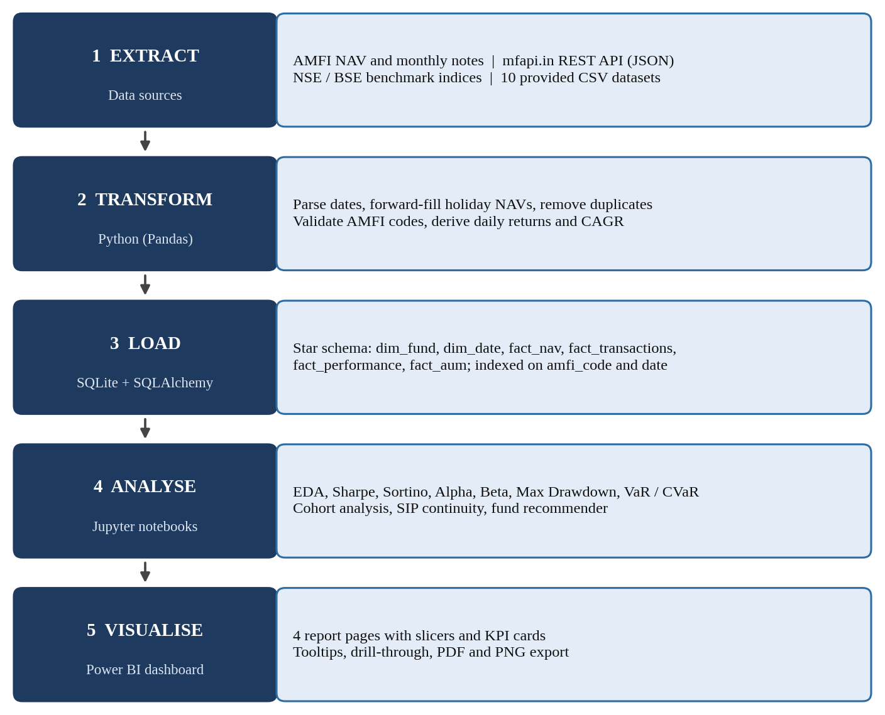
Figure 3: Mutual Fund Analytics Platform: Architecture
Table 11: Datasets Used in the Mutual Fund Project
Dataset | Size | Content
Fund master | 40 rows | Codes, fund house, category, expense ratio, risk grade
NAV history | ~46,000 rows | Daily NAV of 40 schemes, Jan 2022 to May 2026
AUM by fund house | ~90 rows | Quarterly AUM of 10 fund houses
Monthly SIP inflows | 48 rows | Inflow, accounts, registrations, SIP AUM
Scheme performance | 40 rows | Returns, Sharpe, Sortino, Alpha, Beta, drawdown
Investor transactions | ~32,000 rows | Simulated SIP, lumpsum, redemption (5,000 investors)
Benchmark indices | ~8,000 rows | Nifty 50, Nifty 100, Midcap 150, BSE SmallCap

Table 12 summarises the seven-day execution. Live NAV was fetched from mfapi.in for HDFC Top 100 (code 125497) and five large-cap schemes, and every AMFI code in the fund master was validated against the NAV history. The cleaned data was loaded into the star schema of Figure 4. Representative code for the metrics is given in Appendix 2.
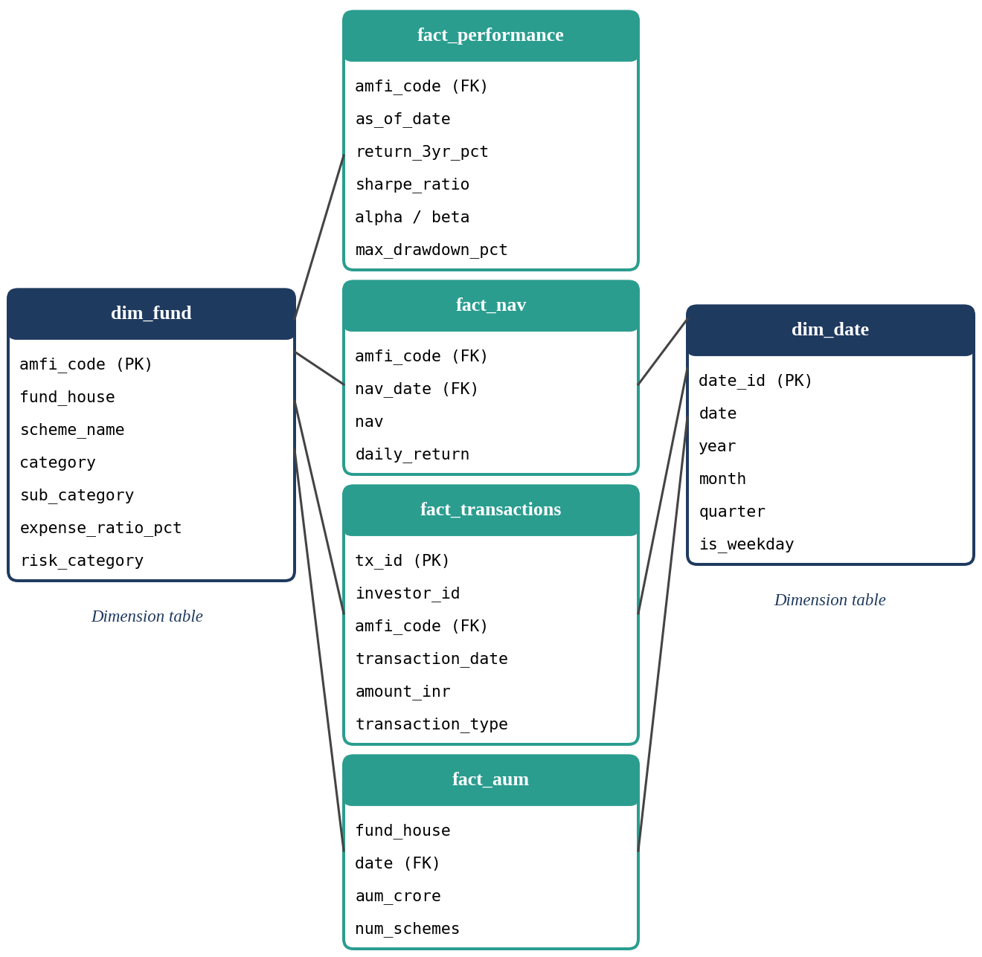
Figure 4: Star Schema of the Mutual Fund Database
Table 12: Mutual Fund Analytics Project: Stage-wise Execution
Day | Work Carried Out | Output
1 | Folder structure, dependencies, loading 10 datasets, live NAV fetch, code validation | Ingestion scripts, raw CSVs
2 | Cleaning NAV, transactions and performance data; star schema; 10 SQL queries | SQLite database, data dictionary
3 | EDA with 15+ charts on NAV, AUM, SIP, demographics, geography and sectors | EDA notebook, 10 findings
4 | Returns, CAGR, Sharpe, Sortino, Alpha, Beta, drawdown, scorecard, tracking error | Performance notebook, scorecard
5 | Four-page Power BI dashboard with slicers, drill-through and tooltips | Dashboard, PDF export
6 | VaR/CVaR, rolling Sharpe, cohort and SIP analysis, HHI, recommender | Advanced analytics notebook
7 | README, final report, 12-slide deck, GitHub push and release tag | Final report, repository

5.2 Project II: Nifty 100 Financial Intelligence Platform
The second project was a 45-day plan to build a financial intelligence system for 92 Nifty 100 companies using seven core datasets (profit and loss, balance sheet, cash flow, company master and others) and five supplementary datasets, for example sectors, peer groups and computed ratios. The platform has seven layers (Figure 5), twelve modules and over fifty KPIs. The simulated price and valuation datasets are clearly labelled so they are not mistaken for real market data.
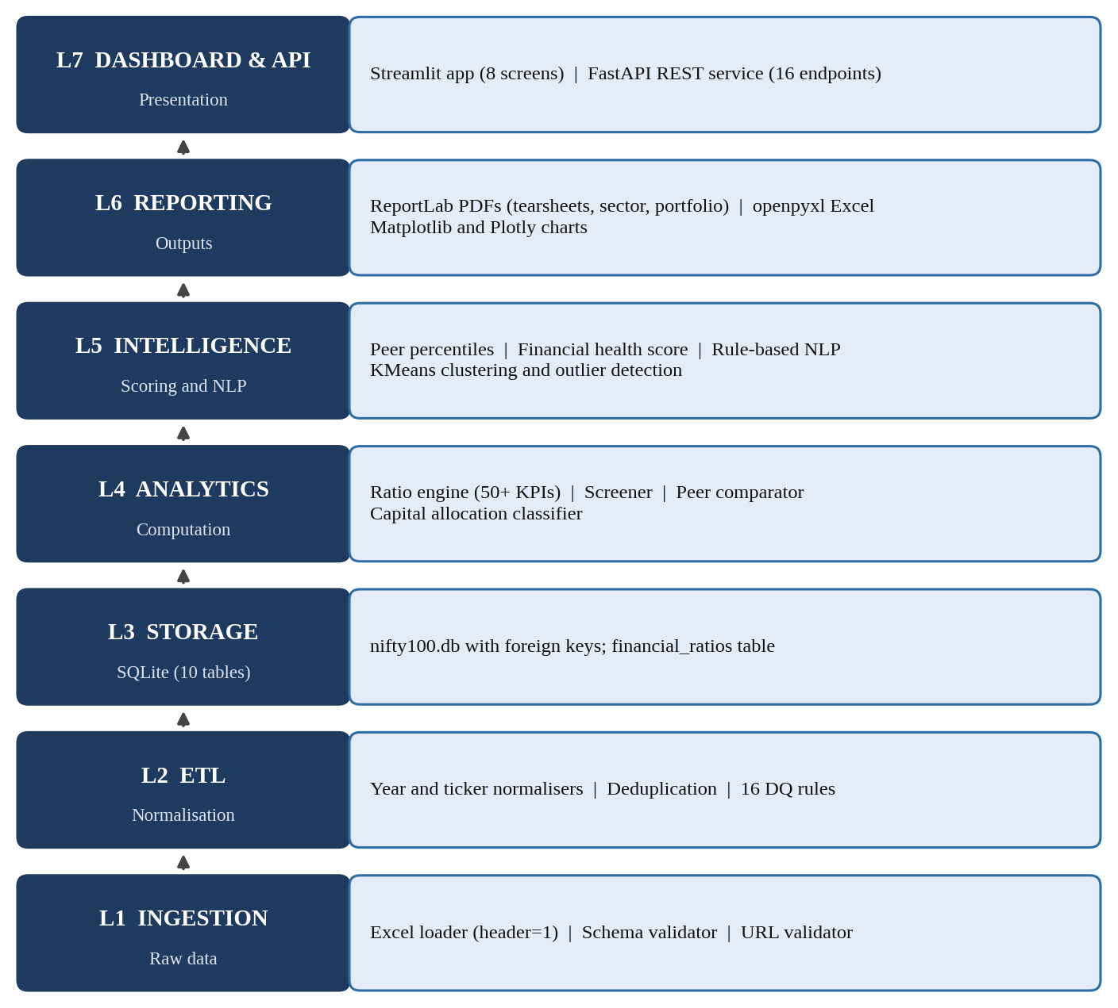
Figure 5: Nifty 100 Platform: Seven-Layer Architecture
Table 13: Nifty 100 Project: Sprint Plan
Sprint | Days | Focus | Exit Gate
1 | 1-7 | ETL and database | Zero critical data quality violations
2 | 8-14 | Ratio engine | 50+ KPIs validated against 5 companies
3 | 15-21 | Screener, scoring, peers | Six presets work; scores 0-100 for all 92
4 | 22-28 | Dashboard and valuation | Streamlit screens navigable
5 | 29-35 | NLP and PDF reports | 92 tearsheet PDFs generated
6 | 36-45 | API, clustering, QA | 16 endpoints; 60+ tests pass

The sprints applied the Chapter 4 skills. The ETL layer used an Excel loader for files with a metadata row, ticker and year normalisers, 16 validation rules and a load audit log. The ratio engine populated a financial_ratios table with the edge cases above. Six YAML-driven screener presets (Quality Compounder, Value Pick, Growth Accelerator, Dividend Champion, Debt-Free Blue Chip and Turnaround Watch) and a composite score of profitability (35%), cash quality (30%), growth (20%) and leverage (15%) supported ranking, while peer comparison used within-group percentiles and radar charts. Later sprints added NLP, KMeans clustering, a 16-endpoint FastAPI service and a pytest suite of 60+ tests against 20 acceptance gates. Table 14 lists the screener presets and Table 15 examples of the data quality rules.
Table 14: Pre-built Screener Presets
Preset | Main Filters
Quality Compounder | ROE > 15%, D/E < 1, FCF > 0, 5-year revenue CAGR > 10%
Value Pick | P/E < 20, P/B < 3, D/E < 2, dividend yield > 1%
Growth Accelerator | 5-year PAT CAGR > 20%, revenue CAGR > 15%
Dividend Champion | Dividend yield > 2%, payout < 80%, FCF > 0
Debt-Free Blue Chip | D/E = 0, ROE > 12%, revenue above Rs. 5,000 crore
Turnaround Watch | 3-year revenue CAGR > 10%, positive latest FCF

Table 15: Examples of Data Quality Rules
Rule | Condition | Severity | Action
DQ-01 | Company primary key is unique | Critical | Halt load
DQ-03 | Child-table company IDs exist in companies | Critical | Reject and log
DQ-04 | Total assets equal total liabilities within 1% | Warning | Flag row
DQ-07 | Year matches YYYY-MM after normalisation | Critical | Reject and log
DQ-13 | Annual report URL returns HTTP 200 | Warning | Log; keep row

5.3 Challenges and Resolutions
Table 16: Challenges and How They Were Handled
Challenge | Resolution
No NAV on weekends and holidays | Re-index to full date range and forward-fill
CAGR distorted by calendar days | Use trading days and 252-day annualisation
Inconsistent tickers and year labels (Mar-23, FY23) | Strip, upper-case; one normalise-year function
Negative equity, zero interest, negative base year | Return None, show 'Debt Free' or set TURNAROUND flag
Bank and NBFC leverage distorting screens | Exclude financials from D/E rule; sector benchmarks
Partial coverage in pre-computed data | Compute KPIs for all 92 companies; use source only to cross-check

5.4 Worked Example: Computing the Core Metrics
To show how the formulas of Table 7 are applied, this section works through a small example. The figures are illustrative, chosen for easy checking, and do not belong to any real scheme.
- CAGR: a scheme whose NAV rises from Rs. 50.00 to Rs. 80.50 in three years has grown by a factor of 1.61, so CAGR = 1.61^(1/3) - 1 = 17.2% a year.
- Sharpe ratio: with an annual return of 14.0%, a risk-free rate of 6.5% and annual volatility of 12.0%, Sharpe = (14.0 - 6.5) / 12.0 = 0.63.
- Sortino ratio: if the downside deviation of the same scheme is 8.0%, Sortino = (14.0 - 6.5) / 8.0 = 0.94. It is higher than the Sharpe ratio because only losses are counted as risk.
- Maximum drawdown: if the NAV peaks at Rs. 82.00 and later falls to Rs. 65.60, the drawdown is 65.60 / 82.00 - 1 = -20%.
In the project the same calculations were run in Python over the full NAV history of each scheme, using functions of the kind shown in Appendix 2, and the results were checked against hand calculations before being loaded into the database. Checking a few cases by hand was an effective way to find errors such as using calendar days instead of trading days.

5.5 Testing and Quality Assurance
Quality assurance was built into both projects instead of being left to the end. In the Mutual Fund project every AMFI code in the fund master was validated against the NAV history, duplicate and missing records were handled before loading, and each notebook ended with a short list of findings that could be traced back to a chart or query. In the Nifty 100 project every sprint ended with an exit gate (Table 13), for example zero critical data quality violations in Sprint 1 and KPI values validated against five companies in Sprint 2.
The final sprint consolidated this work into a pytest suite of more than 60 tests and 20 acceptance gates. The tests covered the ratio formulas and their edge cases, the screener presets, the scoring and the API endpoints. Computing the KPIs for all 92 companies, and using the pre-computed source data only for cross-checking, gave an independent way to find discrepancies. The outcome was a clear understanding that a result is trustworthy only when it can be reproduced, tested and explained.

5.6 Key Learnings from the Application
Applying the skills in two different projects showed me what transfers between problems. The ETL discipline of keeping raw data, cleaning in code, validating, loading and documenting was the same for fund data and company data. Edge-case handling mattered more than the formulas themselves, because real data contains holidays, negative equity, zero interest and missing years. The choice of metric depends on the audience: an investor comparing funds needs risk-adjusted returns, whereas a screener user needs filters and ranks that are easy to explain. Finally, the dashboard and the API showed me that an analysis has value only when someone else can use it, so presentation and documentation are part of the work, not an afterthought.

CHAPTER 6: COMPARISON OF COMPETENCY LEVELS AND SELF-EVALUATION

6.1 Before Training
My skills were shaped by the academic curriculum. I was comfortable with Python and understood SQL and statistics at a conceptual level, but I had limited financial-domain knowledge, little dashboard experience and mostly individual, assignment-level project work.

6.2 After Training
I can now take a business question, build a reproducible ETL pipeline, design a database, compute and interpret financial metrics and present results through dashboards and reports, while following task plans, deliverables and review criteria. Table 17 and Figure 6 compare my self-assessed proficiency before and after training.
Table 17: Competency Comparison Before and After Training
Competency | Before | After
Python / Pandas | Academic ML and data tasks | Structured ingestion, cleaning, ETL, analytics
SQL / Database | Queries and concepts | Schema design, loading, analytical queries
EDA and visualisation | Basic charts | Multi-dataset EDA with financial dimensions
Financial analytics | Limited domain knowledge | CAGR, Sharpe, Sortino, Alpha, Beta, VaR, CVaR
Dashboarding | Limited exposure | Multi-page BI, slicers, drill-through
Data quality | Assignment-level checks | Validation rules, edge cases, reproducibility
Git / documentation | Basic repository use | Structured commits, README, deliverables
Professional workflow | Individual academic work | Tasks, deadlines, sprints, review criteria

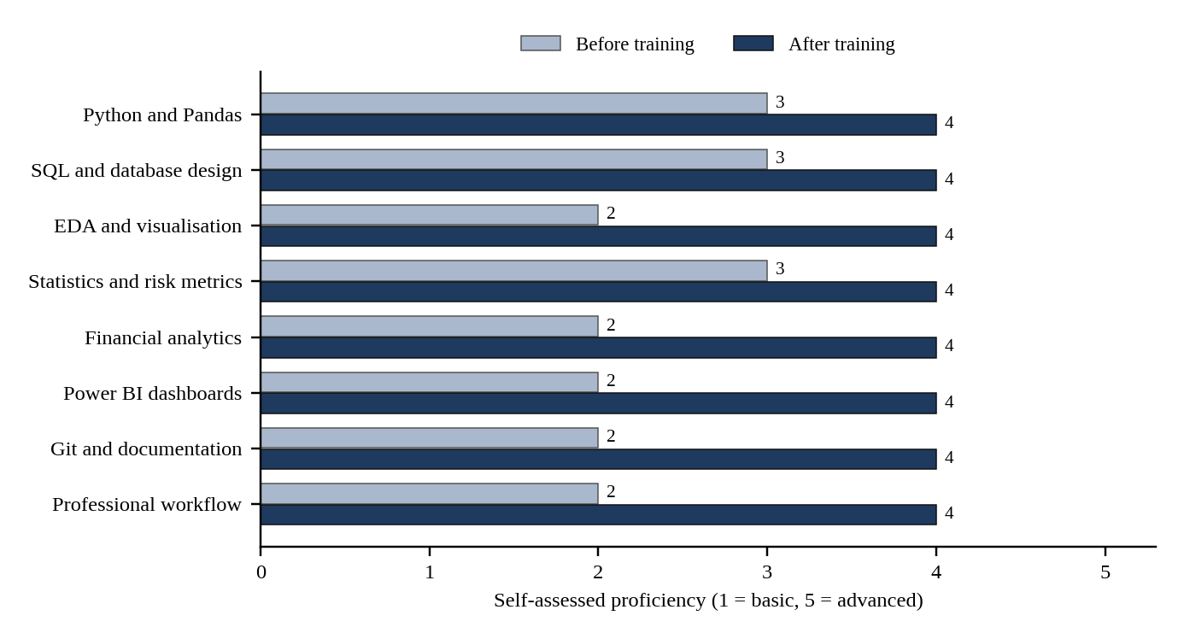
Figure 6: Competency Development During the Internship

6.3 Growth Areas
Technical growth. The biggest change was seeing analytics as a pipeline rather than a single notebook: separating raw and processed data, building database structures, validating inputs, computing metrics and presenting results. Analytical and domain growth. I now understand the difference between return and risk, the role of benchmarks, the meaning of drawdown and why units, periods, missing values and formula definitions matter. Professional growth. Defined deliverables and acceptance criteria taught me to think about quality, not only about finishing code, and showed how analysts work alongside data engineering, dashboard, reporting and QA roles.

6.4 Self-Evaluation
My strengths are willingness to learn, adaptability to unfamiliar tools, persistence in debugging and interest in analytical problem solving. I need to improve in advanced SQL optimisation, deeper financial-domain knowledge, statistical modelling, expert-level dashboard design, API development and production deployment. My plan is to continue with advanced SQL, statistics, machine learning for finance, cloud data tools and a BI certification.

6.5 Application of Learning and Future Learning Plan
The skills gained in the internship apply directly to roles in data analytics, business intelligence and financial technology, and they also support my AI and ML specialisation: clean, validated data and well-designed features are the foundation of any machine learning model, and the pipeline, testing and documentation habits carry over to ML projects. To keep improving, I have planned the learning steps listed in Table 18.
Table 18: Future Learning Plan
Area | Planned Step | Purpose
Advanced SQL | Window functions, query optimisation, indexing | Faster, cleaner analytical queries
Statistics | Hypothesis testing, regression and time-series modelling | Stronger interpretation of financial data
Machine learning for finance | Forecasting, classification and clustering on financial datasets | Combine the AI and ML specialisation with domain knowledge
Cloud data tools | Cloud storage, warehouses and scheduled pipelines | Move from local to production-style pipelines
BI certification | Professional certification in Power BI | Validate and deepen dashboard skills
API and deployment | Packaging and deploying FastAPI services | Production deployment skills

6.6 Conclusion
The internship connected academic learning with industry practice. Working through a focused end-to-end capstone and a broader modular intelligence system gave me both technical skills and a professional approach to data quality, documentation, validation and communication. I am grateful to Bluestock Fintech for this opportunity.

Appendix 1: Internship Offer Letter
Offer letter issued by Bluestock Fintech on 20 July 2026 (ID: BFDA111177) for the position of Data Analyst Intern, 24 July 2026 to 24 September 2026 (part-time, unpaid, remote).
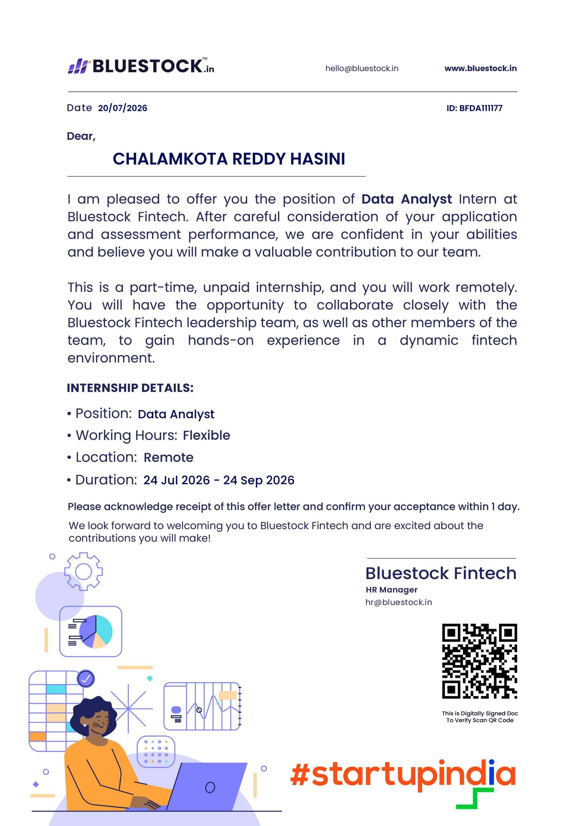

Appendix 2: Sample Technical Workflow (Python)
Representative implementations of the metric formulas and ETL helpers described in Chapters 4 and 5, checked against the examples in the project specification (CAGR of about 10.0% for 100 to 161 over five years; TURNAROUND flag for a negative base year).
import re
import numpy as np
import pandas as pd
from scipy import stats

TRADING_DAYS, RISK_FREE = 252, 0.065

def cagr(nav_start, nav_end, years):
return (nav_end / nav_start) ** (1 / years) - 1

def sharpe(r, rf=RISK_FREE):
return (r.mean() * TRADING_DAYS - rf) / (r.std() * np.sqrt(TRADING_DAYS))

def sortino(r, rf=RISK_FREE):
downside = r[r < 0].std() * np.sqrt(TRADING_DAYS)
return (r.mean() * TRADING_DAYS - rf) / downside

def alpha_beta(fund, bench):
res = stats.linregress(bench, fund)
return res.intercept * TRADING_DAYS, res.slope

def max_drawdown(nav):
return (nav / nav.cummax() - 1).min()

def var_cvar(r, level=5):
var = np.percentile(r, level)
return var, r[r <= var].mean()

def normalize_year(label):
"""Mar-23 / FY23 / 2023 -> 2023-03 ; unparseable -> PARSE_ERROR."""
s = str(label).strip()
if re.fullmatch(r"\d{4}-\d{2}", s):
return s
m = re.fullmatch(r"([A-Za-z]{3})[a-z]*[- ]?(\d{2,4})", s)
if m:
yr = int(m.group(2)); yr += 2000 if yr < 100 else 0
return f"{yr}-{pd.to_datetime(m.group(1), format='%b').month:02d}"
m = re.fullmatch(r"(?:FY)?(\d{2,4})", s, flags=re.I)
if m:
yr = int(m.group(1)); yr += 2000 if yr < 100 else 0
return f"{yr}-03"
return "PARSE_ERROR"

def cagr_with_flag(base, end, n):
if n < 3: return None, "INSUFFICIENT"
if base == 0: return None, "ZERO_BASE"
if base < 0 and end > 0: return None, "TURNAROUND"
if base < 0 and end < 0: return None, "BOTH_NEGATIVE"
if base > 0 and end < 0: return None, "DECLINE_TO_LOSS"
return ((end / base) ** (1 / n) - 1) * 100, ""

Appendix 3: Sample SQL Queries
The queries below are representative of the analytical SQL written in the Mutual Fund project. Table and column names are simplified for illustration.
-- 1. Fund houses ranked by latest AUM
SELECT fund_house, aum_cr
FROM fact_aum
WHERE quarter = (SELECT MAX(quarter) FROM fact_aum)
ORDER BY aum_cr DESC LIMIT 10;

-- 2. Monthly average NAV of one scheme
SELECT strftime('%Y-%m', d.date) AS month, ROUND(AVG(n.nav), 2) AS avg_nav
FROM fact_nav n JOIN dim_date d ON n.date_id = d.date_id
WHERE n.amfi_code = 125497
GROUP BY month ORDER BY month;

-- 3. Year-on-year growth in SIP inflow
WITH yearly AS (
SELECT strftime('%Y', month) AS yr, SUM(sip_inflow_cr) AS inflow
FROM fact_sip GROUP BY yr)
SELECT yr, inflow,
ROUND((inflow - LAG(inflow) OVER (ORDER BY yr)) * 100.0
/ LAG(inflow) OVER (ORDER BY yr), 2) AS yoy_pct
FROM yearly;

-- 4. Transactions by investor state
SELECT i.state, COUNT(*) AS n_txn, SUM(t.amount) AS total_amount
FROM fact_transactions t JOIN dim_investor i ON t.investor_id = i.investor_id
GROUP BY i.state ORDER BY n_txn DESC;

REFERENCES
[1] Bluestock Fintech, Capstone Project: Mutual Fund Analytics Platform, Project Brief, June 2026.
[2] Data Analytics Division, Nifty 100 Financial Intelligence Platform: Project Execution Plan, v1.0, June 2026.
[3] Association of Mutual Funds in India (AMFI), https://www.amfiindia.com; mfapi.in, https://www.mfapi.in.
[4] National Stock Exchange of India, https://www.nseindia.com; BSE India, https://www.bseindia.com.
[5] Official documentation of Python, Pandas, NumPy, SciPy, SQLAlchemy, Streamlit, FastAPI and pytest.

