2. Problem: Check if a Number is Even or Odd

   - Write a program to check if a number is even or odd. An even number is divisible by 2, while an odd number is not.

Output: 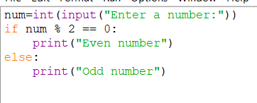

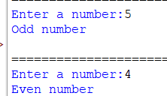

4. Problem: Check if a Year is a Leap Year

   - A year is a leap year if:

     - It is divisible by 4, but not divisible by 100, or

     - It is divisible by 400.

   - Write a program that checks if a given year is a leap year.

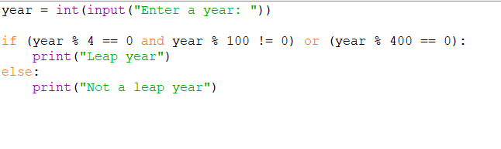

Output:

Enter a year: 2020

Leap year

Enter a year: 2021

Not a leap year

Problem: Check if a Number is Divisible by Both 3 and 5

   - Write a program that checks if a number is divisible by both 3 and 5. If it is, print "Divisible by 3 and 5", otherwise print "Not divisible by 3 and 5".

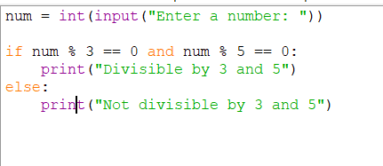

Output:

Enter a number: 10

Not divisible by 3 and 5

Enter a number: 15

Divisible by 3 and 5

 8. Problem: Check if a Person is Eligible to Vote

   - Write a program that checks if a person is eligible to vote. The eligibility condition is that the person's age should be 18 or older.

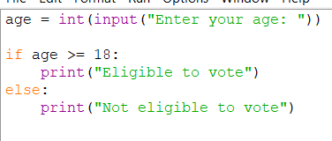

Output:

Enter your age: 19

Eligible to vote

Enter your age: 16

Not eligible to vote

 9. Problem: Check if a Number is a Multiple of 10

   - Write a program to check if a given number is a multiple of 10.

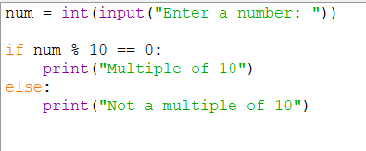

Output:

Enter a number: 10

Multiple of 10

Enter a number: 5

Not a multiple of 10

10. Problem: Compare Two Numbers and Print the Smaller One

   - Write a program to compare two numbers and print the smaller one.

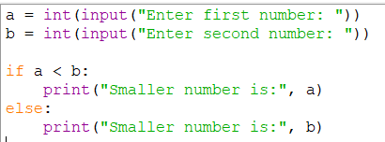

Output:

Enter first number: 10

Enter second number: 5

Smaller number is: 5