CREATE OR REPLACE FUNCTION factorial(

num INT

)

RETURN INT

IS

fact_ INT := 1;

BEGIN

FOR i IN 1..num LOOP

fact_ := fact_ * i;

END LOOP;

RETURN fact_;

END; 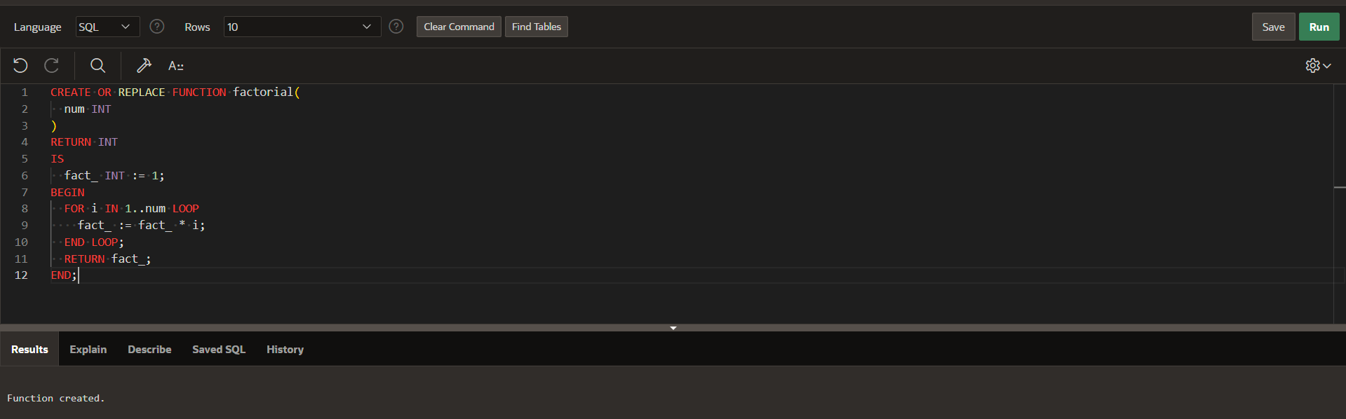Select factorial(10) from dual;

