Large Scale NLP Text Analytics Platform
A Project Based Learning Report Submitted in partial fulfilment of the requirements for the award of the degree

of

Bachelor of Technology
in The Department of Computer Science and Engineering
DATA STRUCTURES AND ALGORITHMS - 3
(25CS2103E)

Submitted by
2510030332 : Lakshith
2510030322 : Rahul
2510030337 : Ranadeep
2510030426 : Varshith
2510030430 : Jivith

Under the guidance of
MR. AFTAB YASEEN


Department of Computer Science and Engineering
Koneru Lakshmaiah Education Foundation, Aziz Nagar
Aziz Nagar – 500075
OCT - 2026
Abstract
Text is the most common kind of data that modern systems have to store, search and summarise, yet the algorithms that handle it are usually taught one at a time, with a few lines of pseudo-code and a table of asymptotic bounds. This project builds a web-based Algorithm Laboratory in which twelve text-processing algorithms can be run, watched and measured on exactly the same input. The algorithms belong to four groups: single-pattern string matching (naive search, Knuth–Morris–Pratt, Rabin–Karp and Boyer–Moore), multi-pattern matching (Aho–Corasick), text indexing structures (trie, suffix array and Kasai's LCP construction) and text analytics (edit distance, TF-IDF, inverted index and text similarity).
A Python backend exposes every algorithm through a REST interface, and a browser front end organises the work into nine workspaces: dashboard, algorithm lab, visualizer, benchmark lab, dataset lab, experiments, learning lab, challenges and research. The benchmark lab generates seeded workloads so that any experiment can be repeated exactly, times each algorithm over several repetitions, and shows measured values beside theoretical complexity without ever declaring a winner. This report explains the architecture, the measurement pipeline, the working of the main algorithms, the experimental set-up and the output screens of the running system.
The measurements collected from the dashboard show that throughput depends heavily on the task an algorithm performs, so a single number cannot rank algorithms from different categories; a fair reading needs the workload, the input size and the pattern length alongside it. The laboratory is meant as a teaching and analysis aid, and its design leaves room for larger corpora, more algorithms and distributed execution.
Keywords: string matching, Knuth–Morris–Pratt, Aho–Corasick, suffix array, TF-IDF, benchmarking, algorithm visualization, REST API, Flask.
List of Figures
Figure 1: Layered architecture of the Algorithm Laboratory: browser interface, Flask REST API, core engine and data layer. 8
Figure 2: Workspace map of the laboratory: nine modules around a common core. 9
Figure 3: Taxonomy of the twelve algorithms in four categories. 10
Figure 4: Prefix (LPS) table of the pattern ABABCABAB as computed for the KMP walk-through. 11
Figure 5: Aho–Corasick goto trie and failure table for the patterns he, she, his and hers. 12
Figure 6: Schematic growth of linear, n log n and quadratic work as the input size increases. 13
Figure 7: Measurement pipeline of the Benchmark Lab from algorithm selection to charts. 14
Figure 8: The four modes of the Benchmark Lab and the inputs they share. 14
Figure 9: Sequence of messages for a single benchmark request. 16
Figure 10: Dashboard of the Algorithm Laboratory: summary cards, laboratory modules, algorithm categories and performance overview. 17
Figure 11: Benchmark Lab, Algorithm Battle tab: algorithm selection and generated-workload settings. 18
Figure 12: Benchmark Lab, Input-size Scaling tab: five input sizes and three selected algorithms. 18
Figure 13: Performance overview chart: average measured throughput from recent battle runs. 19
List of Tables
Table 1: Functional (FR) and non-functional (NFR) requirements of the laboratory. 7
Table 2: Technology stack of the laboratory. 8
Table 3: Laboratory modules and their purpose. 9
Table 4: Logical operations exchanged between the browser and the server. 10
Table 5: Algorithm catalogue with the core idea of each method. 11
Table 6: Standard time and space bounds of the string algorithms. 13
Table 7: Parameters used in the battle and scaling experiments. 16
Table 8: Approximate average throughput read from the performance overview chart. 19
Table 9: Summary of observations from the output screens. 20
Table of Contents
1. Introduction 6
a. Background and motivation 6
b. Problem statement 6
c. Objectives 6
d. Scope and organisation of this report 7
2. Methodology 7
a. Requirements analysis 7
b. Overall architecture 7
c. Module design 8
d. Front-end and back-end interface 9
e. Algorithm catalogue 10
f. Working principle of the main algorithms 11
g. Complexity of the algorithms 13
h. Design of the benchmark engine 13
i. Dataset and experiment management 14
3. System Working 15
a. Dashboard 15
b. Algorithm lab and visualizer 15
c. Benchmark lab 15
d. Dataset lab, experiments and learning lab 15
e. Life cycle of a request 15
4. Experiments 16
a. Set-up 16
b. Procedure 16
c. Threats to validity 17
5. Results 17
a. Dashboard output 17
b. Benchmark configuration screens 17
c. Performance overview 18
d. Discussion 19
6. Conclusion and Future Work 20
References 20
Large Scale NLP Text Analytics Platform

Introduction

Background and motivation
Almost everything a computer system keeps for people to read is text: web pages, log files, source code, product reviews, e-mails, even genome sequences written out as letters. Searching, indexing and comparing that text are therefore among the oldest and most frequently repeated jobs in computing. The search box on a shopping site, the find command in an editor, a plagiarism checker and a spam filter all come down, somewhere underneath, to a small family of classic algorithms that scan strings, build indexes over them or measure how far apart two of them are. Each of these algorithms has a tidy textbook description. What the textbook rarely shows is how it behaves when the input stops being a short example and becomes two hundred thousand characters, or half a million.
That gap is what motivated this project. In class we met Knuth–Morris–Pratt, Rabin–Karp and Boyer–Moore as three different answers to the same question, and our notes gave the worst-case bound of each. A bound, however, is not a measurement. Whether the skipping trick in Boyer–Moore really pays off on a random 26-letter alphabet, how much extra work a hash-based matcher does once the cost of computing hashes is counted, and at what size a quadratic algorithm becomes unusable are questions that only running code can answer. Doing that by hand for twelve algorithms, with identical inputs and repeatable settings, is tedious enough that most students never try it.

Problem statement
We wanted a single environment in which a learner or an analyst can pick any text algorithm, feed it any text and see both what it produced and how long it took. Three requirements shaped the design. The first is uniform treatment: every algorithm must accept the same kind of input and return its result in a comparable form. The second is visibility: it should be possible to look inside an algorithm, for example at the prefix table of KMP or the automaton of Aho–Corasick, instead of only reading the final answer. The third is honest measurement: every number on screen has to come from a real execution at request time, must be repeatable through a fixed random seed, and must not be presented as a verdict on which algorithm is best.
The work was carried out for the course Data Structures and Algorithms-3 (25CS2103E), and it also serves as an exercise in backend design. The system is built around stateless REST endpoints, persistent stores for datasets, experiments and run history, and a front end that holds no algorithmic logic of its own.

Objectives
- Provide twelve text-processing algorithms, grouped into four categories, behind one common calling convention.
- Let the user step through the internal states of each algorithm: comparisons, longest-prefix-suffix tables, automata and dynamic-programming tables.
- Generate reproducible synthetic workloads, and also accept custom text and uploaded TXT or CSV datasets.
- Offer four benchmarking modes (battle, input-size scaling, stress testing and recommendation) built on measured data.
- Store datasets, saved experiments and benchmark runs so that results can be repeated, compared and exported.

Scope and organisation of this report
The laboratory concentrates on running time and throughput of in-memory text processing on a single server. Distributed execution, disk-resident corpora and memory profiling are outside the present scope and are listed under future work. The rest of the report is organised as follows. Section 2 describes the methodology, covering the architecture, the algorithm catalogue, the working principle of the main algorithms and the design of the benchmark engine. Section 3 walks through the working of the system from the user's side. Section 4 states the experimental set-up, Section 5 presents the outputs captured from the running website and discusses them, and Section 6 concludes with limitations and directions for further work.

Methodology

Requirements analysis
Before any code was written we listed what the laboratory has to do and how it has to behave. The functional requirements follow from the three problems described above: running, seeing and measuring. The non-functional ones are about trust. If a learner is going to rely on a number from the benchmark lab, the number has to be repeatable, it has to be measured rather than quoted, and the tool must not freeze when someone asks for an unreasonable input size. Table 1 lists the requirements and the module that satisfies each one.
Table 1: Functional (FR) and non-functional (NFR) requirements of the laboratory.
ID | Requirement | Realised by
FR1 | Run any of the twelve algorithms on user-supplied text | Algorithm Lab
FR2 | Expose internal states (comparisons, LPS table, automaton, DP table) | Visualizer
FR3 | Compare several algorithms on one identical input | Benchmark Lab: Algorithm Battle
FR4 | Show how running time grows with input size | Benchmark Lab: Input-size Scaling
FR5 | Upload, generate, preprocess and version text corpora | Dataset Lab
FR6 | Save, repeat, compare and export experiments | Experiments
NFR1 | Repeatability: the same settings must give the same data | Seeded workload generator
NFR2 | Honest reporting: measured at request time, complexity shown separately, no winner declared | Benchmark engine and interface text
NFR3 | Safety: oversized inputs must not stall the server | Per-algorithm benchmark limits

Overall architecture
The system follows a four-layer design, shown in Figure 1. At the top is the presentation layer, a single web interface that runs in the browser and is split into nine workspaces. It never executes an algorithm itself; it collects the user's choices, sends them to the server and draws whatever comes back. The application layer is a REST API written in Python with the Flask framework [11]. It validates each request, hands it to the right controller and serialises the outcome as JSON. Below it sits the core engine, which holds the algorithm library, the seeded workload generator, the benchmark engine and the step tracer used by the visualizer. The bottom layer is persistence: versioned datasets, saved experiment configurations and the history of benchmark runs.
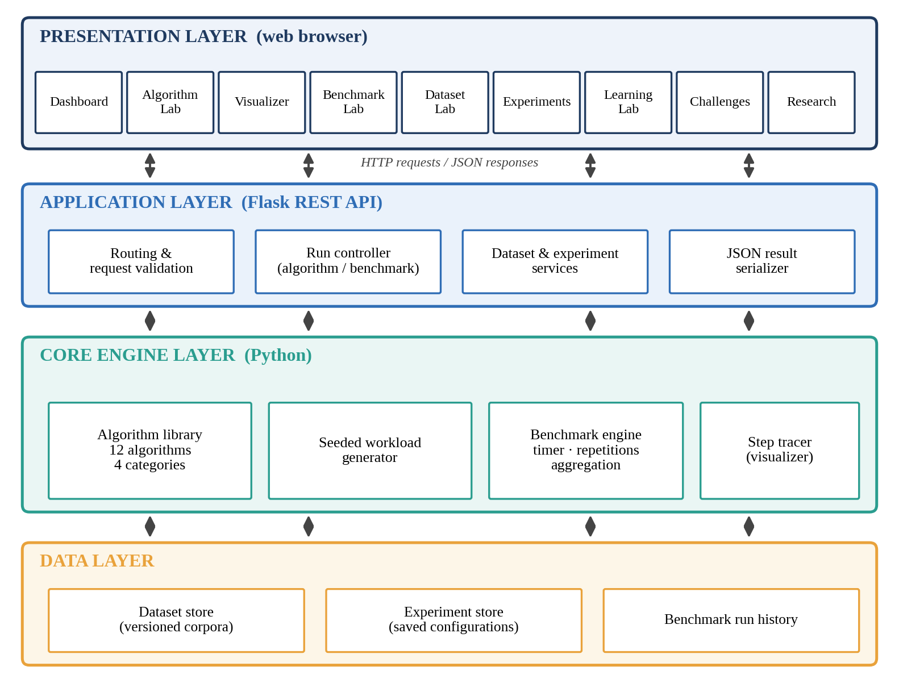
Figure 1: Layered architecture of the Algorithm Laboratory: browser interface, Flask REST API, core engine and data layer.
Keeping the layers apart has a practical benefit. The same engine functions serve the algorithm lab, the visualizer and the benchmark lab, so an algorithm is written once and measured, traced and explained through one code path. A small status indicator in the page header ("API online") reports whether the front end can currently reach the backend, which makes start-up problems easy to spot during development. Table 2 lists the technologies used in each layer.
Table 2: Technology stack of the laboratory.
Layer | Technology | Responsibility
Presentation | Web browser (HTML, CSS, JavaScript) | Forms, tabs, charts and step-by-step viewers; no algorithm logic
Application | Python 3 with Flask | Routing, input validation, orchestration of runs, JSON responses
Core engine | Pure Python modules | Twelve algorithms, seeded workload generation, timing and aggregation
Data | Persistent stores | Versioned corpora, saved experiments, benchmark run records
Development | Visual Studio Code, local server (localhost) | Editing, running and testing the application

Module design
The interface is divided into the nine workspaces visible in the sidebar, drawn as a map in Figure 2. Each one answers a different question a user might have, and Table 3 summarises their roles. The dashboard gives the overview; the algorithm lab runs a single algorithm; the visualizer opens it up; the benchmark lab compares algorithms; the dataset lab supplies inputs; experiments make results repeatable; the learning lab explains; and the challenges and research workspaces extend the laboratory beyond the core tools into practice and study.
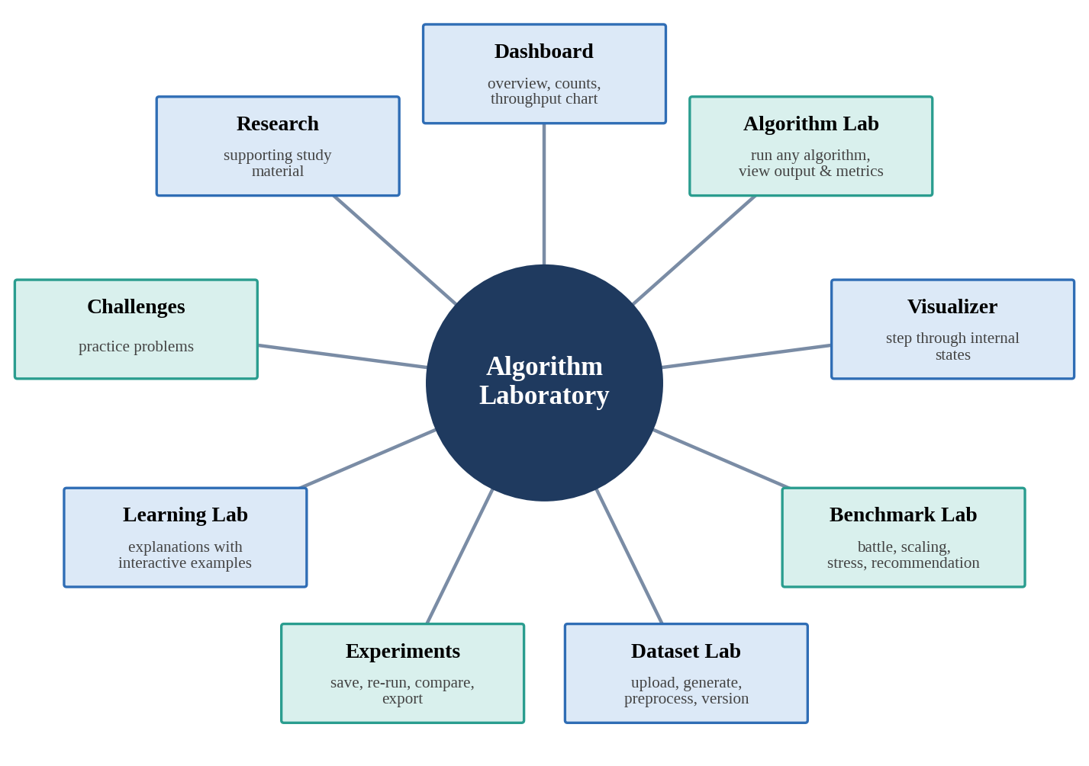
Figure 2: Workspace map of the laboratory: nine modules around a common core.
Table 3: Laboratory modules and their purpose.
Module | Purpose
Dashboard | Summary of algorithms, datasets, benchmark runs and saved experiments, with a throughput overview
Algorithm Lab | Execute any algorithm on user text and inspect its output, metrics and complexity
Visualizer | Step through internal states: comparisons, LPS tables, automata and DP tables
Benchmark Lab | Battles, input-size scaling, stress tests and recommendations on measured data
Dataset Lab | Upload TXT/CSV files, generate synthetic corpora, preprocess and version them
Experiments | Save, re-run, duplicate, compare and export reproducible configurations
Learning Lab | Explanations with interactive examples for each algorithm
Challenges | Exercises that apply the algorithms to concrete problems
Research | Reference material for studying the algorithms in more depth

Front-end and back-end interface
Because the browser holds no algorithmic logic, everything it needs is requested from the server as a small number of logical operations, summarised in Table 4. Each request is self-contained: it carries every setting the server needs, including the seed, so the server does not have to remember anything about the previous call. This statelessness is what lets the same endpoints be called from the browser, from a script or from a test, and it is the property that would allow several server instances to run behind a load balancer in a later version.
Table 4: Logical operations exchanged between the browser and the server.
Operation | Request carries | Response carries
Run algorithm | Algorithm, text, pattern or dictionary | Output, metrics, theoretical complexity
Step trace | Algorithm, text, pattern | Ordered list of internal states for the visualizer
Run battle | Algorithms, input source, size, pattern length and count, seed, repetitions | Timings, throughput and match counts per algorithm, plus the settings used
Run scaling test | As above, with a list of input sizes | Timings per algorithm and size; sizes skipped because of benchmark limits
Manage datasets | Uploaded file or generator settings, preprocessing options | Dataset record with version number
Save / re-run experiment | Complete configuration | Experiment record, or a fresh run of it

Algorithm catalogue
Twelve algorithms were chosen so that together they cover the main ways text is processed. They are arranged in four categories (Figure 3). String matching asks where one pattern occurs in a text. Multi-pattern matching asks the same question for a whole dictionary at once. Text structures build an index over the text so that later queries become cheap. Text analytics goes one step higher and measures similarity or importance. Table 5 gives the task and core idea of each algorithm.
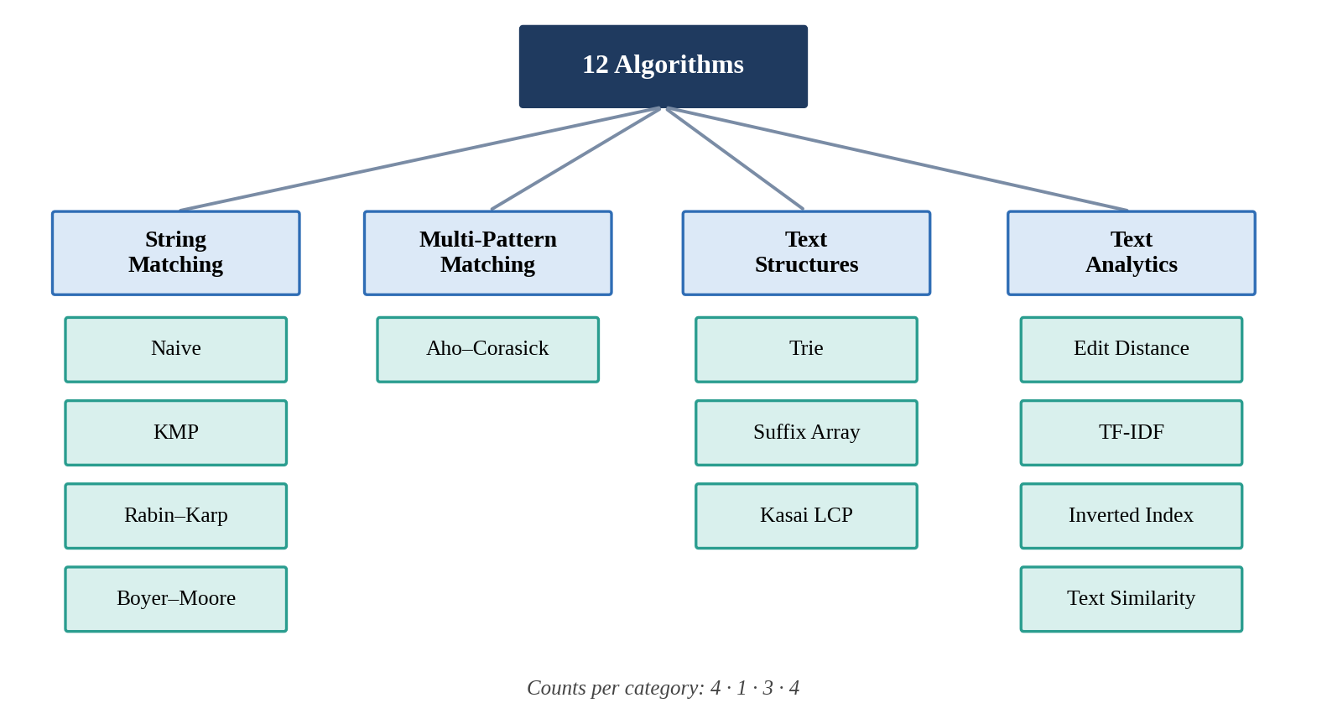
Figure 3: Taxonomy of the twelve algorithms in four categories.
Table 5: Algorithm catalogue with the core idea of each method.
Category | Algorithm | Core idea
String matching | Naive | Slide the pattern one position at a time and compare character by character
 | Knuth–Morris–Pratt | Precompute a prefix table so the text pointer never moves backwards
 | Rabin–Karp | Compare rolling hashes of text windows, verify only on a hash match
 | Boyer–Moore | Compare from the pattern's right end and skip ahead using mismatch rules
Multi-pattern | Aho–Corasick | Merge all patterns into a trie with failure links and scan the text once
Text structures | Trie | Share common prefixes in a tree for fast insertion and lookup
 | Suffix Array | Sorted list of all suffix start positions, searched by binary search
 | Kasai LCP Array | Compute longest-common-prefix values of neighbouring suffixes in linear time
Text analytics | Edit Distance | Dynamic programming count of insertions, deletions and substitutions
 | TF-IDF | Weight a term by its frequency in a document and its rarity across documents
 | Inverted Index | Map every term to the documents (and positions) in which it occurs
 | Text Similarity | Score how close two texts are from their term vectors

Working principle of the main algorithms
Naive matching is the baseline. For every starting position in a text of length n it compares up to m characters of the pattern, giving O(nm) work in the worst case. It needs no preparation and its behaviour is easy to follow, which is why it is the reference against which the others are judged.
Knuth–Morris–Pratt removes the repeated comparisons. Before searching, it computes for every prefix of the pattern the length of the longest proper prefix that is also a suffix; this is the LPS table, shown in Figure 4 for the pattern ABABCABAB. When a mismatch occurs after j matched characters, the pattern is shifted so that its first LPS[j−1] characters line up with text already known to match. The text pointer therefore only moves forward, and the search finishes in O(n) after O(m) preparation [1].
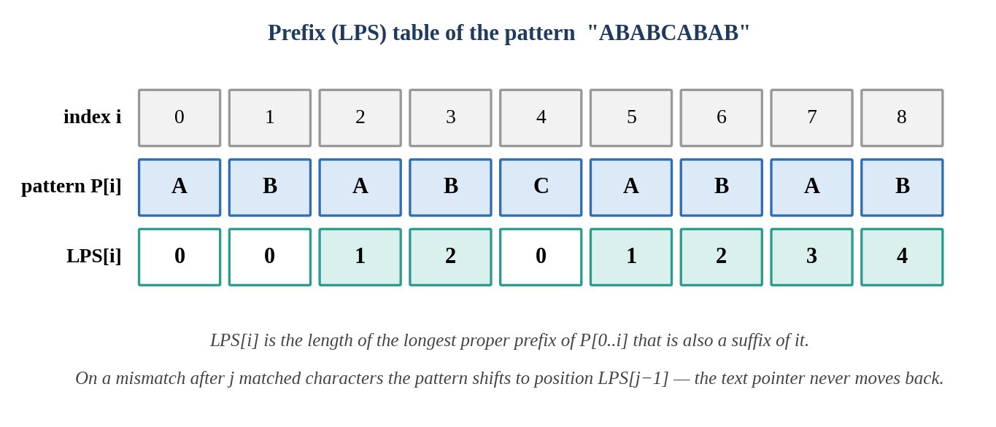
Figure 4: Prefix (LPS) table of the pattern ABABCABAB as computed for the KMP walk-through.
Rabin–Karp replaces character comparisons by comparisons of numbers. A polynomial hash of the pattern is computed once, and the hash of each text window is obtained from the previous window in constant time by removing the outgoing character and adding the incoming one. Only windows whose hash equals the pattern's are checked character by character, so the expected cost is linear, although a long run of hash collisions can push it back towards O(nm) [2]. The method also extends naturally to several patterns of equal length.
Boyer–Moore reads the pattern from right to left and, on a mismatch, uses what it has learned to jump forward by more than one position. The bad-character rule aligns the mismatching text character with its last occurrence in the pattern, and the good-suffix rule reuses a matched tail. On large alphabets and longer patterns the jumps can be long enough that fewer than n characters are examined at all, which is why it is the usual choice in text editors [3]. The benefit shrinks when the alphabet is small or the pattern very short, a point we return to in the results.
Aho–Corasick generalises KMP to a dictionary of patterns. All patterns are inserted into a trie; a breadth-first pass then adds a failure link to every state, pointing to the longest proper suffix of that state's string that is also a prefix of some pattern. The text is scanned once, following goto transitions when possible and failure links otherwise, and every state reached reports the patterns that end there [4]. Figure 5 shows the automaton for the classic dictionary {he, she, his, hers}; its failure table was produced by running our own construction code rather than copied from a reference, and matches the hand derivation.
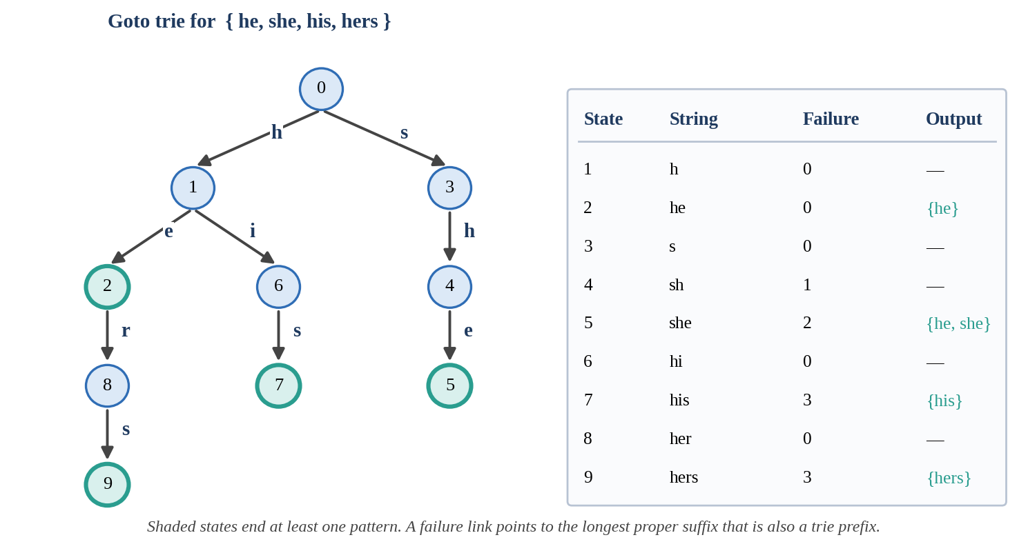
Figure 5: Aho–Corasick goto trie and failure table for the patterns he, she, his and hers.
Trie, suffix array and Kasai's algorithm form the indexing group. A trie stores words along tree paths so that a lookup costs time proportional to the word's length, not to the number of words stored. A suffix array lists the starting positions of all suffixes of a text in sorted order; any substring query then becomes a binary search over this list, costing O(m log n) [5]. Kasai's algorithm builds the longest-common-prefix array that accompanies a suffix array in linear time by exploiting the fact that the value for the next suffix in text order is at most one smaller than the value for the current suffix [6].
Text analytics begins with edit distance, the minimum number of single-character insertions, deletions and substitutions that turn one string into another [7]. With D[i][j] holding the distance between the first i characters of one string and the first j of the other, the table is filled using
D[i][j] = min( D[i−1][j] + 1, D[i][j−1] + 1, D[i−1][j−1] + c(i, j) )
where c(i, j) is 0 when the two characters are equal and 1 otherwise. TF-IDF weights a term t in document d as tf(t, d) × log(N / df(t)), so that words that are frequent in one document but rare in the collection stand out [8]. An inverted index records, for each term, the documents that contain it, turning a keyword query into a lookup and a merge of short lists. Text similarity then compares two documents through their term vectors, for example by the cosine of the angle between them [9].

Complexity of the algorithms
The laboratory shows theoretical complexity next to measured results but keeps the two separate, because they answer different questions. Table 6 collects the standard bounds [10], where n is the text length, m the pattern length, σ the alphabet size, M the total length of all patterns and z the number of reported matches. Figure 6 sketches how the main growth rates diverge as the input grows; it is a schematic of the functions themselves, not a measurement.
Table 6: Standard time and space bounds of the string algorithms.
Algorithm | Preparation | Search / build | Extra space
Naive | none | O(nm) worst case | O(1)
Knuth–Morris–Pratt | O(m) | O(n) | O(m)
Rabin–Karp | O(m) | O(n + m) expected, O(nm) worst | O(1)
Boyer–Moore | O(m + σ) | about O(n/m) best, O(nm) worst | O(m + σ)
Aho–Corasick | O(M) | O(n + z) | O(M·σ) with full table
Trie | O(L) per word of length L | O(L) per lookup | O(total characters)
Suffix array | O(n log n) with prefix doubling | O(m log n) per query | O(n)
Kasai LCP | needs suffix array | O(n) | O(n)
Edit distance | none | O(nm) | O(nm), or O(min(n, m)) with two rows

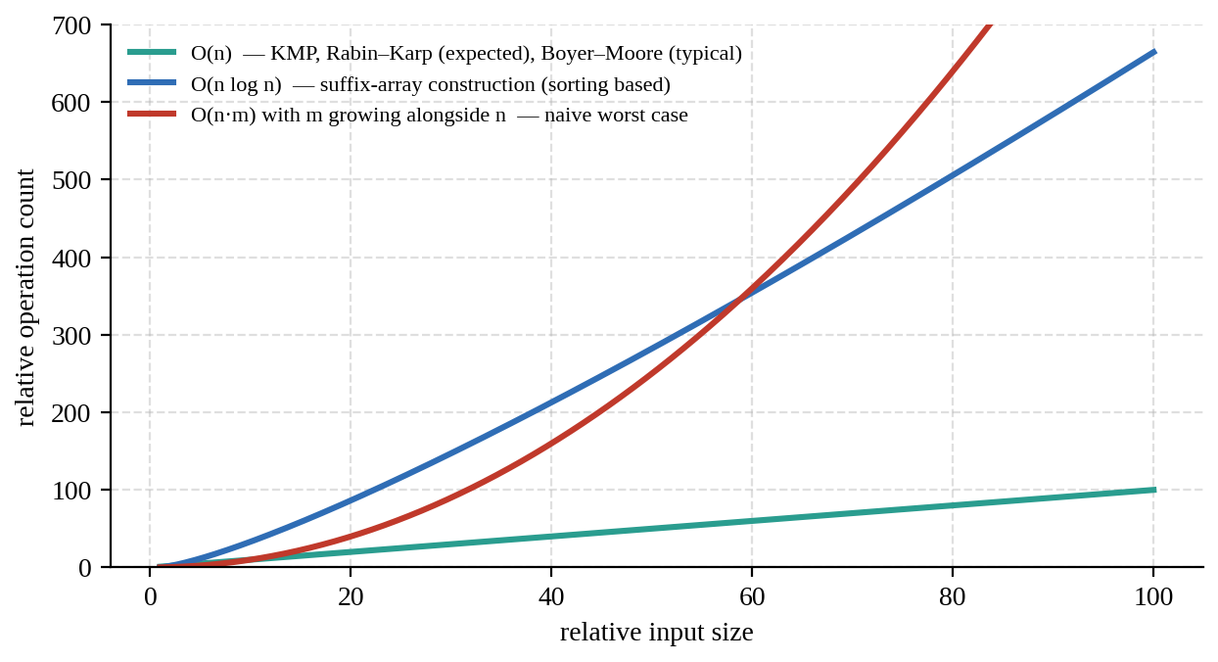
Figure 6: Schematic growth of linear, n log n and quadratic work as the input size increases.

Design of the benchmark engine
The benchmark lab is where the project departs most from a plain demonstration tool. Its pipeline, drawn in Figure 7, starts with the selection of algorithms and an input source: a generated workload, custom text typed by the user, or a stored dataset. The workload generator builds text and patterns from a workload type (for example random letters), a size in characters, a pattern length, a pattern count and a seed. Because the generator is seeded, the same settings always produce the same data, which is what makes two runs comparable and an experiment repeatable. All chosen algorithms receive the same input, adapted to the fields each one requires; a single-pattern matcher, for instance, is given the patterns one by one, while Aho–Corasick receives them together.
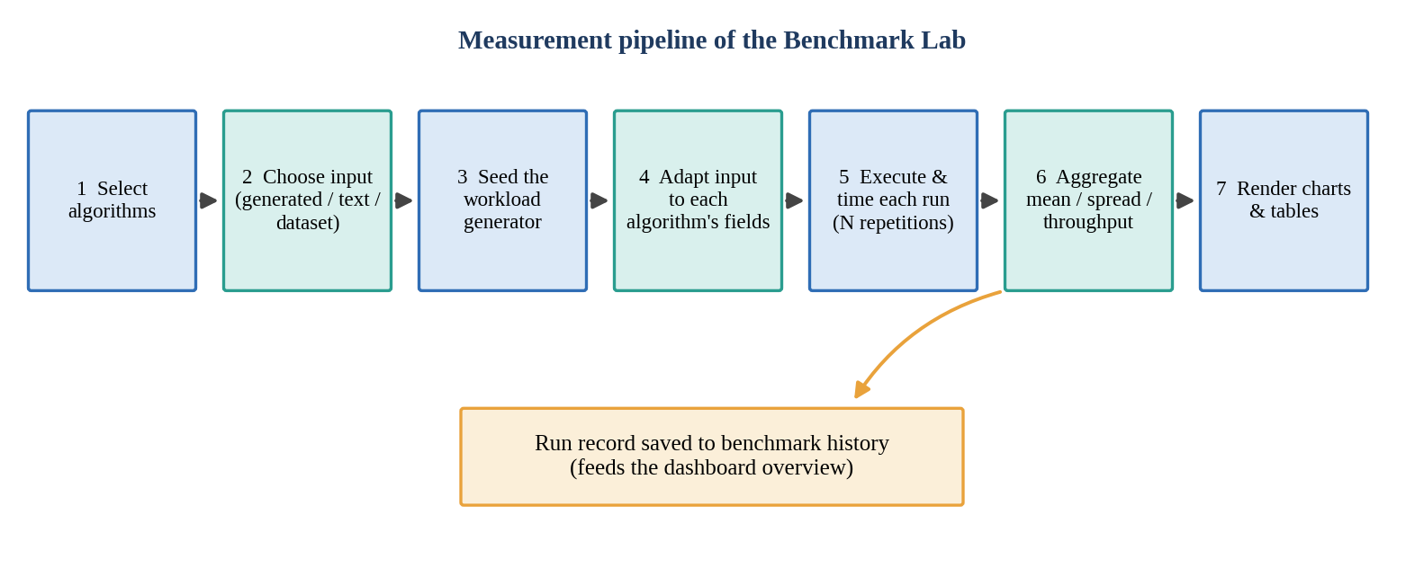
Figure 7: Measurement pipeline of the Benchmark Lab from algorithm selection to charts.
Each algorithm is executed for the requested number of repetitions and every execution is timed on the server. The engine aggregates the repetitions into summary figures and throughput, and records the run so that the dashboard can later show averages. Two design decisions deserve mention. First, an algorithm can carry a benchmark limit: in the scaling mode, input sizes above that limit are skipped for that algorithm instead of freezing the server, a safeguard that matters for quadratic methods. Second, the interface states plainly that no winner is declared; the output is data to be interpreted, not a ranking.
The Benchmark Lab offers four modes, summarised in Figure 8. Algorithm Battle compares chosen algorithms on one input. Input-size Scaling repeats the measurement over a list of growing sizes so that growth curves can be drawn. Stress Testing pushes inputs towards less favourable cases, and Recommendation reads the stored measurements and lists observations about which algorithm suits which situation.
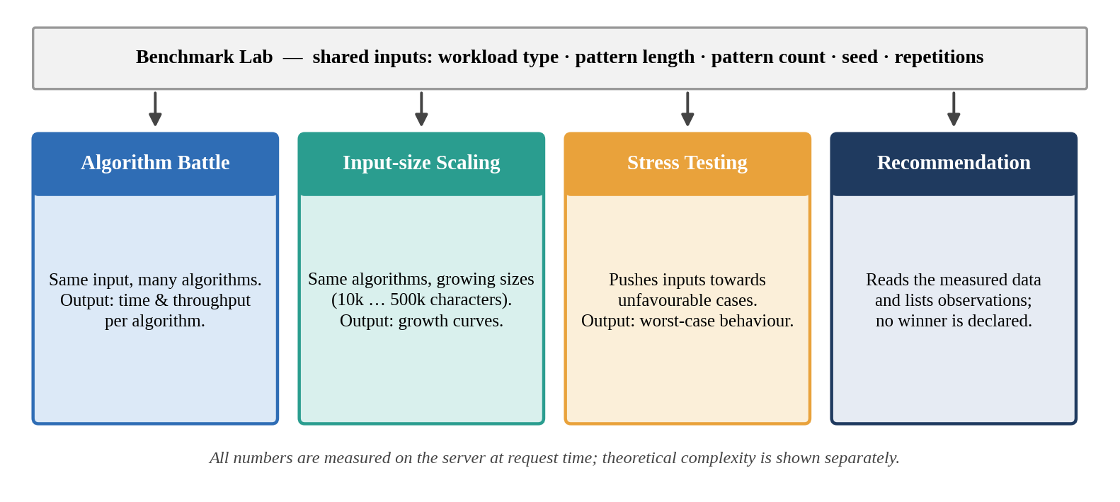
Figure 8: The four modes of the Benchmark Lab and the inputs they share.

Dataset and experiment management
Inputs and settings are treated as first-class records. The dataset lab accepts TXT and CSV uploads, generates synthetic corpora, applies preprocessing and keeps versions, so that an experiment can name exactly which corpus it used. The experiments module saves a complete configuration (algorithms, input source, parameters and seed), re-runs it on demand, duplicates it for variation, compares two saved runs and exports the result. At the time of the captured screens the dashboard reported two datasets, fourteen measured benchmark executions and two saved experiments.

System Working

Dashboard
The dashboard is the landing page. Its headline cards report the number of algorithms (12, across four categories, all of them visualizable), the number of datasets, the number of benchmark runs and the number of saved experiments. Four shortcut buttons start the most common journeys: visualising KMP, running a benchmark battle, adding a dataset and solving a challenge. Below the cards, the laboratory modules are listed with one-line descriptions, followed by the algorithm categories and a performance overview chart that averages the throughput recorded in recent battle runs.

Algorithm lab and visualizer
In the algorithm lab the user selects an algorithm, supplies text (and a pattern or dictionary where relevant) and runs it. The reply contains the algorithm's output, a set of metrics and the theoretical complexity. The visualizer reuses the same engine but records its internal states as it works, so that the user can move forwards and backwards through them: the individual comparisons of a naive scan, the filling of the LPS table in KMP, the construction and traversal of the Aho–Corasick automaton, or the cells of an edit-distance table as they are computed.

Benchmark lab
The benchmark lab opens on the Algorithm Battle tab. The left card lists the algorithms by category, with an all/none toggle for each group, and the right card collects the input settings. A button then sends the request to the server and the page shows tables and charts when the measured results return. The Input-size Scaling tab has the same layout but replaces the single size with a comma-separated list of two to ten sizes. The Stress Testing and Recommendation tabs complete the set.

Dataset lab, experiments and learning lab
The remaining workspaces support the three tools above. A dataset prepared in the dataset lab can be chosen as the input of a battle; a battle configuration that proved interesting can be saved under experiments and repeated later with the same seed; and the learning lab provides the explanation and interactive example for each algorithm, so that a user who does not recognise a name in the benchmark list can read about it without leaving the application.

Life cycle of a request
Figure 9 follows one benchmark request through the system. The browser sends the chosen algorithms, sizes, seed and repetition count to the API. The API asks the workload generator for text and patterns, passes them to the engine, and the engine times every run. Raw timings and match counts travel back to the API, which stores an aggregated record in the run history and returns a JSON document with the results, the theoretical complexity and the settings used. Only at the last step does the browser draw anything.
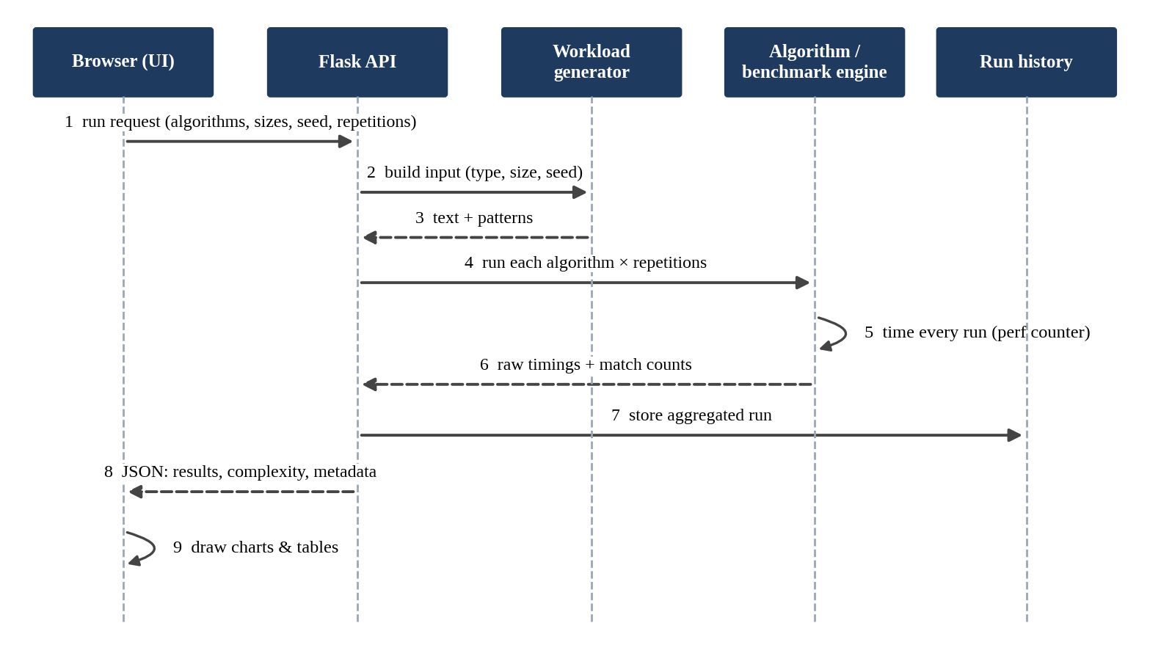
Figure 9: Sequence of messages for a single benchmark request.

Experiments

Set-up
All experiments were run through the laboratory's own Benchmark Lab on a local server, with the browser and the backend on the same machine. We kept every parameter at the values the interface proposes so that anyone can reproduce the runs without guessing. Table 7 lists them. The workload type was random letters, which gives a 26-symbol alphabet with no structure; this is deliberately neutral, but it also means the results say little about natural-language text, DNA or highly repetitive logs.
Table 7: Parameters used in the battle and scaling experiments.
Parameter | Battle | Input-size scaling | Notes
Workload type | Random letters | Random letters | Seeded pseudo-random text
Text size | 200 000 characters | 10 000 – 500 000 | Scaling uses 10 000, 50 000, 100 000, 250 000, 500 000
Pattern length | 8 | 8 | Characters per pattern
Pattern count | 10 | 10 | Patterns searched in each run
Seed | 42 | 42 | Same seed gives the same data
Repetitions | 3 | 3 | Each measurement repeated three times
Algorithms | Naive, KMP, Rabin–Karp, Boyer–Moore | Naive, KMP, Boyer–Moore | String-matching group

Procedure
The battle configuration selects the four string-matching algorithms and a 200 000-character random text with ten patterns of length eight, repeated three times. The scaling configuration keeps the same pattern settings while the text size grows from ten thousand to half a million characters, this time for the naive, KMP and Boyer–Moore algorithms. The dashboard's overview chart was filled from the stored battle runs of all twelve algorithms; since some categories do not take a pattern at all, the interface adapts the shared input to the fields each algorithm needs.

Threats to validity
Three limits should be kept in mind when reading the numbers. Timings were taken on one machine with other programs running, so small differences between algorithms may fall inside normal run-to-run variation; three repetitions reduce but do not remove this. The algorithms are written in Python, so constant factors differ from those of compiled implementations, and an algorithm that is cheap in C may look expensive here. Finally, the dashboard averages runs made with different workloads, which the page itself warns about, so the overview chart is best read as a description of what was run rather than as a controlled comparison.

Results

Dashboard output
Figure 10 shows the dashboard as captured from the running site. The status indicator at the top right reads "API online", confirming that the front end reached the backend. The cards report 12 algorithms in four categories, two versioned datasets, fourteen measured benchmark executions and two saved experiments, and the module cards below them give every workspace a one-line description.
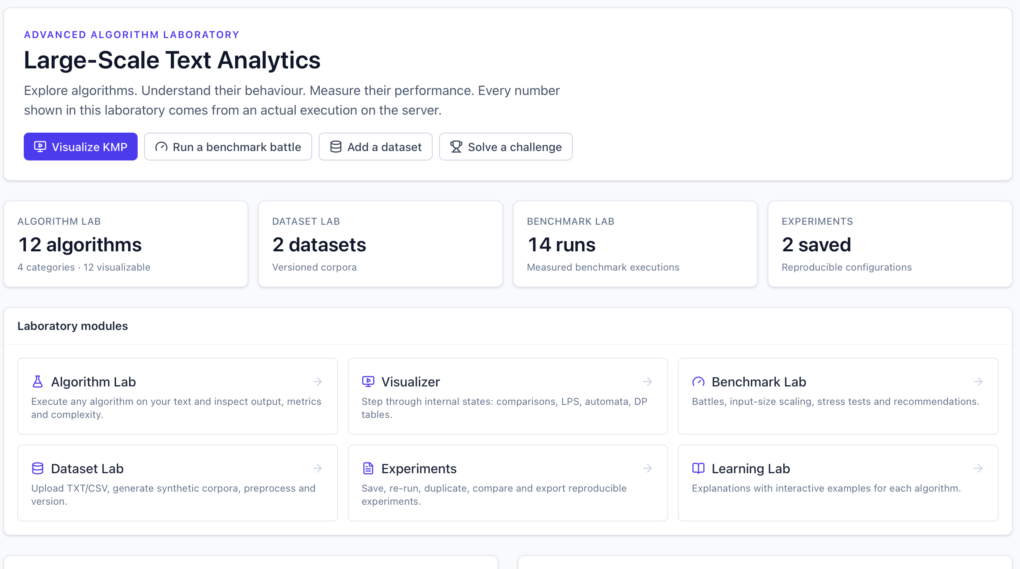
Figure 10: Dashboard of the Algorithm Laboratory: summary cards, laboratory modules, algorithm categories and performance overview.

Benchmark configuration screens
Figure 11 shows the Algorithm Battle tab. The four string-matching algorithms are selected (highlighted in the left card), the input is a generated workload of random letters, and the parameters are the ones listed in Table 7. A note in the card heading reminds the user that all selected algorithms receive the same input, and the page header states that every number is measured on the server at request time.
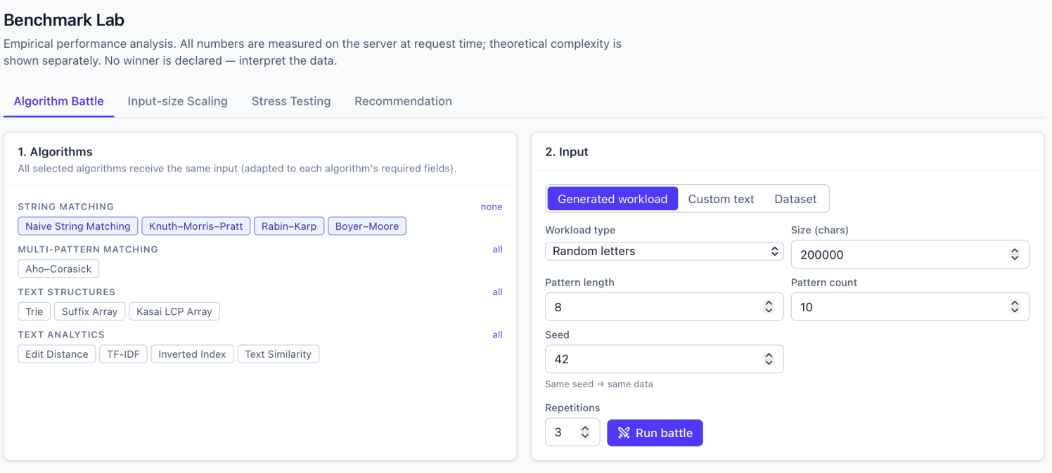
Figure 11: Benchmark Lab, Algorithm Battle tab: algorithm selection and generated-workload settings.
Figure 12 shows the Input-size Scaling tab. Here the text size is replaced by a list of five sizes, from 10 000 to 500 000 characters, and a hint under the field says that each algorithm skips sizes above its own benchmark limit. Naive matching, KMP and Boyer–Moore are selected, and the run is started with the "Run scaling test" button.
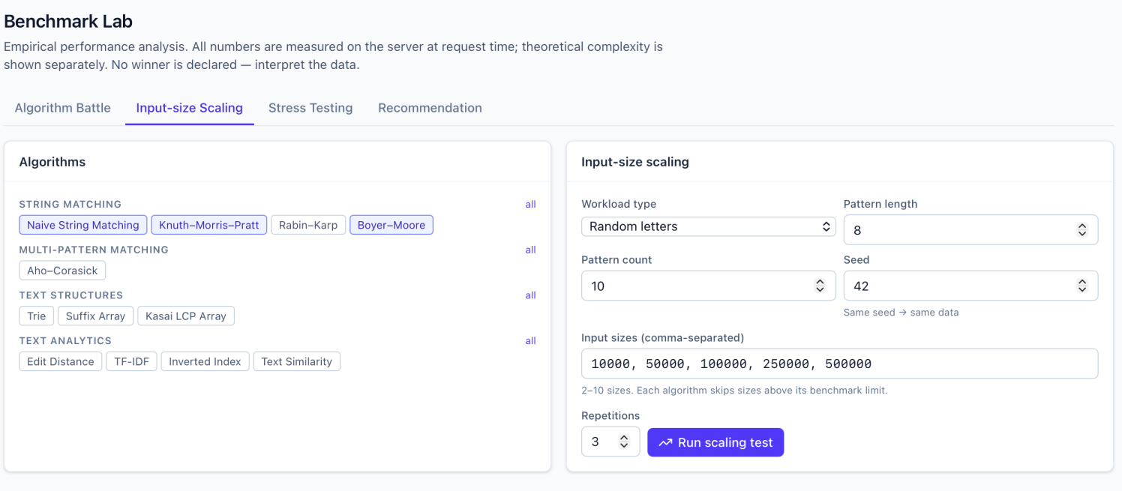
Figure 12: Benchmark Lab, Input-size Scaling tab: five input sizes and three selected algorithms.

Performance overview
The measured throughput averaged over recent battle runs is shown in Figure 13. Reading the bar heights gives the approximate values in Table 8; they are estimates taken from the chart, rounded to the nearest few thousand, and the dashboard axis carries no unit label, so the values are relative figures as reported by the dashboard.
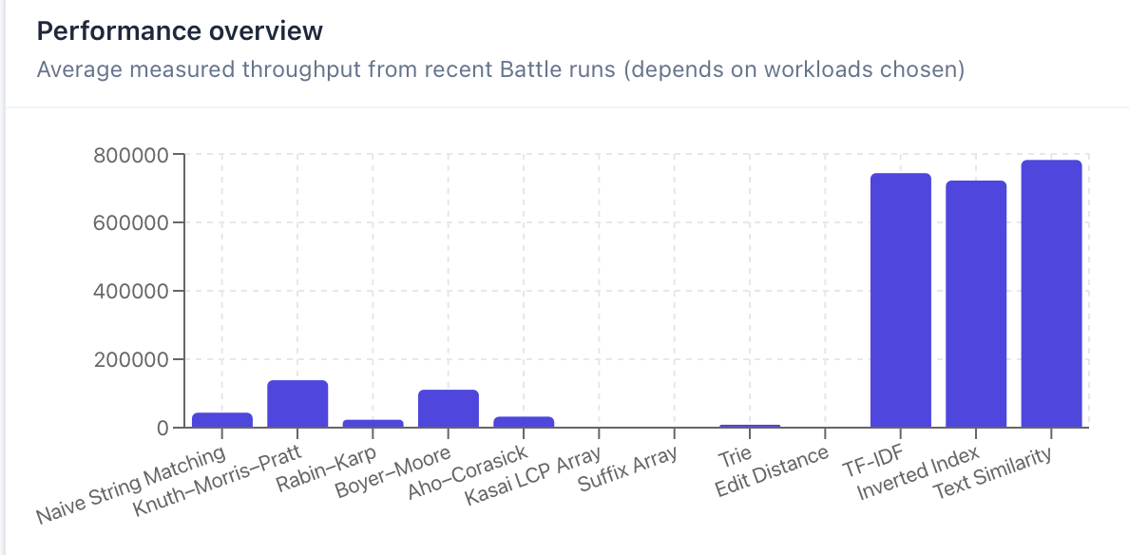
Figure 13: Performance overview chart: average measured throughput from recent battle runs.
Table 8: Approximate average throughput read from the performance overview chart.
Category | Algorithm | Approx. throughput | Visible on chart
String matching | Naive String Matching | ≈ 40 000 | Yes
 | Knuth–Morris–Pratt | ≈ 135 000 | Yes
 | Rabin–Karp | ≈ 20 000 | Yes
 | Boyer–Moore | ≈ 110 000 | Yes
Multi-pattern | Aho–Corasick | ≈ 30 000 | Yes
Text structures | Kasai LCP Array | too small to read | No visible bar
 | Suffix Array | too small to read | No visible bar
 | Trie | ≈ 8 000 | Barely
Text analytics | Edit Distance | too small to read | No visible bar
 | TF-IDF | ≈ 745 000 | Yes
 | Inverted Index | ≈ 720 000 | Yes
 | Text Similarity | ≈ 780 000 | Yes

Discussion
Three patterns stand out. Inside the string-matching group, KMP and Boyer–Moore record the highest throughput, roughly three times that of the naive matcher, while Rabin–Karp sits below it. The last point is plausible rather than surprising: in an interpreted language the per-character cost of updating a hash can exceed the cost of a direct comparison, and on random text the naive matcher usually mismatches on its first or second character, so it rarely does the O(nm) work its worst case describes. Boyer–Moore is clearly ahead of the naive matcher (about 2.7 times) but stays behind KMP, as expected for a 26-letter alphabet and patterns only eight characters long, where long skips are not available. Aho–Corasick, at about 30 000, falls below the naive matcher in these runs, most likely because building and following its automaton adds overhead that pays off only when many more patterns are searched.
Second, the three text-analytics methods that work on terms (TF-IDF, inverted index and text similarity) show throughput more than five times that of the best string matcher. This should not be read as "these algorithms are faster". They perform a different amount of work per unit of input, since they tokenise the text into words and then operate on the words, not on every character position. The dashboard's own subtitle says the values depend on the workloads chosen, and the benchmark page declines to name a winner for the same reason.
Third, Kasai's construction, the suffix array and edit distance barely register on the axis. Their preparation costs are higher (sorting all suffixes, filling an n × m table), and the scaling tab's note about per-algorithm benchmark limits points the same way: such methods cannot be pushed to the largest sizes. Table 9 condenses the observations.
Table 9: Summary of observations from the output screens.
Observation | Evidence | Interpretation
KMP and Boyer–Moore lead the matching group | Highest bars among the first four string matchers | Avoiding repeated comparisons pays off even in Python
Rabin–Karp is the slowest matcher | Lowest bar of the group | Hash updates add per-character overhead on random text
Term-based analytics show the highest throughput | TF-IDF, inverted index and similarity near 700 000 – 800 000 | They work per token, not per character, so units of work differ
Index builders and DP are barely visible | Kasai, suffix array and edit distance bars near zero | Heavy preparation; limited by benchmark limits
Comparison across categories is unsafe | Dashboard note on workloads; no winner declared | Compare only within a category and workload

Conclusion and Future Work
We set out to build an environment in which text algorithms can be run, inspected and measured side by side, and the working system does that. Twelve algorithms in four categories sit behind a common interface, nine workspaces cover running, visualising, benchmarking, data management, experiment tracking and learning, and the benchmark engine produces repeatable, server-measured results that are displayed next to theoretical complexity instead of being turned into a ranking. The captured outputs show the system behaving as designed, and the throughput overview illustrates a lesson that is easy to say and easy to forget: numbers from different workloads and different kinds of algorithm cannot simply be lined up and compared.
Several directions would extend the work. Larger and more realistic corpora, such as natural-language text, DNA sequences and log files, would test the conclusions drawn from random letters. Memory usage could be measured alongside time. Confidence intervals over more repetitions would separate real differences from noise. The algorithms could be reimplemented in a compiled language to compare constant factors, and the benchmark engine could distribute runs across several workers, which would also let the platform handle much larger workloads. Finally, further algorithms, such as the Z-algorithm or suffix automata, can be added simply by registering them with the engine.

References
- D. E. Knuth, J. H. Morris and V. R. Pratt, "Fast pattern matching in strings," SIAM Journal on Computing, vol. 6, no. 2, pp. 323–350, 1977.
- R. M. Karp and M. O. Rabin, "Efficient randomized pattern-matching algorithms," IBM Journal of Research and Development, vol. 31, no. 2, pp. 249–260, 1987.
- R. S. Boyer and J. S. Moore, "A fast string searching algorithm," Communications of the ACM, vol. 20, no. 10, pp. 762–772, 1977.
- A. V. Aho and M. J. Corasick, "Efficient string matching: an aid to bibliographic search," Communications of the ACM, vol. 18, no. 6, pp. 333–340, 1975.
- U. Manber and G. Myers, "Suffix arrays: a new method for on-line string searches," SIAM Journal on Computing, vol. 22, no. 5, pp. 935–948, 1993.
- T. Kasai, G. Lee, H. Arimura, S. Arikawa and K. Park, "Linear-time longest-common-prefix computation in suffix arrays and its applications," in Combinatorial Pattern Matching (CPM 2001), LNCS 2089, Springer, 2001, pp. 181–192.
- V. I. Levenshtein, "Binary codes capable of correcting deletions, insertions and reversals," Soviet Physics Doklady, vol. 10, no. 8, pp. 707–710, 1966.
- K. Spärck Jones, "A statistical interpretation of term specificity and its application in retrieval," Journal of Documentation, vol. 28, no. 1, pp. 11–21, 1972.
- G. Salton and C. Buckley, "Term-weighting approaches in automatic text retrieval," Information Processing & Management, vol. 24, no. 5, pp. 513–523, 1988.
- T. H. Cormen, C. E. Leiserson, R. L. Rivest and C. Stein, Introduction to Algorithms, 4th ed. Cambridge, MA, USA: MIT Press, 2022.
- M. Grinberg, Flask Web Development, 2nd ed. Sebastopol, CA, USA: O'Reilly Media, 2018.

