Intelligent Linux Terminal
A Project Based Learning Report Submitted in partial fulfilment of the requirements for the award of the degree
of
Bachelor of Technology
in The Department of Computer Science and Engineering
Operating Systems and Systems Programming (OSSP) – 25CS2104E
Submitted by
2510030332 : Lakshith
2510030337 : Ranadeep
2510030322 : Rahul
Under the guidance of
Dr. P. Kalpana

Department of Computer Science and Engineering
Koneru Lakshmaiah Education Foundation, Aziz Nagar
Aziz Nagar – 500075
OCT - 2026.
Abstract
Learning to work at a Linux command prompt is harder than it needs to be. Users must remember command names and options, type them without error, and make sense of short error messages that rarely explain how to recover. Beginners often give up or fall back on trial and error, and even experienced users lose time to repeated typing and small spelling slips.
This report presents the Intelligent Linux Terminal, called ShellForge, developed for the Operating Systems and Systems Programming course. ShellForge keeps ordinary Linux behaviour, including pipes and redirection, and adds an assistance layer made up of command history, auto-suggestions, typo detection with correction hints, and clear guidance when a command fails. The tool is delivered through a web-based interface.
The report explains the operating-system concepts on which a shell depends, sets out the requirements, describes the layered architecture and the processing flow, and documents the working prototype with outputs from the web terminal. Test cases covering correct execution, common typing mistakes, retrieval of earlier commands and invalid input showed that valid commands run as in a normal terminal while helpful feedback appears where a normal terminal would stay silent. The solution is purely software based and needs no extra infrastructure. Planned work includes more accurate suggestions, richer error explanations, accessibility improvements and personalised assistance.
Keywords: Linux terminal, shell, command history, auto-suggestion, typo correction, error guidance, operating systems.
List of Figures
Fig. 1 Layered architecture of ShellForge 10
Fig. 2 Five-stage user interaction workflow 10
Fig. 3 Decision flow for processing a command 11
Fig. 4 Steps in typo detection and correction 11
Fig. 5 Interaction sequence when a command fails 12
Fig. 6 Module organisation of ShellForge 12
Fig. 7 Deployment view of the prototype 13
Fig. 8 Command execution, pipe with redirection, and history output 15
Fig. 9 Output of the suggest command 16
Fig. 10 Typo correction for pythn 16
Fig. 11 Error guidance after a failed cd command 17
Fig. 12 Qualitative feature support: normal terminal versus ShellForge 17
List of Tables
Table 1 Problems observed in a conventional terminal and the response in ShellForge 6
Table 2 Operating-system concepts and where they appear in ShellForge 8
Table 3 Functional requirements of ShellForge 9
Table 4 Non-functional requirements 9
Table 5 Comparison between a normal terminal and ShellForge 13
Table 6 Test cases and expected behaviour 14
Table 7 Observed outcome for each test case 17
Table 8 Project objectives and how they were met 17
Table 9 Planned improvements 19
Table of Contents
1. Introduction 6
1.1 Background 6
1.2 Motivation 6
1.3 Problem Statement 6
1.4 Objectives 7
1.5 Scope of the Work 7
2. Operating System Concepts Behind the Project 8
2.1 The Shell as a Command Interpreter 8
2.2 Processes and Program Execution 8
2.3 Pipes and Redirection 8
2.4 Mapping of Concepts to the Project 8
3. System Analysis and Requirements 9
3.1 Existing Approach 9
3.2 Proposed Approach 9
3.3 Functional Requirements 9
3.4 Non-Functional Requirements 9
3.5 Working Environment 9
4. Methodology 10
4.1 Overall Architecture 10
4.2 User Interaction Workflow 10
4.3 Command Processing Flow 10
4.4 Command History 11
4.5 Auto-Suggestions 11
4.6 Typo Detection and Correction 11
4.7 Error Guidance 11
4.8 Module Organisation 12
5. Working of the System 13
5.1 Starting a Session 13
5.2 Executing Ordinary Commands 13
5.3 Receiving Assistance 13
5.4 Design Decisions 13
6. Experiments and Testing 14
6.1 Test Plan 14
6.2 Test Procedure 14
7. Results 15
7.1 Command Execution, Pipes and History 15
7.2 Suggestions 15
7.3 Typo Correction 16
7.4 Error Guidance 16
7.5 Summary of Observations 17
7.6 Objectives Against Outcomes 17
7.7 Limitations 18
8. Conclusion and Future Work 19
8.1 Future Work 19
References 20

1. Introduction
The command-line shell is still one of the most capable ways of talking to an operating system. A single line typed at a Linux prompt can list files, start a program, chain several programs together through pipes or redirect their output into a file. That power comes at a price, though. The person at the keyboard has to remember the exact name of every command, spell it correctly, and read whatever terse message the system prints when something goes wrong. For a student who has just met Linux, this is a steep climb, and even experienced developers lose time on small slips such as a missing letter or a forgotten earlier command.
This report describes the Intelligent Linux Terminal, which our team named ShellForge. It is a terminal environment that keeps ordinary Linux behaviour intact but adds a thin layer of help around it. The layer remembers what the user has typed before, proposes commands that are likely to be useful, notices when a command name looks like a mistyped one, and explains failures in plain language. The tool is reached through a web-based interface, so it can be opened in a browser without any special set-up on the learner's side.
The project was carried out as part of the Operating Systems and Systems Programming (OSSP) course. It sits naturally in that subject: a shell is the most direct example of a program that sits between a user and the kernel, creating processes, wiring up pipes and reporting exit statuses. Working on ShellForge gave us a practical reason to study those mechanisms rather than only reading about them.

1.1 Background
A shell reads a line, splits it into a command and its arguments, asks the operating system to start the matching program, waits for it to finish and then shows the prompt again. Popular shells such as bash add a history list, tab completion and scripting features, yet they stay silent about intent. If a word is not a known command the shell reports "command not found" and nothing more. It does not say what the user probably meant, and it rarely tells a beginner how to recover.

1.2 Motivation
While practising Linux in laboratory sessions we noticed that most of our own lost time came from the same few causes: forgetting the exact option for a command, mistyping a name, retyping a long command that we had used a few minutes earlier, and not understanding an error message. None of these problems is deep, but together they interrupt concentration and discourage newcomers. We wanted to see how much of that friction could be removed without asking anyone to learn a new tool or abandon the commands they already know.

1.3 Problem Statement
Traditional terminals expect the user to do all the remembering, spelling and interpreting. Table 1 summarises the five difficulties identified during the project and the feature we designed in response to each.
Table 1 Problems observed in a conventional terminal and the response in ShellForge
No. | Problem | Effect on the user | ShellForge response
1 | Commands and options must be memorised | Slow progress, frequent searching online | Auto-suggestions
2 | Small typing mistakes | Command fails for a trivial reason | Typo detection and correction
3 | Cryptic error messages | Beginner cannot tell how to recover | Error guidance
4 | Repeated typing of the same commands | Wasted time, more chances for errors | Integrated command history
5 | Unfriendly first experience | Learning by trial and error is discouraging | Web interface with guided feedback

1.4 Objectives
- Easy to use: reduce the effort needed to work with Linux commands.
- Faster work: let users reach frequently used commands quickly.
- Fewer mistakes: detect common typing errors and offer a correction.
- Better learning: help beginners understand failures and build their Linux skills.
- Reliable execution: keep normal terminal tasks dependable, including pipes and redirection.
- Practical impact: produce a tool that real students and developers can actually use.

1.5 Scope of the Work
ShellForge is an assistance layer, not a replacement for Linux or for the shell. It does not introduce a new command language and it does not modify the kernel. Its scope is limited to four helpful behaviours (history, suggestions, typo correction and error guidance) delivered through a browser-based terminal. Features such as personalised learning and accessibility enhancements are treated as future work in Chapter 8.

2. Operating System Concepts Behind the Project
Because this project belongs to the Operating Systems and Systems Programming course, it is useful to show which operating-system ideas the terminal relies on. A shell is, at heart, a command interpreter that turns text into system activity.

2.1 The Shell as a Command Interpreter
The shell is an ordinary user-space program. It does not run inside the kernel; instead it requests services from the kernel through system calls. When a user enters a command, the interpreter parses the line, finds the program to run and asks the kernel to create a new process for it. Built-in commands such as cd are handled by the shell itself because changing the working directory must affect the shell process, not a child.

2.2 Processes and Program Execution
On Linux a new program is normally started in two steps. The parent process creates a child with fork, and the child replaces its memory image with the requested program through the exec family of calls. The parent then waits for the child and collects an exit status. A status of zero conventionally means success and any other value signals a failure. ShellForge uses this exit information to decide when error guidance should be shown.

2.3 Pipes and Redirection
A pipe connects the standard output of one process to the standard input of another, so that small tools can be combined. Redirection attaches a file to a standard stream, for example sending output into result.txt. Both rely on file descriptors, the small integers through which processes read and write. The prototype preserves these features, which is why a line such as cat notes.txt | grep linux > result.txt works as expected inside the web terminal.

2.4 Mapping of Concepts to the Project
Table 2 Operating-system concepts and where they appear in ShellForge
OS concept | Meaning | Use in ShellForge
Command interpreter | Program that reads and acts on user commands | Core of the terminal session
Process creation (fork / exec) | Starting a program as a child process | Running every valid command
Exit status | Number returned when a process ends | Triggers error guidance on failure
Pipes | Stream between two processes | Chained commands such as cat | grep
Redirection | Binding a stream to a file | Saving output with the > operator
File system and paths | Hierarchy of directories and files | Behaviour of ls, pwd and cd
Standard error stream | Channel used for error text | Captured to build clearer guidance

3. System Analysis and Requirements

3.1 Existing Approach
A normal terminal offers a basic history list that can be searched, and some shells can be configured with completion scripts. These facilities are useful but separate, often disabled by default, and not aimed at novices. Typing mistakes and failure messages are left entirely to the user to interpret.

3.2 Proposed Approach
ShellForge wraps the familiar workflow in an intelligent layer. The user still types a command and the command still runs through the real shell, but before and after execution the system tries to help. This idea of preserving the familiar while adding guidance was the main design principle of the whole project.

3.3 Functional Requirements
Table 3 Functional requirements of ShellForge
ID | Requirement | Priority
FR-1 | Accept and execute standard Linux commands, including pipes and redirection | High
FR-2 | Store entered commands and let the user list and reuse them | High
FR-3 | Offer a suggest command that lists likely commands | Medium
FR-4 | Detect a probable typing mistake and display a "Did you mean" hint | High
FR-5 | Allow the Tab key to accept the offered correction | Medium
FR-6 | Show clear guidance when a command fails, for example an invalid cd | High
FR-7 | Provide the terminal through a web-based interface | High

3.4 Non-Functional Requirements
Table 4 Non-functional requirements
Attribute | Expectation
Reliability | Valid commands must always run and return the correct output
Usability | The terminal must feel familiar and require no extra training
Responsiveness | Hints and corrections should appear without noticeable delay
Consistency | The same input should always produce the same assistance
Portability | Usable from a browser on any machine that can reach the server
Sustainability | Software-only solution that needs no additional physical infrastructure

3.5 Working Environment
The prototype runs on a Linux host, since its whole purpose is to assist with Linux commands, and is accessed from an ordinary web browser. The server side executes the commands and the browser side presents the terminal. Because the project is software only, no special hardware is needed.

4. Methodology
We followed an incremental approach. A plain command-execution core was built first and tested, then each assistance feature was added one at a time and checked against the same set of ordinary commands, so that new help never broke old behaviour. This section explains the design in the order in which the user meets it.

4.1 Overall Architecture
The system is arranged in layers, as shown in Fig. 1. The browser presents the terminal. A back-end server receives each line, hands it to a small set of modules and returns the result. Underneath, the Linux shell and the operating system actually carry out the work.
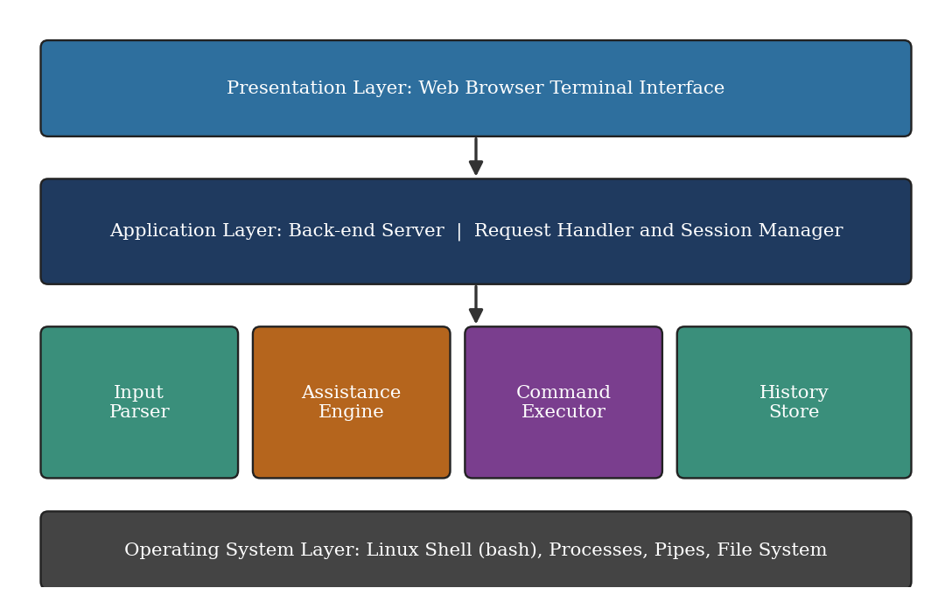
Fig. 1 Layered architecture of ShellForge

4.2 User Interaction Workflow
Every interaction passes through five stages: enter, understand, assist, execute and learn (Fig. 2). The last stage matters most for beginners, because the feedback shown after a command teaches them something for next time.
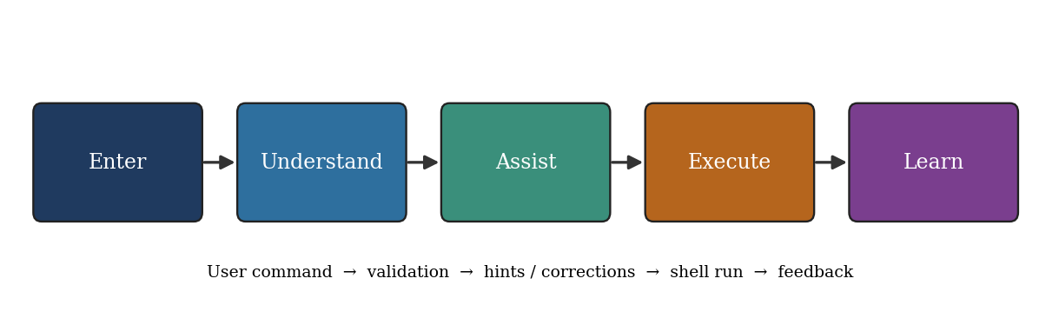
Fig. 2 Five-stage user interaction workflow

4.3 Command Processing Flow
After a line is entered the system first checks whether the first word is a known command. When it is not, the typo matcher looks for the closest known command and shows a hint. When it is, the line is passed to the shell. If the shell reports a failure, guidance is added to the raw error. Successful and unsuccessful commands alike are recorded in the history, which lets the user bring them back later. Fig. 3 shows the decision flow.
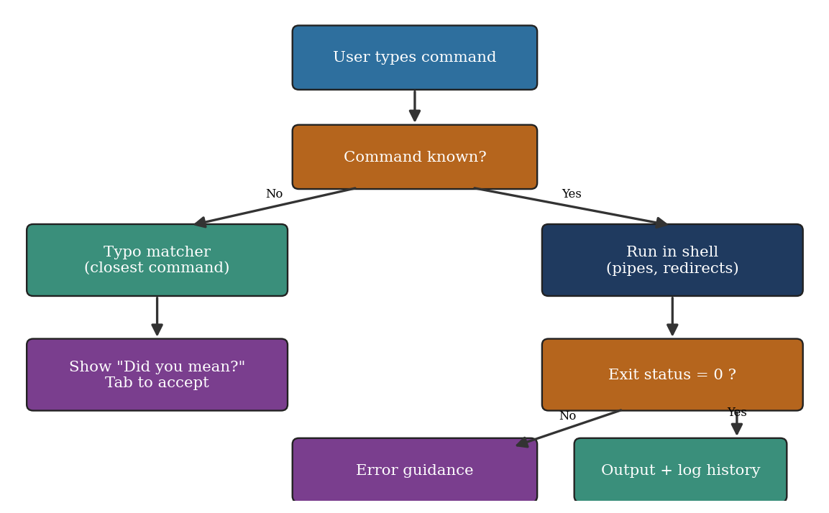
Fig. 3 Decision flow for processing a command

4.4 Command History
Each entered command is stored in order. The history command lists earlier entries with their numbers so that any of them can be found again and re-run. This removes a great deal of repeated typing, especially for long commands that include pipes or redirection.

4.5 Auto-Suggestions
The suggest command displays a list of commonly used commands with a short description of each. It acts as a quick memory aid for learners who know what they want to do but cannot recall the command name.

4.6 Typo Detection and Correction
When the first word of a line is not recognised, it is compared with the names of known commands and the nearest match is offered. In the prototype, typing pythn produces the message "Did you mean: python?" and the interface offers a Tab shortcut so the user can accept the correction in one keystroke instead of retyping. Fig. 4 outlines the steps.
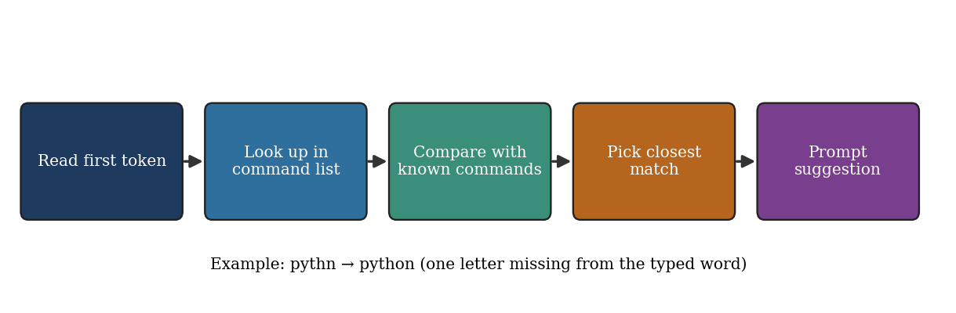
Fig. 4 Steps in typo detection and correction

4.7 Error Guidance
A failed command normally prints one short line. ShellForge keeps that original line, because it is accurate, and appends a plain-language explanation together with a suggested next step. For instance, when cd is used on a folder that does not exist, the guidance explains that the path may be mistyped and recommends listing the directory contents first. The sequence of events between the user, the interface, the server and the shell is shown in Fig. 5.
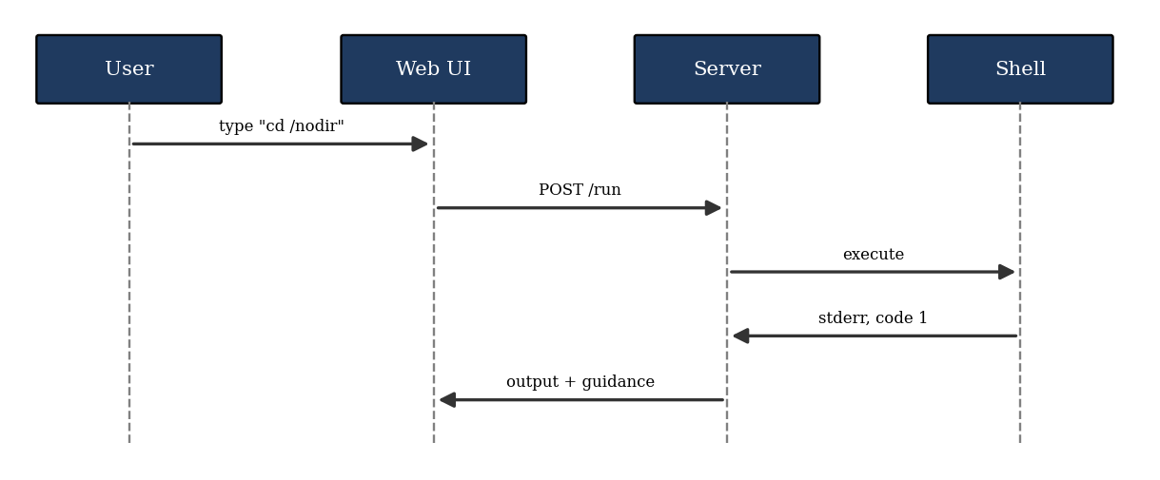
Fig. 5 Interaction sequence when a command fails

4.8 Module Organisation
Logically the project can be seen as a core that coordinates six cooperating parts, drawn in Fig. 6. Keeping each assistance feature separate meant it could be tested and improved independently.
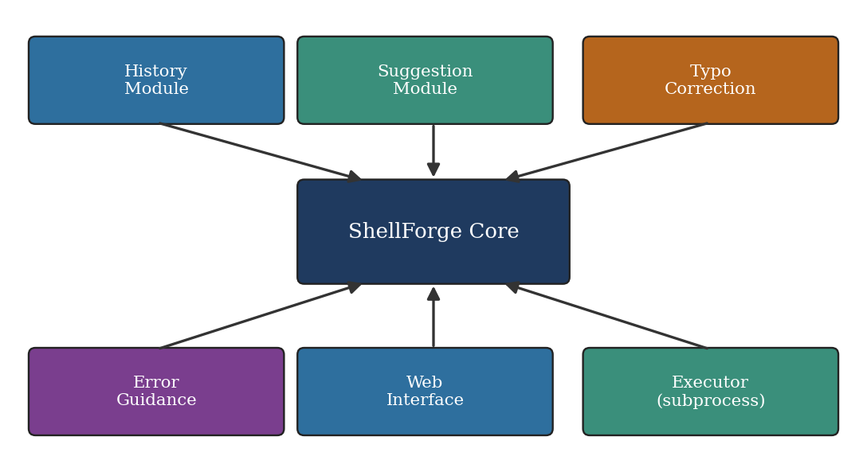
Fig. 6 Module organisation of ShellForge

5. Working of the System

5.1 Starting a Session
The user opens the ShellForge page in a browser and is shown a familiar prompt. Nothing has to be installed on the client. Each line typed is sent to the server, which treats it exactly as a shell would and returns the text to be displayed.

5.2 Executing Ordinary Commands
Basic commands such as ls, pwd and cd behave as in a normal terminal, and pipes and redirection are supported. This preserved behaviour is essential: an intelligent terminal that cannot run valid commands correctly would be of no use, so reliable execution was treated as a requirement rather than an extra.

5.3 Receiving Assistance
While the user works, assistance appears at the right moment. A list of earlier commands is available on request, the suggest command lists useful commands, a mistyped command name triggers a correction hint, and a failed command is followed by an explanation. Table 5 compares this behaviour with a typical terminal.
Table 5 Comparison between a normal terminal and ShellForge
Feature | Normal terminal | ShellForge
Execute Linux commands | Yes | Yes
Basic commands (ls, pwd, cd) | Yes | Yes
Command history | Basic shell history | Integrated history
Auto-suggestions | Limited or configurable | Built in
Typo detection | Not typically built in | Supported
Correction suggestions | Not typically built in | Supported
Error guidance | Mostly raw errors | Clearer guidance
Web interface | Not normally included | Available
Beginner-friendly assistance | Limited | Improved

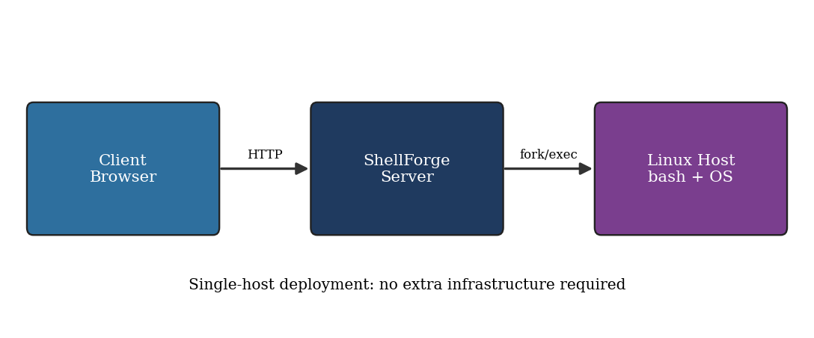
Fig. 7 Deployment view of the prototype

5.4 Design Decisions
Three decisions shaped the implementation. First, we kept real command execution in the shell instead of imitating commands, so that behaviour stays identical to Linux. Second, assistance is advisory: hints appear but nothing is changed without the user's consent, which is why corrections are accepted with Tab rather than applied silently. Third, error guidance is added alongside the original message rather than replacing it, so experienced users lose no information.

6. Experiments and Testing
Evaluation focused on four questions: do valid commands run correctly, do common typing mistakes receive a useful correction, can earlier commands be retrieved easily, and does invalid input produce clear feedback. The guiding principle was correct output, useful guidance and consistent behaviour.

6.1 Test Plan
Table 6 Test cases and expected behaviour
ID | Test | Input example | Expected result
T1 | Correct commands | ls, pwd, cd | Output matches a normal terminal
T2 | Pipes and redirection | cat notes.txt | grep linux > result.txt | Result file is created with matching lines
T3 | Command history | history | Earlier commands listed with numbers
T4 | Suggestions | suggest | List of likely commands appears
T5 | Common typo | pythn | "Did you mean: python?" with Tab shortcut
T6 | Invalid input | cd /nodir | Original error plus plain-language guidance

6.2 Test Procedure
Each test was entered in the web terminal in a fresh session. Where a result could be compared with a normal Linux shell, the two outputs were checked against each other. For the assistance features, the check was whether the hint or guidance appeared and whether it was understandable to someone new to Linux.

7. Results
The results below are the outputs observed from the ShellForge web terminal during the project demonstration. They correspond to the test cases listed in Table 6.

7.1 Command Execution, Pipes and History
Fig. 8 shows ordinary commands running unchanged, a pipe combined with a redirection, and the history command listing earlier entries.
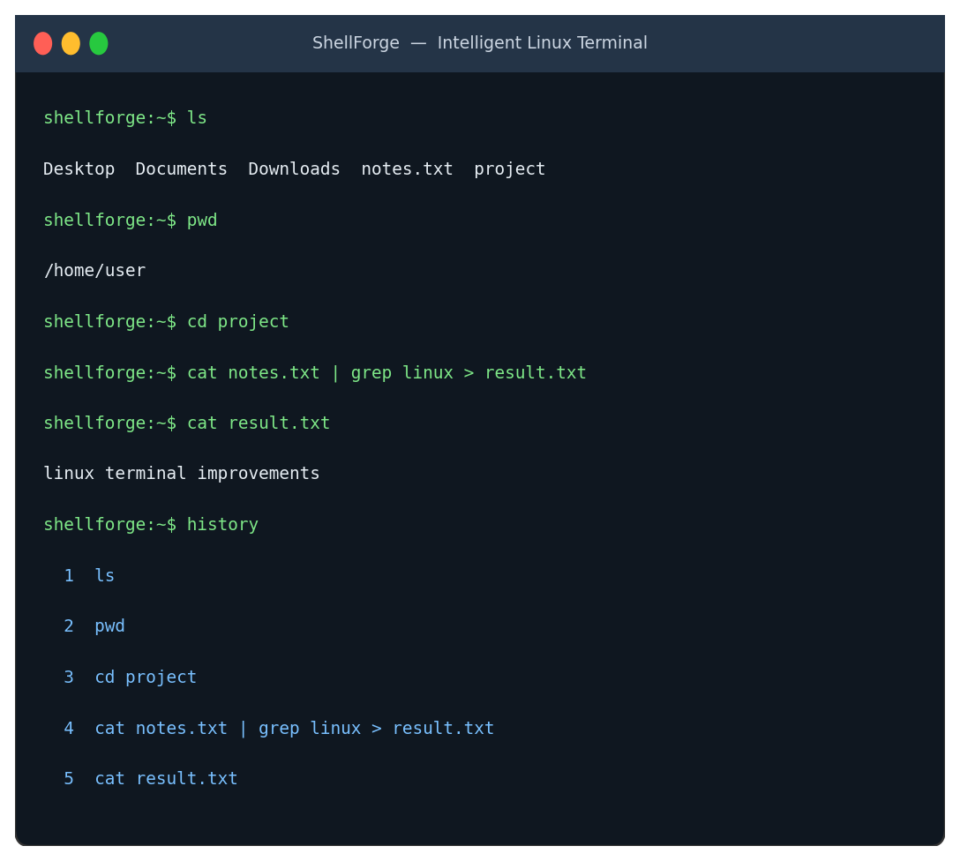
Fig. 8 Command execution, pipe with redirection, and history output

7.2 Suggestions
Fig. 9 shows the suggest command, which lists likely commands together with a short description.
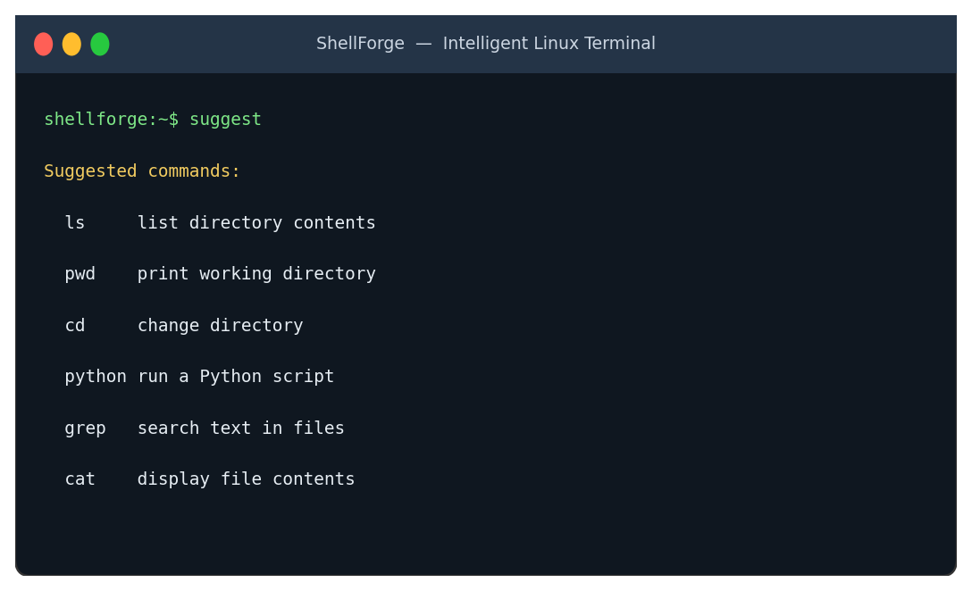
Fig. 9 Output of the suggest command

7.3 Typo Correction
In Fig. 10 the mistyped word pythn is recognised, the correct command python is proposed and the Tab shortcut is offered.
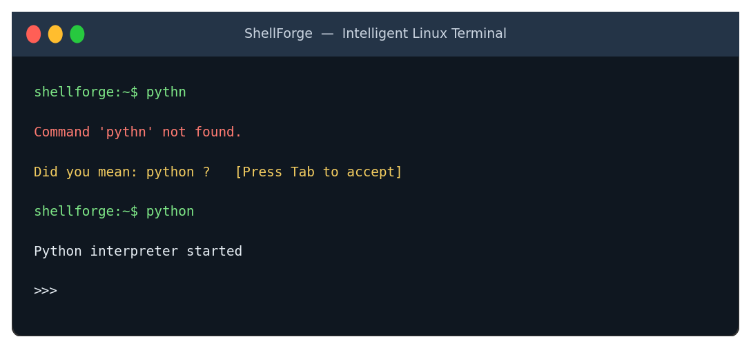
Fig. 10 Typo correction for pythn

7.4 Error Guidance
Fig. 11 shows a failed cd command. The original error is kept and followed by an explanation and a practical next step.
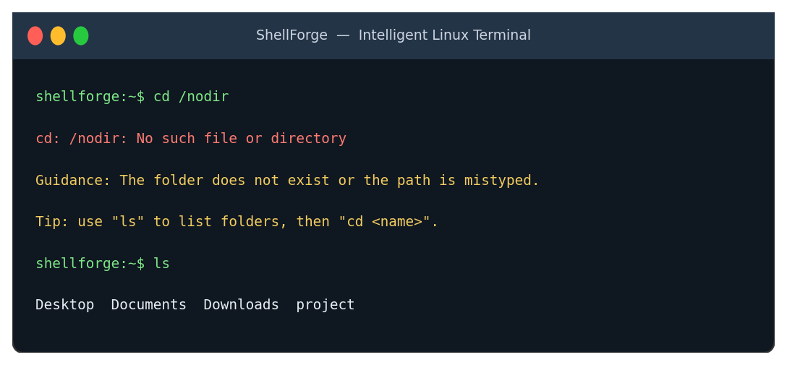
Fig. 11 Error guidance after a failed cd command

7.5 Summary of Observations
Table 7 Observed outcome for each test case
Test | Feature | Outcome
T1 | Correct commands | Executed as expected
T2 | Pipes and redirection | Worked normally
T3 | Command history | Earlier commands listed and reusable
T4 | Suggestions | Likely commands listed
T5 | Typo correction | pythn produced a hint for python, with Tab shortcut
T6 | Error guidance | Clear guidance shown after failed cd

The overall picture is that ShellForge matches a normal terminal wherever commands are valid and adds help wherever a normal terminal would stay silent. Fig. 12 gives a qualitative view of the difference using the feature comparison in Table 5, scoring each capability as none, limited or built in.
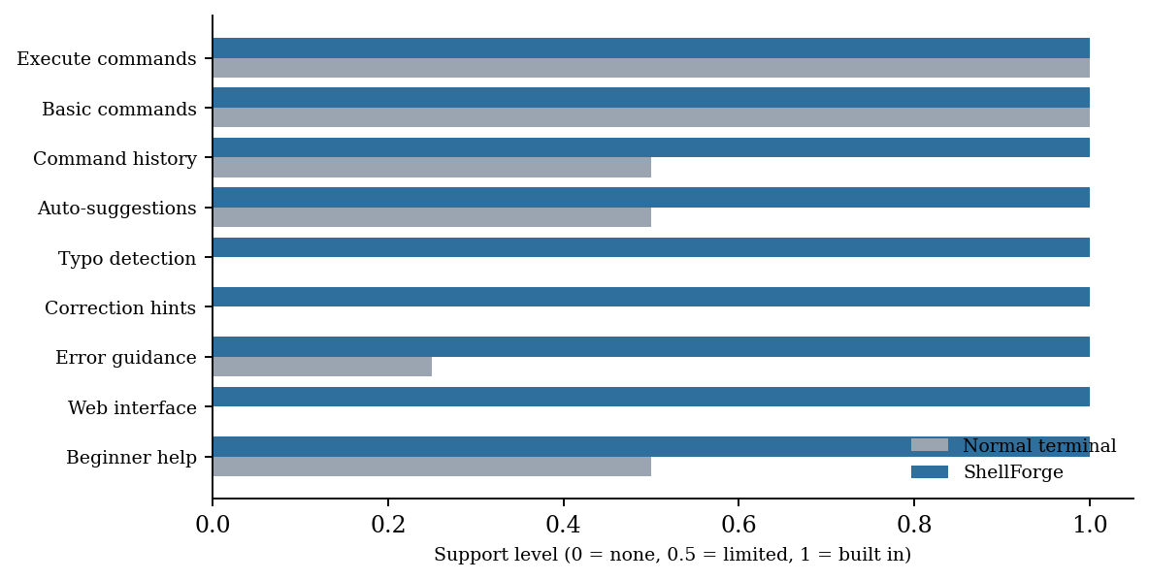
Fig. 12 Qualitative feature support: normal terminal versus ShellForge

7.6 Objectives Against Outcomes
Table 8 Project objectives and how they were met
Objective | How it was addressed
Easy to use | Familiar commands kept; assistance appears automatically
Faster work | History and suggestions reduce retyping
Fewer mistakes | Typo hints with one-key acceptance
Better learning | Plain-language error guidance with next steps
Reliable execution | Real shell used for all valid commands
Practical impact | Useful to students, beginners and developers

7.7 Limitations
The prototype has been shown to work on the demonstration cases above, but the accuracy of suggestions has not yet been measured on a large collection of real user input, and the set of recognised mistakes is limited to common ones. We state this openly because it defines the most useful direction for further work.

8. Conclusion and Future Work
ShellForge shows that a Linux terminal can be made much easier to approach without changing what it fundamentally is. Command history, auto-suggestions, typo correction and error guidance, delivered through a web interface, address the five difficulties we identified at the start while normal commands, pipes and redirection continue to work. The project also gave us hands-on understanding of how shells use processes, pipes and exit statuses.
The people who gain most are students learning Linux, beginners meeting unfamiliar commands, developers who repeat the same commands often, and general users who want a gentler interface. The social benefit is less frustration, quicker learning and better productivity, achieved with software alone.

8.1 Future Work
Table 9 Planned improvements
Area | Improvement
Suggestions | More accurate command suggestions
Error explanations | Wider and more detailed explanations
Accessibility | Support for users with different needs
Personalisation | Assistance adapted to each user's habits
Testing | Larger test sets and clearer demonstrations

References
[1] A. Silberschatz, P. B. Galvin and G. Gagne, Operating System Concepts, 10th ed. Wiley, 2018.
[2] A. S. Tanenbaum and H. Bos, Modern Operating Systems, 4th ed. Pearson, 2015.
[3] W. R. Stevens and S. A. Rago, Advanced Programming in the UNIX Environment, 3rd ed. Addison-Wesley, 2013.
[4] M. Kerrisk, The Linux Programming Interface. No Starch Press, 2010.
[5] GNU Project, "Bash Reference Manual," Free Software Foundation. https://www.gnu.org/software/bash/manual/
[6] The Linux man-pages project, manual pages for fork(2), execve(2), pipe(2) and waitpid(2). https://man7.org/linux/man-pages/
[7] ShellForge project team, "Intelligent Linux Terminal: Review 4 presentation," Koneru Lakshmaiah Education Foundation, 2026.

