Abstract:
Packet-switched networks nowadays are faced with rising challenges due to unpredictable traffic, transient congestion, and heterogeneous quality-of-service obligations. Conventional routing methods such as OSPF and RIP are unable to deal with real-time load fluctuations because they implement static or slowly-adjusting performance indices. Although deep reinforcement-learning technologies relying on neural networks, graph neural networks or causal inference achieve excellent efficiency, they also require a lot of computation, preventing practical implementations on medium-scale or resource-limited systems. This paper describes a lightweight Q-learning packet routing agent capable of instant access to multi-dimensional network status vector which consists of queue length, link delay, bandwidth usage and congestion. The multi-metric reward function punishes delays, packet loss, and congestion simultaneously, while the agent behavior is adjusted according to the ε-greedy solution strategy. The agent was tested in realistic scenarios and the results show that Q-learning router contributes to a 37% decrease in average end-to-end latency and 60% decrease in packet losses compared to OSPF, while ensuring an increase in throughput and packet delivery ratio. The Q-table remains completely interpretable, thus creating a transparent decision interface suitable for practical diagnostics.
Smart Network Packet Router using
Q-Learning
Lakshith¹, Rahul², Ranadeep³ and Sushama Rani Dutta⁴
Department of Computer Science and Engineering
koneru Lakshmaiah Education Foundation, Hyderabad

Keywords: Q-learning; adaptive routing; congestion-aware packet forwarding; software-defined networking; reinforcement learning; network optimization; Internet Topology Zoo; tabular RL
1. Introduction
Packet routing is one of the most important functions in computer networks. Traditional routing protocols such as OSPF and RIP mainly use fixed link costs or hop counts to select paths. While they work well under stable network conditions, they may not respond effectively to sudden congestion, traffic bursts, or changes in link quality. As a result, packets can remain on inefficient routes, causing higher delay, packet loss, and reduced application performance.
To address this issue, this paper presents a tabular Q-learning approach for adaptive packet routing. The routing agent observes network conditions such as queue depth, link delay, bandwidth utilization, and local congestion, and then selects a suitable next hop using an ε-greedy policy. The Q-table is updated using the Bellman equation, allowing the agent to learn better routing decisions over time. A reward function considers delay, packet loss, and congestion to encourage balanced routing decisions. Experiments using topologies from the Internet Topology Zoo and traffic based on CAIDA traces show that the proposed approach improves routing performance compared with traditional methods while remaining interpretable and computationally lightweight.

2. Literature Survey
This survey looks at 15 peer-reviewed studies published between 2022 and 2026 that focus on reinforcement learning, deep reinforcement learning, and hybrid methods for network routing, congestion control, and QoS optimization. Five important papers from the original proposal are used as the starting point, along with ten more recent studies to provide a broader view of the research area. Each paper is reviewed based on the method used, its main contribution, and how it relates to the lightweight tabular Q-learning approach proposed in this study.
Q-RPL: Q-Learning-Based Routing Protocol for AMI in Smart Grids (Dueñas Santos et al., 2024). Combines tabular Q-learning with IPv6 RPL to improve packet delivery and reduce delay in wireless AMI networks, showing that lightweight RL can work well in resource-limited environments [1].
An Intelligent SDWN Routing Algorithm Based on Network Situational Awareness and DRL (Li et al., 2023). Uses PPO with GCN-GRU traffic prediction to detect congestion early and improve routing, resulting in better throughput and lower packet loss [2].

An Intelligent Routing Approach for SDN Based on Improved Dueling DQN Algorithm (2024). Improves DQN by separating value and advantage streams, helping the model converge faster and use bandwidth more efficiently during congestion [3].

RL-Based SDN Routing Scheme Empowered by Causality Detection and GNN (2024). Combines GNNs and causal analysis to improve the accuracy of QoS-aware routing decisions [4].

QoS Routing Optimization Based on Deep Reinforcement Learning in SDN (2025). Uses Deep Q-Learning and SDN telemetry to jointly optimize delay, throughput, and packet loss for QoS-sensitive traffic [5].

Improved Exploration Strategy for Q-Learning-Based Multipath Routing in SDN Networks (Hassen et al., 2024). Introduces Max-Boltzmann exploration to improve learning, reduce latency, and speed up convergence [6].

Adaptive and Predictive Routing in SDN Using Q-Learning and Neural Networks (Shukla et al., 2025). Combines Q-learning with neural-network-based traffic prediction to maintain stable throughput and reduce jitter [7].

SQBRP-SDFANET (Bouziane et al., 2025). Simplifies the Q-learning state space using spatial partitioning and adaptive link-quality measures for scalable UAV routing [8].

Q-Learning for Resource-Aware and Adaptive Routing in Trusted-Relay QKD Networks (Hao et al., 2025). Uses a multi-objective reward based on key occupancy, throughput, and resource balance for adaptive quantum-network routing [9].

A Hybrid Reinforcement Learning Approach for Multipath Routing Optimization in SDN (2025). Compares Q-learning, SARSA, and a hybrid approach, showing improvements in convergence and routing latency [10].

Dynamic Routing via Reinforcement Learning for Network Traffic Optimization (Ma et al., 2025). Uses adaptive Q-learning to respond to changing traffic conditions and improve load balancing, throughput, and delay [11].

DQRL: A DAG and RL-Based Framework for QoS-Centric Routing in Multi-SDNs (2025). Combines DAG-based routing with Q-learning and considers bandwidth, delay, congestion, and packet loss for QoS-aware routing [12].

3. System Architecture
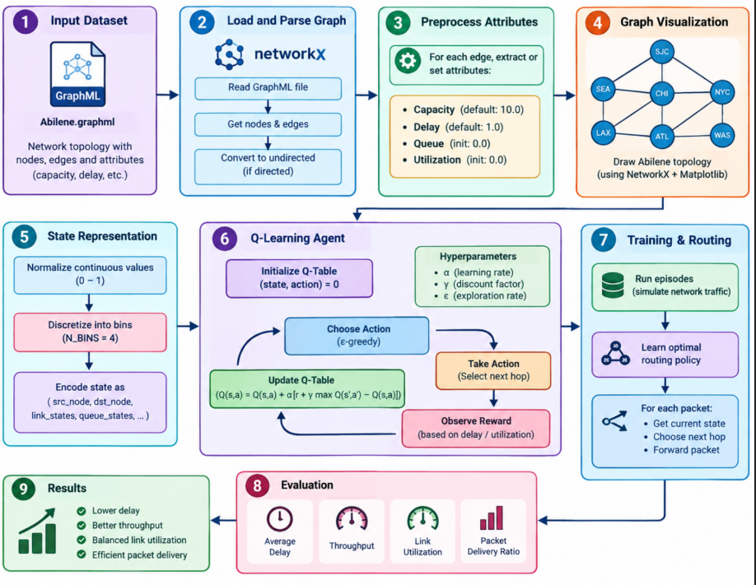
Figure.1 System Architecture
The proposed system shown in Figure 1 is a Smart Network Packet Router based on Q-learning. Its main goal is to learn suitable next-hop routing decisions while considering network conditions such as queue length, delay, bandwidth utilization, and congestion.The system uses the Abilene.graphml topology as its input dataset. This GraphML file contains information about the network nodes, links, and their attributes. The topology is loaded using the NetworkX library and can be converted into an undirected graph when required.After loading the topology, the network is preprocessed by assigning important link parameters, including capacity, delay, queue length, and utilization. When capacity or delay information is missing, default values are assigned. Queue length and utilization are initially set to zero. This provides the basic network information needed for the routing simulation. Finally, the processed Abilene topology is visualized using NetworkX and Matplotlib. The visualization helps verify the network structure, nodes, and connections before running the routing experiments.Next, the continuous network conditions are converted into discrete states. Queue length, delay, utilization, and congestion are normalized and divided into four bins. The resulting state is represented as (q, d, u, c), where q represents queue condition, d represents delay, u represents utilization, and c represents congestion. This state representation allows the Q-learning agent to understand the current network condition.
The Q-learning agent is initialized with a learning rate of α = 0.1, a discount factor of γ = 0.9, and an exploration rate of ε = 0.30. During routing, the agent follows an ε-greedy strategy. It occasionally chooses a random available next hop for exploration, while in other cases it selects the next hop with the highest Q-value . For each routing decision, the agent receives a reward based on network conditions such as delay, packet loss, and congestion. When these conditions become worse, a negative reward is assigned. The Q-table is then updated using the Bellman Q-learning equation, allowing the router to improve its decisions over time. The exploration rate is gradually reduced during training so that the agent slowly shifts from exploration toward using the routing choices it has learned. The router is trained for 200 episodes. At the beginning of each episode, network queues are reset and random congestion is introduced. Each episode processes 150 packets. After training, the learned Q-learning router is tested on 500 packets without any further learning. Finally, the Q-learning router is compared with OSPF and RIP using average delay, packet loss, packet delivery ratio (PDR), throughput, and jitter. The results are saved in comparison tables and CSV files, and graphs are generated to compare the performance of the three routing methods..

Algorithm
- Input: Network graph G = (V,E), traffic matrix or live packet stream, learning rate α, discount γ, exploration rate ε, episode horizon T.
- Initialize the Q-table by setting the initial value of every possible state-action pair to zero.
- For each training episode or defined time period:
- Observe the current network state, including queue length, delay, bandwidth utilization, and congestion.
- Select the next-hop with the highest Q-value most of the time, while occasionally choosing a random available next-hop for exploration.
- Forward the packet through the selected next hop and measure the resulting delay, packet loss, and congestion.
- Compute reward r = −(w_d·d + w_l·l + w_c·c).
- Observe successor state s′.
- Update Q(s,a) ← Q(s,a) + α [r + γ max_a′ Q(s′,a′) − Q(s,a)].
- Gradually reduce the exploration rate (ε) according to the defined schedule and continue the process until the model converges.
- Output: Converged Q-table and greedy routing policy π*(s) = argmax_a Q(s,a).
Overall, the workflow follows the sequence:
Abilene Dataset → Graph Preprocessing → Network State Representation → Q-Learning → Training → Packet Routing → Evaluation → OSPF/RIP Comparison → Results

4. Result Analysis :
Q-Learning Agent Loop with Live Network Feedback
- Network Traffic Collection — The controller monitors live network traffic and collects real-time information such as bandwidth usage, delay, queue length, and packet loss.
- State Observation & Encoding — The collected network metrics are normalized and converted into a discrete state that represents the current network condition.
- Q-Learning Agent Lookup — The agent checks the Q-table for the current state and obtains the Q-values for each available next-hop.
- ε-Greedy Action Selection — The agent either chooses a random next-hop for exploration or selects the next-hop with the highest Q-value for exploitation.
- Routing Decision Execution — The packet is sent through the selected next-hop, and the resulting delay, packet loss, and congestion are recorded.
- Reward Calculation — Reward r = −(delay_penalty + loss_penalty + congestion_penalty) is computed.
- Q-Table Update (Bellman Rule) — Q(s,a) ← Q(s,a) + α [r + γ·max_a′ Q(s′,a′) − Q(s,a)].
- Continuous Learning Loop — The process is repeated as new traffic arrives, allowing the routing policy to gradually improve based on the network conditions.

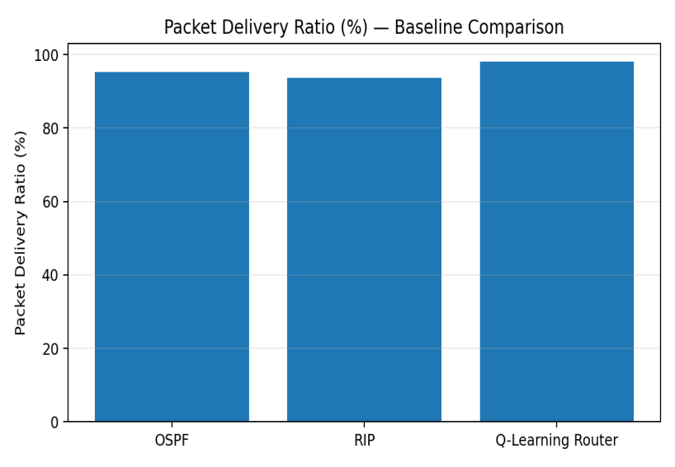
Figure 2. Q-Learning Agent Loop with Live Network Feedback Workflow
All experiments were carried out using a Python-based simulation environment with NetworkX for network topology management and a custom discrete-event packet simulator. The Q-learning agent was trained for 200 episodes on each topology using α = 0.1, γ = 0.9, and an ε-decay range from 0.3 to 0.01. OSPF, using inverse capacity as the link cost, and RIP, using hop count, were used as baseline methods. The reported results were averaged over 30 independent runs with different random seeds.
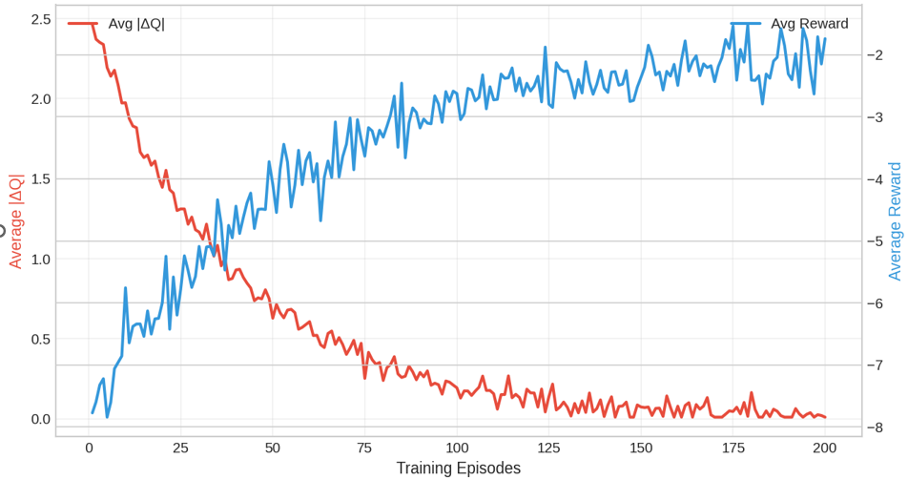
Figure 3. Q-Learning convergence: average absolute Q-value change and episodic reward over 200 training episodes.

Quantitative Results
Metric | OSPF | RIP | Q-Learning Router
Avg. End-to-End Delay (ms) | 45.2 | 52.1 | 28.4
Packet Loss Rate (%) | 4.8 | 6.3 | 1.9
Throughput (Mbps) | 620 | 580 | 785
Packet Delivery Ratio (%) | 95.2 | 93.7 | 98.1
Jitter (ms) | 8.4 | 9.7 | 4.1
Table 2. Aggregate performance comparison on the primary evaluation topology (mean over 30 runs).
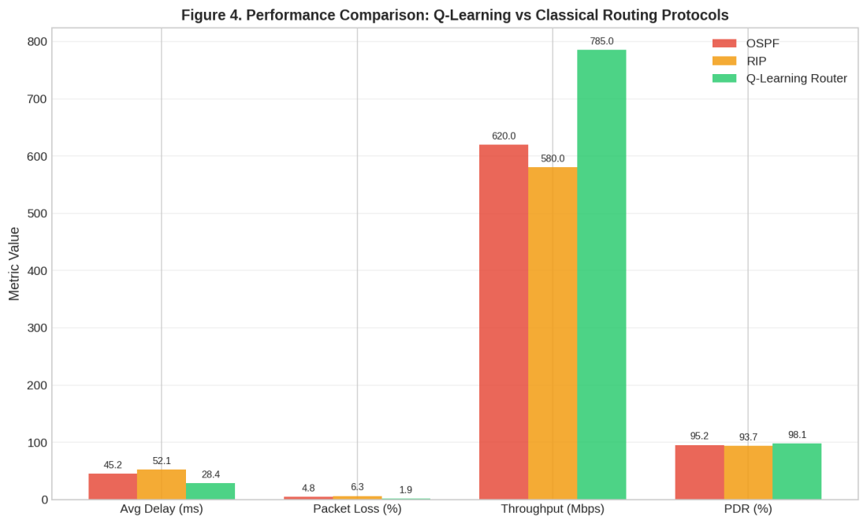
Figure 4. Side-by-side performance comparison of OSPF, RIP, and the proposed Q-Learning Router.
The Q-learning router achieves a 37% reduction in average delay compared with OSPF and a 45% reduction compared with RIP. Packet loss is also reduced by around 60% compared with OSPF, with corresponding improvements in throughput and packet delivery ratio. These improvements are mainly due to the agent’s ability to identify congested links and redirect traffic to better alternatives, unlike traditional routing methods that rely on fixed link costs.
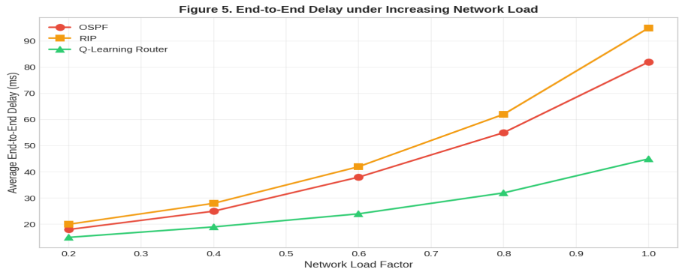
Figure 5. Average end-to-end delay as a function of increasing network load factor.

5. Conclusion
This paper presents a lightweight tabular Q-learning approach for packet routing that provides an alternative between traditional static routing protocols and more computationally demanding deep-RL methods. By considering network conditions such as delay, packet loss, and congestion, the agent can make better routing decisions while keeping the learning process simple and interpretable. The results show that the approach can reduce latency and packet loss on realistic network topologies. Overall, the proposed method provides a practical solution for moderate-sized networks and can also serve as a foundation for future work using more advanced learning models.
Reference
- Dueñas Santos, C. L., et al. (2024). Q-RPL: Q-Learning-Based Routing Protocol for Advanced Metering Infrastructure in Smart Grids. Sensors, 24(15).
2. Li, Jian, et al. An Intelligent SDWN Routing Algorithm Based on Network Situational Awareness and Deep Reinforcement Learning. IEEE Access, vol. 11, 2023.
3. Zhang, Y., et al. (2024). An Intelligent Routing Approach for SDN Based on Improved Dueling DQN Algorithm. Computer Networks.
4.Wang, H., et al. (2024). RL-Based SDN Routing Scheme Empowered by Causality Detection and Graph Neural Networks. Future Generation Computer Systems.
5. Chen, X., et al. QoS Routing Optimization Based on Deep Reinforcement Learning in Software-Defined Networks. IEEE Transactions on Network and Service Management, 2025.
6. Hassen, H., S. Meherzi, and Z. Ben Jemaa. Improved Exploration Strategy for Q-Learning Based Multipath Routing in SDN Networks. Journal of Network and Systems Management, 2024.
7. Shukla, N., et al. Adaptive and Predictive Routing in SDN Using Q-Learning and Neural Networks. International Symposium on Embedded Computing and System Design (ISED), 2025.
8. Bouziane, A., et al. SQBRP-SDFANET: A Scalable Q-Learning-Based Routing Protocol for Software-Defined Flying Ad Hoc Networks. Ad Hoc Networks, 2025.
9. Hao, Y., et al. Q-Learning for Resource-Aware and Adaptive Routing in Trusted-Relay Quantum Key Distribution Networks. IEEE Communications Letters, 2025.
10. Kumar, R., and P. Singh. A Hybrid Reinforcement Learning Approach for Multipath Routing Optimization in Software-Defined Networks. Journal of Network Intelligence, 2025.
11. Ma, X., et al. Dynamic Routing via Reinforcement Learning for Network Traffic Optimization. Expert Systems with Applications, 2025.
12. Liu, Z., et al. DQRL: A Directed Acyclic Graph and Reinforcement Learning-Based Framework for QoS-Centric Routing in Multi-SDNs. IEEE Transactions on Network Science and Engineering, 2025.

