Real-Time Collaborative Document Management System
A Project Based Learning Report Submitted in partial fulfilment of the requirements for the award of the degree

of

Bachelor of Technology
in The Department of Computer Science and Engineering
DATABASE SYSTEMS ENGINEERING AND DISTRIBUTED BACKEND DEVELOPMENT (DBS & DBD) – 25CS1302E

Submitted by
2510030332 : Lakshith
2510030337 : Ranadeep
2510030322 : Rahul
2510030426 : Varshith
2510030430 : Jivith

Under the guidance of
Dr. Sasidhar Kothuru



Department of Computer Science and Engineering
Koneru Lakshmaiah Education Foundation, Aziz Nagar
Aziz Nagar – 500075
OCT - 2026.
Abstract
Teams that write together still lose a surprising amount of time to the same small frustrations: several copies of one file circulating by email, edits that overwrite each other, and no reliable record of who changed what. This report presents DocuSphere, a web-based Real-Time Collaborative Document Management System developed as a Project Based Learning assignment for the course Database Systems Engineering and Distributed Backend Development. The system brings document storage, folder organisation, live co-editing, version history, comments and notifications into a single browser workspace.
DocuSphere follows a layered design. A React and Vite front end talks to a FastAPI back end through REST endpoints and a WebSocket channel. Structured information such as users, folders, document metadata, comments and activity records is kept in PostgreSQL, which is also prepared with the pgvector extension for future semantic search. The text of each document and its saved revisions is held in MongoDB, and Apache Kafka carries notification events away from the editing path so that slow consumers never delay a user. Access is protected with JWT based authentication.
The system was verified through repeatable checks on document retrieval, persistence after refresh, ordering and restoration of versions, and two-session collaboration. The report describes the requirements, architecture, database design, working of each module, test strategy and observed behaviour, and closes with the limitations of the present build and a roadmap for improvement.
Keywords—Collaborative editing, document management, FastAPI, WebSocket, PostgreSQL, MongoDB, Kafka, version history, JWT

List of Figures
Fig. 1. Use case diagram of DocuSphere showing the document owner and collaborator 8
Fig. 2. Iterative development phases followed in the project 9
Fig. 3. Layered architecture of DocuSphere 10
Fig. 4. Entity relationship diagram of the PostgreSQL schema and its link to MongoDB 10
Fig. 5. Token based authentication sequence 11
Fig. 6. Sequence of messages during live editing between two clients 12
Fig. 7. Saving a revision and restoring an earlier revision 13
Fig. 8. Kafka based notification pipeline 13
Fig. 9. Login screen of DocuSphere 16
Fig. 10. Dashboard listing documents, folders and search 17
Fig. 11. Editor with online collaborators and a typing indicator 17
Fig. 12. Version history with preview and restore action 18
Fig. 13. Comments panel attached to a document 18

List of Tables
TABLE I. Comparison of document sharing approaches 7
TABLE II. Functional requirements of DocuSphere 8
TABLE III. Non-functional requirements 8
TABLE IV. Technology stack and the role of each component 9
TABLE V. Main entities of the PostgreSQL schema 11
TABLE VI. MongoDB collections 11
TABLE VII. Main API resources of the back end 14
TABLE VIII. Design challenges and the response adopted 15
TABLE IX. Test plan for the verification of DocuSphere 16
TABLE X. Summary of verification outcomes 19
TABLE XI. Potential user groups and expected benefits 19

Table of Contents
I. Introduction 6
A. Background 6
B. Problem Statement 6
C. Objectives 6
D. Scope and Limitations 6
E. Organisation of the Report 6
II. Literature Review 7
A. Approaches to Concurrent Editing 7
B. Storage of Documents and Metadata 7
C. Messaging and Notifications 7
D. Comparison with Common Sharing Methods 7
III. System Analysis and Requirements 7
A. Users and Use Cases 7
B. Functional Requirements 8
C. Non-Functional Requirements 8
D. Technology Stack 9
IV. Methodology 9
A. Development Approach 9
B. System Architecture 9
C. Database Design 10
D. Data Integrity and Indexing 11
E. Authentication and Authorisation 11
F. Real-Time Collaboration 12
G. Version Management 12
H. Notification Pipeline 13
I. REST Interface 13
J. Front-End Design 14
K. Security Considerations 14
V. System Working 14
A. Registration and Login 14
B. Dashboard and Folders 14
C. Opening and Editing a Document 14
D. Saving and Persistence 15
E. History, Restore and Comments 15
F. Error Handling 15
G. A Typical Session 15
H. Design Challenges and Responses 15
VI. Experiments 15
A. Objective and Method 15
B. Test Environment 15
C. Test Data and Acceptance Criteria 16
D. Test Plan 16
VII. Results 16
A. Authentication and Dashboard 16
B. Live Editing and Presence 17
C. Version History 17
D. Comments and Notifications 18
E. Summary of Outcomes 18
F. Discussion 19
VIII. Applications and Societal Utility 19
A. Innovative and Sustainable Features 19
B. Potential Users 19
C. Responsible Use 19
IX. Conclusion and Future Work 19
References 20

Real-Time Collaborative Document Management System

Introduction

Background
Almost every project, whether it is a college report, a product specification or a set of meeting notes, passes through many hands before it is finished. In practice that journey is often messy. A draft is mailed to four people, each of them saves a private copy, and a week later nobody is certain which file carries the latest changes. File names such as final, final2 and final_reallyfinal are a familiar joke because they describe a genuine problem: when documents live in scattered places, the time spent reconciling them starts to rival the time spent writing them.
Hosted office suites have reduced this pain for many teams, yet the way they work is largely hidden from the people who use them. For students of database and backend engineering the underlying questions are far more interesting than the finished interface. How should the text of a document be stored so that it can be read and written quickly? Where do the rules about who may open a file belong? How can two browsers see the same paragraph change within a moment of each other, and what should happen to the record of earlier versions? Answering these questions touches data modelling, network protocols, messaging and security, which is exactly the mix of topics covered in our course.
DocuSphere was built to explore those questions through a working system. It is a browser based workspace in which users can create documents, arrange them in folders, edit them together at the same time, review earlier versions, discuss the content through comments, and receive notifications about activity that concerns them. The project goal stated in our review presentations was simple: reduce scattered files and slow review cycles by making document work shared, searchable and easy to trace.

Problem Statement
Conventional ways of sharing documents, namely email attachments and shared drive folders, give no live view of who is working on a file, keep no dependable history of changes, and separate the discussion about a document from the document itself. As a result, collaborators duplicate work, overwrite each other and lose context. The problem addressed in this project is to design and implement a centralised web system that stores documents securely, lets several authenticated users edit one document simultaneously, preserves every saved revision for review and restoration, and records activity so that changes can be traced to people.

Objectives
The work was planned around the following objectives.
- To build a central workspace where documents and folders can be created, organised, searched and opened from any modern browser.
- To support live collaboration, including synchronised edits, a visible list of online users and typing signals, using WebSockets.
- To keep a version history of every saved document so that earlier content can be viewed and restored without losing later work.
- To attach comments to documents and to deliver notifications through an asynchronous messaging pipeline.
- To combine a relational database, a document database and a message broker in a way that gives each technology a clear responsibility.
- To protect data with token based authentication and to design the API so that access checks are applied consistently.

Scope and Limitations
The present build concentrates on the core collaboration workflow: sign in, organise, open, edit together, save, review history and discuss. Features that belong to a production grade product, such as granular role management screens, offline editing, export to office formats and automated backups, are considered future work and are listed in the final section. The evaluation reported here is functional. We verified correctness, consistency and persistence through test cases and deliberately avoid claims about large scale performance that we have not measured.

Organisation of the Report
Section II reviews the ideas behind concurrent editing and storage. Section III analyses the requirements and the technology choices. Section IV explains the methodology, including the architecture, database design, authentication, real-time layer, version management and notification pipeline. Section V describes how the finished system works from a user's point of view. Section VI sets out the experiments and test plan, Section VII presents the results with screens from the application, Section VIII discusses innovation and the value of the system to its users, and Section IX concludes with limitations and future directions.

Literature Review

Approaches to Concurrent Editing
The oldest strategy for letting several people share one file is to prevent them from touching it together. Check-in and check-out systems and simple file locks follow this idea. They are easy to reason about, but they turn collaboration into a queue and are poorly suited to teams that want to write side by side. Research on groupware therefore moved towards allowing simultaneous edits and repairing conflicts automatically. Ellis and Gibbs described operational transformation, in which each edit is adjusted against concurrent edits so that all replicas reach the same text [1]. Later work by Sun and colleagues refined the idea with formal properties such as convergence, causality preservation and intention preservation [2].
A second family of solutions, conflict-free replicated data types, avoids transformation altogether by designing the data structure so that concurrent changes merge in a predictable way regardless of the order in which they arrive [3]. Both families are powerful and both are demanding to implement correctly. For a course project with a limited timeline we chose a simpler model in which edits made inside a document session are broadcast through a WebSocket room to the other participants, and the full content is persisted with a debounced save. The trade-offs of this choice, and the path to a stronger conflict strategy, are discussed in the conclusion.

Storage of Documents and Metadata
Relational systems remain the natural home for data with strict structure and relationships, such as users, folders, permissions and comments, because they offer transactions, constraints and flexible queries [4], [5]. Free-form document content behaves differently. It varies in size, is read and written as a whole, and is saved again and again as revisions. Document oriented databases handle that pattern comfortably. Using both in the same system is often called polyglot persistence, and it is the pattern we adopted: PostgreSQL for structured records [11], MongoDB for content and version snapshots [12].

Messaging and Notifications
Notifications are a classic example of work that should not sit inside the request that triggered it. Saving a comment must feel instant, whereas telling every interested user about it can happen a moment later. Log based brokers such as Apache Kafka were designed for this kind of decoupling, offering durable, ordered and partitioned streams that producers and consumers read at their own pace [6]. DocuSphere uses Kafka to separate event creation from event delivery.

Comparison with Common Sharing Methods
Table I compares the main ways in which teams share documents with the approach taken in this project. The comparison is qualitative and describes general characteristics rather than any single commercial product.
- Comparison of document sharing approaches
Aspect | Email attachments | Shared drive folder | Hosted office suite | DocuSphere
Single central copy | No | Partly | Yes | Yes
Simultaneous editing | No | No | Yes | Yes
Online presence shown | No | No | Yes | Yes
Revision history | Manual copies | Limited | Yes | Yes, restorable
Comments on the file | Separate emails | Separate chat | Yes | Yes
Activity record | None | Limited | Varies | Activity log
Open to study and extend | Not applicable | Not applicable | Closed internals | Fully open design

System Analysis and Requirements

Users and Use Cases
Two kinds of actors interact with the system. A document owner creates documents and folders and decides who may share them. A collaborator works on documents that have been shared with them. Both must be authenticated. Fig. 1 shows the main use cases that the system supports and how the two actors relate to them.
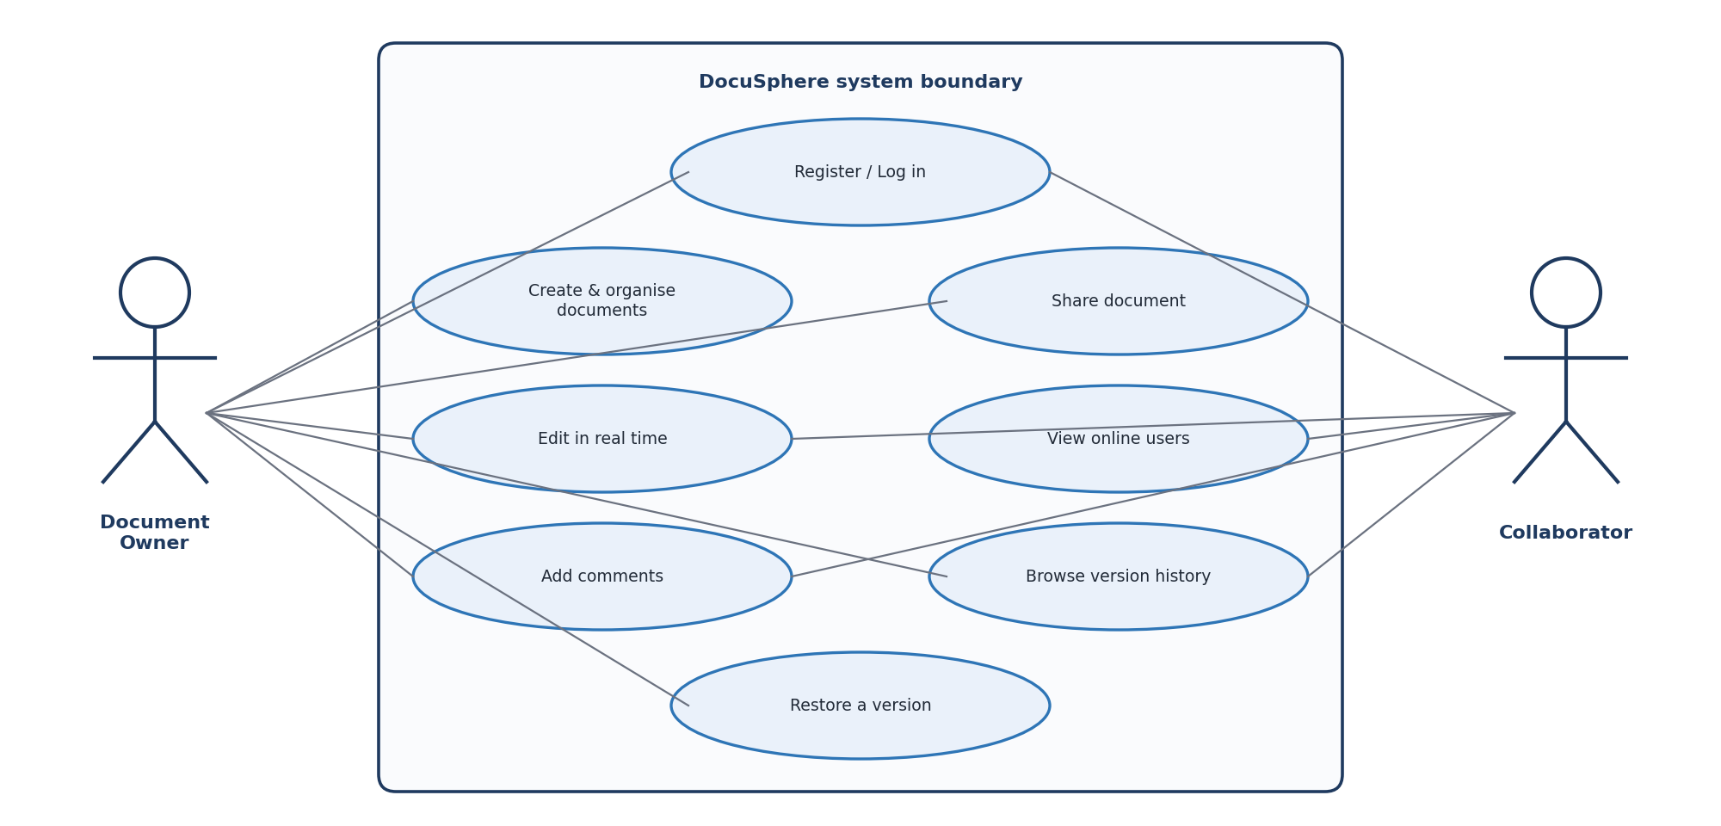
- Use case diagram of DocuSphere showing the document owner and collaborator

Functional Requirements
The functional requirements were collected from the project objectives and from discussions during the review sessions. They are summarised in Table II together with a priority that guided the order of implementation.
- Functional requirements of DocuSphere
ID | Requirement | Description | Priority
FR1 | User authentication | Users register and log in; the server issues a signed token for later requests. | High
FR2 | Document management | Create, rename, open, update and delete documents inside folders. | High
FR3 | Folder organisation | Group documents in folders and list them on a dashboard with basic search. | Medium
FR4 | Live editing | Changes made by one user appear in other open sessions of the same document. | High
FR5 | Online presence | Show which collaborators are currently viewing a document and when someone is typing. | Medium
FR6 | Persistence | Save document content so that the latest text remains after refresh or re-login. | High
FR7 | Version history | Keep ordered revisions, allow preview and restoration of any revision. | High
FR8 | Comments | Attach discussion threads to a document and show them to collaborators. | Medium
FR9 | Notifications | Inform users about relevant activity through an asynchronous pipeline. | Medium
FR10 | Activity record | Log significant actions with user, document and time for traceability. | Medium

Non-Functional Requirements
Beyond features, the system has to behave well. Table III lists the qualities we set as targets. These are design goals that shaped the architecture, not performance claims, and each one is linked to a decision described later in the report.
- Non-functional requirements
Attribute | Requirement | Design response
Security | Only authenticated users reach documents; passwords are never stored in plain text. | JWT bearer tokens, hashed passwords, access check on every endpoint.
Consistency | The text a user saved must be the text returned later. | Single write path through the API, revision stored for every save.
Responsiveness | Editing should feel immediate, with background work kept off the request path. | WebSocket updates, debounced saves, Kafka for notifications.
Maintainability | Parts of the system can be changed or tested independently. | Separate front end, API and data services with clear responsibilities.
Extensibility | New features such as search should fit without redesign. | Metadata schema and pgvector prepared for semantic search.
Usability | Common actions are reachable within a few clicks in the browser. | Dashboard, toolbar editor and side panels for history and comments.

Technology Stack
Each technology in the stack was chosen for a specific reason, and the intent was that no component would be doing a job that another could do better. Table IV summarises the stack.
- Technology stack and the role of each component
Layer | Technology | Role in DocuSphere
Front end | React with Vite | Component based interface for login, dashboard, editor, history and comments; fast development builds.
Back end | FastAPI (Python) | REST endpoints, WebSocket handling, request validation and JWT authentication.
Real-time channel | WebSocket | Two-way connection for live updates, presence and typing signals.
Relational store | PostgreSQL with pgvector | Users, folders, document metadata, access, comments and activity records; vector capability for later search.
Document store | MongoDB | Document content and version snapshots.
Messaging | Apache Kafka | Producer and consumer pipeline for notification events.
Security | JSON Web Token | Stateless proof of identity attached to every protected request.

FastAPI was attractive because it validates request data automatically, supports asynchronous handlers and WebSockets in the same application, and generates interactive API documentation that was handy during testing [7]. React gave us reusable components for the toolbar, document list and side panels [8], and Vite kept rebuild times short.

Methodology

Development Approach
The project was carried out iteratively across the review cycles of the course. We began with requirement analysis and the data model, then built the back end interfaces, added the real-time layer, connected the user interface and finally concentrated on testing and the demonstration. Feedback gathered at each review sent us back to earlier phases when something needed to be corrected, which is why the process in Fig. 2 is drawn with a return path. Working in short loops also let us test the database and the API before the interface existed, so that most defects were found early.
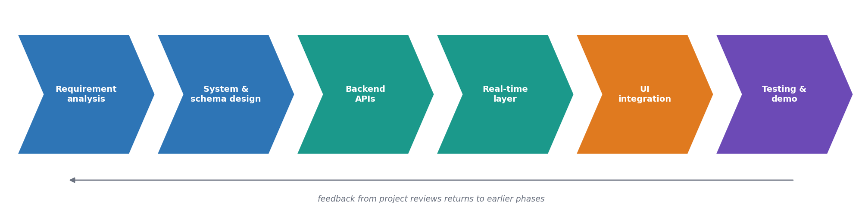
- Iterative development phases followed in the project

System Architecture
DocuSphere is organised into three layers, shown in Fig. 3. The presentation layer is a single page application that runs in the browser. It renders the dashboard and editor, keeps a WebSocket connection open while a document is displayed, and calls the REST interface for everything that needs a request and a response. The application layer is the FastAPI service. It authenticates callers, applies business rules, and coordinates the stores. The data and messaging layer holds the information: PostgreSQL for structured records, MongoDB for document content and revisions, and Kafka for events that are delivered asynchronously.
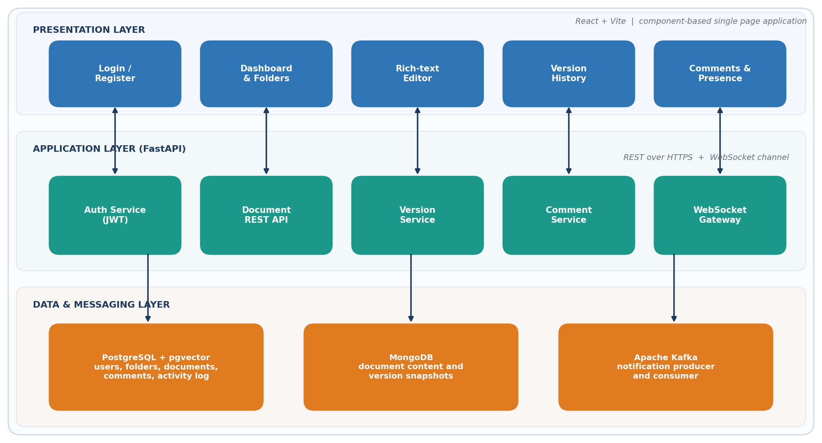
- Layered architecture of DocuSphere
The guiding principle is that every component has one clear responsibility. The front end never talks to a database directly, the API is the only writer of data, and notification delivery is kept apart from document saving. This separation makes each part easier to test in isolation and easier to replace later, for example by moving the notification consumer into its own service.

Database Design
The relational model is shown in Fig. 4. Users own folders and documents, documents may belong to a folder, and a separate access table records which users may open which documents and with what permission. Comments and activity records both point back to a document and to the user who produced them. Table V describes the main entities and their purpose.
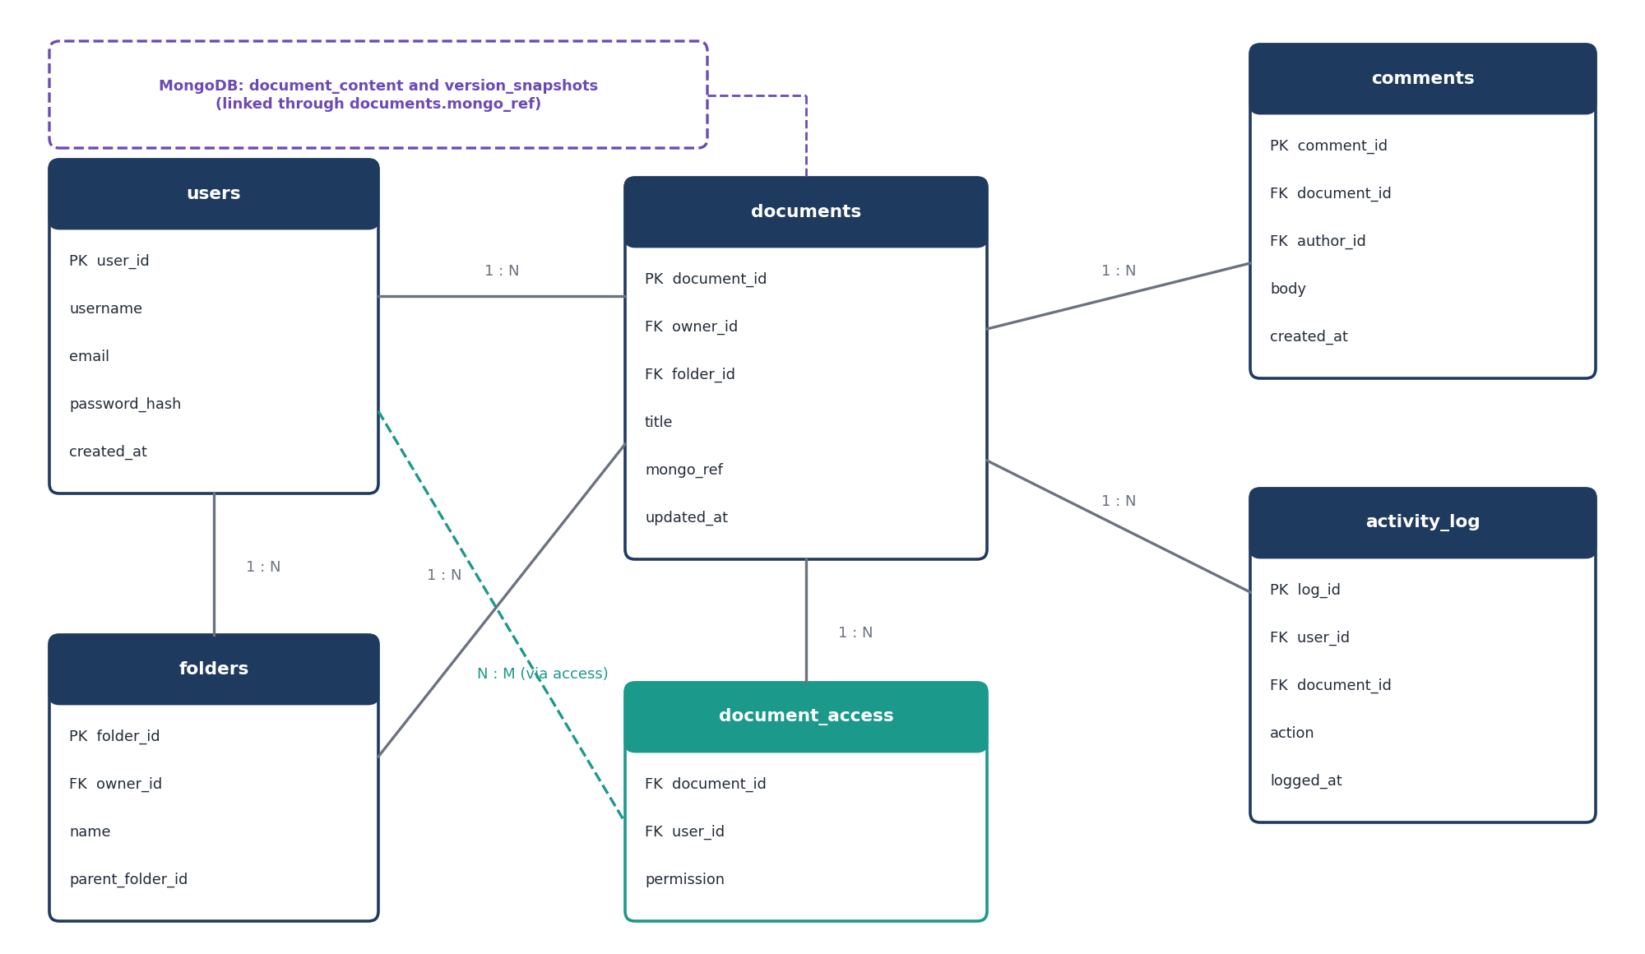
- Entity relationship diagram of the PostgreSQL schema and its link to MongoDB
- Main entities of the PostgreSQL schema
Entity | Key attributes | Purpose
users | user_id, username, email, password_hash, created_at | Registered accounts; only a hash of the password is stored.
folders | folder_id, owner_id, name, parent_folder_id | Hierarchical grouping of documents for each owner.
documents | document_id, owner_id, folder_id, title, mongo_ref, updated_at | Metadata of a document and the reference to its stored content.
document_access | document_id, user_id, permission | Which users may open a shared document and at what level.
comments | comment_id, document_id, author_id, body, created_at | Discussion attached to a document.
activity_log | log_id, user_id, document_id, action, logged_at | Trace of important actions for accountability.

The text of each document is deliberately not stored in these tables. Content changes constantly, is read and written as one block, and produces a new revision at every save. A document database fits that access pattern better than rows and columns. Table VI lists the MongoDB collections. The two databases are connected by a single reference, mongo_ref, held in the document metadata.
- MongoDB collections
Collection | Typical fields | Purpose
document_content | document_ref, title, body, last_saved_by, last_saved_at | The current text of every document.
version_snapshots | document_ref, revision_number, body, saved_by, saved_at | One entry per saved revision, ordered by revision number.

Keeping metadata relational has a further benefit. Foreign keys protect integrity, so a comment can never refer to a document that does not exist, and queries such as listing every document a user may open are simple joins. The pgvector extension [13] adds a column type for embeddings inside the same PostgreSQL instance, which means that semantic search can be added later without introducing yet another database.

Data Integrity and Indexing
A schema is only useful if it stays correct as the application grows, so a few integrity rules were fixed early. Every table has a primary key, relationships are expressed with foreign keys, and the tables are kept in third normal form so that a fact such as a user's email address is stored in exactly one place. Deleting a document removes its access, comment and activity rows together, which avoids orphan records that would otherwise confuse the interface later.
Indexes follow the questions the application asks most often. The dashboard needs every document a user owns or may open, so the owner column and the combination of document and user in the access table are indexed. The comments panel loads all comments for one document in time order, which an index on the document column and creation time serves directly. In MongoDB the revision collection is indexed on the document reference and revision number, so that the history list and the preview of a single revision are both direct lookups rather than scans. None of this is exotic, but it keeps the common operations cheap as the number of documents increases.

Authentication and Authorisation
When a user logs in, the API looks up the account, compares the supplied password with the stored hash and, if they match, returns a signed JSON Web Token [9]. The browser attaches the token as a bearer credential to each later request. The server verifies the signature and expiry before running any handler, so no session state has to be kept in memory. The same token is presented when the WebSocket connection is opened, which means that live editing is protected in the same way as the REST interface. Fig. 5 shows the sequence.
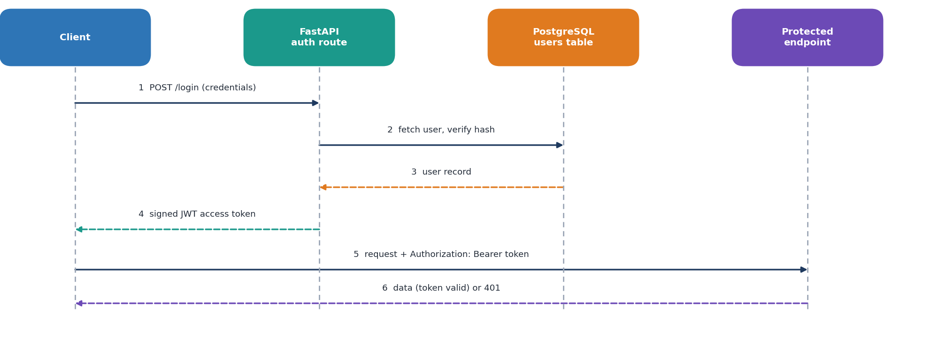
- Token based authentication sequence
Authentication answers the question of who is calling. Authorisation answers what that person may do, and in DocuSphere it is decided from the ownership and access records in PostgreSQL. An owner can always open and change their own document, while a collaborator is allowed only what the access record grants. Because the check is performed in the API and never in the browser, hiding a button in the interface is never the only protection.

Real-Time Collaboration
Live editing relies on the WebSocket protocol, which keeps a single connection open between browser and server so that either side can send a message at any moment [10]. When a user opens a document, the front end connects to a channel for that document and the server places the connection in a room. The server then tells everyone in the room that a new participant has joined, and the editor shows the updated list of online collaborators. Fig. 6 illustrates what happens during a typical exchange.
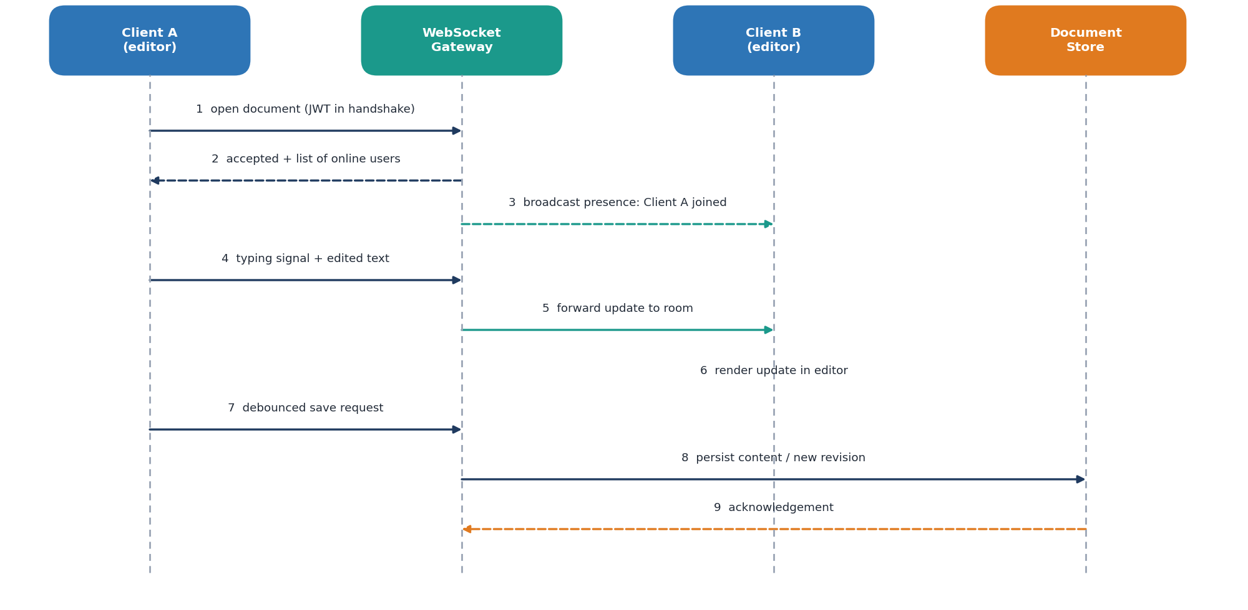
- Sequence of messages during live editing between two clients
Three kinds of messages travel through the room. Presence messages announce that someone has arrived or left. Typing signals tell other participants that a colleague is currently writing, which avoids two people unknowingly working on the same sentence. Update messages carry the edited text, and the server forwards each one to every other connection in the room. Saving is handled separately. The editor waits until the user pauses before sending a save request, which prevents a flood of database writes while someone is typing quickly.
Messages on the socket are small structured objects with a type field and a payload. A join message carries the identity of the arriving user, a typing message carries only the identity and a flag, and an update message carries the edited text together with the document identifier. Keeping the format uniform let the server route every message with one handler and let the front end react to each type with a single switch. When a connection closes, either because the user left or because the network failed, the server removes it from the room and announces the departure, which is why the online counter stays accurate even when a browser tab is simply closed.

Version Management
Every successful save creates a revision rather than overwriting the previous text. The API stores the new content, increments the revision number in the snapshot collection, refreshes the metadata in PostgreSQL and records the action in the activity log. The save flow is drawn in Fig. 7(a). When a user opens the history panel the system returns the revisions in order, the user can preview any of them, and choosing to restore one copies its text forward as the newest revision, as in Fig. 7(b). Restoring therefore never destroys later work; the earlier text simply becomes current again and the history keeps growing.
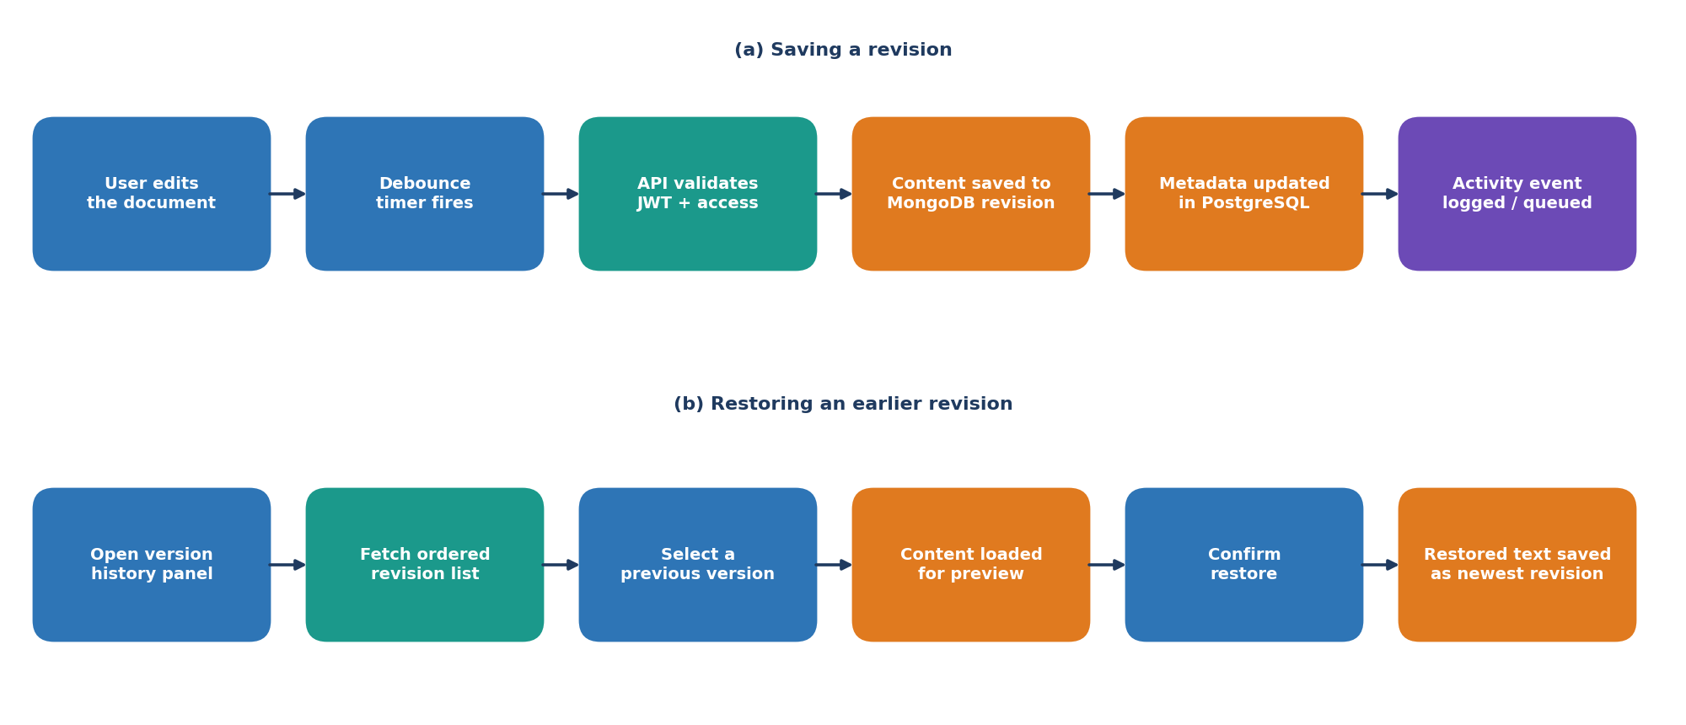
- Saving a revision and restoring an earlier revision

Notification Pipeline
Events that other users should hear about, such as a new comment, a document that has been shared or a version that was restored, are published to a Kafka topic by the API. A consumer reads the topic, stores a notification for each affected user and, if that user is online, pushes it through their open connection. Because the producer only has to hand the event to the broker, the user who wrote the comment is not kept waiting. If the consumer is slow or temporarily stopped, events remain in the log and are processed when it returns. Fig. 8 shows the flow.
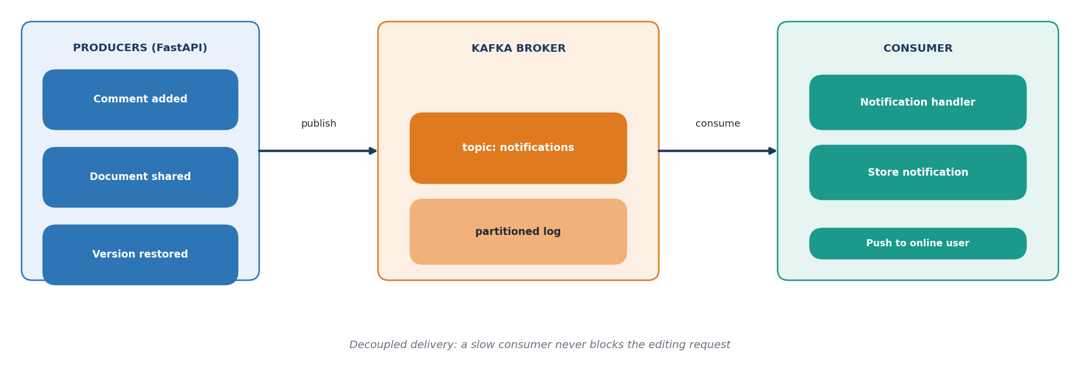
- Kafka based notification pipeline

REST Interface
Operations that need a request and a reply are exposed as REST endpoints. Table VII lists the main resources. Request bodies are validated by the framework, and unauthorised or malformed calls receive clear status codes such as 401 and 422 instead of generic errors.
- Main API resources of the back end
Method | Path | Purpose
POST | /auth/register | Create a new user account.
POST | /auth/login | Verify credentials and return a signed token.
GET | /documents | List documents the caller may open, optionally filtered by folder or search text.
POST | /documents | Create a document in a folder.
GET | /documents/{id} | Return the title and saved content of a document.
PUT | /documents/{id} | Save new content and create a revision.
GET | /documents/{id}/versions | List saved revisions in order.
POST | /documents/{id}/versions/{rev}/restore | Make an earlier revision current as a new revision.
GET / POST | /documents/{id}/comments | Read or add comments on a document.
WS | /ws/documents/{id} | Live channel for presence, typing signals and updates.

Front-End Design
The user interface is built from a small number of focused components: the login page, the dashboard with its folder panel and document list, the editor with its toolbar, and two side panels for version history and comments. Each component owns only the state it needs. For example, the editor keeps the current text and the connection status, while the dashboard keeps the list and the search term. Shared information such as the signed-in user and the token is held once at the top of the application and passed down, so that every request automatically carries the same credential. Keeping components small made it possible for team members to work on different screens in parallel without constantly colliding in the same files.
The interface also follows a few simple usability rules. Actions that change data give immediate visual feedback, long operations show a status label instead of freezing the screen, and destructive actions ask for confirmation. The side panels open next to the document instead of replacing it, so a reader can compare an old revision or read a comment without losing their place.

Security Considerations
Because DocuSphere stores working documents, security was treated as a design input and not as an afterthought. The main measures are listed below.
- Passwords are stored only as salted hashes, so a leaked table does not reveal them.
- Tokens are signed and carry an expiry time, and the server rejects any token that fails verification.
- Authorisation is checked in the API for every document operation, never only in the browser.
- Input is validated by the framework before it reaches business logic, which reduces the chance of malformed data entering the stores.
- Database access goes through parameterised queries and a driver layer, avoiding string-built statements.
- Significant actions are written to the activity log, giving administrators a trail to inspect when something unexpected happens.
These measures cover the main risks for a prototype. A production deployment would add transport encryption on every connection, rate limiting on the login route, secret management for keys and credentials, and regular backups of both databases.

System Working

Registration and Login
A new visitor lands on the login page and can either sign in or create an account. During registration the server checks that the email is not already in use, hashes the password and stores the user record. After a successful login the browser receives the token, keeps it for the session and redirects to the dashboard. Requests made without a valid token are rejected, so a bookmarked document link takes an unauthenticated visitor back to the login screen instead of exposing content.

Dashboard and Folders
The dashboard lists the documents the user owns or has been given access to, along with the owner, the time of the last edit and a short status such as the number of people currently online. A side panel groups documents into folders, and a search box narrows the list by title. Creating a document inserts a metadata row in PostgreSQL and an empty content record in MongoDB, so a new file is immediately ready to open.

Opening and Editing a Document
Selecting a document requests its title and content through the API and, in parallel, opens the WebSocket channel. The editor shows the text with a toolbar for basic formatting. As soon as a second collaborator opens the same file, avatars appear beside the title and the online counter changes. While one person types, the others see a short typing indicator, and the edited text appears in their editor without any refresh.

Saving and Persistence
Saving is automatic. After the user stops typing for a short interval, the editor sends the full content to the API. The status label beside the title changes from a saving message to a confirmation once the server has acknowledged the write. This confirmation matters for correctness: the interface only claims that changes are saved after the back end has actually stored them, so refreshing the page at that point always returns the same text.

History, Restore and Comments
The history panel lists revisions from newest to oldest together with the author and time. Selecting an entry previews its content next to the list, and a single action restores it. The comments panel sits beside the document and shows the thread with the author's initial, the time and the message. Adding a comment stores it in PostgreSQL, writes an entry to the activity log and publishes an event so that the other collaborators are notified.

Error Handling
Failures are expected in any networked application, so the system reports them rather than hiding them. An expired token produces a 401 response and returns the user to the login page. A validation problem returns a descriptive 422 response that the interface can show beside the field. If the WebSocket connection drops, the editor displays an offline notice and keeps the unsaved text in the browser until the connection returns, instead of discarding it.

A Typical Session
To see how the parts fit together, consider a short session. Lakshith signs in and opens the project report from the dashboard. The browser receives the saved text through the API and opens the live channel, and the server announces his arrival to Rahul, who already has the same file open. Rahul begins a paragraph, Lakshith sees the typing indicator, and a few seconds later the new text appears in his editor. When Rahul pauses, his browser sends a save request, the server stores a new revision and the status label confirms it. Lakshith adds a comment asking for a clarification, which is saved, logged and published to the notification topic. Later, noticing that a paragraph was removed by mistake, he opens the history panel, previews an earlier revision and restores it. At no point did anyone have to exchange a file, and every step is recorded.

Design Challenges and Responses
Building a collaborative system raises problems that a single-user application never meets. Table VIII lists the main ones that influenced the design and the response chosen for each.
- Design challenges and the response adopted
Challenge | Why it matters | Response in DocuSphere
Frequent saves while typing | Saving on every keystroke would flood the databases. | Debounced save that fires after the user pauses.
Honest save status | Users must know when text is really stored. | Label changes only after the API acknowledges the write.
Losing earlier work | Overwriting makes mistakes permanent. | Every save and every restore creates a new revision.
Slow side tasks | Notification delivery must not delay editing. | Events are published to Kafka and consumed separately.
Unauthorised access | Document links can be shared or guessed. | Token verification and access checks on every endpoint and socket.
Connection loss | Networks drop without warning. | Editor keeps unsaved text locally and shows an offline notice.

Experiments

Objective and Method
The purpose of the experiments was to establish that the system behaves correctly and consistently, not to rank its speed against other products. Our review plan focused on four areas: retrieval of the right document, persistence after refresh, ordering and restoration of versions, and collaboration between two sessions. We added authentication and comments because they are essential to the workflow. Each check follows the same pattern of stating the objective, performing the action and comparing the observed outcome with the expected one.

Test Environment
Testing was done on a development machine with the React application served by Vite, the FastAPI service running locally, and PostgreSQL, MongoDB and Kafka started as local services. Two browser windows, one of them in a private session, represented two different users so that live behaviour could be observed from both sides. The REST interface was also exercised directly through the interactive documentation page generated by the framework, which made it easy to submit invalid input and confirm the error responses.

Test Data and Acceptance Criteria
Test accounts were created for each team member so that every scenario could be repeated with the same starting state. A small set of documents of different lengths was prepared, including an empty document, a short note and a longer report draft, because empty and long content are the situations most likely to expose mistakes in saving and rendering. A test was accepted only if the observed behaviour matched the expected outcome exactly. A result that was almost right, for example a revision list that was complete but in the wrong order, was recorded as a failure and fixed before the test was repeated. Each test was run more than once, including after restarting the services, to make sure that the outcome did not depend on leftover state.

Test Plan
Table IX lists the test cases. Each one has an identifier that is reused in the results section, so a reader can move from the intended behaviour to the observed behaviour without ambiguity.
- Test plan for the verification of DocuSphere
ID | Feature | Procedure | Expected outcome
T1 | Login | Submit valid and then invalid credentials. | Valid login returns a token and opens the dashboard; invalid login is refused with a clear message.
T2 | Protected access | Call a document endpoint without a token. | The request is rejected with status 401.
T3 | Document retrieval | Open a document from the dashboard by its identifier. | The title and content shown match the stored record.
T4 | Persistence | Edit text, wait for the saved label, refresh the page. | The latest text is still present after reload.
T5 | Version ordering | Save several edits, then open the history panel. | Revisions appear in order with author and time.
T6 | Version restore | Preview an older revision and restore it. | The older text becomes current and appears as the newest revision.
T7 | Live editing | Edit in one session while a second session has the same document open. | Text appears in the second session without refresh.
T8 | Presence and typing | Open the document in two sessions and type in one. | Online users are listed and a typing indicator is shown.
T9 | Comments | Add a comment in one session. | The comment appears for the other collaborator and an activity record is written.

Results

Authentication and Dashboard
The first result concerns access. The login page of the application is shown in Fig. 9. Entering valid credentials opened the dashboard in Fig. 10, while a protected request made without a token was refused, which confirmed that the front end is not the only line of defence. The dashboard lists documents with the owner, the time of the last edit and a status, and the folder panel on the left allows the list to be narrowed.
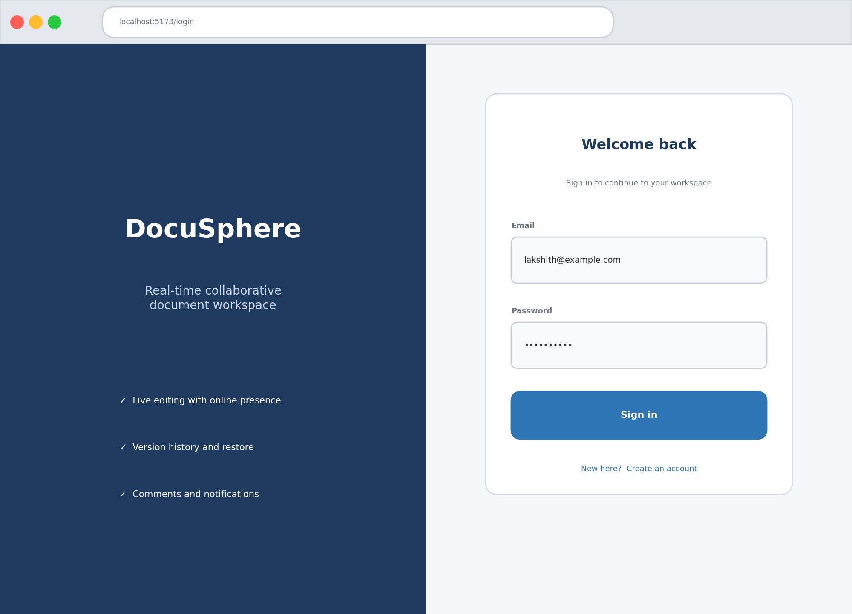
- Login screen of DocuSphere
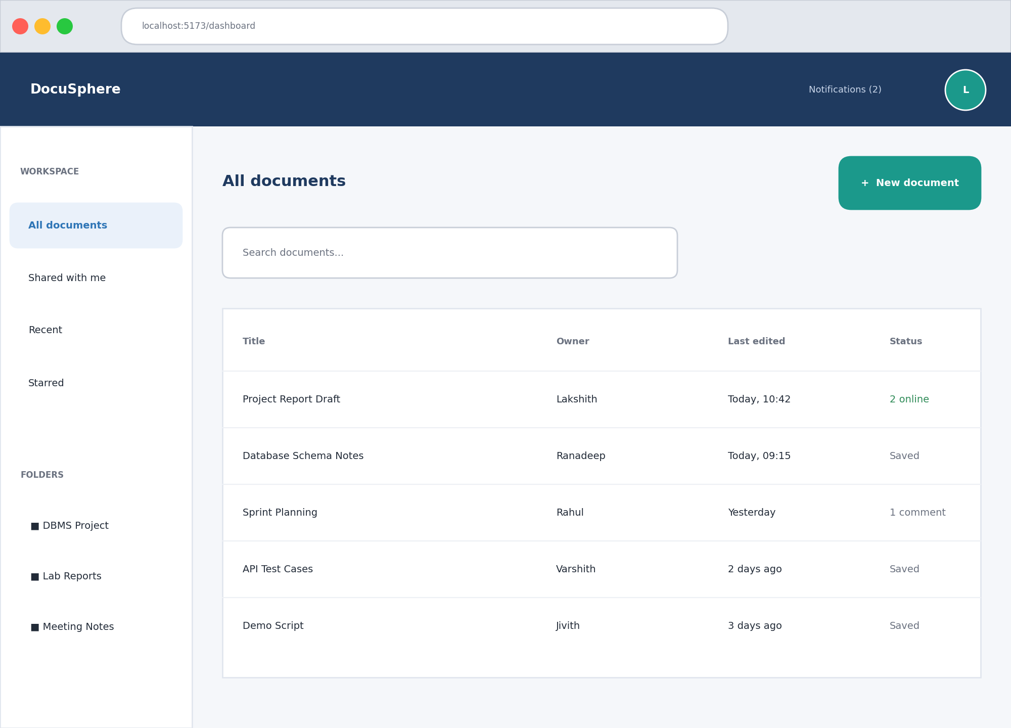
- Dashboard listing documents, folders and search

Live Editing and Presence
Fig. 11 shows the editor with two other collaborators connected. Their avatars and the online counter appear in the title bar, and a typing indicator marks the position where a colleague is writing. In the two-session test the text typed in one window appeared in the other without any refresh, and the saved label returned once the content had been written to the store.
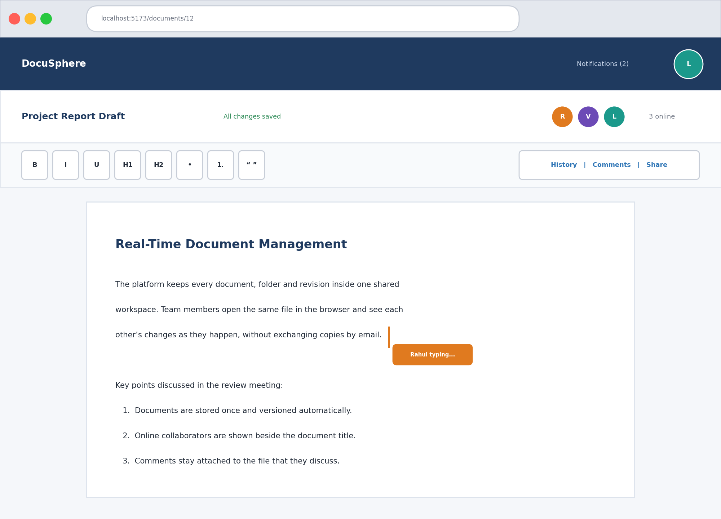
- Editor with online collaborators and a typing indicator

Version History
The history view in Fig. 12 lists revisions from newest to oldest and previews the selected one beside the list. When an older revision was restored, its text became the newest entry in the list and the previous latest version remained available, which matches the intended behaviour of restoring as a new revision.
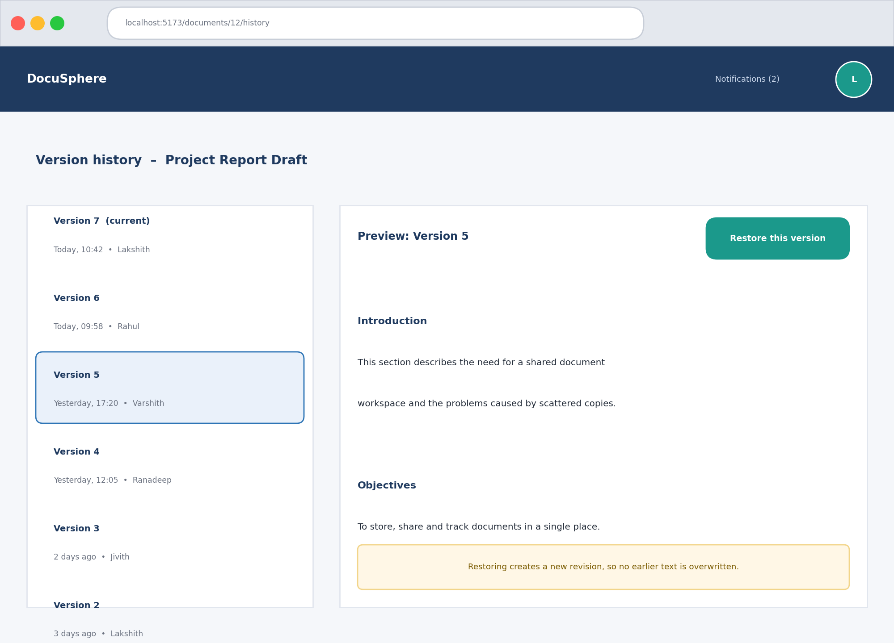
- Version history with preview and restore action

Comments and Notifications
The comments panel in Fig. 13 keeps the discussion next to the text it refers to. A comment added in one session was visible to the other participant, and the corresponding notification event was produced for delivery. Because the event travels through Kafka, the author of the comment did not have to wait for delivery to finish.
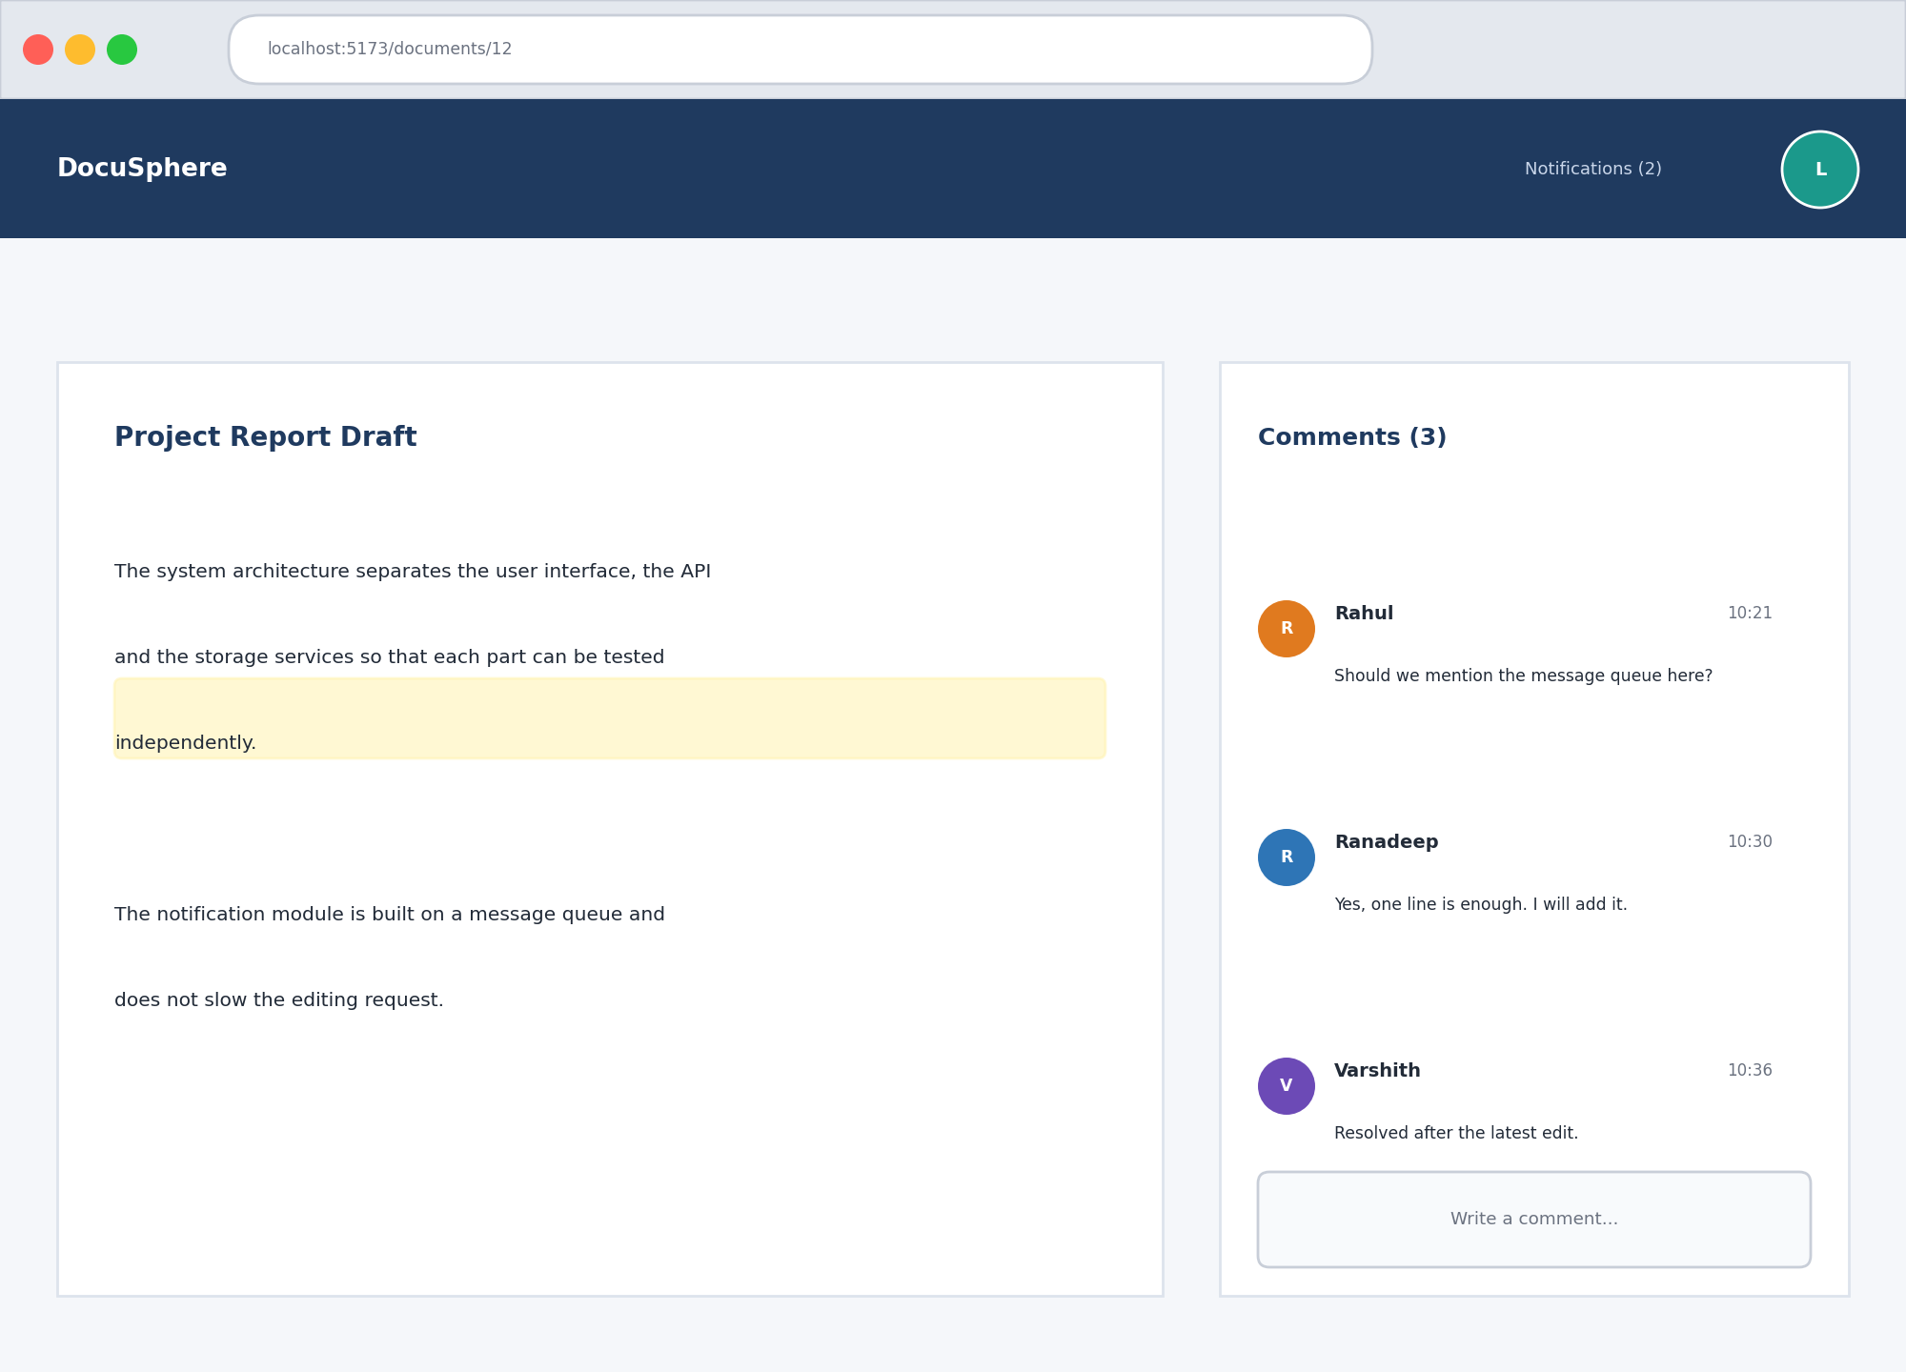
- Comments panel attached to a document

Summary of Outcomes
Table X summarises what was observed for each planned test. The results refer to the functional behaviour defined in the test plan. We have not attempted to publish figures for response time or user capacity, because those would need a separate, repeatable load test.
- Summary of verification outcomes
ID | Feature | Observed behaviour | Result
T1 | Login | Valid credentials opened the dashboard; wrong credentials showed an error. | Pass
T2 | Protected access | Request without a token received a 401 response. | Pass
T3 | Document retrieval | Selected document returned the matching title and content. | Pass
T4 | Persistence | Latest text remained after a page refresh. | Pass
T5 | Version ordering | Revisions were listed in order with author and time. | Pass
T6 | Version restore | Restored text appeared as the newest revision. | Pass
T7 | Live editing | Edits appeared in the second session without refresh. | Pass
T8 | Presence and typing | Online users and typing indicator were displayed. | Pass
T9 | Comments | Comment was visible to the collaborator and logged. | Pass

Discussion
Taken together, the results show that the central promise of the project holds: documents live in one place, several people can work on them at once, and earlier states are never lost. The layered design also paid off during testing, because failures could be traced to a single layer quickly. At the same time the evaluation exposed the limits of the current approach. Updates are forwarded as edited text, so when two people change the same passage in the same instant the later message wins. That is acceptable for a prototype and for small teams, but it is the first thing a production version should improve.

Applications and Societal Utility

Innovative and Sustainable Features
Several features of the project go beyond a basic file store. Live collaboration through WebSockets reduces the need to send files back and forth. Version history lets earlier content be reviewed and restored when a change turns out to be a mistake. The activity log supports traceability and accountability. The metadata design and the vector capability of PostgreSQL make the system search-ready, so semantic search can be added later without restructuring the data. Separating the front end, the API and the data services keeps the system easier to maintain. Finally, keeping documents in one shared electronic workspace reduces unnecessary printing and duplicate copies, which gives the project a small but real sustainability benefit.

Potential Users
The same design serves very different groups. Table XI lists the main ones and the value each can expect from a shared, traceable document workflow.
- Potential user groups and expected benefits
User group | Typical use | Expected benefit
Education | Students and faculty write project reports and shared notes. | Everyone works on one current copy and the guide can follow progress.
Small teams | Teams keep documents, comments and revisions together. | Less time lost to reconciling copies and clearer ownership.
Organisations | Policies and specifications pass through several reviewers. | Version tracking and activity records reduce confusion over copies.
Remote work | Colleagues in different places edit together. | Browser access makes collaboration independent of location.

Responsible Use
A shared workspace is only as trustworthy as the controls around it. Responsible use requires authentication, access control, backups and secure deployment. These are therefore treated as part of the system and not as optional extras, and they are the reason that the roadmap in the next section begins with stronger roles and a hardened deployment.

Conclusion and Future Work
This report described DocuSphere, a Real-Time Collaborative Document Management System that combines document organisation, live editing, version history, comments and notifications in one browser workspace. By giving PostgreSQL, MongoDB and Kafka separate responsibilities and by exposing the whole system through a FastAPI back end and a React front end, the project demonstrates how database engineering and distributed backend techniques come together in a realistic application. The tests carried out on retrieval, persistence, versioning and collaboration behaved as intended, and the architecture proved easy to reason about and to debug.
The experience also taught the team practical lessons. Designing the data model first saved effort later. Treating saving as a separate, acknowledged step made the interface honest about what had been stored. Moving notifications onto a message queue kept the editing path quick. Perhaps most importantly, writing the test cases before the demonstration forced us to describe expected behaviour precisely.
From the learning point of view, the project connected topics that are often taught separately. Normalisation and constraints from the database course met sockets and tokens from backend development, and the need to make them work together in one running system gave the theory a concrete purpose. Working as a team of five also meant agreeing on interfaces early, writing them down and testing them from both sides, which is a habit we expect to keep in later projects.
Several improvements are planned for future work.
- Adopt operational transformation or a conflict-free replicated data type so that simultaneous edits to the same passage are merged instead of overwritten.
- Use the pgvector capability to add semantic search across documents and comments.
- Introduce full role management, with owner, editor and viewer roles and a screen for managing sharing.
- Add automated backups, database migrations and containerised deployment to make the system easier to run securely in production.
- Provide export to common office formats and support for attachments.
- Run repeatable load tests so that response time and user capacity can be reported with measured figures.

References
- C. A. Ellis and S. J. Gibbs, “Concurrency control in groupware systems,” in Proc. ACM SIGMOD International Conference on Management of Data, 1989, pp. 399–407.
- C. Sun, X. Jia, Y. Zhang, Y. Yang and D. Chen, “Achieving convergence, causality preservation, and intention preservation in real-time cooperative editing systems,” ACM Transactions on Computer-Human Interaction, vol. 5, no. 1, pp. 63–108, 1998.
- M. Shapiro, N. Preguiça, C. Baquero and M. Zawirski, “Conflict-free replicated data types,” in Stabilization, Safety, and Security of Distributed Systems (SSS 2011), Springer, 2011, pp. 386–400.
- R. Elmasri and S. B. Navathe, Fundamentals of Database Systems, 7th ed. Pearson, 2016.
- A. Silberschatz, H. F. Korth and S. Sudarshan, Database System Concepts, 7th ed. McGraw-Hill, 2019.
- J. Kreps, N. Narkhede and J. Rao, “Kafka: a distributed messaging system for log processing,” in Proc. NetDB Workshop, 2011.
- FastAPI documentation, “FastAPI framework, high performance, easy to learn, fast to code,” https://fastapi.tiangolo.com.
- React documentation, “React: the library for web and native user interfaces,” https://react.dev.
- M. Jones, J. Bradley and N. Sakimura, “JSON Web Token (JWT),” RFC 7519, Internet Engineering Task Force, 2015.
- I. Fette and A. Melnikov, “The WebSocket Protocol,” RFC 6455, Internet Engineering Task Force, 2011.
- PostgreSQL Global Development Group, “PostgreSQL documentation,” https://www.postgresql.org/docs.
- MongoDB, Inc., “MongoDB manual,” https://www.mongodb.com/docs/manual.
- pgvector project, “Open-source vector similarity search for Postgres,” https://github.com/pgvector/pgvector.

