# VISVESVARAYA TECHNOLOGICAL UNIVERSITY

“JnanaSangama”, Belgaum -590014, Karnataka.



# LAB REPORT

**on**

# OBJECT ORIENTED JAVA PROGRAMMING

***Submitted by***

# Madhusoodan Reddy (1BM21CS099)

***in partial fulfillment for the award of the degree of***

# BACHELOR OF ENGINEERING

***in***

# COMPUTER SCIENCE AND ENGINEERING



**B.M.S. COLLEGE OF ENGINEERING (Autonomous Institution under VTU)**

# BENGALURU-560019 Oct 2022-Feb 2023

**B. M. S. College of Engineering,**

# Bull Temple Road, Bangalore 560019

(Affiliated To Visvesvaraya Technological University, Belgaum)

# Department of Computer Science and Engineering



**CERTIFICATE**

This is to certify that the Lab work entitled “**Object oriented java programming lab**” carried out by **Madhusoodan Reddy(1BM21CS099),** who is bonafide student of **B.M. S. College of Engineering.** It is in partial fulfillment for the award of **Bachelor of Engineering in Computer Science and Engineering** of the Visvesvaraya Technological University, Belgaum during the year 2022-23. The Lab report has been approved as it satisfies the academic requirements in respect of Data structures Lab **- (21CS3PCOOJ )** work prescribed for the said degree.

Rajeshwari M **Dr. Jyothi S Nayak**

Assistant Professor Professor and Head

Department of CSE Department of CSE

BMSCE, Bengaluru ` BMSCE, Bengaluru

# Index Sheet

|  |  |
| --- | --- |
| **Sl.**  **No.** | **Experiment Title** |
| 1 | Quadratic Equations |
| 2 | SGPA Calculation |
| 3 | Implementing Array Of Objects |
| 4 | Area Of Shapes (Abstract Class) |
| 5 | Bank Program |
| 6 | Number Operations - Exception Handling |
| 7 | Age Evaluation - Exception Handling |
| 8 | MultiThreading |
| 9 | Packages |

Course Outcome

|  |  |
| --- | --- |
| CO1 | Apply the knowledge of Java concepts to find the solution for a  given problem. |
| CO2 | Analyze the given Java application for  correctness/functionalities. |
| CO3 | Develop Java programs / applications for a given requirement. |
| CO4 | Conduct practical experiments for demonstrating features of Java. |

# LAB PROGRAM 1: QUADRATIC EQUATIONS

CODE:

import java.util.Scanner; import java.lang.Math; public class Trial

{

public static void main(String[] args)

{

Scanner s = new Scanner(System.in); System.out.println("Enter the coefficients: "); float a = s.nextFloat();

float b = s.nextFloat(); float c = s.nextFloat(); double r1,r2;

float d = (b*b)-(4.0f*a*c); if(d>0)

{

r1=(-b+Math.sqrt(d))/(2*a);

r2=(-b-Math.sqrt(d))/(2*a); System.out.println("Roots are Real"); System.out.println("Root 1: "+r1+" Root 2: "+r2);

}

else if(d==0)

{

}

else

{

r1=(-b)/(2*a); System.out.println("Roots are Equal"); System.out.println("Root is: "+r1);

double e =(-b)/(2.0f*a);

double f =(Math.sqrt(-d))/(2*a); System.out.println("Roots are imaginary"); System.out.println("Root 1: "+e+"i+"+f);

System.out.println("Root 2: "+e+"i-"+f);

}

}

}

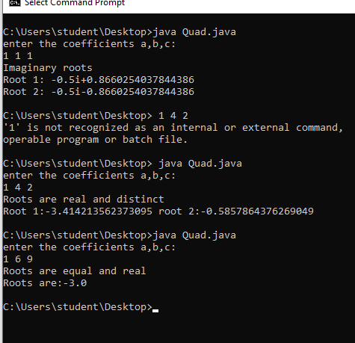

# LAB PROGRAM 2: SGPA CALCULATION

CODE

import java.util.Scanner; class Student

{

String USN; String name;

int[] credits = new int[20]; int[] marks = new int[20]; void input(int n)

{

Scanner s = new Scanner(System.in); System.out.print("Enter Student USN: "); USN = s.nextLine(); System.out.print("Enter Student Name: "); name = s.nextLine();

for(int i=0;i<n;i++)

{

System.out.print("Enter the Subject "+(i+1)+" marks and credits respectively: ");

marks[i] = s.nextInt();

credits[i] = s.nextInt();

}

}

float calculate(int n)

{

int sum_of_credits = 0; float result=0.0f; for(int i=0;i<n;i++)

{

sum_of_credits+=credits[i]; if(calculate_grade_point(marks[i])==-1)

return -1.0f;

else

{

}

}

result = result +(float) (calculate_grade_point(marks[i])*credits[i]);

return (result/sum_of_credits);

}

int calculate_grade_point(int marks)

{

if(marks>=90) return 10;

else if ((marks>=80)&&(marks<90)) return 9;

else if ((marks>=70)&&(marks<80)) return 8;

else if ((marks>=60)&&(marks<70)) return 7;

else if ((marks>=50)&&(marks<60)) return 6;

else if ((marks>=40)&&(marks<50)) return 5;

return -1;

}

void display(int n,float result)

{

System.out.println("\n"); System.out.println("Student Details"); System.out.println();

System.out.println("Student USN: "+USN); System.out.println("Student Name: "+name); System.out.println("Student Marks and Credits"); for(int i=0;i<n;i++)

{

System.out.println("Subject 1 -->\tMarks: "+marks[i]+" Credits: "+credits[i]);

}

System.out.println("SGPA: "+result);

}

}

public class Lab_02_SGPA

{

public static void main(String[] args)

{

Scanner s = new Scanner(System.in); Student s1 = new Student();

System.out.print("Enter the number of subjects: "); int n = s.nextInt();

s1.input(n);

float result = s1.calculate(n); if(result == -1.0f)

{

System.out.println();

System.out.println("The Student has failed in a subject. SGPA cannot be calculated!");

System.exit(0);

}

s1.display(n,result);

}

}

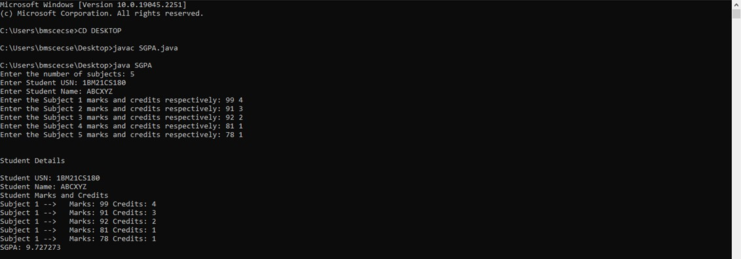

# LAB PROGRAM 3: IMPLEMENTING ARRAY OF OBJECTS

CODE

import java.util.*; import java.io.*;

class Book

{

String title,author; float price;

int num_pages;

Book()

{

title = "Default Value"; author = "Default Value"; price = 0.0f;

num_pages = 0;

}

void setTitle(String title)

{

this.title=title;

}

void setAuthor(String author)

{

this.author=author;

}

void setPrice(float price)

{

this.price=price;

}

void setPages(int num_pages)

{

this.num_pages = num_pages;

}

public String toString()

{

return title+"\t\t"+author+"\t\t"+price+"\t\t"+num_pages+"\n";

}

}

public class BookDetails

{

public static void main(String args[])

{

String t, a; float p;

int np,n;

Scanner s = new Scanner(System.in); System.out.print("Enter the number of Books: "); n = s.nextInt();

Book[] b = new Book[n]; for(int i=0;i<n;i++)

{

System.out.println(); System.out.print("Enter the book name: ");

t = s.next();

System.out.print("Enter the author name: "); a = s.next();

System.out.print("Enter the book price: "); p = s.nextFloat();

System.out.print("Enter the number of pages: "); np = s.nextInt();

b[i] = new Book();

b[i].setTitle(t);

b[i].setAuthor(a);

b[i].setPrice(p);

b[i].setPages(np);

}

System.out.println("Title \t\t Author \t\t Price \t\t Pages\n"); for(int i=0; i<n;i++)

{

System.out.println(b[i]);

}

}

}

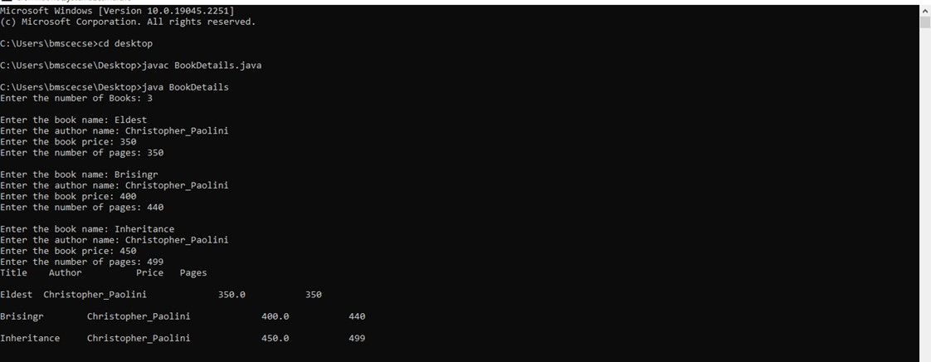

**PROGRAM 4: CALCULATING AREA OF SHAPES (ABSTRACT CLASS)**

CODE

import java.util.Scanner; public class Shape1

{

public static void main(String args[])

{

int choice;

Scanner s = new Scanner(System.in); do

{

System.out.println("1. Calculate Area of Rectangle\n2. Calculate Area of Triangle\n3. Calculate Area of " +

"Circle\n4. Exit the Program\n\nEnter the choice: "); choice = s.nextInt();

switch(choice)

{

case 1: Rectangle r = new Rectangle(); r.printArea();

break;

case 2: Triangle t = new Triangle();

t.printArea(); break;

case 3: Circle c = new Circle(); c.printArea();

break;

case 4: System.out.println("Exiting the program!"); System.exit(0);

break;

default: System.out.println("\nInvalid Choice!\n");

}

}while(true);

}

}

abstract class Shape

{

int a,b;

abstract void printArea();

}

class Rectangle extends Shape

{

void printArea()

{

int area;

Scanner s = new Scanner(System.in);

System.out.println("Enter the length and breadth of rectangle: "); a = s.nextInt();

b = s.nextInt(); area = a*b;

System.out.println("\nArea of Rectangle: "+area+"\n");

}

}

class Triangle extends Shape

{

void printArea()

{

float area;

Scanner s = new Scanner(System.in); System.out.println("Enter the base and height of triangle: "); a = s.nextInt();

b = s.nextInt(); area = 0.5f*a*b;

System.out.println("\nArea of triangle: "+area+"\n");

}

}

class Circle extends Shape

{

void printArea()

{

double area;

Scanner s = new Scanner(System.in); System.out.println("Enter the radius of circle: "); a = s.nextInt();

area = Math.PI*a;

System.out.println("Area of Circle: "+area+"\n");

}

}

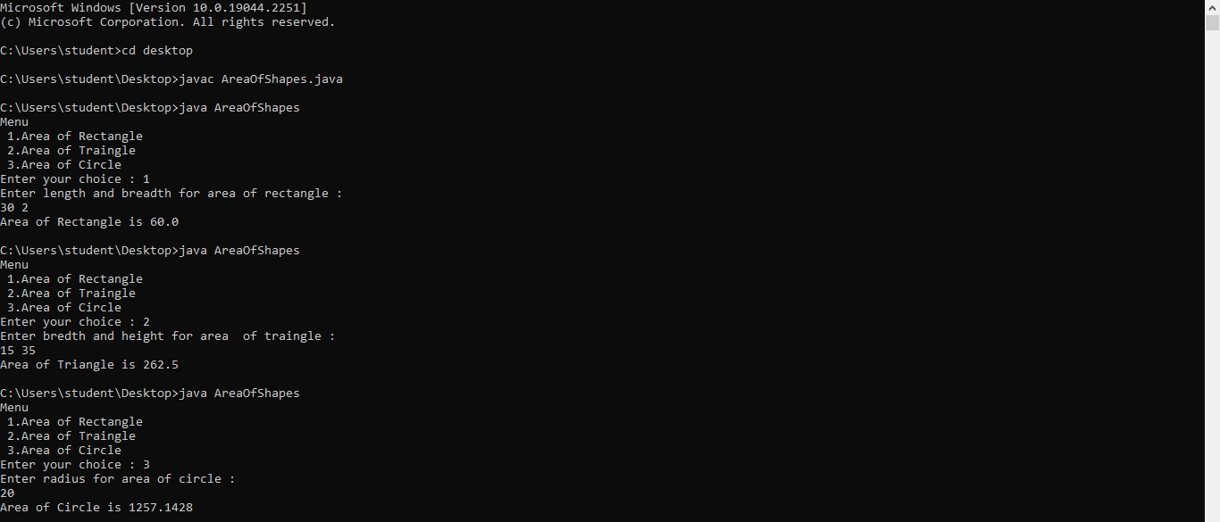

# LAB PROGRAM 5: BANK PROGRAM

CODE

import java.util.Scanner; class Account

{

String customer_name; long acc_no;

float bal;

Scanner s = new Scanner(System.in); public void input()

{

");

System.out.print("\nEnter the Customer Name: "); customer_name = s.nextLine(); System.out.print("\nEnter the Account Number: "); acc_no = s.nextLong();

System.out.print("\nEnter the Starting Amount (Minimum Amount = 5000):

bal = s.nextFloat(); if(bal<5000f)

{

System.out.println("\nAccount Balance cannot be less than 5000.0 \n"); System.exit(0);

}

}

public void display()

{

System.out.println("\nCustomer Name: "+customer_name); System.out.println("Account Number: "+acc_no); System.out.println("Amount: "+bal);

}

}

class Savings extends Account

{

Scanner s = new Scanner(System.in); float deposit,withdraw,interest; public void deposit()

{

System.out.print("\nEnter the amount to be deposited: "); deposit = s.nextFloat();

bal+=deposit; System.out.println("\nBalance: "+bal);

}

public void withdraw()

{

System.out.print("\nEnter the amount to be withdrawn: "); withdraw = s.nextFloat();

if(bal<5000)

{

System.out.println("\nInsufficient Balance");

}

else

{

"+bal);

}

bal-=withdraw;

System.out.println("\nAmount Withdrawn: "+withdraw+"\nBalance:

}

public void check_Bal()

{

if(bal<5000)

{

System.out.println("\nInsufficient Balance!!\nBalance: "+bal);

}

else

{

System.out.println("\nBalance: "+bal);

}

}

public void interest()

{

interest=(bal*6)/100; bal+=interest;

System.out.println("\nInterest Credited: "+interest+"\nBalance :"+bal) ;

}

}

class Current extends Account

{

float deposit, withdraw, penalty;

public void deposit()

{

System.out.print("\nEnter Amount to be deposited: "); deposit = s.nextFloat();

bal += deposit; System.out.println("Balance: " + bal);

}

public void check_Bal()

{

if (bal < 5000)

{

penalty = (0.1f * bal);

System.out.println("\nInitial Account Balance: "+bal); bal = bal-penalty;

System.out.println("\nLow balance!\nPenalty Amount: " + penalty + "\nAccount balance: " + bal);

}

else

{

System.out.println("\n Balance: " + bal);

}

}

public boolean check_Bal_part_2()

{

if (bal < 5000)

{

penalty = (0.1f * bal);

System.out.println("\nInitial Account Balance: "+bal); bal = bal-penalty;

System.out.println("\nLow Balance!\nPenalty Amount: " + penalty + "\nAccount balance: " + bal);

return false;

}

return true;

}

public void withdraw()

{

System.out.print("\nEnter Amount to withdraw: "); withdraw = s.nextFloat();

if(check_Bal_part_2())

{

bal-=withdraw;

System.out.println("\nAmount Withdrawn: "+withdraw+"\nBalance:

"+bal);

}

}

public void chequebook()

{

System.out.println("\nCheque Book has been Issued!");

}

}

public class Bank

{

public static void main(String[] args)

{

");

Scanner s = new Scanner(System.in); String ch;

int n;

Current c = new Current(); Savings sa = new Savings();

System.out.print("\nEnter the Account Type (S for Savings , C for Current) : ch = s.next();

switch(ch.toLowerCase())

{

case "s" : sa.input();

do

{

System.out.print("\n1. Deposit \n2. Withdrawal \n3. Check Balance \n4. Check Interest"

+"\n5. Show Account Details \n6. Exit Transaction\n\nEnter

your choice: ");

n = s.nextInt(); switch(n)

{

case 1 : sa.deposit(); break;

case 2 : sa.withdraw(); break;

case 3 : sa.check_Bal(); break;

case 4 : sa.interest(); break;

case 5 : sa.display(); break;

case 6 : System.out.println("\nExiting Transaction!"); System.exit(0);

break;

default : System.out.println("\nInvalid Operation");

}

}while(true); case "c" : c.input();

do {

System.out.print("\n1. Deposit \n2. Withdrawal \n3. Check Balance \n4. Issue Cheque Book"

+ "\n5. Show Account Details \n6. Exit Transaction\n\nEnter

your choice: ");

n = s.nextInt(); switch (n) {

case 1:

c.deposit(); break;

case 2:

c.withdraw(); break;

case 3:

c.check_Bal(); break;

case 4:

c.chequebook(); break;

case 5:

c.display(); break;

case 6:

System.out.println("\nExiting Transaction!");

System.exit(0);

break; default:

System.out.println("\nInvalid Operation");

}

}while(true);

default : System.out.println("\nInvalid Choice"); break;

}

}

}

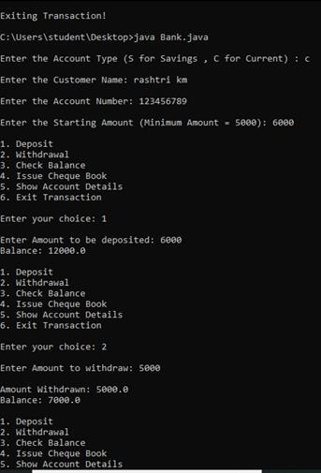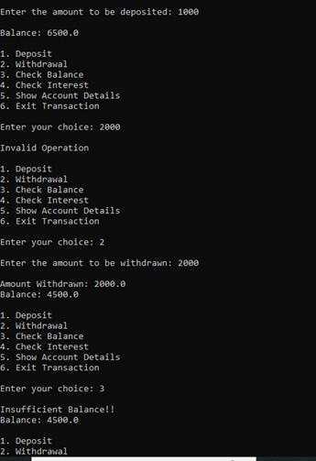

# LAB PROGRAM 6: NUMBER OPERATIONS - EXCEPTION HANDLING

CODE

import java.util.InputMismatchException; import java.util.Scanner;

interface Z

{

public int calc(int a,int b);

}

class Y implements Z

{

public int calc(int a, int b)

{

int c = a/b; return c;

}

}

public class Try_1

{

public static void main(String[] args)

{

Scanner s = new Scanner(System.in);

Y o = new Y(); int num1,num2; try

{

System.out.println("Enter the two numbers: "); num1 = s.nextInt();

num2 = s.nextInt();

int c = o.calc(num1,num2); System.out.println("Quotient: "+c);

}

catch(ArithmeticException | InputMismatchException e1)

{

System.out.println("Exception: "+e1);

}

}

}

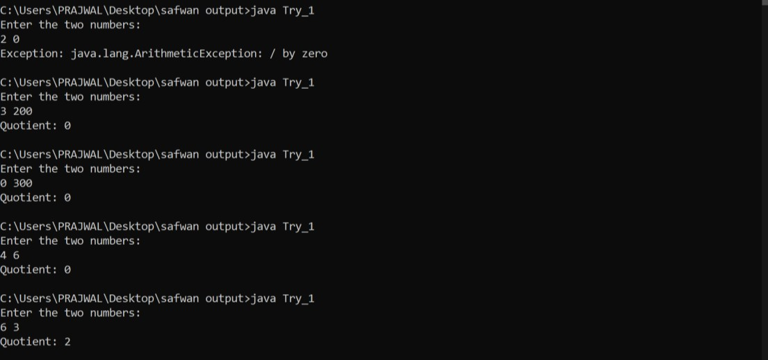

# LAB PROGRAM 7: AGE EVALUATION - EXCEPTION HANDLING

CODE

import java.util.Scanner;

public class Age

{

public static void main(String[] args) throws WrongAge,InvalidAge

{

new Son();

}

}

class WrongAge extends Exception

{

public String getMessage()

{

return "Age Cannot Be Negative";

}

}

class InvalidAge extends Exception

{

public String getMessage()

{

return "Son's Age cannot be greater than Father's!";

}

}

class Father

{

Scanner s = new Scanner(System.in); int f;

Father() throws WrongAge

{

System.out.print("Enter the Father's Age: "); f = s.nextInt();

try

{

if(f<0)

throw new WrongAge();

}

catch(WrongAge e1)

{

System.out.println(e1.getMessage());

System.exit(0);

}

}

}

class Son extends Father

{

int son;

Son() throws WrongAge,InvalidAge

{

super();

System.out.print("Enter the Son's Age: "); son = s.nextInt();

try

{

if(son<0)

throw new WrongAge();

}

catch(WrongAge e2)

{

System.out.println(e2.getMessage()); System.exit(0);

}

try

{

if(son>f)

throw new InvalidAge();

}

catch(InvalidAge e3)

{

System.out.println(e3.getMessage()); System.exit(0);

}

System.out.println("Ages are appropriate");

}

}

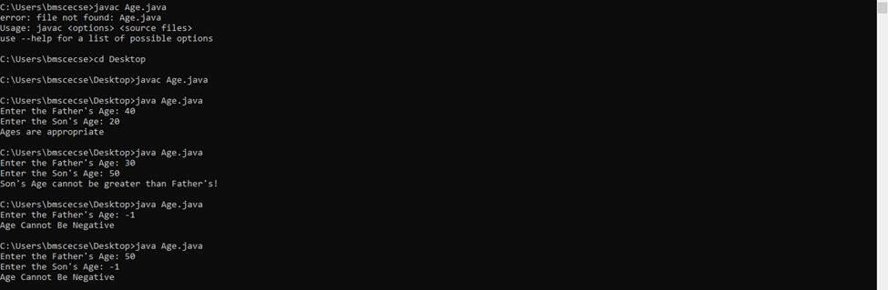

# LAB PROGRAM 8: MULTI-THREADING

CODE

class MyThread extends Thread

{

long time;

private volatile boolean running = true; MyThread(){ System.out.println("Default");

}

MyThread(String name, long time)

{

super(name); this.time = time;

}

public void pause()

{

running = false;

}

public void run()

{

try

{

while(running)

{

System.out.println(this.getName()); Thread.sleep(time*1000);

}

}

catch(InterruptedException ie)

{

System.out.println("Exception caught in method");

}

}

}

class Main

{

public static void main(String [] args)

{

MyThread mt1 = new MyThread("BMS", 10); MyThread mt2 = new MyThread("CSE", 2); mt1.start();

mt2.start(); Try

{

Thread.sleep(20*1000); mt1.pause();

mt2.pause();

}

catch(InterruptedException ie)

{

System.out.println("Exception caught in main");

}

}

}

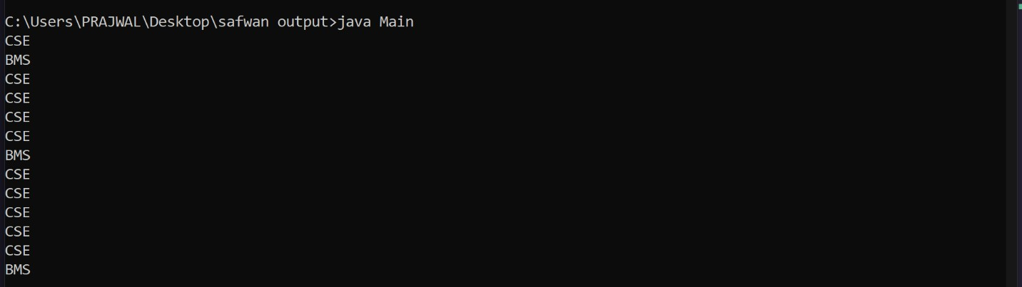

# LAB PROGRAM 9: Packages

CODE

File 1 package cie;

import java.util.Scanner;

public class student { // rename the file as student.java make it public and execute

String sname = new String();

String usn = new String();

int sem;

public student() {

Scanner s = new Scanner(System.in);

System.out.println("Enter your name: ");

sname = s.next();

System.out.println("Enter your usn: ");

usn = s.next();

System.out.println("Enter your sem: ");

sem = s.nextInt();

}

}

package cie;

import java.util.Scanner;

import cie.student;

public class internal extends student { // when this is public, save the file as internal.java and save it

protected float marks[] = new float[5];

public internal() {

Scanner ss = new Scanner(System.in);

for (int i = 0; i < 5; i++) {

System.out.println("Enter Subject " + (i + 1) + " Internal marks");

marks[i] = ss.nextInt();

}

}

}

package see;

import java.util.Scanner;

import cie.internal;

import cie.student;

public class external extends internal {

float marks2[] = new float[5];

public external() {

Scanner ss=new Scanner(System.in); for(int i=0;i<5;i++) {

System.out.println("Enter Subject " + (i+1) + " External

marks" );

marks2[i]=ss.nextFloat();

}

}

public void calc() {

for (int i = 0; i < 5; i++) {

System.out.println("Sum of Internal and External marks for Subject " + i + " is " + (marks[i] + marks2[i]));

}

}

}

import java.util.Scanner;

import cie.internal;

import cie.student;

import see.external;

class pmain {

public static void main(String xx[]) {

Scanner s = new Scanner(System.in);

external b1 = new external();

b1.calc();

}

}

Output:

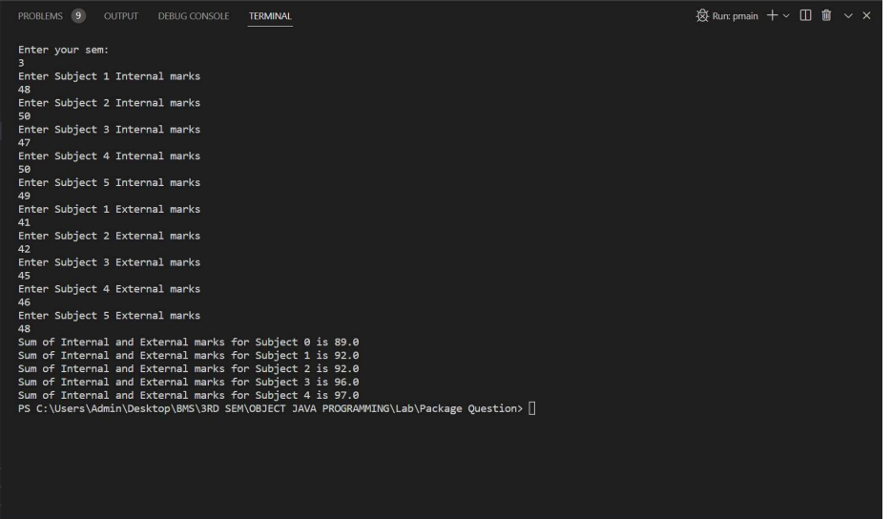

}

}

public void calc() {

for(int i=0;i<5;i++) {

System.out.println("Sum of Internal and External marks for Subject " + i+ " is " + (marks[i]+marks2[i]));

}

}

}

File 4

import java.util.Scanner; import cie.internal; import cie.student; import see.external;

class pmain {

public static void main(String xx[]) { Scanner s=new Scanner(System.in);

external b1= new external(); b1.calc();

}

}