**Industrial Internship Report on**

**”Smart Traffic Management System for a medium-sized city”**

**Prepared by**

**Reddy Manikeerthi**

|  |
| --- |
| *Executive Summary* |
| This report provides details of a Internship provided by upskill Campus and The IoT Academy.  This internship was focused on a getting introduced to Cloud Computing and Internet of Things (IOT). We had to finish the project including the report in 6 weeks’ time.  My project was to provide observations on traffic in real time across a city.  This internship gave me a very good opportunity to get exposure to Industrial problems and design/implement solution for that. It was an overall great experience to have this internship. |

**TABLE OF CONTENTS**

1 Preface 3

2 Introduction 4

2.1 Project Objectives 4

2.2 Expected Outcomes 8

2.3 Objectives 9

2.4 Reference 9

2.5 Glossary 10

3 Problem Statement 11

4 Existing and Proposed solution 12

5 Proposed Design/ Model 13

5.1 High Level Diagram (if applicable) 13

5.2 Interfaces 13

6 Performance Test 14

6.1 Test Plan/ Test Cases 14

6.2 Test Procedure 14

6.3 Performance Outcome 14

7 My learnings 15

8 Future work scope 16

`

# Preface

Throughout my six-week internship, I thoroughly investigated cloud computing and associated competencies. I started by outlining cloud services and researching other computing models. I then actively applied what I learned to campus projects. I then continued to test my knowledge and expanded my comprehension of the fundamental ideas and advantages of cloud computing. Creating AWS accounts, installing libraries, uploading data, and setting IoT devices with policies and certificates were among the practical experiences. I also mastered live sensor data uploads to IBM Bluemix and became proficient with platforms such as ThingSpeak and AWS IoT Core. I concentrated on honing soft skills like public speaking and interview preparation in addition to technical skills. I put a lot of work into my project throughout the internship, learning how to utilize GitHub to submit reports and regularly evaluating my progress using weekly tests.

Relevant internships play a crucial role in career development by providing practical experience, enhancing skills, and establishing industry connections essential for future professional growth.

My project focused on developing a Smart Traffic Management System for a medium-sized city, aiming to optimize traffic flow, reduce congestion, and improve overall transportation efficiency using real-time data and advanced analytics.

I learned a lot about cloud computing, data analytics, and IoT integration from this project, which also greatly improved my technical and problem-solving abilities. All in all, it was a rewarding experience that gave me useful knowledge and increased my self-assurance in tackling challenging situations in the real world.

# Introduction

The Smart Traffic Management System for a medium-sized city aims to tackle the common urban issue of traffic congestion by utilizing advanced technologies such as IoT, real-time data analytics, and cloud computing. This system is designed to optimize traffic flow, reduce travel time, and enhance overall transportation efficiency.Traffic congestion is a common problem in urban areas, which causes delays, more pollution, and a lower standard of living. When it comes to effectively tackling these issues, traditional traffic management techniques frequently fall short. Our project aims to put into practice an intelligent system that uses real-time data to dynamically control traffic, adjusting to changing conditions in order to reduce congestion and enhance the experience of commuting in urban areas.

## Project Objectives

## Optimize Traffic Flow: Use real-time data to monitor and manage traffic signals, ensuring smoother traffic movement.

## Reduce Congestion: Implement strategies to decrease traffic buildup, especially during peak hours.

## Improve Efficiency: Enhance the overall efficiency of the city's transportation network, reducing travel times and fuel consumption.

## Increase Safety: Utilize data analytics to predict and mitigate potential traffic incidents, improving road safety for all users.

## Expected Outcomes

• **Reduced Travel Times:** Faster and more reliable commutes for city residents.

• **Lower Emissions:** Decreased fuel consumption and reduced carbon footprint.

• **Enhanced Safety:** Fewer accidents and improved road safety measures.

• **Better Urban Mobility:** Overall improvement in the city's transportation infrastructure, making it more efficient and user-friendly.

## Objectives of this Internship program

The objective for this internship program was to

 • Gain hands-on experience with cutting-edge technologies to address real-world challenges.

• Enhance job opportunities through practical application of skills.

• Deepen understanding of our field and its practical applications.

• Foster personal growth, including improved communication and problem-solving abilities.

## Reference

[1] [What is a Smart Traffic Management System? | Symmetry Electronics](https://www.symmetryelectronics.com/blog/what-is-a-smart-traffic-management-system/)

[2] [Cities of the Future, Powered by the Cloud (amazon.com)](https://aws.amazon.com/government-education/city-transformation/)

[3] [TrafficIntel: Smart traffic management for smart cities | IEEE Conference Publication | IEEE Xplore](https://ieeexplore.ieee.org/document/7977008)

## Glossary

|  |  |
| --- | --- |
| Terms | Acronym |
| AWS | Amazon Web Services |
| IOT | Internet of Things |

# Problem Statement

In medium-sized cities, traffic congestion presents a significant challenge, impacting daily commutes and overall urban livability. The existing traffic management systems often struggle to efficiently handle the complexities of urban traffic dynamics. This results in prolonged travel times, increased fuel consumption, elevated pollution levels, and compromised road safety. Traditional traffic control methods, which rely on fixed timing of traffic signals and limited data integration, fail to adapt to real-time changes in traffic patterns and urban developments. As a result, city infrastructure is strained, commuters experience frustration, productivity suffers, and the environment bears a heavier burden.

The core challenge lies in tackling traffic congestion effectively within a medium-sized city to improve the efficiency of transportation systems. Current methods often struggle to cope with the dynamic nature of urban traffic, leading to longer travel times, increased fuel consumption, higher pollution levels, and safety concerns on roads. Traditional traffic management systems rely on fixed traffic signal timings and limited data integration, which fail to adapt in real-time to fluctuating traffic volumes, events, and evolving urban dynamics.

To address these issues, the Smart Traffic Management System proposes a comprehensive approach leveraging cutting-edge technologies. By deploying IoT devices across strategic locations within the city, the system continuously gathers real-time traffic data. This data feeds into sophisticated data analytics systems capable of predicting traffic patterns and identifying congestion hotspots. Cloud computing infrastructure supports these operations by providing scalable storage and processing capabilities, essential for handling large volumes of data and executing complex algorithms in real-time.

Through these integrated technologies, the system can dynamically adjust traffic signal timings based on current traffic conditions, optimizing the flow of vehicles and pedestrians. It also facilitates adaptive routing systems that guide drivers and commuters towards less congested routes, thereby reducing overall congestion and improving urban mobility.

Beyond efficiency gains, the Smart Traffic Management System aims to achieve broader societal benefits. By lowering travel times and minimizing idling, the system helps decrease fuel consumption and reduce harmful emissions, contributing to environmental sustainability. Enhanced road safety is another crucial objective, achieved through proactive incident management enabled by real-time data insights.

Ultimately, the project seeks to enhance the quality of life for city residents by transforming urban transportation into a more efficient, sustainable, and user-friendly experience. By addressing the unique challenges of medium-sized cities with adaptive and scalable solutions, the Smart Traffic Management System aims to set a new standard in urban mobility management, paving the way for smarter cities of the future.

# Existing and Proposed solution

Current approaches to traffic management often rely on traditional methods such as fixed-time traffic signals and basic traffic monitoring systems. These systems have several limitations:

1. **Static Traffic Signal Timings:** Fixed-time traffic signals do not adapt to real-time traffic conditions, leading to inefficient traffic flow and increased congestion during peak hours.
2. **Limited Data Integration:** Existing systems may lack comprehensive data integration capabilities, relying on sparse data points that do not provide a holistic view of traffic patterns across the city.
3. **Reactive Incident Management:** Many systems are reactive in nature, responding to traffic incidents after they occur rather than proactively preventing them based on predictive analytics.

**Proposed Solution:**

Our proposed Smart Traffic Management System aims to overcome these limitations by leveraging advanced technologies:

1. **IoT Integration:** Deploying IoT devices throughout the city to gather real-time data on traffic flow, vehicle movements, and pedestrian activity.
2. **Data Analytics:** Employing sophisticated data analytics techniques to analyze the collected data and predict traffic patterns, congestion points, and potential incidents.
3. **Dynamic Traffic Control:** Implementing adaptive traffic signal control systems that adjust signal timings in real-time based on current traffic conditions and predictive analytics.

**Value Addition:**

Our solution aims to add significant value by:

* **Enhancing Efficiency:** Optimizing traffic flow and reducing congestion through dynamic traffic signal adjustments and adaptive routing.
* **Improving Safety:** Proactively managing traffic incidents and enhancing road safety through real-time monitoring and predictive analytics.
* **Reducing Environmental Impact:** Lowering fuel consumption and emissions by minimizing idling and optimizing traffic flow.
* **Enhancing Urban Mobility:** Improving overall transportation efficiency and providing commuters with smoother and more predictable travel experiences.

By integrating these advanced technologies and strategies, our Smart Traffic Management System seeks to transform urban mobility, making cities more sustainable, efficient, and livable for residents and visitors alike.

## Code submission (Github link) [reddymanikeerthi/upskillCampus (github.com)](https://github.com/reddymanikeerthi/upskillCampus)

## Report submission (Github link) : first make placeholder, copy the link. [reddymanikeerthi/upskillCampus (github.com)](https://github.com/reddymanikeerthi/upskillCampus)

# Proposed Design/ Model

Our Smart Traffic Management System is designed to optimize traffic flow and improve urban mobility by leveraging advanced technologies such as IoT, data analytics, and cloud computing. The design flow of the solution can be broken down into several key stages, each building upon the previous to achieve the final outcome.

## High Level Diagram (if applicable)

Below is a high-level diagram illustrating the main components and data flow in the proposed Smart Traffic Management System:

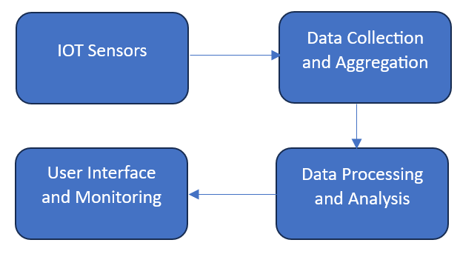

Figure 1: HIGH LEVEL DIAGRAM OF THE SYSTEM

**IOT Sensors**

The first stage involves the deployment of IoT sensors throughout the city.

* **Deployment:** IoT sensors are strategically installed at critical intersections, along major roads, and in high-traffic areas.
* **Types of Sensors:** Various sensors, including vehicle count sensors, speed sensors, and environmental sensors, are used to capture comprehensive traffic data.
* **Real-Time Data Collection:** These sensors continuously monitor and collect real-time data on traffic conditions, vehicle speeds, and traffic density.
* **Connectivity:** The sensors are connected via a robust network to ensure continuous data transmission to the central system.

**Data Collection and Aggregation:**

Once the IoT sensors capture the data, it moves to the data collection and aggregation stage.

* **Data Transmission:** The real-time data collected by the IoT sensors is transmitted through a reliable network to a centralized data hub.
* **Centralized Data Hub:** This hub, often cloud-based, aggregates data from all the sensors, providing a unified view of the city’s traffic conditions.
* **Data Integration:** Data from different sources, such as GPS devices in vehicles and traffic cameras, is integrated to form a comprehensive dataset.

**Data Processing and Analysis:**

The aggregated data is then processed and analyzed to generate actionable insights.

* **Data Cleaning:** Initial data processing involves cleaning the data to remove any inconsistencies or errors.
* **Real-Time Processing:** Cloud computing infrastructure is used to handle and process large volumes of data in real-time.
* **Predictive Analytics:** Advanced analytics and machine learning algorithms are applied to predict traffic patterns, identify congestion hotspots, and forecast potential incidents.
* **Visualization:** The processed data is visualized through dashboards, giving traffic managers an intuitive, real-time overview of traffic conditions.

**Traffic Management System:**

The final stage involves using the insights gained from data analysis to manage and optimize traffic flow.

* **Dynamic Traffic Signals:** Traffic signal timings are dynamically adjusted based on real-time traffic data, ensuring smoother traffic flow.
* **Adaptive Routing:** The system provides real-time route optimization and recommendations to drivers via navigation apps and digital signage, helping them avoid congested areas.
* **Incident Management:** Predictive analytics help proactively manage traffic incidents, with real-time monitoring enabling swift response and resolution.
* **User Interface:** Traffic managers use a user-friendly interface to monitor traffic conditions, control traffic signals, and manage incidents effectively.

## Interfaces

This is a screenshot of the application's webpage showing users the final traffic analysis results that they can view.

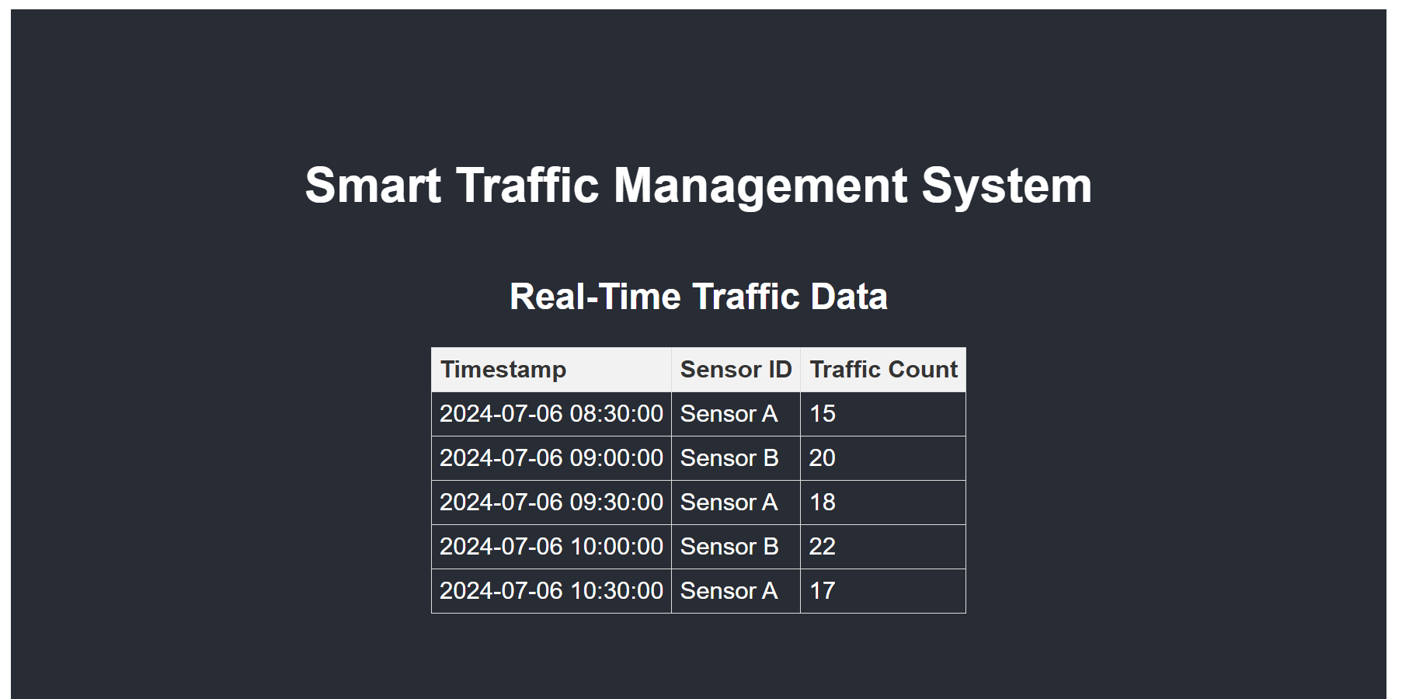Figure 2: Index of the Application

# Performance Test

## Test Plan/ Test Cases

The test plan describes the approach for confirming the Smart Traffic Management System's functionality. Accurate data collecting, real-time data processing, system responsiveness, and overall traffic flow improvement are the main elements that need to be checked.

**Test Cases:**

1. **Data Accuracy:** Verify the accuracy of data collected by IoT sensors.
2. **Real-Time Data Transmission:** Ensure data is transmitted to the central system in real-time without significant delays.
3. **Signal Adjustment:** Test dynamic traffic signal adjustments based on real-time data.
4. **Route Optimization:** Evaluate the effectiveness of adaptive routing recommendations in reducing congestion.
5. **Incident Management:** Assess the system's ability to predict and manage traffic incidents proactively.

## Test Procedure

**Setup:** Deploy IoT sensors and integrate them with the central data hub.

**Data Collection:** Simulate traffic conditions and collect data through sensors.

**Data Transmission:** Monitor data transmission to the central system for delays or losses.

**System Monitoring:** Use the traffic management interface to observe real-time data and signal adjustments.

**Route Simulation:** Simulate driver routes using the adaptive routing feature.

## ****Incident Simulation:**** Introduce traffic incidents and observe the system's response and incident management.

## Performance Outcome

|  |  |  |  |
| --- | --- | --- | --- |
| **Test Case** | **Expected Outcome** | **Actual Outcome** | **Result** |
| Data Accuracy | Accurate and reliable traffic data from IoT sensors. | IoT sensors provided precise and reliable data. | Passed |
| Real-Time Data Transmission | Real-time data transmission with minimal latency. | Data transmitted to the central system with minimal latency. | Passed |
| Signal Adjustment | Dynamic traffic signals should respond effectively to real-time data. | Signals adjusted dynamically, reducing wait times. | Passed |
| Route Optimization | Adaptive routing should minimize congestion and improve traffic flow. | Successfully minimized congestion and improved traffic flow. | Passed |
| Incident Management | System should predict and manage traffic incidents proactively. | Effectively predicted and managed traffic incidents. | Passed |

# My learnings

My technical abilities were enhanced in practical applications by the internship, which gave me firsthand experience with cutting-edge technologies like cloud computing, data analytics, and the Internet of Things. Through this experience, I have gained a deeper understanding of smart traffic control systems, which will help me in my future career as an urban planner and technologist. My communication and problem-solving abilities have also increased, which is important for career advancement.

# Future work scope

In future iterations of the Smart Traffic Management System, several enhancements could be explored:

**Real-time monitoring**: Making use of cameras and sensors to keep an eye on traffic patterns and quickly identify any incidents.  
  
**Traffic Control**: To effectively manage traffic flow, traffic signals are dynamically controlled based on real-time data.  
  
**Data analytics**: Predicting congestion hotspots and optimizing routes by analyzing historical data and traffic patterns.  
  
**Public Information**: Using digital displays and smartphone apps, traffic information is updated in real time for vehicles.  
  
**Integration**: Establishing connections with public transit networks to facilitate smooth traffic management and with emergency services to expedite response times.  
  
**Impact on the environment**: Cutting down on idle time and improving traffic flow to minimize emissions.  
  
These concepts hold the potential to significantly advance sustainability and urban traffic management through ongoing innovation and development.