Assignment -2

**Que 1-Assignment 1: SDLC Overview - Create a one-page infographic that outlines the SDLC phases (Requirements, Design, Implementation, Testing, Deployment), highlighting the importance of each phase and how they interconnect.**

Solution-Software Development Life Cycle (SDLC) Overview

1. Requirements Phase:
   * Gather Requirements: Engage stakeholders to identify needs and expectations.
   * Analyze Requirements: Understand the scope, constraints, and goals of the project.
   * Document Requirements: Create detailed specifications to guide development.

Importance: Establishes a clear understanding of what needs to be built and why, laying the foundation for the entire project.

1. Design Phase:
   * Architectural Design: Define the system architecture and high-level components.
   * Detailed Design: Specify interfaces, algorithms, and data structures.
   * User Interface Design: Design the user experience and interface elements.

Importance: Transforms requirements into a technical blueprint, ensuring a structured approach to development.

1. Implementation Phase:
   * Coding: Write code based on design specifications and coding standards.
   * Unit Testing: Test individual components to ensure they function correctly.
   * Integration: Integrate components to build the complete system.

Importance: Turns design into reality, producing the software solution according to specifications.

1. Testing Phase:
   * Unit Testing: Validate the functionality of individual units or modules.
   * Integration Testing: Verify interactions between integrated components.
   * System Testing: Test the complete system against requirements.

Importance: Ensures the quality, reliability, and correctness of the software, identifying and addressing defects early.

1. Deployment Phase:
   * Release Planning: Plan the rollout strategy and schedule for deployment.
   * Deployment: Release the software to production or end-users.
   * Maintenance: Provide ongoing support, updates, and enhancements.

Importance: Delivers the software to users, ensuring it meets their needs and functions as expected in the real-world environment.

Interconnection:

* + Iterative Process: Phases are interconnected and iterative, allowing for feedback and adjustments throughout the lifecycle.
  + Collaboration: Close collaboration among stakeholders, developers, testers, and users is essential for success.
  + Continuous Improvement: Learnings from each phase inform future iterations, driving continuous improvement.

**Que 2 Assignment 2: Develop a case study analyzing the implementation of SDLC phases in a real-world engineering project. Evaluate how Requirement Gathering, Design, Implementation, Testing, Deployment, and Maintenance contribute to project outcomes**.

**Solution-**

**Case Study: Implementation of SDLC Phases in a Real-World Engineering Project**

**Project Overview**: Company Y, a multinational automotive manufacturer, embarked on a project to develop a next-generation electric vehicle (EV) targeting the consumer market. The project aimed to design and produce an EV that combines cutting-edge technology with sustainable and eco-friendly features.

1. **Requirement Gathering**: The project kicked off with a series of workshops involving cross- functional teams comprising engineers, designers, marketing specialists, and environmental experts. Stakeholders conducted market research, analyzed consumer preferences, and identified regulatory requirements related to EVs. Key requirements included range, charging infrastructure compatibility, safety features, and aesthetic design.

**Outcome**: Comprehensive understanding of customer needs, market trends, and regulatory constraints, guiding the direction of the project.

1. **Design:** Based on the gathered requirements, the design phase commenced with the development of conceptual sketches, 3D models, and virtual prototypes. Engineers focused on optimizing the vehicle's aerodynamics, battery placement, and energy efficiency. Designers collaborated to create sleek and futuristic exterior designs while ensuring ergonomic and comfortable interiors. Additionally, software architects designed onboard systems for vehicle control, entertainment, and connectivity.

**Outcome**: Detailed design blueprints and digital prototypes that translated stakeholder requirements into actionable development plans.

1. **Implementation**: The development team utilized a concurrent engineering approach to begin prototyping and manufacturing components while design work was ongoing. Advanced manufacturing techniques such as 3D printing and laser cutting were employed to accelerate the production process. Software developers worked in tandem to write code for the vehicle's embedded systems, including the battery management system, vehicle control unit, and infotainment system.

**Outcome**: Simultaneous progress in design and manufacturing, ensuring timely completion of the prototype vehicle.

1. **Testing**: A rigorous testing regimen was implemented to evaluate the performance, safety, and reliability of the EV prototype. Component-level testing included stress tests on batteries, durability tests on chassis components, and performance tests on electric motors. Integration testing was conducted to ensure seamless interaction between hardware and software subsystems. Extensive real-world testing was also performed, including road tests in various environmental conditions.

**Outcome**: Identification and resolution of design flaws and performance issues, ensuring the prototype meets quality and safety standards.

1. **Deployment**: Upon successful testing and validation of the prototype, the EV entered the production phase. Manufacturing facilities were retooled and production lines were optimized to accommodate the unique requirements of EV production. Supply chain partners were engaged to ensure a steady supply of components and materials. Initial production runs were closely monitored to identify and address any manufacturing defects or quality issues.

**Outcome**: Smooth transition from prototype to mass production, ensuring consistency and reliability in the manufactured vehicles.

1. **Maintenance**: Post-production, the engineering team continued to monitor field performance and gather feedback from customers. Software updates and improvements were rolled out periodically to enhance the vehicle's functionality and address any emerging issues. Customer support teams were equipped to assist with technical inquiries and provide maintenance services, ensuring a positive ownership experience for EV owners.

**Outcome:** Continuous improvement and refinement of the EV based on real-world usage and customer feedback, fostering brand loyalty and long-term success.

**Conclusion:** By effectively implementing the SDLC phases, Company Y successfully developed and launched a groundbreaking electric vehicle that met consumer expectations for performance, safety, and sustainability. Through meticulous requirement gathering, innovative design, efficient implementation, rigorous testing, seamless deployment, and proactive maintenance, the project achieved its objectives and established Company Y as a leader in the EV market.

**Que3- Assignment 3: Research and compare SDLC models suitable for engineering projects. Present findings on Waterfall, Agile, Spiral, and V-Model approaches, emphasizing their advantages, disadvantages, and applicability in different engineering contexts.**

**Solution-**

1. **Waterfall Model:**

**Advantages:**

* + Sequential Process: Progresses linearly through phases (requirements, design, implementation, testing, deployment).
  + Clear Milestones: Well-defined stages with specific deliverables at each phase.
  + Documentation: Emphasizes thorough documentation, facilitating clarity and traceability.

**Disadvantages:**

* + Rigidity: Little flexibility for changes once a phase is completed.
  + Late Feedback: Stakeholder feedback often comes late in the process, increasing the risk of costly changes.
  + Long Delivery Time: Large projects may experience delays due to sequential nature.

Applicability: Suitable for projects with well-understood and stable requirements, where changes are unlikely or can be managed through formal change control processes.

1. **Agile Model:**

**Advantages:**

* + Flexibility: Embraces change and allows for iterative development.
  + Customer Collaboration: Regular feedback from stakeholders ensures alignment with customer needs.
  + Early Delivery: Prioritizes delivering working software in short iterations.

**Disadvantages:**

* + Complexity: Requires highly collaborative and self-organizing teams.
  + Documentation: May lack comprehensive documentation, leading to knowledge gaps.
  + Scope Creep: Continuous changes may lead to scope creep if not managed effectively.

Applicability: Ideal for projects with evolving requirements, where frequent delivery of usable increments is valued, and customer involvement is crucial throughout the development process.

1. **Spiral Model:**

**Advantages:**

* + Risk Management: Emphasizes risk identification and mitigation throughout the project lifecycle.
  + Flexibility: Allows for iterative development and refinement of prototypes.
  + Feedback Loop: Incorporates customer feedback early and often, reducing the risk of late-stage changes.

**Disadvantages:**

* + Complexity: Requires thorough risk analysis and management expertise.
  + Resource Intensive: Prototyping and iterations can consume time and resources.
  + Suitability: May not be suitable for small or straightforward projects due to its complexity.

**Applicability:** Well-suited for projects with high uncertainty and evolving requirements, where early identification and mitigation of risks are critical.

1. **V-Model:**

**Advantages:**

* + Traceability: Emphasizes traceability between requirements and test cases.
  + Early Testing: Testing activities are initiated early in the development lifecycle.
  + Structured Approach: Provides a structured approach to software development and testing.

**Disadvantages:**

* + Rigidity: Similar to Waterfall, changes late in the process can be costly and time- consuming.
  + Documentation Overload: Requires extensive documentation, which can be cumbersome.
  + Sequential Nature: Limited flexibility for iterative development and customer feedback.

**Applicability:** Suitable for projects with clear and stable requirements, where thorough testing and traceability are critical, and changes are minimal or well-controlled.

**Que 4 Assignment 4: Create an infographic illustrating the Test-Driven Development (TDD) process. Highlight steps like writing tests before code, benefits such as bug reduction, and how it fosters software reliability**.

**Solution**

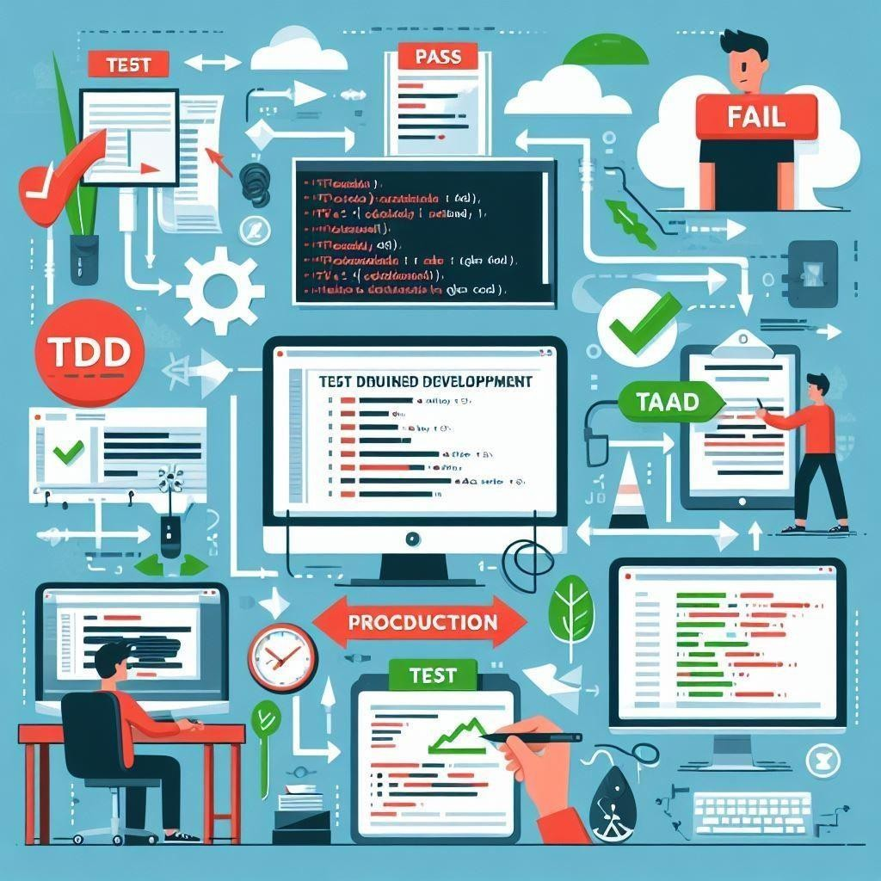

**Image: Illustration of developer writing test code before writing production code**

**Test-Driven Development (TDD) Process Infographic**

1. **Write Test:**
   * Developers write automated tests for a small piece of functionality before writing the corresponding production code.
   * Tests are written to define the desired behavior and functionality of the code.
2. **Run Test:**
   * Automated test suite is executed to validate the code.
   * Initial test will fail as no code has been written yet.
3. **Write Code:**
   * Developers write the minimum amount of code necessary to make the failing test pass.
   * Focus is on writing only what's needed to fulfill the test requirements.
4. **Run Test Again**:
   * Automated test suite is executed again to verify that the newly written code passes the test.
   * Test should now pass, indicating successful implementation of the functionality.
5. **Refactor Code**:
   * Developers refactor the code to improve readability, maintainability, and performance.
   * Refactoring is done without changing the behavior of the code as verified by the tests.

**Benefits of TDD:**

* + Bug Reduction: By writing tests first, developers catch bugs early in the development process, reducing the likelihood of defects in the final product.
  + Improved Code Quality: TDD encourages developers to write clean, modular, and well- structured code that is easier to maintain and extend.
  + Increased Reliability: With a comprehensive suite of automated tests, developers can confidently make changes to the codebase without fear of introducing regressions.

**How TDD Fosters Software Reliability**:

* + Continuous Testing: TDD promotes a culture of continuous testing, where every code change is validated against a suite of automated tests.
  + Regression Prevention: Automated tests act as a safety net, catching regressions and ensuring that existing functionality remains intact.
  + Early Feedback: TDD provides immediate feedback on the correctness of code, allowing developers to quickly identify and fix issues.

**Que 5-Produce a comparative infographic of TDD, BDD, and FDD methodologies. Illustrate their unique approaches, benefits, and suitability for different software development contexts. Use visuals to enhance understanding.**

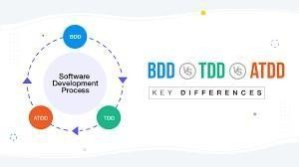

1. **Test-Driven Development (TDD):**

Approach:

* + Developers write tests before writing production code.
  + Focuses on writing small, incremental tests to drive the development process. Benefits:
  + Early Bug Detection: Catch bugs early in the development process.
  + Improved Code Quality: Encourages clean, modular code design.
  + Increased Confidence: Provides a safety net for refactoring and code changes. Suitability:
  + Ideal for projects with clear and well-defined requirements.
  + Best suited for small to medium-sized projects with a focus on code reliability.

1. **Behavior-Driven Development (BDD):**

Approach:

* + Focuses on behavior and outcomes rather than implementation details.
  + Uses natural language specifications (e.g., Given-When-Then) to define tests. Benefits:
  + Enhanced Collaboration: Promotes collaboration between developers, testers, and stakeholders.
  + Improved Communication: Helps ensure alignment between technical and non- technical team members.
  + User-Centric: Tests are written from the perspective of end-users, ensuring that features meet their needs.

Suitability:

* + Suitable for projects with complex business logic and evolving requirements.
  + Best suited for teams that prioritize collaboration and communication.

1. **Feature-Driven Development (FDD):**

Approach:

* + Focuses on building features incrementally based on client priorities.
  + Emphasizes short iterations and frequent client feedback. Benefits:
  + Incremental Delivery: Delivers tangible results to clients in short cycles.
  + Client-Centric: Aligns development efforts with client priorities and business objectives.
  + Scalable: Scales well for large, complex projects with multiple teams. Suitability:
  + Suitable for large-scale projects with evolving requirements and multiple stakeholders.
  + Best suited for projects where client involvement and feedback are essential.

**Conclusion**: Each methodology offers a unique approach to software development, catering to different project requirements and team dynamics. Whether it's the test-driven approach of TDD, the collaborative nature of BDD, or the feature-centric approach of FDD, choosing the right methodology depends on factors such as project size, complexity, and stakeholder involvement.