# ABSTRACT

In a digital world full of tantrums and melt-downs, a human being requires assistance in the matters of health, safety and security, Emergency Services to round it off. With the help of our project, we tend to deliver aid in conditions where every other resource fails. No matter what emergency it is, one can find solution swiftly and help themselves reach the shores of safety with us being by your side all the time. The services provided are Map, SOS, and Guide. The current location of the user is shown on the map (provided that GPS is on) along with all the necessary and available resources around the user. SOS is the standout feature of the project as it paves way for reaching to your loved ones more efficiently. When you click on the SOS button your co-ordinates (location) are sent to your nominees (phone numbers which the user will be giving while registering) along with your custom message. Guide option helps you to find help from online sources. The point is to help people more swiftly, effortlessly, safely.

Keywords: tantrums

### HOME MODULE:

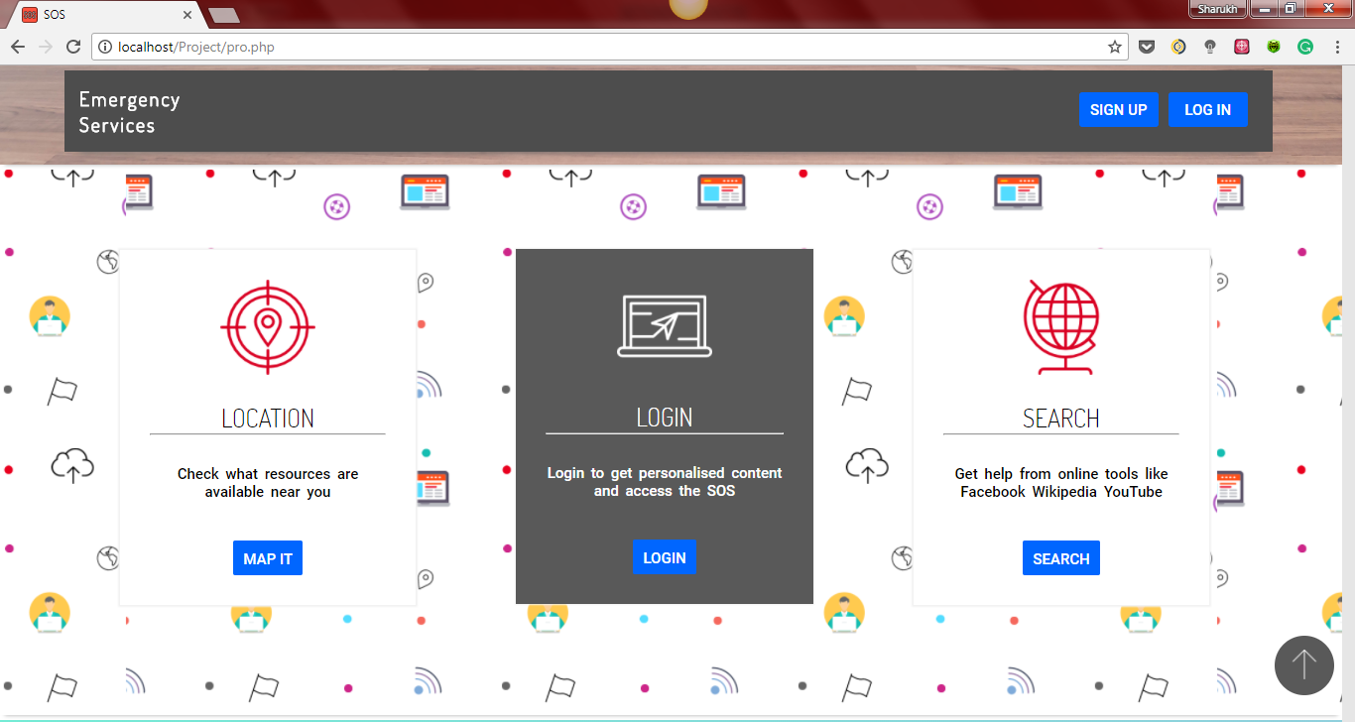

### MAP MODULE:

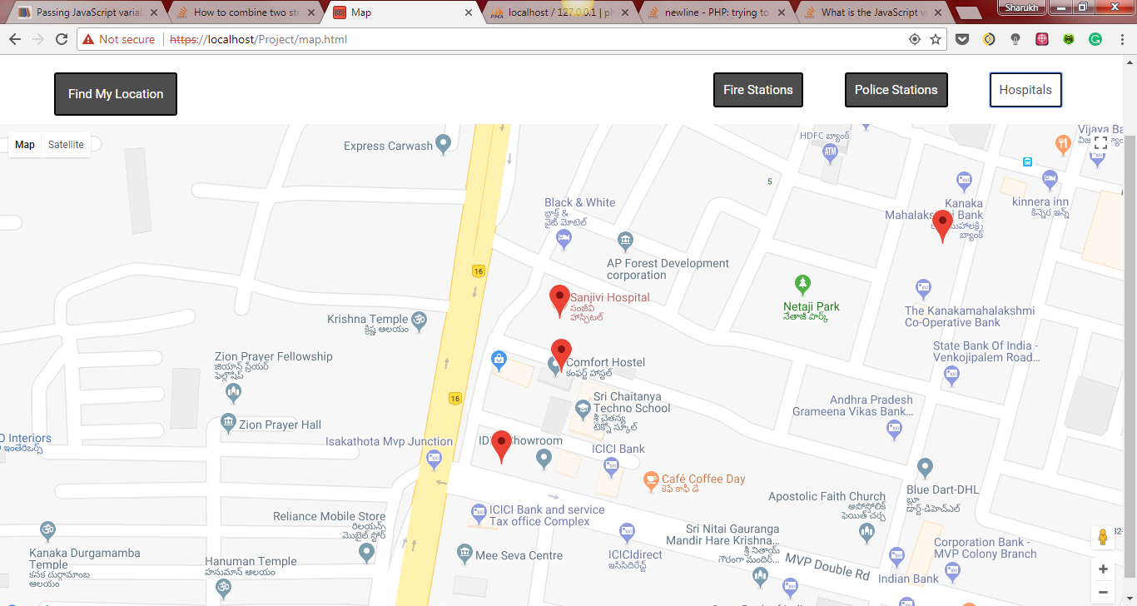

### SEARCH MODULE:

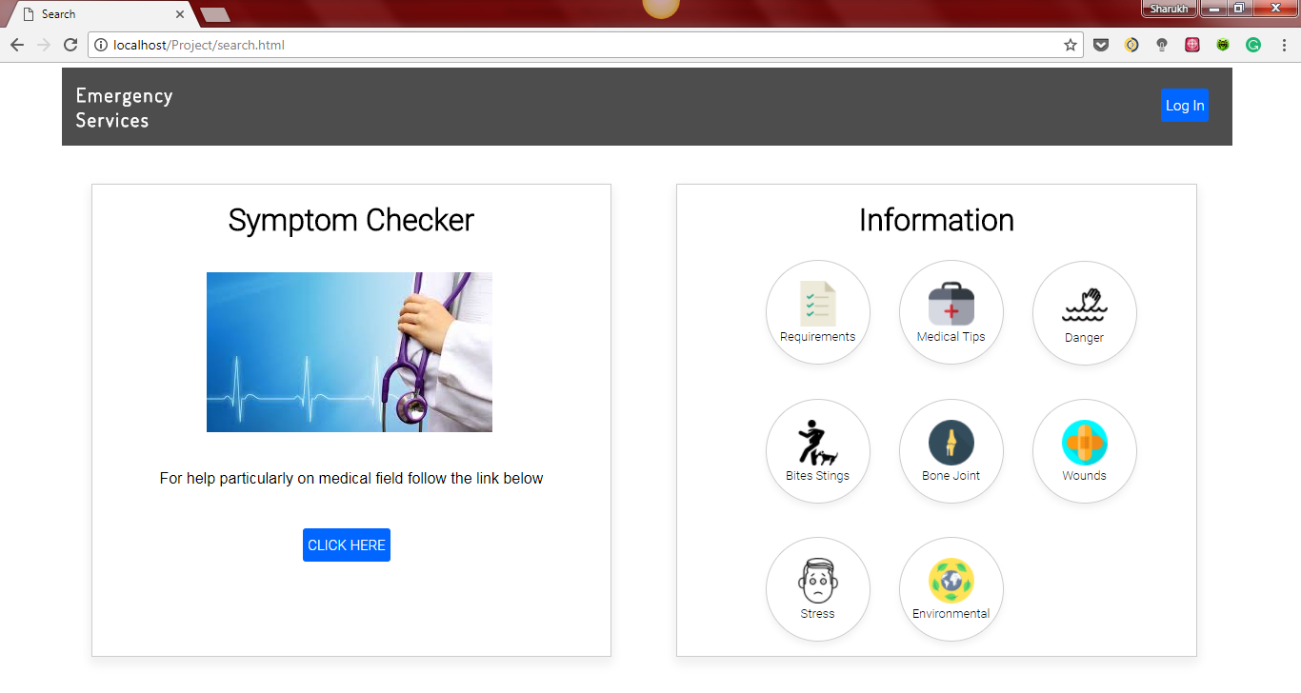

### SIGNUP/LOGIN MODULE:

