ISyE 552 — Lab 2: Force, EMG, and Fatigue
Vishwak Parth Reddy

Introduction
Handgrip tasks are a clean way to study localized muscle fatigue because the force level can be set as a percentage of each person’s maximum. In this lab we measured endurance time (ET) at five intensities (20–100% of MVC), collected Borg 6–20 ratings of perceived exertion (RPE) every 30 seconds, and quantified objective fatigue using the drop from pre- to post-trial MVC. For one participant we also recorded EMG from the wrist flexor and extensor to see how signal amplitude (RMS) and frequency content (median power frequency, MPF) changed across the hold. We expected ET to fall as %MVC increased, RPE to climb during sustained effort, RMS to rise, and MPF to shift downward as fatigue developed. These trends connect directly to jobs that require sustained gripping, where higher force demands can rapidly reduce endurance and increase injury risk.

Methods
Six volunteers (three male, three female) completed handgrip endurance trials using a dynamometer and stopwatch. After a brief warm-up, each participant performed three MVC trials with two minutes rest; the maximum value was used as the pre-MVC. Target forces were set to 20%, 40%, 60%, 80%, and 100% of pre-MVC. Trial order was randomized per participant, and participants rested ten minutes between endurance trials. For each trial, participants matched the target force until volitional exhaustion and ET was recorded. Immediately after exhaustion, participants performed one post-MVC. Percent strength loss was calculated as (pre-MVC − post-MVC) ×100 / pre-MVC. RPE (Borg 6–20) was collected every 30 seconds during the hold. EMG was collected for one participant from the flexor and extensor carpi radialis using Noraxon Ultium EMG, including a 10-second resting baseline. EMG was processed in 10-second windows to compute RMS and MPF; for RPE–EMG comparisons, EMG values were resampled to 30-second bins.

Results
Table 1. Mean ET by %MVC (separated by sex) plus Rohmert curve values.
%MVC | Male mean ET (s) | Female mean ET (s) | Rohmert ET (s)
20 | 112.67 | 175.33 | 385.93
40 | 47.67 | 56.44 | 96.99
60 | 21.67 | 18.99 | 45.34
80 | 5.00 | 13.32 | 21.36
100 | 0.00 | 3.33 | 7.01
Table 2. Mean percent strength loss by %MVC.
%MVC | Male mean strength loss | Female mean strength loss
20 | 33.1% | 35.1%
40 | 47.9% | 40.7%
60 | 36.4% | 34.4%
80 | 33.9% | 30.9%
100 | 43.4% | 24.2%

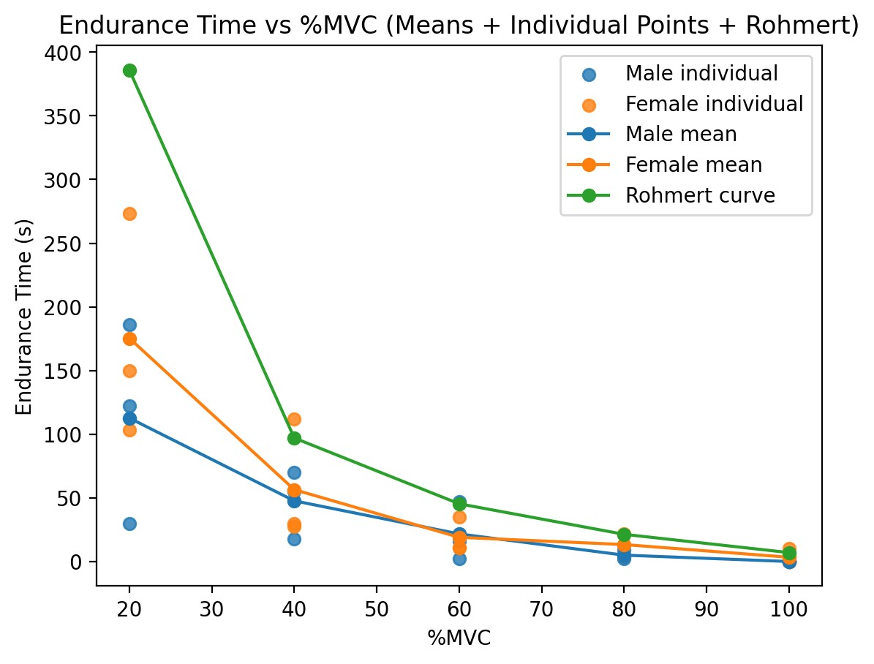
Figure 1. Mean endurance time (ET) curves for males and females with individual points and Rohmert curve.
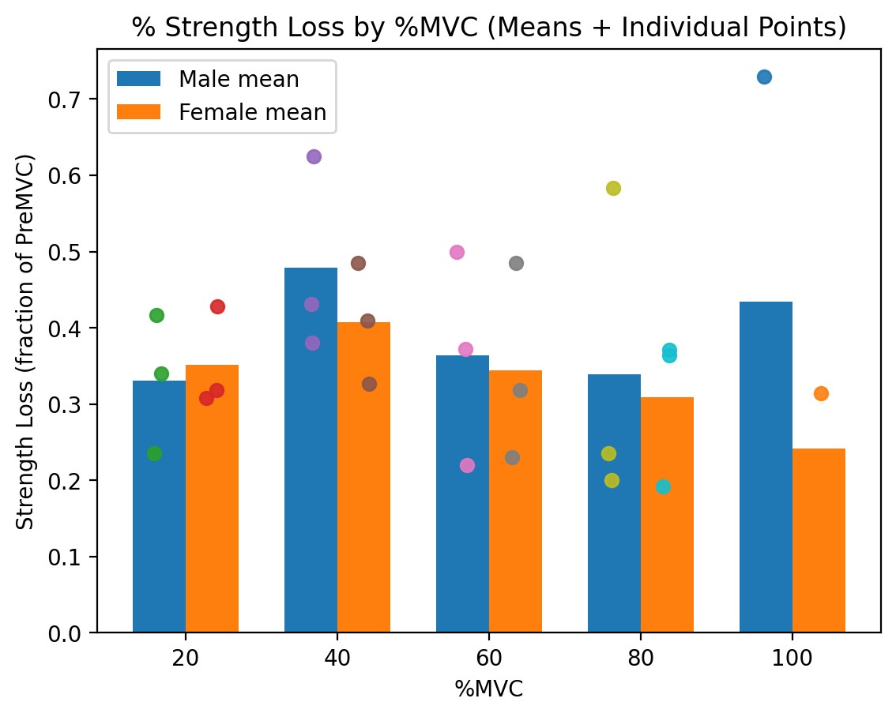
Figure 2. Percent strength loss by %MVC (clustered by sex) with individual points.
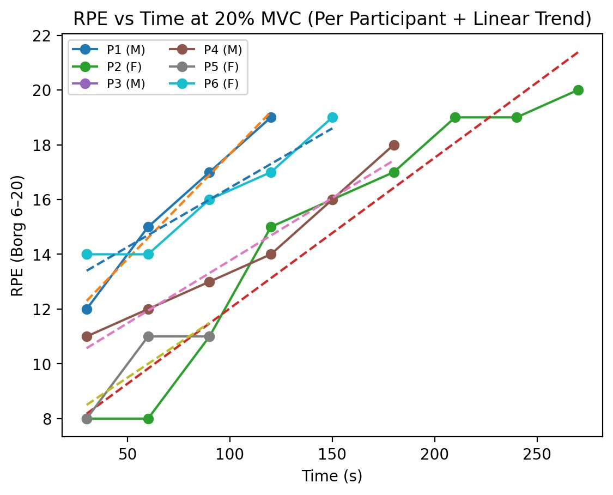
Figure 3. RPE vs time at 20% MVC with linear trends for each participant.
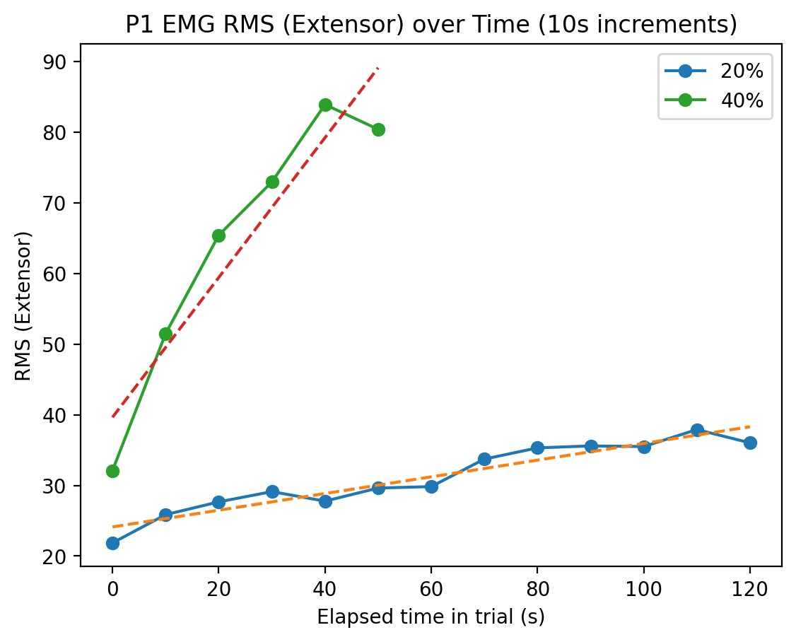
Figure 4a. EMG RMS over time (P1; extensor; 10 s windows).
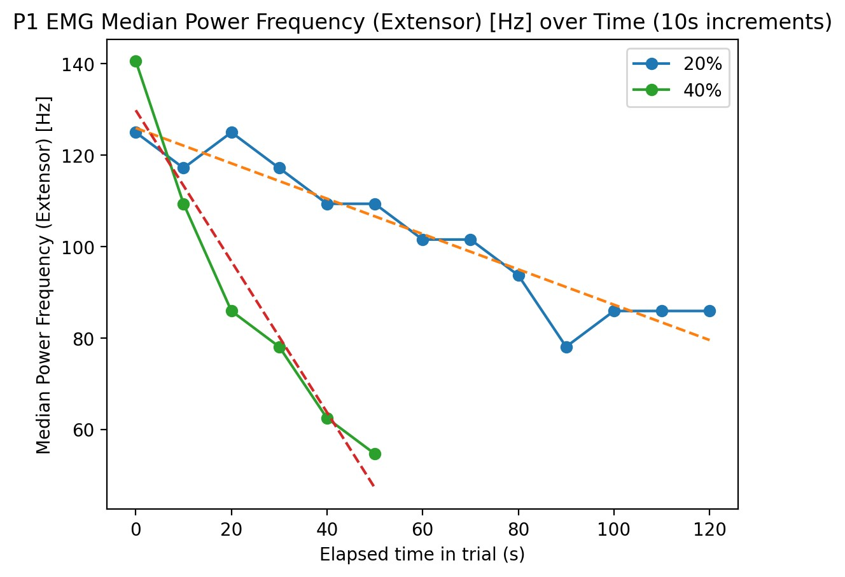
Figure 4c. EMG median power frequency over time (P1; extensor; 10 s windows).
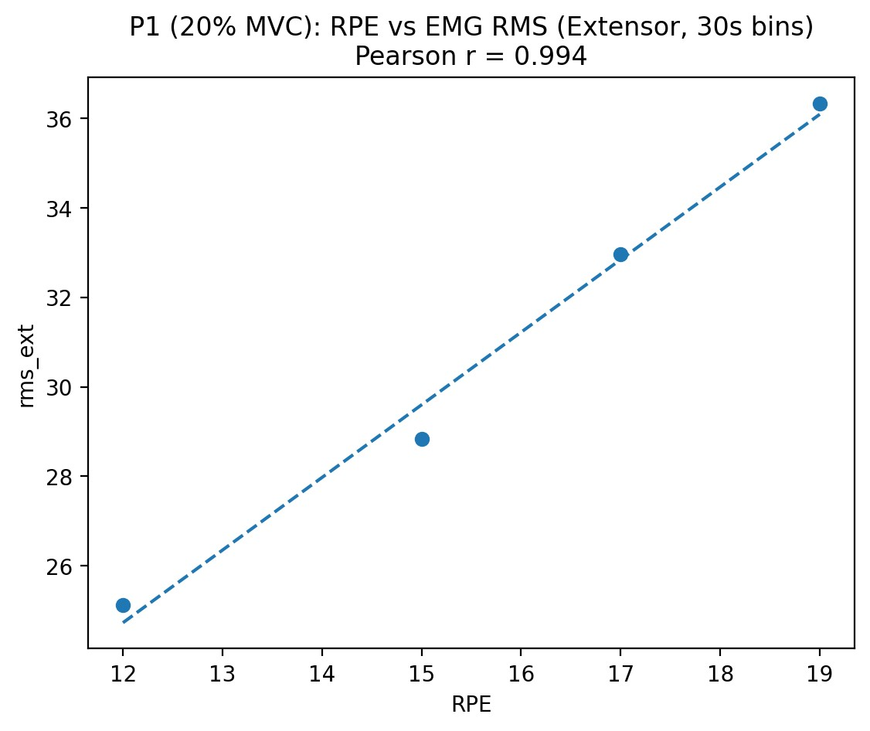
Figure 5a. RPE vs EMG RMS (P1; 20% MVC; EMG resampled to 30 s).
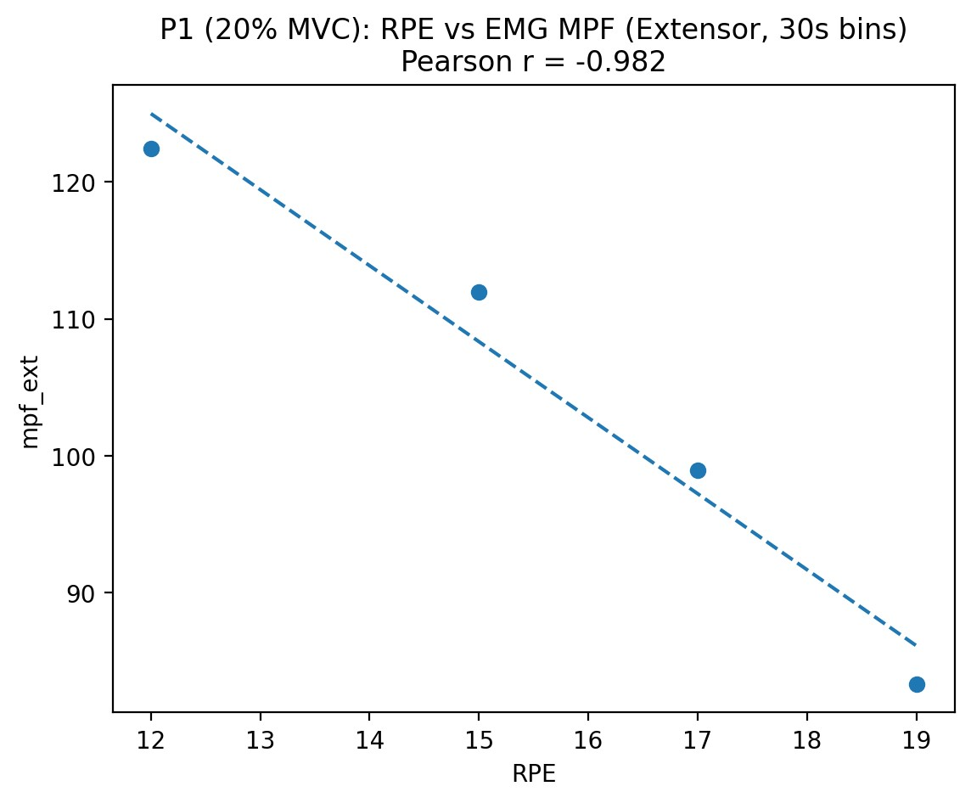
Figure 5b. RPE vs EMG MPF (P1; 20% MVC; EMG resampled to 30 s).

Discussion
Across the five intensity levels, the fatigue measures changed in the expected direction. Endurance time dropped as %MVC increased (Figure 1), and the steep decline between 20% and 60% MVC matched what we saw during data collection: even small increases in required force made the hold feel much less steady and much more time-limited. At 100% MVC, several trials were recorded as 0 s, so the 100% point is best treated as an immediate failure/transition point rather than a smooth continuation of the endurance curve.
Compared with Rohmert’s curve, our class endurance times were generally lower, especially at 20–40% MVC (Figure 1). Rohmert’s curve is an idealized reference built from controlled conditions, while our lab trials included normal variation in force matching, grip technique, dynamometer fit, and how strictly each person treated the “can’t maintain it anymore” endpoint. Even the effort of staying exactly on the target can shorten the hold.
Variability was visible in the individual data points. Differences in hand size, forearm posture, and whether someone unintentionally recruited the shoulder/upper arm can shift the load between muscle groups. Motivation and pain tolerance also matter because the endpoint is voluntary. Finally, the randomized trial order helps, but a participant’s pacing strategy and how they recovered during the 10-minute rest window can still influence later trials.
Strength loss showed moderate-to-large drops across trials (Figure 2). Because the post-MVC is taken right after exhaustion, timing and coaching make a big difference: a small delay, inconsistent encouragement, or difficulty ramping back up quickly can change the measured loss even if the underlying fatigue is similar.
RPE increased over time during sustained effort (Figure 3). Using a linear fit at 20% MVC, the average slope was about 3.67 RPE units per minute for males and 2.97 units per minute for females in this dataset. RPE is useful because it is fast to collect and it captured clear within-trial changes even when endurance times differed across participants.
For the EMG participant (P1), RMS rose over time and MPF declined (Figure 4), consistent with increased recruitment and a fatigue-related shift of the power spectrum to lower frequencies. The extensor RMS slope at 20% MVC was about 0.118 per second (10 s windows) and MPF decreased at about -0.386 Hz per second; at 40% MVC the changes were steeper (RMS 0.989 per second; MPF -1.652 Hz per second).
When EMG was resampled to 30-second bins, RPE tracked EMG changes closely for P1 at 20% MVC: RPE and extensor RMS were strongly positively correlated (r = 0.994), while RPE and extensor MPF were strongly negatively correlated (r = -0.982) (Figure 5).
Each measure has advantages and limitations. ET is simple and intuitive, but it depends heavily on motivation and how tightly the target force is enforced. Strength loss is more objective, but it still depends on effort during the post-MVC and the timing right after exhaustion. RPE is low-cost and surprisingly informative, but it is subjective and scale interpretation differs across people. EMG provides physiological detail (amplitude and spectral shifts), but it requires careful electrode placement, low-noise recording, and thoughtful processing; short trials can also limit slope estimates.
From an occupational perspective, these results highlight why sustained high-force gripping is risky: endurance drops quickly as force demand rises, so workers reach fatigue sooner and may compensate with awkward postures or higher co-contraction. For routine workplace monitoring, RPE and simple task-based endurance checks are the most feasible. Strength testing can be added for higher-risk jobs or for pre/post shift screening. EMG is best used for targeted evaluations or redesign studies. Practical improvements include reducing required grip force (better handle design, power-assisted tools), adding micro-breaks, rotating tasks to vary muscle use, and training workers to avoid sustained pinch and excessive wrist deviation.

