Lab 3: Human Mental Workload
Final Report
Vishwak Parth Reddy
ISyE 552 – Human Factors Design and Evaluation

Introduction
Mental workload is the amount of cognitive demand placed on a person while they are trying to complete a task. In this lab, workload was manipulated with three levels of an n-back task: 1-back, 2-back, and 3-back. As the task becomes harder, participants must keep more information active in working memory, respond accurately under time pressure, and divide attention between the primary task and a secondary count-back task. Because no single metric captures workload perfectly, the analysis used three complementary measurement approaches: performance, self-report, and physiology.
The main purpose of this report is to examine how those workload measures changed as task difficulty increased and to determine whether the different methods told a similar story. Primary-task accuracy, secondary-task behavior, NASA-TLX, and ECG-based measures were analyzed together so the final interpretation would not depend on only one signal. In practical human factors work, that kind of triangulation matters because an operator can sometimes keep performing well even when the task feels harder or the body is showing signs of strain.

Methods
The final dataset contained eight participant records for the performance and NASA-TLX analyses. Each participant completed one block each of the 1-back, 2-back, and 3-back task. During the final minute of each block, participants also performed a secondary task in which they counted backward by threes for one minute. The experimenter recorded the number of count-backs completed and the number of mistakes.
After each workload block, participants reported perceived workload with the NASA Task Load Index (NASA-TLX). Actiheart ECG recordings were processed into heart rate (HR), RMSSD, and LF/HF ratio for each workload condition. In this report, HRV was interpreted primarily through RMSSD and LF/HF because those were the usable ECG-derived features available in the processed dataset.
For Objective 1, means and standard deviations were computed within each workload condition for primary-task accuracy, secondary-task errors, secondary-task count-backs, NASA-TLX, HR, RMSSD, and LF/HF. For Objective 2, Pearson correlations were pooled across all workload levels. Scatter plots were created for RMSSD, NASA-TLX, and primary-task accuracy because those variables provided one representative measure from physiology, self-report, and performance, while also showing the clearest cross-method comparison in the dataset. Some ECG rows were unavailable after preprocessing, so the physiology summaries and physiology-related correlations are based on the valid observations only.

Results
Table 1. Mean ± SD by workload condition.
Measure | 1-back | n | 2-back | n | 3-back | n
Primary-task accuracy (%) | 82.8 ± 21.4 | 8 | 75.3 ± 12.8 | 8 | 66.5 ± 9.8 | 8
Secondary-task errors | 1.50 ± 1.41 | 8 | 1.38 ± 1.77 | 8 | 1.25 ± 1.49 | 8
Secondary-task count-backs | 21.25 ± 6.09 | 8 | 21.62 ± 5.26 | 8 | 23.62 ± 7.52 | 8
NASA-TLX score | 51.25 ± 15.55 | 8 | 66.25 ± 10.77 | 8 | 77.58 ± 12.36 | 8
Heart rate (bpm) | 75.61 ± 7.18 | 6 | 73.18 ± 8.20 | 5 | 75.32 ± 8.86 | 7
RMSSD (ms) | 41.01 ± 9.71 | 6 | 48.04 ± 15.53 | 5 | 39.84 ± 12.29 | 7
LF/HF ratio | 2.499 ± 1.880 | 6 | 2.759 ± 2.542 | 5 | 2.314 ± 1.530 | 7
Table 1 shows a clear separation across workload levels for the two measures that responded most strongly: primary-task accuracy and NASA-TLX. Accuracy fell steadily from 82.8% in 1-back to 75.3% in 2-back and 66.5% in 3-back, while NASA-TLX rose from 51.2 to 66.2 and then 77.6. That pattern indicates that participants both felt the workload increase and had more difficulty sustaining performance as the task became harder. By contrast, the secondary-task measures were less diagnostic in this dataset. Errors declined slightly across the three conditions (1.50, 1.38, 1.25), and count-backs increased modestly (21.3, 21.6, 23.6), so the secondary task did not show the expected workload cost.
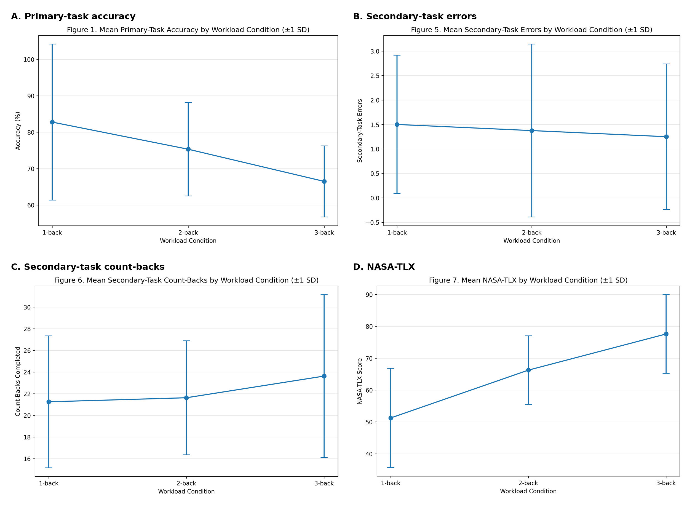
Figure 1. Performance and subjective workload across the three workload conditions (mean ± SD).
The ECG measures were more variable than the self-report and primary-task measures. HR stayed nearly flat across conditions (75.6, 73.2, and 75.3 bpm). RMSSD increased from 41.0 ms in 1-back to 48.0 ms in 2-back, then dropped to 39.8 ms in 3-back, so only the highest workload condition showed the expected reduction relative to the starting condition. LF/HF also changed only slightly (2.50, 2.76, 2.31). Figure 2 therefore suggests that the physiological measures were less monotonic and less cleanly separated than NASA-TLX and accuracy. This part of the dataset should be interpreted more cautiously because the valid ECG sample sizes were smaller than the performance and NASA-TLX sample sizes.
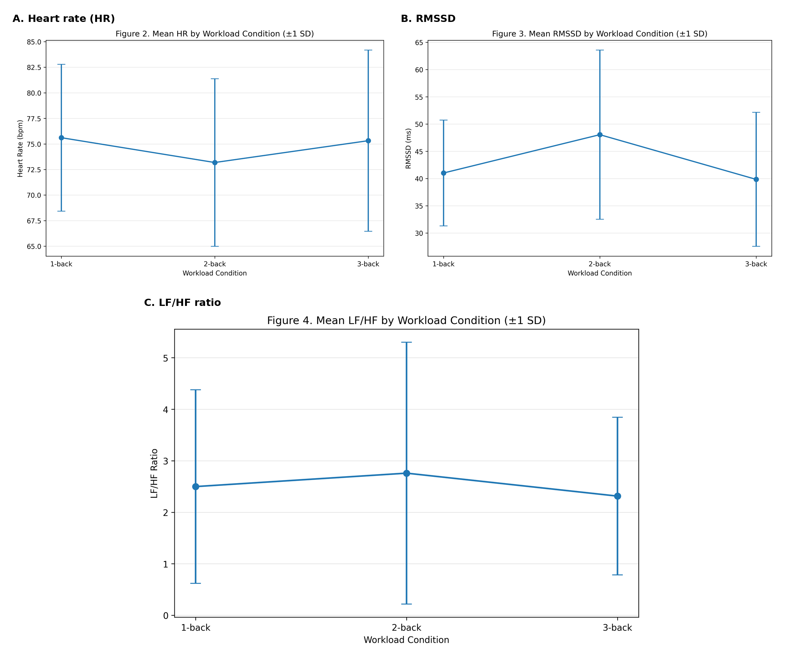
Figure 2. ECG-based workload measures across the three workload conditions (mean ± SD).
Table 2. Pooled correlation matrix (Pearson r).
Measure | NASA-TLX | Accuracy | Errors
HR | 0.20 | 0.26 | —
RMSSD | -0.44 | -0.25 | —
LF/HF | 0.09 | 0.05 | —
NASA-TLX | — | -0.23 | —
Accuracy | — | — | -0.15
Note. Physiology-related correlations are based on 18 valid pooled observations. NASA-TLX vs accuracy and accuracy vs errors are based on 24 pooled observations.
The pooled correlations were generally weak to modest. The strongest relationship was the inverse association between RMSSD and NASA-TLX (r = -0.44), which suggests that lower vagally mediated variability tended to occur when participants rated the task as more demanding. HR showed only weak positive associations with NASA-TLX (r = 0.20) and accuracy (r = 0.26), while LF/HF was close to zero for both NASA-TLX (r = 0.09) and accuracy (r = 0.05). NASA-TLX and primary-task accuracy were weakly negative (r = -0.23), and accuracy and secondary-task errors were also weakly negative (r = -0.15). Figure 3 visualizes the same pattern: the clearest slope appears in the RMSSD versus NASA-TLX plot, while the other relationships are more scattered.
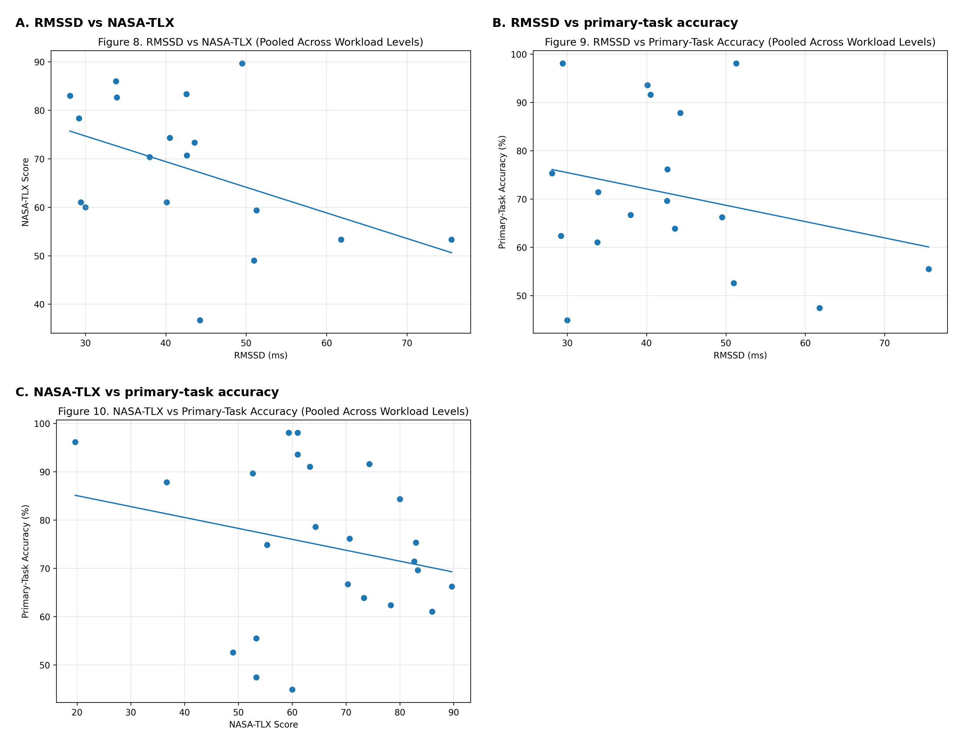
Figure 3. Scatter plots used for cross-method comparison.

Discussion

Sensitivity of the measures
The clearest workload effects in this lab came from NASA-TLX and primary-task accuracy. Both changed in the expected direction across the three workload levels: perceived workload rose, and main-task performance fell. That makes intuitive sense for an n-back task because the memory and attentional demands become more obvious to the participant as the task moves from 1-back to 3-back. The secondary-task measures were much less sensitive here. Instead of getting worse with higher workload, count-backs increased slightly and errors fell slightly. That pattern suggests that the secondary task was either not demanding enough, was scored with too much noise, or was influenced by pacing strategies that differed across participants. The physiological measures were the most mixed. RMSSD showed some sensitivity, especially when 3-back was compared with 1-back, but HR and LF/HF did not separate the conditions clearly.

How the measures relate to one another
The correlation results show only partial agreement among the methods. That is not surprising, because each measure reflects a different side of workload. NASA-TLX captures how hard the task felt. Primary-task accuracy captures whether participants could still meet the task demands. ECG features capture autonomic response, which can be affected by workload but also by timing, posture, breathing, and signal quality. The moderate negative correlation between RMSSD and NASA-TLX fits the usual interpretation of RMSSD: as perceived workload rises, parasympathetic activity tends to be reduced. Still, the fact that the correlation was only moderate and the other correlations were weak is a reminder that workload is not a single, perfectly unified construct.

Comparison with published work
The broad pattern of the present results is consistent with what is commonly seen in n-back workload studies. As task difficulty increases, people usually report higher workload and show lower task performance, and that same pattern appeared clearly in this dataset. From 1-back to 3-back, NASA-TLX increased by 26.3 points and primary-task accuracy dropped by 16.3 percentage points, which reflects a meaningful workload effect. The physiology results were less consistent. HR stayed almost unchanged across the three conditions, and LF/HF did not increase in a clean stepwise way. That weaker physiology pattern most likely reflects the short recording windows, the small sample, and the fact that several ECG rows were unavailable after preprocessing.

Sources of error and limitations
Several sources of error could have affected the results. The most obvious one is the missing ECG data, which reduced the sample size for HR, RMSSD, and LF/HF. Short task segments also make HRV features less stable, especially for frequency-domain measures such as LF/HF. If start and stop times were even slightly off, the extracted physiological window may not have matched the true task period exactly. The secondary task was scored manually, so experimenter timing and recording accuracy could also have introduced error. Participants may have used different strategies as they adapted to the n-back task, and that can blur clean workload trends. NASA-TLX is useful and sensitive, but it is still retrospective and subjective. Finally, this was a small lab sample, so the results should be treated as informative but not definitive.

Implications
Taken together, the results support the idea that workload should be assessed with more than one method. If this analysis had relied only on the secondary task or only on HR, the conclusion would have been much less clear. NASA-TLX and primary-task accuracy gave the strongest and most interpretable separation across workload levels, while RMSSD offered the most meaningful physiological link to perceived demand. For future studies, larger samples, longer stable ECG windows, stricter synchronization, and perhaps repeated blocks per workload condition would improve the physiology analysis and make the triangulation stronger.

Conclusion
This lab showed that increasing n-back difficulty clearly increased perceived mental workload and reduced primary-task performance. Among all of the measures examined, NASA-TLX and primary-task accuracy were the most sensitive to the workload manipulation. The ECG measures were less consistent, although RMSSD showed a meaningful inverse relationship with perceived workload when the data were pooled. The secondary-task measures were the least convincing in this dataset, which suggests that they were either too noisy or not demanding enough to reflect the changes in cognitive load reliably. Overall, the findings lined up with the expectation that harder n-back conditions would feel more demanding and would make the main task harder to perform, but the physiology did not separate the three conditions as cleanly as expected. In future work, more participants, cleaner ECG segments, longer analysis windows, and tighter task synchronization would likely improve the physiological side of the analysis. Even with those limitations, the study was useful because it showed why workload in real systems should be evaluated from multiple angles. Designers and researchers need to know not only whether a task feels hard, but also whether performance is slipping and whether the body is showing signs of strain.

