10.
clc;
clear;
close all;

%% Read speech signal
[x, Fs] = audioread('speech.wav');

% Convert stereo to mono
if size(x,2) > 1
x = mean(x,2);
end

%% Add noise
noise = 0.05 * randn(size(x));
noisy = x + noise;

%% STFT parameters
win = hamming(256);
noverlap = 128;
nfft = 512;

%% Spectrogram of noisy speech
[S,F,T] = spectrogram(noisy, win, noverlap, nfft, Fs);

%% Estimate noise spectrum
% First 5 frames are assumed to contain mainly noise
noise_mag = mean(abs(S(:,1:5)),2);

%% Spectral subtraction
magnitude = abs(S);
phase = angle(S);

clean_mag = max(magnitude - noise_mag, 0);

%% Reconstruct spectrum
S_clean = clean_mag .* exp(1j*phase);

%% Inverse STFT
clean = istft(S_clean, Fs, ...
'Window', win, ...
'OverlapLength', noverlap, ...
'FFTLength', nfft);

clean = clean(:);

%% Match signal lengths
L = min(length(x),length(clean));

x = x(1:L);
noisy = noisy(1:L);
clean = clean(1:L);

%% Plot signals
figure;

subplot(3,1,1);
plot(x);
grid on;
xlabel('Sample');
ylabel('Amplitude');
title('Original Speech Signal');

subplot(3,1,2);
plot(noisy);
grid on;
xlabel('Sample');
ylabel('Amplitude');
title('Noisy Speech Signal');

subplot(3,1,3);
plot(clean);
grid on;
xlabel('Sample');
ylabel('Amplitude');
title('Speech After Spectral Subtraction');

%% Play noise-reduced speech
soundsc(clean,Fs);
output:
Amplitude
|
| /\ /\ /\
|___/ \____/ \___/\____/ \____
|
+--------------------------------> Sample
Amplitude
|
| /\ /\ /\/\ /\ /\/\ /\ /\
|/ \/ \_/ V \_/ V V \__
|
+--------------------------------> Sample
Amplitude
|
| /\ /\ /\
|___/ \____/ \___/\____/ \____
|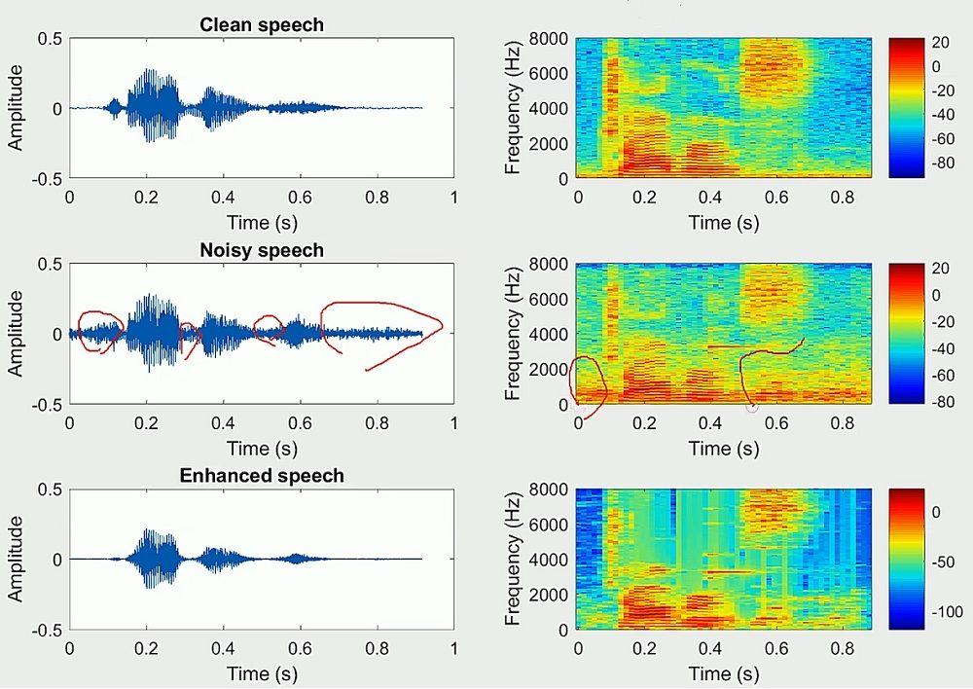
+--------------------------------> Sample
