EXP .1
import numpy as np
from scipy import signal
import matplotlib.pyplot as plt

# Clear previous plots (equivalent to MATLAB's figure; close all; clc; clear)
plt.close('all')

# Filter specifications
Fs = 10000 # Sampling frequency
Fp = 1000 # Passband frequency
…# • Stopband Attenuation (𝑅𝑠) = 20 dB (Note: original code used 60dB, not 20dB)
# • Passband Frequency (𝐹𝑝) = 1000 Hz
# • Stopband Frequency (𝐹𝑠) = 3000 Hz (Note: original code used 1500Hz for Fst)
# • Sampling Frequency (𝐹𝑠𝑎𝑚𝑝𝑙𝑖𝑛𝑔) = 8000 Hz (Note: original code used 10000Hz for Fs)
# • Filter Choice = Low-Pass Filter (LPF)

OUTPUT:
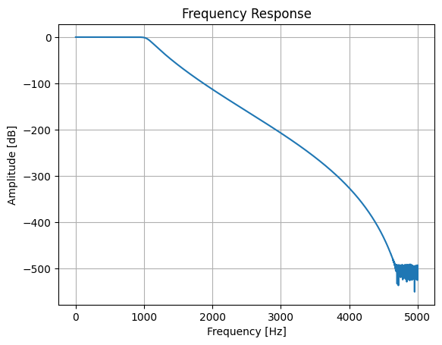
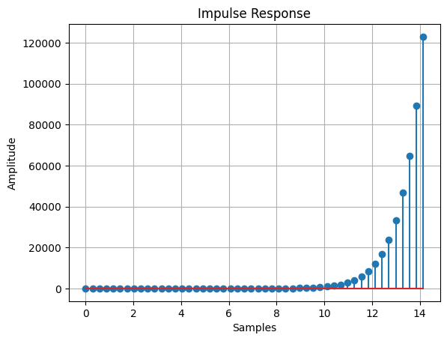
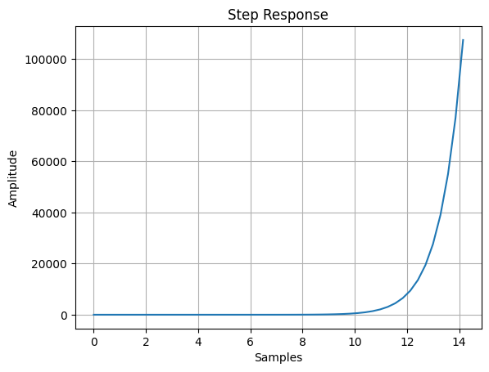
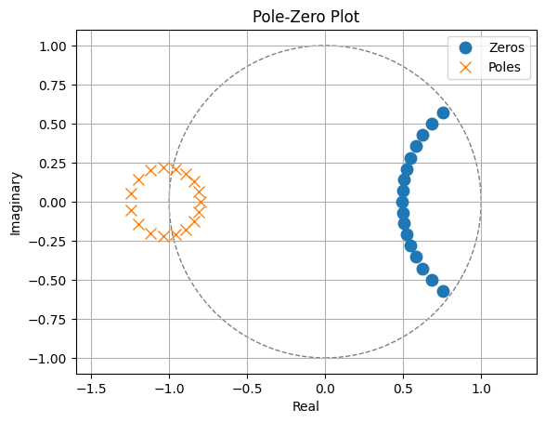
Minimum Filter Order (N) = 17
Cutoff Frequency (Wn) = 0.2076

