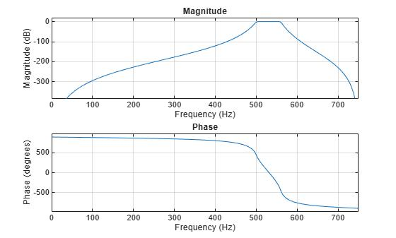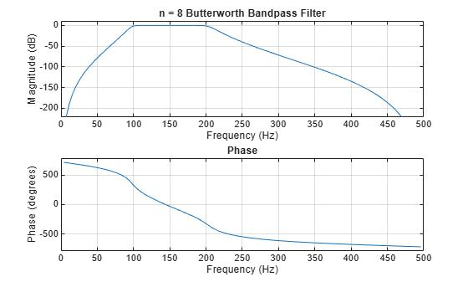clc;
clear;
close all;

% Specifications
Fs = 1000; % Sampling frequency (Hz)
Fp1 = 100; % Lower passband frequency (Hz)
Fp2 = 300; % Upper passband frequency (Hz)
Rp = 1; % Passband ripple for Chebyshev Type-I (dB)
Rs = 40; % Stopband attenuation (dB)

% Normalized frequencies
Wp = [Fp1 Fp2] / (Fs/2);
Ws = [80 320] / (Fs/2);

%% Butterworth Band-Pass Filter
[Nb, Wnb] = buttord(Wp, Ws, Rp, Rs);
[b_butt, a_butt] = butter(Nb, Wnb, 'bandpass');

%% Chebyshev Type-I Band-Pass Filter
[Nc, Wnc] = cheb1ord(Wp, Ws, Rp, Rs);
[b_cheb, a_cheb] = cheby1(Nc, Rp, Wnc, 'bandpass');

%% Display Filter Orders
fprintf('Butterworth Filter Order = %d\n', Nb);
fprintf('Chebyshev Type-I Filter Order = %d\n', Nc);

%% Frequency Response
[H1, f] = freqz(b_butt, a_butt, 2048, Fs);
[H2, ~] = freqz(b_cheb, a_cheb, 2048, Fs);

figure;

plot(f, 20*log10(abs(H1)));
hold on;
plot(f, 20*log10(abs(H2)));
grid on;

xlabel('Frequency (Hz)');
ylabel('Magnitude (dB)');
title('Butterworth vs Chebyshev Type-I IIR Band-Pass Filters');
legend('Butterworth', 'Chebyshev Type-I');
xlim([0 500]);

%% Pole-Zero Plot
figure;

subplot(1,2,1);
zplane(b_butt, a_butt);
title('Butterworth Band-Pass Filter');

subplot(1,2,2);
zplane(b_cheb, a_cheb);
title('Chebyshev Type-I Band-Pass Filter');

