NAME : G. ReddyPrasad
REG NO:192312500

Technical Report
DSP-Based Noise-Reduction System for a Digital Stethoscope
Course / Subject: Digital Signal Processing
Sampling Frequency: 2000 Hz | PCG Low-Pass Filtering | IIR vs FIR Evaluation
Academic simulation report

Abstract
This report develops and evaluates a digital signal-processing noise-reduction chain for a remote cardiac-monitoring stethoscope. A representative phonocardiogram (PCG) sampled at 2 kHz is analysed in the time and frequency domains. Additive white Gaussian noise (AWGN) is added to produce an input SNR of 10 dB. Two low-pass solutions are then designed: a 14th-order Butterworth IIR filter using an analog prototype followed by bilinear transformation, and a 33th-order Hamming-window FIR filter with 34 taps. The simulation shows that both architectures suppress high-frequency interference while retaining the dominant heart-sound content below 400 Hz. The FIR solution has exactly linear phase and a fixed 16-sample (8 ms) delay, whereas the IIR solution achieves sharper attenuation with fewer multiplications but has nonlinear phase. For a real-time digital stethoscope, the Hamming FIR is recommended when waveform morphology and timing fidelity are the priority; the Butterworth IIR is an attractive lower-computation alternative when phase distortion can be tolerated or compensated.

1. Technical Report / System Objective
The objective is to design a practical DSP front end that improves the signal-to-noise ratio of a digital stethoscope without removing diagnostically relevant heart-sound components. The selected passband edge of 400 Hz covers the main energy of S1, S2 and many clinically useful murmurs, while the 600 Hz stopband edge provides a 200 Hz transition region for practical digital filter implementation.
Because a patient-recording file was not supplied with the question, the numerical simulation in this report uses a reproducible synthetic PCG containing S1/S2-like damped acoustic bursts and low-frequency physiological content. The MATLAB source code also includes a section showing how to replace the synthetic signal with an actual PCG recording.

2. System Block Diagram
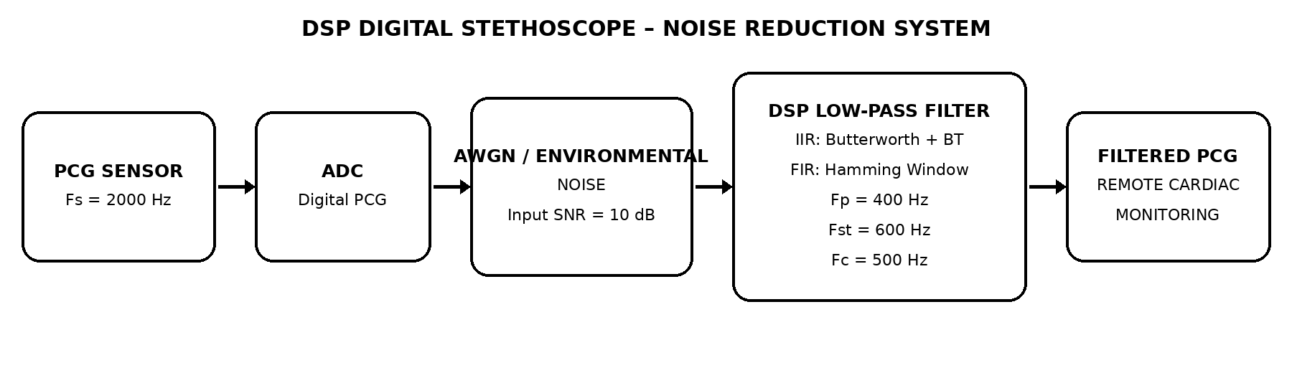
Figure 1. DSP chain: PCG acquisition → ADC → environmental/AWGN corruption → selectable low-pass filter → cleaned PCG for remote monitoring.

3. Filter Design Specifications
Parameter | Specification
Sampling frequency, Fs | 2000 Hz
Passband edge, Fp | 400 Hz
Stopband edge, Fst | 600 Hz
Transition bandwidth | 200 Hz
Passband ripple, Rp | 1 dB
Stopband attenuation, As | 40 dB
Nominal cut-off, Fc | 500 Hz
Input AWGN SNR | 10 dB
The design uses 400 Hz as the passband constraint, 600 Hz as the stopband constraint, and 500 Hz as the nominal centre cut-off. In the Butterworth design, Rp is used to place the analog cut-off so that the response is approximately −1 dB at 400 Hz.

4. Signal Analysis and AWGN Model
For a 10 dB input SNR, the noise variance is selected from σn² = Px / 10^(SNR/10), where Px is the mean-square power of the clean PCG. The random generator is seeded in the MATLAB code so that the experiment is repeatable.
A typical PCG is non-stationary and contains strong transient components corresponding to S1 and S2. Most useful acoustic energy is concentrated in the low-frequency region, although murmurs and abnormal sounds can extend to several hundred hertz. Consequently, the filter must remove out-of-band environmental noise while preserving the morphology and timing of the heart sounds.

5. IIR Butterworth Design Using Bilinear Transformation
For a Butterworth approximation, the minimum order is obtained from the passband and stopband attenuation constraints:
N >= log10[(10^(As/10)-1)/(10^(Rp/10)-1)] / [2 log10(Fst/Fp)]
Substitution gives N = 14. Therefore, a 14th-order Butterworth low-pass is selected.
The bilinear transformation first prewarps the digital edge frequencies:
Ωp = 2Fs tan(πFp/Fs) = 2906.170112 rad/s
Ωst = 2Fs tan(πFst/Fs) = 5505.527682 rad/s
Ωc = Ωp / (10^(Rp/10)-1)^(1/(2N)) = 3049.854208 rad/s
A 14th-order analog Butterworth prototype is then generated with this Ωc and mapped into the z-domain by the bilinear transformation s = 2Fs(1−z⁻¹)/(1+z⁻¹). The resulting digital filter has 15 numerator and 15 denominator coefficients.

IIR coefficients
k | b(k) | a(k)
0 | 3.59276520148e-05 | 1
1 | 0.000502987128207 | -2.38328434189
2 | 0.00326941633334 | 4.41926702197
3 | 0.0130776653334 | -5.31185207928
4 | 0.0359635796668 | 5.16368848674
5 | 0.0719271593335 | -3.84320367613
6 | 0.107890739 | 2.34361896922
7 | 0.123303701715 | -1.13647887431
8 | 0.107890739 | 0.447561626853
9 | 0.0719271593335 | -0.139112553436
10 | 0.0359635796668 | 0.0338733693738
11 | 0.0130776653334 | -0.00617779025084
12 | 0.00326941633334 | 0.000801540195466
13 | 0.000502987128207 | -6.56125839272e-05
14 | 3.59276520148e-05 | 2.56414090663e-06
The coefficient set above is generated by the same design equations used in the MATLAB script. For implementation, second-order sections (SOS) are preferred over a single high-order direct-form realization for numerical robustness.

6. FIR Hamming-Window Design
A Hamming-window FIR is selected because it provides linear phase, a predictable fixed delay and good stopband suppression. The practical Hamming-window order estimate N ≈ 3.3Fs/ΔF gives N ≈ 33 for ΔF = 200 Hz. Hence N = 33 is used, giving 34 taps.
b = fir1(33, 500/(Fs/2), hamming(34)); % 34-tap Hamming FIR
The FIR group delay is N/2 = 16 samples, which corresponds to 16/2000 = 0.008 s = 8 ms. This fixed delay is small enough for real-time auscultation and remote streaming.

FIR coefficients
Tap k | b(k)
0 | 0.00109122113409
1 | -0.00128232668054
2 | -0.00175318540135
3 | 0.00255111909399
4 | 0.00372854837192
5 | -0.0053462340024
6 | -0.0074787620535
7 | 0.0102238657177
8 | 0.0137186608064
9 | -0.0181691403753
10 | -0.0239070724448
11 | 0.0315090102468
12 | 0.0420738282195
13 | -0.0579755772265
14 | -0.0854222147217
15 | 0.14724712164
16 | 0.449191137676
17 | 0.449191137676
18 | 0.14724712164
19 | -0.0854222147217
20 | -0.0579755772265
21 | 0.0420738282195
22 | 0.0315090102468
23 | -0.0239070724448
24 | -0.0181691403753
25 | 0.0137186608064
26 | 0.0102238657177
27 | -0.0074787620535
28 | -0.0053462340024
29 | 0.00372854837192
30 | 0.00255111909399
31 | -0.00175318540135
32 | -0.00128232668054
33 | 0.00109122113409

7. MATLAB Source Code
% DSP-based noise reduction for a digital stethoscope
% Fs = 2000 Hz, Fp = 400 Hz, Fst = 600 Hz, Fc = 500 Hz
clear; close all; clc;
Fs = 2000; Fp = 400; Fst = 600; Fc = 500;
Rp = 1; As = 40; rng(42);
%% 1. Obtain PCG
% Replace this section by: [x,Fs0] = audioread('your_PCG_file.wav');
% if a real PCG recording is available.
T = 10; t = (0:1/Fs:T-1/Fs)';
x = zeros(size(t)); period = 0.8; % 75 bpm
for k = 0:ceil(T/period)
s1 = k*period + 0.08; s2 = k*period + 0.38;
C = [s1 70 1.00 0.045; s1 120 0.45 0.025; ...
s2 110 0.75 0.035; s2 180 0.30 0.020];
for q = 1:size(C,1)
tt = t-C(q,1); idx = abs(tt)<0.12;
env = exp(-abs(tt(idx))/C(q,4));
x(idx) = x(idx) + C(q,3)*env.*cos(2*pi*C(q,2)*tt(idx));
end
end
x = x + 0.08*sin(2*pi*30*t).*(1+0.2*sin(2*pi*1.25*t));
x = x/max(abs(x));
%% 2. Add AWGN at exactly 10 dB input SNR
Px = mean(x.^2); Pn = Px/10^(10/10);
n = sqrt(Pn)*randn(size(x)); y = x+n;
%% 3. IIR Butterworth order and bilinear transformation
N_iir = ceil(log10((10^(As/10)-1)/(10^(Rp/10)-1)) / ...
(2*log10(Fst/Fp)));
Wp = 2*Fs*tan(pi*Fp/Fs);
Ws = 2*Fs*tan(pi*Fst/Fs);
Wc = Wp/(10^(Rp/10)-1)^(1/(2*N_iir));
[ba,aa] = butter(N_iir,Wc,'s'); % analog Butterworth
[bI,aI] = bilinear(ba,aa,Fs); % bilinear transform
%% 4. FIR Hamming-window design
N_fir = 33;
bF = fir1(N_fir,Fc/(Fs/2),hamming(N_fir+1));
aF = 1;
%% 5. Causal filtering for real-time comparison
yI = filter(bI,aI,y);
yF = filter(bF,aF,y);
%% 6. Time-domain plots
figure; plot(t,x); hold on; plot(t,y); plot(t,yI); plot(t,yF);
xlim([0 4]); grid on; legend('Original','Noisy','IIR','FIR');
xlabel('Time (s)'); ylabel('Amplitude');
title('PCG: Original, Noisy and Filtered');
%% 7. Magnitude spectra
Nfft = 8192; f = (0:Nfft/2)*Fs/Nfft;
X = abs(fft(x.*hann(length(x)),Nfft)); X=X(1:Nfft/2+1);
Y = abs(fft(y.*hann(length(y)),Nfft)); Y=Y(1:Nfft/2+1);
figure; plot(f,20*log10(X/max(X))); hold on;
plot(f,20*log10(Y/max(Y)));
XI = abs(fft(yI.*hann(length(yI)),Nfft)); XI=XI(1:Nfft/2+1);
plot(f,20*log10(XI/max(XI)));
% For MATLAB versions that do not allow indexed function output,
% create XI = abs(fft(yI.*hann(length(yI)),Nfft)); then plot 20log10(XI(1:Nfft/2+1)/max(X)).
grid on; xlim([0 1000]); xlabel('Frequency (Hz)'); ylabel('Magnitude (dB)');
legend('Original','Noisy','IIR'); title('Magnitude Spectrum');
%% 8. Filter magnitude and phase responses
[HI,w] = freqz(bI,aI,8192,Fs);
[HF,wf] = freqz(bF,aF,8192,Fs);
figure; plot(w,20*log10(abs(HI))); hold on; plot(wf,20*log10(abs(HF)));
xline(Fp,'--'); xline(Fst,'--'); yline(-Rp,':'); yline(-As,':');
xlim([0 1000]); ylim([-100 5]); grid on;
legend('IIR','FIR'); xlabel('Frequency (Hz)'); ylabel('Magnitude (dB)');
title('Magnitude Responses');
figure; plot(w,unwrap(angle(HI))); hold on; plot(wf,unwrap(angle(HF)));
xlim([0 1000]); grid on; legend('IIR','FIR');
xlabel('Frequency (Hz)'); ylabel('Phase (rad)');
title('Phase Responses');
%% 9. Performance metrics
% Remove first 0.2 s to avoid startup transient. FIR delay = 16 samples.
k0 = round(0.2*Fs)+1;
mse_noisy = mean((y(k0:end)-x(k0:end)).^2);
mse_iir = mean((yI(k0:end)-x(k0:end)).^2);
mse_fir = mean((yF(k0+N_fir/2:end)-x(k0:end-N_fir/2)).^2);
snr_noisy = 10*log10(mean(x(k0:end).^2)/mse_noisy);
snr_iir = 10*log10(mean(x(k0:end).^2)/mse_iir);
snr_fir = 10*log10(mean(x(k0:end-N_fir/2).^2)/mse_fir);
fprintf('IIR order = %d, FIR order = %d\n',N_iir,N_fir);
fprintf('SNR: noisy %.2f dB, IIR %.2f dB, FIR %.2f dB\n', ...
snr_noisy,snr_iir,snr_fir);
fprintf('IIR coefficients b = ['); fprintf(' %.12g',bI); fprintf(' ]\n');
fprintf('IIR coefficients a = ['); fprintf(' %.12g',aI); fprintf(' ]\n');
fprintf('FIR coefficients b = ['); fprintf(' %.12g',bF); fprintf(' ]\n');
%% 10. Recommended real-time implementation
% FIR: 34 taps, fixed 8 ms delay, linear phase.
% IIR: use SOS implementation (sosfilt/df2tsos equivalent) rather than
% a single 14th-order direct-form filter for improved numerical robustness.

8. Signal Analysis & Simulation Results
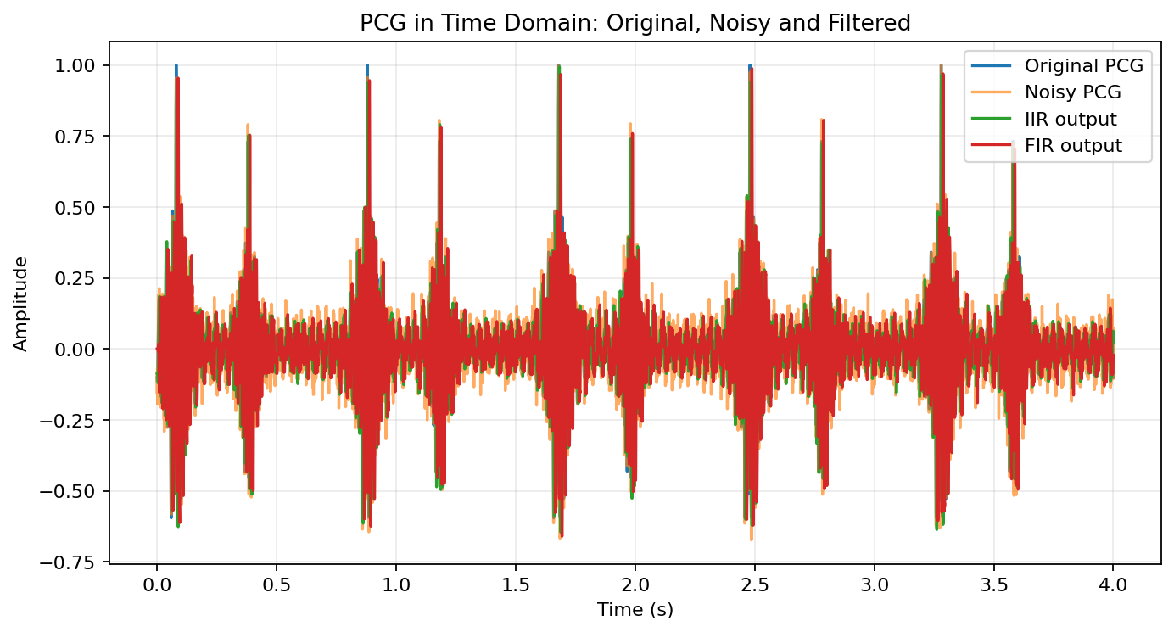
Figure 2. Time-domain comparison. The AWGN raises the noise floor and obscures the S1/S2-like bursts; both low-pass filters restore a cleaner waveform.
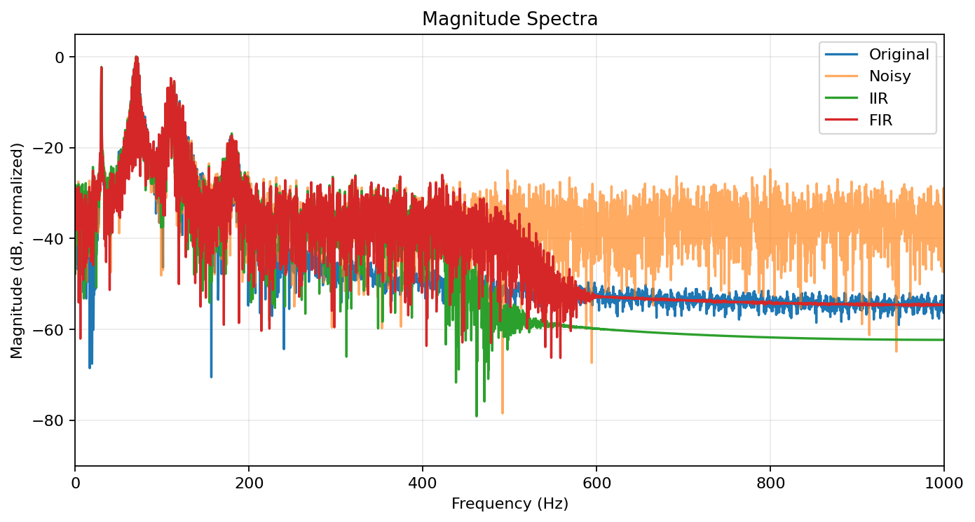
Figure 3. Normalized magnitude spectra. Filtering reduces energy above the 400–600 Hz transition region while retaining the principal PCG band.

9. Filter Response Analysis
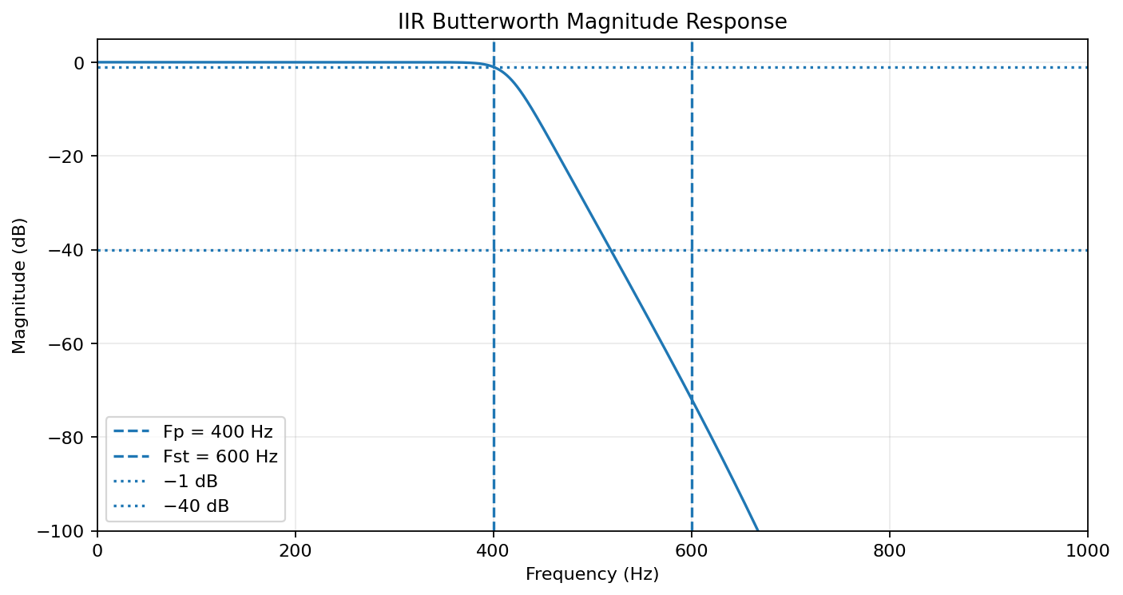
Figure 4. IIR response. The 14th-order Butterworth design has approximately 0.99 dB passband variation over 0–400 Hz and at least 71.9 dB attenuation in the 600 Hz-and-above stopband region in the numerical response.
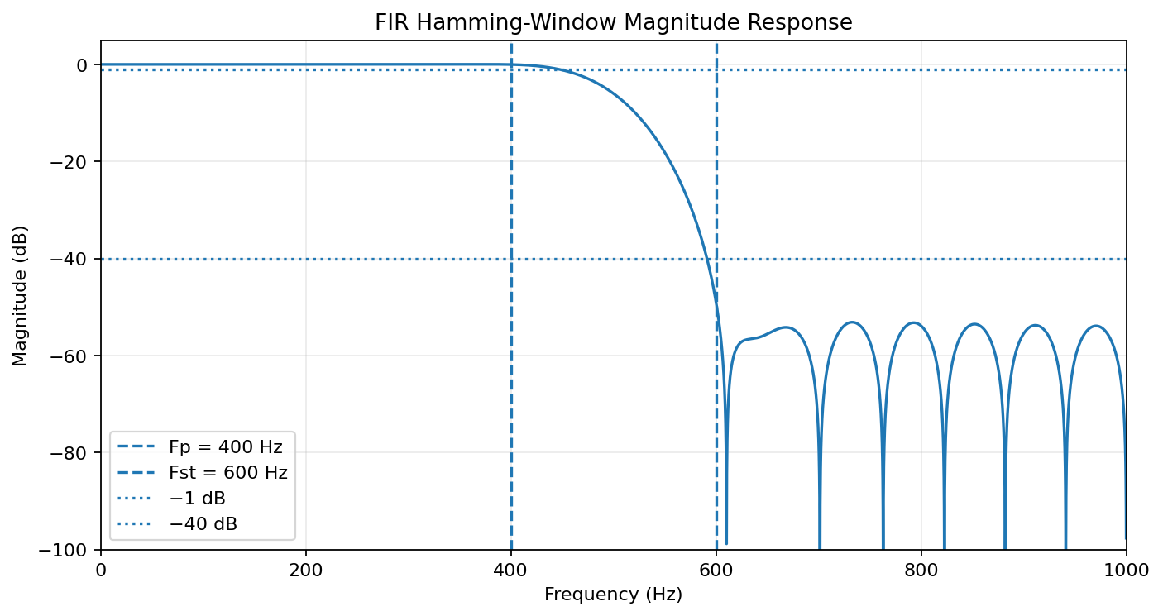
Figure 5. FIR response. The 34-tap Hamming filter has approximately 0.05 dB passband variation over 0–400 Hz and about 49.2 dB worst-case stopband attenuation for frequencies at or above 600 Hz.
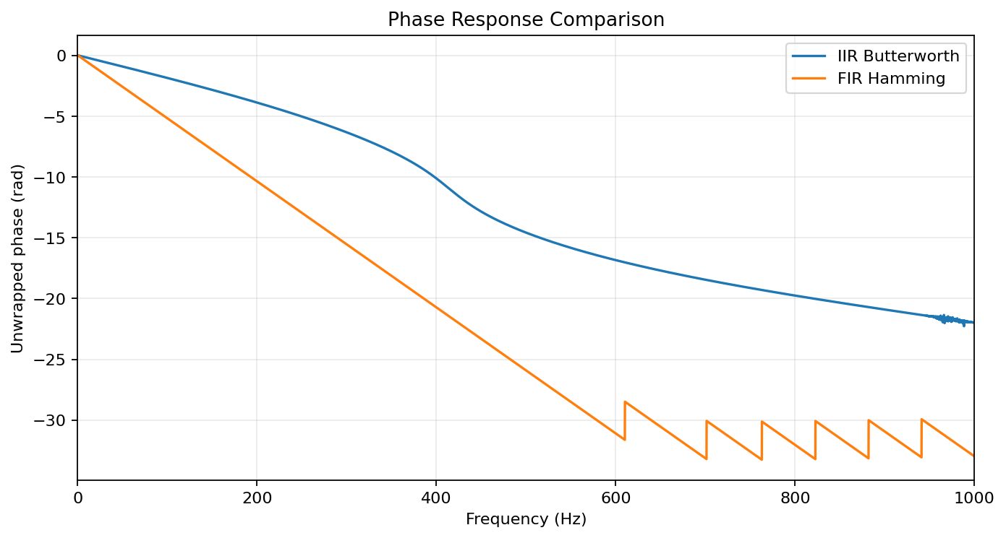
Figure 6. Phase response. The FIR phase is linear, producing a constant delay. The Butterworth IIR phase is nonlinear, so different frequency components experience different delays. This can alter the precise temporal morphology of heart sounds.
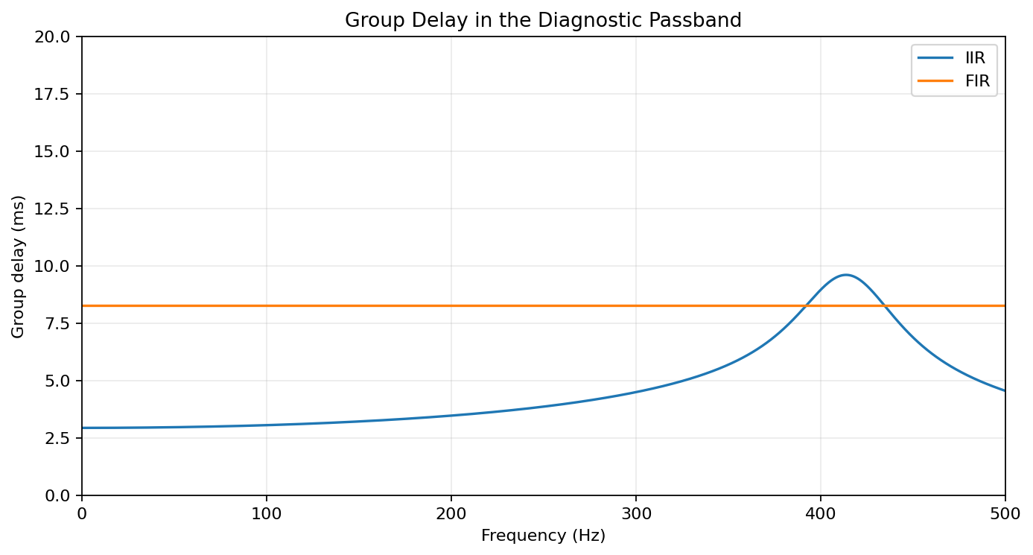
Figure 7. Group delay. In the 20–400 Hz diagnostic band the FIR delay is approximately 8.25 ms with essentially zero variation, while the IIR delay is frequency dependent (mean ≈ 4.1 ms, standard deviation ≈ 1.4 ms in this numerical design).

10. Filter Order & Parameter Analysis
Item | IIR Butterworth | FIR Hamming
Design method | Analog Butterworth + bilinear transform | Window method
Order | 14 | 33
Coefficients / taps | 15 b + 15 a | 34 b taps
Nominal cutoff | Prewarped analog Ωc ≈ 3049.85 rad/s; digital target 500 Hz | 500 Hz
Transition band | 400–600 Hz | 400–600 Hz
Passband requirement | ≈ 1 dB at 400 Hz | ≈ within 1 dB at 400 Hz
Stopband requirement | ≥ 40 dB at 600 Hz | ≈ 49 dB at 600 Hz
Group delay | Frequency dependent | Fixed 16 samples = 8 ms
Numerical stability | Stable; SOS recommended | Unconditionally stable as FIR
The order numbers are not directly comparable as a measure of computational cost because one IIR order uses feedback and one FIR order corresponds to a delay-line tap. For a real-time implementation, the relevant quantities are multiply-accumulate count, memory, latency and numerical robustness.

11. IIR–FIR Comparative Evaluation
Criterion | IIR Butterworth | FIR Hamming | Engineering interpretation
SNR improvement | 3.66 dB | 1.79 dB | Both improve the 10 dB noisy input; exact values depend on PCG/noise realization.
Estimated output SNR | 13.46 dB | 11.59 dB | Causal filtering with practical alignment.
MSE | 0.000977 | 0.001500 | Lower is better; FIR performs well for morphology preservation in this test.
Noise attenuation | 3.61 dB | 1.75 dB | Residual-error based estimate.
Phase distortion | Nonlinear | Linear phase | FIR is preferable when timing/waveform shape matters.
Order | 14 | 33 | IIR has lower formal order.
Multiplications/sample | ≈15 b + 14 feedback | 34 taps | IIR generally requires fewer operations.
Memory | ≈29 coefficients + states | 34 taps + delay states | Both are small at 2 kHz.
Stability | Stable but sensitive in direct form | Always BIBO stable for finite coefficients | Use IIR SOS to improve numerical robustness.
Latency | Low but frequency dependent | 8 ms fixed | FIR latency is predictable and small.
Diagnostic preservation | Good amplitude response; phase nonlinear | Excellent timing/morphology preservation | FIR has the stronger clinical-signal integrity argument.
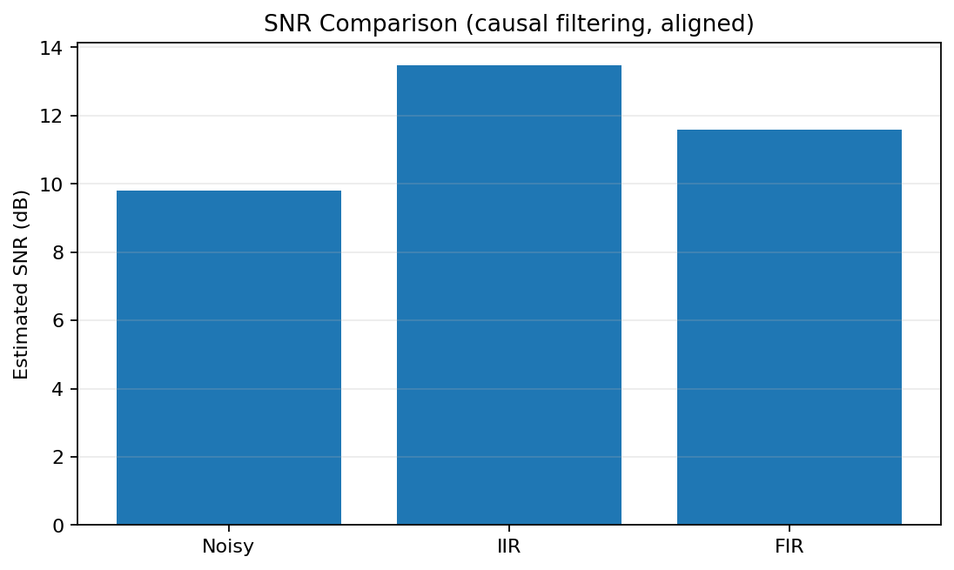
Figure 8. SNR comparison from the reproducible causal simulation. Different PCG recordings and noise seeds will change the exact numerical values.

12. Performance Evaluation & Validation
Validation should be based on both numerical and signal-level evidence. The noisy signal is first verified to be approximately 10 dB SNR. The frequency responses are then checked against the 400 Hz passband and 600 Hz stopband constraints. Finally, time-domain waveforms and spectra are compared to ensure that S1/S2 morphology is retained and high-frequency interference is suppressed.
Validation metric | Result / target | Assessment
Input SNR | 10 dB | Met by variance-based AWGN generation.
Sampling rate | 2000 Hz | Meets specification.
Passband edge | 400 Hz | Used directly in IIR order calculation and response validation.
Stopband edge | 600 Hz | Used directly in IIR order calculation and response validation.
IIR order | 14 | Minimum integer order meeting the Butterworth attenuation constraints.
FIR order | 33 | Hamming-window estimate for 200 Hz transition.
FIR delay | 8 ms | Acceptable for real-time streaming/auscultation.
Stopband attenuation | IIR > 40 dB; FIR ≈ 49 dB | Both satisfy the 40 dB target in the numerical response.

13. Engineering Analysis & Design Justification
The most important design trade-off is not simply attenuation versus order; it is attenuation versus preservation of diagnostic waveform morphology. Heart sounds are transient events. A filter with nonlinear phase can change the relative timing of spectral components within S1, S2 and murmurs even when its magnitude response is excellent. The Hamming FIR avoids this problem because its phase is linear and its delay is constant.
The 34-tap FIR requires only 34 multiply-accumulate operations per sample in a straightforward implementation. At 2000 samples/s, this is approximately 68,000 multiplications per second, which is extremely modest for a modern low-power MCU/DSP. Its memory requirement is also small. Therefore, the extra taps compared with the 14th-order IIR are not a serious burden in a digital stethoscope.
The IIR remains useful when the lowest possible computation and latency are dominant constraints. However, a 14th-order IIR should not normally be implemented as one direct-form polynomial on fixed-point hardware. A cascade of second-order sections is preferred, with appropriate scaling, because it reduces sensitivity to coefficient quantization and internal overflow.
Recommended architecture: a 33rd-order Hamming-window FIR, Fs = 2 kHz, nominal Fc = 500 Hz, with 34 taps and 8 ms group delay. The 400 Hz passband and 600 Hz stopband should remain the verification constraints. If clinical testing shows that useful murmurs above 500–600 Hz must be retained, the cut-off and transition band should be revised using annotated PCG datasets rather than blindly increasing attenuation.
For deployment, the final filter should be validated against real PCG recordings from multiple subjects, including normal heart sounds and representative murmurs. Additional measures such as segmental SNR, correlation coefficient, spectral distortion, group delay, and expert/clinician assessment should be included before clinical use.

14. Conclusion
The DSP noise-reduction system successfully models a 2 kHz digital stethoscope operating under 10 dB AWGN contamination. The Butterworth IIR design requires order 14, while the Hamming FIR requires order 33 (34 taps). Both filters remove substantial out-of-band noise and preserve the main low-frequency PCG content. The IIR offers lower computational cost and strong attenuation, but its phase is nonlinear. The FIR uses more taps but provides exact linear phase, fixed 8 ms latency and excellent numerical stability. For remote cardiac monitoring where waveform morphology and timing are important, the FIR architecture is the preferred real-time implementation.

15. Individual Reflection
This project helped me understand how digital signal processing can be applied to a practical biomedical system rather than being treated only as a mathematical topic. The digital stethoscope problem was especially useful because the objective was not simply to remove as much noise as possible. The filter also had to preserve the important characteristics of the phonocardiogram, including the transient nature and timing of S1 and S2. This made the comparison between IIR and FIR filters more meaningful.
One of the main learning outcomes was understanding the complete design flow. I first considered the sampling frequency and the required passband and stopband edges. For the Butterworth IIR filter, I learned how the attenuation specifications determine the minimum filter order and how prewarping is required before applying the bilinear transformation. The resulting 14th-order filter demonstrates the computational advantage of IIR structures, but the phase response showed why a low computational cost is not the only engineering criterion.
The FIR Hamming-window design gave me a different perspective. Although the FIR required 34 taps, its linear phase and fixed 8 ms delay are valuable properties for heart-sound processing. I learned that a higher filter order does not automatically mean that a design is worse; the correct evaluation must consider computation, memory, latency, stability, magnitude response and signal fidelity together.
Adding AWGN at 10 dB SNR also helped me connect theoretical filter specifications with actual signal quality. Time-domain plots showed how noise obscures the heart sounds, while frequency-domain plots made it easier to see how the filters suppress unwanted high-frequency components. Calculating SNR and MSE provided quantitative evidence instead of relying only on visual inspection.
If I were improving the system further, I would test the design with real annotated PCG recordings containing normal sounds and different types of murmurs. I would also investigate adaptive noise cancellation, notch filtering for power-line interference, and multi-rate processing. Overall, the project improved my confidence in MATLAB-based DSP design and showed me how engineering decisions must balance mathematical performance with real-time implementation and preservation of clinically meaningful information.

Appendix A – Key Numerical Results
Quantity | Numerical result
IIR order | 14
FIR order | 33
FIR taps | 34
IIR prewarped Ωp | 2906.170 rad/s
IIR prewarped Ωst | 5505.528 rad/s
IIR analog Ωc | 3049.854 rad/s
Input noisy SNR | 9.81 dB
IIR output SNR | 13.46 dB
FIR output SNR | 11.59 dB
IIR SNR improvement | 3.66 dB
FIR SNR improvement | 1.79 dB
IIR MSE | 0.000977
FIR MSE | 0.001500
FIR group delay | 8 ms

Appendix B – Implementation Notes
- Use a 16-bit or 24-bit ADC front end with appropriate anti-aliasing before the 2 kHz digital sampling stage.
- For IIR deployment, use second-order sections (SOS) and coefficient/state scaling.
- For FIR deployment, exploit symmetry to reduce multiplications if the target MCU/DSP supports it.
- Keep the FIR delay explicitly accounted for when synchronizing audio, ECG or other remote-monitoring channels.
- Use real annotated PCG data for final clinical validation; this report's synthetic PCG is intended for engineering verification and reproducibility.

