EXP.1.2

clc;
clear;
close all;

% Specifications
Fs = 10000; % Sampling Frequency (Hz)
Fp = 3000; % Passband Frequency (Hz)
Fst = 2000; % Stopband Frequency (Hz)

% Calculate minimum filter order
[N, Wn] = buttord(Fp/(Fs/2), Fst/(Fs/2), 1, 60);

% Design High-Pass Butterworth Filter
[b, a] = butter(N, Wn, 'high');

%% Magnitude and Phase Response
figure;
freqz(b, a);
title('Magnitude and Phase Response');

%% Impulse Response
figure;
[h, n] = impz(b, a, 50);
stem(n, h, 'filled');
grid on;
xlabel('Samples');
ylabel('Amplitude');
title('Impulse Response');

%% Step Response
figure;
x = ones(1, 50); % Unit step input
y = filter(b, a, x); % Step response
stem(0:49, y, 'filled');
grid on;
xlabel('Samples');
ylabel('Amplitude');
title('Step Response');

%% Group Delay
figure;
grpdelay(b, a);
title('Group Delay');

%% Pole-Zero Plot
figure;
zplane(b, a);
title('Pole-Zero Plot');

%% Display Results
fprintf('Minimum Filter Order (N) = %d\n', N);
fprintf('Cutoff Frequency (Wn) = %.4f\n', Wn);
OUTPUT:

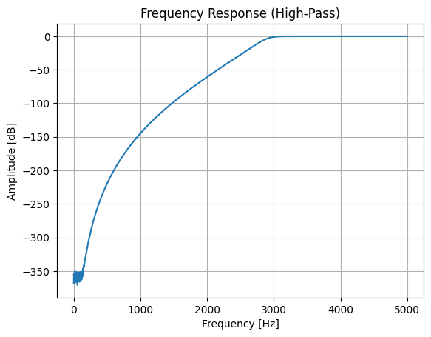
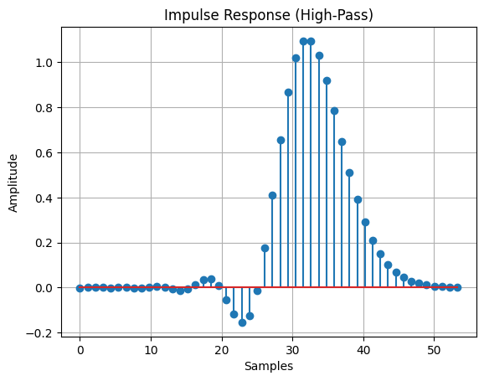
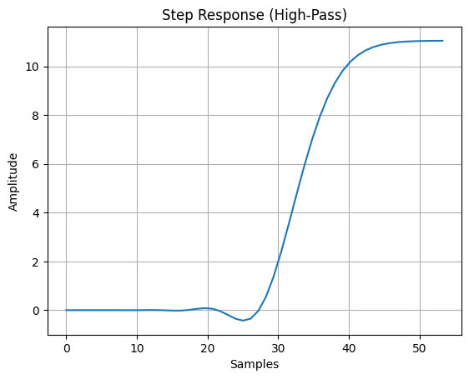
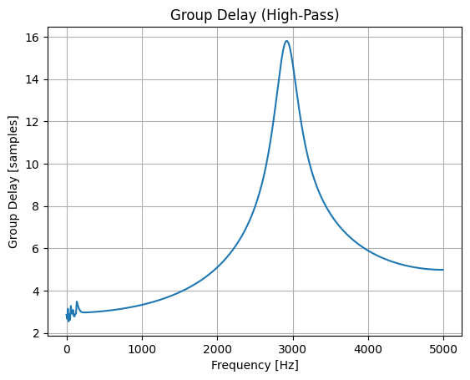
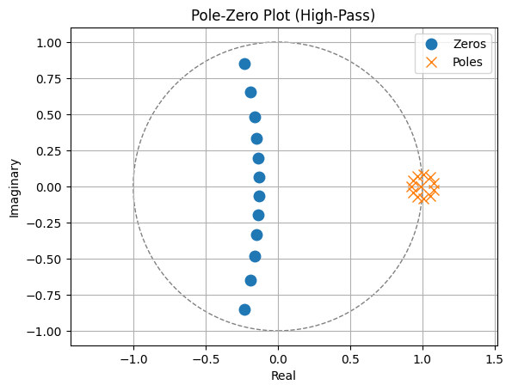
Minimum Filter Order (N) = 12
Cutoff Frequency (Wn) = 0.5828

