Alfido Tech Internship
Task 3: Data Logger – Sensor to SD Card
Name:
Praveena Reddy
Domain:
Embedded Systems
Tools Used:
- Wokwi Simulator
- Arduino IDE

1. Objective
The objective of this project is to collect temperature and light sensor data and log the readings for monitoring and analysis. The system demonstrates sensor interfacing, data acquisition, and data logging using Arduino.

2. Components Used
- Arduino UNO
- DHT22 Temperature Sensor
- LDR Sensor Module
- SD Card Module
- RTC Module (DS3231)
- Potentiometer
- Breadboard
- Jumper Wires

3. Software Used
- Wokwi Simulator
- Arduino IDE

4. Circuit Diagram
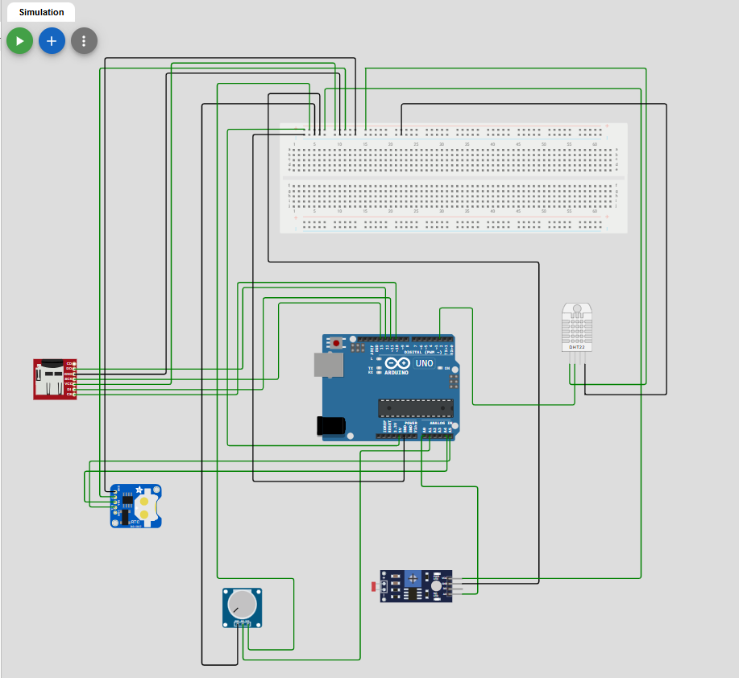

5. Working Principle
The DHT22 sensor measures temperature and the LDR sensor module measures light intensity. Arduino continuously reads the sensor values and generates data samples in CSV format. The RTC module can be used to provide timestamps for recorded data, while the SD card module can be used to store the collected information. In the simulation environment, the collected data is displayed through the Serial Monitor in CSV format.

6. Arduino Code
#include <DHT.h>

#define DHTPIN 2
#define DHTTYPE DHT22

DHT dht(DHTPIN, DHTTYPE);

const int lightPin = A0;

int sampleNumber = 0;

void setup() {
Serial.begin(9600);
dht.begin();

// CSV Header
Serial.println("Sample,Temperature_C,Light_Value");
}

void loop() {

float temperature = dht.readTemperature();

int lightValue = analogRead(lightPin);

sampleNumber++;

// CSV Format Output
Serial.print(sampleNumber);
Serial.print(",");

Serial.print(temperature);
Serial.print(",");

Serial.println(lightValue);

delay(1000); // 1 sample per second
}

7. Output Screenshots
Circuit Screenshot
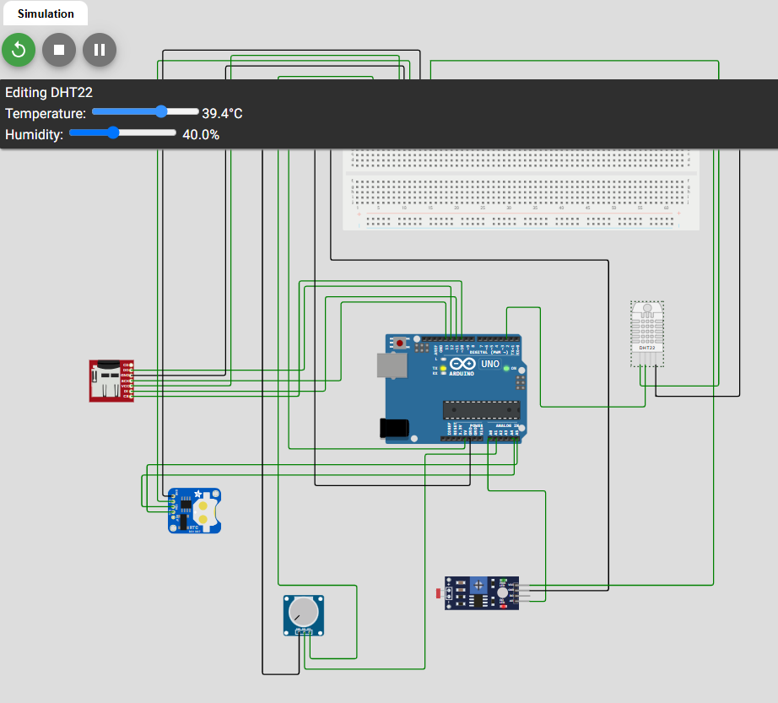
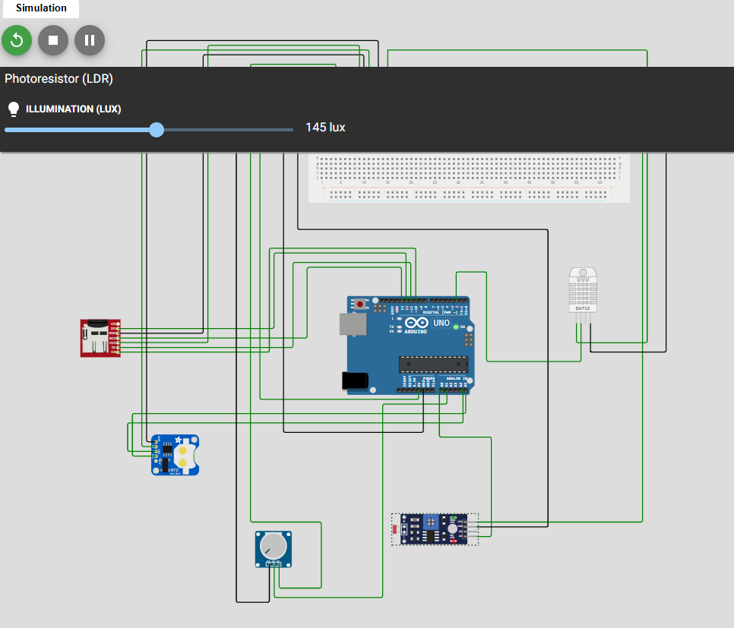

Serial Monitor Output and CSV data output
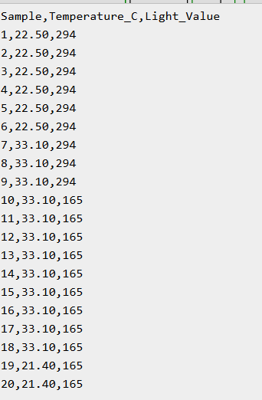
Code Screenshot
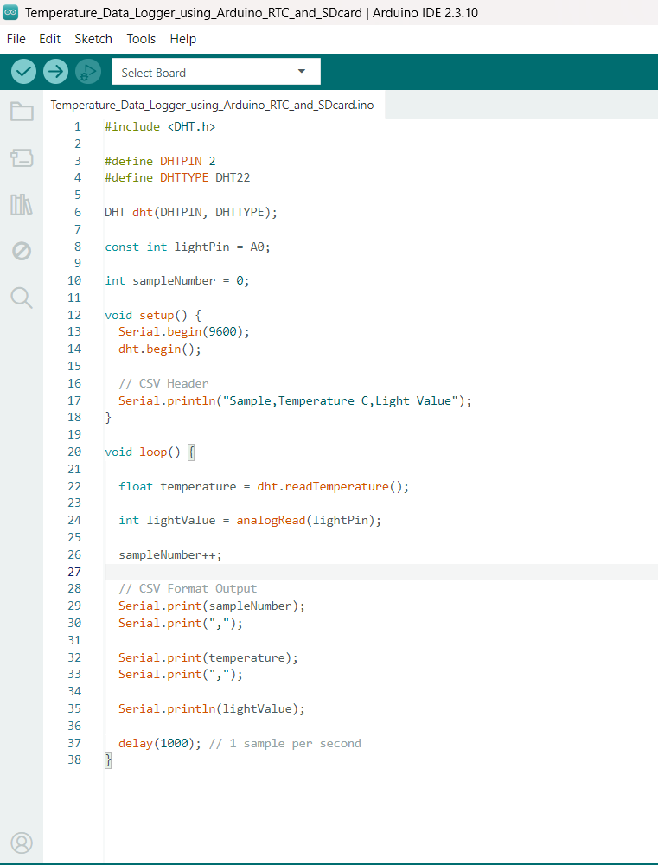

8. Results
The system successfully collected temperature and light sensor readings and displayed the data in CSV format through the Serial Monitor. The generated data samples demonstrated the functionality of a basic data logging system and can be extended for SD card storage in real hardware implementations.

9. Conclusion
This project demonstrates the fundamental concepts of embedded systems including sensor interfacing, data acquisition, serial communication, and data logging. The system successfully monitored environmental parameters and generated structured sensor data suitable for storage and analysis.

10. GitHub Repository Link
Paste your GitHub repository link here.
Example:
https://github.com/YourUsername/Task-3-Data-Logger

11. Demo Video Link
https://drive.google.com/file/d/1wElw7HRz64R_U_cHYo60h7t4nUwPX1JA/view?usp=sharing

