AI CODE EXPLAINER
An AI-Powered Tool for Understanding Source Code
PROJECT REPORT
Submitted by | [Student Name / Roll Number]
Department | [Department Name]
Institution | [College Name]
Project guide | [Guide / Faculty Name]
Academic year | [Academic Year]

Abstract
AI Code Explainer is a browser-based learning application designed to help students understand source code. A user selects a programming language, enters code into an editor, and requests an explanation. The frontend sends the code to a Python FastAPI backend. The backend validates the request and uses the Google Gemini API to generate a structured explanation containing a plain-English summary, a line-by-line breakdown, expected output, and debugging suggestions. The interface presents these sections in separate cards so that beginners can study a program more easily. The backend is configured through environment variables, and automated tests use mocked AI responses to check application behavior without requiring a live API call for every test.

Keywords
Artificial Intelligence, Code Explanation, Google Gemini, FastAPI, Python, JavaScript, Web Application

Table of Contents
- 1. Introduction
- 2. Problem Statement
- 3. Objectives and Scope
- 4. Technologies Used
- 5. System Design and Architecture
- 6. Implementation
- 7. Testing and Results
- 8. Security and Limitations
- 9. Future Enhancements
- 10. Conclusion
- Appendix A: Running the Project

1. Introduction
Learning to program requires more than memorizing syntax. Students need to understand what each statement does, how values move through a program, what output may be produced, and how common errors can be corrected. Reading unfamiliar code can be difficult for beginners, especially when explanations are scattered across multiple learning resources.
AI Code Explainer addresses this learning need by combining a simple code editor with an AI-generated explanation. The application is intended as a study aid: it explains code but does not execute the submitted program.

2. Problem Statement
Beginners can find it challenging to interpret source code line by line and predict its output. Manual searching for each statement can interrupt the learning process. The project aims to provide a single interface that turns submitted code into a structured, beginner-friendly explanation while keeping the user in control of the code being studied.

3. Objectives and Scope

3.1 Objectives
- Provide a simple browser interface for entering source code.
- Allow the user to select a supported programming language.
- Validate submitted code on the backend before requesting an explanation.
- Use the Google Gemini API to produce a structured explanation.
- Display a summary, line-by-line analysis, expected output, and debugging tips.
- Keep API credentials outside frontend code and source control.
- Use automated tests to check validation, error handling, and AI-response processing.

3.2 Scope
The current implementation is an educational prototype. Its AI output is a prediction generated by a language model, not a guarantee that the code will behave exactly as described. The application does not run submitted code. Actual language support and request-size limits are determined by the backend and frontend implementation.

4. Technologies Used
Technology | Purpose
HTML | Defines the structure of the web interface.
CSS | Styles the layout, editor, explanation cards, and responsive visual design.
JavaScript | Handles browser interactions and sends requests to the backend API.
Python | Implements backend logic and request handling.
FastAPI | Provides HTTP endpoints for health checks and code explanation.
Google GenAI Python SDK | Connects the backend to the Google Gemini API.
python-dotenv | Loads environment variables from a local .env file during development.
pytest / unittest.mock | Runs automated tests and replaces external Gemini calls with controlled test responses.

5. System Design and Architecture
The application follows a simple client–server architecture:
1. User
Enters code and selects a language in the browser.
2. Frontend (index.html, style.css, script.js)
Validates basic input and sends an HTTP request to the backend.
3. FastAPI backend (backend/main.py)
Checks the request, reads server-side configuration, and prepares a prompt.
4. Google Gemini API
Generates the requested structured explanation.
5. Response to frontend
The backend returns structured fields; the browser displays the explanation cards.

5.1 Main backend endpoints
GET /api/health — reports backend health and whether AI configuration is enabled.
POST /api/explain — accepts code and language, validates the request, calls the configured Gemini model, and returns the explanation.

5.2 Expected explanation structure
- simple_explanation: a plain-English summary of the program.
- line_by_line: an array of line numbers, code snippets, and explanations.
- example_output: predicted terminal or console output.
- debugging_suggestions: tips about possible errors and improvements.

6. Implementation

6.1 Frontend
The frontend provides a source-code editor, a language selector, an Explain Code action, and a results area. The results area separates the generated summary, line-by-line explanation, expected output, and debugging suggestions. A status indicator communicates whether the backend reports that AI is connected.

6.2 Backend and AI integration
The FastAPI backend reads GEMINI_API_KEY from the local environment configuration. The Google GenAI client is initialized on the server, and the API key is not intended to be placed in HTML or JavaScript. Submitted code is validated before the model request. The backend processes the model response and handles missing configuration, provider failures, and unexpected response formats with error handling.

6.3 Example
print("hello world")
Plain-English explanation: The print function displays the text inside the quotation marks.
Expected output:
hello world
The expected output is an AI prediction based on the submitted code. In this example, it matches the output produced by Python.

7. Testing and Results
The development notes provided for this project report that the backend automated test suite passed 16 out of 16 tests. The suite includes mocked Gemini success responses, handling of markdown-wrapped or malformed JSON, API error handling, missing-key behavior, partial-response fallbacks, health checks, input validation, oversized-code validation, and CORS preflight handling. These results are based on the test summary supplied during development and should be rerun from the final project folder before submission.

7.1 User interface evidence
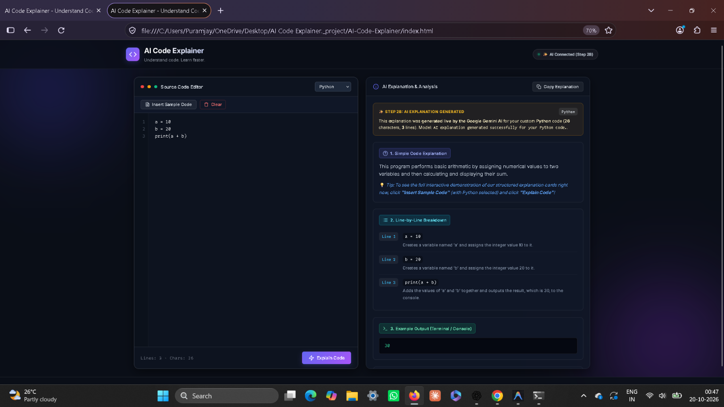
Figure 1. AI Code Explainer interface showing a successful Gemini-generated explanation for a short Python arithmetic program.

7.2 Test summary
Test area | Purpose
Mocked Gemini success | Checks that valid model output is mapped to the expected response fields.
Malformed / partial model response | Checks fallback handling when the returned data is incomplete or invalid.
Provider/API failure | Checks that provider failures are handled without crashing the server.
Missing API key | Checks behavior when AI credentials are not configured.
Input validation | Checks empty, whitespace-only, missing, and oversized code submissions.
Health and CORS | Checks health endpoints and browser preflight behavior.

8. Security and Limitations

8.1 Security practices
- Keep the Gemini API key in backend/.env and ensure .env is excluded by .gitignore.
- Never publish the API key in screenshots, reports, public repositories, or frontend files.
- If a key has been exposed in a screenshot or shared content, revoke it and create a replacement key.
- Do not execute submitted code as part of the explanation workflow.

8.2 Limitations
- AI-generated explanations can be inaccurate or incomplete and should be reviewed critically.
- Availability, rate limits, and supported model names depend on the Google Gemini API account and current service conditions.
- A network connection is required for live AI explanations.
- The current prototype does not execute code to verify the predicted output.
- The interface and API should be tested in the final submission environment.

9. Future Enhancements
- Add support for more programming languages and language-specific validation.
- Provide a downloadable explanation report for each submitted program.
- Add syntax highlighting and editor conveniences.
- Improve handling of rate limits and temporary model unavailability.
- Add optional examples, quizzes, and interactive follow-up questions for learners.
- Deploy the frontend and backend to a secure hosting environment with monitored usage limits.

10. Conclusion
AI Code Explainer demonstrates how a web frontend, a Python API, and a generative AI service can work together to support programming education. It presents code explanations in a consistent structure that helps beginners connect source statements with their purpose and expected output. The project also demonstrates practical backend concepts such as input validation, environment-based configuration, external API integration, error handling, and automated testing. Before final submission, the student should rerun the tests, confirm the live API works, replace the cover-page placeholders, and ensure no API secret is included in the submitted files.

Appendix A: Running the Project
From PowerShell, open the backend directory and activate the virtual environment:
cd "C:\Users\[YourUser]\OneDrive\Desktop\AI-Code-Explainer\backend"
.\venv\Scripts\activate
python -m pip install -r requirements.txt
python -m pytest -q
python -m uvicorn main:app --reload --host 127.0.0.1 --port 8000
Keep the server terminal open while using the website. Open the project’s index.html in a browser (or use a local static server if required by the frontend). The backend health endpoint can be checked at http://127.0.0.1:8000/api/health. Never paste the API key into chat or include it in this report.

Before Submission: Checklist
- ☐ Replace all bracketed placeholders on the cover page.
- ☐ Rerun the automated tests from the final project folder and update the reported count if it changes.
- ☐ Verify the website can produce a live explanation while the backend is running.
- ☐ Make sure backend/.env is not included in the submission archive.
- ☐ Revoke and replace any API key visible in the IDE screenshot that was shared.
- ☐ Follow your college’s required formatting, citation, and binding rules.

