**§ Task: Listen to the podcast / watch the video and write a 3-5 sentence reaction to the podcast. State in your own words what you learned, what expanding your knowledge of the topic and what you found interesting about the information you received.**

I agree with Doc Searles and Katherine Druckmann that data visualisation and open source are extremely new and early topics because they have only recently gained attention due to improvements in data collection and computing capacity. Everyone has some knowledge or experience to provide, and that is typically how things work now. Because of it, employees are given the ability to work with data and have experience, but they are simply not included in the discussion surrounding the data of their organisation. Being able to ask these questions for ourselves, acquire the answers, and then be able to impart our knowledge to one another is what it means to be empowered.

**§ Task: Go to observablehq.com and find ONE project. With the one project please enumerate the following:**

**a) please give the title, URL and description of the project on Observable,**

**(b) describe the datasets used in the project (you can just provide 1 sentence summary of the dataset),**

**(c) provide a brief description of the visualizations used (1 sentence),**

**(d) describe why you found this dataset / project interesting (no more than 2 sentences).**

Title: How Has Men’s Tennis Changed From 1973–2021?

URL: <https://observablehq.com/@unkleho/how-has-mens-tennis-changed-from-1973-2021>

Every year, men who play tennis become a little bit taller and a little bit heavier. Once commonplace in tennis, the one-handed backhand shot is now considered to be in risk of extinction. Even among left-handed players, there have been some fascinating developments since 1973. All of these topics are discussed in depth in this study.

According to the author the dataset that was used in this study was collected from <https://www.atptour.com/en/rankings> and the dataset discusses about the male tennis players from various countries who have played between 1973–2021.

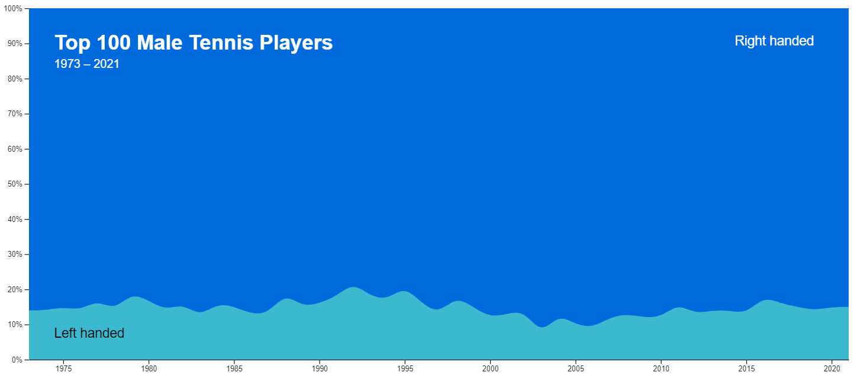

Author have used interesting and interactive density plots that explains the density (in percentage) of the left-handed male tennis players over the years.

This study is focused on the changes and interpretations that were observed over a period of time with interactive charts that I find really interesting about the project. The author have clearly interpreted the results and sticks to the main topic through out the study.