**JIRA Interview Questions**

**Q1. Explain what is JIRA?**

JIRA is an issue tracking product or a software tool developed by Atlassian, commonly used for bug tracking, project management and issue tracking; it is entirely based on this three aspects.

**Q2. What can be referred as an issue in JIRA?**

In JIRA, an issue can be anything like a

Software bug

* The project task
* A help-desk ticket
* The leave request form

For More Software QA Tutorials and Interview preparations please visit:[www.tonmoyelearn.com](http://www.tonmoyelearn.com/)

**Q3. How Are Issues Handled in JIRA?**

**Creating a JIRA issue:**

Issues form the crux of JIRA, so to create them there in option right on the menu bar:

[Creating a JIRA issue 1 JIRA Interview Questions](http://cdn2.softwaretestinghelp.com/wp-content/qa/uploads/2013/10/Creating-a-JIRA-issue-1.jpg)

Click on “Create Issue” button. Alternately, when you type “c” while on the JIRA page, the following ‘Create Issue’ dialog opens up.

[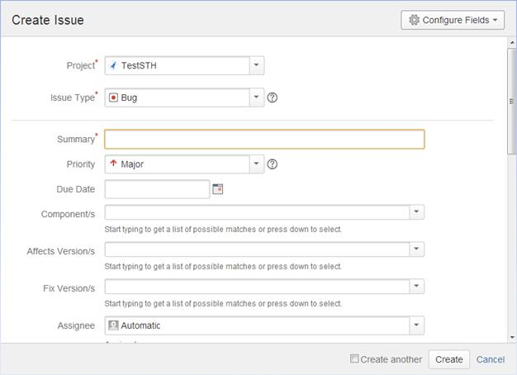](http://cdn2.softwaretestinghelp.com/wp-content/qa/uploads/2013/10/Creating-issues-in-JIRA-2.jpg)

All the fields in this page are self explanatory.  We will discuss the most important one below.

**Project**: Every issue belongs to a project. You can choose the same by clicking on the drop down and choosing the project that you want this issue to belong to.

[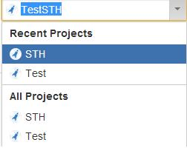](http://cdn2.softwaretestinghelp.com/wp-content/qa/uploads/2013/10/Creating-issues-in-JIRA-3.jpg)

**Issue type**:  This field displays all the types of issues that can be created and tracked via JIRA. The following options are available in this list (this list might differ depending on the setting set by the administrator):

[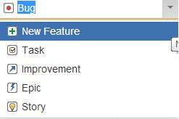](http://cdn2.softwaretestinghelp.com/wp-content/qa/uploads/2013/10/Creating-issues-in-JIRA-4.jpg)

The items Bug, new feature, task, improvement are exactly what their names imply. Epic and story are more relevant to agile projects. Story is a requirement in Agile that needs to be tracked from start to finish. Epic is a group of stories.

Choose the issue type as needed. I am going to go with “Bug”.

**Summary**: Give your bug a title here.  When used right, this field can be very successful at transmitting a lot of critical information. Some aspects to note here:

A bug/defect is essentially something that is not right. The right way to approach a bug title is to concisely define ‘what’s wrong’.

An example of a bad title/summary is : “There should be an option to clear the contents on the screen”.  When I read this my initial reaction is going to be – “Okay, there should be- but what’s the problem here? Is the option not present at all? Or is the option present and not clearing the content?”

It is also agreed, that when I open this bug and look into it in detail, I am sure I will find the answer to this question.

However, the emphasis here is to use this “Summary” field in the most efficient manner. Therefore, a more apt summary/title would be “The option to clear the contents on the home login page does not clear the fields when clicked.”

In the limited space that this field provides try to write your title in a way that communicates the exact issue without any ambiguity.

**Priority:**  This field can take one of the following values.

Choose an appropriate option for your bug.

[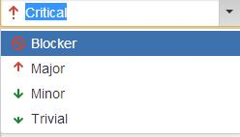](http://cdn.softwaretestinghelp.com/wp-content/qa/uploads/2013/10/Creating-issues-in-JIRA-5.jpg)

**Component**: This list will display the components of the Project. Choose appropriately.

**Affected Version and Fix version:** These two fields will display the versions available for the project. It is not necessary that a certain issue that you encountered in a certain version gets fixed in the same one. In cases like that, you can choose the affected version as the current version and fix version as the next one.

Also, these fields can take multiple values. You can choose to set that a certain issue affects both version 1 and version 2 as below:

[Creating issues in JIRA 6 JIRA Interview Questions](http://cdn.softwaretestinghelp.com/wp-content/qa/uploads/2013/10/Creating-issues-in-JIRA-6.jpg)

**Assignee**: You can type the name of the person to whom this issue should be handed over further. You can also assign an issue to yourself.

**Q4. Why use JIRA?**

The reason behind using JIRA is

* Upfront and fair licensing policy
* Features that is not available elsewhere
* Get latest update on the progress of projects
* It run anywhere and recognized with many famous companies
* Easily extensible and customizable

**Q5. Is it possible to access JIRA cloud site via a mobile device?**

Yes, it is possible to access JIRA cloud site via a mobile device. You have to just use the URL of the JIRA cloud site in your mobile web browser.

**Q6. Explain labeling and linking issue in JIRA?**

Labeling Issue: It enables you to categorize an issue in a more informal way than assigning it to a component or version. You can then search issues according to label.

Linking Issue: This feature enables you to link an association between two issues on either on the same or different JIRA servers.

For More Software QA Tutorials and Interview preparations please visit:[www.tonmoyelearn.com](http://www.tonmoyelearn.com/)

**Q7. Mention the types of reports generated in JIRA?**

JIRA offer reports that show statistics for projects, versions, people or other fields within issues. Various reports included with JIRA are:

* Average Age Report
* Pie Chart Report
* Resolution Time Report
* Recently Created Issues Report
* Resolved vs. Created Issues Report
* Single Level Group by Report
* Time Tracking Report
* User Workload Report
* Workload Pie Chart Report, etc.

**Q8. Explain what is Cloning an Issue?**

Cloning as issue allows you to create a duplicate of the original issue so that many employees can work on a single issue within a single project. The clone issue can be connected to the original issue. A clone issue holds following the information

* Summary
* Description
* Assignee
* Environment
* Priority
* Issue Type
* Security
* Reporter
* Components, etc.

**Q9. Mention what things are not included in cloned issue in JIRA?**

* Time tracking
* Issue history
* Comments

**Q10. How to Use JIRA Effectively for Managing Agile Projects?**

**JIRA – Agile Project**

Agile Methodology for software development has gained immense popularity in the recent years.

Agile Projects follow an incremental approach to development of the requirements.

**The highlights of an Agile/Scrum Project are:**

1. The requirements are created/agreed upon and the grouped together into a Product Backlog
2. The requirements (User stories) are ranked in the order of priority and business importance
3. Once ranked, the stories are assigned developmental cycles (Sprints) that last for approx. 4-6 weeks.
4. The detailed documentation is avoided. Instead, a scrum board is maintained that will show the status and progress.

JIRA successfully supports all the activities listed above for projects following an Agile Methodology. In this article, we will see how.

Note – Firstly, you will need *JIRA Agile add-on* if you have not gotten it already.

**User stories in JIRA are created using JIRA issues:**

* You can have a product backlog by creating a main User story and having various sub-tasks under it.
* Or you can create an Issue type -Epic and Issue type – Story linked to it. To do so, in the ‘Create Issue’ page you can go to “Configure Fields” and choose “Epic link” field to be included in the issue creation screen. – This is the most commonly used method.

[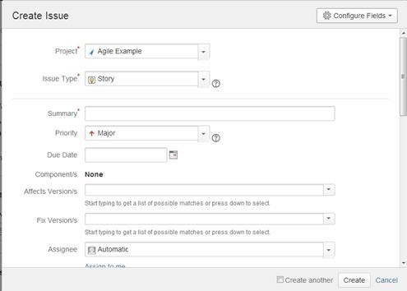](http://cdn.softwaretestinghelp.com/wp-content/qa/uploads/2013/10/JIRA-Agile-Project-1.jpg)

[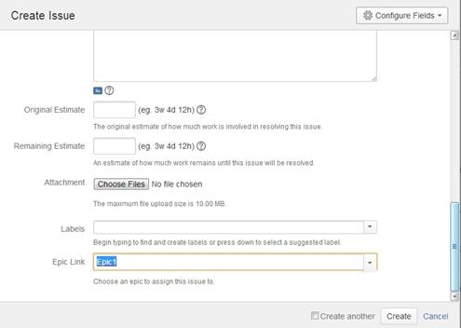](http://cdn2.softwaretestinghelp.com/wp-content/qa/uploads/2013/10/JIRA-Agile-Project-2.jpg)

**Note**: You will not be able to link Epic to another Epic.

The next important feature of an Agile Project is the Scrum board. JIRA provides a solid basis to facilitate it. The feature is called a “Board”, and it is right there under the “Agile” menu item. *(This menu option will be available only if you have the JIRA Agile add-in; this was previously called ‘GreenHopper’)*

**JIRA features that help achieve the Agile process:**

**Feature #1)** A user can create and manage boards in Agile. – It will display the issues from the same project or multiple projects so the progress can be monitored from one place

**Feature #2)**There are two kinds of boards in JIRA agile. What are they and what they do is explained in the below window. Choose the appropriate board and continue through the steps to create a board. You will have to choose the projects from which issues are to be considered. In this article we are going to discuss a Scrum board.

[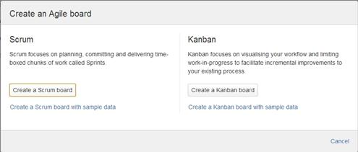](http://cdn2.softwaretestinghelp.com/wp-content/qa/uploads/2013/10/JIRA-Agile-Project-3.jpg)

**Feature #3)**After a board is created you will be able to configure it as you see fit. Basically, there are two modes to a board – Plan and work. As the name implies, plan is the part where you can categorize your requirements (stories) into Sprints. Work mode is when you can track the time spent and the overall progress. Apart from these two you can generate several reports.

**Feature #4) Plan mode:**

The following is how the plan mode looks like:

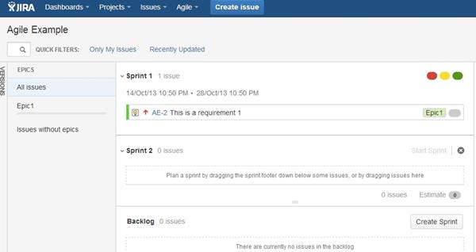

* The plan mode displays all the user stories created for the project.
* You can use the LHS menu to decide the basis on which the issues need to be displayed. You can choose to view all the issues or only the ones related to a certain Epic.
* Change the order in which issues need to be considered simply by dragging them up or down in the backlog.
* From the RHS side menu upon clicking on an issue, you can create links, sub tasks, log work and perform any other activity like you would on a normal issue.
* You can use this screen to create a sprint too, if you have the right permissions.

**Feature #5)** **Work mode:**

This will display the Active sprint information. All the user stories are going to be categorized into To do, In progress and Done to show the progress clearly.

[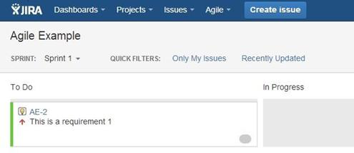](http://cdn2.softwaretestinghelp.com/wp-content/qa/uploads/2013/10/JIRA-Agile-Project-5.jpg)

**Feature #6) Agile Reports:**

Go to Agile Board->Reports. As you can see, there are lots of custom Agile reports that can be generated using JIRA. All you have to do is, choose the report that you would like and decide the data based on which this report should be generated.

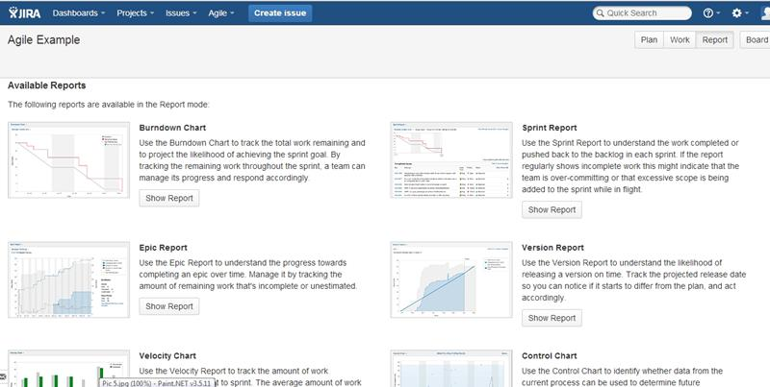

**Feature #7) Managing boards:**

With the right permissions or if you are an admin, you will be able to configure a board after its creation. To do so, go to “Agile->Manage Boards”. In the following screen, select the “Configure” option next to the board that you want to edit from the list of the all boards available.

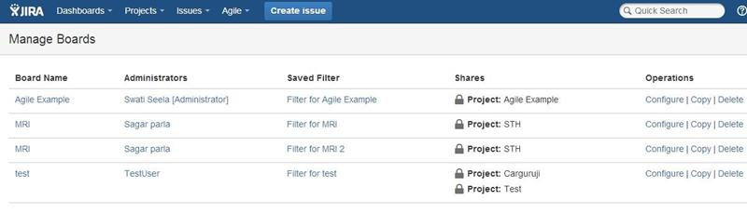

From the following page that comes up you will be able to define/edit the details as needed:

[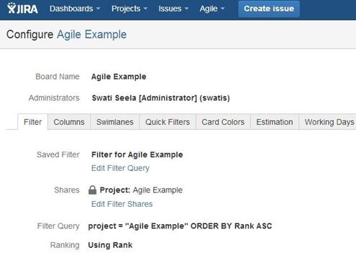](http://cdn.softwaretestinghelp.com/wp-content/qa/uploads/2013/10/JIRA-Agile-Project-8.jpg)

**Conclusion:**

That completes the basic introduction into how JIRA can be used for Agile Projects. In my opinion, the tool when used right can provide solid support for this methodology. **Since the focus on documentation is low in Agile, JIRA can be your one stop-shop to have everything in one place.**

Now, the obvious question: How is JIRA agile helpful for testers? Frankly, for the QA fraternity the scope of JIRA is either for bug tracking or task tracking – these do not change whether they are Agile Projects or regular ones. But having a good knowledge of this methodology by itself and the tool provided support is important because the IT world is shifting its focus to Agile – and we want to know all there is to know about it to make the best of it.

**Q10. Explain what is the use of “Move Issue” wizard in JIRA?**

* The move issue wizard enables you to specify another project in your JIRA instance. Move wizard permit you to change certain attributes of an issue like
* Issue Type: If your issue is a custom issue type and does not occur in your target project, you must choose a new issue type for your issue
* Issue Status: If you have assigned your issue as a custom issue status and it does not exist in your project, you must select a new issue status for your issue
* Custom Fields: If you have determined required custom fields for your issue, which do not occur in the target project, you must set values for them.

**Q11. How security setting is helpful in JIRA?**

JIRA’S security setting restricts the access to the issue to only those person who is allowed to work on the issue or a member of the chosen security level. Security level of an issue can be set either when the issue is created or when the issue is being edited

**Q12. Explain how you can share an issue with other users?**

You can email an issue by using the share option in JIRA. You can also email other JIRA users a link to the issue by sharing the issue with them or by mentioning them in an issue’s Description or Comment field.

**Q13. Explain how you can modify multiple bulk issues?**

To modify multiple bulk issues, you can use Bulk Change option from the “Tools” menu of the navigator. All the issues on the current page can be selected for the bulk operation. The following list details the available bulk operations like

* Workflow Transition
* Delete
* Move
* Edit

**Q14. Explain how you can disable mail notification for Bulk Operations?**

To disable mail notification for a particular Bulk Operations, you have to de-select the “Send Notification” checkbox in the bulk operation wizard.

**Q15. What does an issue change history include?**

Issue change history includes

* Deletion of a comment
* Deletion of a worklog
* Creation or deletion of an issue link
* Attachment of a file
* Changes to an issue field

**Q16. Explain what does the three color indicates tracking times or duration for an issue?**

Three color will be displayed representing the amount of time spent behind the issue

* Original Estimate (Blue): The amount of time originally estimated to resolve the issue
* Remaining Estimate(Orange): The remaining amount of time left to resolve the issue
* Time Spen or Logged (Green): The amount of time spent so far while resolving the issue

**Q17. When you log a defect using TestDirector or JIRA what fields do you see?**

When we log a defect, we see Defect ID (it shows later in TestDirector), Summary (where we write short description of the defect), Description (long description of the defect), Detected by (Person who found the defect, (it’s you), Severity (meaning-is the defect critical? High? Medium? Or Low?), Date, Detected in Version, Priority, Project, Status, Assigned to and so on. Click the link below to see the fields when you report defects in JIRA or TestDirector:

Defect Fields in JIRA

**Q18. Managing Issues, Using Workflow Progress and the Reporting Feature**

The issue once created can be accessed by searching the ID, browsing the “Issues” menu item or going to the project details and checking the issues tab.

When you access an issue and click on its link, the details will be displayed. All the actions that can be performed on the particular issue are available on the header of an issue details screen:

[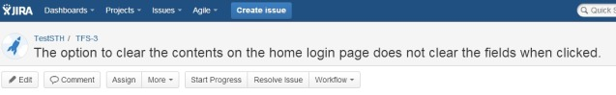](http://cdn2.softwaretestinghelp.com/wp-content/qa/uploads/2013/10/Atlassian-JIRA-Tutorial-1.jpg)

**We will go in a sequential order from Right to left and discuss all the options.**

**Manage Issues in JIRA:**

**1) Edit:**  As the name suggests, this option lets you modify an issue created. Click on it and modify the information as desired. Choose ‘Update’ when done. This is similar to “Create Issue” dialog.

[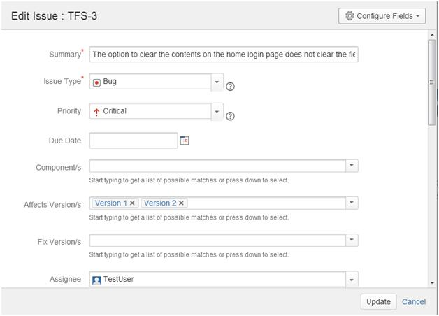](http://cdn2.softwaretestinghelp.com/wp-content/qa/uploads/2013/10/Atlassian-JIRA-Tutorial-2.jpg)

**2)** **Comment**:  This is a useful way to record the proceedings on an issue and to communicate with the concerned members. Enter your comments and choose the option to restrict viewership:

[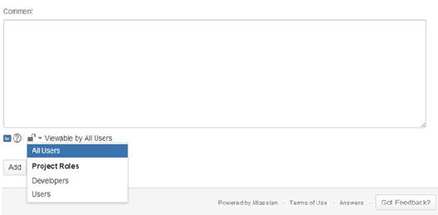](http://cdn.softwaretestinghelp.com/wp-content/qa/uploads/2013/10/Atlassian-JIRA-Tutorial-3.jpg)

**3) Assign:**  This is the option you would need when you want to shift the ownership of an issue. Enter the Assignee information, comments (anything that you would want to communicate) and choose the viewership of the comment. Once an issue is assigned to the user, an automatic email is sent (if this option is chosen by the admin) and the issue appears on the assignee’s dashboard on login.

[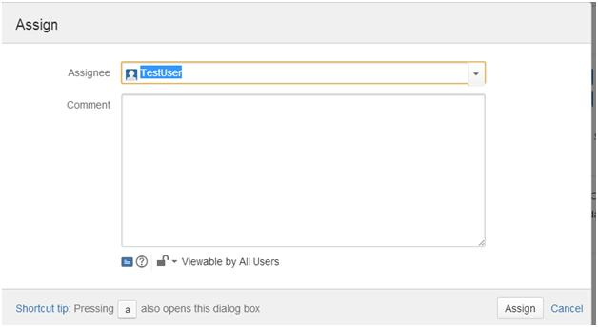](http://cdn2.softwaretestinghelp.com/wp-content/qa/uploads/2013/10/Atlassian-JIRA-Tutorial-4.jpg)

**4) More:** The following options are available under the “More” menu item:

[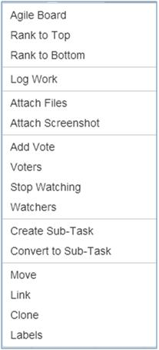](http://cdn2.softwaretestinghelp.com/wp-content/qa/uploads/2013/10/Atlassian-JIRA-Tutorial-16.jpg)

**Agile Board, Rank to Top, Rank to Bottom** -> Related to Agile Projects – the details of which are going to be coming up in a later article.

**Attach Files, Attach Screenshots ->** Lets you attach files to an issue.  The screenshot option will auto capture a screenshot. All you need to do is print screen on your machine and you can directly copy it here into JIRA.

**Add Vote, Voters, Stop watching, Watchers** -> Voting is a process that JIRA users can perform to support the resolution of an issue favorably or unfavorably. The options in this section facilitate the same. You can also choose to watch an issue – when you do so, all the changes to it will be notified to you.

**Create Sub-Task, Convert to Sub-task** -> These are the options that help create and work with sub-tasks.

**Labels** -> This concept is similar to the “Labels” that we find on various blog and web pages. You can categorize issues based on Version and Component formally, but when in need of something more informal, this option can be used. For example, all the issues raised to track peer review comments can be labeled “peer review” to view and track them easily.

**5) Log work:**  This is a way to track the progress on your issue in terms of time. When this option is used, the following dialog opens up. As you can see, the detailed information about how much time is spent on an issue, how much is remaining, etc can be logged here.

[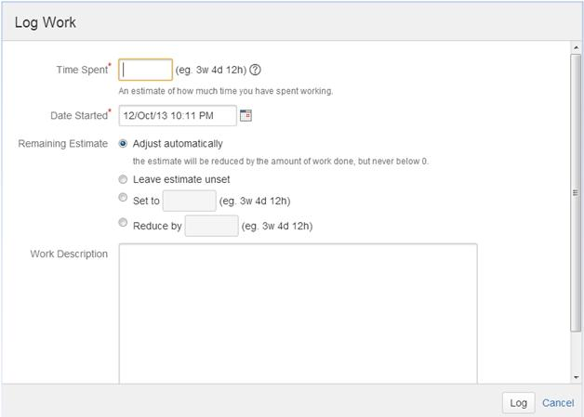](http://cdn.softwaretestinghelp.com/wp-content/qa/uploads/2013/10/Atlassian-JIRA-Tutorial-5.jpg)

**6) Move:** JIRA issues can be moved across projects. However, the move from one project to another might mean a different target workflow, a different issue type, a new status etc. It is therefore advisable to analyze thoroughly how the move is going to affect the issue before going ahead with this.

[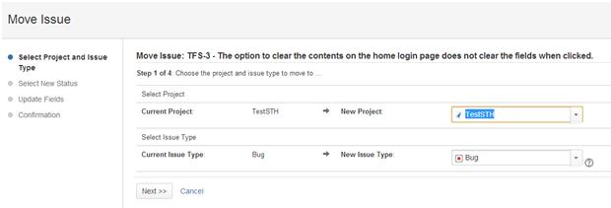](http://cdn2.softwaretestinghelp.com/wp-content/qa/uploads/2013/10/Atlassian-JIRA-Tutorial-6.jpg)

**7)** **Link:**  This is a very versatile feature of JIRA that allows you can logically link issues with one another and establish relationships/dependencies.

An example situation where this can be used in QA projects is when a certain defect prevents you from working a certain requirement. You can use this option to show the dependency.

When this link is accessed, the following dialog opens up. Using this dialog is very simple:

[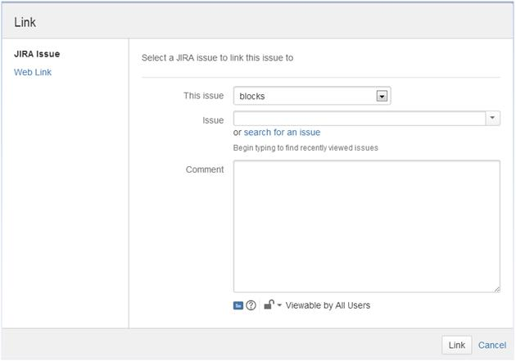](http://cdn2.softwaretestinghelp.com/wp-content/qa/uploads/2013/10/Atlassian-JIRA-Tutorial-7.jpg)

The different kind of associations can be chosen from the “This issue” list box. The list contains:

[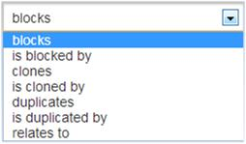](http://cdn2.softwaretestinghelp.com/wp-content/qa/uploads/2013/10/Atlassian-JIRA-Tutorial-8.jpg)

**Q19. Learn the Admin Aspects of JIRA Test Management Tool**

**JIRA- Project Management:**

Project management is one of the first and most important concepts in administration. A JIRA admin can:

1. Create a project
2. Configure an already created Project.

**Create Project:**

**1)** Once you login, in the dashboard itself you will have a few options to get started:

[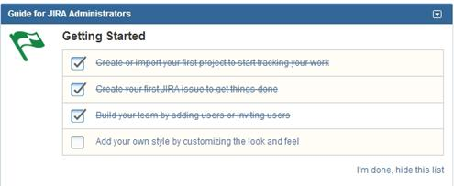](http://cdn2.softwaretestinghelp.com/wp-content/qa/uploads/2013/10/JIRA-Admin-Tutorial-1.jpg)

**2)** You can either click on the item in the list or you can choose:

[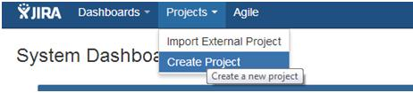](http://cdn2.softwaretestinghelp.com/wp-content/qa/uploads/2013/10/JIRA-Admin-Tutorial-2.jpg)

Or go to the Administration->Projects menu option:

And then in this page, you will have an option to “Add Project”

**3)**  Choose any of the above 3 methods to add a project. In the below window, choose the type of the project.

**Tip**: The Project type will determine the type of workflow your issues will go through.

[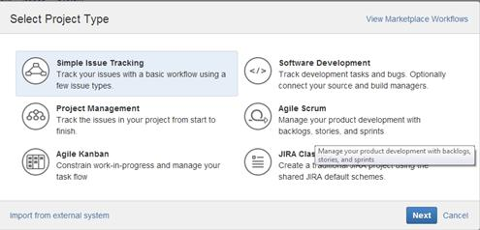](http://cdn.softwaretestinghelp.com/wp-content/qa/uploads/2013/10/JIRA-Admin-Tutorial-3.jpg)

**Note:** Please note the “Import from external systems” link at the bottom of the page.  If you have been using a different bug/issue tracking system and would like to migrate to JIRA. This is the option you could use. Also, if all you had earlier is an excel sheet for all your issues, you can create a project by importing all the issues in the CSV file into JIRA.

**4)** Enter the project Name, Key (once chosen cannot be changed) and assign a Project Lead (the person who is responsible for the overall project). Click Submit when done.

[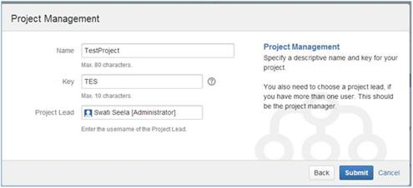](http://cdn.softwaretestinghelp.com/wp-content/qa/uploads/2013/10/JIRA-Admin-Tutorial-4.jpg)

**5)** The project gets created and the following details are displayed. By going to the “Administration” link you will be able to configure the project.(in case of an already configured project, you can edit the configurations)

[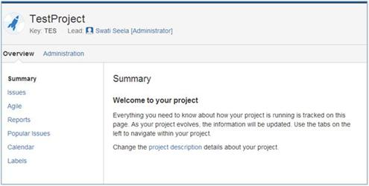](http://cdn2.softwaretestinghelp.com/wp-content/qa/uploads/2013/10/JIRA-Admin-Tutorial-5.jpg)

**Configuring a Project:**

As you can see below, you can choose the issue types  that need to show up, the workflow that the project follows

, versions and components, people involved and the level of access permissions they have etc.

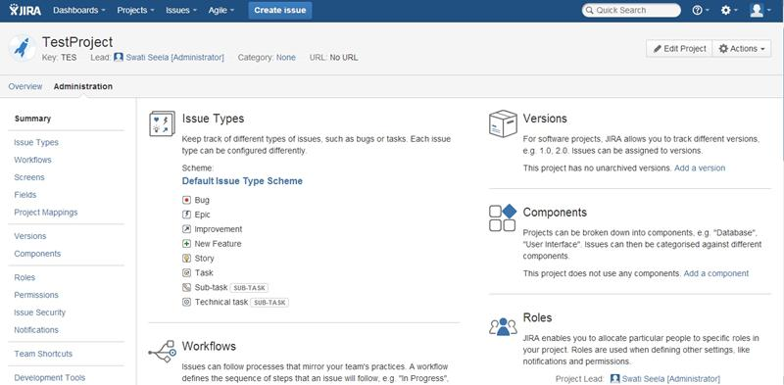

**User Management**

User creation being the most important part of the User Management process, it is not limited to just that.  The other important user related activities performed by a JIRA admin are:

1. Edit a particular user information
2. Delete a user
3. Creating users groups
4. Creating Roles
5. Permissions
6. Setting Preferences

We will see the creations, deleting and editing of an issue in details below. For the rest of the operations, we would encourage you to try them on the site with your trial ID.

**Note**: With the trial you can add up to 10 users to your account i.e., 9 additional users and 1 admin, yourself.

Firstly, Go to Administration->User Management:

There are two ways in which you can add users to JIRA.

* Create them manually.
* Send an invite to join JIRA to a user’s email ID

**Let us look at create manually in detail:**

**1)** Click on Create User button in the below page:

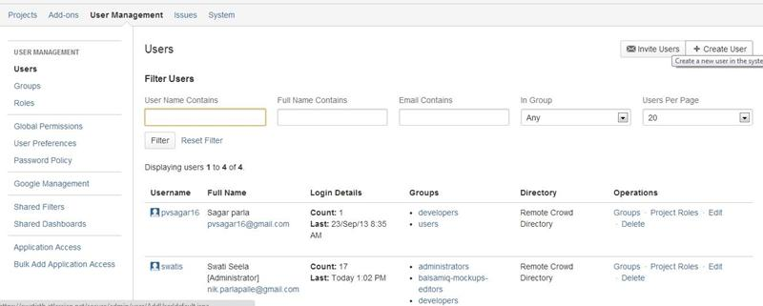

**2)** Enter the user details in the “Create new user” dialog that opens up. In the below example I have entered only mandatory fields. The others are self-explanatory and can be set as required.