BDA400
DATA SCIENCE TOOLS AND TECHNIQUES
ASSIGNMENT 1
Markdown Buddy Use ChatGPT to Draft and Format R Docs
Student Name: Chinnakotla Reddysekhar
GitHub Repository: https://github.com/reddysekhar6/BDA400-Technical-Analysis

AI Assistance Declaration
AI Assistance Declaration: I used ChatGPT (GPT-5.6 Luna) for ideation, code-structure suggestions, documentation layout, and explanation. Prompts used are documented in the appendix. I verified the final outputs against the assignment instructions, the supplied synthetic data, and direct programmatic checks. I am responsible for the accuracy and originality of the submitted work.

1. Project Documentation Plan
The project documentation is organized around the purpose, setup, example usage, inputs, outputs, verification, repository structure, and AI disclosure. This follows the assignment requirement to identify common README sections and refine the structure through AI prompting.
Section | Purpose
Overview | Explains the technical-analysis project and its role.
Installation | Lists R/RStudio and package setup.
Example Usage | Shows how the project scripts are sourced.
Repository Structure | Makes files and assignment folders easy to locate.
Verification | Explains previewing and testing before submission.
AI Assistance Disclosure | Documents the AI tool, prompts, and human review.

2. Prompting and Refinement
Seed prompt: "Explain what sections a good GitHub README for an R data analysis project should include."
Refinement prompt: "Revise the sections list so it’s concise and uses Markdown headers and bullet formatting."
Critique/validation prompt: "Check the Markdown syntax for correctness and readability."
The README was then structured specifically around the BDA400 technical-analysis project instead of using a generic data-science template.

3. R Markdown Documentation
The accompanying analysis.R script provides the documented synthetic-data workflow, and technical_analysis_documentation.Rmd explains its purpose, inputs, outputs, example code, and quality checks.

4. Verification and Refinement
The final Markdown uses consistent headings, fenced R code blocks, bullet lists, and a repository tree. The structure was checked against the supplied assignment requirements, including the requirement for a README, an R Markdown document, AI disclosure, Reflection.md, and the repository naming convention.

5. Conclusion
The completed documentation creates a clear starting point for the later technical-analysis assignments. The main improvement is consistency: a reader can identify what the project does, how its files are organized, what inputs are expected, and where verification belongs without needing to inspect every R script first.

6. Documentation Evidence
The submission package includes a generated README preview showing the Markdown structure and repository documentation. The R Markdown source is also included in the Assignment_1 folder.
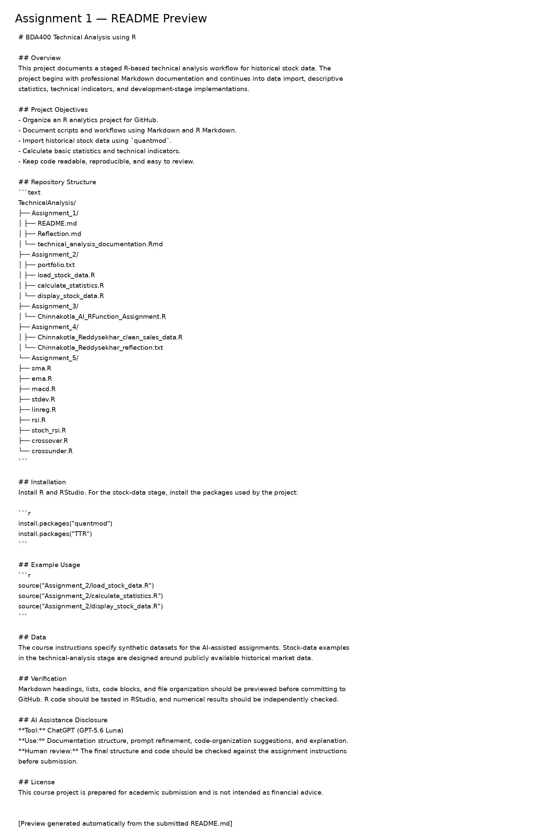
Figure 1. README documentation preview generated from the submitted project files.

