BDA400
DATA SCIENCE TOOLS AND TECHNIQUES
ASSIGNMENT 4
Ask AI Clean This Dataset with R and dplyr
Student Name: Chinnakotla Reddysekhar
GitHub Repository: https://github.com/reddysekhar6/BDA400-Technical-Analysis

AI Assistance Declaration
AI Assistance Declaration: I used ChatGPT (GPT-5.6 Luna) for data-cleaning workflow design, dplyr structure, validation checks, and documentation. Prompts used are documented in the appendix. I verified the final outputs against the assignment instructions, the supplied synthetic data, and direct programmatic checks. I am responsible for the accuracy and originality of the submitted work.

1. Dataset Overview
The supplied synthetic dataset contains 610 rows and five fields: OrderID, Product, Quantity, Price, and Customer. The analysis below uses the actual column names in the supplied file.
Field | Type | Observed issue
OrderID | Integer | No missing values observed.
Product | Character | 49 missing values.
Quantity | Numeric | 95 missing values; non-positive values; extreme value 1000.
Price | Numeric | No missing values observed.
Customer | Character | No missing values observed.

2. Data Quality Issues Identified

2.1 Missing values
Product has 49 missing entries and Quantity has 95 missing entries. Because both fields are necessary to interpret a sales transaction, records missing either field were excluded from the cleaned analytical dataset.

2.2 Duplicate records
Nine exact duplicate rows were detected. These were removed with distinct() so that repeated copies of the same transaction would not be counted twice.

2.3 Invalid quantities
The Quantity field contains zero and negative values. These values are not meaningful as completed sales quantities in this synthetic sales context, so records with Quantity <= 0 were removed.

2.4 Extreme quantity
A quantity of 1000 occurs in the source data and is substantially larger than the main cluster of quantities. It was treated as an unreasonable extreme value and removed. The decision is documented in the R script rather than hidden inside an unexplained transformation.

3. AI Prompt Sequence

Seed
I have a sales dataset in R with missing customer IDs, inconsistent region names, and outliers in revenue. What are common data cleaning steps I should perform using dplyr?

Refinement
Here is a sample of my data (first 10 rows). Suggest R code using dplyr to fix these issues.

Critique/Validation
Please explain what each line of your suggested R code does, and how I can confirm it worked correctly.

Debugging
This AI-generated code gives an error: 'object not found'. How can I debug or rewrite it in R?

Readability
Simplify this mutate() chain for readability.

Best-practice review
Does this cleaning pipeline follow tidyverse best practices? Suggest improvements.
Dataset-specific adaptation: the supplied file did not contain CustomerID, Region, or Revenue. The final workflow was therefore adapted to the actual fields present in the CSV.

4. Before and After Verification
Metric | Before | After
Rows | 610 | 379
Duplicate rows | 9 | 0
Missing Product | 49 | 0
Missing Quantity | 95 | 0
Non-positive Quantity | 81 | 0
Quantity = 1000 | 20 | 0
Total missing cells | 144 | 0

5. Product Distribution After Cleaning
Product | Rows
Widget | 131
Thingamajig | 126
Gadget | 122

6. Interpretation and Conclusion
The cleaning process reduced the dataset from 610 to 379 rows. The reduction is not, by itself, evidence that the dataset became better; the important point is that each removal was tied to a documented quality rule. After cleaning, there are no exact duplicate rows, no missing Product or Quantity values, no non-positive quantities, and no quantity values equal to 1000. The resulting file is therefore more consistent for downstream sales summaries while preserving the original raw file separately.

7. Reflection
The accompanying reflection file records the cleaning workflow, dataset-specific reasoning, verification results, and lessons from the AI-assisted process.

8. Verification Evidence Appendix
The following verification evidence supports the documented cleaning workflow and before/after checks. It is included with the submission for review.
Assignment4_Before_After_Verification.png
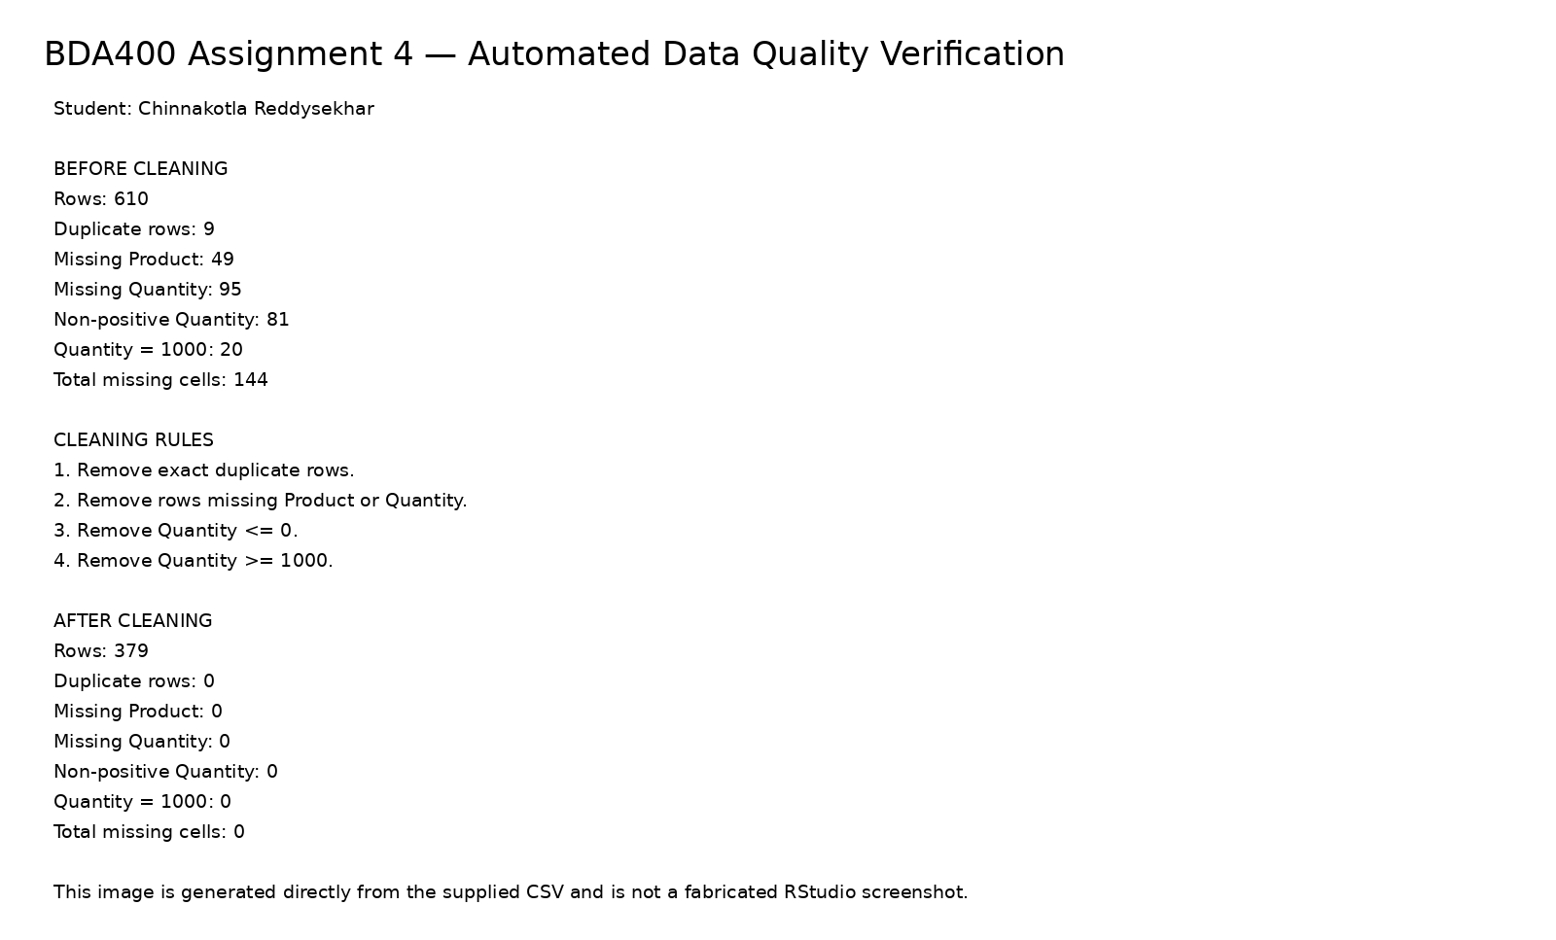
Assignment4_Product_Counts_After_Cleaning.png
