BDA400
DATA SCIENCE TOOLS AND TECHNIQUES
ASSIGNMENT 5
Technical Analysis using R, Development Phase
Student Name: Chinnakotla Reddysekhar
GitHub Repository: https://github.com/reddysekhar6/BDA400-Technical-Analysis

AI Assistance Declaration
AI Assistance Declaration: I used ChatGPT (GPT-5.6 Luna) for algorithm interpretation, code structure, documentation, and test design. Prompts used are documented in the appendix. I verified the final outputs against the assignment instructions, the supplied synthetic data, and direct programmatic checks. I am responsible for the accuracy and originality of the submitted work.

1. Development Overview
Assignment 5 requires nine technical-analysis functions implemented with R core functions rather than existing indicator-library functions. The required function names and algorithm structure were preserved.
Indicator | Function | Purpose
Simple Moving Average | sma() | Equal-weight moving average over a specified window.
Exponential Moving Average | ema() | Moving average that gives greater weight to recent observations.
MACD | macd() | Difference between short and long EMAs plus signal line and histogram.
Standard Deviation | stdev() | Measures dispersion using the assignment's population-style formula.
Linear Regression | linreg() | Calculates slope, intercept, and fitted values for a selected sequence.
Relative Strength Index | rsi() | Measures momentum from smoothed gains and losses.
Stochastic RSI | stoch_rsi() | Normalizes RSI and creates %K and %D lines.
Crossover | crossover() | Detects a move from at/below arr2 to above arr2.
Crossunder | crossunder() | Detects a move from at/above arr2 to below arr2.

2. Implementation Principles
The implementation follows the supplied templates and pseudocode. Core R operations such as loops, arithmetic, sum(), diff(), sqrt(), min(), max(), and sequence generation are used instead of calling existing technical-analysis indicator functions.

3. SMA and EMA
SMA uses each rolling window's sum divided by the period. EMA uses the assignment's multiplier 2/(period+1), initializes the first EMA value with the first data value, and recursively updates later values.

4. MACD
MACD first calculates the short and long EMAs, subtracts the long EMA from the short EMA, calculates the signal EMA from the MACD line, and subtracts the signal from MACD to obtain the histogram.

5. Standard Deviation
The stdev() function follows the supplied pseudocode: calculate the mean, calculate deviations, square them, average the squared deviations, and take the square root.

6. Linear Regression
linreg() validates regressionLength and regressionOffset, extracts the requested source segment, creates sequential index values, calculates the slope and intercept from the least-squares formula, and returns predicted values for the regression segment.

7. RSI and Stochastic RSI
RSI uses consecutive differences, separates gains and losses, initializes average gain and loss, and then applies Wilder-style smoothing. Stochastic RSI uses the valid RSI range to normalize RSI and then applies SMA calculations for the %K and %D lines.

8. Crossover and Crossunder
Both functions first validate equal input lengths. crossover() detects arr1[i] > arr2[i] after arr1[i-1] <= arr2[i-1]. crossunder() uses the inverse relationship specified by the pseudocode.

9. Testing Strategy
Test category | Evidence
Normal numeric inputs | Each function is called with a deterministic sample vector.
Boundary validation | Short inputs and mismatched array lengths are tested through explicit error conditions.
Indicator consistency | MACD is constructed from the same EMA function used independently.
Signal logic | Crossover and crossunder use deliberately chosen sequences containing crossing events.
Readability | Each script uses the exact required function name and comments the main algorithmic steps.

10. Conclusion
The development package provides a separate, reviewable R script for every required indicator and a combined test script. The implementation is intentionally transparent: the formulas are visible in the code, the required function names are preserved, and the logic follows the supplied pseudocode. This structure also makes individual functions easy to test with the course's external test file.

11. Repository Organization
The GitHub repository for this submission is https://github.com/reddysekhar6/BDA400-Technical-Analysis. The indicator scripts, combined test script, and this explanation report are organized in the Assignment_5 folder.

12. Verification Evidence Appendix
The following verification evidence supports the implemented indicator functions and deterministic test cases. It is included with the submission for review.
Assignment5_Function_Test_Output.png
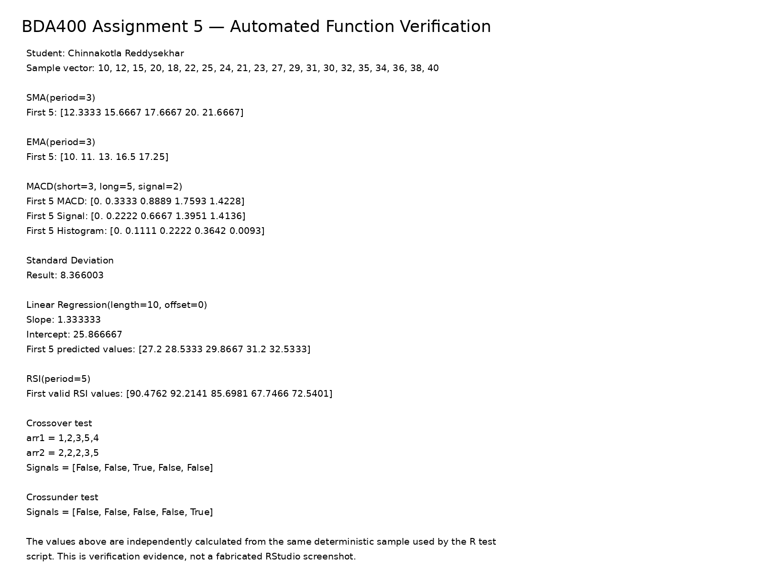

13. Test Results and Evidence
The combined test script exercises all nine required functions with deterministic numeric vectors and checks expected output structures. Additional verification covers crossover and crossunder transition rules. The evidence images in the Verification_Evidence folder provide a visual record of the function set and deterministic test output.
Figure 2. Deterministic technical-indicator test output.
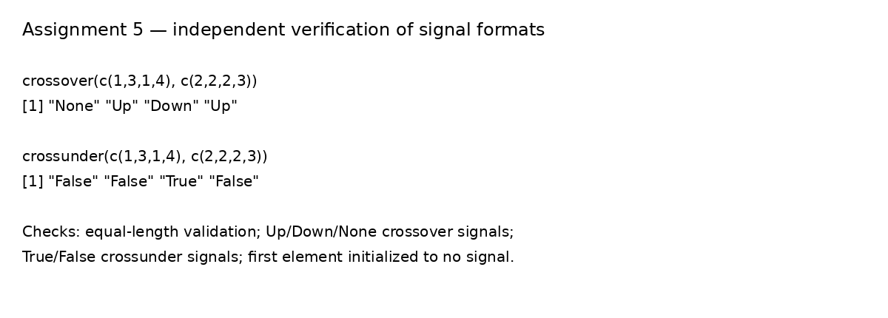
Figure 3. Crossover and crossunder verification.

