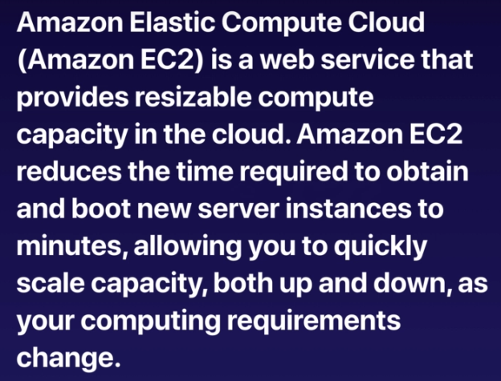

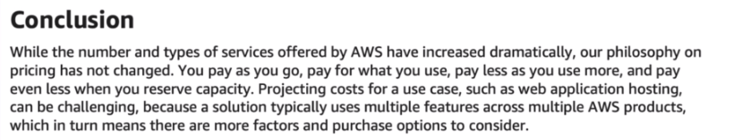

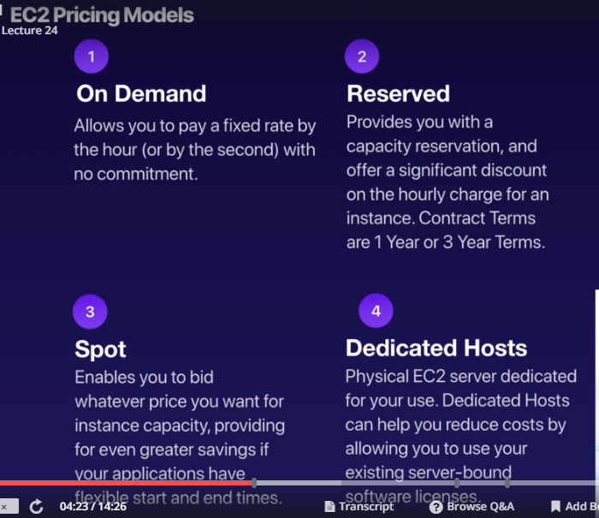

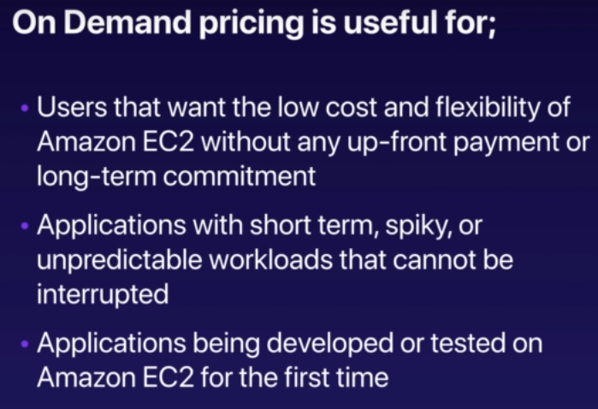

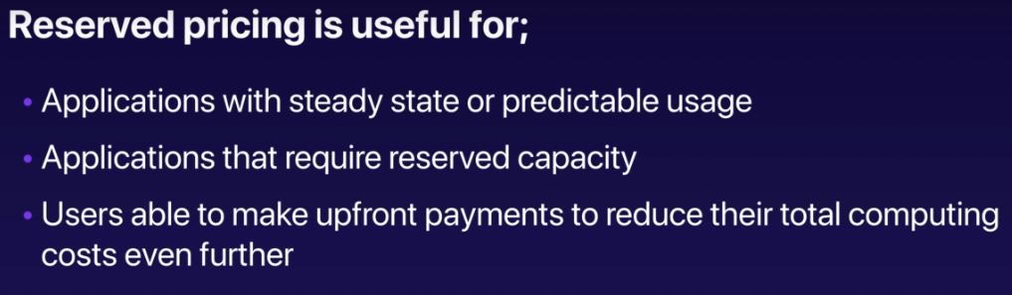



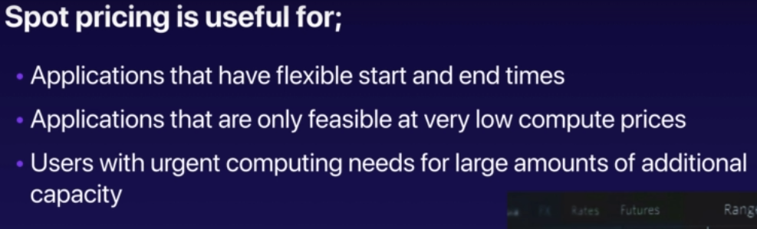

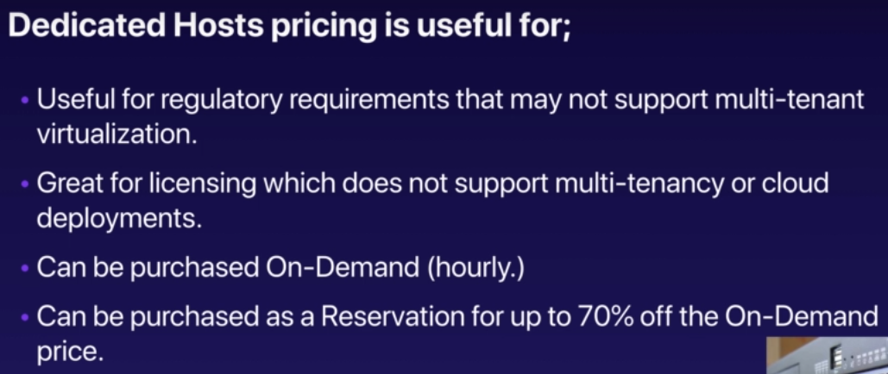

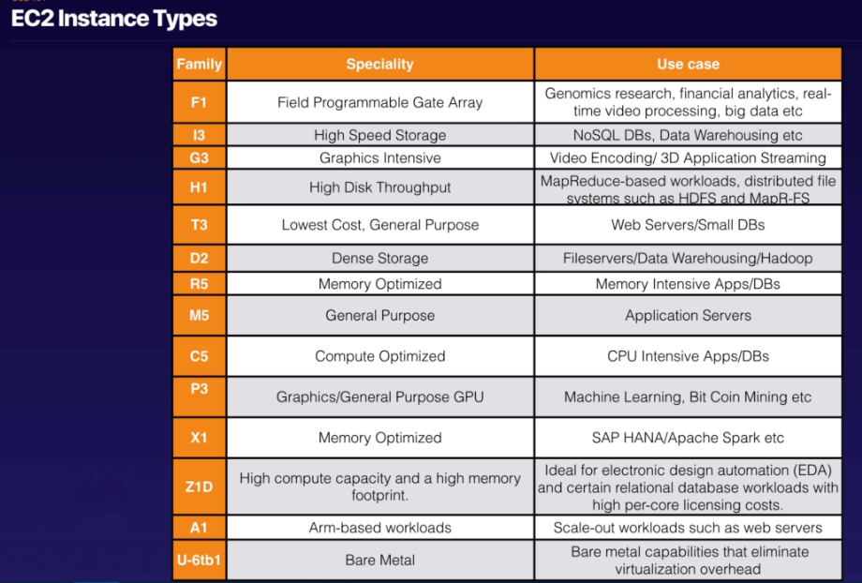



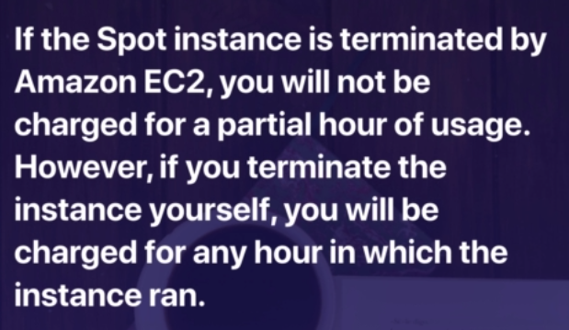

Important question above one

While launching instance, chose protect against accidental termination.

Providing additional tags like name of the server, department, who created would help us track the instance later on.

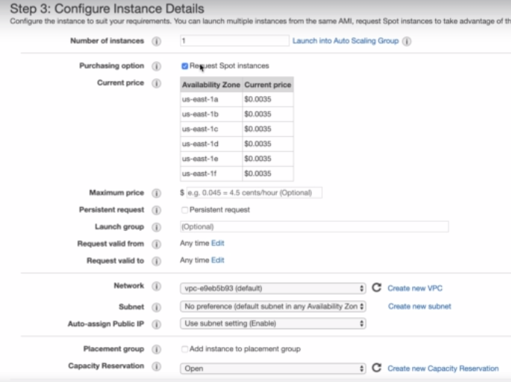

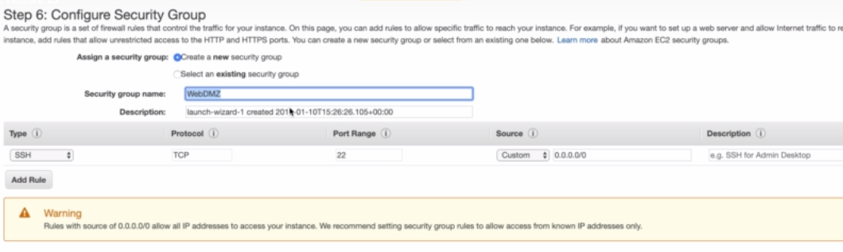

After login to instance yum update -y to update os based updates.

To install apache web server, use

Yum install httpd -y

Cd /var/www/html and create index.html here

Service httpd start => starts the server

Chkconfig on => will ensure if machine reboots this would start automatically

The **Chkconfig** command tool allows to configure services start and stop automatically in the **/etc/rd.d/init.d** scripts through command line.

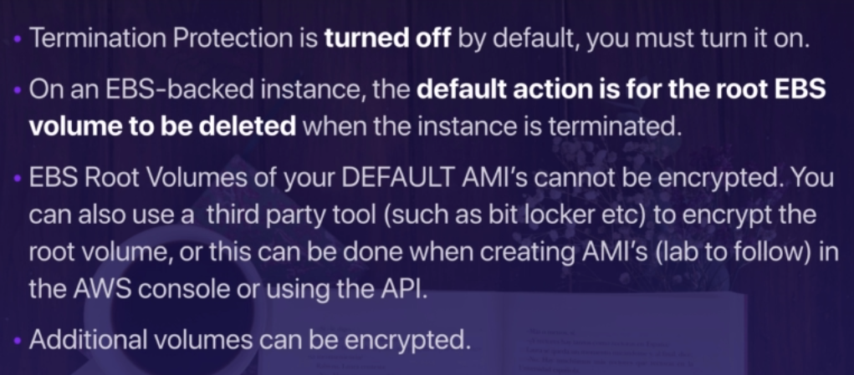

The information about instance can be obtained as below

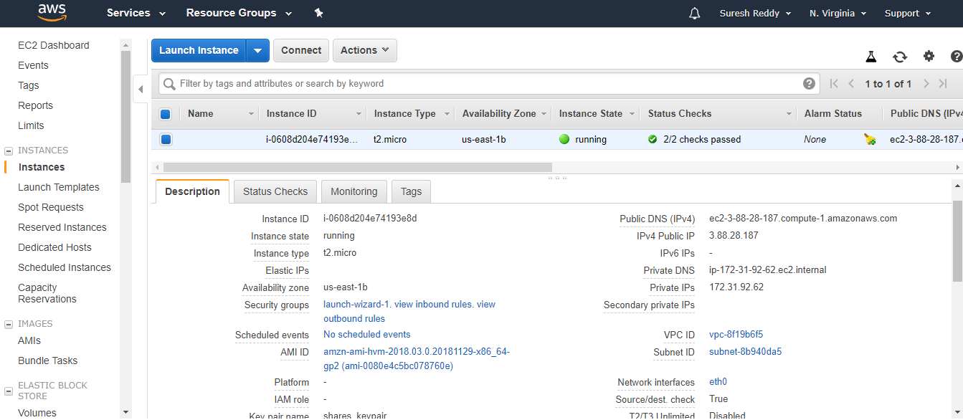

Monitoring tab shows various graphs depicting cpu and memory usage etc

Tags section shows tags associated with this instance.