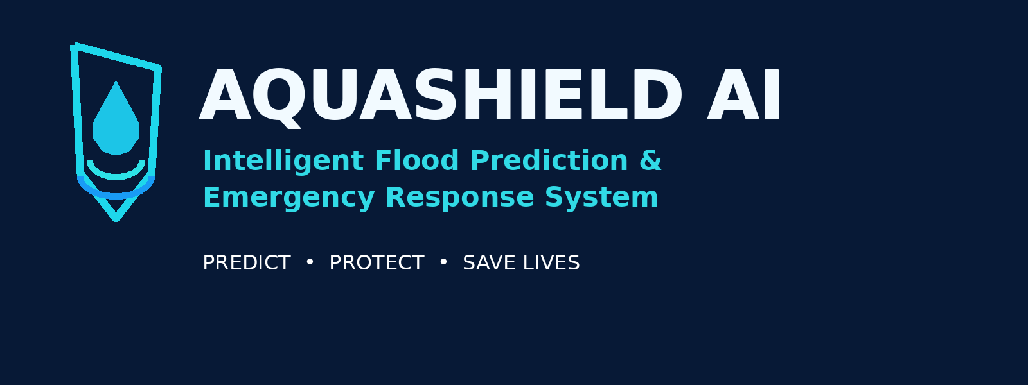
PROJECT REPORT
Intelligent Flood Prediction & Emergency Response System
Hackathon Prototype | AQUANEX simulation + HydroGuard incident-response capabilities

1. Executive Summary
AQUASHIELD AI is a prototype concept for integrating flood-risk simulation, water-level and rainfall scenario monitoring, incident reporting, priority scoring, and emergency alert demonstrations in one interface. It is designed to help demonstrate how earlier risk awareness and coordinated response workflows can support safer communities.

2. Problem Statement
Flood events can escalate quickly when rainfall, rising water, blocked drainage, and incident reports are not brought together. Manual reporting and delayed communication can make it harder for response teams to prioritize hotspots and coordinate action.

3. Proposed Solution
- Virtual water-level and rainfall simulation with selectable scenarios.
- Rule-based risk and priority scoring for illustrative incidents.
- Incident submission and status tracking for response teams.
- Hotspot visualization and task assignment workflow.
- Demonstration alert paths for SMS event logging and a local browser speaker alarm.

4. System Workflow
Data / scenario input → simulation and risk assessment → hotspot or incident prioritization → alert event → response task coordination → status update and review.

5. Main Modules
Module | Purpose
Simulation | Explore normal, heavy-rain, rising-water, and sensor-fault scenarios using virtual data.
Incident dashboard | Record sample incidents, view priority scores, and track response statuses.
Alert demo | Log simulated SMS events and play a browser-local speaker sound.
Task coordination | Assign a response team, due time, and status to a reported incident.

6. Technology Stack
Python and Flask backend; HTML, CSS, and JavaScript frontend; JSON files for prototype data; browser audio for the local alarm demonstration. Deployment and live integrations require additional engineering.

7. Expected Benefits
- A single demo environment for simulation and incident coordination.
- Clearer visualization of risk scenarios and response priorities.
- A repeatable hackathon demonstration of alerting workflows.
- A foundation for future validated data feeds and approved alert integrations.

8. Existing Approaches vs AQUASHIELD AI Prototype
Capability | Basic/manual workflow | AQUASHIELD AI prototype
Scenario simulation | Often separate or unavailable | Included with virtual data
Incident prioritization | Manual assessment | Illustrative priority scoring
Alerting demonstration | Manual notification | Simulated SMS log + local browser audio
Response task tracking | Separate tools or calls | Prototype task list and status tracking

9. Testing Plan
- Launch the Flask app and confirm both dashboard and simulation routes load.
- Run normal, heavy-rain, rising-water, and sensor-fault scenarios.
- Submit an incident with valid severity and drainage status.
- Verify priority ordering and response status updates.
- Trigger the demo alert and confirm it is explicitly marked simulated.
- Create and update a response task.

10. Limitations and Safety
This is a demonstration prototype, not a certified warning system. Sensor values and map examples may be sample or virtual data. SMS is not delivered to real phones, and browser audio does not operate external sirens. No forecast accuracy claim is made. Real deployment requires validated hydrological models, reliable sensor infrastructure, fail-safe engineering, secure access controls, authorized telecom integration, privacy review, and emergency-agency approval.

11. Future Scope
- Connect calibrated river/rain gauges and official weather feeds.
- Evaluate and validate forecasting models on historical flood data.
- Integrate a consent-based, approved SMS/voice gateway.
- Add secure user roles, audit logs, backups, and deployment monitoring.
- Conduct field testing with local authorities and accessibility reviews.

12. Conclusion
AQUASHIELD AI demonstrates a unified workflow linking flood scenarios, risk visualization, incident triage, and response coordination. The prototype is intended for education and hackathon demonstration, with real-world use dependent on further validation and safety engineering.

