Wisdom and Chance Game Rules (2025)

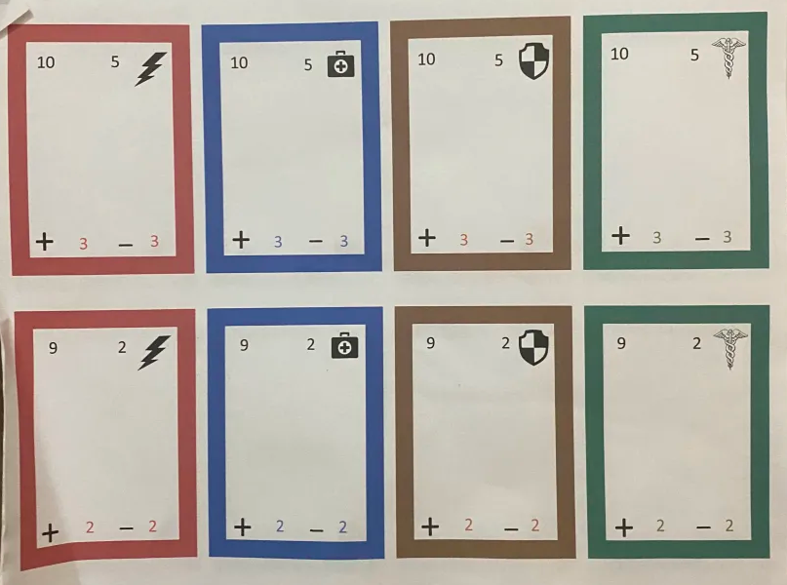
Example of game cards.

Game Rules and Setup

Deck and Commander Setup
- Deck Composition:
  - Each player starts with a 40-card deck.
  - Each deck must contain four unit cards for each power rank level.
  - A player can have up to two copies of any card.
- Commander Selection:
  - Each player must choose one commander for their deck before the start of the game.

Starting the Game
- Determine Turn Priority:
  - Decide who has turn priority, typically via a dice roll or rock-paper-scissors.
- Initial Setup:
  - Both players start with 40 HP.
  - Each player draws five cards.

Game Phases
Each round consists of several phases:
- Draw Phase:
  - Both players draw two cards.
- Deployment Phase:
  - Both players choose two unit cards from their hand and place them face down in the battlefield zone.
- Tactics Phase:
  - Players decide whether to use tactics via their commanders by spending advance and withdrawing resources.
- Combat Phase:
  - Resolve combat between the deployed ally cards.
  - Remind players to flip their cards only during the combat phase.
  - If they reveal them during the tactics phase, both players could see their opponent's card details and plan accordingly.
- Calculation Phase:
  - Both players flip their unit cards face up and then proceed with the calculations.
  - Calculate power levels by adding unit power levels, buffs, debuffs, and traits, as well as any tactics effects. The player with the highest power level deals damage to their opponent equal to the difference.
- End Phase:
  - Each player moves their unit cards to the medical ward (the yard), regardless of win or lose.
  - Both players gain 1victory or 1 withdrawal point depending if they won the combat phase or not.

Winning the Game
- The objective is to reduce the opponent's HP to zero.

Key Terms Index
Traits:
- Inherent buffs that units have, shown in the upper right corner of the card with an associated number. Traits may include specific elements or faction icons for more complex interactions.
Examples of Traits:
- Quick Strike: Deals damage to the opponent at the start of combat equal to the trait number modifier.
- Care Package: Heals your HP by the trait number modifier.
- Restoration: Returns units from the medical ward to your deck or hand equal to the trait number modifier.
- Guardian: Blocks damage up to the trait number modifier per combat.
Commander:
- The character card leading the player's armies of units. Commanders usually have 4-8 tactics abilities that can be used during the tactics phase by spending advance and withdrawing counters earned from defeats and victories during the combat phase. These abilities can be passive or active and typically affect certain factions or units.
Power Level:
- The base power level of a unit card, shown in the upper left corner of the card.
Buff Modifier:
- Located in the lower left corner, this modifier increases the power of other unit cards by the specified amount, provided the ally unit matches the element color or faction. If the modifier is black, it applies to any unit. This buff only affects cards other than itself.
Debuff Modifier:
- Shown in the lower right-hand corner of a unit. It reduces the power of all enemy units individually if they match the color or faction of the debuff symbols. If the debuff is black, it works on all enemy units.
FACTIONS
- ( factions) are icons that are on the unit or comander that indicate their affiliations
ELEMENTS
- comanders and units most prominent connection to certain part of universe such as air earth watter or fire.

