Chat Application

Analysis and Design Document

Student: Sergiu Redeca

**Group: 30234**

Revision History

|  |  |  |  |
| --- | --- | --- | --- |
| **Date** | **Version** | **Description** | **Author** |
| 06/04/2017 | 0.2-alpha | Architectural and domain model | Sergiu Redeca |
|  |  |  |  |
|  |  |  |  |
|  |  |  |  |

Table of Contents

I. Project Specification 4

II. Elaboration – Iteration 1.1 4

1. Domain Model 4

2. Architectural Design 4

2.1 Conceptual Architecture 4

2.2 Package Design 4

2.3 Component and Deployment Diagrams 4

III. Elaboration – Iteration 1.2 4

1. Design Model 4

1.1 Dynamic Behavior 4

1.2 Class Design 4

2. Data Model 4

3. Unit Testing 4

IV. Elaboration – Iteration 2 4

1. Architectural Design Refinement 4

2. Design Model Refinement 4

V. Construction and Transition 5

1. System Testing 5

2. Future improvements 5

VI. Bibliography 5

# Project Specification

*[Present the project specification]*

# Elaboration – Iteration 1.1

# Domain Model



# Architectural Design

## Conceptual Architecture

For the project, the multilayer architecture will be used.

We have 3 layers:

* Presentation layer – represented by Client Layer package
* Logic layer – represented by the Server Layer package
* Data layer – the database



## Package Design

## 

## Component and Deployment Diagrams

# 

# Elaboration – Iteration 1.2

# Design Model

## Dynamic Behavior

*Interaction diagram – sequence diagram: the user successfully logs in and sends a message Interaction diagram - communication diagram: the user successfully logs in and sends a message*

**

## Class Design

*[Create the UML class diagram; apply GoF patterns and motivate your choice]*

*Server-side UML diagram*

**

# Data Model

*The data model of the system.*

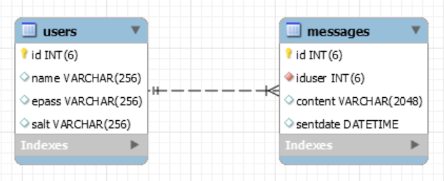

# Unit Testing

*[Present the used testing methods and the associated test case scenarios.]*

# Elaboration – Iteration 2

# Architectural Design Refinement

*[Refine the architectural design: conceptual architecture, package design (consider package design principles), component and deployment diagrams. Motivate the changes that have been made.]*

# Design Model Refinement

## *[Refine the UML class diagram by applying class design principles and GRASP; motivate your choices. Deliver the updated class diagrams.]*

# Construction and Transition

# System Testing

*[Describe how you applied integration testing and present the associated test case scenarios.]*

# Future improvements

*[Present future improvements for the system]*

# Bibliography

<https://en.wikipedia.org/wiki/Domain_model>