Student: Sergiu Redeca

**Group: 30234**

Table of Contents

1. Requirements Analysis 3

1.1 Assignment Specification 3

1.2 Functional Requirements 3

1.3 Non-functional Requirements 3

2. Use-Case Model 3

3. System Architectural Design 3

4. UML Sequence Diagrams 3

5. Class Design 3

6. Data Model 3

7. System Testing 3

8. Bibliography 3

1. Requirements Analysis

# Assignment Specification

*The application is used to manage the orders of a furniture manufacturer. It has two types of users: the regular user (the order manager) and the administrator.*

*The regular user can:*

* *Add/update/view order information (customer, shipping, address, identification number, delivery date, status)*
* *Create/update/delete/view product information (name, description, color, size, price, stock)*
* *Add products to order (the price should be updated accordingly)*

*The administrator can:*

* *CRUD (create, read, update, delete) employees’ information*
* *Generate reports for a particular period containng activities performed by the employees*

# Functional Requirements

*The users should perform the previously mentioned opperations.*

# Non-functional Requirements

*The software should be easy-to-use.*

*Also, the data will be stored in a DB. The login should be secured.*

2. Use-Case Model

*Use case:*

*Level: <one of: summary level, user-goal level, sub-function>*

*Primary actor: regular user*

*Main success scenario: <the steps of the main success scenario from trigger to goal delivery>*

*Extensions: <alternate scenarios of success or failure>*

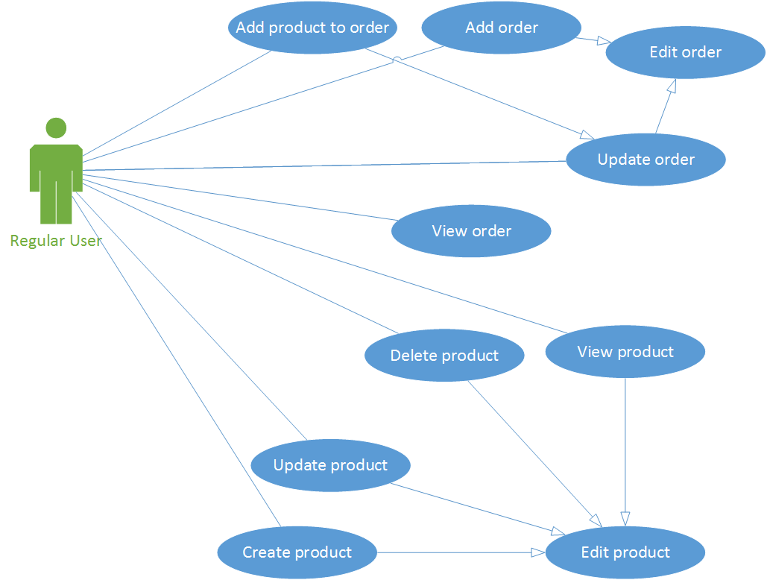

*Use case:*

*Level: <one of: summary level, user-goal level, sub-function>*

*Primary actor: administrator*

*Main success scenario: <the steps of the main success scenario from trigger to goal delivery>*

*Extensions: <alternate scenarios of success or failure>*

*Use case: <use case goal>*

*Level: <one of: summary level, user-goal level, sub-function>*

*Primary actor: <a role name for the actor who initiates the use case>*

*Main success scenario: <the steps of the main success scenario from trigger to goal delivery>*

*Extensions: <alternate scenarios of success or failure>*

3. System Architectural Design

**3.1 Architectural Pattern Description**

*[Describe briefly the used architectural patterns.]*

**3.2 Diagrams**

*[Create the system’s conceptual architecture; use architectural patterns and describe how they are applied. Create package, component and deployment diagrams]*

4. UML Sequence Diagrams

*[Create a sequence diagram for a relevant scenario.]*

5. Class Design

**5.1 Design Patterns Description**

*[Describe briefly the used design patterns.]*

**5.2 UML Class Diagram**

*[Create the UML Class Diagram and highlight and motivate how the design patterns are used.]*

6. Data Model

*[Present the data models used in the system’s implementation.]*

7. System Testing

*[Present the used testing strategies (unit testing, integration testing, validation testing) and testing methods (data-flow, partitioning, boundary analysis, etc.).]*

8. Bibliography