**UNIVERSITY OF THE IMMACULATE CONCEPTION COLLEGE FACULTY RANKING AND PROMOTION SYSTEM**

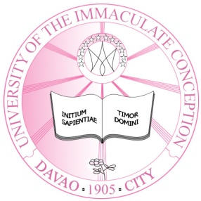

A System Presented to the Faculty of the

Information Technology Education Program

University of the Immaculate Conception

Fr. Selga St., Davao City

_________________

In Partial Fulfilment of the

Academic Requirements for the Subject

SOFTWARE ENGINEERING

(SE-324)

BATO-ON, NASHRA L.

CALOYON, MARY MAE G.

ORTIZ, GENESIS D.

RAMOS, EMMANUEL JOHN N.

March 2013