# Part I

# SYSTEMS ANALYSIS REPORT

**Introduction**

The evolution of information systems in relation to the business industry started from manual operations to flat file operations such as a spreadsheet wherein the storage, retrieval, manipulation, transmission and processing of data is much faster. It already uses the so-called legacy systems that the individual files are not related to each other. From the spreadsheet models it evolved to database models. In this present time, because of the evolution of information systems most institutions today require a high degree of processing data and information. Some of these institutions are now using an automated system that enables an organization to automate and integrate its key business processes with the help of the technology.

Technology, as defined by most of the people, is the making, modification, usage, and knowledge of tools, machines, techniques, crafts, systems, methods of organization, in order to solve a problem, improve a preexisting solution to a problem, achieve a goal or perform a specific function. It can also refer to the collection of such tools, machinery, modifications, arrangements and procedures. Technology changes from time to time. The evolution of technology coincides with the evolution of information systems. When combined, these two things can innovate many things in this world even the impossible things might be possible. Living standards of the people in the world requires a high degree of advancement in technologies. With the invention of the researchers, several works become easier and accurate. Without these inventions and innovations there will be a lot of wasted time from transferring of data to retrieval of information. Since a manual process requires a large amount of time to have an accurate result of information.

The University of the Immaculate Conception College Faculty Ranking and Promotion Committee has been experiencing this kind of problem with their manual process in their ranking system of the college full time faculty. The manual process of encoding and computing the points earned by a faculty consumes time. Sometimes the possibility that there will be an inaccuracy of information retrieved is also a problem. With this type of arising problem in the committee, and as a team of software engineers, the members of the team took advantage to the problem by proposing a system that would solve the problems encountered by the institution in terms of ranking their faculty by developing an automated Ranking and Promotion System for the College Department.

**The Organization**

In 1905, the University of the Immaculate Conception was founded by the Religious of the Virgin Mary (RVM) sisters in Davao City. From a parochial school which offers intermediate and primary courses named “EscuelaCatolica de San Pedro”. After the World War II the school was named into Immaculate Conception College after it received its college status. In 1947, the school offered the first two courses in college and as time passes by, UIC offers many courses up to now. And today, it is one of the most prestigious schools in Davao City which has enrollees from preparatory, primary, secondary and tertiary levels.

The Ranking and Promotion Committee (RPC) operates under the UIC. The RPC is in charge of ranking and promoting the full time faculties in teaching the college department in the university. It is composed of a chairperson and six members appointed by the university president. The members of the Committee sit en banc once a year to deliberate matters concerning faculty credentials and other matters pertaining to faculty’s rank. The members of the RPC follows criteria based on qualification and tripod functions adapted from the Sarmiento’s “Faculty Classification and Ranking” for college or university teachers.

*Vision*

A global Catholic university that envisions the transformation of society in response to the signs of the times.

*Mission*

We commit ourselves to:

* Serve others with humility and love
* Exercise leadership in the pursuit of excellence in instruction, research, and community service
* Respect the dignity of the person especially the poor
* Work for justice, promote peace and preserve the integrity of creation
* Promote and strengthen out Filipino culture and values

*Goal*

In order for us to approximate our vision and live our mission, we dedicate all our human resources to transform the members of the University of the Immaculate Conception family to become enlightened, empowered, pro-active and liberated Christian leaders living in a humane and harmonious community for love of God and love of country.

*Philosophy and Objectives*

The University of the Immaculate Conception faithfully adheres to the Catholic philosophy of education, which emphasizes the development of the whole person to make him/her useful and happy in this life in preparation for his/her eternal destiny with the Creator. She shares an integrated view of the human person grounded in the person of Jesus Christ (PCP II, 264). She leads in the work of evangelization with Christian living as the core of the curriculum and considers Christian life as intimately woven within the life of the community in variety levels: domestic Church->BEC->parish->diocese->local->universal Church (PCP II, 625).

*Business Environment*

The University of the Immaculate Conception (UIC) operates in the city of Davao with three campuses; one for the high school and elementary departments which are located in Bajada and the other two campuses is for the college department; namely, the Bonifacio and Fr. Selga campuses.

In both campuses for the college department, there are offices of different organizations located in the school. These offices are in charge of different responsibilities to meet the needs of the students enrolled in the university as well as the staffs and faculties employed in it. Some of the offices in the university have already an automated system which makes their jobs easier and faster in terms of processing since there are a lot of students enrolled in the university. To manage the data and records, the university has one server located in the main campus at Fr. Selga Street which is administered by a network administrator. And also, some of the areas inside the university have already an access in the internet.

The Ranking and Promotion Committee (RPC) is one of the organizations in the university which job is to rank and promote the full time faculties employed in the college department based on individual checklist supported by pertinent documents before the start of the academic year. Their office is located in the ground floor, Scholarship office to be specific. But different from other offices, the RPC still uses the manual operation in their ranking system using a pen and a paper as the medium of doing the process.

*Critical Success Factors*

The University of the Immaculate Conception (UIC) is one of the most prestigious schools in Davao City. It operates for more than a century founded by the RVM sisters. It has ten (10) programs as of now, and each program offers different courses which has a good quality of Marian education. The UIC trains its students to be integrated, God-centered, nationalistic, innovative transformative, excellent and service-oriented in their chosen field in a unified society.

The UIC college department always aims to produce graduates who are capable of bridging theory and practices. It envisions men and women who contribute to his/her community’s transformation by being transformed first, and who can kindle goodness and positive values wherever they are. Behind the success factors of the university are the undying efforts of the students, staffs and professors employed in the school to give the students a good and excellent quality of education. And to value these efforts exerted by the professors they are paid according to their rank in the years of service they offered in the university which is the mainline of the diligent and reliable people behind the Ranking and Promotion Committee (RPC) who were chosen by the university president.

With this critical success factors and achievements, the UIC college department will continue to produce excellent graduates for the years to come.

# 

# The Current System

The Ranking and Promotion Committee current ranking system uses a manual process in retrieving, manipulating, conducting, and processing of data. It uses a paper and calculator, but in this case, the current system computes long procedures to summarize those reports. They enhanced the process using Microsoft Excel for a paperless and less cost of time doing those calculations. But, even if they use the Microsoft Excel still they encounter some problems, like printing different format of reports, and the final output of computations are not accurate due to rounding off numbers thus, lead to inconsistency and wrong determination of rank of a particular faculty.

The current system of the Ranking and Promotion Committee also requires lot of papers because, each faculty is ranked with an individual checklist form and, these forms are stored in a cabinet for reference and retrieval purposes in the future. By this method of storing those data in the cabinet, damages due to fire and water is not impossible to happen, which might be a reason of losing all the data and information for each faculty.

*Description of Operations*

The procedures in their operations are in manual process wherein it uses a paper, pen and a calculator, the step-by-step procedures that the current system does are the following:

1. Human Resource (HR) officer sets standards for ranking and promotion of full time faculty members and endorses the composition of members for the college ranking and promotion to the President, then the President approves the list.
2. The approved list of committee members will be distributed to the program whose names are in the list. Each list of the members in the committee will sign the appointment to signify their approval.

After the program secretary has submitted the faculty credentials.

1. The committee chairperson calls for a meeting and start to give the faculty credentials to the committee member of which he/she is assigned to.
2. The committee chairperson gives each member a dummy MS Excel file and the member receives the dummy excel file together with the faculty credentials to encode and compute the points earned of the faculty he/she was ranking.
3. The committee member ranks the faculty using individual checklist then encodes it to the MS Excel.
4. The committee member submits her/his MS Excel file to the committee chairperson for verification and validation.
5. If there are errors, the chairperson will give it back to the committee to review the checklist form.
6. The committee member submits her/his MS Excel file to the committee chairperson for verification and validation.
7. The committee chairperson discusses and presents the final results for committee approval and made some corrections, if there are.

If there are no errors, the chairperson will create a summary encoded in MS Excel.

1. The committee chairperson prints the summary results and the committee members sign for it for final approval.
2. The committee chairperson submits all the checklists and summary forms signed by all members of the committee to the Human Resource officer for approval.

Figure 1.0Activity Diagram of the Current System



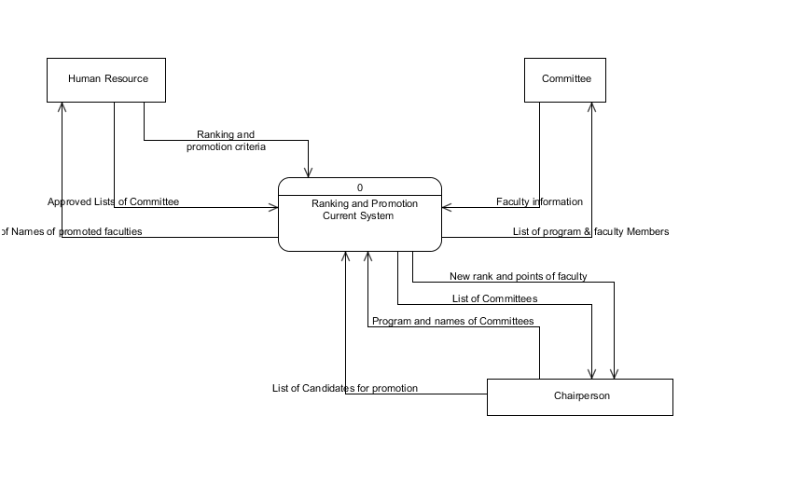

Figure 1.1Context Level Data Flow Diagram of the Current System

*Level 0 Data Flow Diagram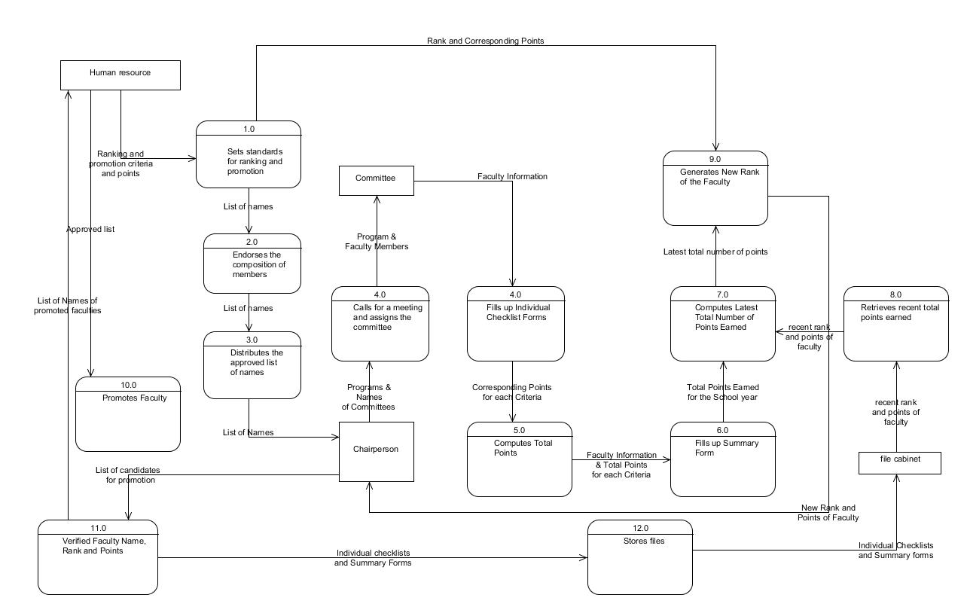*

Figure 1.2Level 0 Data Flow Diagram of the Current System

Problem/Opportunity Definition

This part of the project shows the performance, information, economic, efficiency and service in the organization after examining the process of the company’s current system based on the current problems encountered by the users, the causes and effects of that problem and the opportunities that the new system might offer.

Table 1.0 *Problem-Opportunity Definition Matrix*

|  | Problem | Opportunities | Cause(s) | Effect(s) |
| --- | --- | --- | --- | --- |
| **P**erformance | The process of computing the points earned by each faculty is slow. | The system will automatically compute for total points earned by each faculty. There will be no hassle on the part of the committee and the chairperson. | The computation is done manually with a pen, paper and a calculator. | Time consuming on the part of the committees because they need to carefully compute the points earned by each faculty. |
| **I**nformation | There is a possibility that results are not accurate. | There will be an accuracy of results in the final information. | The computation is done manually using a calculator. | Logical error can occur. |
| **E**conomics | Requires a lot of papers because each faculty is rated using a ranking and promotion checklist. | The usage of papers is minimized because the system has a built-in ranking and promotion checklist form. | Ranking and Promotion checklist form for every faculty used for rating. | Requires a lot of papers in producing the checklists and for creating the summary of results. |
| **C**ontrol | Security of the data and information are not prioritized. | The system will restrict the access of viewing and altering the important data and information. The system, can allow the chairperson to control the access of the committee. There is also a required username and password for the committee members. | Data and Information are only written in papers and stored in cabinets. | The confidentiality of information and integrity of data might be violated. The papers are prone to tampering, and altering of results is not impossible to happen. |
| **E**fficiency | Voluminous number of papers stored in the cabinet. Slow in terms or retrieval of records. | The system can automatically search and retrieve the ranking and promotion data using a database. The searching and retrieval of information is easy and efficient for the committee and its members since there is a search and view options in the system. | The record for each faculty is written using a piece of document and in order to preserve that data, the documents must be stored in a cabinet. And, as many records added in each year, there are more documents stored in the cabinet. | There are a lot of documents which makes the searching and retrieval of information hassle on the part of the committee. |
| **S**ervice | Extra effort on the work needed to be done by the Chairperson in generating reports, due to the number of faculty members. | The system can automatically generate reports based on the entered data of the committee for each faculty. | There is no automated system that will generate reports based on the computer results. | Hassle on the part of the chairperson and the committee because they have to do it manually. |

Based on the Problem-Definition Matrix, there are problems encountered in the current system of ranking and promotion of college faculty used in the organization.

The following are the problems identified in the current system:

1. Slow process

Basically because it is done manually, this makes the performance of the system slow in terms of processing the data and information.

1. Prone to tampering

Since it is based on manual ranking the medium of ranking is a pencil so knowing the possibilities there’s a chance of changing other ranks by other committee members. Confidentiality of data and information might also be violated.

1. Voluminous Paper

Since the current system is being used by a University, the estimated faculty members are for about 78-89 faculty members maybe 12-20 per program and these may require a lot of costs in terms of producing papers.

1. Inaccuracy of reports

Since the calculation of points is done by a calculator there is a possibility that the calculation results are inaccurate.

1. Hassle in generating reports

The system cannot generate reports automatically which makes the job of the chairperson very hassle.

1. Unsorted records

The records are not easy to access because of the huge volume of papers and folders used.

Functional Requirements

The College Faculty Ranking and Promotion system is a Management Information (MIS) type of Information system that is should be used by the Ranking and Promotion chairperson and its committee members of the University of the Immaculate Conception. It should provide the management of the records base on the credentials of the faculty member and decides whether to rank or promote it or not based on the computed results from the earned points on each criterion. The system should also generate report to the human resource, chairperson or committee members to identify the current rank of a faculty member. The system must have the functionalities like adding, viewing, updating, searching, activating and deactivating users whether it is a human resource, chairperson and committee member. They are the ones to rank or promote a faculty member.

The system must have ranking and promotion functionalities that ranks or promotes a faculty member that is also restricted to only the chairperson and its committees’ specific assignment although the chairperson is allowed to rank or promote all of the programs. Lastly, the system must allow permitted users to view or print the faculty checklist and summary report; this is to review once again the points that are being given to a faculty member.

From the identified problems and opportunities, most problems encountered by the University of the Immaculate Conception College Faculty Ranking and Promotion Committee came from the ranking and promotion method. The major problem is in the performance wherein the computing of points earned by each faculty is done manually which makes the process very slow. Another problem is the accuracy of results wherein the chairperson should review all the tabulated points by each committee to make sure that there are no errors committed during the ranking and promotion method which is a burden to the chairperson of the committee. To support the needs of the chairperson and its committee, generating report should also be included. The following are functionalities that are needed based on the interviews conducted.

**Faculty Ranking and Promotion System**

**Account Management**

1. Log in/Log out
2. The user should be able to login into the system based on the following data:
3. Username
4. Password
5. The system should identify whether the user is a human resource, chairperson or a committee.
6. The user should be able to log out from the system successfully.
7. Account Settings
8. The user can be able to change the data in his/her account such as:
9. First Name
10. Middle Name
11. Last Name
12. Gender
13. Username
14. Password

**User Management**

1. Add User
2. If a user is a human resource, he/she can add an account for chairperson and committee.
3. The user can do the following information such as:
4. First Name
5. Middle Name
6. Last Name
7. Gender
8. User Level (Human Resource, Chairperson, Committee)
9. Program
10. Program to Rank
11. Username
12. Password
13. Account Status(Activated/Deactivated)
14. View/Display Users
15. If a user is a human resource, he/she can view list of chairpersons and committee members.
16. If a user is a chairperson, he/she can view list of committee members.
17. The system can display all the user’s information:
18. Username
19. First Name, Last Name, Middle Name
20. Account Status
21. User level
22. Search User
23. If a user is a human resource, he/she search chairpersons and committee members in the system.
24. If a user is a chairperson, he/she can search committee members.
25. The user can search a user’s information using:
26. User’s Last Name
27. User’s First Name
28. User’s Username
29. Update User
30. If a user is a human resource, he/she can update the information of a chairperson or a committee member.
31. The human resource can be able to edit the following users’ information:
32. First Name
33. Middle Name
34. Last Name
35. Gender
36. User level
37. Program
38. Username
39. Program to Rank
40. Account Status(Activated/Deactivated)
41. If a user is a chairperson, he/she can update the committees’ information such as:

Program to Rank

1. Activate/Deactivate User Account
2. If a user is a human resource, he/she can activate/deactivate accounts of chairperson or committee members.

**Faculty Management**

1. Add Faculty
2. If a user is a human resource or a chairperson he/she can add a faculty information to the database such as:
3. First Name
4. Middle Name
5. Last Name
6. Gender
7. Program
8. Educational Qualification
9. Record Status
10. View/Display All Faculty
11. If a user is a human resource or a chairperson he/she can view the list of all faculty and his/her information such as:
12. Complete Name
13. Record Status(Activated/Deactivated)
14. Search Faculty
15. If a user is a human resource or a chairperson he/she can search a faculty from the system using the following data:
16. Program
17. Faculty’s Last Name
18. Faculty’s First Name
19. Update Faculty
20. If a user is a human resource or a chairperson he/she can update a faculty’s information such as:
21. First Name
22. Middle Name
23. Last Name
24. Gender
25. Program
26. Educational Qualification
27. Record Status(Activate/Deactivate)
28. Activate/Deactivate Record Status
29. If a user is a human resource or a chairperson he/she can activate or deactivate a faculty’s record status.

**Program Management**

If a user is a human resource, he/she can perform the following:

1. Add Program
2. Add a program to the system. Necessary data for this module is:
3. Program Name
4. View/Display Program
5. View all the list of programs. Information displayed are:
6. Program Name
7. Committee-in-charge
8. Update Program
9. Update the program name of a program.

**Qualification Management**

If a user is a human resource, he/she can perform the following:

1. Add Qualification
2. Add a qualification with the necessary data to the database:
3. Qualification Name
4. Maximum Points
5. Overall Percentage
6. View/Display Qualification
7. View the list of qualifications and its corresponding information such as:
8. Qualification Name
9. Items
10. Maximum Points
11. Overall Percentage
12. Search Qualification
13. Search a qualification using:
14. Qualification Name
15. Update Qualification
16. Update a qualification’s information such as:
17. Qualification Name
18. Maximum Points
19. Overall Percentage
20. Remove Qualification
21. Deactivate a qualification from the database and its corresponding items.
22. Print Qualification
23. Print the list of qualifications.

V. Add Item

1. Add an item under a qualification with the necessary data such as:
2. Item Name

VI. View Items

1. View the list of items of a qualification

VII. Update Item

1. Update the information of an item such as:
2. Item Name
3. Qualification

VIII. Remove Item

1. Remove an item from the list of items.

**School Year Management**

If a user is a human resource, he/she can manipulate this module.

1. Add School year

a. Add school year to the list.

II. Set School year

a. Set current school year

III. View School year

a. Displays the list of school year

**Ranking Management**

If a user is a human resource, he/she can manipulate this module.

I. Add Rank

a. Necessary data are needed:

* 1. Rank Name
  2. Minimum Educational Qualification
  3. Remarks

II. Update Rank

a. The following data can be updated:

1. Rank Name
2. Minimum Educational Qualification
3. Remarks

III. Remove Rank

a. The user can be able to remove a rank from the list of ranks.

IV. View Rank

a. Displays all the list of rank information such as:

1. Rank Name
2. Subranks
3. Corresponding Points
4. Degree
5. Prevailing Criteria

V. Search Rank

a. The user can search a rank from the database using:

i. Rank Name

VI. Print Rank

a. The user can be able to print all the ranks containing the following information such as:

1. Rank Name
2. Subranks
3. Corresponding Points
4. Degree
5. Prevailing Criteria

VII. Add Subrank

a. The user can be able to add a subrank in an existing rank using:

1. Minimum Points
2. Maximum Points

VIII. Update Subrank

a. The user can be able to update a subrank information such as:

1. Minimum Points
2. Maximum Points
3. Rank

IX. Remove Subrank

a. The user can be able remove a subrank from the list of subranks.

**Data Management**

Fill Up Checklist

1. If a user is a chairperson or a committee, he/she can fill up the checklist of a faculty with the necessary data such as:
2. Faculty Name
3. Qualification
4. Items
5. Corresponding Points

View Faculty Records

If a user is a chairperson or a human resource, he/she can view the records of a faculty of all programs.

If a user is a committee he/she can only view the records of a faculty that belongs to the program assigned to him/her.

The system will display all the information such as:

Faculty Name

School Year

Previous Rank

Qualification

Items

Corresponding Points

Total

Average

Update Faculty Records

If a user is a chairperson, he/she can update the records of the entire faculty ranked for the current school year.

If a user is a committee member, he/she can only update the records of the entire faculty assigned to him/her for the current school year with the necessary data such as:

1. Corresponding points

Search Faculty Records

If a user is a human resource, he/she can search all the records of the entire faculty members in the database using the data such as:

1. Program Name
2. School Year
3. Faculty’s Last Name
   1. If a user is a chairperson, he/she can search all the records of the entire faculty ranked in the current school year by entering the data such as:
   2. If a user is a committee, he/she can search all the records of the entire faculty belongs to a program that is assigned to him/her by entering the following data such as:

Program Name

Faculty’s Last Name

1. Print Individual Records

If a user is a human resource, chairperson or a committee he/she can print all the following data of a ranked faculty such as:

1. Faculty Name
2. Previous Rank
3. School Year
4. Qualification
5. Items
6. Corresponding Points
7. Total
8. Average
9. Generate Summary Report

If a user is a human resource, a chairperson or a committee he/she can view all the list of reports of all faculties ranked with the information such as:

1. Program Name
2. Faculty Name
3. Total Points
4. Previous Points
5. Previous Rank
6. Current Points

vii. Current Rank

viii. Pegged Rank

ix. Remarks

1. Search Report
2. If a user is a human resource, he/she can search for a report of all the ranked faculties by entering the following data:
3. Program Name
4. School Year
5. Faculty’s Last Name
6. If a user is a chairperson, he/she can search for a report of all the ranked faculties for the current school year by entering the following data:
7. Program Name
8. Faculty’s Last Name
9. If a user is a committee, he/she can search for a report of all the ranked faculties that belongs to a program assigned to him/her for the current school year by entering the following data:
10. Program Name
11. Faculty’s Last Name
12. Generate Individual Report
13. If a user is a human resource, chairperson or a committee he/she can view all the following data of a ranked faculty such as:
14. Faculty Name
15. Previous Rank
16. Program Name
17. School Year
18. Qualification Name
19. Qualification Maximum Points
20. Points Earned for the Current School Year
21. Points Percentage
22. Total Points Earned from the Current Ranking
23. Points Earned from the Previous Ranking
24. Total
25. Equivalent Rank
26. Remarks
27. Evaluated by
28. Update Report
29. If a user is a human resource, he/she can update the entire faculty’s report.
30. If a user is a chairperson, he/she can update the entire faculty’s report for the current school year.
31. If a user is a committee, he/she can update the faculty’s report that belongs to a program assigned to him/her for the current school year.

The following data can be updated by the users mentioned above:

Remarks

1. Print Individual Report

a. If a user is a human resource, chairperson or a committee he/she can print an individual report of a faculty in the form of pdf that contains information such as:

1. Faculty Name
2. Previous Rank
3. Program Name
4. School Year
5. Qualification Name
6. Qualification Maximum Points
7. Points Earned for the Current School Year
8. Points Percentage
9. Total Points Earned
10. Points Earned from the Previous Ranking
11. Total
12. Equivalent Rank
13. Remarks
14. Evaluated by

**Others**

Back up Database

If a user is a human resource or a chairperson, he/she can back the database of the system in the form of zip format.

Table 1.1 *Use Case Glossary*

| Use Case Glossary | | |
| --- | --- | --- |
| **Use-Case Name** | **Use-Case Description** | **Participating Actors and Roles** |
| Faculty Ranking and Promotion System |  |  |
| 1. Log in | Logs in the user into the system. | Human Resource, Chairperson, Committee |
| 1. Log out | Logs out the user from using the system. | Human Resource, Chairperson, Committee |
| 1. Account Settings | Updates his/her account. | Human Resource, Chairperson, Committee |
| 1. Add User | Adds a user whether it is a chairperson or a committee member. | Human Resource |
| 1. View Users | Shows the lists of the following users. | Human Resource, Chairperson |
| 1. Search Users | Searches a user from the system. | Human Resource, Chairperson |
| 1. Update User | Updates the information from the list of users. | Human Resource |
| Assigns committee members to rank a program. | Chairperson |
| 1. Activate/Deactivate Users | Activates or deactivates a user. | Human Resource |
| 1. Add Faculty | Adds a faculty records. | Human Resource, Chairperson |
| 1. View Faculty | Shows the list of the faculty and information needed. | Human Resource, Chairperson |
| 1. Search Faculty | Searches a faculty from the system. | Human Resource, Chairperson |
| 1. Update Faculty | Edits the information about the faculty. | Human Resource, Chairperson |
| 1. Activate/Deactivate Faculty | Activates or deactivates a faculty. | Human Resource, Chairperson |
| 1. Add Qualification | Adds qualifications needed. | Human Resource |
| 1. View Qualification | Shows the lists of the qualification needed. | Human Resource |
| 1. Update Qualification | Updates the qualifications. | Human Resource |
| 1. Search Qualification | Searches a qualification from the system. | Human Resource |
| 1. Remove Qualification | Deletes a qualification and its corresponding items. | Human Resource |
| 1. Print Qualification | Prints a list of qualification | Human Resource |
| 1. Add Items | Adds Items for a qualification. | Human Resource |
| 1. View Items | Shows the list of the items from the database. | Human Resource |
| 1. Update Items | Updates Item information. | Human Resource |
| 1. Delete Items | Deletes an item. | Human Resource |
| 1. Add Rank | Adds rank in the system. | Human Resource |
| 1. View Rank | Shows the list of the rank. | Human Resource |
| 1. Update Rank | Edits the information on rank. | Human Resource |
| 1. Search Rank | Searches a rank from the system. | Human Resource |
| 1. Remove Rank | Removes the details about rank. | Human Resource |
| 1. Print Rank | Prints a list of Ranks | Human Resource |
| 1. Add Sub-Rank | Adds sub-rank. | Human Resource |
| 1. Update Sub-Rank | Updates the information of a sub-rank. | Human Resource |
| 1. Remove Sub-Rank | Removes the details of the sub-rank. | Human Resource |
| 1. Add School Year | Adds a school year to the database. | Human Resource |
| 1. View School Year | View list of school year | Human Resource |
| 1. Set School Year | Sets the current school year for the ranking | Human Resource |
| 1. Add Program | Adds Program information. | Human Resource |
| 1. View Program | Shows the list of Programs | Human Resource |
| 1. Update Program | Edits the information about the Program. | Human Resource |
| 1. Fill-Up Checklist | Able to fill the checklist needed for the ranking of the faculty. | Chairperson, Committee |
| 1. View Faculty Records | Displays the faculty Records and their corresponding points in the form of checklist. | Human Resource, Chairperson, Committee |
| 1. Search Faculty Records | Searches a faculty record from the database. | Human Resource, Chairperson, Committee |
| 1. Update Faculty Records | This use case can edit the data of the records submitted. | Chairperson, Committee |
| 1. Print Faculty Records | Prints the records of a faculty in the form of pdf. | Human Resource, Chairperson, Committee |
| 1. Generate Individual Reports | Generates report of the current and previous standing of a faculty. | Human Resource, Chairperson, Committee |
| 1. Search Reports | Searches a report/summary of a faculty. | Human Resource, Chairperson, Committee |
| 1. Print Individual Reports | Prints the generated reports. | Human Resource, Chairperson, Committee |
| 1. View Summary Reports | Displays summary of reports for a school year. | Human Resource, Chairperson, Committee |
| 1. Print Summary Reports | Prints a summary report | Human Resource, Chairperson, Committee |
| 1. Update Faculty Reports | Updates the remarks of a faculty report. | Human Resource, Chairperson, Committee |
| 1. Backup Database | Executes backup database in a format of .sql. | Human Resource, Chairperson |

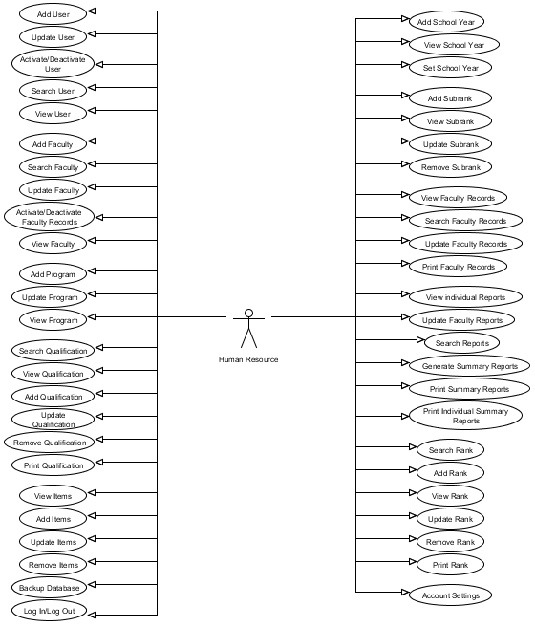

Figure 1.3 *Use Case Diagram for Human Resource*

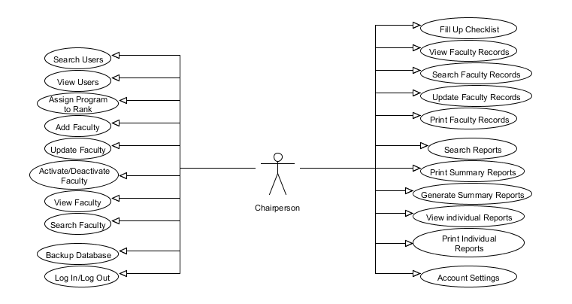

Figure 1.4 *Use Case Diagram for Chairperson*

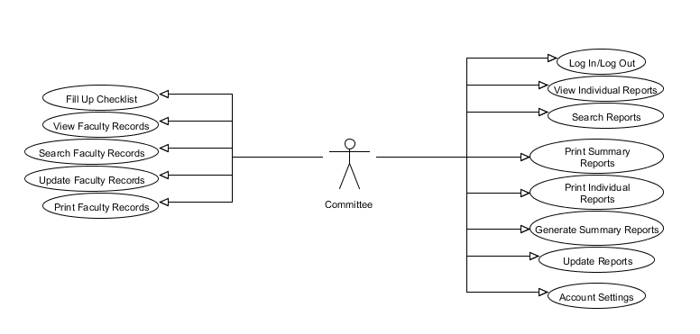

Figure 1.5 *Use Case Diagram for Committee*

Feasible Alternatives

In the given Problem-Opportunity Definition matrix, there are problems that the University of the Immaculate Conception encountered in their current process of ranking and promoting the college faculty which can lead to a possibility of inaccuracy of results due to manual processing of computing the points. There are solutions that the proposed system will provide to solve the main problems that the organization encountered with their current system. The proposed system will provide a ranking and promotion System for the committees and chairperson which is the automation of computing the points earned by each faculty. The automated ranking and promotion system will automatically compute the points earned by each faculty that will result to the improvement in terms of performance. The performance will not be slow, and the confidentiality of data and information in the system is secured and protected.

Alternative Solutions

1. Use Google spreadsheet

Google is web-based data storage for ease of accessing files anywhere. It offers different kinds of solutions for business problems over the years. One of these is the Google spreadsheet wherein a user can access his files anywhere and share it to anybody. This solution might be appropriate during the ranking process of the full time faculty employed in the university. Hence, this alternative would provide a guarantee that there would be less hassle in computing the points earned by each faculty. All files can be shared to everybody with the permission of the person who created it. Basically, it would be the chairperson who is responsible in sharing the spreadsheet to his/her committee members.

2. Create a Customized Ranking and Promotion System

The second alternative solution is to create a customized ranking and promotion system for the ranking and promotion committee. Wherein the system will do all the computation in the system and protection of the confidentiality and integrity of data and information involved in the ranking. It would also cater the setting of the rules and standards that would automatically update for the computation of points.

Feasibility Analysis

Operational Feasibility

*Alternative Solution 1*

In the current system of the Ranking and Promotion Committee (RPC), they already use the Microsoft Excel in computing for the summary reports. Upon implementing this solution, the chairperson can share a certain file to a committee such as a readymade spreadsheet for the ranking. And the committee would just have to encode the points in the spreadsheet. Both the chairperson and the committee can view this document. Yet, there are still disadvantages from this solution such as the confidentiality of data and information involved in the ranking. Anybody who has an access to the file can share it to other person if he/she opts to.

*Alternative Solution 2*

The ranking and promotion system will provide efficiency of computer results for each points earned by the faculty. Wherein, the system will only require input from the committee or chairperson and it would automatically output the total result of the points. This would be an easy alternative solution in the problem of the ranking and promotion committee since the conditions of the systems are based from the handbook of the ranking and promotion committee. In terms of manpower, there would be no burden on the part of the members of the ranking and promotion committee since the system will automatically generate reports for each result. It would only require the basic literacy of the ranking and promotion committee’s in using computers. Based on the interviews conducted by the proponents, the ranking and promotion committee are literate enough to use the system and each member of the committee has their own computer unit such as a laptop.

Technological Feasibility

*Alternative Solution 1*

The current system wherein the chairperson uses Microsoft Excel in generating reports considering the equipments being used is capable of sustaining the solution. The chairperson and the members already have their laptops. Once the ranking of faculty started the chairperson may share the spreadsheet to the committee for them to rank the faculty members of the program assigned to them.

*Alternative Solution 2*

The RPC members had already their own computer laptops. This solution would only require Web browsers installed in the laptops of the users in order for them to use the system online; web browsers such as Google Chrome and Mozilla Firefox will do. For storage of records and information, since there is no single computer unit deployed in the scholarship office – the office where the users rank and promote the faculty, this solution would require a computer unit to be placed in the office which has a minimum specifications of the following:

* 512 RAM
* 10GB hard disk space
* Windows XP or higher Operating System

In the company, there are a lot of available computer units in their other offices which is qualified for the minimum requirements of this solution.

Economic Feasibility

*Alternative Solution 1*

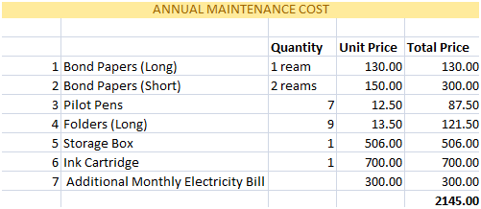

Table 1.2 *Annual Maintenance Cost of the Alternative Solution 1*

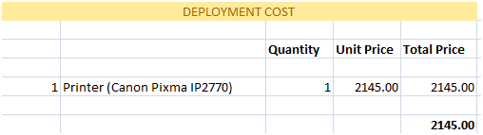

Table 1.3 *Deployment Cost of the Alternative Solution 1*

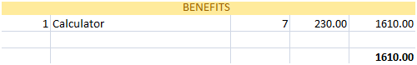

Table 1.4 *Benefit of the Alternative Solution 1*

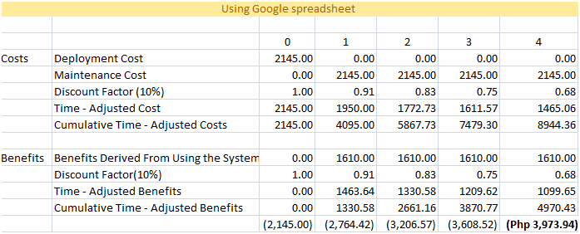

Table 1.5 *Net Present Value of the Alternative Solution 1*

The net present value of the alternative solution one which is using Google spreadsheet indicates a bad investment. After 5 years, the business cannot benefit from the investment they made during the first year of implementation. Thus, this solution might put the organization’s money at risk.

*Alternative Solution 2*

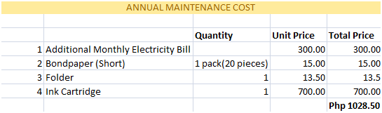Table 1.6 *Annual Maintenance Cost of the Alternative Solution 2*

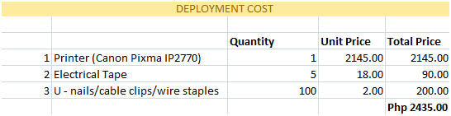

Table 1.7 *Deployment Cost of the Alternative Solution 2*

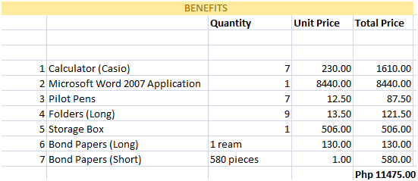

Table 1.8 *Benefits of the Alternative Solution 2*

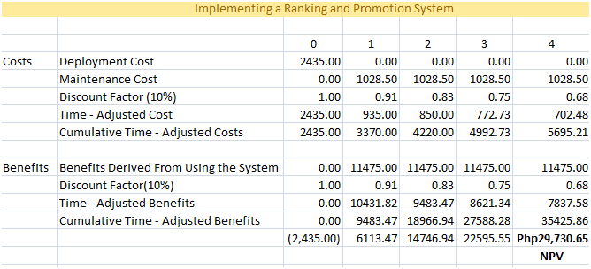

Table 1.9 *Net Present Value of the Alternative Solution 2*

The net present value of the proposed system shows that the company would spend small expenses in terms of deployment and annual cost. It also offers a large amount of benefits for the company.

Schedule Feasibility

*Alternative Solution 1*

The schedule feasibility of using the Google spreadsheet requires a small amount of time upon implementing the solution. This would include the planning, constructing functionalities, system designing, purchasing the application, coding for the formulas, testing and maintenance of the system. The figure below shows the schedule of the alternative solution:

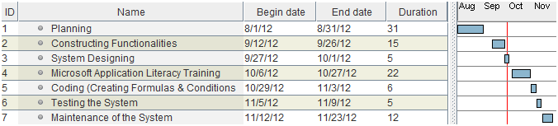

Figure 1.6 *Gantt Chart of the Alternative Solution 1*

*Alternative Solution 2*

The allotted time for the proponents to accomplish the system is two semesters. The first semester has 18 weeks to finish all the documentation for the system this includes the project planning and project analysis design. Second semester is scheduled for the project implementation which involves the coding, the user acceptance training as well as the maintenance and evaluation of the system. The estimated time-frame of this system including both the documentation and implementation is 10 months. The table below shows the scheduled feasibility gantt chart for this alternative solution which is creating a customized ranking and promotion system for the committees.

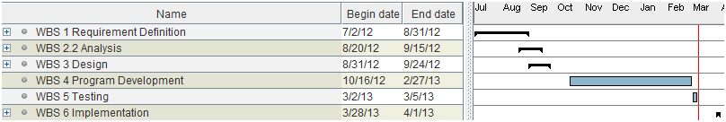

Figure 1.7 *Gantt Chart of the Alternative Solution 2*

Table 1.10 *Weighted Scoring Model for the Different Candidates*

| Feasibility Criteria | Wt. | Candidate 1  (Google Spreadsheet) | Candidate 2 (Proposed System) |
| --- | --- | --- | --- |
| Operational Feasibility  **Functionality:** A description of to what degree the candidate would benefit the organization and how well the system would work.  **Political**. A description of how well received this solution would be from user management, user, and organization perspective. | 30% | Supports functionalities for the system such as acquiring correct results. Can improve the system in terms of performance. But the security and confidentiality of the data can still be easily compromised.  **Score: 70** | Fully supports the required functionalities of the system. Confidentiality of the data and information is secured. It is designed to have username and encrypted password wherein the authorized person can control the access of other users. This also speeds up the performance of the ranking system.  **Score:100** |
| Technical Feasibility  Technology: An assessment of the maturity, availability (or ability to acquire) and desirability of the computer technology needed to support this candidate.  **Expertise:** An assessment of the technical expertise needed to develop, operate and maintain the candidate system. | 30% | There are enough resources in terms of technology that the company can provide to acquire the solution. Each user has already a laptop computer and there are also available computer units located in the university. There would be a requirement for literacy training of the users in terms of creating formulas in spreadsheet and implementing conditions.  **Score:80** | The members can be personally train by the proponents on how to operate the system. In maintaining and developing the system the proponents could cater it.  **Score: 90** |
| Economic Feasibility  Cost to develop:  Payback period(discounted)  Net present value:  Detailed calculations: | 30% | Approximately  Php 80, 341.00  (Php 3,973.94)  (See Economic Feasibility)  **Score: 60** | Approximately  Php 2,435.00  Php29,730.65  (See Economic Feasibility)  **Score: 90** |
| Schedule Feasibility  An assessment of how long the solution will take to design and implement. | 10% | 3 months  **Score: 90** | 10 months  **Score:80** |
| Ranking | 100% | 75 | 90 |

Scope

* The system focused only in the Ranking and Promotion System of the University of the Immaculate Conception College Department.
* It can cater to the computations of the points earned by each full time faculty of the said with a rule that member of the faculty must submit his/her application form with valid supporting documents to his/her associate chairperson not later than the ranking date.
* The system can also add, update, view, search, activate/deactivate users and restrict the access of users to any other data depending on their roles in the ranking and promotion committee.
* The system can also generate and print reports for every after ranking.
* The system can store and retrieve previous records of each faculty.
* The system improves accuracy in computing points.
* The system sets standards and rules for the ranking and promotion such as:

i. Ranking Management

ii. Qualification Management

iii. Academic Year Management

**Delimitations**

* The system is limited only for the college department of the University of the Immaculate Conception.
* Faculties can only be ranked if they are in full time status in the said institution based from the ranking and promotion committee rules of the organization.
* The system is used only during the ranking date of the faculties which is scheduled once a year.
* The proponents did not cover any computation regarding on the salary of the faculties.

**The Proposed System**

*General Objective*

The proponents of this system aim to automate the current ranking and promotion system of the University of the Immaculate Conception college department for a better output and less effort to the chairperson and the committee members.

*Specific Objectives*

* To cater to the automated computations of the points earned by a faculty member.
* To set standards for the ranking and promotion in an automated manner.
* To implement restrictions in viewing of sensitive data in the system such as activating and deactivating the user accounts.
* To be able to add, update, view, search, activate and deactivate users flexibly.
* To be able to store or retrieve records from the previous checklists.
* To be able to generate accurate reports of points in every after ranking such as:

1. Educational Qualification
2. Teaching Proficiency
3. Research/ Productive Scholarship
4. Training Programs
5. Community Extension Services
6. Total Points Earned
7. Previous Rank
8. New Rank
9. Previous Points
10. Current Points
11. Pegged
12. Remarks
13. Evaluated by

*Scope of Automation*

**Physical Data Flow Diagram**

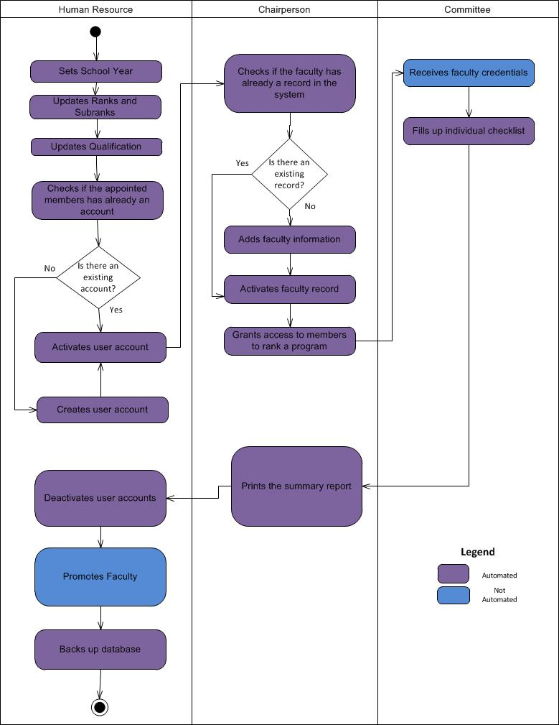

Figure 1.8 *Activity Diagram of the Proposed Ranking and Promotion System*

*Context Level Data Flow Diagram*

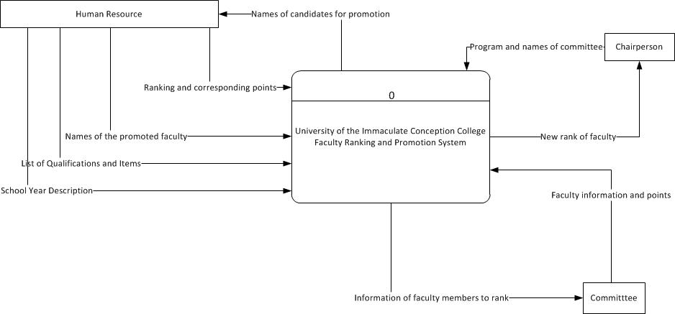

Figure 1.9 *Context Level Data Flow Diagram of the Proposed System*

*Level 0 Data Flow Diagram*

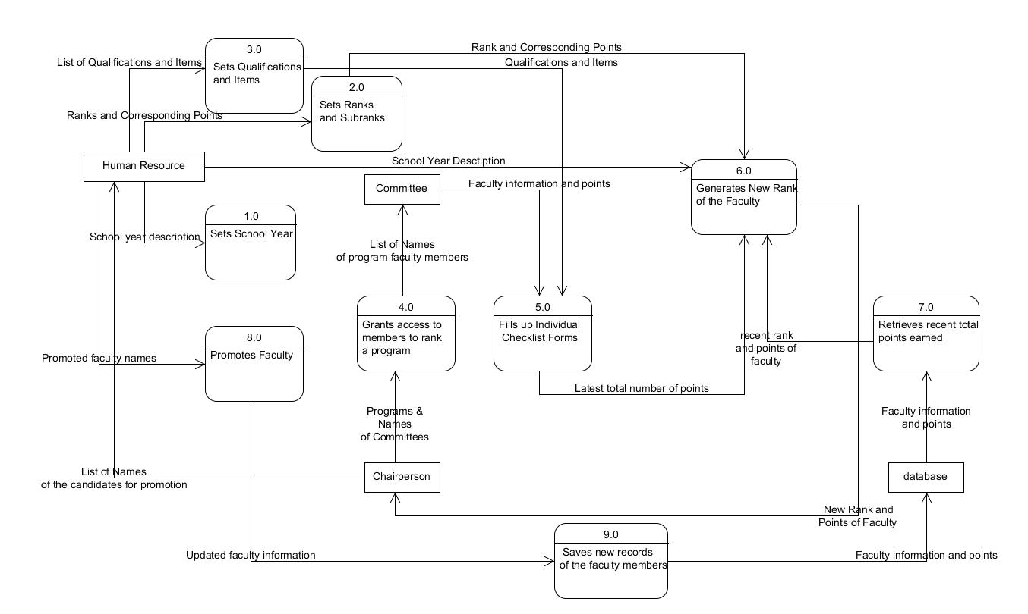Figure 1.10 *Level 0 Data Flow Diagram of the Proposed System*

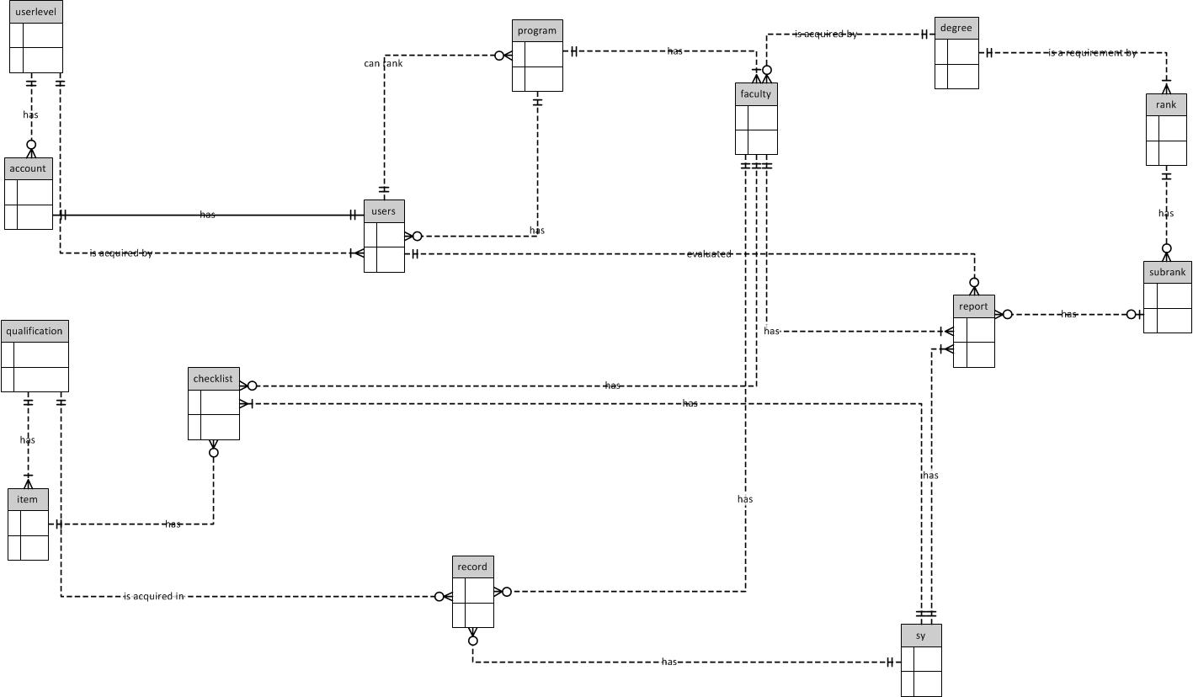**Entity Relationship Diagram**

Figure 1.11 *Context Data Model*

**

Figure 1.11 *Context Data Model*

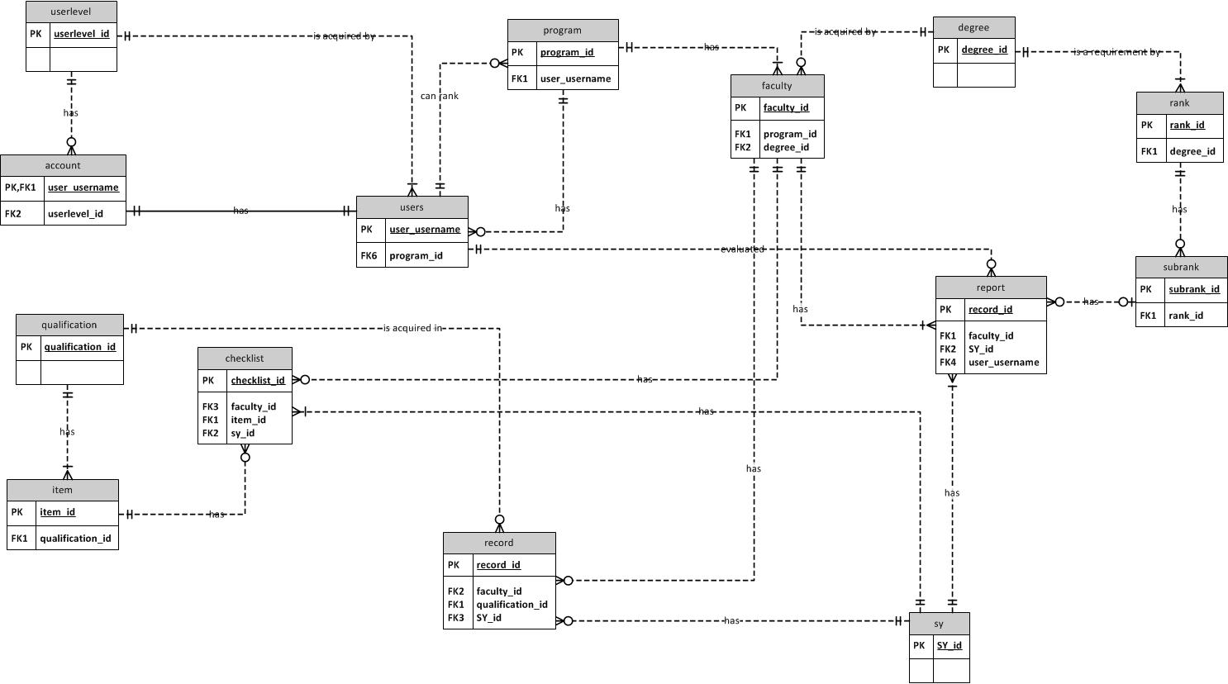Figure 1.12 *Key-based Data Model*

**Figure 1.12 *Key-based Data Model*

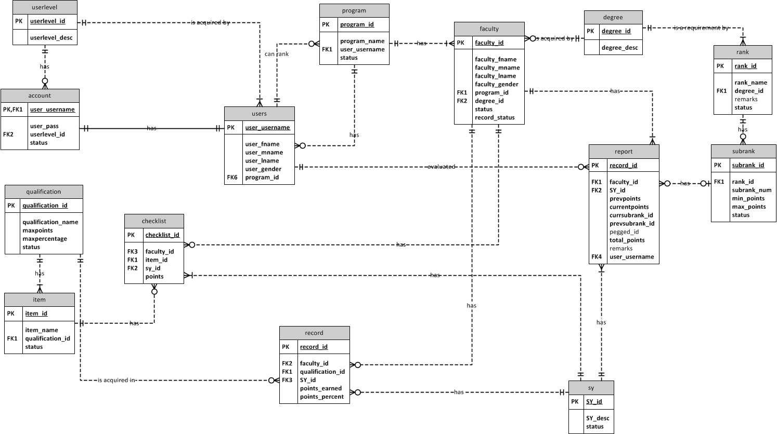Figure 1.13 *Full Attributed Data Model*

**Figure 1.13 *Full Attributed Data Model*

**Data Dictionary**

Data dictionary for the Data Flow Diagram

1. Setting of School Year

Description

The Human Resource sets current school year for the ranking.

Output Flows:

Current SchoolYear

1. Setting Qualification & Items

Description

The Human Resource sets qualification and items for the ranking.

Input Flows:

Qualification

Items

Output Flows:

List of Items

1. Setting Ranks and Subranks

Description

The Human Resource sets ranks and subranks for the ranking.

Input flows:

Faculty Rank

Sub Rank

Corresponding Points

Minimum Educational Qualification

Output flows:

Ranks and Subranks

1. First Checking

Description

The Human Resource checks if his/her appointed Committees have his/her account in the system.

Input flows:

Committee names

Output flows:

If Committee has no accounts proceed create account. Else, proceed to first activation

1. Account Creation

Description

The Human Resource creates an account for his/her chairperson/committees.

Input flows:

First Name

Middle Name

Last Name

Gender

User Level

Program Belongs to

Program to Rank

Username

Password

Status

Output flows:

Chairperson/Committee information

1. First Activation

Description

The Human Resource activates his/her chairperson and committees.

Input flows:

Chairperson/Committee names

Output flows:

Committee Status

1. Second Checking

Description

The chairperson checks if his/her faculty members has a record in the system.

Input flows:

Faculty Name

Output flows:

If faculty has records in the system, activate faculty member. Else, Add faculty Information

1. Fill-Up Information

Description

The chairperson fill ups the information about the faculty to rank.

Input flows:

First Name

Middle Name

Last Name

Gender

Program

Qualification

Status

Output flows:

Faculty information’s

1. Assignment

Description

The Chairperson assigns his/her members to rank a program.

Input flows:

Committee names

Program to rank

Output flows:

Committee names

Program to rank

Faculty records of the department assigned to rank

1. Receiving

Description

The committee receives his/her program to rank

Input flows:

Faculty Records

Output flows:

Faculty Records

1. Fill up

Description

The committee fill ups an individual checklist.

Input flows:

Points earned by the faculty according to given credentials.

Status of the faculty

Output flows:

Summary of points

1. Printing

Description

The Chairperson prints the reports from the given checklist.

Input flows:

Summary of reports

Output flows:

Summary of reports

1. Deactivation

Description

The Human Resource deactivates their accounts.

Input flows:

Username of Chairperson and Committee

Output flows:

Status

1. Promotion

Description

The Human Resource promotes the faculty.

Input flows:

Faculty Summary

Output flows:

New Rank

1. Back Up

Description

The Human Resource backs up the system files.

Input flows:

All Data

Output flows:

All Data

FILES

Checklist

Description

A file containing the faculty members information and credentials.

Location: General Processes ()

Input flows:

Faculty names and credential

Output flows:

Individual checklist

ENTITIES

1. Human Resource

Description

The appointee and the overall head of the chairperson and the committee.

Location: Context Level ()

Input flows:

Creation of account

Promotion of a faculty member

Initiation of revision and proposal

Output flows:

New rank of a faculty member

1. Chairperson

Description

The head of the committee.

Location: Context Level ()

Input flows:

Creation of account

Viewing of checklist

Grants access to members to rank

Output flows:

Summary forms

1. Committee

Description

The appointed six members of the Human Resource.

Location: Context Level ()

Input flows:

Creation of account

Fill up individual checklist

Add faculty information

Output flows:

Recent rank of the faculty

Table 1.11 *Data Dictionary for the Entity Relationship Diagram*

|  |  |
| --- | --- |
| **Entity** | **Business Definition** |
| Human Resource Head | Someone who is in charge of the salaries and ranks of the workforce in a company. |
| Committee | is a type of small deliberative assembly that is usually intended to remain subordinate to another, larger deliberative assembly—which when organized so that action on committee requires a vote by all its entitled members |
| Chairperson | Someone who has the highest officer of an organized group such as a board committee, or deliberative assembly. |

**Part II**

**PROJECT DESCRIPTION**

**Project Title**

The proponents decided that the proposed system will be entitled “University of Immaculate Conception College Full Time Faculty Ranking and Promotion System”.

**Project Organization**

Figure 2.0 *Project Organization*

|  |  |
| --- | --- |
| **ROLE** | **TASKS** |
| Project Manager | The team leader, in charge of the group throughout the entire project, assigned the tasks to the team. |
| System Analyst | The researcher, understood the entirety of the business, in its processes, its problems, and analyses the possible solutions to resolve the problem. |
| System Programmer | Coded the program. |
| Head Documentation | Did the documentation, keeping all necessary documents that are part in creating/building the system. |
| System Tester | Tested the system has no bugs and met the company’s needs. Ensures that the system functions must according to user requirements. |
| System Designer | Designed the system. |
| Database Designer | Designed the database of the system. |

Table 2.0 *Project Organization Tasks Definition*

**Project Methodology**

The proponents used the Waterfall model as the methodology in building the system. This model provides a clear cut template for requirement definition, analysis, design, program development, testing, and implantations. In this model, each phase begins after the preceding phase has been completed. The design of the system will be completed before the program development phase begins. Using this model, it allows the project manager to schedule the different phases and their activities more confidently as there is little iteration and rework allowed.

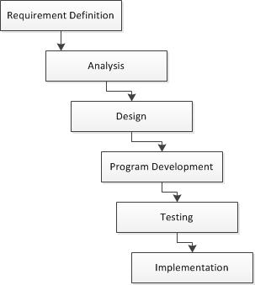

Figure 2.1 *Waterfall Model Design Process*

The waterfall model is a sequential one, consisting of the following process areas:

* Requirement Definition
  + The proponents gathered and analyzed all the necessary data and information, to produce a complete and unambiguous specification of what the system is required to do.
* Analysis
  + The proponents conducted series of meetings to discuss the software architecture of the system and they identify the components within the software and relationship between the components.
* Design
  + The proponents allotted time for meetings to discuss the detailed implementation of each component that is specified and come up with a design of the software such as the designing the diagrams, interface and the database required for the implementation of the proposed system.
* Program Development
  + In this phase, the proponents had already gathered and discussed the language to be used in building the system then proponents decided to choose PHP language as the code generator and MySQL sever for the database.
  + This is also the phase wherein the proponents did the actual implementation such as coding for the system based on the designed diagrams in the design phase.
* Testing
  + The proponents validated and checked system’s result whether it already attained the planned design and projected the correct and accurate results.
* Implementation
  + In the future the proponents will be going to deploy the system and it will be verified by the users. This phase is where the validation of the software rigidly implements the specified requirements.

**Project Schedule**

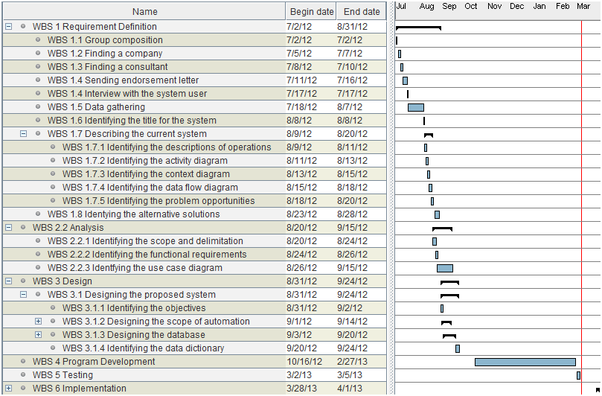

Figure 2.2 *Project Schedule*

**Technology**

During the development of the system, the proponents used the following technologies:

I. System Development

* XAMPP - X (any of four different operating systems), Apache, MySQL, PHP and Perl (XAMPP) for control panel in connecting the Komodo Edit 6 in the database, MySQL server for the database in retrieving and storing the data that is being processed.
* PHP Hypertext Pre-processor (PHP) - an open-source server–side scripting language for Web development that produces dynamic Web pages. The main language used by the proponents in building the system.
* HTML (Hyper Text Manipulating Language) – a markup language used by the proponents’ in creating web pages displayed in the browser.
* CSS (Cascading Style Sheet) – a style sheet language used by the proponents’ in describing the presentation of the look and formatting of the web pages.
* JQuery (Javascript Query) – a Javascript library used by the proponents’ in simplifying the client side scripting of HTML.
* CodeIgniter - a web development framework which serves as a toolkit to minimize the amount of code needed for the given task.
* Pdf (Portable Document Format) - for the printout of the generated reports and list of each and every data needed of the Ranking and Promotion.
* Komodo Edit 7 – an open-source and free code editor wherein the proponents coded the system.

II. System Documentation

* UMLet (Unified Modeling Language) – an open-source UML tool used by the proponents’ in creating the diagrams.
* Microsoft Word 2007 – word processor designed by the Microsoft, the proponents used this application in documenting the system.
* Microsoft Visio 2010 – in lay-outing data models of the database design the proponents used 2D-object drawing application.
* Gantt Project – a free desktop schedule management tool used by the proponents in making their schedules.

III. System Design

* My Structured Query Language (MySQL) server 5.0 – serves as the database management system in building the system. It is where all the data is stored and retrieved by the system.
* Adobe CS5 Photoshop – a graphics editing program developed and published by the Adobe System which is used by the proponents’ in designing the graphics and images used in the system.

VI. Presentation

* Microsoft Powerpoint 2007 – presentation program developed by Microsoft used by the proponents in presenting their proposal.
* Prezi – in the final presentation, the proponents’ will use this cloud based presentation program tool.

V. File Transfer/Sharing

* Dropbox – a file hosting service operated by Dropbox Inc. used by the proponents in sharing the files for a faster and efficient development.
* Tortoise SVN – during the system coding, the proponents used this subversion client for fasting coding.

VI. System Deployment

* PHP Cloud – a free cloud development environment to be used by the proponents’ during the deployment of the system.

For the hardware requirements, the system will be in need of a set of computers with an operating system of at least Windows XP or a higher and a minimum of 512 RAM. The system also needs a minimum of 10GB hard disk free space.

The proponents believed that by the use of the applications mentioned above, it will support all the functionalities of the system that is being targeted by the proponents.

**Part III**

**SYSTEM ACCEPTANCE AND TRAINING**

User Acceptance Testing (UAT)

During the course of the study, the proponents conducted an interview to one of the committees of the Ranking and Promotion to know the process of their current system and how to be able to help them make the flow of the ranking much easier.

Based on the information gathered by the proponents, the problems encountered are the following:

* Slow in terms of processing the computations of the points earned by each faculty that is being ranked.
* There is a high risk of inaccuracy in generating reports.
* Usage of papers is voluminous.
* Security and confidentiality of the data store is not prioritized.

From the identified problems, the proponents decided to help the Ranking and Promotion Committee members to change their system by making it automated and hassle free.

After the acceptance of the proposed system, all of the data are gathered to know the needed requirements of the Ranking and Promotion members in order to attain the smooth transactions of ranking system.

To confirm that the functions of the proposed system have been developed correctly, a User Acceptance Testing (UAT) has been conducted. The following test cases were used:

Functional Requirements Test Cases

1. **Account Management**  a. Successfully Log-in

b. Identification of the User

c. Successfully Log-out

d. Update User Account Information

1. **Human Resource Level** a. User management
2. Add User
3. Search User

**iii.** View User

1. Update User

2.Activate/Deactivate User

b. Faculty management

1. Add Faculty
2. View Faculty

**iii.** Update Faculty

1. Activate / Deactivate Faculty Records

**iv.** Search Faculty

c. Program Management

1. Add Program
2. View Program Information

1. Update Program

d. Qualification Management

1. Add Qualification
2. Search Qualification
3. View Qualification
4. Update Qualification
5. View Item information
6. Update Item
7. Remove Item
8. Add Item
9. Remove Qualification
10. Print List of Qualification

e. School year management

1. Add School Year
2. View School Year
3. Set School Year

f. Ranking management

1. Add Rank
2. Search Rank
3. View Rank
4. Update Rank
5. View Sub Rank
6. Update Sub-Rank
7. Remove Sub Rank
8. Add Sub Rank
9. Remove Rank
10. Print List of Ranks

g. Data management

1. Search Faculty Records
2. View Faculty Records
3. Print Faculty Records
4. Update Faculty Records

**iii.** Generate Summary Reports

1. View Individual Records
2. Print Individual Reports
3. Update Faculty Reports
4. Search Reports

h. Others

1. Back Up Database

**3.** **Chairperson Level**

1. User management
2. View User
3. Assign Committee
4. Search User
5. Faculty management
6. Add Faculty
7. View Faculty
8. Update Faculty
9. Activate/Deactivate Faculty Records

**iii.** Search Faculty

1. Data management
2. Fill Up checklist.
3. Search Faculty records
4. View Faculty Records
5. Update Faculty Records
6. Prints Faculty Records
7. Generate Report
8. View Individual Report
9. Print Summary Report
10. Print Individual Report
11. Search Report
12. Update Report

d. Others

1. Back-Up Files

**4. Committee Level**

1. Data management
2. Fill-Up Checklist
3. Search Faculty Records

**iii.** View Faculty Records

1. Update Faculty Records
2. Prints Faculty Records

**iv.** Generate Reports

1. View Individual Report
2. Print Summary Report
3. Search Report
4. Update Report
5. Print Individual Report

Each of the test cases was examined and all the results were noted. Table 3.0 shows the results of the User Acceptance Testing (UAT) for Human resource Level.

**Human Resource Level**

User Acceptance and Testing

| Test Case # | Tested By: | Test Date | Expected Outcome | Actual Outcome | Remarks |
| --- | --- | --- | --- | --- | --- |
| 1.a | Mr. Exander T. Barrios | March 5, 2013 | The user should able to login  Human Resource, Chairperson or Committee. | **OK** |  |
| 1.b |  |  | To identify the user level of the logged-in user. | **OK** |  |
| 1.c |  |  | To be able to log out from the system. | **OK** |  |
| 1.d |  |  | To be able to edit information on user account. | **OK** |  |
| 2.a.i |  |  | To be able to add user information in the database. | **OK** |  |
| 2.a.ii |  |  | To be able to search a user using his/her last name. | **OK** |  |
| 2.a.iii |  |  | To be able to view list of names and information about the users. | **OK** |  |
| 2.a.iii.1 |  |  | To be able to update user profile information. | **OK** |  |
| 2.a.iii.2 |  |  | To be able to activate/deactivate user account. | **OK** |  |
| 2.b.i |  |  | To be able to add faculty information in the database. | **OK** |  |
| 2.b.ii |  |  | To be able to view list of faculty information. | **OK** |  |
| 2.b.ii.1 |  |  | To be able to update the information of a faculty. | **OK** |  |
| 2.b.ii.2 |  |  | To be able to activate/deactivate a faculty’s record. | **OK** |  |
| 2.b.iii |  |  | To be able to search a faculty using program name or faculty’s last name. | **OK** |  |
| 2.c.i |  |  | To be able to add program name in the database. | **OK** |  |
| 2.c.ii |  |  | To be able to view list of program names. | **OK** |  |
| 2.c.ii.1 |  |  | To be able to edit information about the program. | **OK** |  |
| 2.d.i |  |  | To be able to add qualification information in the database. | **OK** |  |
| 2.d.ii |  |  | Manage to search qualification from the system. | **OK** |  |
| 2.d.iii |  |  | To be able to view list of qualifications’ information. | **OK** |  |
| 2.d.iii.1 |  |  | To be able to edit a qualification’s information. | **OK** |  |
| 2.d.iii.2 |  |  | To be able to view the list of items of a qualification. | **OK** |  |
| 2.d.iii.2.a |  |  | To be able to edit information about an item. | **OK** |  |
| 2.d.iii.2.b |  |  | To be able to remove an item when selected. | **OK** |  |
| 2.d.iii.2 |  |  | To be able to add information about an item. | **OK** |  |
| 2.d.iii.2 |  |  | To be able to remove the selected qualification in the list. | **OK** |  |
| 2.d.iv |  |  | To be able to print a copy of the lists of qualifications. | **OK** |  |
| 2.e.i |  |  | To be able to add school year data. | **OK** |  |
| 2.e.ii |  |  | To be able to view list of school year. | **OK** |  |
| 2.e.iii |  |  | To be able to set the current school year to be used. | **OK** |  |
| 2.f.i |  |  | To be able to add ranking information in the database. | **OK** |  |
| 2.f.ii |  |  | To be able to search a rank from the database. | **OK** |  |
| 2.f.iii |  |  | To be able to view rank information. | **OK** |  |
| 2.f.iii.1 |  |  | To be able to edit rank information. | **OK** |  |
| 2.f.iii.1.a |  |  | To be able to view subrank’s information. | **OK** |  |
| 2.f.iii.1.a.I |  |  | To be able to edit sub rank information. | **OK** |  |
| 2.f.iii.1.b |  |  | To be able to remove sub rank in the list. | **OK** |  |
| 2.f.iii.2 |  |  | To be able to remove the rank from the list. | **OK** |  |
| 2.f.iv |  |  | To be able to print list of ranks from the database. | **OK** |  |
| 2.g.i |  |  | To be able to search a record of a faculty member depending upon the program name, record’s school year or faculty’s last name. | **OK** |  |
| 2.g.ii |  |  | To be able to view the individual checklist of a ranked faculty. | **OK** |  |
| 2.g.ii.1 |  |  | To be able to print a faculty’s individual checklist. | **OK** |  |
| 2.g.iii |  |  | To be able to view and search the summary report depending upon the program name, school year or faculty’s last name. | **OK** |  |
| 2.g.iii.1 |  |  | To be able to view individual report of a ranked faculty member. | **OK** |  |
| 2.g.iii.2 |  |  | To be able to print summary reports. | **OK** |  |
| 2.h.i |  |  | To be able to back up the database. | **OK** |  |

Table 3.0 *UAT Checklist for Human Resource Level*

Each of the test cases was examined and all the results were noted. Table 3.1 shows the results of the User Acceptance Testing (UAT) for Chairperson Level.

**Chairperson Level**

User Acceptance Testing

| Test Case # | Tested By: | Test Date | Expected Outcome | Actual Outcome | Remarks |
| --- | --- | --- | --- | --- | --- |
| 1.a | Mr. Exander T. Barrios | March 5, 2013 | To be able to log in into the system. | **OK** |  |
| 1.b |  |  | To identify the user level of the logged-in user. | **OK** |  |
| 1.c |  |  | To be able to log out from the system. | **OK** |  |
| 1.d |  |  | To be able to edit information on user account. | **OK** |  |
| 3.a.i |  |  | To be able view list of committees. | **OK** |  |
| 3.a.i.1 |  |  | To be able to assign committees to rank a program. | **OK** |  |
| 3.a.ii |  |  | To be able to search a committee. | **OK** |  |
| 3.b.i |  |  | To be able to add a faculty’s information. | **OK** |  |
| Test Case # | Tested By: | Test Date | Expected Outcome | Actual Outcome | Remarks |
| 3.b.ii |  |  | To be able to view the list of names and information of the faculty from the database. | **OK** |  |
| 3.b.ii.1 |  |  | To be able to update information of faculty member. | **OK** |  |
| 3.b.ii.2 |  |  | To be able to activate/deactivate the record status of a faculty member. | **OK** |  |
| 3.b.iii |  |  | To be able to search information and list of faculty members. | **OK** |  |
| 3.c.i |  |  | To be able to fill up the checklist for ranking purposes. | **OK** |  |
| 3.c.ii |  |  | To be able to search a faculty record. | **OK** |  |
| 3.c.iii |  |  | To be able to view list of faculty records. | **OK** |  |
| 3.c.iii.1 |  |  | To be able to edit records of a faculty member. | **OK** |  |
| 3.c.ii.21.a |  |  | To be able to print the individual checklist of a faculty. | **OK** |  |
| 3.c.iv |  |  | To be able to view summary report. | **OK** |  |
| 3.c.iv.1 |  |  | To be able to view individual reports of faculty. | **OK** |  |
| Test Case # | Tested By: | Test Date | Expected Outcome | Actual Outcome | Remarks |
| 3.c.iv.2 |  |  | To be able print summary report. | **OK** |  |
| 3.c.vi.2 |  |  | To be able to print individual report. | **OK** |  |
| 3.d.i |  |  | To be able to back up database. | **OK** |  |

Table 3.1 *UAT Checklist for Chairperson Level*

Each of the test cases was examined and all the results were noted. Table 3.2 shows the results of the User Acceptance Testing (UAT) for Committee Level.

**Committee Level**

User Acceptance Testing

| Test Case # | Tested By: | Test Date | Expected Outcome | Actual Outcome | Remarks |
| --- | --- | --- | --- | --- | --- |
| 1.a | Mr. Exander T. Barrios | March 5, 2013 | To be able to log in into the system. | **OK** |  |
| 1.b |  |  | To identify the user level of the logged-in user. | **OK** |  |
| 1.c |  |  | To be able to log out from the system. | **OK** |  |
| 1.d |  |  | To be able to edit information on user account. | **OK** |  |
| Test Case # | Tested By: | Test Date | Expected Outcome | Actual Outcome | Remarks |
| 4.a.i |  |  | To be able to fill up individual checklist. | **OK** |  |
| 4.a.ii |  |  | To be able to search a faculty’s record. | **OK** |  |
| 4.a.iii |  |  | To be able to view list of faculty who has record for the current school year. | **OK** |  |
| 4.a.iii.1 |  |  | To be able to update a faculty’s record. | **OK** |  |
| 4.a.iii.2 |  |  | To be able to print a faculty’s individual checklist. | **OK** |  |
| 4.a.iv |  |  | To be able to view summary report. | **OK** |  |
| 4.a.iv.1 |  |  | To be able to view individual report. | **OK** |  |
| 4.a.iv.2 |  |  | To be able to print summary report. | **OK** |  |
| 4.a.iv.2 |  |  | To be able to search a faculty’s report. | **OK** |  |

Table 3.2 *UAT Checklist for Committee Level*

**Part IV**

# CONCLUSIONS AND RECOMMENDATIONS

**Conclusion**

Faculty Ranking and Promotion system is way much better tool to use rather than the manual system that they are using, during of ranking the full time faculty member. Since the University composes of more than 128 full time faculty staff, the system is suitable for the following activities by the users during the ranking:

1. Standardized rules in ranking such as:

1. Setting of School Year
2. Updating Qualifications and Items
3. Updating Ranks, its corresponding points and required educational qualification.

2. A secure confidentiality of data through implementing restrictions depending on the user level of a user.

3. Lessened work of the committees and minimized the time consumed while doing the ranking due to automated computations of points and accurate results every after ranking.

5. Easy retrieval of sorted data and storage of records in the database lessens the usage of checklist forms.

6. Generate reports automatically and print accurate reports in the form of Pdf(Portable Document Format) from the points earned by a faculty.

7. Usage of papers is minimized due to the built-in checklist in the system.

The system functionalities are guaranteed working properly and all the functional requirements are met. Furthermore, the system created has a user friendly interface that will be easily manipulated.

**Recommendations**

After the system is implemented and all of the functional requirements were met, the proponents set some recommendations to keep the system useful and optimized for future use. In order to enhance the said system the following requirements are needed:

1. Graphical report by the use of bar graph to monitor the changes ranked faculties each academic year for a clear presentation of changes in a faculty’s rank.
2. Allowing the faculty member to log in into the system using his/her account and have an access to view and monitor his/her records.
3. An SMS application that will send a message to a faculty with his/her newly updated rank every after ranking.
4. Record the logs of the users every time they were logged in into the system.

**APPENDICES**

a.) Letters

b.) Minutes

c.) Survey Questionnaire

d.) User Acceptance and Training Checklist

e.) Sample Checklist Form

f.) Evaluation Comments

g.) Progress Reports

h.) Screen Shots

i.) Curriculum Vitae