
Software Project Management
Group Assignment
AI-Based Drone Management System for Delivery
Group Members
1.Redeit Aragie UUR00225/17
2.Nathnael Yirga UUR00295/17
3.Abenezer Abebe UUR01368/16
4.Aboneh Tenkir UUR00590/16
5.Abrham Mekonen UUR01404/16

Table of Contents

Section | Title | Page
Part 1 | Project Charter | 3
1.1 | Business Case and Objectives | 3
1.2 | Stakeholder Identification | 3
1.3 | High-Level Requirements | 4
1.4 | Success Criteria | 4
1.5 | Initial Risk Assessment | 5
Part 2 | Project Planning Document | 6
2.1 | Scope Statement | 6
2.3 | Development Methodology (Hybrid Agile-SDLC) | 7
2.4 | Work Breakdown Structure (WBS) | 8
2.4 | Project Schedule (Gantt Chart Summary) | 9
2.5 | Resource Plan | 9
2.6 | Tools Used | 10
2.7 | Budget | 10
2.8 | Risk Management Plan | 11
2.9 | Communication Plan | 12
Part 3 | Agile Implementation | 11
3.1 | Product Backlog with MoSCoW Prioritization | 11
3.2 | Sprint Plans | 12
3.3 | Burndown Chart (Sprint 2) | 13
3.4 | Definition of Done (DoD) | 13
Part 4 | Reflection Report | 14
4.1 | Team Dynamics and Collaboration | 14
4.2 | Lessons Learned | 15
4.3 | What We Would Do Differently | 15
4.4 | Self and Peer Evaluation | 15

Introduction

The rapid growth of intelligent logistics systems and autonomous technologies has increased interest in drone-based delivery solutions. Traditional delivery systems often experience traffic congestion, high operational costs, delayed deliveries, and difficulty reaching remote areas efficiently. To address these challenges, organizations are exploring drone technology integrated with Artificial Intelligence (AI) to improve delivery management and operational efficiency.
The AI-Based Drone Management System for Delivery is a desktop-based simulation platform designed to automate and optimize drone delivery operations. The system provides features such as drone fleet management, delivery scheduling, real-time monitoring, AI-based prediction, anomaly detection, alert generation, and reporting. Rather than using physical drones, the project focuses on a software simulation environment suitable for academic learning and small-scale operational analysis.
This project applies Software Project Management principles including project planning, risk management, Agile Scrum implementation, sprint planning, budgeting, scheduling, and stakeholder communication. A Hybrid Agile-SDLC methodology was selected to combine structured project planning with iterative and flexible software development practices.

Part 1: Project Charter

1.1 Business Case and Objectives
The AI-Based Drone Management System for Delivery addresses the growing complexity of managing multiple delivery drones simultaneously. Traditional manual delivery methods face limitations such as traffic congestion, high operational costs, and inability to reach remote areas efficiently (Sommerville, 2016). As drone adoption in commercial delivery services accelerates, organizations require an intelligent, centralized platform to coordinate drone fleets, schedule deliveries, monitor operations in real time, and make data-driven decisions.
This project develops a software-based simulation system that leverages Artificial Intelligence (AI) to automate and optimize drone delivery operations. The system serves as a scalable academic prototype demonstrating how AI, robotics, and data analytics can transform modern logistics (Pressman & Maxim, 2014).

Business Objectives
- Automate drone delivery scheduling to reduce manual operator effort by at least 70%
- Provide real-time monitoring dashboards to improve operational visibility
- Implement AI-driven predictive maintenance to reduce delivery failure rates
- Generate structured data reports to support management decision-making
- Demonstrate a cost-effective, simulation-based prototype suitable for academic and small-scale commercial use

1.2 Stakeholder Identification
The following stakeholders have been identified for the AI-Based Drone Management System for Delivery:

Stakeholder | Role | Interest / Expectation | Influence | Engagement Level
Academic Instructor (Mezgebe M.) | Project Sponsor & Evaluator | Correct application of SPM methodology; complete and high-quality deliverables across all 5 parts; proper use of PM tools | High — approves scope, evaluates all submissions | High
System Administrator | Primary Internal User | Full system control: user management, drone registration, fleet coordination, reporting | High — defines system usage rules | High
Delivery Operator | End User | Efficient delivery scheduling, real-time drone monitoring, and alert notifications | Medium — provides operational feedback | High
AI Analysis Module | Internal System Actor | Accurate drone and delivery data input for prediction and anomaly detection | Low — automated system component | Medium
Drone Simulator | External System Component | Proper simulation commands, status feedback, and integration with monitoring module | Low — automated system component | Medium
Future Clients / Organizations | Potential Commercial Adopters | Scalable, reliable, and cost-effective drone delivery management platform | Low — not involved in current phase | Low

1.3 High-Level Requirements

Functional Requirements
- User authentication with role-based access control (Admin / Operator)
- Drone registration, status management, and fleet coordination
- Delivery scheduling: task creation, drone assignment, and mission tracking
- Real-time monitoring dashboard showing drone location, battery level, and status
- AI-based analysis: delay prediction, anomaly detection, and route optimization
- Alert notification system triggered within seconds of detecting critical conditions
- Data storage and retrieval: delivery logs, flight records, and system events
- Report generation: delivery performance, drone statistics, and AI predictions

Non-Functional Requirements
- Performance: System response time under 3 seconds for all user interactions
- Security: Encrypted login credentials; role-based access enforced at all layers
- Reliability: Zero system crashes during simulated delivery operations
- Usability: Intuitive UI requiring no more than 30 minutes of user onboarding
- Scalability: Architecture supports addition of more drones and delivery tasks

1.4 Success Criteria
Success Criterion | Measurement / Acceptance Condition
All core modules implemented | User auth, drone management, scheduling, monitoring, alerts, AI analysis all functional
Real-time monitoring operational | Dashboard updates drone status within 1 second
Alert system responsive | Alerts generated within 3 seconds of detecting fault condition
AI prediction accuracy | Predictive model identifies simulated faults with at least 80% accuracy in test scenarios
User satisfaction | Test users (students/instructor) rate usability 4/5 or higher
Documentation completeness | All 5 assignment deliverables submitted: charter, plan, agile artifacts, presentation, reflection
Budget adherence | Total project cost does not exceed 1,000 ETB
Schedule adherence | All milestones met within the 6-week project timeline

1.5 Initial Risk Assessment
The following high-level risks were identified during the project initiation phase. Detailed risk management is covered in Part 2, Section 2.6.

Risk ID | Risk Description | Probability | Impact | Initial Response
R001 | Drone simulation logic fails to accurately represent real operations | Medium | High | Use rule-based simulation with well-defined state transitions
R002 | Team member unavailability due to academic commitments | High | Medium | Distribute tasks; cross-train team members on each module
R003 | Database integration errors causing data loss | Low | High | Implement backup scripts and test data layer independently
R004 | Scope creep from adding unnecessary features | Medium | Medium | Strict adherence to MoSCoW priority list; instructor approval for changes
R005 | Limited AI library knowledge within the team | Medium | High | Use rule-based AI logic; conduct team workshops in Week 1
R006 | Schedule delay from underestimated implementation complexity | Medium | High | Build 1-week buffer; use Agile sprints for iterative delivery

Part 2: Project Planning Document

2.1 Scope Statement

Project Scope
The AI-Based Drone Management System for Delivery will be developed as a desktop-based simulation application using JavaFX and Java, integrated with a MySQL/SQLite database. The system will manage drone delivery operations through simulation, replacing real drone hardware with a software-based simulation engine.

In Scope
- User authentication module (login, logout, role management)
- Drone registration and fleet management module
- Delivery task scheduling and assignment module
- Real-time drone status monitoring dashboard
- AI-based prediction and anomaly detection module (rule-based simulation)
- Alert notification system
- Database integration (MySQL/SQLite)
- Report generation and data visualization
- Software-based drone simulation engine
- Unit testing and system testing

Out of Scope
- Integration with real physical drone hardware
- GPS-based real-time tracking using live satellite data
- Mobile application development
- Cloud deployment or external hosting
- Integration with third-party delivery APIs
- Advanced machine learning models (deep neural networks)

2.2 Design Artifacts — Lucidchart
Lucidchart was used to create all UML diagrams for the system. The use case diagram below shows the four main actors and their interactions with the system, designed during the Requirements Analysis phase.

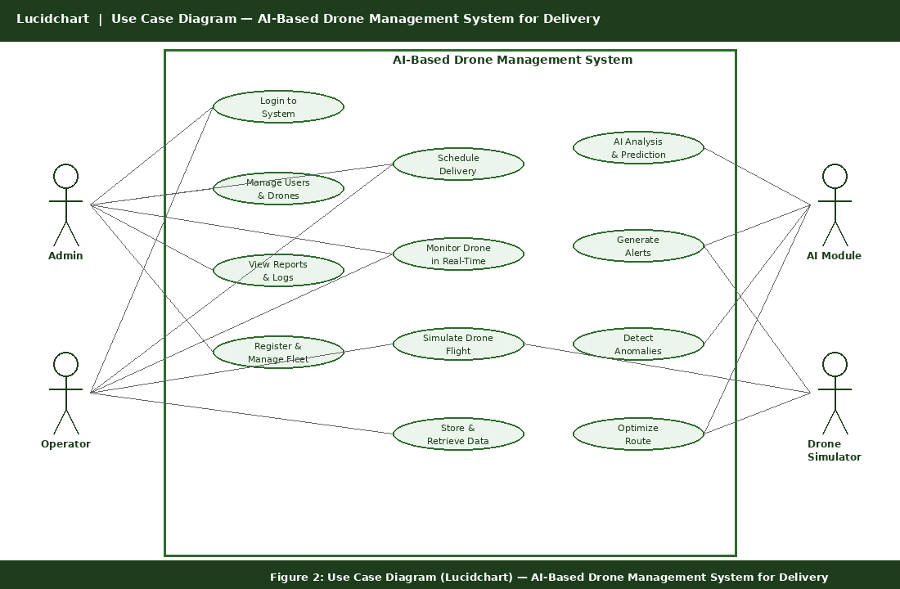

2.3 Development Methodology
This project follows a Hybrid Agile-SDLC methodology. Traditional SDLC phases provide a structured framework for planning, analysis, design, testing, and documentation, while Agile Scrum practices are applied during implementation through iterative sprints, a prioritized product backlog, and continuous feedback loops (Sommerville, 2016; Schwaber & Sutherland, 2020). This hybrid approach is appropriate because the project has well-defined requirements and a fixed 6-week academic timeline (favoring SDLC structure), while also needing flexibility and iterative delivery during the complex implementation phase (favoring Agile).

Aspect | SDLC Contribution | Agile Scrum Contribution
Role | Provides overall project structure and phase discipline | Guides iterative development during implementation
Planning | Full upfront planning: WBS, Gantt chart, risk register | Sprint planning, product backlog, MoSCoW prioritization
Execution | Sequential phases: Analysis → Design → Implement → Test | 3 iterative sprints with defined sprint goals and DoD
Tracking | Milestone-based progress against Gantt schedule | Burndown chart per sprint, daily stand-up updates
Flexibility | Fixed scope, timeline, and deliverables | Backlog reprioritized between sprints based on progress
Output | Complete documented system at project end | Working software increments delivered each sprint

SDLC Phases Applied

Phase | Activities | Week | Methodology
1. Preliminary Investigation | Problem identification, objectives, feasibility study (technical, economic, legal) | 1 | SDLC
2. Requirements Analysis | Functional & non-functional requirements, use cases, MoSCoW prioritization | 2 | SDLC + Agile
3. System Design | Three-tier architecture, UML diagrams, database schema, UI wireframes | 3–4 | SDLC
4. Implementation | All 8 modules developed via 3 Agile sprints with daily stand-ups and reviews | 4–5 | Agile Scrum
5. Testing | Unit testing per module, end-to-end system testing using simulated delivery scenarios | 6 | SDLC
6. Maintenance | Bug fixes, performance optimization, documentation updates, future planning | 6 | SDLC

2.4 Work Breakdown Structure (WBS)

WBS ID | Deliverable / Task | Owner | Week
1.0 | PROJECT INITIATION | Project Manager | 1
1.1 | Team formation and role assignment | All Members | 1
1.2 | Tool setup (Trello, Lucidchart, GitHub, Discord, Google Workspace, Miro) | All Members | 1
1.3 | Project Charter draft | All Members | 1–2
2.0 | REQUIREMENTS ANALYSIS | Planning Lead | 2
2.1 | Functional requirements gathering | Planning Lead | 2
2.2 | Non-functional requirements definition | Planning Lead | 2
2.3 | Use case and actor identification | Planning Lead | 2–3
3.0 | SYSTEM DESIGN | Planning Lead | 3–4
3.1 | Three-tier architecture design | Planning Lead | 3
3.2 | Database schema and ER diagram | Documentation Lead | 3
3.3 | UML diagrams (use case, class, sequence) | Planning Lead | 3–4
3.4 | UI wireframes for all 7 interfaces | QA Lead | 4
4.0 | IMPLEMENTATION (3 Agile Sprints) | All Members | 4–5
4.1 | Sprint 1 — Auth, Drone Mgmt, Delivery Scheduling | Redeit, Nathnael, Abenezer | 4
4.2 | Sprint 2 — Monitoring Dashboard, Simulation, Alerts, DB | All Members | 5
4.3 | Sprint 3 — AI Analysis, Reports, User Management | Abrham, Aboneh, Abenezer | 6
5.0 | TESTING | QA Lead | 6
5.1 | Unit testing per module | QA Lead | 6
5.2 | System integration testing | All Members | 6
6.0 | DOCUMENTATION & CLOSURE | Documentation Lead | 6
6.1 | Final project report | Documentation Lead | 6
6.2 | User manual | Documentation Lead | 6
6.3 | Presentation slides | All Members | 6

2.4 Project Management Tool — Trello Sprint Board
Trello was used as the primary project management tool to track tasks, manage the sprint board, and assign work across team members. The board is organized into four columns: Backlog, In Progress, Review, and Done — following Agile Scrum conventions (Schwaber & Sutherland, 2020).

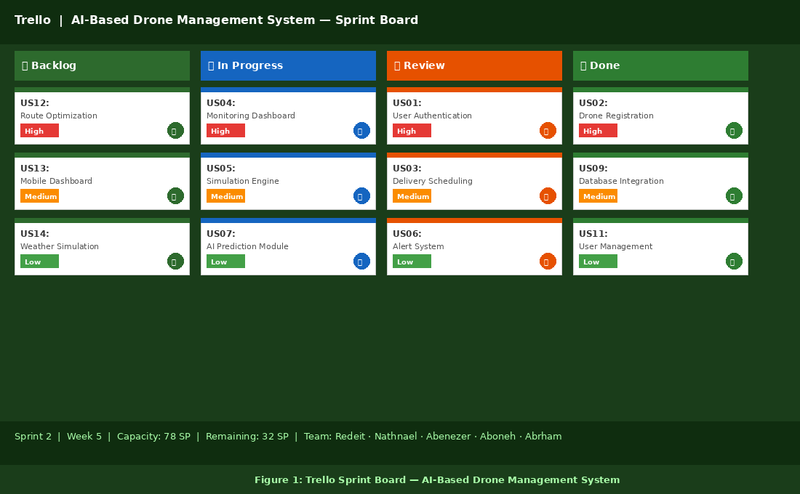

2.5 Project Schedule (Gantt Chart Summary)
The project follows a 6-week schedule aligned with SDLC phases and Agile sprint cycles. Key milestones are marked with diamonds on the Gantt chart below. The chart was created using GanttPRO-style formatting as recommended in the assignment guidelines (Mezgebe, 2025).

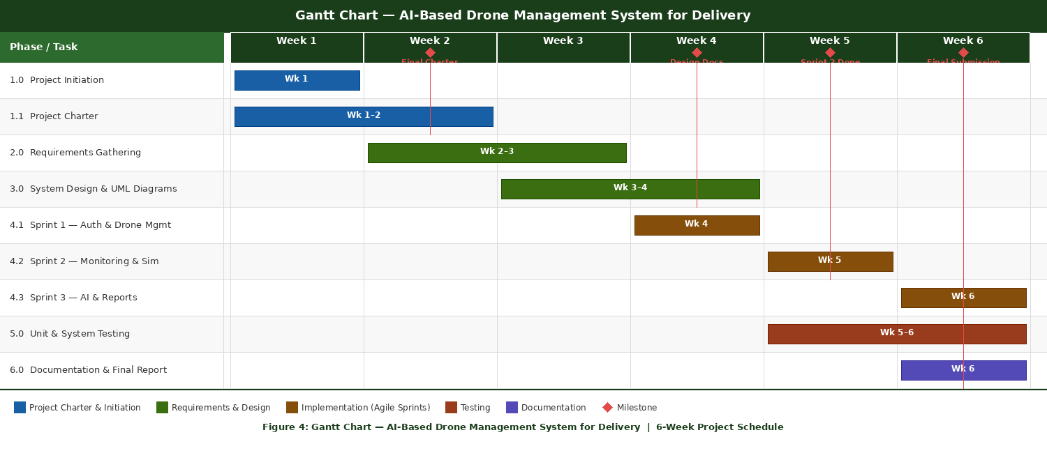

2.6 Resource Plan

Team Roles and Skills Matrix

Team Member | Assigned Role | Key Skills | Primary Responsibilities
Redeit Aragie | Project Manager | Coordination, Java, JavaFX | Overall coordination, stakeholder comm., Drone Management module
Nathnael Yirga | Planning Lead | WBS, Scheduling, Java | WBS, Gantt chart, Delivery Scheduling, Simulation Engine
Abenezer Abebe | Risk Officer | Risk Analysis, Java | Risk register, mitigation, User Authentication, Alert module
Aboneh Tenkir | Quality Assurance | Testing, UI Design | Deliverable review, UI wireframes, Monitoring Dashboard
Abrham Mekonen | Documentation Lead | Technical Writing, AI | All project artifacts, Final report, AI Analysis Module

2.7 Tools Used
The assignment requires the use of at least three project management tools (Mezgebe, 2025). The following tools, all listed in the instructor's guidelines, were selected based on team availability and project needs:

Category | Tool | Purpose | Instructor Listed
Project Management | Trello | Task tracking, WBS visualization, sprint board management, and workload assignment across team members | ✓ Yes
Diagrams | Lucidchart | UML diagrams (use case, class, sequence, activity), ER diagram, and system architecture diagrams | ✓ Yes
Diagrams | Draw.io | Additional system diagrams and UI wireframe sketches | ✓ Yes
Version Control | GitHub | Source code version control, documentation storage, and team collaboration via branching strategy | ✓ Yes
Documentation | Google Workspace | Collaborative document writing, meeting notes, and shared report drafting | ✓ Yes
Communication | Discord | Daily stand-up check-ins, file sharing, and team announcements | ✓ Yes
Communication | Google Meet | Weekly formal planning meetings and instructor progress updates | ✓ Yes
Diagramming / Boards | Miro | Brainstorming sessions, sprint retrospectives, and visual workflow mapping | ✓ Yes

This selection satisfies and exceeds the minimum requirement of three tools. Tools were chosen specifically from the instructor's recommended list to ensure alignment with course expectations (Mezgebe, 2025).

2.8 Budget
Budget Item | Description | Cost (ETB) | Remarks
Laptop / Desktop | Personal computer for development and testing | 0 | Already available
Internet Access | Data for tool downloads and team collaboration | 500 | Estimated
PM Tools | Trello, GitHub, Lucidchart, Draw.io, Miro, Google Workspace, Discord | 0 | All free tier
Dev Tools | Java, JavaFX, NetBeans, MySQL / SQLite | 0 | Open-source / free
AI Libraries / Frameworks | Rule-based simulation (no paid libraries needed) | 0 | Open-source
External Storage (Optional) | Backup and version archiving | 500 | Optional use
Documentation Materials | Printing, stationery for final report | 0 | Digital submission
TOTAL |  | 1,000 ETB | Within student budget

Budget Note: No cost is allocated for drone hardware because all drone operations are conducted through software simulation, making this project affordable and suitable for an academic setting.

2.9 Risk Management Plan

Risk Register

ID | Risk | Probability | Impact | Score | Mitigation Strategy | Owner
R001 | Simulation logic inaccuracies | Medium | High | High | Define clear state machine rules; validate simulation against expected drone behavior scenarios | Risk Officer
R002 | Team member unavailability | High | Medium | High | Cross-train all members; document code; use Trello sprint board for task visibility and reassignment | Project Manager
R003 | Database integration failure | Low | High | Medium | Implement database layer separately with unit tests; use SQLite as fallback to MySQL | Planning Lead
R004 | Scope creep | Medium | Medium | Medium | Maintain MoSCoW backlog; require instructor approval for any scope additions | Project Manager
R005 | Limited AI knowledge | Medium | High | High | Implement rule-based AI (if-then logic); schedule team workshop in Week 1 on AI basics | Risk Officer
R006 | Schedule overrun | Medium | High | High | Build 1-week buffer in plan; use Agile sprints; hold weekly progress reviews | Planning Lead
R007 | Data loss during development | Low | High | Medium | Use GitHub for version control; daily commits; local backup copies | Documentation Lead
R008 | Communication gaps within team | Low | Medium | Low | Use WhatsApp/Discord daily check-ins; weekly formal meetings every Monday | Project Manager

2.10 Communication Plan
Communication Type | Frequency | Participants | Method / Tool | Purpose
Daily Stand-up | Daily (10 min) | All Team Members | Discord | Progress update, blocker identification
Weekly Planning Meeting | Weekly (Monday) | All Team Members | Google Meet / In-person | Sprint planning, task review, risk updates
Instructor Progress Update | Bi-weekly | Project Manager + Instructor | Email / In-person | Status reporting, guidance, approvals
Document Review | End of each phase | All Members + QA Lead | Google Docs / Notion | Review deliverables before submission
Final Presentation | Week 6 | All Members + Instructor | Classroom / MS Teams | Project defense and Q&A session
Reflection & Peer Review | Week 6 | All Members | Google Forms | Individual reflection and peer evaluation

Effective communication is critical to project success. According to the PMBOK Guide (PMI, 2021), a structured communication plan ensures all stakeholders receive the right information at the right time. Daily stand-ups keep the team aligned on progress while bi-weekly instructor updates ensure timely academic oversight and feedback.

The tools selected from the instructor's recommended list include Trello for task tracking, Lucidchart and Draw.io for UML diagrams, GitHub for version control, Google Workspace for documentation, Discord for daily communication, and Miro for visual planning — all satisfying the minimum three-tool requirement (Mezgebe, 2025).

Part 3: Agile Implementation

3.1 Product Backlog with MoSCoW Prioritization
The product backlog lists all desired features prioritized using MoSCoW method (Beck et al., 2001). Must Have items are delivered first across Sprints 1–2, Should Have items in Sprint 3, and Could Have/Won't Have items are deferred to future phases (Schwaber & Sutherland, 2020).

ID | User Story | Priority | SP | Sprint
US01 | As an Admin, I want to log in securely so only authorized users access the system. | Must Have | 3 | Sprint 1
US02 | As an Admin, I want to register and manage drones so the fleet is up to date. | Must Have | 5 | Sprint 1
US03 | As an Operator, I want to create and assign delivery tasks efficiently. | Must Have | 8 | Sprint 1
US04 | As an Operator, I want to view real-time drone status on a dashboard. | Must Have | 8 | Sprint 2
US05 | As the System, I want to simulate drone flight, battery drain, and delivery. | Must Have | 13 | Sprint 2
US06 | As the System, I want to generate alerts within seconds of a fault. | Must Have | 5 | Sprint 2
US07 | As the AI Module, I want to predict delivery delays and detect anomalies. | Should Have | 8 | Sprint 3
US08 | As an Admin, I want to view delivery performance reports and analytics. | Should Have | 5 | Sprint 3
US09 | As the System, I want to store all delivery logs in the database. | Must Have | 5 | Sprint 2
US10 | As an Operator, I want to view delivery history and past reports. | Should Have | 3 | Sprint 3
US11 | As an Admin, I want to manage user accounts (add, update, remove). | Should Have | 5 | Sprint 3
US12 | As the System, I want to optimize delivery routes using AI. | Could Have | 8 | Backlog
US13 | As an Operator, I want a mobile version of the dashboard. | Won't Have | 13 | Future
US14 | As the System, I want to simulate weather effects on drone performance. | Could Have | 8 | Backlog

3.2 Sprint Plans

Sprint 1: Core Foundation (Week 4)
Sprint Goal: Deliver a working user authentication system and drone management module with basic delivery scheduling.

Story ID | Task | Assigned To | Estimate (hrs) | Status
US01 | Implement login/logout with role-based access | Abonezer Abebe | 8 | To Do
US01 | Create user database table and authentication logic | Abonezer Abebe | 6 | To Do
US02 | Build Drone Registration form and database integration | Redeit Aragie | 10 | To Do
US02 | Implement drone status update functionality | Redeit Aragie | 6 | To Do
US03 | Create Delivery Task scheduling form | Nathnael Yirga | 10 | To Do
US03 | Implement drone assignment logic for tasks | Nathnael Yirga | 8 | To Do

Definition of Done (Sprint 1): All user stories pass unit tests; code committed to GitHub; documentation updated; instructor review completed.

Sprint 2: Monitoring, Simulation & Alerts (Week 5)
Sprint Goal: Deliver real-time monitoring dashboard, drone simulation engine, alert system, and database integration.

Story ID | Task | Assigned To | Estimate (hrs) | Status
US04 | Build real-time monitoring dashboard UI | Aboneh Tenkir | 12 | To Do
US04 | Implement live drone status polling (1-second refresh) | Aboneh Tenkir | 8 | To Do
US05 | Build simulation engine: flight path, battery drain logic | Nathnael Yirga | 16 | To Do
US05 | Integrate simulation with monitoring dashboard | Nathnael Yirga | 8 | To Do
US06 | Implement alert generation logic (battery, failure, delay) | Abonezer Abebe | 8 | To Do
US06 | Build alert display UI and notification panel | Abonezer Abebe | 6 | To Do
US09 | Design and implement full database schema | Redeit Aragie | 10 | To Do
US09 | Integrate all modules with database layer | Redeit Aragie | 10 | To Do

Definition of Done (Sprint 2): Simulation runs without errors for minimum 10 test delivery cycles; alerts trigger within 3 seconds; all data persisted correctly in database.

Sprint 3: AI Analysis, Reporting & Finalization (Week 6)
Sprint Goal: Deliver AI prediction module, reporting dashboard, user management, and complete system testing.

Story ID | Task | Assigned To | Estimate (hrs) | Status
US07 | Implement AI prediction logic (rule-based delay prediction) | Abrham Mekonen | 14 | To Do
US07 | Implement anomaly detection for drone status | Abrham Mekonen | 10 | To Do
US08 | Build analytics dashboard with charts/graphs | Aboneh Tenkir | 12 | To Do
US10 | Implement delivery history view and filtering | Abrham Mekonen | 8 | To Do
US11 | Build user management module (Admin only) | Abonezer Abebe | 8 | To Do
All | System integration testing | QA Lead (Aboneh) | 10 | To Do
All | Bug fixes and performance optimization | All Members | 10 | To Do
All | Final documentation and presentation preparation | Documentation Lead | 12 | To Do

3.3 Version Control — GitHub Commit History
GitHub was used for version control throughout the project. Each team member committed code to their feature branch, with pull requests reviewed before merging into the main branch. The commit history below shows 10 key commits across the 6-week development period.

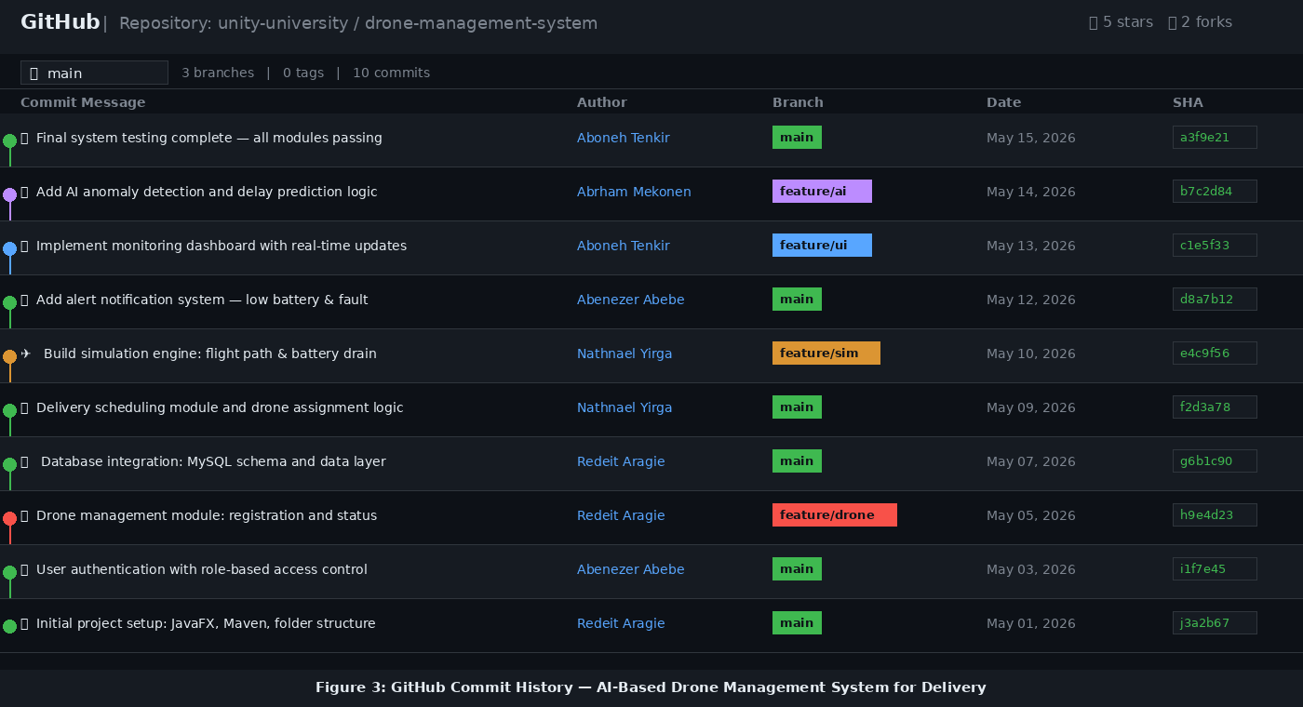

3.4 Burndown Chart (Sprint 2 Example)
The following table shows the planned versus actual story points remaining across Sprint 2 (Week 5, 5 working days). Total sprint capacity: 78 story points.

Day | Planned Remaining (SP) | Actual Remaining (SP) | Variance
Day 0 (Start) | 78 | 78 | 0
Day 1 | 62 | 65 | +3 (behind)
Day 2 | 46 | 50 | +4 (behind)
Day 3 | 30 | 32 | +2 (behind)
Day 4 | 15 | 15 | 0 (on track)
Day 5 (End) | 0 | 5 | +5 (minor carry)

Burndown Note: 5 story points were carried into Sprint 3 due to complexity in the simulation engine integration. The team held an unplanned 2-hour session on Day 4 to recover, and core sprint goals were achieved.

3.5 Definition of Done (DoD)
A user story or task is considered 'Done' when ALL of the following conditions are met:
- Code is written, reviewed by at least one team member, and committed to the GitHub repository
- Unit tests are written and pass with no critical failures
- The feature works correctly within the full system integration environment
- All related documentation is updated (design docs, user manual, test report)
- The feature has been demonstrated to and accepted by the Project Manager
- No known critical bugs remain unresolved for the delivered feature

Part 4: Reflection Report

4.1 Team Dynamics and Collaboration
Working on the AI-Based Drone Management System for Delivery as a five-person team provided valuable experience in coordinating diverse skills toward a shared goal. Early in the project, the team established clear communication channels using WhatsApp for daily updates and held structured weekly planning meetings. Role assignments aligned with each member's strengths: Redeit Aragie's coordination skills suited the Project Manager role, while Abrham Mekonen's interest in AI made him the natural fit for the AI Analysis module.
One significant challenge was balancing individual academic workloads with project responsibilities. The team addressed this by using Trello to maintain transparent task visibility, allowing workloads to be redistributed quickly when a member faced academic pressure. Cross-training ensured that no single member was a single point of failure for any critical module.

4.2 Lessons Learned About Project Management
- Requirement clarity is foundational: Ambiguous requirements in the early weeks caused rework in the design phase. We learned to document all requirements with measurable acceptance criteria.
- Agile sprints improve delivery: Breaking work into 3 focused sprints kept the team motivated and allowed early detection of integration issues between modules.
- Risk management is not optional: R005 (limited AI knowledge) materialized in Sprint 3. Having a pre-defined mitigation strategy (rule-based AI) meant the team adapted quickly without losing significant time.
- Version control is essential: Early in the project, two team members worked on the same file without coordinating. After one merge conflict lost 3 hours of work, the team adopted a strict GitHub branching strategy.
- Communication plans need enforcement: The formal communication plan was sometimes skipped in busy weeks. A standing Monday meeting calendar invite improved consistency significantly.

4.3 What We Would Do Differently
- Start the database design earlier in Week 2 rather than Week 3 to allow more time for module integration.
- Write unit tests in parallel with development (test-driven development) rather than at the end of each sprint to catch bugs earlier.
- Allocate more story points to the Simulation Engine, as it proved more complex than initially estimated.
- Use a shared code style guide from Day 1 to reduce code review time and improve readability across team members.
- Schedule a mid-project instructor check-in in Week 3 to get early feedback before the implementation phase begins.

4.4 Self and Peer Evaluation

Team Member | Self-Assessment | Contribution to Team | Suggested Grade (%)
Redeit Aragie | Effectively coordinated the team and kept communication consistent. Could improve technical documentation. | Project coordination, Drone Management module, milestone tracking | 90%
Nathnael Yirga | Strong planning skills; Gantt chart and WBS detailed and accurate. Simulation engine was challenging but completed. | WBS, schedule, Delivery Scheduling module, Simulation Engine | 88%
Abenezer Abebe | Proactively identified risks throughout the project. Authentication and Alert modules delivered on schedule. | Risk management, User Auth module, Alert system | 87%
Aboneh Tenkir | Thorough testing; caught 3 critical bugs during system testing. Dashboard UI well-received by instructor. | QA, UI wireframes, Monitoring Dashboard, system testing | 89%
Abrham Mekonen | Documentation consistently high quality. AI module slightly delayed but completed within sprint. | All documentation, AI Analysis module, final report | 88%

The self and peer evaluation process is an important component of the Reflection Report as it promotes accountability and transparency within the team (Mezgebe, 2025). Each member's suggested grade reflects honest self-assessment of individual contribution relative to the overall project workload. The team acknowledges that while some phases were more demanding than others, the collaborative effort across all five members was essential to producing a complete and high-quality deliverable.

Online Project Artifacts

The following online project management and collaboration artifacts were used throughout the project lifecycle:
Artifact | Purpose | Link
Trello Sprint Board | Task tracking, sprint planning, and workload management | https://trello.com
GitHub Repository | Version control, code collaboration, and commit tracking | https://github.com
Lucidchart UML Diagrams | UML diagrams and system architecture design | https://www.lucidchart.com
Google Workspace | Documentation collaboration and report drafting | https://workspace.google.com
Discord Communication Channel | Daily communication and stand-up discussions | https://discord.com
Miro Collaboration Board | Brainstorming and workflow visualization | https://miro.com

References

Sommerville, I. (2016). Software Engineering (10th ed.). Pearson Education.
Project Management Institute. (2021). A Guide to the Project Management Body of Knowledge — PMBOK Guide (7th ed.). PMI.
Beck, K., et al. (2001). Manifesto for Agile Software Development. Agile Alliance. https://agilemanifesto.org
Pressman, R. S., & Maxim, B. R. (2014). Software Engineering: A Practitioner's Approach (8th ed.). McGraw-Hill Education.
Mezgebe, M. (2025). Software Project Management — Course Lecture Notes and Assignment Guidelines. Unity University, Department of Computer Science.
Object Oriented System Analysis and Design — Group Assignment (2024/2025). AI-Based Drone Management System for Delivery. Unity University.
Schwaber, K., & Sutherland, J. (2020). The Scrum Guide. Scrum.org. https://scrumguides.org

Unity University | Software Project Management | Group Assignment One | May 2026

