**TEC-Redes Avanzadas**

**Laboratorio VLAN**

**Priscilla Piedra**

**Martin Flores**

**Switch 1**

Switch#show etherchannel port-channel

Channel-group listing:

----------------------

Group: 1

----------

Port-channels in the group:

---------------------------

Port-channel: Po1 (Primary Aggregator)

------------

Age of the Port-channel = 00d:00h:34m:25s

Logical slot/port = 2/1 Number of ports = 2

GC = 0x00000000 HotStandBy port = null

Port state = Port-channel

Protocol = LACP

Port Security = Disabled

Ports in the Port-channel:

Index Load Port EC state No of bits

------+------+------+------------------+-----------

0 00 Fa0/13 Automatic 0

0 00 Fa0/14 Automatic 0

Time since last port bundled: 00d:00h:01m:47s Fa0/14

Group: 2

----------

Port-channels in the group:

---------------------------

Port-channel: Po2

------------

Age of the Port-channel = 00d:00h:37m:43s

Logical slot/port = 2/2 Number of ports = 3

GC = 0x00000000 HotStandBy port = null

Port state = Port-channel

Protocol = PAGP

Port Security = Disabled

Ports in the Port-channel:

Index Load Port EC state No of bits

------+------+------+------------------+-----------

0 00 Fa0/10 Automatic 0

0 00 Fa0/11 Automatic 0

0 00 Fa0/12 Automatic 0

Time since last port bundled: 00d:00h:01m:19s Fa0/12

**Switch 2**

Switch#show etherchannel port-channel

Channel-group listing:

----------------------

Group: 1

----------

Port-channels in the group:

---------------------------

Port-channel: Po1 (Primary Aggregator)

------------

Age of the Port-channel = 00d:00h:51m:59s

Logical slot/port = 2/1 Number of ports = 2

GC = 0x00000000 HotStandBy port = null

Port state = Port-channel

Protocol = LACP

Port Security = Disabled

Ports in the Port-channel:

Index Load Port EC state No of bits

------+------+------+------------------+-----------

0 00 Fa0/13 Active 0

0 00 Fa0/14 Active 0

Time since last port bundled: 00d:00h:04m:32s Fa0/14

Group: 3

----------

Port-channels in the group:

---------------------------

Port-channel: Po3

------------

Age of the Port-channel = 00d:00h:48m:56s

Logical slot/port = 2/3 Number of ports = 2

GC = 0x00000000 HotStandBy port = null

Port state = Port-channel

Protocol = PAGP

Port Security = Disabled

Ports in the Port-channel:

Index Load Port EC state No of bits

------+------+------+------------------+-----------

0 00 Fa0/15 Active 0

0 00 Fa0/16 Active 0

Time since last port bundled: 00d:00h:08m:13s Fa0/16

**Switch 3**

Switch#show etherchannel port-channel

Channel-group listing:

----------------------

Group: 2

----------

Port-channels in the group:

---------------------------

Port-channel: Po2

------------

Age of the Port-channel = 00d:00h:42m:43s

Logical slot/port = 2/2 Number of ports = 3

GC = 0x00000000 HotStandBy port = null

Port state = Port-channel

Protocol = PAGP

Port Security = Disabled

Ports in the Port-channel:

Index Load Port EC state No of bits

------+------+------+------------------+-----------

0 00 Fa0/10 On 0

0 00 Fa0/11 On 0

0 00 Fa0/12 On 0

Time since last port bundled: 00d:00h:02m:59s Fa0/12

Group: 3

----------

Port-channels in the group:

---------------------------

Port-channel: Po3

------------

Age of the Port-channel = 00d:00h:45m:01s

Logical slot/port = 2/3 Number of ports = 2

GC = 0x00000000 HotStandBy port = null

Port state = Port-channel

Protocol = PAGP

Port Security = Disabled

Ports in the Port-channel:

Index Load Port EC state No of bits

------+------+------+------------------+-----------

0 00 Fa0/15 On 0

0 00 Fa0/16 On 0

Time since last port bundled: 00d:00h:07m:08s Fa0/16

**Ping test**

**PAgP test sin cables**

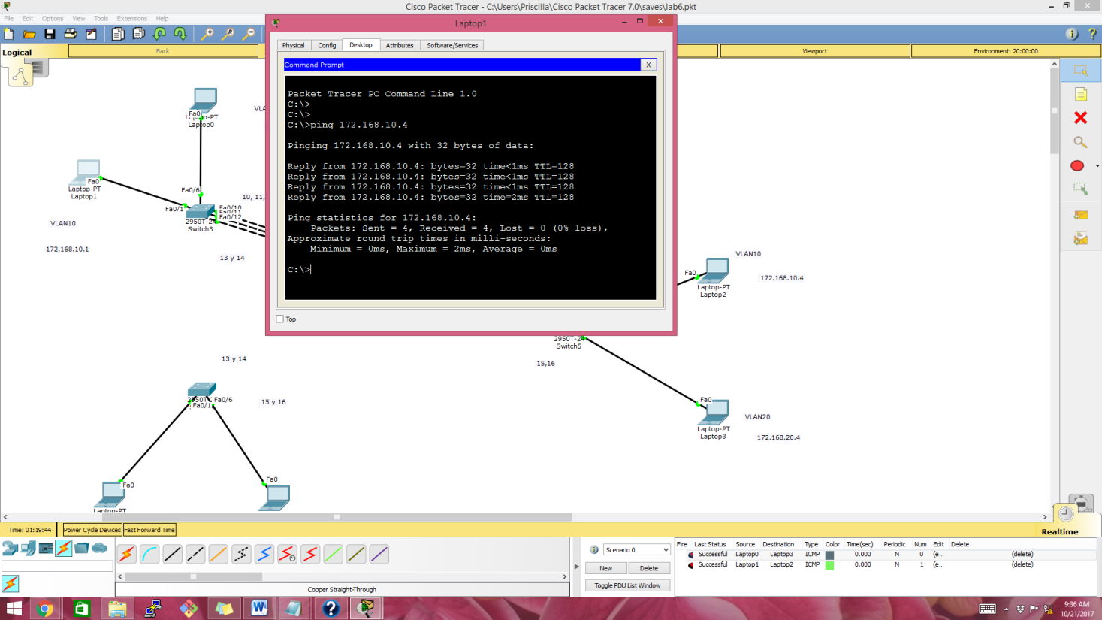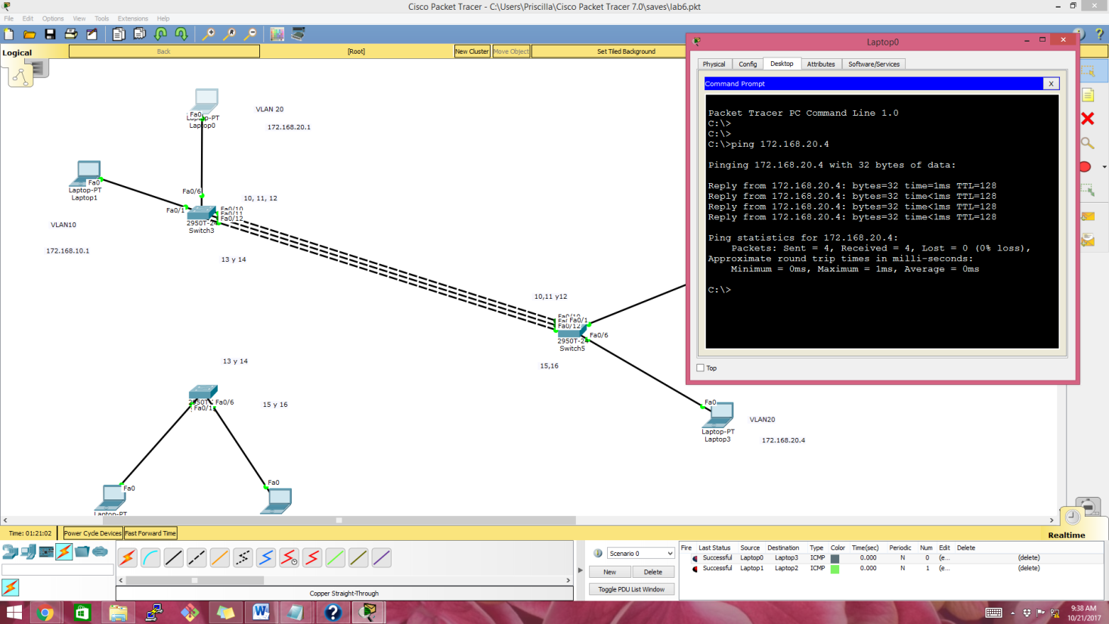

**Etherchannel manual test sin cables**

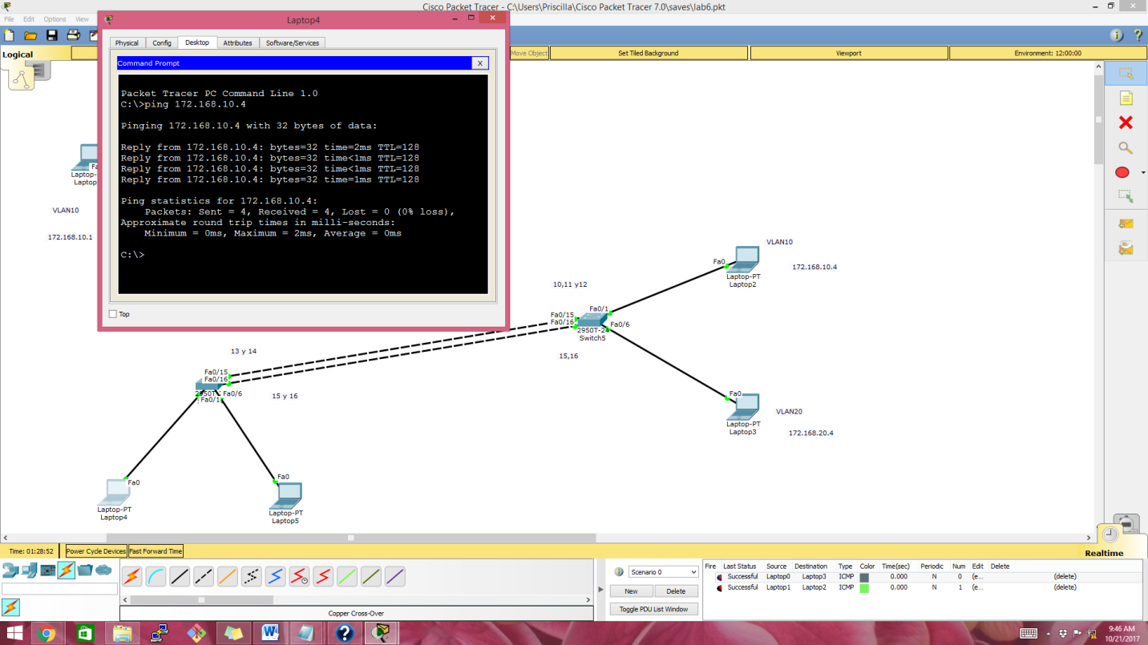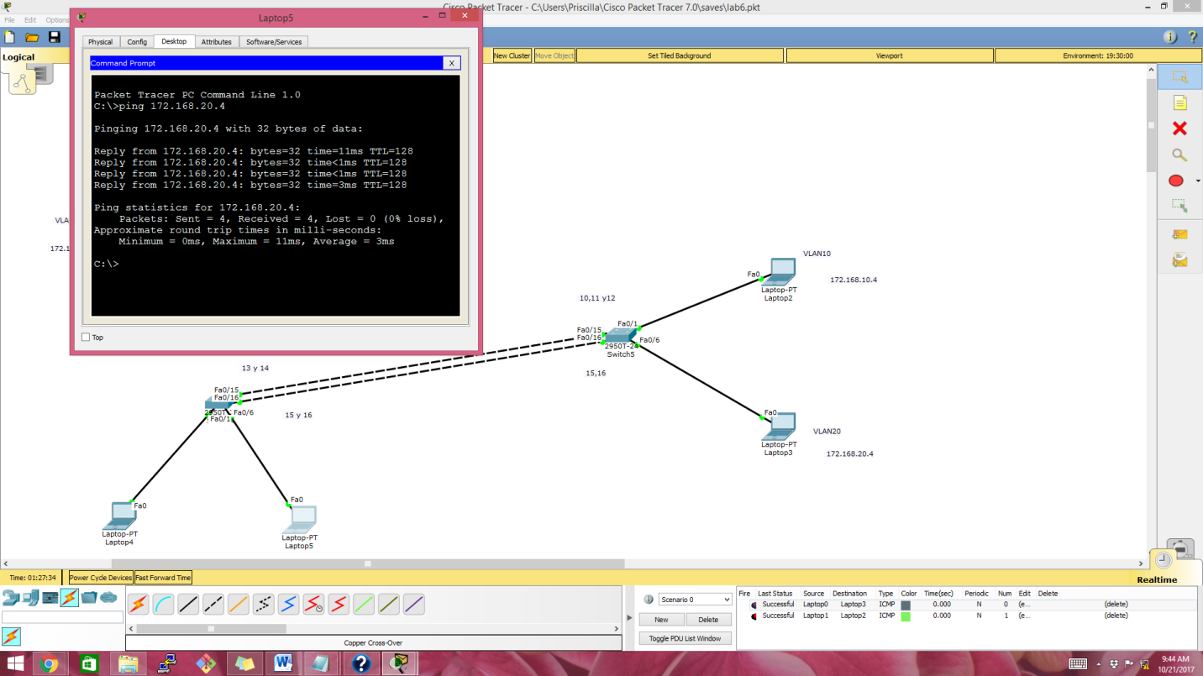

**Lacp test sin cables**

