|  |  |  |  |  |  |  |  |
| --- | --- | --- | --- | --- | --- | --- | --- |
| **PRECIOS DE CARSO** | | | | | | | |
| **MODELO** | **ME** | **RMSE** | **MAE** | **MPE** | **MAPE** | **MASE** | **ACF1** |
| Holt Lineal | 0.3589731 | 3.102371 | 2.231052 | 1.46271 | 8.718584 | 0.3041492 | 0.08771068 |
| Holt Exponencial | 0.3820347 | 3.084039 | 2.255759 | 1.80131 | 8.66498 | 0.3075174 | 0.1095764 |
| Holt Amortiguado Aditivo | 0.4397666 | 3.035081 | 2.095378 | 0.3962192 | 7.947755 | 0.2856533 | 0.08089299 |
| Holt Amortiguado Multiplicativo | 0.2970349 | 3.027483 | 2.118695 | 0.2887801 | 8.075333 | 0.2888321 | 0.0859234 |

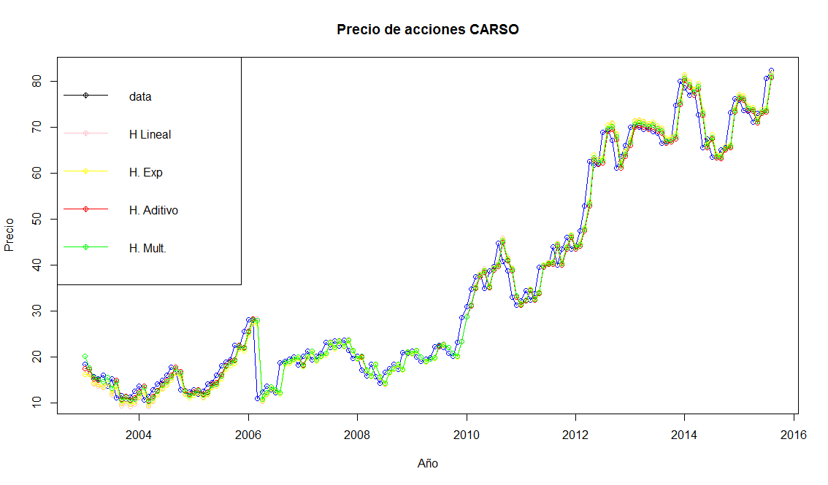

Los modelos que mejor se ajustan a los datos reales de la base de series de tiempo dado los resultados son: HOLT LINEAL y HOLT AMORTIGUADO MULTIPLICATIVO.

|  |  |  |  |  |  |  |  |
| --- | --- | --- | --- | --- | --- | --- | --- |
| **PRECIOS DE ICA** | | | | | | | |
| **MODELO** | **ME** | **RMSE** | **MAE** | **MPE** | **MAPE** | **MASE** | **ACF1** |
| Holt Lineal | 0.2627835 | 2.748065 | 1.993614 | 1.005671 | 9.975125 | 0.2323059 | 0.1775005 |
| Holt Exponencial | 0.01241301 | 2.745637 | 1.94774 | -1.392372 | 9.904715 | 0.2269605 | 0.2062648 |
| Holt Amortiguado Aditivo | -0.3239895 | 2.562973 | 1.892685 | -3.457997 | 10.21986 | 0.2205452 | 0.1600799 |
| Holt Amortiguado Multiplicativo | -0.3157556 | 2.566239 | 1.909182 | -3.884578 | 10.47294 | 0.2224675 | 0.1794819 |

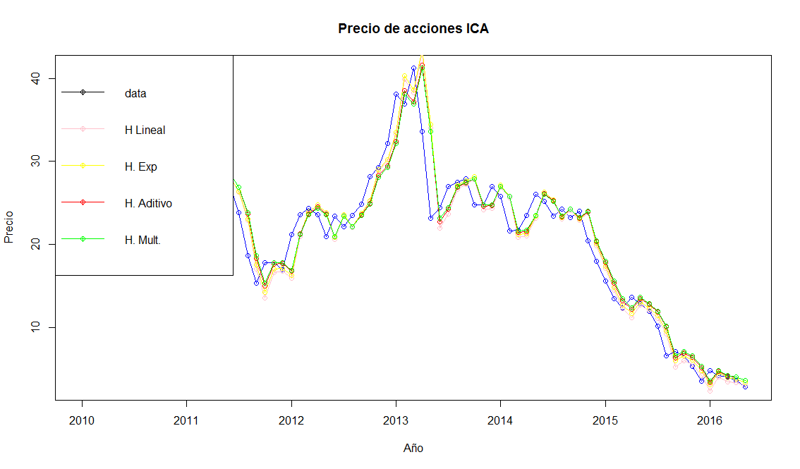

Los modelos que mejor se ajustan a los datos reales de la base de series de tiempo dado los resultados son: HOLT LINEAL y HOLT EXPONENCIAL.