

fast food in London , find the best place

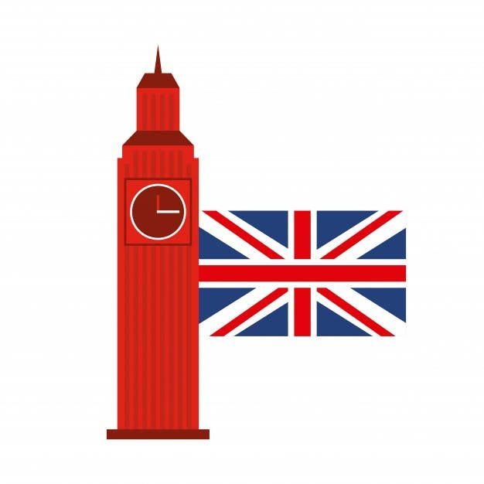



**Business Problem**

A contractor want to start a new business in fast food in London. Unfortunately, he has no idea about the right area for this project.

Therefore, he decided to rely on the science of data analysis in order to find the appropriate area for this new project,



Data acquisition and cleaning

In order to solve our business problem, we will use two datasets:

* **List_of_London_boroughs :**

This dataset is constructed by scraping the Wikipedia page : "https://en.wikipedia.org/wiki/List_of_London_boroughs", the final dataset will help us to get boroughs Coordinates and also the population of each borough .

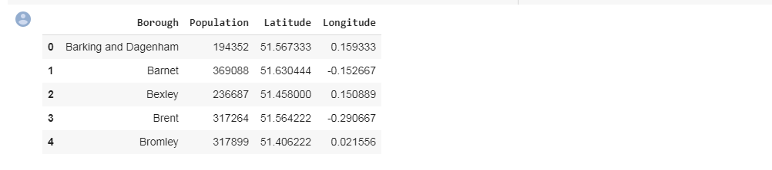

* **Foursquare location data :**



# Methodology Section

In the project we will mainly use two methodologies in order to have enough information has to make a decision:

 Data visualization :

We will visualize first our data in order to get information about population and the top boroughs according to population:



## Data clustering :

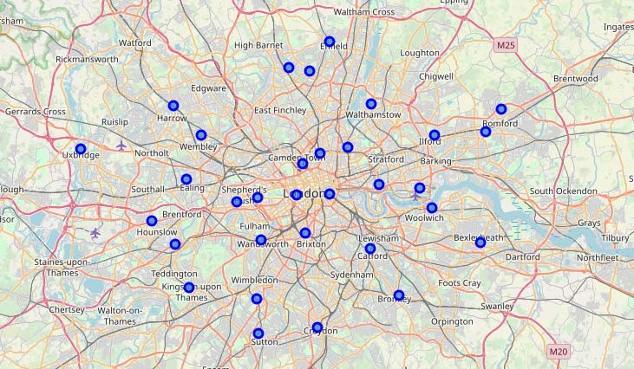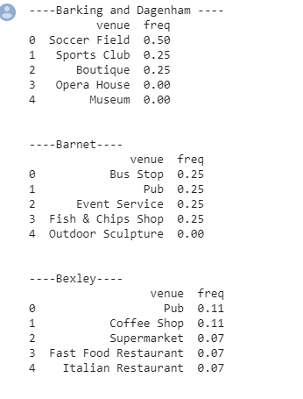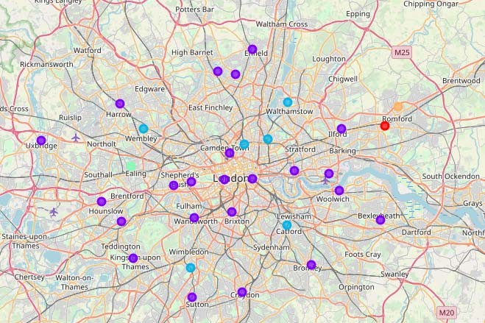



Results

After the first visualization, we get that the first 5 boroughs according to population are:

* Croydon (372 K )
* Barnet (369 K )
* Ealing (342 K )
* Enfield (320 K )
* Newham (318 K )



Venues frequencies

----Newham----

Venue freq

* Light Rail Station 0.25
* Supermarket 0.25
* Gym / Fitness Center 0.12
* Bus Station 0.12

 Pub 0.12

----Ealing----

Venue freq:

* Park 0.75
* Pharmacy 0.25
* American Restaurant 0.00
* Outdoor Sculpture 0.00
* Museum 0.00

----Croydon----

Venue

freq:

* Coffee Shop 0.17
* Clothing Store 0.17

 Pub 0.10

* Bookstore 0.07
* Women's Store 0.03
* Pub 0.5
* Indian Restaurant 0.1
* Grocery Store 0.1
* Coffee Shop 0.1
* Sandwich Place 0.1

freq

----Enfield----

Venue

* Bus Stop 0.25

 Pub 0.25

* Event Service 0.25
* Fish & Chips Shop 0.25
* Outdoor Sculpture 0.00

freq:

----Barnet----

Venue



**Competitive rate :**

 The sum of frequencies of venues in boroughs multicoated by **+1** (if the venue will be benefit for our business for example: +1 for schools , stadium

,...) , by **-1**(if the venue make a danger for our business for example another restaurant )

|  |  |
| --- | --- |
| **Borough** | **rate** |
| **Croydon** | -0.17+0.17+0.10+.07+0.03=**0.2** |
| **Barnet** | 0.25+0.25+0.25+0.25=**1** |
| **Ealing** | 0.75+0.25=**1** |
| **Enfield** | 0.5-0.1+0.1-0.1-0.1=**0.3** |
| **Newham** | 0.25+0.25+0.12+0.12+0.12=**0.86** |



# Discuss Section

In the end, the best borough for starting a fast food restaurant in London with the big frequencies of population, and less competitive venues are:

### BARNET OR EALING

**NEWHAM**

By : belodi Abdelhamid, Mirat amin , cherquaoui mouad