RedEye sip2api Gateway — Product Manual
  - Code Blue / RRT Notification Gateway - v1.6.5-c23f3eb
RedEye Network Solutions LLC, in conjunction with Claude Code
Table of Contents


RedEye sip2api Gateway

RedEye sip2api Gateway

Code Blue / RRT Notification Gateway
SIP in. Page out. Every time.

Product build | v1.6.5+ (build c23f3eb, the v1.7 line) — current production
Document version | 2.0
Date | July 07, 2026
Prepared by | RedEye Network Solutions LLC, in conjunction with Claude Code
Prepared for | Tift Regional Medical Center and RedEye Support (shared)
Classification | Confidential — shared between RedEye and the named customer
This is a single, shared deliverable — the customer and RedEye support receive the same document in full.

Document Control

About this document
This is the official product manual for the RedEye sip2api Gateway (Code Blue / RRT Notification Gateway). It is a single, shared deliverable: the customer (Tift Regional Medical Center) and the RedEye Network Solutions support team receive the same document, in full — no separate “internal” edition, nothing withheld between the parties.
Field | Value
Product | RedEye sip2api Gateway
Product build described | v1.6.5+ (build c23f3eb) — the in-progress v1.7 line, current production
Document version | 2.0
Date | July 07, 2026
Prepared by | RedEye Network Solutions LLC, in conjunction with Claude Code
Prepared for | Tift Regional Medical Center and RedEye Support (shared)
Classification | Confidential — shared between RedEye and the named customer

Scope & version note
This edition documents the product as currently deployed in production — build c23f3eb (branch main), which is v1.6.5 plus 6 commits on the unreleased v1.7 line. The As-Built section is a live inventory of the production host captured 2026-07-07. Where features are still in development (High-Availability, zero-downtime restarts, remaining Dashboard-v2 and dedupe/logging items), they appear only in the High-Availability Plan and Roadmap sections, clearly marked as planned.

Regeneration & cadence
This manual is produced by a repeatable, in-repository documentation pipeline (the product-docs skill) and is regenerated on each release. Each regeneration refreshes the modular source sections and the live host As-Built inventory, recompiles the .md and .docx, and appends a row to the revision history below. The compiled deliverable is published as a versioned release asset.

Revision history
Doc ver. | Product build | Date | Author | Summary of changes
1.0 | v1.5.1 | 2026-07-02 | RedEye + Claude Code | Initial edition — documented the v1.5.1 single-service deployment.
2.0 | v1.6.5+ (c23f3eb) | July 07, 2026 | RedEye + Claude Code | Regenerated against the current production build: two-service topology, durable delivery (outbox + retries + escalation), watchdog, real health + inbound-liveness, enforcing dedupe, RFC3339/UTC timestamps, Dashboard v2. Reliability content moved from “roadmap” to “current”; roadmap re-scoped to the open items (HA, zero-downtime restarts, etc.). As-Built refreshed from a live host inventory.

A note on safety-critical use
The RedEye sip2api Gateway participates in a life-safety notification path (Code Blue / RRT overhead paging). Operators and support staff should read the Reliability, Delivery Guarantees & Known Limitations section in full and understand the governing principle: a duplicate overhead page is acceptable; a missed page is never.

Glossary & Terminology
This glossary defines the SIP, networking, clinical, and platform terms used throughout the RedEye sip2api Gateway manual. It is written for a mixed audience — clinical/telecom staff and IT/network engineers at Tift Regional Medical Center, plus RedEye support — so every entry defines its jargon in plain language and, where useful, ties the term to how the gateway actually uses it.
Unless a term is explicitly labeled (roadmap) or (planned), every definition below describes current production behavior in product v1.5.1. Terms that belong to the in-progress v1.6.0 reliability release or the future high-availability (HA) design are labeled as such and are not current behavior.
One-sentence orientation: A Rauland nurse-call station places a SIP INVITE to the gateway; the gateway answers, reads the caller’s area/room/bed and call purpose, builds a spoken (TTS) message, and triggers an InformaCast Fusion overhead page — “SIP in, page out.”

Conventions used in this glossary
- (roadmap) / (planned) — a v1.6.0 or HA capability that is designed or partially coded but not part of the deployed v1.5.1 behavior.
- <CLIENT_ID> / <CLIENT_SECRET> — placeholders. Real OAuth2 credential values never appear in this manual.
- Northbound — traffic from the gateway up to InformaCast Fusion (HTTPS/443). Southbound — traffic from Rauland down to the gateway (SIP/5060).

A
ACK
The third message of the SIP three-way INVITE handshake (INVITE → 200 OK → ACK). The caller sends ACK to confirm it received the gateway’s 200 OK, finalizing the dialog. In this gateway the ACK is effectively a formality: the gateway answers and immediately tears the call down (see Immediate-BYE).
Allowlist (IP allowlist)
The set of source networks permitted to send SIP to the gateway, expressed in CIDR notation. In production the allowlist is 172.16.0.0/12. Any SIP packet from outside the allowed networks is rejected with 403 Forbidden and dropped before processing. This is the gateway’s primary southbound access control.
Area
The first numeric field parsed from the SIP caller username (a{area}), identifying the physical zone the alert came from (e.g. area 730 → “1st Floor. E.D.”). Areas are translated to spoken location text via the areas table in lookups. Unknown areas fall back to default_area (“Unknown Area.”).
Area/room/bed
The three-part location identity encoded in the SIP caller username as a{area}*r{room}*b{bed} (bed optional). Parsed by the gateway into a CallerInfo record and turned into human-readable location text for the page. Example username a730*r201 → area 730, room 201, no bed.
Audience (OAuth2)
A parameter in the OAuth2 token request identifying the target API tenant — here, the Fusion provider ID (a customer-owned UUID from the Fusion admin console). It scopes the issued token to Tift’s Fusion provider.

B
Bed
The optional third location field (b{bed}) in the SIP caller username, identifying a specific bed within a room. Omitted when the nurse-call station is not bed-specific.
BYE
The SIP request that ends an established call/dialog; the receiver answers 200 OK. The gateway sends a BYE almost immediately after answering (see Immediate-BYE) because it needs no live audio — it only needs the INVITE’s caller data to fire a page.

C
Call-ID
A globally-unique SIP header identifying a single call/dialog; every message in one call (INVITE, ACK, BYE) carries the same Call-ID. The gateway uses it to correlate messages of one transaction in logs. (roadmap: in the HA design, Call-ID is the persistence key that pins one call to one gateway node.)
CANCEL
A SIP request that aborts an INVITE before it has been answered. The gateway responds 200 OK and cleans up any pending call state.
Code Blue
The highest-acuity clinical alert this gateway carries — a patient in cardiopulmonary arrest requiring an immediate resuscitation response. Encoded in the SIP display name (keyword “Blue”) and mapped to the spoken label “Code Blue.” The gateway’s core reliability principle exists for this event: a duplicate page is acceptable; a missed page is never acceptable.
CSeq (Command Sequence)
A SIP header pairing a sequence number with a method name (e.g. 1 INVITE, 2 BYE); it orders requests within a dialog and matches responses to requests.

D
Dialog
A peer-to-peer SIP relationship between two endpoints, established by a successful INVITE/200 OK/ACK exchange and identified by the Call-ID plus the From and To tags. The gateway establishes a dialog only long enough to answer and immediately end it.
Display name
The human-readable label in the SIP From header, before the <sip:...> URI (e.g. "Code Blue Rm 201"). The gateway substring-matches it against the call_purposes table to determine the alert type (Code Blue / RRT / Code Pink).
Duplicate INVITE
A repeated INVITE for the same clinical event, commonly seen here because the Rauland source double-emits — roughly one-third or more of events arrive as duplicates. This is expected upstream behavior, not a gateway defect. Consistent with the at-least-once principle, the gateway currently delivers each INVITE it receives (a duplicate page is preferred over a missed one). (roadmap: v1.6.0 adds shadow-only clinical de-duplication telemetry — see Dedupe.)
Dedupe (clinical de-duplication) (roadmap, v1.6.0)
A planned observe-only feature that fingerprints the clinical (area, room, bed, purpose) tuple to measure how often true duplicate pages arrive. It ships inert (never suppresses a page) and is explicitly out of scope for v1.5.1, where no de-duplication occurs.

E
Event-ID / event correlation
An identifier used to tie together the log lines, database row, and page for a single nurse-call event. In v1.5.1 correlation is done through the SIP Call-ID and the database record for the call. (roadmap: v1.6.0 introduces an explicit, stable INVITE transaction fingerprint (v1:<hex>) derived from Call-ID / From / CSeq for tighter correlation.)
Egress (northbound egress)
The gateway’s outbound HTTPS connection on port 443 to api.icmobile.singlewire.com, used to fetch OAuth2 tokens and trigger Fusion scenarios.

F
Fusion → see InformaCast Fusion.
fusion_status
The field recorded per call capturing the outcome of the northbound Fusion delivery. A successful trigger records the HTTP status; a delivery exception records fusion_status = -1 with no durable retry in v1.5.1. The 2026-06-12 lost Code Blue is an example: a transient connect-timeout during the inline token fetch produced fusion_status = -1.

I
Immediate-BYE
The gateway’s defining call-handling behavior: it answers the INVITE with 200 OK and then immediately sends a BYE (no media exchanged, roughly one second end-to-end). The gateway needs only the INVITE’s headers to build a page, so it does not hold the call open. This mirrors the Rauland nurse-call receiver’s own behavior; the call_timeout is 1 second.
INVITE
The SIP request that initiates a call. The Rauland station sends an INVITE to the gateway carrying the caller username (area/room/bed) and display name (purpose). The INVITE is the trigger for the entire page pipeline.
InformaCast Fusion (Singlewire)
The mass-notification / overhead-paging platform (from vendor Singlewire) that actually broadcasts the audible page. The gateway is a client of Fusion: it authenticates via OAuth2 and triggers a pre-built scenario whose spoken content is the gateway-composed TTS string. Fusion base URL: https://api.icmobile.singlewire.com/api.
IP allowlist → see Allowlist.

L
Lookups (lookups.yaml)
The customer-owned translation tables that turn coded SIP fields into spoken English. Three tables: areas (area ID → location text), call_purposes (display-name keyword → alert label, e.g. “Blue” → “Code Blue”), and area_rooms / rooms (specific room mappings), each with a default fallback. Editing this file changes what the overhead page says without a code change.

O
OAuth2 client-credentials flow
The machine-to-machine authentication the gateway uses against Fusion. It POSTs a <CLIENT_ID> / <CLIENT_SECRET> plus the audience (provider ID) to the token endpoint and receives a bearer access token, which it then presents on the scenario-trigger call. No user is involved — the gateway is the client. In v1.5.1 the token is fetched inline on the page path (and refreshed once on a 401); this inline fetch is one source of occasional multi-second deliveries and was implicated in the 2026-06-12 incident. (roadmap: v1.6.0 moves token refresh to a background loop off the hot path.)
Outbox (roadmap, v1.6.0)
A planned durable, record-first delivery store: every page would be written to the database as pending before any network send, then driven through a retry/backoff state machine (pending → delivering → delivered | failed | expired) by a background worker. This does not exist in v1.5.1 — today’s delivery is a single inline attempt with no durable retry. The outbox is the central fix for the missed-page failure mode.

P
Proxy (SIP proxy)
The intermediary that forwards Rauland’s SIP toward the gateway. In the production path the Rauland UAC (172.20.9.170) sends to a proxy (172.20.9.176), which is the actual packet source and Contact seen by the gateway (10.249.0.60). Knowing the proxy is the packet source matters for reading SIP logs and for the allowlist.
Purpose (call purpose)
The clinical alert type of the event (Code Blue, RRT, Code Pink), determined by keyword-matching the SIP display name against the call_purposes table. An unrecognized purpose falls back to default_purpose.

R
Room
The second numeric field parsed from the SIP caller username (r{room}), identifying the room within an area. Rendered in the page as a mapped room name if one exists in lookups, otherwise as default_room_format (“Room {room}.”).
RRT (Rapid Response Team)
A clinical alert requesting a rapid-response team for a patient who is deteriorating but not yet in full arrest — a step below Code Blue. Encoded via the display-name keyword “RRT” → spoken label “Rapid Response Team.”
RTP (Real-time Transport Protocol)
The protocol that carries live audio in a normal SIP call. This gateway exchanges no meaningful audio — it answers and immediately ends the call (see Immediate-BYE), so RTP is not a functional part of v1.5.1 paging. (Where a silence stream is referenced elsewhere, it exists only to satisfy media negotiation, not to carry a page; the page itself is spoken by Fusion, not over RTP.)

S
Scenario / scenario-notification
A pre-configured notification template inside InformaCast Fusion. The gateway does not build the page’s routing or audio path itself — it triggers the customer’s scenario (name “SIPtoTTSBridge”, id 4cba52d8-0d50-11f1-aba0-913f93e445e2) via the scenario-notification API, passing the composed announcement into the scenario’s customTTS field variable. Fusion then speaks it (voice “Joanna”) to the “Tifton/TRMC/Main Hospital” device group.
SDP (Session Description Protocol)
The small text block carried inside SIP INVITE/200 OK messages that describes the proposed media session (codecs, IP, ports). Because the gateway does immediate-BYE, SDP is negotiated as a formality and no real media session is used.
SIP (Session Initiation Protocol)
The signaling protocol (RFC 3261) used to set up, modify, and tear down real-time sessions such as calls. Rauland uses SIP to signal a nurse-call alert to the gateway. The gateway binds SIP on 0.0.0.0:5060 over both UDP and TCP.
Singlewire → see InformaCast Fusion.
SQLite
The embedded, file-based database (/var/lib/sipgw/calls.db) where the gateway records every processed call — timestamp, caller info, parsed area/room, the TTS string, and the Fusion result. It backs the dashboard’s call history.
systemd
The Linux service manager that runs the gateway as a single unit, sipgw.service (Type=simple, Restart=always, RestartSec=5), under the unprivileged sipgw user with hardening (NoNewPrivileges, ProtectSystem=strict, PrivateTmp) and CAP_NET_BIND_SERVICE so it can bind port 5060. systemd restarts the service automatically if it exits.

T
481 “Call Leg/Transaction Does Not Exist”
A specific, harmless SIP error occasionally seen from a BYE-before-ACK race — the gateway’s immediate-BYE arrives before the caller’s ACK, so the peer replies 481 Call Leg/Transaction Does Not Exist. The page is still delivered; no action is needed. (This exact reason phrase is used consistently across the manual.)
TTS (text-to-speech)
The spoken announcement. The gateway composes the text (e.g. “Attention! Attention! Code Blue! 1st Floor. E.D. Room 201. …”) by combining the parsed purpose, area, and room via lookups, with configurable preambles and repetition; Fusion performs the actual speech synthesis (voice “Joanna”) and broadcast.

U
UAC (User Agent Client)
The SIP endpoint that originates a request. Here the Rauland nurse-call system (172.20.9.170) is the UAC that emits the INVITE; the gateway acts as the receiving user agent (server side) for that call.
UTC (timestamps)
All log and record timestamps are currently in UTC. The logging.timezone config value is present but not applied; the host clock runs UTC, so timestamps are UTC in effect. This is a known item. (roadmap: v1.6.0 issue #12 introduces canonical RFC3339-Z UTC timestamps with host-local display.)

W
Watchdog / heartbeat / real /health (roadmap, v1.6.0)
Planned liveness machinery — a writer heartbeat row, a systemd Type=notify watchdog, and a /health endpoint backed by that heartbeat. Not present in v1.5.1. Today the service relies on systemd Restart=always for recovery.
WAL (Write-Ahead Logging) (roadmap, v1.6.0)
A SQLite journaling mode planned alongside the outbox to let a read-only dashboard read consistently while the writer commits. v1.5.1 does not run the database in WAL mode.

Related reading
- Overview & Architecture — how these pieces fit together end to end.
- Call Flow — the step-by-step lifecycle of one INVITE → page.
- Lookup Tables Reference — the full areas, call_purposes, and room tables.
- Troubleshooting — reading 481, duplicate INVITEs, and fusion_status = -1 in the logs.
Roadmap note: Terms marked (roadmap) / (planned) — Outbox, Dedupe, Watchdog/heartbeat//health, WAL, background token refresh, RFC3339-Z timestamps, and HA — describe the in-progress v1.6.0 reliability release and future high-availability design. They are documented here for orientation only and do not reflect current v1.5.1 production behavior.

Executive Summary
The RedEye sip2api Gateway is a life-safety integration appliance that turns a nurse-call event into an overhead page — automatically, and reliably enough to trust with a Code Blue. When a clinician at Tift Regional Medical Center pulls a Code Blue or presses a Rapid Response button, the Rauland nurse-call system emits a SIP INVITE. The gateway answers that call, reads who and where from the SIP headers, composes a spoken announcement, and fires an InformaCast Fusion scenario that broadcasts it to the overhead IP speakers. No human retypes a room number, and no page waits on someone to notice a screen.
SIP in. Page out. Every time.

Why this product exists
Overhead notification for a Code Blue or RRT has one job and no acceptable failure mode: a real page must never be dropped, duplicated, delayed, or sent to the wrong place. The Rauland nurse-call system and InformaCast Fusion do not speak a common language — one talks SIP, the other a REST API behind OAuth2. Before this gateway, bridging them meant a fragile, best-effort hop with no memory: if the single outbound call to Fusion timed out, the page was simply gone, with nothing to retry it and no one alerted that it had vanished. That is exactly what happened on 2026-06-12, when a Code Blue was lost to a momentary network timeout during an inline token fetch. That incident is the reason the current release exists, and it is the class of failure the current release is built to make impossible.

What it does
The gateway sits on host sip2apibridge on the clinical network and runs continuously as two independent services so that the paging path is never at the mercy of the reporting UI:
- The call-path service (sipgw.service) receives every SIP INVITE, validates its source against an IP allowlist, parses the caller’s area, room, and bed, resolves them to human-readable names, assembles the text-to-speech announcement, and drives its durable delivery to Fusion.
- The dashboard service (sipgw-dashboard.service) is a separate, read-only web UI on port 8080. It shows the live call history, a 90-day chart of calls by type, per-call detail correlated across every log stream, a date-picker log viewer, and a real health signal — and it can be restarted at any time without interrupting a single page.
A typical announcement, for a Code Blue in Room 201 of the E.D., is spoken to every configured speaker as: “Attention! Attention! Code Blue! 1st Floor. E.D. Room 201.” — repeated three times.

The reliability principle
The design rule behind every feature is record-first, then deliver. The instant a call is answered, the page is written to a durable, crash-safe database before any attempt is made to send it. Only then does a background delivery worker take over, sending the page to Fusion with bounded retries and exponential backoff, surviving a Fusion outage or even a process crash mid-send. If a page still cannot be delivered, it is escalated to a human channel rather than silently lost. The OAuth token that authorizes each send is refreshed in the background, off the critical path, so a real page never waits on a token round-trip — closing the exact gap that lost the 2026-06-12 Code Blue.
Two further guarantees round out the current production build:
- Duplicate suppression, clinically signed off. Rauland emits two INVITEs for roughly a third of events; the gateway now collapses those true duplicates within a 2-second window, keyed to the specific bed and call purpose. The window is deliberately narrow and bed-aware: two patients coding in one room are never merged, an RRT and a Code Blue are never merged, and a genuine re-page more than two seconds later is always delivered. Every race resolves toward delivery, never a wrongful drop, and even a suppressed page is still recorded as an audit row.
- Honest liveness. A watchdog restarts the call-path service if its event loop ever hangs, and /health reports the real freshness of the writer’s heartbeat, Fusion reachability, and how long it has been since the last inbound SIP message from Rauland — so “quiet” and “broken” are never confused.
Under it all sit non-negotiable safety invariants: test and dry-run traffic can never fire a real page or touch the production database, SIP is accepted only from the allowlisted clinical networks, and every credential is masked in the logs.

Who it is for
This manual is a single shared deliverable for two audiences at once:
- Tift Regional Medical Center — the IT, telecom, and clinical staff who own, operate, and depend on the system.
- RedEye Network Solutions support — the engineers who install, monitor, and maintain it.
Both receive the same document, in full, with nothing withheld. It documents the current production build (c23f3eb, the v1.7 line). Features still in development — the high-availability epic, zero-downtime restarts, and OS-patch coordination — appear only in the clearly labeled HA Plan and Roadmap sections.

Authoring credit
The RedEye sip2api Gateway and this manual were produced by RedEye Network Solutions LLC, in conjunction with Claude Code.

Product Overview & Key Concepts
RedEye sip2api Gateway — “SIP in. Page out. Every time.” Code Blue / RRT Notification Gateway. Built by RedEye Network Solutions LLC, in conjunction with Claude Code. This section documents the current production build (c23f3eb, the v1.7 line — v1.6.5 + 6 commits) deployed at Tift Regional Medical Center on host sip2apibridge.

1. What it is, at a glance
The RedEye sip2api Gateway is a small, single-purpose, life-safety appliance. It sits between the hospital’s Rauland Responder nurse-call system and Singlewire InformaCast Fusion, the overhead mass-notification platform. Its one job is to turn a nurse-call emergency into an audible overhead page — reliably, every time.
When a clinician triggers a Code Blue, Rapid Response Team (RRT), or Code Pink at a nurse-call station, the Rauland system dials the gateway as if it were a phone. The gateway is not a phone: it answers the call, reads the who / where / what out of the SIP signaling, builds a spoken announcement (“Code Blue… 4th Floor… I.C.U… Room 12…”), and hands that announcement to InformaCast Fusion, which broadcasts it over the hospital’s overhead speakers.
In plain terms:
A nurse presses a Code Blue button. Seconds later, the overhead speakers announce it — with the unit and room spoken aloud. The gateway is the box that makes that happen.
The product is deliberately narrow. It is not a PBX, not a full SIP stack, and not a general integration bus. It does exactly one path — SIP INVITE in, Fusion overhead page out — and it does that path durably.

At-a-glance facts
Product | RedEye sip2api Gateway (a.k.a. sipgw)
Purpose | Convert Rauland nurse-call SIP INVITEs into InformaCast Fusion overhead pages
Deployed build | c23f3eb (branch main, v1.7 line)
Host | sip2apibridge — Ubuntu 24.04.4, Python 3.12.3
Listens for SIP | 10.249.0.60:5060 (UDP and TCP)
Web dashboard | http://10.249.0.60:8080 (read-only, internal network)
Upstream (in) | Rauland UAC 172.20.9.170 → proxy 172.20.9.176 → gateway
Downstream (out) | InformaCast Fusion REST API (https://api.icmobile.singlewire.com/api), scenario SIPtoTTSBridge
Supported call types | Code Blue, Rapid Response Team (RRT), Code Pink — extensible via lookup tables
Core promise | A real emergency page is never dropped. Delivery is durable and retried.

2. End-to-end value: from button-press to overhead page
The whole system exists to close one gap: the Rauland nurse-call world speaks SIP, and the InformaCast overhead-paging world speaks a REST API. Nothing off the shelf bridges the two with the reliability a Code Blue demands. The gateway is that bridge.
Each hop adds value:
- Rauland → SIP. The nurse-call system already knows how to place a SIP call when an alert fires. The gateway meets it there, on the wire the hospital already runs.
- SIP → meaning. The emergency’s identity is encoded in the SIP From header — the purpose in the display name (e.g. “Blue”), and the location in the username (e.g. a731r1200 → area 731, room 1200). The gateway parses this into a structured CallerInfo.
- Meaning → speech. Using site-specific lookup tables (lookups.yaml), the gateway translates codes into words a responder actually hears: area 731 becomes “4th Floor… I.C.U…”, the purpose “Blue” becomes “Code Blue”. The result is a clear, repeated, speech-ready announcement.
- Speech → Fusion. The announcement is delivered to the InformaCast Fusion scenario SIPtoTTSBridge via its REST API. Fusion owns the actual audio broadcast to the overhead speakers and to any subscribed devices.
- Durability wraps all of it. The page is written to a durable store before any network call, so a Fusion hiccup, a token timeout, or a process crash cannot silently swallow it.

3. Key concept: the paging path — nurse-call → SIP → TTS → Fusion
The paging path is the heart of the product. It runs entirely inside the writer process (sipgw.service), and it is the path everything else is built to protect.
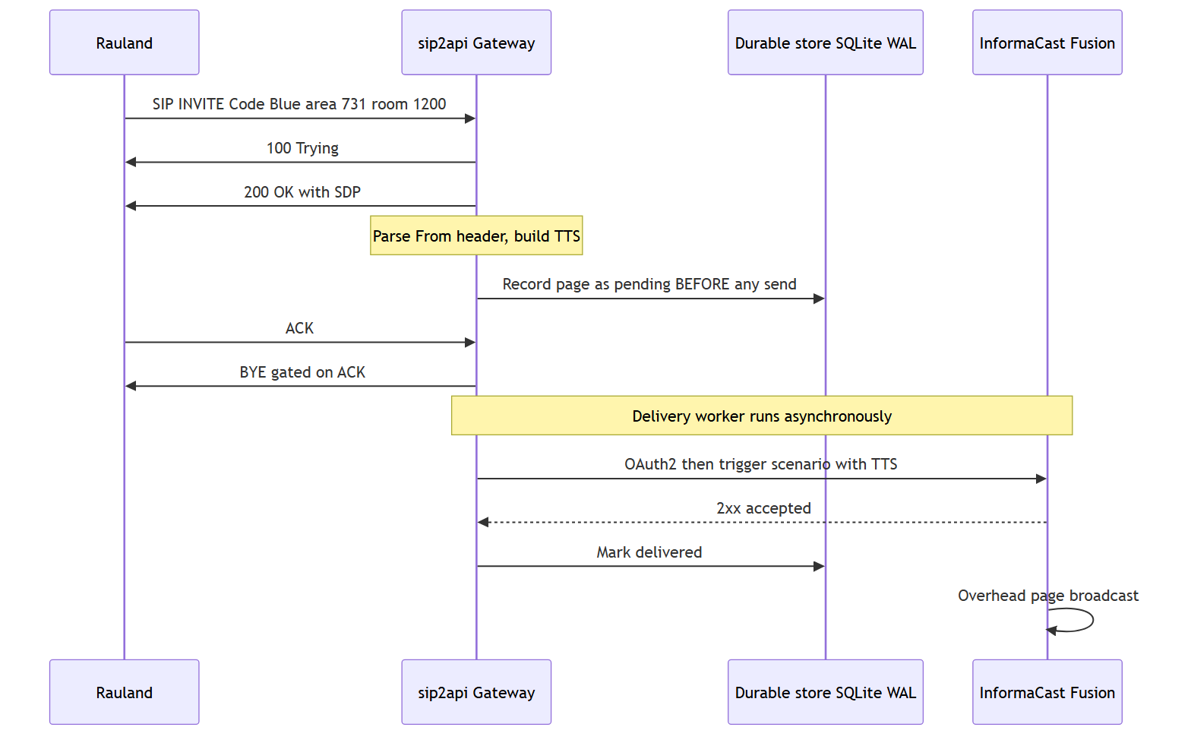
The stages, in order:
- Ingress (SIP). Rauland sends a SIP INVITE to 10.249.0.60:5060 (UDP or TCP). The gateway runs a purpose-built, lightweight SIP handler (only INVITE / ACK / BYE / CANCEL / OPTIONS) — chosen over a full SIP stack for zero native dependencies and full behavioral control. The source IP is checked against the SIP allowlist (172.16.0.0/12, 127.0.0.0/8, 10.0.0.0/8) before anything else happens.
- Answer. The gateway replies 100 Trying, then 200 OK with SDP (advertising PCMU/8000). The call is answered like a real endpoint would.
- Parse. The From header is decoded into a CallerInfo: purpose from the display name, area / room / (optional) bed from the username pattern a{area}r{room}[b{bed}].
- Compose TTS. The lookup tables convert the codes into a speech-ready string, which is then wrapped with a preamble and repeated for clarity on a noisy overhead system.
- Record durably. The page is written to the SQLite database (WAL mode) in state pending — this happens before any attempt to reach Fusion. This is the durability boundary (see §5).
- Deliver asynchronously. A background delivery worker picks up the pending row and delivers it to Fusion — authenticating via OAuth2 and triggering the SIPtoTTSBridge scenario with the TTS string as the payload. Retries and escalation apply if the first attempt fails.
- Broadcast. Fusion accepts the trigger (2xx) and performs the actual overhead broadcast. The gateway marks the row delivered.
Crucially, delivery is fully decoupled from the SIP call. The gateway does not hold the phone call open waiting for Fusion. It answers Rauland immediately, records the page, tears the call down cleanly, and lets the delivery worker do the network work on its own schedule. A Fusion outage never backs up onto the SIP side, and a slow SIP teardown never delays a page.

4. Key concept: the immediate-BYE model (ACK-gated teardown)
Because the gateway does not need to keep an audio channel open — Fusion, not the SIP call, carries the announcement — it uses an immediate-BYE model in production. As soon as it has answered (200 OK) and dispatched the page, it wants to hang up the SIP call and free the resource.
The subtlety is when it hangs up. Earlier behavior sent the gateway’s BYE in the same instant as the 200 OK, which could race ahead of the caller’s ACK and reach the proxy before the three-way handshake finished — drawing a 481 Call Leg/Transaction Does Not Exist. The current build fixes this by gating teardown on the ACK:
- After the 200 OK, the gateway keeps the call and fires the page immediately (decoupled — the page never depends on the ACK, BYE, or any teardown outcome).
- The gateway’s BYE is deferred until the caller’s ACK confirms the handshake, guaranteeing correct INVITE → 200 → ACK → BYE ordering with no 481.
- A lost-ACK fallback timer (immediate_bye_ack_timeout_seconds, default 2.0s) tears the call down anyway if the ACK never arrives, so a dropped ACK cannot leave a call stuck.
- All teardown paths — ACK arrives, fallback fires, peer BYE, or shutdown — funnel through one idempotent teardown that sends the BYE exactly once and frees the RTP port exactly once. A duplicate ACK or an ACK/fallback race can never double-send.
The governing rule is answer-SIP-first, deliver-async: the page is recorded and dispatched independently of the ACK/BYE/fallback outcome, so no SIP teardown quirk can ever lose a Code Blue.

5. Key concept: durable, at-least-once delivery — “duplicate OK, missed never”
This is the single most important idea in the product, and the reason it exists in its current form.

The principle
A real emergency page is never dropped, never silently lost, never gated behind some other machinery. If forced to choose, the gateway would rather send a page twice than miss one.
That is the meaning of at-least-once, “duplicate OK / missed never.” A dropped Code Blue is a potential death; a duplicated overhead page is a minor annoyance. The whole delivery design leans, at every branch point, toward the safe side of that trade.

Why it matters — the incident that shaped it
On 2026-06-12, a Code Blue was lost. The gateway tried to fetch an OAuth token inline, on the critical path, at the moment it needed to page. A transient httpx.ConnectTimeout during that fetch failed the send (fusion_status=-1), and because delivery was best-effort and single-shot, there was no retry — the page was simply gone. That must never happen again.
The current build prevents that exact failure with three changes working together: - The page is recorded before any network send, so it survives a failure or crash. - Delivery is retried with backoff, so a transient timeout is recovered from, not fatal. - The OAuth token is refreshed in the background, off the critical path, so a page never blocks on a token round-trip in the first place.

How durability works (the transactional outbox)
The gateway implements a transactional outbox. Every page moves through an explicit state machine backed by the SQLite database (WAL mode), tracked in the calls.state column:
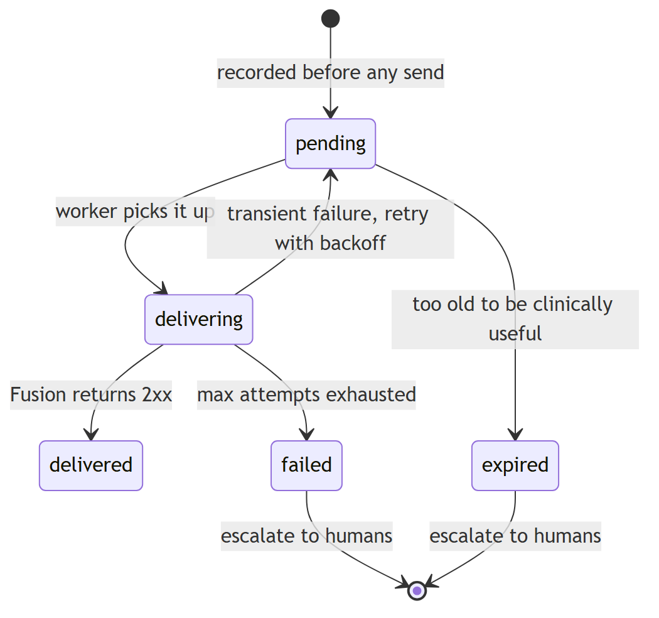
- Record-first is sacred. create_pending_call() inserts the pending row before the gateway even tries to reach Fusion. From that instant the page survives a Fusion outage, a network blip, or a process crash.
- Bounded retries with backoff. The delivery worker retries failed attempts with exponential backoff (honoring an upstream Retry-After when present), up to a bounded number of attempts.
- Crash recovery. On startup, any page left mid-flight by a crash is re-queued for redelivery — nothing in flight is lost across restarts. (This re-queue is exactly why the model is at-least-once: after a crash the gateway may resend rather than risk having missed one.)
- Escalation. A page that permanently fails or expires triggers an escalation to a human channel (a NOC/Teams/Slack/PagerDuty endpoint), so a delivery that truly cannot complete becomes a loud, visible alert rather than a silent loss.
- Background OAuth refresh. The Fusion access token is kept warm by a background refresh loop, so the first real Code Blue never pays a token-fetch latency — closing the 2026-06-12 failure mode at its root.
The states you will see in the calls.state column: pending, delivering, delivered, retrying, failed, expired, duplicate, and legacy (pre-outbox rows migrated losslessly).

6. Key concept: enforcing duplicate suppression
Rauland has a quirk: for roughly one in three events it emits two INVITEs for the same clinical emergency. Left alone, that means two identical overhead pages for one Code Blue — clinically confusing (“is there a second patient?”) and noisy.
The current build suppresses these duplicates with an enforcing deduper. This was enabled in this build after clinical sign-off (it ships disabled-by-default in the reference config; the production config.yaml turns it on):
dedupe:
enforce: true
window_seconds: 2
match_bed: true
match_purpose: true
How it works, and — more importantly — how it stays safe:
- Keyed on the upstream event_id. Rauland’s double-emit carries the same upstream event identifier on both INVITEs, so the two are recognized as one clinical event and collapsed. The match also considers the clinical fingerprint (area, room, bed, purpose) within a short 2-second window.
- A genuine second emergency is always delivered. Two different Code Blues for the same room, or a Code Blue and an RRT, are distinct clinical events and are both paged — the deduper only collapses the true same-event double-emit.
- Suppression can never drop a real page — by construction. The deduper runs after the record-first insert. It never gates or delays the insert or the delivery. When it does suppress, it transitions the already-recorded duplicate row to state duplicate — and that transition is guarded on the row still being pending. If the delivery worker has already picked the row up, the row is delivered anyway. This is the deliberate fail-safe direction: deliver a duplicate rather than risk dropping a page.
In short: dedupe makes the nice-to-have better (no double announcements) without ever compromising the must-have (no missed page). It is consistent with, not an exception to, the “duplicate OK / missed never” principle — the one duplicate it removes is a known upstream artifact, keyed on the upstream event id, and the safety fallback still favors delivery in every ambiguous case.

7. Key concept: the two-service topology
The gateway runs as two independent systemd services, deliberately split so that the read-only web UI can never interfere with the life-safety paging path.
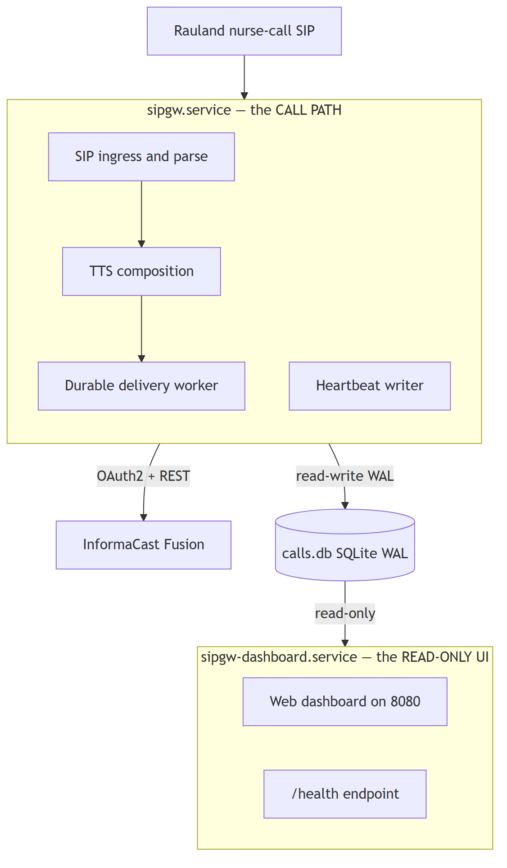
Service | Role | Type | Can restart independently?
sipgw.service | The call path: SIP ingress + parse + TTS + durable delivery. Owns all database writes and stamps a liveness heartbeat. | Type=notify, WatchdogSec=30s | This is the paging service; restart only when coordinated.
sipgw-dashboard.service | A separate read-only web UI (dashboard_app.py) on :8080. Opens the database read-only. | Type=simple | Yes — it can be restarted or crash without interrupting paging.
Why the split matters:
- Isolation. A runaway UI request, a dashboard crash, or a dashboard restart cannot touch the paging path. The two processes share only the SQLite database file, and the dashboard opens it read-only (PRAGMA query_only=ON) — it can never mutate a page or the heartbeat. The writer owns every write.
- Watchdog. The writer runs under a systemd Type=notify watchdog (WatchdogSec=30s): a hung event loop is detected and the service restarted. This watchdog is on the writer exclusively.
- Honest health. Because the writer and dashboard are separate processes, the dashboard’s /health reads the writer’s heartbeat row from the database. A healthy /health therefore means the paging process is genuinely alive — not merely that the web server answered. /health also surfaces Fusion reachability and the age of the last inbound SIP from Rauland (an inbound-liveness signal that the nurse-call link is up).
Operational note. Because the paging service and the OS must be coordinated, uncoordinated restarts are a known hazard: on 2026-07-07 an unattended-upgrades (needrestart) auto-restart bounced the paging service (issue #20, remediated). OS patching must be coordinated with the paging window; zero-downtime writer restarts (socket activation, issue #19) are on the roadmap.

8. Supported call types
Call types are data, not code. The gateway derives the purpose of a page by matching keyword substrings in the SIP display name against the call_purposes table in lookups.yaml. Adding or renaming a call type is a lookup-table edit — no code change, no redeploy of the application logic.
The production build recognizes:
Trigger keyword (in SIP display name) | Spoken purpose | Notes
Blue | Code Blue | Cardiac/respiratory arrest — the primary life-safety case.
RRT | Rapid Response Team | Clinical deterioration escalation.
Pink | Code Pink | Infant/child security. (Also mapped as specific room names in a few areas.)
Two design choices reinforce the safety posture:
- First match wins, in table order — so ordering in lookups.yaml is meaningful.
- The default is the most critical. When no keyword matches (or the display name is empty), the gateway falls back to default_purpose: "Code Blue" — deliberately choosing the most urgent interpretation so an unrecognized alert is never under-classified.
Location is resolved the same way: the areas table maps an area number to a speech-ready unit name (e.g. 731 → "4th Floor... I.C.U..."), and an area_rooms table provides room-level overrides (e.g. 730*01001 → "C... 32"). This is how the same generic room number can be spoken correctly across different units. New units, rooms, and call types are all onboarded by editing lookups.yaml.

9. Where to go next
If you want to… | See
Understand the internal modules and data flow in depth | Architecture
Configure the gateway, Fusion credentials, or dedupe | Configuration
Edit area/room/purpose mappings | Lookup Tables
Operate, restart, and monitor the services | Operations
Diagnose a missed or duplicated page | Troubleshooting
Understand the security posture and the SIP allowlist | Security
See what is planned (HA, zero-downtime restarts) | HA Plan / Roadmap

Architecture
RedEye sip2api Gateway — Code Blue / RRT Notification Gateway “SIP in. Page out. Every time.”
This section documents the current production build (c23f3eb, the v1.7 line: v1.6.5 + 6 commits) as deployed on host sip2apibridge at Tift Regional Medical Center. It describes the system that IS running today. Features that are still in development (the HA epic, socket-activated restarts, remaining Dashboard-v2 phases) are called out only in the Roadmap and HA Plan sections of this manual and are labeled planned.

1. What the gateway does
The RedEye sip2api Gateway is a life-safety protocol bridge. Rauland Responder (the nurse-call system) knows how to place a SIP call; InformaCast Fusion knows how to make an overhead page. Nothing off the shelf connects the two. The gateway sits in the middle: it answers the SIP INVITE that Rauland places for a Code Blue or Rapid Response Team (RRT) event, extracts who / where / why from the call, turns that into a spoken text-to-speech (TTS) announcement, and drives Fusion’s Scenarios API to page it overhead.
The single design imperative is “page out, every time.” A Code Blue that is placed must result in an overhead page even if Fusion is momentarily unreachable, even if the OAuth token expired at the wrong moment, and even if the gateway process crashes in the half-second between answering the call and delivering the page. The architecture below exists to make that guarantee durable rather than best-effort.

1.1 The problem this build solves
On 2026-06-12 a Code Blue was lost. The old code fetched an OAuth token inline on the page path; that fetch hit a transient httpx.ConnectTimeout, the trigger returned fusion_status = -1, and there was no retry — the page silently evaporated. The current build eliminates that failure mode by:
- Recording the page first (durable SQLite row) and delivering it asynchronously with bounded retries, so a transient network fault is retried instead of dropped.
- Refreshing the OAuth token in the background, off the page’s critical path, so a page never waits on (or dies from) a token fetch.
- Escalating to a human when a page can genuinely not be delivered, instead of failing silently.

2. System context
Three actors, one direction of flow: nurse-call in, overhead page out.
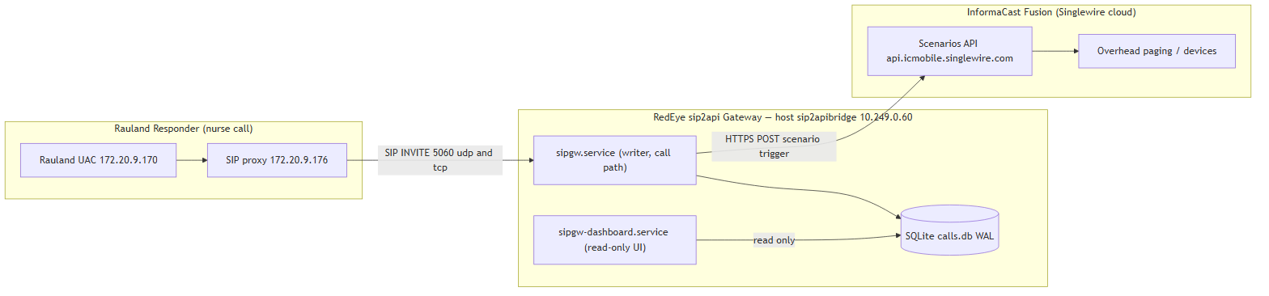
The upstream SIP path. Rauland’s user agent (172.20.9.170) does not talk to the gateway directly; it routes through the Rauland-side SIP proxy (172.20.9.176), which forwards the INVITE to the gateway’s SIP IP 10.249.0.60 (interface ens34) on port 5060 (UDP and TCP). The gateway therefore sees 172.20.9.176 as the immediate signaling peer. Both addresses fall inside the SIP allowlist (172.16.0.0/12), so both are accepted; any source outside the allowlist is answered with 403 Forbidden and never becomes a page.
The downstream page path. The gateway calls Fusion’s Scenarios API at https://api.icmobile.singlewire.com/api. It authenticates with OAuth2 client-credentials against /token (audience = the customer’s provider ID), then POSTs to /v1/scenario-notifications?scenarioId=<SIPtoTTSBridge scenario id> with the TTS string as the answer to the customTTS field. Fusion resolves the scenario’s audience and pages it overhead. Credentials are masked everywhere in this manual as <CLIENT_ID> / <CLIENT_SECRET>; the customer-owned scenario, audience, and field identifiers are the customer’s own and may appear.
Two services, one host. The gateway is not a monolith. The call path (sipgw.service) and the web UI (sipgw-dashboard.service) are independent systemd units in separate OS processes. The dashboard can be restarted, upgraded, or crash without ever interrupting paging. Both are covered in §6.

3. A call, end to end (durable delivery)
The following sequence is the heart of the system. Note the two decoupling points that make the page durable: the page is recorded before it is delivered (so a crash or outage cannot lose it), and the SIP dialog is torn down independently of delivery (so answering the call never waits on Fusion).
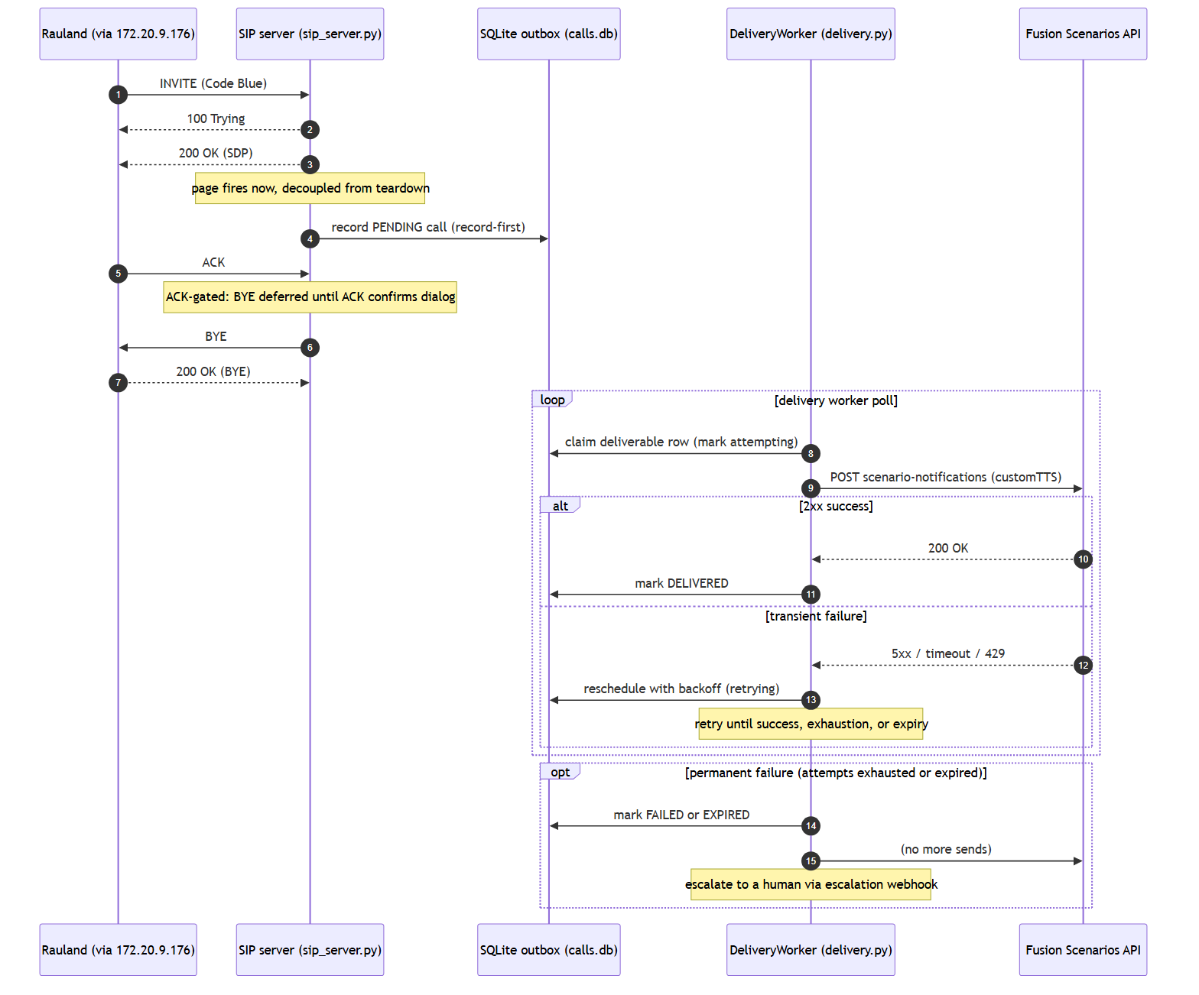

3.1 Why the ordering matters
- 200 OK before record, page before teardown. The gateway answers the INVITE immediately (100 Trying, then 200 OK with SDP). The page callback (_safe_callback → on_call) fires via asyncio.create_task the moment the call is answered — it is not chained behind ACK, BYE, or the delivery result. Rauland gets a fast, clean answer regardless of Fusion’s health.
- Record-first. on_call parses the caller, builds the TTS, and writes a PENDING row to the outbox before any attempt to reach Fusion. From that instant the page is durable: even a hard crash before the first delivery attempt leaves a recoverable row on disk (§5.3).
- ACK-gated immediate-BYE. In immediate_bye mode (the deployed default) the gateway sends 200 OK, keeps the dialog, and defers its own BYE until the caller’s ACK confirms the three-way handshake. This fixes the historical 481 race in which a BYE could outrun the ACK. A lost ACK is covered by a per-call fallback timer (immediate_bye_ack_timeout_seconds, 2.0 s) that tears the dialog down and frees the RTP port so a dropped ACK can never strand a dialog or leak a port.
- Delivery is a separate loop. The DeliveryWorker polls the outbox on its own cadence, claims deliverable rows, and drives the Fusion POST with retries and backoff. Success marks the row DELIVERED; permanent failure marks it FAILED or EXPIRED and escalates.

4. Internal pipeline
Inside the writer process, an inbound INVITE flows through a short, well-bounded pipeline. The dashboard is deliberately drawn outside that pipeline — it is a separate process that only reads the same database.
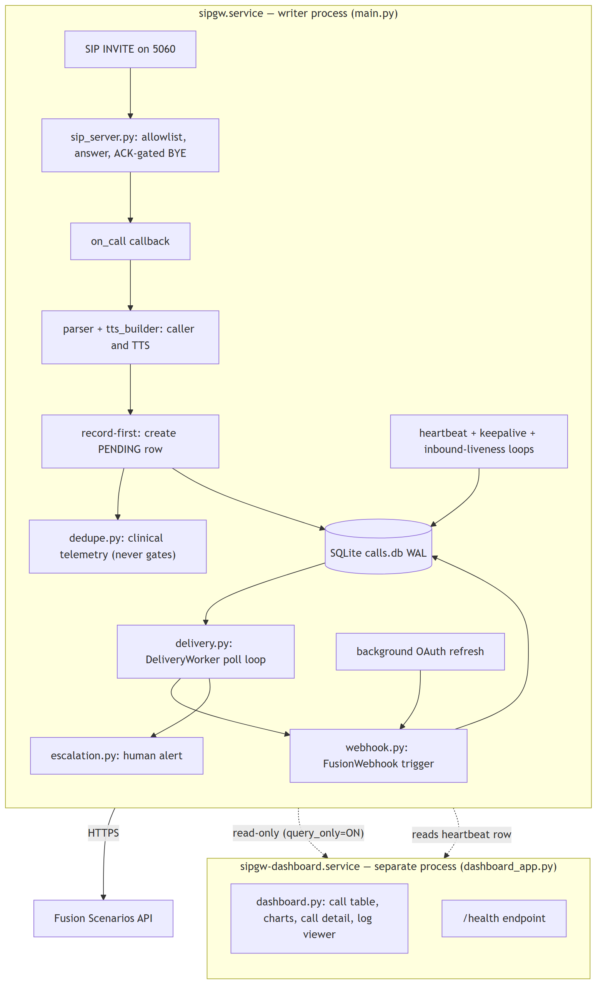

4.1 Stage-by-stage
Stage | Module | Responsibility
Ingress | sip_server.py | Listen on 5060 UDP+TCP; enforce the source-IP allowlist; answer INVITE (100/200); run ACK-gated immediate-BYE teardown; stamp last-inbound time for liveness.
Parse + compose | parser.py, tts_builder.py, lookups.py | Extract caller/room/area from the From header; resolve area name and call purpose from lookups.yaml; assemble the spoken TTS string (preamble + play count).
Record-first | main.on_call → database.py | Persist the page as a PENDING row before any delivery attempt. This is the durability boundary.
Dedupe (telemetry) | dedupe.py | Compute a clinical fingerprint and, when a shadow window is configured, log clinical duplicates. In this build it runs after the insert and never gates delivery (see §4.2).
Deliver | delivery.py | Poll the outbox, claim rows, drive the Fusion POST with bounded retries + backoff, honor Retry-After delta-seconds, expire stale rows, and invoke escalation on permanent failure.
Webhook | webhook.py | OAuth2 client-credentials auth with a background token refresher; POST the scenario trigger; single 401 re-auth-and-retry; surface Retry-After to the worker; bounded read-only reachability probe for /health.
Escalate | escalation.py | Fire a human alert (Teams/Slack/PagerDuty/NOC webhook) when a page fails or expires.
Liveness | main.py loops + watchdog.py | Heartbeat writer, Fusion reachability keepalive, inbound-liveness flush, and the systemd Type=notify watchdog pinger.

4.2 Dedupe status in this build — an accuracy note
Rauland double-emits roughly one INVITE in three (two INVITEs per event). The dedupe subsystem (dedupe.py) exists to measure and eventually suppress those, but in the deployed c23f3eb build it ships inert:
- The on_call insert is record-first and never gated — the deduper is evaluated after the PENDING row is written, purely as telemetry.
- With the shipped config (dedupe.enforce: false, dedupe.window_seconds: 0) the deduper does not even query the database and always returns a no-suppress decision. Setting window_seconds > 0 with enforce: false turns on shadow logging (WOULD suppress ...) but every page is still delivered.
- enforce: true is a fatal config error by policy (real suppression requires clinical sign-off). Even the (unreachable) enforce branch is never allowed to drop a second real Code Blue for the same room — the fail-safe direction is always “deliver.”
The clinical fingerprint (cf-v1:, keyed on area/room/bed/purpose) is deliberately distinct from the SIP transaction fingerprint (v1:, from Call-ID/From/CSeq in sip_message.py) used for INVITE-retransmit correlation and the event_id column. The two are never conflated. Enforcing, event-id-keyed suppression is tracked as roadmap work (issues #5 and the dedupe tail).

5. The durable outbox

5.1 Storage
All state lives in a single SQLite database at /var/lib/sipgw/calls.db, opened in WAL (write-ahead logging) mode. WAL is what lets the writer commit pages while the dashboard reads concurrently without blocking. The writer process owns every write; the dashboard opens the same file read-only (query_only=ON) and can never mutate a page or heartbeat.
The calls table carries the outbox columns: state, attempts, last_error, delivered_at, sip_call_id, duplicate_of, is_test, and event_id, with supporting indexes. Test traffic (is_test = 1, set in dry-run) never fires a real page and never counts in statistics or dashboard rollups.

5.2 State machine
Each page is a row that moves through a small, explicit state machine. The worker is the only mutator of these states.
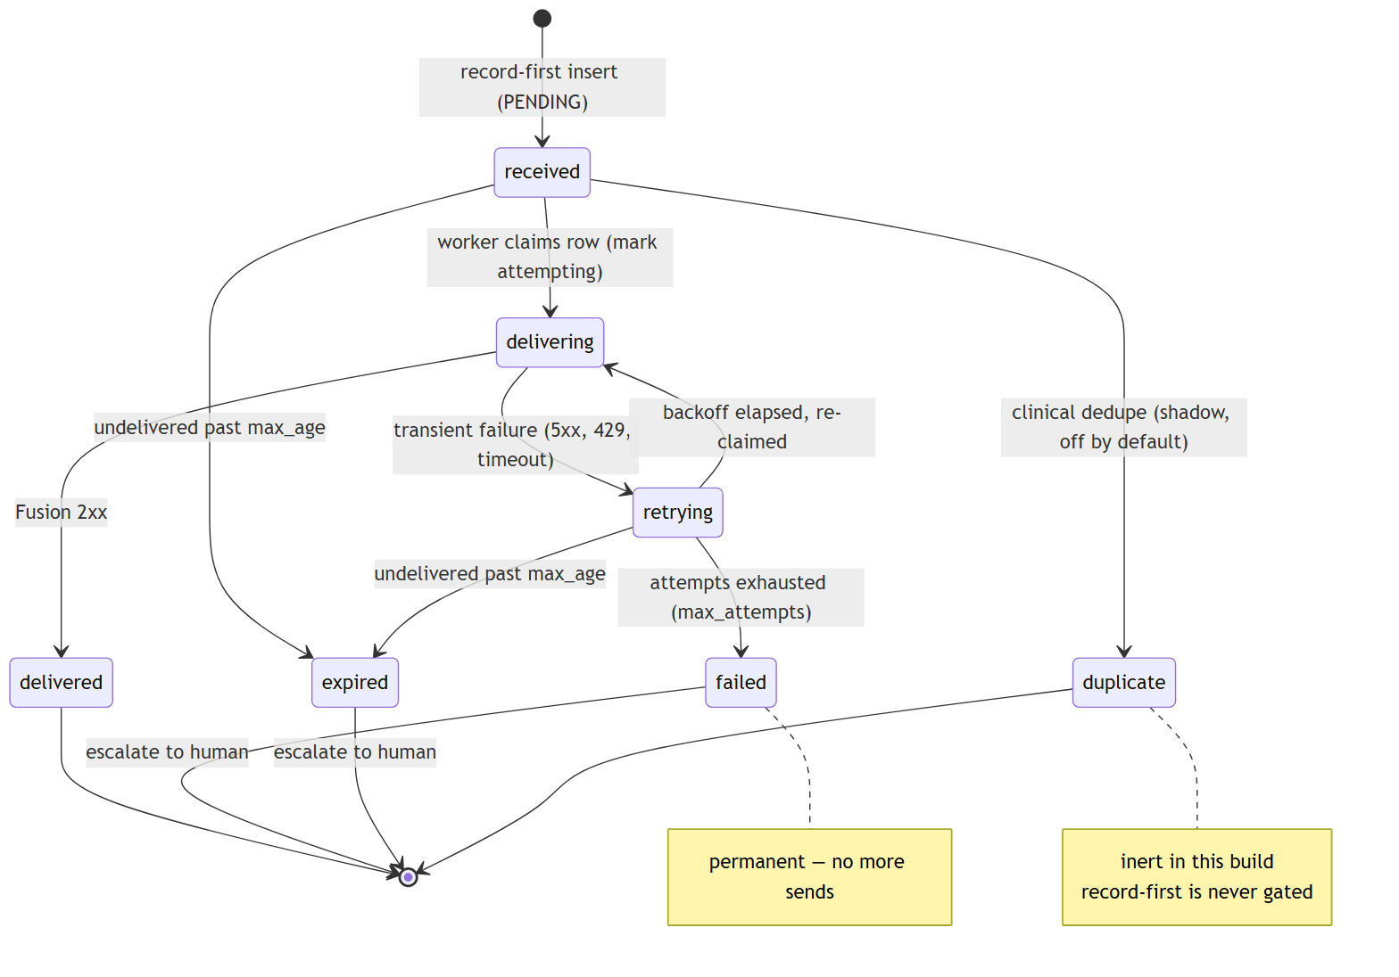
Reading the states:
- received → delivering → delivered is the happy path: recorded, claimed, POSTed, 2xx.
- retrying is entered on any transient failure (5xx, 429, timeout, or the -1 “exception” status). The worker computes a backoff — exponential from base_backoff_seconds, capped at max_backoff_seconds, and it honors a Fusion Retry-After delta-seconds header when present — then re-claims the row when the cooldown elapses.
- failed is terminal: attempts reached max_attempts with no success. The worker records the last status/error and escalates.
- expired is terminal: the page sat undelivered longer than max_age_seconds. It is escalated as well — a page that can no longer be trusted to be timely is surfaced to a human rather than delivered late and silently.
- duplicate is the dedupe terminal state. It exists in the schema and the state model, but in this build the record-first insert is never gated, so pages are not routed here in production (§4.2).
The legacy state (rows written by pre-outbox builds) is treated as already-handled and is excluded from the deliverable set; state-aware statistics (#10) classify legacy, delivered, and in-flight rows correctly on the dashboard.

5.3 Crash recovery — at-least-once delivery
On startup the worker calls recover(), which returns any crash-orphaned delivering rows to received (recover_inflight). If the process died mid-POST — after claiming a row but before recording its outcome — that row is simply re-queued and retried. Combined with record-first insertion, this gives at-least-once delivery: the only way a recorded page leaves the system is DELIVERED, FAILED (escalated), or EXPIRED (escalated). It is never silently dropped. (On a graceful shutdown the worker also best-effort drain()s the queue, but durability does not depend on drain succeeding.)

5.4 OAuth off the critical path
webhook.py runs a background token refresh loop that renews the OAuth token roughly token_refresh_margin_seconds before it expires. Delivery therefore almost always uses a warm cached token; the on-demand fetch inside trigger_scenario is a fallback, not the norm. A single 401 triggers one clear-cache-and-retry. This is the direct architectural fix for the 2026-06-12 incident: no page waits on — or dies from — an inline token fetch.

6. Deployment topology — two independent services
The paging path is deliberately isolated from the UI. Two systemd units run on the same host and share only the SQLite file (writer read-write, dashboard read-only).
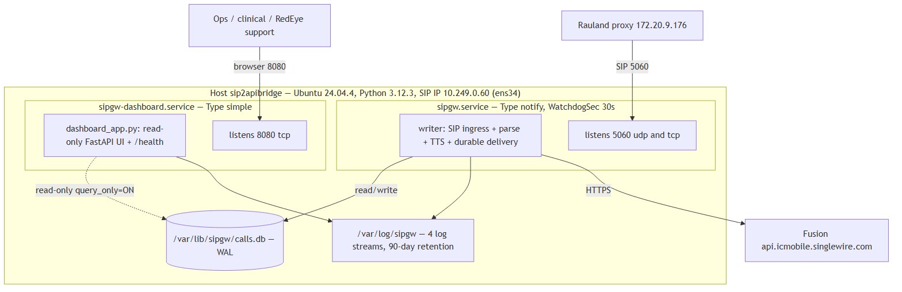

6.1 The two units
 | sipgw.service (writer) | sipgw-dashboard.service (dashboard)
systemd type | Type=notify, WatchdogSec=30s | Type=simple
Entry point | python -m sipgw.main <config> | python -m sipgw.dashboard_app <config>
Owns | SIP ingress, parse, TTS, the durable delivery worker, escalation, heartbeat, watchdog | Read-only web UI on :8080 and /health
DB access | read-write (all writes) | read-only (query_only=ON)
Listens | 5060 UDP + TCP | 8080 TCP
Restart impact | interrupts paging (mitigated by record-first + recovery) | none — paging continues uninterrupted
Why split (#14). The dashboard is a rich FastAPI app (call table, a 90-day stacked chart by call type, a correlated /call/{id} detail view, a date-picker log viewer, per-call diagnostic-bundle export). Running it in-process with the writer would mean a UI dependency, a memory leak, or a routine dashboard upgrade could jeopardize the paging path. Splitting the processes means the dashboard can be restarted or fail on its own while the writer keeps answering INVITEs and delivering pages. The two processes must not both attach the rotating file handler to the writer’s shared logs (a midnight doRollover() race would corrupt them), so the dashboard uses dashboard-safe logging to its own sipgw_dashboard.log.

6.2 /health and liveness
/health is served by the dashboard but reflects the writer’s health, because the writer stamps a heartbeat row and the dashboard reads it:
- Heartbeat freshness is the sole determinant of the HTTP status code. The writer stamps a heartbeat every heartbeat_interval_seconds (10 s); /health returns 503 once the heartbeat is older than stale_after_seconds (30 s). Everything else on /health is informational and never flips the status code by default.
- Fusion reachability — a bounded, read-only GET of the scenario every keepalive_interval_seconds (300 s). It never triggers a scenario and never sends a page; the result is stamped for /health as an informational field. A transient Fusion blip is deliberately not allowed to 503 a single node (which a monitor could then pull or restart). Turning that into a hard 503 is opt-in (fail_on_fusion_unreachable, default off).
- Inbound-liveness — Rauland sends SIP only on real events (no keepalives), so the writer stamps the time of the last allowed-network inbound SIP and flushes it to the DB. /health surfaces last_inbound_sip_age_s; the dashboard shows “Last inbound from Rauland” and turns amber past inbound_stale_after_seconds (5 days). This is informational; optional silence-escalation is off by default and, if enabled, must be set above the historical ~4.27-day maximum quiet gap to avoid false alarms.

7. Host, ports, and network facts
Fact | Value
Host | sip2apibridge, Ubuntu 24.04.4, Python 3.12.3
SIP / SDP IP | 10.249.0.60 (interface ens34)
SIP port | 5060 UDP and TCP (writer)
Dashboard port | 8080 TCP (read-only UI, no auth — see below)
Install root | /opt/sipgw (venv /opt/sipgw/venv)
Logs | /var/log/sipgw — 4 streams, 90-day retention
Database | /var/lib/sipgw/calls.db (WAL)
SIP allowlist | 172.16.0.0/12, 127.0.0.0/8, 10.0.0.0/8
Upstream SIP | Rauland UAC 172.20.9.170 → proxy 172.20.9.176 → gateway
Fusion base | https://api.icmobile.singlewire.com/api, scenario SIPtoTTSBridge, field customTTS
Four log streams (/var/log/sipgw), rotated at midnight with async rotation (#6):
- sipgw.log — writer application log (the call/delivery narrative).
- sipgw_api_debug.log — full Fusion HTTP request/response captures (secrets masked).
- sipgw_sip_debug.log — raw inbound/outbound SIP messages and INVITE fingerprints.
- sipgw_dashboard.log — the dashboard process’s own log.
Timestamps. The host clock is Etc/UTC and all stored timestamp values are canonical UTC RFC3339 millis-Z. Note the config key logging.timezone: America/New_York is declared but not applied to stored timestamps in this build — persisted times are UTC. The dashboard renders local wall-clock for display.

7.1 Security posture at the perimeter
There is no host firewall active (nftables is empty). Ingress protection currently relies entirely on the application-layer SIP allowlist in sip_server.py, which 403s any source outside the allowed networks before it can become a page. Two hardening items follow directly from this and are carried in the Security and Roadmap sections:
- Add an nftables policy scoping 5060 and 8080 to the expected source networks, so the OS enforces the boundary in addition to the app.
- The dashboard on :8080 has no authentication. It is read-only and hides test rows, but it exposes call detail and log content. Until it is placed behind auth or a network boundary, treat :8080 as sensitive and restrict it at the network layer.

8. Design principles (why it’s shaped this way)
- Record before you send. Durability is a property of when you persist, not of how hard you retry. Writing the PENDING row before the first Fusion attempt is what converts “best-effort page” into “durable page.”
- Decouple the SIP dialog from delivery. Answering the call and tearing it down must never wait on Fusion. The page fires on a separate task; the delivery worker runs on its own loop.
- Keep the token warm, off the path. The one incident this build was built around was an inline token fetch on the critical path. Background refresh removes that class of failure entirely.
- Isolate the UI from the paging path. A read-only dashboard in its own process can never take paging down with it.
- Fail safe, then fail loud. Ambiguity always resolves toward deliver the page (dedupe never drops a real Code Blue; recovery re-queues orphans). When a page genuinely cannot be delivered, it is FAILED/EXPIRED and escalated to a human, never dropped in silence.

Continue to the Configuration, Operations, Security, and Reliability sections for the operational detail behind each component described here. Planned work — the NetScaler active/active HA epic (#17), zero-downtime socket-activated restarts (#19), OS auto-restart coordination (#20), and remaining Dashboard-v2 phases (#13) — is documented, and labeled planned, in the HA Plan and Roadmap sections.

Components & Dependencies
This section is the definitive map of the deployed build (production c23f3eb, the v1.7 line = v1.6.5 + 6 commits). It answers three questions:
- What modules make up the sipgw package, and what is each one responsible for?
- What does the gateway depend on — Python packages and external systems — to do its job?
- Which of those modules runs in which of the two systemd services?
Everything here reflects what is installed and running on host sip2apibridge today. Where a module ships a capability in an inert or shadow state (dedupe enforcement is the notable case), that is called out explicitly rather than described as if it were active.

1. Package layout
The application is a single Python package, sipgw, installed at /opt/sipgw and run out of its own virtualenv (/opt/sipgw/venv, Python 3.12.3). Two separate processes are started from it — the writer (python -m sipgw.main) and the dashboard (python -m sipgw.dashboard_app) — but they import from the same package on disk.
/opt/sipgw/
├── sipgw/ # the application package
│ ├── __init__.py
│ ├── main.py # WRITER entry point (call path)
│ ├── dashboard_app.py # DASHBOARD entry point (read-only UI)
│ ├── config.py # config loader + fail-fast validation
│ ├── logging_config.py # dual logging + async rotation
│ ├── sip_server.py # SIP UA server (INVITE/ACK/BYE/CANCEL/OPTIONS)
│ ├── sip_message.py # raw SIP parse + invite_fingerprint (#15)
│ ├── rtp_handler.py # RTP u-law silence to hold the call up
│ ├── parser.py # username/display-name → area/room/bed/purpose
│ ├── lookups.py # area-name / purpose lookup tables (lookups.yaml)
│ ├── tts_builder.py # parsed call → announcement text
│ ├── webhook.py # Fusion OAuth2 + scenario trigger (FusionWebhook)
│ ├── delivery.py # durable outbox / retry worker (DeliveryWorker)
│ ├── escalation.py # human-channel alert on delivery failure
│ ├── dedupe.py # clinical dedupe — SHIPS SHADOW/DISABLED
│ ├── database.py # SQLite (WAL) call store + heartbeat
│ ├── watchdog.py # systemd Type=notify / sd_notify pinger
│ ├── safety.py # dry-run / test-mode NO-SEND guarantee
│ └── dashboard.py # FastAPI UI, charts, /call/{id}, /health, log viewer
├── config.yaml # deployment config (secrets masked in this manual)
├── lookups.yaml # area + purpose lookup tables
└── venv/ # Python 3.12 virtualenv

2. Module responsibility table
Modules are grouped by the role they play. “Runs in” tells you which service(s) import and exercise the module at runtime — W = writer (sipgw.service), D = dashboard (sipgw-dashboard.service).

Entry points & shared setup
Module | Runs in | Responsibility
__init__.py | W · D | Package marker. """sipgw - SIP-to-Webhook Gateway for Informacast Fusion.""" Nothing runtime-bearing.
main.py | W | Writer entry point (python -m sipgw.main <config.yaml>). Wires the SIP server + delivery worker + heartbeat writer + watchdog together and owns all DB writes. Since the #14 two-service split it no longer serves HTTP; it keeps writing the heartbeat row that the dashboard reads for /health.
dashboard_app.py | D | Dashboard entry point (python -m sipgw.dashboard_app <config.yaml>). Runs the FastAPI UI in its own process. Opens the shared SQLite DB read-only (query_only=ON) so it can never mutate a page or heartbeat, uses dashboard-safe logging so it never attaches the writer’s rotating file handler, and mirrors the writer’s bootstrap (load_config → effective_dry_run → prod-DB barrier → validate_config) so a misconfigured/unsafe dashboard refuses to start exactly like the writer does.
config.py | W · D | Loads config.yaml into typed dataclasses with sensible defaults for every value, and provides fail-fast validation (#9). Notably makes dedupe.enforce=true a fatal config error — enforcement is forbidden in production today.
logging_config.py | W · D | Dual logging: stdout + a daily-rotating file with .tgz compression and retention purge (#6, async rotation). Exposes a dashboard-safe setup so the read-only process never races the writer at midnight doRollover(). Note: logging.timezone: America/New_York is declared but not applied to stored timestamps — the host clock is Etc/UTC and stored timestamps are UTC RFC3339 millis-Z.

SIP ingress & parsing (the call path)
Module | Runs in | Responsibility
sip_server.py | W | Purpose-built lightweight SIP UA server on UDP+TCP 5060. Answers INVITE, holds the call up with RTP silence, and terminates on BYE/CANCEL/timeout. Implements only the SIP methods the gateway needs (INVITE, ACK, BYE, CANCEL, OPTIONS), not full SIP. Enforces the SIP source allowlist and performs the ACK-gated immediate-BYE that fixed the old 481 race. Supports multiple concurrent inbound calls.
sip_message.py | W | Parses raw SIP requests/responses into a structured form (the INVITE/ACK/BYE/CANCEL subset). Home of the invite_fingerprint (#15) — the SIP transaction identity (Call-ID / From / CSeq), i.e. “is this a retransmit of the same INVITE.” Distinct from the clinical fingerprint in dedupe.py.
rtp_handler.py | W | RTP silence sender. Emits u-law silence (0xFF) so the held SIP call stays up, and discards any inbound RTP. This is what keeps Rauland from tearing the call down before the page is built.
parser.py | W | Extracts area / room / bed from the SIP username (a{area}r{room}[b{bed}], asterisks stripped) and call purpose from the SIP display name.
lookups.py | W · D | Loads the area-name and call-purpose substitution tables from lookups.yaml so they can be edited without a code change. (The dashboard’s verify-lookups view reads these too.)
tts_builder.py | W | Builds the announcement text from parsed call info: base "{CallPurpose}! {AreaName} {RoomName}", then assembles the preamble + 3× repetition sent to Fusion as customTTS.

Delivery, durability & escalation
Module | Runs in | Responsibility
database.py | W (rw) · D (ro) | SQLite call store (/var/lib/sipgw/calls.db, WAL) via aiosqlite. Holds the call history + delivery state machine (state, attempts, last_error, delivered_at, sip_call_id, duplicate_of, is_test, event_id + indexes) and the heartbeat row. The writer owns all writes; the dashboard opens it read-only.
webhook.py | W | FusionWebhook — the InformaCast Fusion client. OAuth2 client-credentials auth (token cached and auto-refreshed off the critical path) plus scenario triggering: POST {base}/token for the token, then POST {base}/v1/scenario-notifications?scenarioId=… with the customTTS field. It is the only thing that talks to Fusion, and it carries the §2a no-send guard in dry-run.
delivery.py | W | DeliveryWorker — the durable outbox. Pages are recorded first (state='pending') by the SIP path, then delivered asynchronously here, so a Fusion outage or a crash between record-and-send cannot drop a Code Blue. Retries with exponential backoff (honoring Retry-After), escalates on exhaustion, and expires pages left undelivered too long. On startup recover() returns crash-orphaned delivering rows to pending (at-least-once delivery). It drives FusionWebhook; it never sends anything itself.
escalation.py | W | Escalator — alerts a human channel (Teams/Slack/PagerDuty/NOC via escalation.webhook_url) when a page hits terminal failed (retries exhausted) or expired (staleness). Injected into the delivery worker as on_escalate; when absent the worker only logs. Shares the dry-run no-send guarantee. Escalation errors are logged, never raised — they must never disrupt delivery.
dedupe.py | W | Computes the clinical identity of a page — the normalized (area, room, bed, purpose) tuple (cf-v1: prefix). Ships SHADOW / DISABLED. With the deployed config (enforce: false, window_seconds: 0) evaluate() does not even query the DB and always returns no-suppress; a test-only window_seconds > 0 turns on a shadow lookup that logs WOULD suppress … but still never drops a page. enforce: true is forbidden (validate_config fatal). This is deliberately distinct from sip_message.py’s SIP-transaction invite_fingerprint and must never be conflated with it. See the note below.

Health, safety & UI
Module | Runs in | Responsibility
watchdog.py | W | systemd Type=notify + WatchdogSec integration via a pure-Python sd_notify. Sends READY=1 once listeners are up and pings the watchdog on a cadence. Pings prove event-loop liveness only (decoupled from DB writes), so transient DB slowness never restarts the life-safety pager. Structurally inert when NOTIFY_SOCKET is unset (tests, dry-run, non-systemd, single-service rollback).
safety.py | W · D | The load-bearing NO-SEND guarantee for dry-run / test mode. In effective dry-run the shared httpx client is built with NoSendGuardTransport, which refuses to forward any request whose host is not 127.0.0.1 — every Fusion origin and the escalation POST share this client, so none can reach a real host during testing. Also provides is_test marking so test traffic never fires a real page and never counts in stats. Effective dry-run = config.dry_run or env SIPGW_DRY_RUN=1; the environment may only enable dry-run, never disable it.
dashboard.py | D | The FastAPI web UI (Dashboard v2). Call table with pagination + auto-refresh, 90-day stacked chart by call type, the correlated /call/{id} call-detail view, date-picker log viewer, per-call plain-text diagnostic bundle export, verify-lookups, and the real /health endpoint (delivery health + Fusion reachability + last-inbound-SIP age). Hides is_test rows. No authentication — see the Security section.
The two fingerprints — do not confuse them. invite_fingerprint (in sip_message.py, prefix v1:) is the SIP transaction identity: “is this the same INVITE arriving twice on the wire.” The clinical fingerprint (in dedupe.py, prefix cf-v1:) is the who/where/why identity: “is this the same clinical event.” They are separate functions on purpose. The clinical one is shadow/disabled and never drops a page in the deployed build.
Dedupe status, stated plainly. The Rauland source double-emits (~1 in 3 events arrives as two INVITEs). In the current production build those duplicates are not actively suppressed by dedupe.py — it ships inert. The config keys exist (dedupe.enforce, dedupe.window_seconds) and the shadow telemetry can be enabled for measurement, but enforcement remains gated behind clinical sign-off and is a fatal config error today. Treat enforcing dedupe as a Roadmap item (#5 tail), not a shipped behavior.

3. Runtime dependencies

3.1 Python packages
The gateway runs on CPython 3.12.3 in a dedicated virtualenv. The repository pins loose lower bounds in requirements.txt; the table below lists both those pins and the actual versions resolved in the deployed venv on sip2apibridge (from the host inventory). When reproducing the environment, match the deployed column.
Package | requirements.txt pin | Deployed version | Used by / why
httpx | >=0.27.0 | 0.28.1 | Async HTTP client for all Fusion calls (webhook.py) and escalation POSTs (escalation.py); the dry-run NoSendGuardTransport plugs in here.
fastapi | >=0.115.0 | 0.129 | Dashboard web framework (dashboard.py / dashboard_app.py).
starlette | (via fastapi) | (fastapi-matched) | ASGI plumbing under FastAPI — routing, requests/responses. Pulled in transitively.
uvicorn[standard] | >=0.32.0 | 0.41 | ASGI server that runs the dashboard app.
aiosqlite | >=0.20.0 | 0.22 | Async SQLite access for the call store + heartbeat (database.py).
PyYAML | >=6.0 | 6.x | Parses config.yaml and lookups.yaml (config.py, lookups.py).
Jinja2 | >=3.1.0 | 3.1.x | HTML templating for the dashboard.
anyio | (via httpx/starlette) | (dep-matched) | Async concurrency primitives underlying httpx and Starlette. Transitive.
tzdata | (present) | (present) | IANA tz database on a slim Ubuntu host, so America/New_York resolves for the dashboard’s local-wall-clock display.
pytest, pytest-asyncio | >=8.0.0, >=0.24.0 | (test only) | Test suite; not required at runtime and not part of the paging path.
No third-party SIP or RTP stack is used — sip_server.py, sip_message.py, and rtp_handler.py are purpose-built on the Python standard library (asyncio, sockets, struct). This keeps the life-safety call path free of heavyweight external SIP dependencies.

3.2 External systems
The gateway is a bridge, so its “dependencies” also include the systems on either side of it and the network between them.
External system | Role | Endpoint / identity (deployment facts)
Rauland nurse-call (upstream SIP) | Source of INVITEs (Code Blue / RRT events) | UAC 172.20.9.170 → proxy 172.20.9.176 → gateway 10.249.0.60:5060. Rauland double-emits ~1/3 of events.
InformaCast Fusion / Singlewire (downstream API) | Fires the overhead page | Base https://api.icmobile.singlewire.com/api; scenario “SIPtoTTSBridge” (4cba52d8-…), field customTTS, audience 2ffd6864-… (customer-owned). OAuth2 client-credentials — <CLIENT_ID> / <CLIENT_SECRET> are masked.
Escalation channel (optional) | Human alert on delivery failure | escalation.webhook_url (Teams/Slack/PagerDuty/NOC). Opt-in.
Network / DNS | Reachability of both sides | SIP allowlist 172.16.0.0/12, 127.0.0.0/8, 10.0.0.0/8; outbound HTTPS to Fusion. No host firewall is active (empty nftables) — ingress relies on the app allowlist. See Security.
systemd (host init) | Process supervision + watchdog + restart | Type=notify watchdog on the writer; Restart=always on both units.
Host filesystem | State + logs | DB /var/lib/sipgw/calls.db (WAL), logs /var/log/sipgw (four streams, 90-day retention).

4. Which modules run in which service
The paging path is intentionally isolated from the UI: they are two independent systemd units sharing only the SQLite database and the log directory on disk. Restarting the dashboard cannot interrupt paging.
 | sipgw.service (WRITER) | sipgw-dashboard.service (DASHBOARD)
Entry point | python -m sipgw.main config.yaml | python -m sipgw.dashboard_app config.yaml
systemd type | Type=notify, WatchdogSec=30 | Type=simple
Port | 5060 udp+tcp (SIP) | 8080 tcp (HTTP)
DB access | read-write (owns all writes) | read-only (query_only=ON)
Privileged bind | CAP_NET_BIND_SERVICE (port 5060) | none (unprivileged 8080)
Restart / resource | Restart=always, StartLimitIntervalSec=0 | Restart=always, MemoryMax=256M, CPUQuota=50%
Modules exercised | main, config, logging_config, sip_server, sip_message, rtp_handler, parser, lookups, tts_builder, webhook, delivery, escalation, dedupe, database (rw), watchdog, safety | dashboard_app, dashboard, config, logging_config (dashboard-safe), database (ro), lookups, safety
Both units run as the unprivileged sipgw user/group with NoNewPrivileges, ProtectSystem=strict, ProtectHome, and PrivateTmp. The writer’s watchdog lives only on the writer — the dashboard is a plain long-running HTTP server, so a stuck UI request can never trip the life-safety watchdog. The dashboard also gets its own memory/CPU envelope (MemoryMax/CPUQuota, effective only under real systemd cgroups) so a runaway UI request cannot starve the writer.
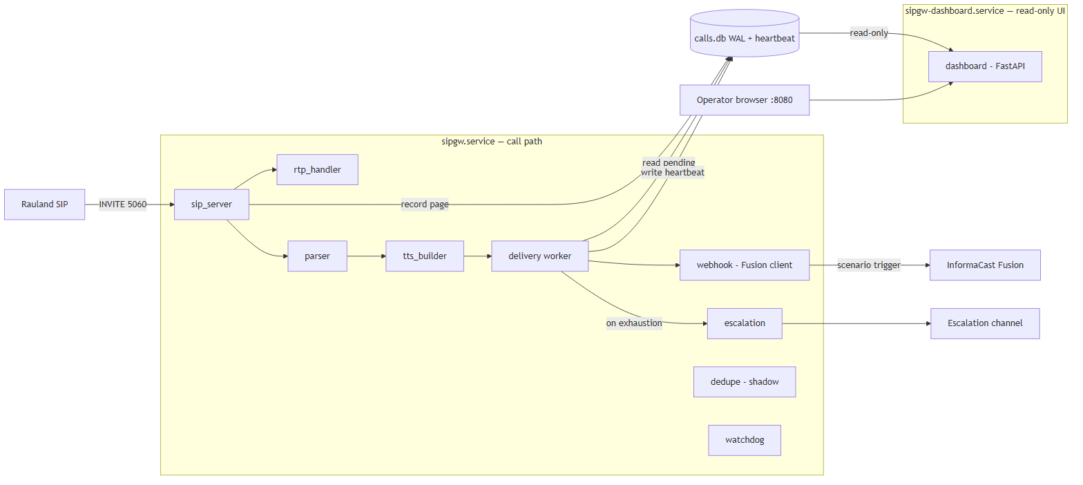

5. Dependency risk notes
- No third-party SIP/RTP stack. The wire-facing code is standard-library only. That removes a class of supply-chain and CVE exposure from the call path, at the cost of implementing only the SIP subset the gateway needs.
- httpx is the single outbound HTTP dependency and the single choke point for the dry-run NO-SEND guard. Both the Fusion client and escalation share one guarded client, so the safety property holds structurally rather than by per-call-site discipline.
- Loose lower-bound pins vs. deployed versions. requirements.txt pins minimums, not exact versions; the deployed venv resolved to the versions in §3.1. For reproducible rebuilds, pin the deployed column (or a lockfile) so a future pip install cannot silently pull a newer FastAPI/uvicorn/httpx into the life-safety path.
- dedupe.py ships inert. It is present, imported, and constructed, but it does not gate delivery. Do not rely on it to collapse Rauland’s duplicate INVITEs in the current build; that remains a Roadmap item pending clinical sign-off.

Installation & Configuration
This section covers everything required to stand up the RedEye sip2api Gateway on a fresh host and configure it for production: prerequisites, the installer and the two systemd units, the full config.yaml key reference, the lookups.yaml area/room/purpose tables (with worked “add a new area/room” examples), the firewall/port model, and the environment variables that control config paths and dry-run.
This documents the current production build (c23f3eb, the v1.7 line on main) as deployed on host sip2apibridge. Where the code and older docs disagree, the code wins — the authoritative key list below was read straight from sipgw/config.py at this build.

1. Prerequisites
Requirement | Production value | Notes
Operating system | Ubuntu 24.04.4 LTS | Any modern systemd Linux works; the installer targets Debian/Ubuntu (apt).
Python | 3.12.3 | Installer accepts >= 3.11; production runs 3.12.
Privileges | root for install | The service itself runs as the unprivileged sipgw user.
Privileged port | UDP/TCP 5060 | Granted via CAP_NET_BIND_SERVICE, not by running as root.
Egress | HTTPS 443 to Singlewire | The gateway must reach api.icmobile.singlewire.com for OAuth + paging.
Python packages | see requirements.txt | httpx, fastapi, uvicorn[standard], aiosqlite, pyyaml, jinja2, tzdata (plus pytest/pytest-asyncio for the test suite). Installed into a venv by install.sh.
The gateway is pure-Python with no compiled extensions; the only OS packages the installer adds are python3-venv and python3-pip.

Production filesystem layout
Path | Purpose | Owner / mode
/opt/sipgw | Application code + config.yaml + lookups.yaml | sipgw, config 640
/opt/sipgw/venv | Python virtual environment | sipgw
/var/log/sipgw | Log files (4 streams, see §4) | sipgw, 750
/var/lib/sipgw | SQLite DB calls.db (WAL mode) | sipgw, 750
/etc/systemd/system/sipgw.service | Writer unit | root
/etc/systemd/system/sipgw-dashboard.service | Dashboard unit | root

2. Installation

2.1 Run the installer
Copy the release tree to /opt/sipgw, then run the installer as root:
sudo bash /opt/sipgw/install.sh
install.sh is idempotent and performs seven steps:
- Python check — finds python3.12/python3.11/python3 and requires >= 3.11.
- System deps — apt-get install python3-venv python3-pip.
- Service user — creates the system user sipgw (nologin, home /opt/sipgw).
- Directories — creates /var/log/sipgw and /var/lib/sipgw, owned by sipgw, mode 750.
- Virtualenv — builds /opt/sipgw/venv and pip install -r requirements.txt.
- Ownership — chowns the tree to sipgw; keeps install.sh/uninstall.sh root-owned; sets config.yaml to 640, owner sipgw (it holds the Fusion secret).
- systemd — installs and enables both units, then daemon-reload.
After the installer completes, before first start:
sudo -u sipgw editor /opt/sipgw/config.yaml # set the Fusion client_id / client_secret / scenario_id / audience / scenario_field_id
sudo -u sipgw editor /opt/sipgw/lookups.yaml # confirm area / room mappings

2.2 The two systemd services
The paging path is deliberately split from the UI so the dashboard can be restarted (or crash) without ever interrupting paging.
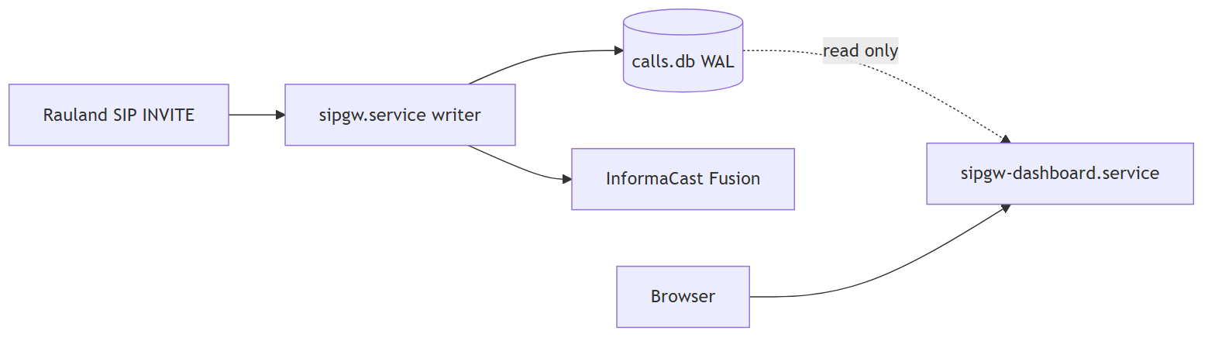
Unit | Type | Role | Watchdog | Port | Runs
sipgw.service | notify | Writer / life-safety path: SIP ingress, parse, TTS, durable delivery, heartbeat | WatchdogSec=30 | 5060 udp+tcp | python -m sipgw.main /opt/sipgw/config.yaml
sipgw-dashboard.service | simple | Read-only web UI + /health | none | 8080 tcp | python -m sipgw.dashboard_app /opt/sipgw/config.yaml
Key unit facts:
- Writer (sipgw.service) — Type=notify with WatchdogSec=30: the app sends READY=1 once listeners are up and pings the watchdog on a cadence; a hung event loop is detected and the process restarted. Restart=always, RestartSec=5, and StartLimitIntervalSec=0 so start-rate limiting can never wedge the pager in a failed state. Hardened with NoNewPrivileges, ProtectSystem=strict, ProtectHome, PrivateTmp, and ReadWritePaths=/var/log/sipgw /var/lib/sipgw /opt/sipgw. Binds the privileged port via AmbientCapabilities=CAP_NET_BIND_SERVICE — it does not run as root.
- Dashboard (sipgw-dashboard.service) — plain Type=simple long-running HTTP server (no watchdog — that stays on the life-safety writer). Opens the DB read-only (query_only) and reads only the writer’s heartbeat row for /health. Bounded by MemoryMax=256M and CPUQuota=50% so a runaway UI request can never starve the writer. Binds unprivileged 8080, so no CAP_NET_BIND_SERVICE.
Both units load the same config.yaml and set SIPGW_CONFIG=/opt/sipgw/config.yaml and SIPGW_LOOKUPS=/opt/sipgw/lookups.yaml in their environment.

2.3 Start, verify, and follow logs
sudo systemctl start sipgw # writer FIRST
sudo systemctl start sipgw-dashboard # then the UI
systemctl status sipgw sipgw-dashboard
journalctl -u sipgw -f # writer
journalctl -u sipgw-dashboard -f # dashboard
# Dashboard + health once up:
curl -s http://<host-ip>:8080/health
Because the dashboard is independent, systemctl restart sipgw-dashboard is safe at any time and never touches the paging path.

3. config.yaml — full reference
config.yaml lives at /opt/sipgw/config.yaml (mode 640, owner sipgw, since it holds the Fusion secret). Both services read it. A seed template ships as config.yaml.example.
Loader behavior (config.py): resolution order is explicit path > SIPGW_CONFIG env > /opt/sipgw/config.yaml. A missing file or any missing key falls back to the built-in default. Unknown keys and unknown sections are not fatal — they are ignored but logged as a non-fatal warning (unknown key '…' ignored (typo?)), so a typo shows up loudly in the startup log instead of silently doing nothing.
Fail-fast validation (validate_config) runs at startup. In production (dry-run off) it refuses to start unless the Fusion credentials, scenario_id, audience, and a preset scenario_field_id are all present, plus a set of range checks (ports, RTP range, CIDRs, delivery tuning). Other odd-but-survivable values become warnings.

3.1 sip: — SIP ingress and dialog handling
sip:
bind_ip: "0.0.0.0"
bind_port: 5060
allowed_networks:
- "172.16.0.0/12"
- "127.0.0.0/8"
- "10.0.0.0/8"
call_timeout_seconds: 600
immediate_bye: true
immediate_bye_ack_timeout_seconds: 2.0
rtp_port_range_start: 10000
rtp_port_range_end: 20000
Key | Default | Meaning
bind_ip | 0.0.0.0 | Address the SIP listener binds.
bind_port | 5060 | SIP port (UDP + TCP). Must be 1–65535 (validated).
allowed_networks | ["172.16.0.0/12"] | CIDR allowlist for accepted SIP sources. Each entry must be a valid CIDR (validated); an empty list means every source is rejected (warned). This is the primary ingress control today — see §5.
call_timeout_seconds | 600 | Max dialog lifetime before the gateway tears it down. <=0 warns.
immediate_bye | false (prod sets true) | ACK-gated immediate BYE: the gateway answers 200 OK, keeps the dialog, and sends its BYE only after the caller’s ACK — killing the old 481 race.
immediate_bye_ack_timeout_seconds | 2.0 | Per-call fallback: if the ACK is lost, fire the deferred BYE and free the RTP port after this many seconds so a dropped ACK can never strand a dialog. <=0 with immediate_bye on is warned (the BYE could fire before an ACK arrives).
rtp_port_range_start | 10000 | Low end of the RTP port pool.
rtp_port_range_end | 20000 | High end. Must be > start (fatal otherwise).
Production allowlist matches the upstream SIP path: Rauland UAC 172.20.9.170 → proxy 172.20.9.176 → gateway 10.249.0.60.

3.2 fusion: — InformaCast Fusion webhook (secrets live here)
fusion:
base_url: "https://api.icmobile.singlewire.com/api"
token_url: "https://api.icmobile.singlewire.com/api/token"
audience: "<PROVIDER_ID>"
scenario_id: "<SCENARIO_ID>"
scenario_endpoint: "/v1/scenario-notifications"
variable_name: "customTTS"
scenario_field_id: "<FIELD_ID>"
client_id: "<CLIENT_ID>"
client_secret: "<CLIENT_SECRET>"
token_refresh_margin_seconds: 300
dry_run: false
Key | Default | Meaning
base_url | https://api.icmobile.singlewire.com/api | Fusion API base. Must be an http(s) URL (fatal otherwise).
token_url | …/api/token | OAuth2 token endpoint. Must be http(s) (fatal otherwise).
audience | "" | Fusion provider/audience ID. Required in production. Customer-owned; may be shown.
scenario_id | "" | The “SIPtoTTSBridge” scenario ID. Required in production.
scenario_endpoint | /v1/scenario-notifications | Scenario-trigger path appended to base_url.
variable_name | customTTS | The scenario field variable the TTS string is written into.
scenario_field_id | "" | Resolved field ID for variable_name. Required (preset) in production so the first real page never triggers a live field-id lookup.
client_id | "" | OAuth2 client id. Required in production. Mask as <CLIENT_ID> — never print the value.
client_secret | "" | OAuth2 client secret. Required in production. Mask as <CLIENT_SECRET> — never print.
token_refresh_margin_seconds | 300 | Refresh the OAuth token this many seconds before expiry so a page never blocks on a token round-trip (background refresh).
dry_run | false | When true (or env SIPGW_DRY_RUN=1), the HTTP client is built with the no-send guard so no notification can reach a real host. See §6.
Secret handling: set client_id, client_secret, scenario_id, audience, and scenario_field_id on the host only. The file is 640/sipgw-owned. In docs, screenshots, and support bundles the credential values must appear only as <CLIENT_ID> / <CLIENT_SECRET>.

3.3 tts: — spoken-message shaping
tts:
play_count: 3
message_preamble: "Attention! Attention! "
iteration_preamble: ""
Key | Default | Meaning
play_count | 3 | How many times the page repeats.
message_preamble | "Attention! " | Text prepended to the first spoken iteration.
iteration_preamble | "Attention! " | Text prepended to each subsequent iteration.

3.4 delivery: — durable-outbox retry worker
delivery:
max_attempts: 6
base_backoff_seconds: 2.0
max_backoff_seconds: 60.0
max_age_seconds: 900.0
poll_interval_seconds: 1.0
batch_size: 20
Key | Default | Meaning
max_attempts | 6 | Delivery attempts before a page is marked failed and escalated. Must be >= 1 (fatal otherwise).
base_backoff_seconds | 2.0 | Initial retry backoff.
max_backoff_seconds | 60.0 | Backoff ceiling.
max_age_seconds | 900.0 | An undelivered page older than this is marked expired and escalated. <=0 warns.
poll_interval_seconds | 1.0 | Worker poll cadence. Must be > 0 (fatal otherwise).
batch_size | 20 | Rows claimed per poll.
This outbox + retry loop is what prevents the 2026-06-12 lost-Code-Blue failure mode (a transient timeout during an inline OAuth fetch): the call is durably recorded first, then delivered with bounded retries, with the token refreshed off the critical path.

3.5 escalation: — human alert channel on permanent failure
escalation:
webhook_url: ""
timeout_seconds: 10.0
Key | Default | Meaning
webhook_url | "" | Teams/Slack/PagerDuty/NOC webhook fired when a page is failed or expired. Empty disables escalation (failures still logged at ERROR). Must be http(s) if set (fatal otherwise). In production, an empty value is warned.
timeout_seconds | 10.0 | HTTP timeout for the escalation POST.

3.6 health: — heartbeat, Fusion reachability, inbound liveness
health:
heartbeat_interval_seconds: 10.0
stale_after_seconds: 30.0
keepalive_interval_seconds: 300.0
fail_on_fusion_unreachable: false
fusion_unreachable_max_age_seconds: 0.0
inbound_flush_interval_seconds: 30.0
inbound_stale_after_seconds: 432000.0
inbound_escalate_after_seconds: 0.0
path: "/var/lib/sipgw/calls.db"
Key | Default | Meaning
heartbeat_interval_seconds | 10.0 | Writer stamps a heartbeat this often; the dashboard reads it.
stale_after_seconds | 30.0 | /health returns 503 once the heartbeat is older than this (the single liveness authority).
keepalive_interval_seconds | 300.0 | Cadence of the read-only Fusion reachability probe (a bounded scenario GET — never a page). < 30s warns (may hammer Fusion).
fail_on_fusion_unreachable | false | Opt-in: when true, a present + fresh failed probe makes /health return 503 fusion-unreachable. Default off — a Fusion blip stays informational only. Keep false with a single node behind an LB/monitor.
fusion_unreachable_max_age_seconds | 0.0 | Freshness bound for the degrade above. 0.0 = auto-derive from probe cadence.
inbound_flush_interval_seconds | 30.0 | How often the writer flushes the last-inbound-SIP time to the DB.
inbound_stale_after_seconds | 432000.0 (5 days) | Dashboard shows “last inbound from Rauland” amber past this. Informational — never gates /health.
inbound_escalate_after_seconds | 0.0 (OFF) | Opt-in once-per-episode silence alert via the escalation webhook. If enabled, keep it above the observed ~4.27-day max quiet gap (recommend >= 432000); a lower value warns.
path | /var/lib/sipgw/calls.db | DB path used by the health/heartbeat reads (mirrors database.path).

3.7 dedupe: — clinical duplicate suppression
IMPORTANT — what this build actually does. At c23f3eb the dedupe feature ships SHADOW / DISABLED and safe-by-default. enforce: true is a fatal config error — the writer refuses to start with it on — because suppressing a page is dropping a Code Blue, and enforcement is not yet clinically approved in code. Only the two keys below are consumed at this build; match_bed and match_purpose exist as dataclass fields (defaults true) but do not enable enforcement.
dedupe:
enforce: false # true = FATAL at this build (refuses to start)
window_seconds: 0 # 0 = shadow lookup never runs; >0 = shadow telemetry only
match_bed: true # field present; not an enforcement switch at this build
match_purpose: true # field present; not an enforcement switch at this build
Key | Default | Meaning
enforce | false | false = never suppresses. true is fatal at this build.
window_seconds | 0 | 0 = the duplicate lookup never runs. >0 with enforce:false is shadow-only telemetry: each clinical duplicate is logged (WOULD suppress … gap=…) and annotated (duplicate_of) to measure the real duplicate rate — but every page is still delivered.
match_bed | true | Match key includes bed (field present; consumed once enforcement ships).
match_purpose | true | Match key includes call purpose (field present; consumed once enforcement ships).
Recommended production setting: leave enforce: false. To measure the Rauland double-emit rate without ever suppressing, set window_seconds: 60 — this turns on the shadow “WOULD suppress” telemetry only. Enforcing suppression (collapsing the two INVITEs Rauland emits per event) is on the roadmap and requires both clinical sign-off and the code change that lifts the fatal guard; until then it is documented as planned, not deployed.

3.8 logging:
logging:
log_dir: "/var/log/sipgw"
retention_days: 90
rotation_time: "midnight"
timezone: ""
api_debug_log: true
sip_debug_log: true
Key | Default | Meaning
log_dir | /var/log/sipgw | Directory for the log streams.
retention_days | 90 | Rotated-log retention.
rotation_time | midnight | Daily rotation boundary.
timezone | "" | Display/day-boundary zone; "" reads the host local tz. Note: the production host clock is Etc/UTC, so stored timestamps are UTC RFC3339 regardless — setting America/New_York here affects dashboard display/day-bucketing, not the stored timestamp value.
api_debug_log | true | Enable the API debug stream.
sip_debug_log | true | Enable the SIP debug stream.
The writer owns four rotating streams in log_dir: sipgw.log, sipgw_api_debug.log, sipgw_sip_debug.log. The dashboard writes its own sipgw_dashboard.log (never the writer’s files), for four streams total, 90-day retention.

3.9 dashboard:
dashboard:
port: 8080
bind_ip: "0.0.0.0"
auto_refresh_seconds: 30
page_size: 20
Key | Default | Meaning
port | 8080 | Dashboard HTTP port. Must be 1–65535 (fatal otherwise).
bind_ip | 0.0.0.0 | Address the dashboard binds.
auto_refresh_seconds | 30 | Client-side auto-refresh interval.
page_size | 20 | Call-table rows per page.
Security note: the dashboard has no authentication (“No authentication required” — dashboard.py). Restrict access at the network layer (see §5).

3.10 database:
database:
path: "/var/lib/sipgw/calls.db"
Key | Default | Meaning
path | /var/lib/sipgw/calls.db | SQLite DB (WAL mode). Required (fatal if empty). The writer opens it read-write; the dashboard opens it read-only. In dry-run, a hard barrier refuses to start if this resolves to the production DB (see §6).

4. lookups.yaml — area / purpose / room tables
lookups.yaml (seed: lookups.yaml.example) maps the numeric IDs Rauland sends into speech-ready names. It is hot-reloaded: lookups.py tracks the file’s mtime and reloads on change with no service restart — edits go live on the next call. A malformed edit is caught and the previous good tables keep serving.
Resolution order for the path: explicit > SIPGW_LOOKUPS env > /opt/sipgw/lookups.yaml.

4.1 The four tables
Section | Shape | Purpose
areas | area_id: "Spoken name" | Area ID → speech-ready area name. Phonetic spelling and ... pauses are intentional for TTS clarity.
call_purposes | substring: "Spoken purpose" | Substring searched in the SIP display name; first match wins.
rooms | room: "Spoken name" | Room-only fallback (empty {} in production).
area_rooms | "area*room": "Spoken name" | Area+room combo override — highest priority; disambiguates the same room number across areas.
Plus the defaults: default_area ("Unknown Area."), default_purpose ("Code Blue" in production — deliberately the most critical, fail-safe), default_room_format ("Room {room}.", {room} is the numeric placeholder).
Room-name resolution priority (get_room_name):
- area_rooms["area*room"] combo override, else
- rooms[room], else
- default_room_format.
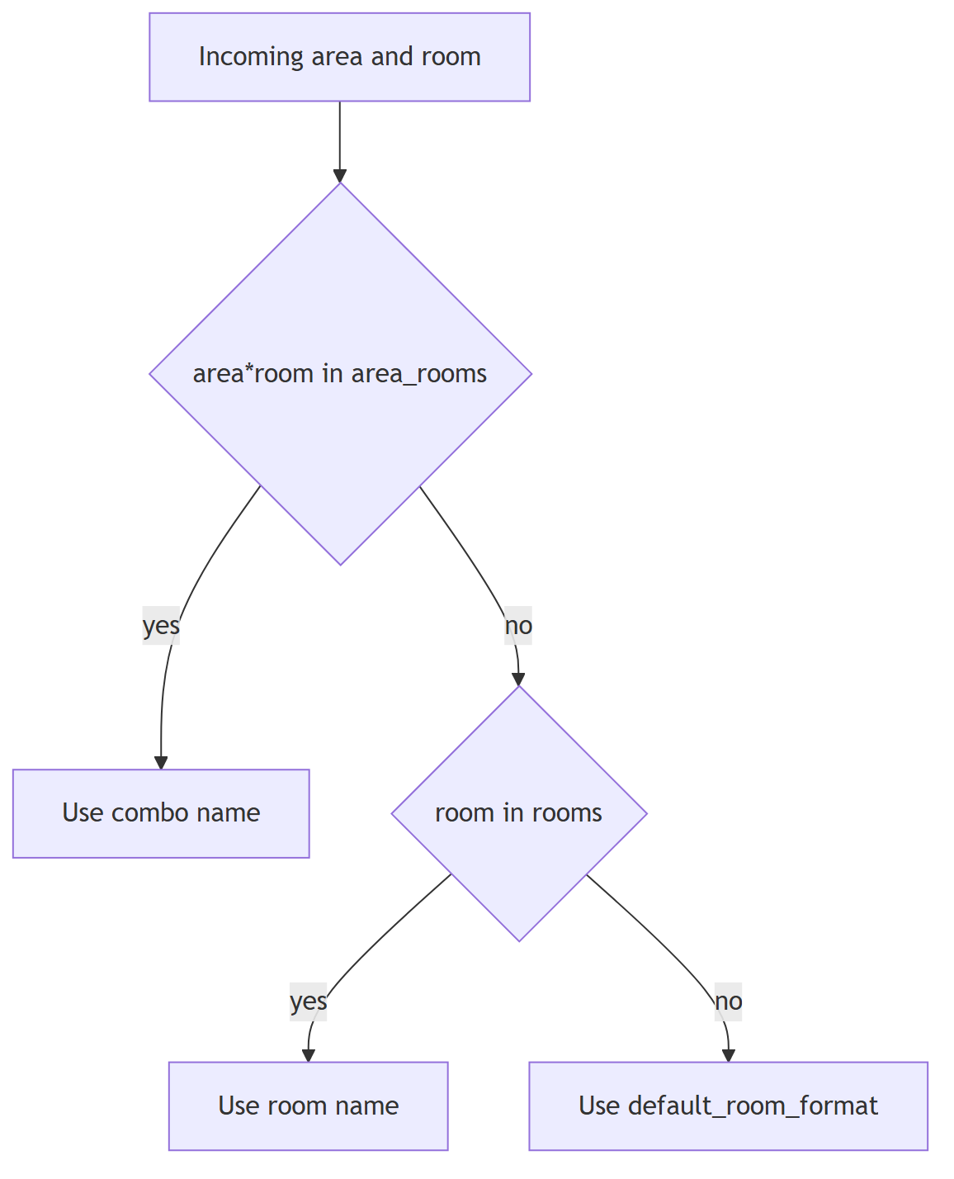

4.2 Worked example — add a new area
Say a new unit “4th Floor Oncology” is assigned area ID 740. Add one line under areas::
areas:
# …existing entries…
740: "4th Floor... Oncology..."
Use ... between phrases where you want the TTS voice to pause, and phonetic spellings where the raw text mis-speaks (e.g. 720: "1st Floor... Pack you..." for PACU). Save the file — the next page for area 740 speaks the new name; no restart needed.

4.3 Worked example — add a new room (combo override)
Room 2250 already exists as “Echo 2” under area 797. Suppose area 740 also has a room 2250 that must be spoken differently. Add a combo override — it wins over any rooms entry:
area_rooms:
# …existing entries…
"740*2250": "Oncology Infusion Bay 2"
If instead a room number should map the same way regardless of area, put it in the room-only table:
rooms:
"2250": "Echo Bay"
Remember the code appends a trailing "." to rooms/area_rooms values (so write "Oncology Infusion Bay 2", not "Oncology Infusion Bay 2."), whereas default_room_format supplies its own punctuation.

4.4 Verifying lookups
Two ways to confirm an edit took effect:
- Dashboard — the dashboard exposes /api/verify-lookups (surfaced in the UI’s verify-lookups panel). Because lookups hot-reload, it reflects the current file.
- Logs — on each load, sipgw.log records a line like Loaded 35 area, 3 purpose, 0 room, and 273 area+room mappings from /opt/sipgw/lookups.yaml; a change on disk logs lookups.yaml changed on disk, reloading.... Compare the counts against what you expect after the edit.
After a non-trivial edit, send one test event (or a dry-run drill — see §6) and confirm the spoken area/room/purpose match, since a wrong mapping speaks a wrong location on a live Code Blue.

5. Firewall, ports, and network exposure

5.1 Port table
Direction | Proto / Port | Peer | Purpose
Inbound | UDP 5060 | SIP allowlist (Rauland path) | SIP INVITE ingress
Inbound | TCP 5060 | SIP allowlist | SIP over TCP
Inbound | UDP 10000–20000 | RTP peers | RTP media (config rtp_port_range_*)
Inbound | TCP 8080 | Ops / admin subnet only | Dashboard + /health (no auth)
Outbound | TCP 443 | api.icmobile.singlewire.com | Fusion OAuth token + scenario trigger
Production host sip2apibridge = 10.249.0.60 (ens34). App-level SIP allowlist: 172.16.0.0/12, 127.0.0.0/8, 10.0.0.0/8.

5.2 No host firewall today — recommendation
Current state: the host has no active firewall (nftables ruleset is empty). Ingress protection relies entirely on the app-level SIP allowlist (sip.allowed_networks), and the dashboard on :8080 has no authentication.
Recommended hardening (add an nftables ruleset):
- Allow 5060 udp+tcp only from the SIP allowlist sources.
- Allow 8080 tcp only from the ops/admin management subnet — this is the sole guard on the unauthenticated dashboard.
- Allow the RTP range (10000–20000/udp) from expected media peers.
- Allow egress 443 to Singlewire.
- Default-drop everything else inbound.
Example skeleton (adapt the source prefixes to your environment):
table inet sipgw {
chain input {
type filter hook input priority 0; policy drop;
ct state established,related accept
iif "lo" accept
ip saddr { 172.16.0.0/12, 10.0.0.0/8, 127.0.0.0/8 } udp dport 5060 accept
ip saddr { 172.16.0.0/12, 10.0.0.0/8, 127.0.0.0/8 } tcp dport 5060 accept
ip saddr { 172.16.0.0/12, 10.0.0.0/8 } udp dport 10000-20000 accept
ip saddr <MGMT_SUBNET> tcp dport 8080 accept
}
}
Keep the app allowlist as defense-in-depth even after adding nftables.

6. Environment variables
Variable | Set by | Effect
SIPGW_CONFIG | both units (/opt/sipgw/config.yaml) | Config path when no explicit path is passed. Resolution: explicit arg > SIPGW_CONFIG > default.
SIPGW_LOOKUPS | both units (/opt/sipgw/lookups.yaml) | Lookups path. Resolution: explicit > SIPGW_LOOKUPS > default.
SIPGW_DRY_RUN | operator (unset in prod) | =1 forces dry-run: the HTTP client is wrapped in the no-send guard so no outbound notification can reach a real host (only 127.0.0.1 is forwarded, for local mock drills).
Dry-run semantics (safety.py) — important safety properties:
- Effective dry-run = config.fusion.dry_run OR SIPGW_DRY_RUN=1. The env var can only enable dry-run, never disable it — there is no code path that lets an env value force real sending when the config has it on.
- In dry-run every log line is prefixed [TEST] across all streams, and test traffic is marked is_test — it never fires a real page and never counts in stats.
- Production-DB barrier: in dry-run/test the writer refuses to start if database.path resolves to the production DB (/var/lib/sipgw/calls.db). Staging runs must point database.path at a staging-only file, so no test artifact can ever land in the production DB.
Use dry-run for install validation and mapping drills:
sudo -u sipgw SIPGW_DRY_RUN=1 \
/opt/sipgw/venv/bin/python -m sipgw.main /opt/sipgw/staging-config.yaml
(Point the staging config’s database.path away from the production DB, or the barrier will abort startup by design.)

Security & Hardening
This section documents the security posture of the RedEye sip2api Gateway as deployed in the current production build (c23f3eb, the v1.7 line) on host sip2apibridge. It is written for BOTH the Tift Regional IT/telecom team and RedEye support: it states plainly what is protected today, what is not yet protected, and gives concrete hardening recommendations. Nothing is withheld.
Because this gateway sits on the life-safety paging path (Rauland nurse-call SIP INVITE → InformaCast Fusion Code Blue / RRT overhead page), the security model deliberately favors availability over lockdown: a control that could silently drop or delay a page is treated as a hazard, not a feature. Several choices below (no start-rate limiting, informational-only health degrade, wide SIP allowlist) follow directly from that priority.

1. Security posture at a glance
Control | Status today | Where enforced
Credential masking in logs (client_id and client_secret, bearer tokens, access_token) | Enforced | webhook.py _log_request()
SIP source-IP allowlist | Enforced (application layer) | sip_server.py _is_allowed()
systemd sandboxing on both units | Enforced | sipgw.service, sipgw-dashboard.service
Egress TLS to Singlewire Fusion | Enforced (HTTPS) | fusion.base_url / token_url
Background OAuth token refresh (token off the critical path) | Enforced | webhook.py refresh loop
Dry-run / test-mode no-send guarantee | Enforced (structural) | safety.py NoSendGuardTransport
Config file permissions (0640), data/log dirs (0750) | Enforced at install | install.sh
Host firewall (nftables) on :5060 / :8080 | NOT PRESENT — flagged below | —
Dashboard authentication on :8080 | NONE — flagged below | —
Coordinated OS auto-restart of the paging service | NOT enforced — lesson #20 | —
The three highlighted rows are the open gaps. They are addressed in §8 Known gaps & hardening recommendations.

2. Trust boundaries
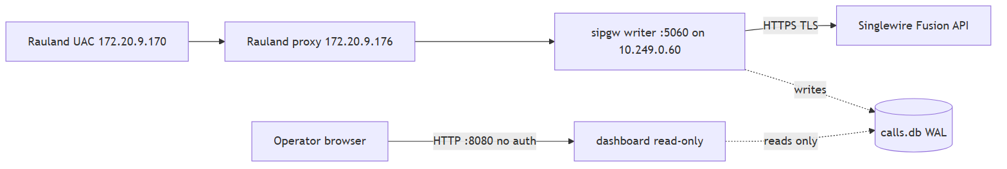
Three boundaries matter:
- Ingress (Rauland → :5060). Untrusted at the packet level (UDP/TCP 5060 is bound on 0.0.0.0). The only gate today is the application allowlist (§3). There is no host firewall in front of it.
- Egress (gateway → Fusion). Outbound HTTPS to https://api.icmobile.singlewire.com/api. TLS-protected; OAuth2 client-credentials. Secrets never leave the host in cleartext and are masked in logs (§4).
- Management (operator → :8080). The dashboard is a read-only, unauthenticated web UI. Anyone who can reach TCP 8080 on 10.249.0.60 can view call history, room/area, and diagnostic bundles (§6, §7).

3. Network ingress: SIP source-IP allowlist
The writer (sipgw.service) binds SIP on 0.0.0.0:5060 (UDP + TCP) and gates every inbound message by source IP against sip.allowed_networks.
Current production allowlist (config.yaml):
sip:
bind_ip: "0.0.0.0"
bind_port: 5060
allowed_networks:
- "172.16.0.0/12" # Rauland / hospital RFC1918 range (UAC + proxy live here)
- "127.0.0.0/8" # loopback (local drills / mock server)
- "10.0.0.0/8" # gateway's own subnet (10.249.0.60) and adjacent infra
Enforcement (sip_server.py):
def _is_allowed(self, addr: str) -> bool:
try:
ip = ip_address(addr)
return any(ip in net for net in self.allowed_networks)
except ValueError:
return False
A message from a non-allowlisted source is answered 403 Forbidden and dropped before any parse, TTS, dedupe, or delivery work is done. Importantly, the inbound-liveness timestamp is stamped only AFTER the allowlist check, so stray or hostile traffic on :5060 cannot mask a real Rauland-side outage in the /health liveness signal.
Posture note — this is application-layer, not packet-layer. The allowlist runs inside the Python process; a packet still reaches the socket and the app before it is rejected. The allowlist is also wide (three large RFC1918 blocks) because the Rauland call path spans multiple hospital subnets and must never be accidentally excluded. It is not a substitute for a firewall — see §8. Tightening the allowlist to just the Rauland UAC/proxy hosts (172.20.9.170, 172.20.9.176) plus loopback and the gateway subnet is a reasonable defense-in-depth step, but must be coordinated with telecom so no legitimate call source is dropped.

4. Credential handling & log masking

4.1 Secrets at rest
The Fusion OAuth2 client credentials (fusion.client_id, fusion.client_secret) live only in /opt/sipgw/config.yaml. That file is installed mode 0640, owned by the sipgw service account — readable by the service, not world-readable. The data and log directories are 0750.
# install.sh
chmod 640 "$INSTALL_DIR/config.yaml"
chmod 750 "$LOG_DIR" "$DATA_DIR"
Operational rule: never widen config.yaml to world-readable, and never commit a filled-in config.yaml to source control. The repository ships config.yaml.example with placeholders (YOUR_CLIENT_ID, YOUR_CLIENT_SECRET) only.

4.2 Secrets in logs — masking is enforced
The four log streams (sipgw.log, sipgw_api_debug.log, sipgw_sip_debug.log, sipgw_dashboard.log) capture full request/response traces for troubleshooting. webhook.py _log_request() masks every credential-bearing field by default (mask_secrets=True):
- Authorization: Bearer … request header → truncated to the first 27 characters + ....
- client_secret=… in the form-encoded token request body → replaced with ***.
- client_id=… in the token request body → replaced with ***. (This client_id masking was added in the v1.7 line; previously the client_id VALUE could appear in sipgw_api_debug.log.)
- access_token in JSON token responses → truncated to the first 20 characters + ....
body_text = re.sub(r"(client_secret=)([^&]+)", _mask, body_text)
body_text = re.sub(r"(client_id=)([^&]+)", _mask, body_text)
Net effect: neither the client_id value nor the client_secret value nor a full bearer/access token is ever written to disk in the shipped configuration.

4.3 OAuth token off the critical path
A background refresh loop (webhook.py) renews the Fusion OAuth token ~token_refresh_margin_seconds (default 300s) before expiry, guarded by an asyncio.Lock. This is both a reliability and a security property: the token is never fetched inline during a Code Blue page (which is exactly what caused the 2026-06-12 lost page), and the token is cached in memory only, never persisted. Egress to the token endpoint and the scenario endpoint is HTTPS/TLS.

5. Host & service sandboxing (systemd)
Both units run as the unprivileged sipgw user/group and carry matching sandbox directives. This is the primary OS-level containment today.
Directive | sipgw.service (writer) | sipgw-dashboard.service (UI) | Effect
User / Group | sipgw / sipgw | sipgw / sipgw | No root.
NoNewPrivileges | true | true | No setuid escalation.
ProtectSystem | strict | strict | Whole FS read-only except allowlisted paths.
ReadWritePaths | /var/log/sipgw /var/lib/sipgw /opt/sipgw | /var/lib/sipgw /var/log/sipgw | Only its own data/log dirs are writable.
ProtectHome | true | true | /home, /root hidden.
PrivateTmp | true | true | Private /tmp.
Capabilities | CAP_NET_BIND_SERVICE (ambient + bounding) | none | Writer may bind privileged :5060; dashboard binds unprivileged :8080 and holds no caps.
MemoryMax / CPUQuota | — | 256M / 50% | Dashboard cannot starve the life-safety writer.
LimitNOFILE | 65535 | 65535 | FD headroom.
Design intent worth noting:
- The writer holds exactly one capability (CAP_NET_BIND_SERVICE) and no more — the capability bounding set is pinned to it.
- The dashboard holds no capabilities and is boxed by a memory/CPU cgroup so a runaway UI request cannot degrade paging. (These cgroup limits are enforced only under real systemd with the relevant controllers; they are inert in containers/CI.)
- StartLimitIntervalSec=0 on both units: start-rate limiting is deliberately disabled so systemd can never wedge the life-safety pager in the failed state after repeated restarts. This is an availability choice, called out here because it interacts with the OS-patching lesson in §8.

6. The dashboard: read-only, but unauthenticated
sipgw-dashboard.service runs dashboard_app.py on :8080 (bound 0.0.0.0). Its integrity story is strong; its confidentiality/access story is the main gap.
What protects it:
- It opens calls.db read-only (query_only=ON after connect) and only reads the writer’s heartbeat row. It cannot write call state, cannot fire a page, and cannot corrupt the outbox. Restarting or crashing the dashboard has zero effect on paging — the two services are fully decoupled.
- It is memory/CPU-capped (§5) and holds no capabilities.
What does NOT protect it:
- There is no authentication and no authorization on :8080. Any host that can reach TCP 8080 on 10.249.0.60 can browse the full call table, the 90-day charts, the /call/{id} correlated detail view, the date-picker log viewer, and can export per-call plain-text diagnostic bundles. Those bundles and views include room/area/bed and TTS message text (§7).
Stated assumption (documented, not assumed-safe): the current design assumes :8080 is reachable only from a trusted management network/VLAN. That assumption is not currently enforced by any control on the host — there is no firewall (§8) and no app auth. Treat network reachability to :8080 as equivalent to full read access to call history.
Recommendation: restrict :8080 at the network layer (management VLAN / firewall rule, see §8) and/or place an authenticating reverse proxy in front of the dashboard. Until then, do not route :8080 onto any general-access subnet.

7. Data sensitivity: PHI-adjacency
The gateway does not store patient names or MRNs, but the data it does handle is PHI-adjacent and should be treated as sensitive under the hospital’s HIPAA posture:
- Room / area / bed identifiers parsed from the SIP INVITE (and resolved via lookups.yaml).
- TTS message text (customTTS) — e.g. “Code Blue, ICU room 4” — which is what gets announced overhead and is stored/displayed for correlation.
- These appear in calls.db, in the log streams, in the dashboard detail views, and in exported diagnostic bundles.
Handling controls in force:
- Data at rest is under /var/lib/sipgw (0750) and /var/log/sipgw (0750), owned by sipgw.
- 90-day retention with async rotation (#6) bounds how long room/TTS data persists.
- Diagnostic bundles are plain text — when shared with RedEye support, treat them as PHI-adjacent: transfer over an encrypted channel and delete local copies after use.
- The /call/{id} and log views are gated only by network reachability to :8080 (§6) — which is exactly why restricting that port matters here.

8. Known gaps & hardening recommendations
These are the deployed build’s real weaknesses. Fixing the first two is the highest-value security work available today.

8.1 No host firewall (HIGH) — add nftables for :5060 and :8080
Per the 2026-07-07 host inventory, sip2apibridge runs with empty nftables (no active host firewall). All ingress protection currently rests on the application allowlist (§3, which only covers :5060) and on the assumption that :8080 is on a trusted network (§6, unenforced).
Recommendation: add an nftables ruleset that:
- Permits UDP/TCP 5060 only from the Rauland source ranges (ideally the UAC/proxy hosts 172.20.9.170 / 172.20.9.176, or the 172.16.0.0/12 block if per-host is too brittle) plus loopback.
- Permits TCP 8080 only from the designated management VLAN / jump host.
- Permits established/related and drops everything else inbound by default.
This gives packet-layer defense in depth in front of the app allowlist and, critically, provides the only access control the dashboard would otherwise have. Stage and test any ruleset against a live drill before enabling — a mis-scoped rule that blocks Rauland would silently break paging.

8.2 Dashboard has no auth (HIGH) — restrict the network path
See §6. Until authentication exists in the product, keep :8080 on a management network and firewall it (§8.1). Do not expose it broadly.

8.3 Uncoordinated OS auto-restart of the paging service (HIGH) — lesson #20
On 2026-07-07, an unattended-upgrades / needrestart auto-restart bounced sipgw.service uncoordinated (issue #20). Because the gateway is currently a single paging node, an OS-driven restart at the wrong moment is a direct availability risk to Code Blue delivery — the OS took a life-safety action with no operational coordination.
Recommendations:
- Coordinate or disable unattended restarts of sipgw.service. On Ubuntu 24.04, prevent needrestart from auto-restarting the paging unit and schedule any required restart into a maintenance window with clinical/telecom awareness. Keep security patching, but take the service restart decision out of the OS’s hands for this unit.
- Treat any restart of the writer as a paging outage window, however brief. The durable outbox (WAL) means an in-flight call survives a clean restart, but an INVITE arriving during the socket-down instant is not yet protected.
- Durable fix — issue #19 (planned, roadmap): zero-downtime writer restarts via systemd socket activation, so the SIP socket stays up across a writer restart and no inbound INVITE is dropped during a bounce. This is the structural remedy for #20 and is tracked as roadmap, not shipped.

8.4 Wide SIP allowlist (MEDIUM)
The 172.16.0.0/12 + 10.0.0.0/8 allowlist is broad (§3). Once §8.1 provides a firewall, consider narrowing the app allowlist toward the specific Rauland hosts for defense in depth. Change only with telecom sign-off.

9. Safe-by-default: dry-run / test mode never pages
safety.py provides a structural no-send guarantee for development, staging, and drills — it is not discipline at each call site, it is enforced at the transport layer so it cannot be bypassed by forgetting a flag.
- Effective dry-run = config dry_run: true OR env SIPGW_DRY_RUN=1. The environment can only enable dry-run; there is deliberately no code path by which any env value forces real sending. (effective_dry_run().)
- In dry-run the shared httpx client is built with NoSendGuardTransport, which refuses any request whose host is not 127.0.0.1: it records the attempt and returns a synthetic response instead of touching the network. Because every Fusion origin (token fetch, field resolve, scenario trigger, the Fusion reachability keepalive) and the escalation webhook share this one client, none of them can reach a real host in dry-run.
ALLOWED_HOSTS = frozenset({"127.0.0.1"}) # the ONLY host that may receive traffic in dry-run
- Production-DB barrier (assert_safe_database_path): if dry-run/test is active and database.path resolves to the production DB (/var/lib/sipgw/calls.db), startup aborts (ProdDatabaseBarrier). Test runs must point at a staging DB — no test artifact can land in production.
- [TEST] log marker (TestMarkerFilter): while dry-run/test is active, every log line across all three writer streams is prefixed [TEST], including every physical line of multi-line SIP/API dumps, so no test line is ever mistaken for a real page.
- is_test marking: test traffic marked is_test never fires a real page, never counts in stats, and is hidden from the dashboard — test drills cannot pollute clinical metrics.
Security relevance: this is what lets RedEye and Tift run realistic paging drills and staging tests safely — a misconfigured test cannot emit a real overhead page, cannot hit the escalation channel, and cannot write to the production database.

10. Operator security checklist
- config.yaml is mode 0640, owned by sipgw; never world-readable, never committed with real secrets.
- Confirm log masking is active (grep the api-debug log for client_secret / client_id values — you should see ***, and never a real token).
- Add nftables restricting :5060 to Rauland sources and :8080 to the management VLAN (§8.1).
- Keep :8080 off any general-access subnet until authentication exists (§6, §8.2).
- Disable/coordinate unattended-upgrades restarts of sipgw.service; restart only in a maintenance window (§8.3, #20).
- Treat exported diagnostic bundles and dashboard views as PHI-adjacent; transfer encrypted, delete after use (§7).
- Verify both units still run as sipgw with NoNewPrivileges and ProtectSystem=strict after any change (§5).
- For any staging/drill, confirm SIPGW_DRY_RUN=1 (or config dry_run) and a staging database.path before starting (§9).

Operations Runbook
Scope. Day-2 operations for the deployed production build (c23f3eb, the v1.7 line) on host sip2apibridge (Ubuntu 24.04.4, Python 3.12.3). This section is command-level: how to start, stop, restart, upgrade, reconfigure, and read the running system, and how to drive Dashboard v2. Everything here documents what is deployed today. Planned features (zero-downtime restarts, HA) live only in the Reliability / Roadmap sections and are labeled planned there.

1. The two-service model — the one fact that governs every restart
The gateway runs as two independent systemd units. Understanding which one you are touching is the single most important operational rule, because they have very different blast radii.
Unit | Role | Type / watchdog | Port(s) | Restart impact on paging
sipgw.service | The call path — SIP ingress, parse, TTS, durable delivery, heartbeat | Type=notify, WatchdogSec=30 | 5060 udp+tcp | Interrupts paging for the restart window (~0.3 s SIP blip). Coordinate.
sipgw-dashboard.service | Read-only web UI + /health | Type=simple (no watchdog) | 8080 tcp | None. Paging continues uninterrupted.
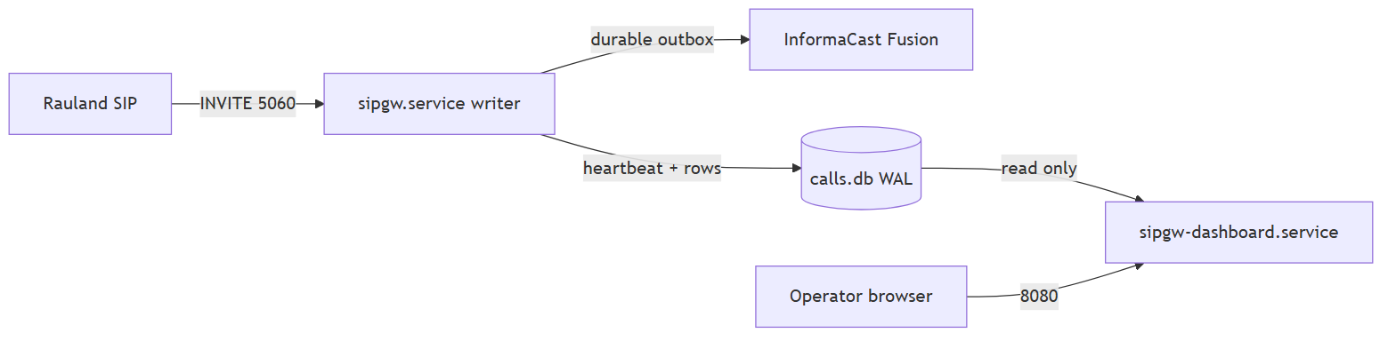
Why this split matters (issue #14). The dashboard opens the shared SQLite database read-only (query_only=ON) and only reads the writer’s heartbeat. It never writes a page and never touches the SIP path. That means:
- You can restart, upgrade, or debug the dashboard freely — during a busy shift, mid-incident, anytime — without any paging outage.
- A restart of sipgw.service briefly drops the SIP listeners. Rauland only sends SIP on a real Code Blue / RRT event, so the practical risk is small, but the rule stands: treat every sipgw.service restart as a (very short) planned paging outage and coordinate it (see §5 and the OS-patching lesson from issue #20).
Golden rule. Dashboard down ≠ paging down. If /health or the web UI is unreachable but sipgw.service is active (running), paging is still working. Verify the writer before you ever touch it.

2. Status — check before you act
Always check both units. Do the writer first; it is the life-safety process.
# One-line status of both units
systemctl status sipgw.service sipgw-dashboard.service --no-pager
# Just the active/failed state, scriptable
systemctl is-active sipgw.service # -> active
systemctl is-active sipgw-dashboard.service # -> active
# Are they enabled to start on boot? (both should be 'enabled')
systemctl is-enabled sipgw.service sipgw-dashboard.service
What a healthy writer looks like:
● sipgw.service - sipgw - SIP-to-Webhook Gateway for Informacast Fusion
Loaded: loaded (/etc/systemd/system/sipgw.service; enabled; preset: enabled)
Active: active (running) since ...
Watchdog: 30s
Status: "READY=1" <- sd_notify: listeners are up
Two extra signals that the writer is truly alive (not just “process exists”):
- Watchdog. Type=notify + WatchdogSec=30 means the writer must ping systemd from its event loop (every ~15 s). A hung event loop is detected and the pager is auto-restarted. systemctl show sipgw -p WatchdogUSec shows the armed value.
- /health heartbeat. The writer stamps a heartbeat every ~10 s; the dashboard’s /health returns 503 stale if it ages past 30 s. This is the authoritative external liveness check (see §7.6).
# Fast end-to-end liveness (writer heartbeat, via the read-only dashboard)
curl -s http://localhost:8080/health | python3 -m json.tool

3. Start / stop / restart — per unit
All commands are root / sudo. Substitute the unit name deliberately.

3.1 The dashboard (safe — no paging impact)
Restart the dashboard any time. This is the whole point of the #14 split.
sudo systemctl restart sipgw-dashboard.service # safe, anytime
sudo systemctl stop sipgw-dashboard.service # UI + /health go dark; PAGING UNAFFECTED
sudo systemctl start sipgw-dashboard.service
While the dashboard is stopped: the web UI and /health are unavailable, so any external monitor watching /health will alarm — expected, and it does not mean paging is down. Confirm with systemctl is-active sipgw.service.

3.2 The writer (coordinate — brief paging interruption)
A writer restart drops the SIP listeners for the restart window (a ~0.3 s SIP blip in normal operation). Do it as a coordinated, announced action.
sudo systemctl restart sipgw.service # COORDINATE: brief paging interruption
Pre-flight checklist before restarting the writer:
- Announce to clinical/telecom that overhead paging is briefly interrupted.
- Check the backlog first — do not restart on top of undelivered pages if avoidable:
- curl -s http://localhost:8080/health | python3 -c \
"import sys,json; d=json.load(sys.stdin); print('backlog:', d.get('backlog'))"
- Durable delivery means an in-flight page survives a restart (it is a WAL row in state pending/retrying and the delivery worker resumes it on start-up) — but a clean, low-backlog moment is still the right time.
- Restart, then immediately re-verify:
- systemctl is-active sipgw.service && \
curl -s http://localhost:8080/health | python3 -m json.tool
- Expect active and status: ok with a small heartbeat_age_s.
Never disable the writer’s auto-restart. Restart=always, RestartSec=5, and StartLimitIntervalSec=0 are deliberate: the pager must never get wedged in failed by start-rate limiting. If you must take it down for maintenance, use stop (not a config edit) and start when done.
Do NOT let the OS restart the writer uncoordinated (issue #20). On 2026-07-07 an unattended-upgrades / needrestart pass bounced the paging service on its own schedule. Coordinate OS patching with a maintenance window; the permanent fix (zero-downtime writer restarts via socket activation, #19) is planned — see Reliability / Roadmap. Until then, you own restart timing.

3.3 Enable / disable on boot
Both units are installed enabled (start on boot). Leave them enabled.
systemctl is-enabled sipgw.service sipgw-dashboard.service # expect: enabled / enabled
# Only if ever needed:
sudo systemctl enable sipgw.service sipgw-dashboard.service

3.4 After editing a .service unit file
systemd caches unit files. If you edit /etc/systemd/system/sipgw*.service, reload the daemon before restarting:
sudo systemctl daemon-reload
sudo systemctl restart sipgw-dashboard.service # or sipgw.service (coordinate)

4. Configuration changes — what needs a restart and what doesn’t
Change | File | Applies via
Lookups (area / room / purpose names, defaults) | /opt/sipgw/lookups.yaml | Hot reload — NO restart (see §4.1)
Gateway config (SIP, Fusion, delivery, dedupe, health, logging) | /opt/sipgw/config.yaml | Writer restart (coordinate)
Dashboard-only config (port, page_size, auto_refresh_seconds) | config.yaml dashboard: block | Dashboard restart only (safe)
systemd unit file | /etc/systemd/system/sipgw*.service | daemon-reload + restart

4.1 lookups.yaml hot reload (no restart)
lookups.yaml maps SIP area/room IDs and call-purpose keywords to the speech-ready phrases that go into the TTS page. It is hot-reloaded on change — no service restart, no paging interruption.
Mechanism (sipgw/lookups.py): every lookup call checks the file’s mtime; when it changes, the table is reloaded on the next event. If the file is malformed or mid-write, the previous good table keeps serving (the load is exception-safe and never blanks the maps) — a bad edit degrades gracefully rather than breaking paging.
Procedure:
sudo -u sipgw nano /opt/sipgw/lookups.yaml # edit as the sipgw user
# (optional but recommended) validate YAML before it goes live:
python3 -c "import yaml,sys; yaml.safe_load(open('/opt/sipgw/lookups.yaml')); print('YAML OK')"
Then verify the reload took, without waiting for a real Code Blue:
- In the dashboard, open Verify lookups (§7.5) — it re-reads the file from disk and reports counts + any errors.
- Or watch the writer log for the reload line:
- journalctl -u sipgw -f | grep -i lookups
# -> "lookups.yaml changed on disk, reloading..."
# -> "Loaded N area, M purpose, ... mappings from /opt/sipgw/lookups.yaml"
Caution. Because the reload is silent and automatic, an accidental save of a syntactically-valid-but-wrong table takes effect on the next page. Always confirm with Verify lookups after editing. Keep a backup: cp /opt/sipgw/lookups.yaml /opt/sipgw/lookups.yaml.bak-$(date +%F).

5. Upgrade procedure (deploy a new build)
The gateway is deployed from a Git checkout under /opt/sipgw with a venv at /opt/sipgw/venv. Upgrades follow the same shape the installer sets up (install.sh). The writer restart at the end is the only paging-affecting step, so it is done last, coordinated, and verified.
Pre-flight
# 1. Announce a short paging-maintenance window (writer restart at the end).
# 2. Snapshot the current state so rollback is trivial.
cd /opt/sipgw
git rev-parse --short HEAD # record current build (e.g. c23f3eb)
sudo cp config.yaml /opt/sipgw/config.yaml.bak-$(date +%F)
sudo cp lookups.yaml /opt/sipgw/lookups.yaml.bak-$(date +%F)
sudo cp /var/lib/sipgw/calls.db /var/lib/sipgw/calls.db.bak-$(date +%F) # WAL DB backup
Apply
cd /opt/sipgw
sudo -u sipgw git fetch --all
sudo -u sipgw git checkout <new-tag-or-commit> # the new build
# Update Python deps into the existing venv (idempotent)
sudo /opt/sipgw/venv/bin/pip install --upgrade -r requirements.txt
# If any .service file changed in the new build, reinstall + reload:
sudo cp sipgw.service /etc/systemd/system/sipgw.service
sudo cp sipgw-dashboard.service /etc/systemd/system/sipgw-dashboard.service
sudo systemctl daemon-reload
Restart order — dashboard first (safe), writer last (coordinated)
# 1. Dashboard first — zero paging impact; confirms the new build parses/starts.
sudo systemctl restart sipgw-dashboard.service
curl -s http://localhost:8080/health >/dev/null && echo "dashboard up"
# 2. Writer last — the brief paging interruption. Coordinate + verify.
sudo systemctl restart sipgw.service
systemctl is-active sipgw.service
curl -s http://localhost:8080/health | python3 -m json.tool # expect status: ok
Both processes fail-fast on a bad config (validate_config refuses to start on a fatal problem and exits non-zero), so a misconfigured upgrade surfaces immediately in systemctl status / journal rather than silently.
Post-upgrade verification
git -C /opt/sipgw rev-parse --short HEAD # confirm the new build hash
journalctl -u sipgw -n 40 --no-pager # look for "READY=1", clean start, no tracebacks
curl -s http://localhost:8080/health | python3 -m json.tool
Then run the relevant host drills documented in docs/TESTING.md (e.g. the SIP dialog drill and the dedupe drill) in dry-run/test mode so the exercise never fires a real page.
Rollback
cd /opt/sipgw
sudo -u sipgw git checkout <previous-commit> # the hash recorded in pre-flight
sudo /opt/sipgw/venv/bin/pip install -r requirements.txt
sudo systemctl restart sipgw-dashboard.service # safe
sudo systemctl restart sipgw.service # coordinated
The database schema is backward-tolerant across the v1.6.x/v1.7 line, but a DB backup was taken in pre-flight if a restore is ever needed.

6. Reading the logs
There are two complementary lenses: journald (per unit) and the four log files on disk. All file timestamps are UTC RFC3339 (...Z), UTC-sortable and directly string-matchable against Fusion’s Date/createdAt fields.
Timezone note. logging.timezone: America/New_York may appear in config, but the log-file stamps are always UTC-Z by design. The dashboard renders wall-clock local for humans; the raw files stay UTC. Do not be surprised that a 20:00 ET event shows 00:00Z in the files.

6.1 journalctl — per unit (live, no file access needed)
# Live tail the writer (the call path)
journalctl -u sipgw.service -f
# Live tail the dashboard
journalctl -u sipgw-dashboard.service -f
# Last N lines / since a time
journalctl -u sipgw.service -n 200 --no-pager
journalctl -u sipgw.service --since "2026-07-07 12:00" --until "2026-07-07 13:00"
# Errors only, this boot
journalctl -u sipgw.service -p err -b --no-pager

6.2 The four log files (/var/log/sipgw, 90-day retention)
Each rotates daily at UTC midnight and is compressed to .tgz; files older than 90 days are purged. Rotation runs off the event loop (async, issue #6) so it never stalls the SIP path.
File | Written by | Contents
sipgw.log | writer | Main application log — call lifecycle, delivery, retries, escalation, watchdog
sipgw_api_debug.log | writer | Northbound Fusion/API traces (OAuth, webhook POSTs, responses) — api_debug_log: true
sipgw_sip_debug.log | writer | Raw SIP/SDP message traces (INVITE, 200 OK, ACK, BYE) — sip_debug_log: true
sipgw_dashboard.log | dashboard | The dashboard process’s own log — a distinct file the writer never touches
Why the dashboard has its own file. Two processes each owning a rotating handler on the same file would race at midnight doRollover() and corrupt logs. setup_dashboard_logging deliberately writes only sipgw_dashboard.log plus stdout (captured by journald). This is part of the #14 isolation.
Common file reads:
# Follow the main writer log
tail -f /var/log/sipgw/sipgw.log
# Grep a Call-ID across the SIP + main logs (correlation by hand)
grep "<sip-call-id>" /var/log/sipgw/sipgw_sip_debug.log /var/log/sipgw/sipgw.log
# Read yesterday's rotated, compressed main log without extracting it
zcat /var/log/sipgw/sipgw.log.2026-07-06.tgz | less
# (For the dashboard's date-picker, which does this decompression for you, see §7.4.)
For per-call correlation, prefer the dashboard’s /call/{id} view (§7.3) and its diagnostic bundle export (§7.3) — they join the SIP-debug, main, and api-debug streams by the exact Call-ID for you.

7. Dashboard v2 — operator user guide
Open http://<host>:8080/ (deployed at http://10.249.0.60:8080/). The dashboard is read-only — nothing you click can send a page or mutate a record. It hides is_test rows everywhere (test traffic never appears in the operator UI, stats, chart, or exports).
No authentication. The dashboard has no login and binds 0.0.0.0:8080 with no host firewall active. Treat the URL as sensitive and restrict network access to it (see the Security section; adding nftables for :8080 is a standing recommendation).

7.1 The call table (home page /)
The landing page shows the calls for the selected day (default: today) with:
- Stat cards — success / failed / pending / suppressed counts, plus a “Last call from Rauland” banner (the durable last real page, with a relative age like “3 h ago”). The banner survives a writer restart.
- Call rows — time (local wall-clock, click-through to the detail view), caller/bed, derived purpose, and a plain-language delivery status glyph (delivered / failed / pending). Paginated (page_size, default 20).
- Auto-refresh — 10/30/60/120/300 s, live view only. Historical days do not auto-refresh.
The date picker drives both the table and the log viewer together — pick a day and the calls table, the day’s stats, and the log panels all move to that same local day.

7.2 90-day call-type chart
A stacked bar chart of calls by type over the last 90 days (Code Blue, RRT, etc.). Purpose is derived live from each call’s SIP display-name via lookups.yaml, so all rows are covered (including legacy rows) and any new call type appears automatically. Chart build failures are swallowed — the chart simply hides, the dashboard never errors on it.

7.3 /call/{id} — correlated call-detail view + diagnostic bundle
Click any call’s time to open /call/{id}, the single most useful troubleshooting screen. It joins three sources for one event, keyed on the call’s authoritative sip_call_id (written on the SIP path):
- SIP blocks — the exact INVITE / 200 / ACK / BYE for this Call-ID from sipgw_sip_debug.log.
- Main-log lines — the matching lifecycle/delivery lines from sipgw.log.
- API-debug candidates — the likely Fusion/API traces (clearly labeled a heuristic, since the API log has no Call-ID).
Unknown id → clean 404 (never a 500); a test row is treated as not-found.
Per-call diagnostic bundle export. On the detail view, the bundle link downloads a plain-text file (/call/{id}/bundle.txt, saved as sipgw-call-<id>.txt) containing the same correlated SIP + main + API context as one copy/paste blob. This is the artifact to attach to a support ticket or paste to RedEye — it captures everything about one event with a single click.
# Grab a bundle from the CLI (e.g. for call #482)
curl -s -OJ http://10.249.0.60:8080/call/482/bundle.txt

7.4 Date-picker log viewer
Below the table, the page shows the log lines for the selected day, in up to three panels: main (sipgw.log), SIP debug, and API debug (the debug panels appear only when those streams are enabled). “A day” is the configured display zone’s local day; the viewer transparently reads across the overlapping UTC log files and decompresses .tgz rotated files for you, so you can browse history without shelling into the host. The zone label is shown so you always know which wall-clock the lines are rendered in.

7.5 Verify lookups
The Verify lookups action (backed by /api/verify-lookups) re-reads lookups.yaml from disk and reports the parsed area / room / purpose counts and any validation errors. Use it:
- After any lookups edit (§4.1) to confirm the hot reload picked up a valid table before the next real page relies on it.
- During onboarding of new areas/beds to sanity-check the mapping.
There is also /api/sample-lookups, which downloads a fully-commented sample lookups.yaml you can use as an editing reference.

7.6 /health — the machine-readable liveness endpoint
GET http://<host>:8080/health is the endpoint for external monitors and for your own quick checks. Its status code is keyed solely on writer-heartbeat freshness:
Response | Meaning
200 {"status":"ok", "heartbeat_age_s": …} | Writer heartbeat is fresh → paging path alive
503 {"status":"stale", "heartbeat_age_s": …} | Heartbeat older than 30 s → writer stalled/hung
503 {"status":"no-heartbeat"} | Writer has never stamped a heartbeat (not started)
The 200 body also carries informational fields that never change the status code (a Fusion blip or a delivery backlog must never 503 the sole node and get it restarted):
- backlog, last_delivered_at, last_failed_at, last_error — delivery health.
- fusion_reachable, fusion_detail, fusion_checked_age_s — the read-only Fusion reachability probe (a GET of the scenario; it never sends a page).
- last_inbound_sip_at, last_inbound_sip_age_s — age of the last inbound SIP from Rauland (link-liveness; Rauland is silent between real events, so this is informational, not an alarm).
# Human-readable snapshot
curl -s http://10.249.0.60:8080/health | python3 -m json.tool
# Scriptable up/down (exit non-zero if not 200)
curl -sf http://10.249.0.60:8080/health >/dev/null && echo UP || echo DOWN
There are two opt-in, default-off degrade behaviors (health: block): fail_on_fusion_unreachable (let a fresh Fusion-unreachable probe 503 the node) and inbound_escalate_after_seconds (fire the escalation webhook after a long inbound silence). Both are off in production by design — enabling the first on a single node can get the node pulled on a transient Fusion blip. See the Configuration and Reliability sections before touching them.

8. Quick command reference
# --- Status (do this first, always) ---
systemctl status sipgw.service sipgw-dashboard.service --no-pager
curl -s http://localhost:8080/health | python3 -m json.tool
# --- Dashboard (SAFE — no paging impact) ---
sudo systemctl restart sipgw-dashboard.service
# --- Writer (COORDINATE — brief paging interruption) ---
curl -s http://localhost:8080/health | python3 -c "import sys,json;print('backlog:',json.load(sys.stdin).get('backlog'))"
sudo systemctl restart sipgw.service
systemctl is-active sipgw.service
# --- Logs ---
journalctl -u sipgw.service -f
journalctl -u sipgw-dashboard.service -f
tail -f /var/log/sipgw/sipgw.log
# --- Lookups hot reload (NO restart) ---
sudo -u sipgw nano /opt/sipgw/lookups.yaml
# then: dashboard -> Verify lookups, or:
journalctl -u sipgw -f | grep -i lookups
# --- Unit-file edit ---
sudo systemctl daemon-reload && sudo systemctl restart sipgw-dashboard.service
The one rule to remember: restart the dashboard freely; restart the writer only as a coordinated, announced, verified action.

Monitoring, Health & Backup/DR
Product: RedEye sip2api Gateway — SIP in. Page out. Every time. Applies to: production build c23f3eb (branch main, the v1.7 line = v1.6.5 + 6 commits) on host sip2apibridge. Audience: Tift Regional IT + clinical/telecom, and RedEye support. Identical content for both.
This section covers how you know the gateway is alive and delivering pages, how it distinguishes a silent-dead node from a genuinely-quiet night, and how to back up, restore, and pull diagnostics for a support ticket.
Everything here documents what is deployed today. Planned high-availability work (LB active/active, socket-activation zero-downtime restart) lives only in the “HA Plan” and “Roadmap” sections and is not described here.

1. The two things that must always be true
The gateway’s job is life-safety: a Rauland Code Blue / RRT SIP INVITE must become an InformaCast Fusion overhead page every time. Monitoring exists to answer two questions continuously:
- Is the paging writer alive? — the sipgw.service process that ingests SIP and delivers pages.
- Is the end-to-end path healthy? — can we still hear Rauland (inbound), and can we still reach Fusion (outbound), and is the durable outbox draining?
The design deliberately keeps these separate. Only question 1 controls the /health status code. Everything from question 2 is surfaced as informational telemetry so that a Fusion blip, a delivery backlog, or a quiet night can never trip an external monitor into killing or pulling the sole paging node.
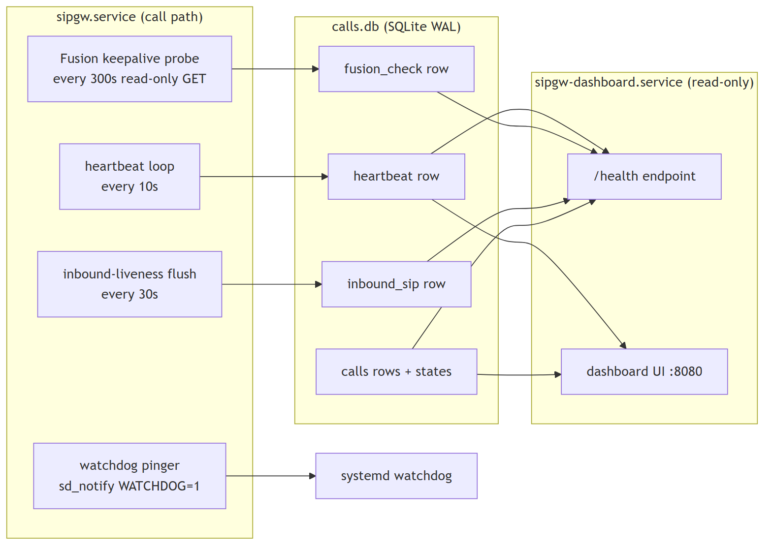
The writer and the dashboard are two independent systemd services. The dashboard reads the shared database over a read-only (query_only=ON) connection and never mutates it, so the dashboard can be restarted at any time without interrupting paging.

2. The /health endpoint
/health is served by the dashboard process at http://10.249.0.60:8080/health. It is the single machine-readable liveness signal. (Code: dashboard.py, health() and _health_info(); snapshot query in database.py:delivery_health_snapshot.)

2.1 What sets the status code
The HTTP status code is keyed solely on the writer heartbeat. The writer stamps a heartbeat row every heartbeat_interval_seconds (default 10 s). The dashboard reads it:
Condition | HTTP | status
Heartbeat fresher than stale_after_seconds (default 30 s) | 200 | ok
Heartbeat older than stale_after_seconds | 503 | stale (includes heartbeat_age_s)
No heartbeat row at all | 503 | no-heartbeat
This is the “silent-dead” detector: if the writer process wedges, crashes, or is killed, its heartbeat goes stale within ~30 s and /health returns 503. A monitor or a human sees the node is down even though no page has failed yet.
Design guarantee. A Fusion outage, a delivery backlog, or a quiet Rauland link do not change the status code by default. Only the heartbeat does. This prevents an external monitor from pulling or restarting the only paging node over a transient upstream problem.

2.2 Informational fields (never flip the code)
When the heartbeat gate passes, /health adds a body of informational fields read from the shared DB. Any read failure here is swallowed — /health can never 500 on an info read.
{
"status": "ok",
"heartbeat_age_s": 3.2,
"backlog": 0,
"last_delivered_at": 1751894400.0,
"last_failed_at": null,
"last_error": null,
"fusion_reachable": true,
"fusion_detail": "HTTP 200",
"fusion_checked_age_s": 41.7,
"last_inbound_sip_at": 1751890000.0,
"last_inbound_sip_age_s": 4400.0
}
Field | Meaning | Source
backlog | Real (non-test) calls still pending + delivering — the outbox depth | count_by_state
last_delivered_at | Epoch of the most recent successful delivery | calls
last_failed_at / last_error | Most recent failed/expired call + its truncated error | calls
fusion_reachable | Result of the last outbound reachability probe (true/false/null=unknown) | fusion_check
fusion_detail | Short human string, e.g. HTTP 200 | fusion_check
fusion_checked_age_s | Age of that probe | fusion_check
last_inbound_sip_at / last_inbound_sip_age_s | When we last heard SIP from Rauland | inbound_sip
Test/dry-run rows (is_test=1) are excluded from backlog, last_delivered_at, and last_failed_at, so drills never pollute health.

2.3 Outbound: the Fusion reachability keepalive
The writer runs a read-only reachability probe every keepalive_interval_seconds (default 300 s): a short-timeout GET of the scenario definition through the same no-send-guarded HTTP client used for delivery. (main.py:_keepalive_loop → webhook.py:check_reachable → database.py:write_fusion_check.)
- It is not a page path. It never triggers the scenario and never sends an overhead page. In dry-run the no-send guard makes it reach no real host and return a synthetic 200.
- It never holds the OAuth token lock across the network call, so the probe can never delay a real page (the background token refresher keeps the token warm — see the Reliability section).
- The result (ok + checked_at + short detail) is stamped to the fusion_check DB row and surfaced as the fusion_* fields above.
Optional degrade (opt-in, default OFF). Set health.fail_on_fusion_unreachable: true to make a present + fresh ok=false probe return 503 status="fusion-unreachable". null (never probed / older writer) and stale checks are treated as unknown and stay 200 (fail-safe). Freshness bound = fusion_unreachable_max_age_seconds, or 0.0 to auto-derive it from the probe cadence (keepalive_interval_seconds × 2 + stale_after_seconds).
Caution — this is a foot-gun by design. With fail_on_fusion_unreachable: true, a Fusion blip will 503 the node. On the current single-node deployment there is nothing to fail over to, so a monitor wired to restart/pull on 503 would take the pager offline over an upstream problem. Leave it OFF on the single node; it exists for the future LB active/active topology (Roadmap #17). The config validator will warn if you enable the flag while the keepalive is disabled.

2.4 Inbound: solving “silent-dead vs genuinely-quiet”
Rauland sends SIP only on real clinical events — there are no keepalives — and roughly a quarter of days have zero calls, with an observed maximum quiet gap of about 4.27 days. So “no calls for hours” is normal and must never look like a fault. But a broken inbound link (proxy down, allowlist wrong, network cut) also looks like silence. The inbound-liveness monitor separates the two:
- The SIP server records the wall-clock time of the last request received from an allowed (Rauland) network, in memory (sip_server.py:last_inbound_at).
- The writer flushes that timestamp to the DB every inbound_flush_interval_seconds (default 30 s), and never overwrites the persisted value with now/None when it has seen no datagram since boot — so a writer restart during a real silence cannot clobber the last-real value (main.py:_inbound_flush_loop, database.py:write_inbound_seen).
- /health and the dashboard surface last_inbound_sip_age_s. The dashboard turns this amber once it exceeds inbound_stale_after_seconds (default 432000 s = 5 days, deliberately longer than the observed max quiet gap). This is informational only — it never flips the /health code.
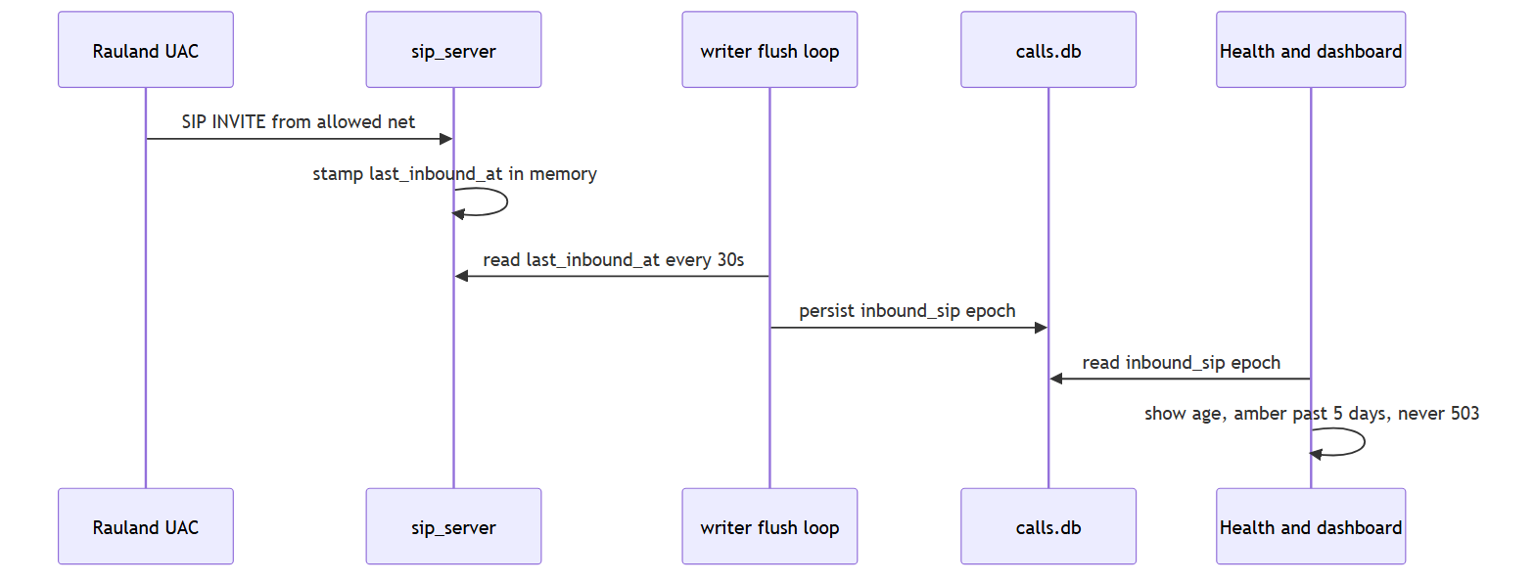
Optional silence escalation (opt-in, default OFF). Set health.inbound_escalate_after_seconds > 0 to fire an escalation once per silence episode via the escalation webhook when inbound age exceeds the threshold (main.py:_maybe_escalate_inbound_silence). It de-duplicates on the reference epoch so you get one alert per episode, and it resets when inbound resumes. Because a 4-plus-day quiet stretch is normal, set the threshold generously (well above ~4.3 days) if you enable it. It never sends a page and never gates /health.

2.5 Health config reference
From config.yaml.example (block health:):
health:
heartbeat_interval_seconds: 10.0 # writer stamps liveness this often
stale_after_seconds: 30.0 # /health 503 once heartbeat older than this
keepalive_interval_seconds: 300.0 # read-only Fusion reachability GET cadence
fail_on_fusion_unreachable: false # opt-in: fresh ok=false -> 503 (see caution)
fusion_unreachable_max_age_seconds: 0.0 # 0 = auto (keepalive*2 + stale_after)
inbound_flush_interval_seconds: 30.0 # persist last-inbound-SIP time this often
inbound_stale_after_seconds: 432000.0 # 5 days -> dashboard shows amber
inbound_escalate_after_seconds: 0.0 # 0 = OFF; >0 = once-per-episode alert

2.6 Probing /health operationally
# Simple up/down (exit non-zero on 503):
curl -fsS http://10.249.0.60:8080/health >/dev/null && echo UP || echo DOWN
# Full body, human-readable:
curl -s http://10.249.0.60:8080/health | python3 -m json.tool
A good external monitor polls /health and alerts on 503 (status stale/no-heartbeat). On the single node, do not auto-restart the writer from an external monitor over a 503 — investigate first (see the Troubleshooting section); an unsupervised auto-restart already caused incident #20.

3. The systemd watchdog
sipgw.service runs Type=notify with WatchdogSec=30. The writer proves event-loop liveness to systemd with a pure-Python sd_notify implementation (watchdog.py).
- On startup the writer sends READY=1; on clean shutdown it sends STOPPING=1.
- A background pinger sends WATCHDOG=1 on a cadence of half of systemd’s WATCHDOG_USEC (so ~15 s for a 30 s window). If the event loop stalls and misses pings, systemd restarts the service per its unit policy.
- The pinger is completely inert when not under systemd (WATCHDOG_USEC/NOTIFY_SOCKET unset) — tests, dry-run runs, and non-systemd invocations behave exactly as before.
Why event-loop liveness, not DB writes. The watchdog proves the async loop is turning, deliberately decoupled from database writes. Transient DB slowness must never restart the life-safety pager. The heartbeat (which does touch the DB) is the separate signal that feeds /health.
Check it:
systemctl status sipgw.service # look for WATCHDOG=1 / Notify state
journalctl -u sipgw.service -b | grep -i watchdog

4. Dashboard: state-aware stats and the 90-day chart
The dashboard (dashboard.py, ~2155 lines) is a read-only UI on :8080. It hides is_test rows everywhere so drills never appear in customer-facing counts.

4.1 State-aware stats
Stats are computed from the durable call state (the calls.state column), not from guessing at a raw HTTP code. _stats_from_rows (and its live-day twin get_today_stats) classify each call identically:
Bucket | States counted
success | delivered (+ legacy rows with a 2xx fusion_status)
failed | failed + expired (+ legacy rows with a non-2xx/NULL fusion_status)
pending | pending + delivering
suppressed | duplicate (dedupe suppression)
Legacy rows (pre-outbox, state = legacy) are back-classified by their stored fusion_status so historical days and the live day report the same semantics. Per-call delivery state is shown with a glyph + plain-language label (e.g. ✓ Delivered, ✗ NOT SENT - rejected, ○ Pending) so status is never signalled by colour alone (WCAG).

4.2 90-day calls-by-type stacked chart
A self-contained inline-SVG stacked bar chart buckets the last 90 days of real calls by type (call purpose, derived from the display name), one bar per day. It is rendered server-side from data already fetched, is read-only, and has zero SIP impact.

4.3 Correlated call-detail view and log viewer
- /call/{id} — a correlated call-detail view joining the calls row to the SIP messages (exact sip_call_id join), the application-log lines that reference the Call-ID, and a heuristic Fusion API exchange (matched by TTS body + time window, since the API debug log carries no Call-ID; ambiguous matches are shown, never silently picked).
- Date-picker log viewer — one picker drives both the call table and the on-page log viewer for a chosen day.
- verify-lookups — validates lookups.yaml and reports results.
All dashboard timestamps display in the configured local timezone via display_local, while the underlying stored/log timestamps are UTC (see §6).

5. Backup & Disaster Recovery
Three things constitute the gateway’s recoverable state:
- The call database — /var/lib/sipgw/calls.db (SQLite, WAL mode).
- Configuration — /opt/sipgw/config.yaml.
- Lookups — /opt/sipgw/lookups.yaml (area/room → page mappings).
The code itself lives in git and on the host at /opt/sipgw; the venv is reproducible. The irreplaceable artifacts are the three above.

5.1 WAL-safe database backup (do this, not cp)
The database runs in WAL mode (PRAGMA journal_mode=WAL, synchronous=NORMAL, busy_timeout=5000). That means at any instant the on-disk state is spread across three files:
File | Role
calls.db | main database
calls.db-wal | write-ahead log (may hold committed pages not yet checkpointed)
calls.db-shm | shared-memory index for the WAL
A plain cp calls.db backup.db is unsafe — it can capture the main file without the committed pages still in -wal, producing a torn/stale copy. Always use SQLite’s online backup API, which produces a single consistent file while the writer keeps running:
# Consistent, hot backup — safe while sipgw.service is live:
sqlite3 /var/lib/sipgw/calls.db ".backup '/var/backups/sipgw/calls-$(date -u +%Y%m%dT%H%M%SZ).db'"
.backup walks the live database under SQLite’s locking and folds in the -wal contents, so the output is a self-contained .db with no sidecars needed. Notes:
- Run it as a user that can read the DB (root, or the service user). It is read-only against the source.
- The output is a normal DB file; it does not need -wal/-shm alongside it to restore.
- If you must copy raw files instead (not recommended), you must copy all three (calls.db, calls.db-wal, calls.db-shm) together, atomically — but prefer .backup.
A minimal daily backup job (cron/systemd timer), keeping 30 days:
#!/usr/bin/env bash
set -euo pipefail
DEST=/var/backups/sipgw
mkdir -p "$DEST"
STAMP=$(date -u +%Y%m%dT%H%M%SZ)
sqlite3 /var/lib/sipgw/calls.db ".backup '$DEST/calls-$STAMP.db'"
cp /opt/sipgw/config.yaml "$DEST/config-$STAMP.yaml"
cp /opt/sipgw/lookups.yaml "$DEST/lookups-$STAMP.yaml"
# integrity-check the backup we just took:
sqlite3 "$DEST/calls-$STAMP.db" 'PRAGMA integrity_check;'
find "$DEST" -type f -mtime +30 -delete
Store backups off-host (the same off-host store used for the log bundles). The DB holds the audit trail of every page; treat it as clinical record-adjacent.

5.2 Restore
The call DB is an audit/history store — the live paging path does not need it pre-populated to function (a fresh DB is created and migrated on first start). Restore it to recover history and in-flight outbox state.
# 1. Stop the writer so nothing is mid-write:
sudo systemctl stop sipgw.service
# 2. (Optional) move the current DB + sidecars aside:
sudo mv /var/lib/sipgw/calls.db /var/lib/sipgw/calls.db.old 2>/dev/null || true
sudo mv /var/lib/sipgw/calls.db-wal /var/lib/sipgw/calls.db-wal.old 2>/dev/null || true
sudo mv /var/lib/sipgw/calls.db-shm /var/lib/sipgw/calls.db-shm.old 2>/dev/null || true
# 3. Put the backup in place (a .backup output is a single file — no sidecars):
sudo cp /var/backups/sipgw/calls-YYYYMMDDTHHMMSSZ.db /var/lib/sipgw/calls.db
sudo chown sipgw:sipgw /var/lib/sipgw/calls.db # match service user/perms
# 4. Verify, then start:
sqlite3 /var/lib/sipgw/calls.db 'PRAGMA integrity_check; PRAGMA journal_mode;'
sudo systemctl start sipgw.service
curl -fsS http://10.249.0.60:8080/health >/dev/null && echo UP
On start the writer re-applies WAL mode and runs migrations, so a backup taken from any recent build re-opens cleanly. To restore config/lookups, drop the saved files back into /opt/sipgw and restart the affected service (a lookups/config change requires a writer restart to take effect — coordinate per incident #20’s lesson, §6).

5.3 Bare-host rebuild (DR)
To rebuild sip2apibridge from nothing: reinstall Ubuntu 24.04, redeploy /opt/sipgw from git (c23f3eb), recreate the venv, restore config.yaml + lookups.yaml + calls.db from backup, reinstall both systemd units, then confirm SIP ingress on 5060 udp+tcp and /health on 8080. Full step-by-step is in the deployment/cutover runbook; the DR-critical inputs are the three backed-up artifacts above.

6. Log management

6.1 The four log streams
Logging is configured in logging_config.py. There are four files under /var/log/sipgw:
File | Contents | Logger | Toggle
sipgw.log | Main application log (call path, delivery, escalation) | sipgw | always on
sipgw_api_debug.log | Northbound Fusion API traces (no Call-ID) | sipgw.api_debug | logging.api_debug_log
sipgw_sip_debug.log | Detailed SIP message traces | sipgw.sip_debug | logging.sip_debug_log
sipgw_dashboard.log | Dashboard process log | sipgw (dashboard proc) | dashboard
The debug streams are enabled in the deployed config (api_debug_log: true, sip_debug_log: true).
Two processes, no shared rotating handler. The writer owns sipgw.log / sipgw_api_debug.log / sipgw_sip_debug.log. The dashboard process writes only its own sipgw_dashboard.log. This is deliberate (setup_dashboard_logging): two processes each owning a rotating handler on the same file would race at midnight rotation and corrupt logs. The dashboard therefore never attaches to the writer’s files.

6.2 Rotation, compression, retention
- Daily rotation at UTC midnight (when="midnight"), one file per calendar day, suffix %Y-%m-%d.
- Rotated files are compressed to .tgz and files older than 90 days are purged (retention_days: 90).
- Rotation and compression run off the event loop on a background thread (async QueueHandler/QueueListener), so a logging call from the call path only enqueues and never blocks on disk I/O or a rotation (issue #6). The queue is flushed at interpreter exit.

6.3 UTC timestamps
Every log line is stamped in canonical UTC RFC3339 milliseconds-Z, e.g. 2026-07-01T18:23:45.007Z, regardless of host timezone (ISO8601Formatter). This makes all four streams byte-for-byte zone-consistent, UTC-sortable, and directly string-matchable against Singlewire’s Date/createdAt fields for far-end correlation.
Known nuance. The host clock is Etc/UTC and the config declares logging.timezone: America/New_York (or empty), but that setting is not applied to log stamps — log-file timestamps are hard-coded UTC-Z. The dashboard and CSV export render local wall-clock via display_local; only the raw log files are UTC. When reading raw logs alongside the dashboard, remember the log is UTC and the UI is local.
Because rotation rolls at 00:00 UTC and stamps are UTC-Z, each day-file’s boundary and its internal timestamps are self-consistent.

6.4 Operational lesson: coordinate OS patching (#20)
On 2026-07-07 an unattended-upgrades/needrestart auto-restart bounced the paging service uncoordinated (issue #20, remediated). The monitoring takeaway: an external monitor or an OS patch job that restarts sipgw.service on its own can drop the paging path with no coordination. Patch during a maintenance window and confirm /health is UP afterward. Zero-downtime writer restarts via socket activation (#19) are the planned fix (Roadmap).

7. Exporting a support bundle
There are two complementary ways to hand RedEye support (or a vendor) the evidence for one event.

7.1 Per-call diagnostic bundle (one click, one event)
From the call-detail page, export a plain-text diagnostic bundle at:
http://10.249.0.60:8080/call/{id}/bundle.txt
_render_bundle_text (dashboard.py) assembles a copy/paste-friendly text/plain report with these sections:
- CALL RECORD — the full calls row: id, created_at (local + epoch), caller, area/room, TTS string, fusion_status, response_time_ms, state, attempts, last_error, sip_call_id, event_id.
- SIP MESSAGES — the SIP debug blocks joined by exact Call-ID (or a clear note if SIP debug is off / no match / a pre-outbox legacy row with no sip_call_id).
- APPLICATION LOG — main-log lines that reference the Call-ID.
- FUSION API EXCHANGE — the heuristic TTS/time-matched API block(s), explicitly flagged provisional; if more than one matched, all are shown and labelled ambiguous (nothing is silently suppressed).
This is the fastest way to attach “everything about page X” to a ticket without leaking anything beyond that one call. Grab it from a terminal too:
curl -s "http://10.249.0.60:8080/call/1234/bundle.txt" -o call-1234-bundle.txt

7.2 Raw logs for a time range
For a broader window (an incident spanning many events), collect the raw streams for the affected UTC day(s) directly:
# Today's live files:
sudo tar czf /var/backups/sipgw/logs-$(date -u +%Y%m%d).tgz \
-C /var/log/sipgw sipgw.log sipgw_api_debug.log sipgw_sip_debug.log sipgw_dashboard.log
# A specific past day (rotated files are already .tgz):
ls /var/log/sipgw/*.2026-06-12.tgz
Pair the raw-log bundle with the DB backup (.backup, §5.1) for a complete forensic snapshot. Because all four streams are UTC-Z stamped, they line up on a single UTC timeline and correlate against Singlewire’s records without timezone math.

8. Quick reference
Task | Command / URL
Liveness (up/down) | curl -fsS http://10.249.0.60:8080/health
Full health JSON | curl -s http://10.249.0.60:8080/health \| python3 -m json.tool
Watchdog / notify state | systemctl status sipgw.service
Writer logs (live) | journalctl -u sipgw.service -f
Dashboard logs (live) | journalctl -u sipgw-dashboard.service -f
Hot DB backup | sqlite3 /var/lib/sipgw/calls.db ".backup '/var/backups/sipgw/calls-$(date -u +%Y%m%dT%H%M%SZ).db'"
DB integrity check | sqlite3 <backup.db> 'PRAGMA integrity_check;'
Per-call bundle | http://10.249.0.60:8080/call/{id}/bundle.txt
Log dir | /var/log/sipgw (4 streams, 90-day .tgz retention, UTC-Z)
DB path | /var/lib/sipgw/calls.db (WAL: .db + .db-wal + .db-shm)
Config / lookups | /opt/sipgw/config.yaml, /opt/sipgw/lookups.yaml
Golden rules - /health 503 means the writer is dead/stale — investigate, don’t reflexively auto-restart on the single node (#20). - A quiet Rauland link is normal; inbound-liveness is amber-after-5-days and informational — it never 503s. - Back up the DB with sqlite3 .backup, never a bare cp (WAL sidecars). - Raw logs are UTC; the dashboard is local.

As-Built — Current Production Deployment
Snapshot captured 2026-07-07 19:23 UTC from host sip2apibridge by the read-only product-docs host inventory. Describes the deployed build c23f3eb (branch main) — i.e. v1.6.5 + 6 commits, the in-progress v1.7 line. The deployed code matches GitHub main HEAD; the working tree carries only untracked backup files (no code divergence).

Host & platform
Attribute | Value
Hostname | sip2apibridge
OS | Ubuntu 24.04.4 LTS
Kernel | Linux 6.8.0-124-generic (x86_64)
CPU | Intel Xeon Platinum 8558P — 4 vCPU (1 socket × 4 cores, 1 thread/core)
Memory | 15 GiB (~1.2 GiB used at capture) + 4 GiB swap
Storage | root / 38 GB (22% used); dedicated /var LV 32 GB (3% used)
Timezone | Etc/UTC (NTP-synced)
Uptime | ~3 weeks, 2 days at capture

Network
- Single interface ens34 → 10.249.0.60/24; default route 10.249.0.1.
- 10.249.0.60 is the address the Rauland nurse-call system targets for SIP.

Deployed build
Attribute | Value
Commit | c23f3eb (2026-07-03) — feat(#13): F3 — group Today view + real last-call-from-Rauland lookback
Branch | main (= GitHub main HEAD — no local code divergence)
Relative to releases | v1.6.5 + 6 commits (the unreleased v1.7 line)
Working tree | untracked backups only: config.yaml.pre-v1.7.*, lookups.yaml.bkp, fixesprompt.md — no tracked-file modifications
Python | 3.12.3 (venv /opt/sipgw/venv)
Key package versions: fastapi 0.129.0 · starlette 0.52.1 · uvicorn 0.41.0 · httpx 0.28.1 · httpcore 1.0.9 · aiosqlite 0.22.1 · PyYAML 6.0.3 · Jinja2 3.1.6 · anyio 4.12.1.

Services — two-service topology
Two independent systemd units, both active & enabled (the call path is isolated from the dashboard):
Unit | Type | Restart | WatchdogSec | Listens | Role
sipgw.service | notify | always (5s) | 30s | 5060/udp+tcp | Call path — SIP + durable delivery
sipgw-dashboard.service | simple | always (5s) | — | 8080/tcp | Reporting UI (read-only DB reader)
Both unit files are installed under /etc/systemd/system/. Both last (re)started 2026-07-07 06:29:48 UTC — an unattended-upgrades (needrestart) auto-restart, tracked as issue #20 and remediated; NRestarts=0 since. socket-activation units are not present (zero-downtime restarts, #19, not yet deployed).

Listening ports
Proto | Port | Process | Purpose
UDP | 5060 | sipgw | SIP (inbound INVITE)
TCP | 5060 | sipgw | SIP (inbound INVITE)
TCP | 8080 | sipgw-dashboard | Web dashboard

Firewall & ingress filtering ⚠
- No host firewall is active — the nftables ruleset is effectively empty and firewalld is not installed.
- Ingress is filtered at the application layer by the SIP allowlist sip.allowed_networks: 172.16.0.0/12, 127.0.0.0/8, 10.0.0.0/8 — plus upstream network ACLs.
- Recommendation (defense-in-depth): add an nftables policy restricting :5060 to the nurse-call/SIP sources and :8080 to trusted management hosts. The dashboard has no authentication, so :8080 exposure should be constrained at the network/firewall layer.

Configuration (/opt/sipgw/config.yaml — secrets masked)
Section | Key settings
sip | bind 0.0.0.0:5060; allowlist 172.16.0.0/12, 127.0.0.0/8, 10.0.0.0/8; call_timeout_seconds: 1; immediate_bye: true; RTP range 10000–20000
fusion | base https://api.icmobile.singlewire.com/api; audience 2ffd6864-…; scenario 4cba52d8-… (“SIPtoTTSBridge”); endpoint /v1/scenario-notifications; field customTTS (23435ce7-…); client_id/client_secret redacted
tts | play_count: 3; message_preamble: "Attention! Attention! "; iteration_preamble: ""
logging | dir /var/log/sipgw; retention_days: 90; rotation midnight; timezone: America/New_York (declared; host clock is UTC — see note); api + sip debug logs on
dashboard | port 8080; bind 0.0.0.0; auto_refresh_seconds: 30; page_size: 20
database | /var/lib/sipgw/calls.db
dedupe | enforce: true; window_seconds: 2; match_bed: true; match_purpose: true (clinically signed-off duplicate suppression)
Timestamp note: logging.timezone is set to America/New_York but the host clock is Etc/UTC, so emitted timestamps render in UTC. When reading logs, interpret times as UTC (subtract 4h for EDT / 5h for EST).

Database
- SQLite /var/lib/sipgw/calls.db — WAL journal mode (.db-wal + .db-shm sidecars present); 307 call rows at capture.
- Schema (calls) — base columns plus the durable-delivery/outbox columns: state, attempts, last_error, delivered_at, sip_call_id, duplicate_of, is_test, event_id. Indexes: idx_calls_created_at, idx_calls_state, idx_calls_event_id.
- A pre-migration backup calls.db.bak-int-columns (2026-03-24) is retained alongside.

Logs
Four daily-rotated streams in /var/log/sipgw/ (compressed to .tgz, 90-day retention, ~1.3 MB on disk at capture):
Stream | Contents
sipgw.log | Application events (calls, delivery, lifecycle)
sipgw_api_debug.log | Northbound HTTP traces (OAuth + scenario POST)
sipgw_sip_debug.log | Raw inbound/outbound SIP messages
sipgw_dashboard.log | Dashboard service (new with the two-service split)
Timestamps are UTC.

Refreshing this section
This inventory is captured by the read-only host-inventory step of the product-docs skill (see the skill in .claude/skills/product-docs/). Re-run it on the host at each release to refresh the As-Built with the then-current build, schema, and configuration.

Reliability, Delivery Guarantees & Known Limitations
Applies to: RedEye sip2api Gateway production build c23f3eb (branch main, the v1.7 line = v1.6.5 + 6 commits), deployed on host sip2apibridge.
This section documents the durable delivery model as it works today — the transactional outbox, the delivery worker, the state machine, escalation, and background token refresh — then states plainly what the design does and does not guarantee, and which remaining limitations the roadmap addresses.

1. The core promise: “Duplicate OK, missed never”
A Code Blue or RRT page is a life-safety signal. The single design rule that shapes every reliability decision in this product is:
It is acceptable to deliver a page twice. It is never acceptable to miss one.
Everything in this section — recording the page before we try to send it, retrying on failure, expiring only after a long deadline and escalating when we do, keeping the OAuth token off the critical path, gating the SIP teardown behind the ACK — exists to honor that rule. Where the design has to choose, it chooses at-least-once delivery (a possible duplicate) over any risk of at-most-once (a possible miss).
This is why clinical suppression of duplicates ships DISABLED (see §7): dropping a page is the one thing the gateway must never do by accident, so it is gated behind explicit clinical sign-off that has not been given.

2. Durable delivery model (transactional outbox)
Older builds sent the page inline, on the SIP thread, at the moment the INVITE arrived. If that single HTTP call to Fusion failed, the page was gone — there was nothing to retry from and nothing that recorded the intent to page. That is exactly the failure that lost a Code Blue on 2026-06-12 (§6).
The current build uses a transactional outbox. Delivery is split into two phases with a durable boundary in between:
- Record first. The instant a valid page is parsed, the SIP path writes a durable pending row to SQLite (create_pending_call, database.py) and commits it — before any attempt to reach Fusion. The page now survives a crash, a restart, or a Fusion outage.
- Deliver asynchronously. A separate background worker (DeliveryWorker, delivery.py) polls for pending rows and delivers them with bounded retries and backoff, driving the Fusion webhook client. The SIP thread never blocks on the network.
The database runs in SQLite WAL mode (PRAGMA journal_mode=WAL, synchronous=NORMAL) at /var/lib/sipgw/calls.db. WAL is what makes “record-first” a real durability guarantee (the commit is on disk before delivery is attempted) and lets the read-only dashboard read the same file concurrently without blocking the writer.
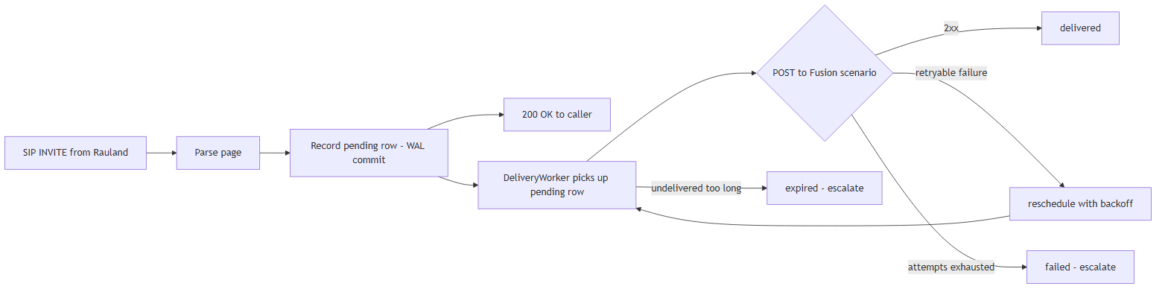
Why this is durable. The critical guarantee is the ordering record -> commit -> attempt. If the process dies at any point after the commit — power loss, SIGKILL, an OS-triggered restart — the pending (or crash-orphaned delivering) row is still on disk and is re-driven on the next startup (§4). No page is ever “in flight only in memory.”

Delivery tuning (defaults, from delivery.py / config.py)
Setting | Default | Meaning
max_attempts | 6 | Delivery attempts before a page is marked failed and escalated.
base_backoff_seconds | 2.0 | First retry delay; doubles each attempt (exponential backoff).
max_backoff_seconds | 60.0 | Ceiling on any single backoff interval.
max_age_seconds | 900.0 | A page still undelivered after 15 min is marked expired and escalated.
poll_interval_seconds | 1.0 | How often the worker sweeps for deliverable rows.
batch_size | 20 | Rows examined per sweep.
Backoff is exponential (base * 2^(attempt-1), capped at max_backoff_seconds), but if Fusion returns a Retry-After header with a delta-seconds value, the worker honors that instead (capped at the same ceiling). The Retry-After HTTP-date form is intentionally not honored — it falls back to exponential backoff (see webhook.py _parse_retry_after).

3. The delivery state machine
Every call row carries a state column. The DeliveryWorker and the DB helpers move a row through these states. This is the single source of truth for “did this page get out?” and it is what the dashboard’s stats and /call/{id} view read.
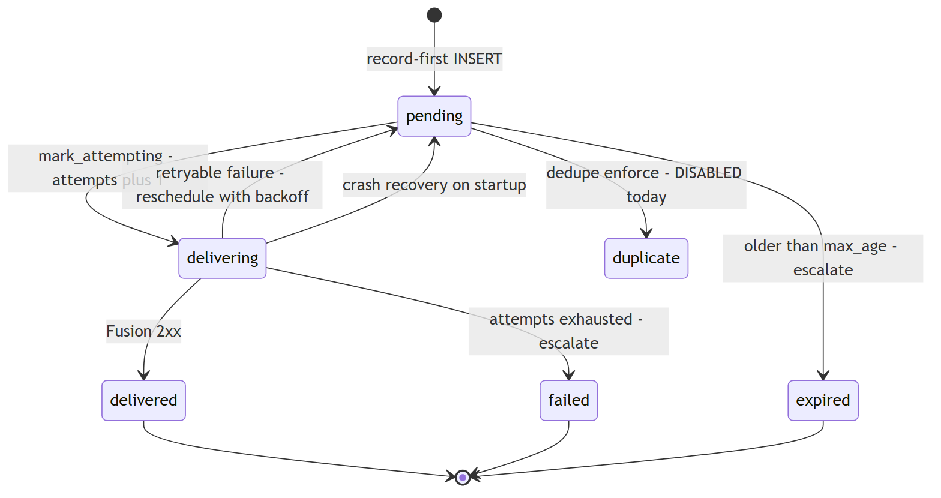
State | Meaning | Terminal?
pending | Recorded durably, awaiting a delivery attempt (or waiting out a backoff cooldown before the next one). This is the state a page sits in between retries. | No
delivering | The worker has claimed the row and is mid-attempt (attempts was just incremented). A crash here is recovered back to pending on startup. | No
delivered | Fusion returned 2xx. The page is out; delivered_at, fusion_status, and response_time_ms are stamped and last_error cleared. | Yes (success)
retrying | Conceptual label for a page that has failed at least once and is scheduled for another attempt. On disk this is represented as pending with attempts > 0 and a non-null last_error; the worker holds an in-memory cooldown until the backoff elapses. | No
failed | Delivery exhausted max_attempts without a 2xx. last_error records the last status; escalation fires. Requires human attention. | Yes (failure)
expired | The page stayed undelivered past max_age_seconds (15 min default). Marked expired, escalation fires. A very stale page is retired rather than paged out minutes late. | Yes (failure)
duplicate | A page suppressed as a clinical duplicate. Not used in production today — dedupe enforcement ships disabled (§7). Reserved for the enforcement path; when it exists, the row is recorded but deliberately not delivered. | Yes (suppressed)
legacy | Pre-outbox rows that predate the state machine (the ~300 historical prod rows the migration back-filled). Classified for stats by their stored fusion_status, not re-delivered. | Yes (historical)
Notes on the “retrying” state. It is a reporting state, not a distinct on-disk value: the retry path calls reschedule(), which returns the row to pending with an updated last_error and fusion_status, while the worker keeps a per-row cooldown (_next_before) in memory. That cooldown is intentionally in memory only — if it is lost to a restart, the row is simply re-attempted sooner, which is the safe direction (we would rather retry early than late).

4. Crash recovery and graceful drain
- Startup recovery. On boot, recover() calls recover_inflight(), which flips every crash-orphaned delivering row back to pending. A page that was mid-attempt when the process died is re-queued and delivered. This is the mechanism that turns “record-first” into genuine at-least-once delivery across restarts.
- Graceful drain. On a clean shutdown the worker runs drain() (best-effort, deadline-bounded) to flush any pending rows before exiting. Durability does not depend on drain succeeding — record-first plus startup recovery already cover a hard stop; drain is purely an optimization to empty the queue on a coordinated stop.
- Systemd watchdog. sipgw.service runs Type=notify with WatchdogSec=30s (watchdog.py). If the writer wedges, systemd restarts it and startup recovery re-drives the queue.

5. Background OAuth token refresh (token off the critical path)
Fusion’s Scenarios API requires an OAuth2 bearer token. In the old inline model, if the cached token was expired at the moment a page arrived, the page’s own delivery had to stop and fetch a fresh token first — a network round-trip on the critical path, and precisely the kind of transient failure that lost the 2026-06-12 page.
The current build runs a background refresh loop (start_token_refresh / _refresh_loop in webhook.py):
- A dedicated task keeps a valid token cached at all times, renewing it roughly token_refresh_margin_seconds (default 300s) before expiry.
- When a page is delivered, the token is almost always already warm — no fetch on the paging path.
- If a delivery ever does hit a 401 (token revoked/rotated mid-flight), trigger_scenario clears the cache, re-authenticates, and retries the POST once inline — and any remaining failure still falls through to the durable retry loop rather than being lost.
- Token refresh takes the token lock only while actually refreshing; the reachability probe and the delivery path never block each other on it.
The net effect: token acquisition is no longer a single point of failure on the paging path. A transient token-endpoint hiccup is absorbed by the background loop and the outbox retries, not paid for by a live Code Blue.

6. The 2026-06-12 lost Code Blue: what happened, and how this build prevents it
What happened. A Code Blue INVITE arrived and was processed on the old inline delivery path. Delivering the page required an OAuth token fetch, and that fetch hit a transient httpx.ConnectTimeout. Because delivery was inline and there was no durable record and no retry, the exception propagated, the call was recorded with fusion_status = -1, and the page was never sent. One transient network timeout on the critical path lost a life-safety notification with no second chance.
How the current build prevents it. Every contributing factor has been removed:
2026-06-12 failure factor | Current-build mitigation
Delivery was inline on the SIP thread. | Record-first outbox — the page is durably committed before any network attempt (§2).
A single transient timeout was fatal. | Bounded retries with backoff — up to max_attempts (6) attempts before failure (§3).
Token fetch happened on the paging path. | Background token refresh keeps the token warm off the critical path (§5).
A lost page was silent (just fusion_status=-1). | On permanent failure/expiry, escalation fires to a human channel (§8).
A crash mid-send lost the page entirely. | Startup recovery re-drives crash-orphaned rows (§4).
Under today’s build, that exact scenario would land the page in pending, retry it within seconds as the transient timeout cleared, and deliver it — or, in a genuine sustained outage, escalate it loudly rather than dropping it silently.

7. Duplicate INVITEs and clinical dedupe (SHADOW mode today)
The upstream behavior. Rauland’s nurse-call source emits two INVITEs per event for a meaningful fraction (~1/3) of events. Left unhandled, this means some events would produce two overhead pages.
What ships in production today — accuracy note. The clinical dedupe module (dedupe.py) is present but ships DISABLED / SHADOW-only. The shipped config is:
dedupe:
enforce: false # never suppresses a page
window_seconds: 0 # the duplicate-lookup query never even runs
match_bed: true
match_purpose: true
With these defaults:
- evaluate() computes a stable clinical fingerprint (cf-v1: — normalized area / room / bed / purpose) but, because window_seconds is 0, never queries the database and never suppresses anything.
- Setting window_seconds > 0 with enforce: false turns on shadow telemetry only: each clinical duplicate is logged as WOULD suppress ... gap=<seconds> ... and annotated in duplicate_of, so the real duplicate rate can be measured — but the page is still delivered.
- enforce: true is treated as an out-of-policy configuration. validate_config warns loudly (*** DEDUPE SUPPRESSION ACTIVE ***), and even in that state the main paging path never gates delivery on the decision. Suppression that actually drops a page requires clinical sign-off that has not been given.
Why disabled? Suppressing a duplicate is indistinguishable, in code, from dropping a real second Code Blue for the same room. Per the “missed never” rule (§1), that trade is gated behind explicit clinical approval. Until then the gateway delivers both INVITEs — a duplicate page is the accepted, safe outcome.
Two identities are kept strictly separate and must never be conflated:
- SIP transaction identity (v1: invite_fingerprint, #15) — a retransmit of the same INVITE (same Call-ID/From/CSeq).
- Clinical identity (cf-v1: fingerprint, #5) — who/where/why (area/room/bed/purpose).
The upstream event-id (extracted from the SIP Call-ID, stored in the indexed event_id column) is recorded on every page as telemetry and is a prerequisite for the future HA “one-call-one-host” work, but today it is annotation only — never a match key, never a delivery gate.

8. Escalation on permanent failure
When a page reaches a terminal failure state, the gateway makes the failure loud rather than silent (on_escalate callback -> escalation.py):
- failed (retries exhausted) and expired (undelivered past the deadline) both trigger escalation.
- The escalator POSTs a JSON summary (reason, call id, caller, area/room, attempts, fusion_status, last_error) to the configured escalation.webhook_url (Teams / Slack / PagerDuty / NOC).
- If no webhook is configured, the failure is still logged at ERROR (ESCALATION (no webhook configured) — ...) so it is visible in sipgw.log.
- Escalation is robust by contract: any failure inside the escalator is logged and swallowed, never raised — a broken alert channel can never disrupt delivery of the next page.
- In dry-run/test the escalation client carries the same no-send guard as the Fusion client, so drills cannot page a real human channel.
Operational recommendation: set escalation.webhook_url in production. Without it, a failed/expired page is recorded and logged but will not actively alert anyone.

9. SIP correctness: ACK-gated BYE (the 481 race, fixed)
The gateway answers each INVITE (200 OK), then in immediate-BYE mode tears the call back down so the RTP port is freed promptly. An older build could send the gateway’s BYE before the caller’s ACK had arrived, drawing a 481 Call Leg/Transaction Does Not Exist from the far end and leaving the SIP dialog in an inconsistent teardown.
The current build (sip_server.py, #11) makes teardown ACK-gated:
- After sending 200 OK, the gateway keeps the call and defers its BYE until the caller’s ACK confirms the three-way handshake. This guarantees INVITE -> 200 -> ACK -> BYE ordering — the BYE never outruns the ACK, so no 481 is drawn.
- A lost-ACK fallback timer (immediate_bye_ack_timeout_seconds) tears the call down anyway if the ACK never arrives, so a dropped ACK can’t leak a call or an RTP port.
- The teardown funnel is a single-fire, idempotent path — whichever of {ACK arrives, fallback fires, peer BYE, shutdown} happens first sends the deferred BYE exactly once.
Crucially, the page does not depend on any of this. The durable page is recorded from the INVITE handler; ACK/BYE/fallback are the SIP-hygiene layer and never gate whether the page goes out.

10. What the design guarantees (and what it does not)
Guaranteed (as deployed):
- At-least-once delivery of every accepted page, across process crashes, restarts, Fusion outages, and transient token/network failures — via record-first + WAL durability + bounded retries + startup recovery.
- No silent loss — a page that ultimately can’t be delivered ends in failed or expired and is escalated (and always logged).
- Token acquisition is not on the critical path.
- SIP teardown is spec-correct (no 481 race) and independent of the paging guarantee.
- Duplicate pages are tolerated, never dropped by accident — clinical suppression is off by default.
Explicitly NOT guaranteed:
- Exactly-once delivery. The design is at-least-once by choice. A retry after an ambiguous response (e.g., a 2xx that was lost in transit) can produce a duplicate page. This is accepted under the “duplicate OK” rule.
- Ordering across pages. The worker delivers oldest-first per sweep, but retries and backoff mean a retried page can be delivered after a newer one. Each page is independent; there is no cross-page sequencing contract.
- Delivery within a hard latency bound. Normal delivery is sub-second, but a page under retry/backoff can take up to max_age_seconds (15 min) before it is retired as expired. There is no faster hard SLA than “delivered as soon as Fusion accepts it, or escalated.”
- Automatic de-duplication of Rauland’s double-INVITEs — suppression is disabled (§7).

11. Known limitations (and the roadmap that addresses them)
These are real, current limitations of build c23f3eb. The fixes live in the Roadmap and are not deployed today.

11.1 Single node — no automatic failover (roadmap #17)
The gateway runs on a single host (sip2apibridge). Durability protects against process crashes and transient failures, but not against loss of the host itself (hardware failure, network partition, a long OS outage). While the node is down, no pages are delivered; a stale page resumes when the node returns and startup recovery re-drives the queue, but there is no live second node.
Roadmap #17 (HA epic): NetScaler load-balanced active/active with autonomous durable nodes, one-call-one-host via Call-ID persistence, a delivery-aware /health monitor, and failover-without-failback. Planned; not built.

11.2 Uncoordinated OS-triggered restarts (issues #20, #19)
On 2026-07-07, an unattended-upgrades/needrestart auto-restart bounced the paging service uncoordinated (issue #20). Because delivery is durable, no page was lost — the outbox and startup recovery covered it — but the restart was uncoordinated, i.e., it could interrupt an in-flight attempt at an arbitrary moment rather than during a drained, quiescent window.
Roadmap #20: coordinate OS patching / auto-restarts with the paging service. Roadmap #19: zero-downtime writer restarts via systemd socket activation, so the SIP listener survives a writer restart with no dropped datagrams.
This is an operational lesson, not a delivery-durability gap: the durable outbox already prevented data loss; #19/#20 close the availability window during patching.

11.3 Timestamp timezone (documented quirk)
The host clock is Etc/UTC and stored timestamps are canonical UTC RFC3339. The config declares logging.timezone: America/New_York, but that value is not applied to stored timestamps — on-disk timestamps are UTC. The dashboard renders local wall-clock for humans; day-boundary bucketing keys off the numeric created_at epoch, so mixed legacy-local and new-UTC rows still classify correctly. This is a cosmetic/config-clarity item, not a reliability defect.

11.4 No host firewall on the paging ports (security-adjacent, see Security section)
There is currently no host firewall (empty nftables) on :5060 and :8080; ingress relies on the application-level SIP allowlist, and the dashboard has no authentication. This does not affect delivery guarantees but is a hardening gap — see the Security section for the recommended nftables rules.

12. Reliability at a glance
Concern | Mechanism | Module
Don’t lose a page on a transient failure | Record-first outbox + bounded retries + backoff | delivery.py, database.py
Survive a crash mid-delivery | WAL durability + startup recover_inflight() | database.py
Keep auth off the critical path | Background token refresh | webhook.py
Make permanent failures loud | Escalation on failed / expired | escalation.py
Don’t drop a real duplicate Code Blue | Clinical dedupe ships disabled (shadow) | dedupe.py
No 481 on SIP teardown | ACK-gated deferred BYE + lost-ACK fallback | sip_server.py
Detect a wedged writer | systemd Type=notify watchdog | watchdog.py
Report true delivery state | state column + state-aware stats | database.py, dashboard
Bottom line: as deployed, the gateway is a durable, single-node, at-least-once paging system that will not silently lose a Code Blue. Its remaining gaps are availability during host loss and OS patching — addressed by the HA and restart-coordination roadmap items, which are planned and not yet in production.

High-Availability Plan (Next Iteration)
Status: PLANNED — not deployed. Everything in this section describes the next iteration of the RedEye sip2api Gateway. The current production build (c23f3eb, the v1.7 line) runs a single autonomous durable node (sip2apibridge, 10.249.0.60). The single node is already hardened for reliability — record-first durable outbox, bounded retries with backoff, background OAuth refresh, watchdog, and a delivery-aware /health — so the HA work below adds node-level redundancy, not a rewrite. It is tracked as the open HA epic #17, with #19 (zero-downtime writer restarts) as its near-term companion. Nothing here should be read as a description of what is live today.
This section documents the target HA architecture, the design decisions behind it, the companion zero-downtime-restart work, and the concrete open requirements (NetScaler, Singlewire, Rauland) that must be satisfied before HA can be cut in.

1. Why HA, and why now
The gateway is on the life-safety path: a real Code Blue or RRT INVITE from Rauland must become an InformaCast Fusion overhead page every time. The current single node already survives the failure modes that used to lose a page within one host:
- a Fusion outage or transient httpx.ConnectTimeout (the 2026-06-12 loss) — now absorbed by the durable outbox + bounded retries + background token refresh;
- a process crash between “page received” and “page delivered” — now recovered on restart (recover_inflight() returns orphaned delivering rows to pending);
- duplicate upstream INVITEs — now collapsed by enforcing dedupe.
What a single node cannot survive is the loss of the host itself: a kernel panic, a hypervisor failure, a NIC/link failure on ens34, an OS patch that wedges the box, or a botched maintenance window. During any of those, there is no second node to answer the SIP INVITE, and a page can be lost at the front door before the durable outbox ever sees it.
The 2026-07-07 unattended-upgrades / needrestart incident (#20) made the gap concrete: an OS auto-restart bounced the paging service uncoordinated, with no second node to carry traffic during the blip. That incident motivates both tracks below — node redundancy (#17) and zero-downtime restarts (#19).
HA goal: no single host failure — planned or unplanned — can drop, delay past the retry budget, or duplicate a Code Blue.

2. Target topology (planned)
Two or more autonomous durable nodes sit behind an HA NetScaler load balancer that fronts the SIP virtual IP. Rauland points at the NetScaler SIP VIP instead of directly at the gateway. Each node is a full, independent copy of today’s production node: its own SIP listener, its own record-first durable outbox (SQLite WAL), its own delivery worker, escalation, and dashboard. Nodes are shared-nothing — there is no shared database, no cross-node lock, and no leader election on the paging path.
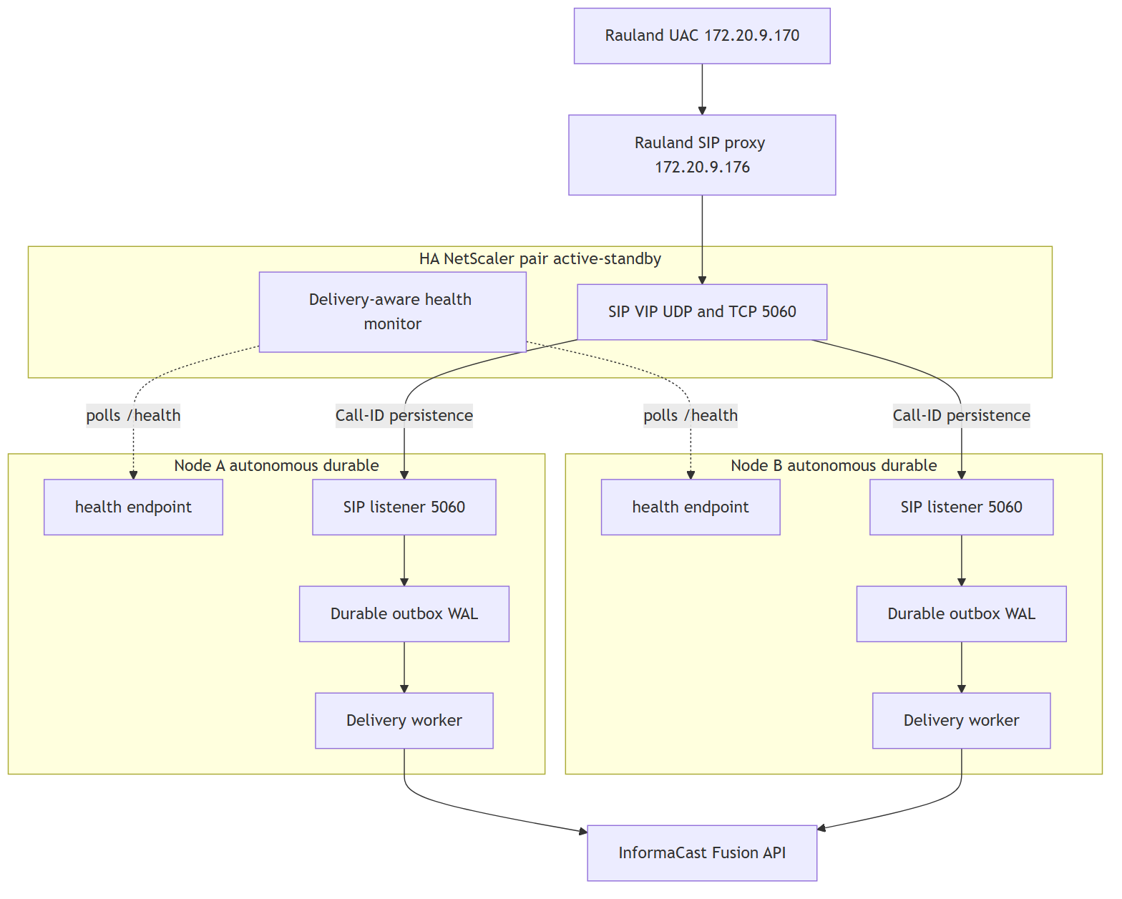
Key properties:
Property | Design choice
Load balancer | HA NetScaler pair fronting a single SIP VIP (UDP and TCP 5060)
Node model | 2+ autonomous, shared-nothing nodes; each a full durable gateway
Call affinity | One call to one node via SIP Call-ID persistence (not source IP)
Durability | Per-node durable outbox (record-first WAL) — no shared DB
Health | Delivery-aware /health monitored by the LB; unhealthy nodes drained
Failover | Automatic failover on, automatic failback off (see §5)
Maintenance | Native drain of a node (stop new calls, finish in-flight)

3. Call affinity: SIP Call-ID persistence (not source IP)
The single most important LB decision is how a call is pinned to a node.
A SIP call is a multi-message dialog — INVITE, ACK, and BYE for the same call must all reach the same node, because that node holds the in-memory dialog state keyed on the Call-ID. In the current code the SIP server stores every live call in self.calls[call_id] and matches the follow-up ACK and BYE back to it by Call-ID; a message that lands on the wrong node is an “ACK for unknown call” and the ACK-gated immediate-BYE teardown cannot complete cleanly.
The obvious LB persistence method — source-IP affinity — does not work here. Every INVITE arrives from the single Rauland proxy source 172.20.9.176 (Rauland UAC 172.20.9.170 → proxy 172.20.9.176 → gateway). Source-IP persistence would therefore pin all traffic to one node and defeat the entire purpose of HA: the “balancer” would never balance, and losing that one node would lose everything.
The persistence key must be the SIP Call-ID header. The NetScaler must parse the SIP message, extract Call-ID, and hash it to a node, so that:
- every INVITE for a new Call-ID is balanced across the healthy node set;
- every subsequent ACK / BYE for that same Call-ID lands on the same node that answered its INVITE.
This is a hard NetScaler requirement (see §6). The gateway already emits the retransmit-stable transaction fingerprint (v1:…, keyed on Call-ID + From + CSeq) and persists the upstream event_id derived from the Call-ID, so the node-side correlation needed to reason about “one call → one host” is already in place; the missing piece is Call-ID-based persistence on the balancer.

4. Autonomous durable nodes — no shared state
Each node keeps the per-node durable outbox exactly as it works today. There is deliberately no shared database and no cross-node coordination on the paging path:
- A node that answers an INVITE records the page first (state pending, WAL) on its own disk before any Fusion send, then its own delivery worker drives pending → delivering → delivered | failed | expired with bounded retries and backoff, escalating on permanent failure.
- Because a whole call (INVITE + ACK + BYE) is pinned to one node by Call-ID persistence, that node owns the page end-to-end. There is never a hand-off of a half-delivered page between nodes, so there is nothing to replicate and no split-brain to resolve on the delivery path.
- If a node dies after recording a page but before delivering it, that page lives in that node’s WAL. On restart the node’s recover_inflight() re-queues it and delivery resumes. HA does not change this contract — it just means the rest of the cluster keeps answering new calls while the dead node is down or recovering.
This shared-nothing model is what makes the nodes “autonomous”: each is independently correct and independently durable. The LB adds availability for new calls; the per-node outbox continues to guarantee durability for calls a node has already accepted.
Duplicate suppression is per-node. Enforcing dedupe (window 2s, event-id / clinical-key based) runs against each node’s own WAL. Rauland’s ~1-in-3 double-INVITE is collapsed correctly as long as both INVITEs of one event land on the same node — which Call-ID persistence guarantees when both INVITEs share a Call-ID. See §6 for the Singlewire idempotency-key backstop that covers the residual cross-node case.

5. Failover with no automatic failback
Failover is automatic; failback is not.
- Failover (automatic). When the LB’s delivery-aware monitor marks a node unhealthy (see below), the NetScaler stops sending it new calls and distributes them across the remaining healthy node(s). In-flight calls already pinned to a surviving node are unaffected.
- No automatic failback. When a previously-failed node comes back healthy, the LB does not automatically resume steering new calls to it. A node is returned to rotation only by a deliberate operator action.
The reason is life-safety stability. A node that is flapping — healthy, then unhealthy, then healthy again on a short cycle (e.g. a partial network fault, an OOM loop, or a half-finished OS patch) — would, under automatic failback, be handed live Code Blue traffic during a window when it is not actually trustworthy. “No automatic failback” makes recovery an explicit, observed, human-gated step: an operator confirms the node is genuinely healthy (its outbox has drained, its /health has been solidly green, logs are clean) and only then returns it to the active set. We prefer a brief period running on fewer-but-known-good nodes over auto-rejoining a flapping node onto the paging path.

Delivery-aware health as the failover signal
Failover is only as good as the health signal driving it. The LB must not rely on a bare TCP-connect or “the web server answered” check — a node can accept TCP on 5060 while its delivery pipeline is stuck. The monitor polls each node’s existing delivery-aware /health, which already reflects:
- writer heartbeat freshness — /health returns 200 {"status":"ok"} only when the writer’s heartbeat is fresher than stale_after_seconds (default 30s); a dead or hung writer returns 503 stale / 503 no-heartbeat. This is genuine cross-process writer liveness, not just “the HTTP server is up”;
- delivery backlog and last-delivered telemetry (backlog, last_delivered_at);
- Fusion reachability (fusion_reachable, fusion_checked_age_s) — optional degrade available;
- inbound-liveness / Rauland-reachability (last_inbound_sip_age_s) — “is the Rauland link up, or just quiet?”.
For HA, the LB monitor should key failover on the /health status code (heartbeat-driven, the current authoritative liveness signal), with a fast poll interval so a dead node is drained from the SIP VIP within a small number of seconds rather than the current single-node self-restart timeframe. The informational fields (backlog, fusion_reachable, last_inbound_sip_age_s) feed operator dashboards and the failback decision; whether any of them should also gate LB removal is an open policy question (see §6). Today, deliberately, a Fusion blip or a delivery backlog does not flip the single node’s /health status code — because on a lone node, self-evicting on a transient Fusion issue would take the only pager offline. In a multi-node cluster that trade-off can be revisited: with peers available, a node with a genuinely stuck delivery pipeline could be drained. That is a config decision to make at HA cut-in, not a code change already shipped.

6. Companion: zero-downtime writer restarts (#19)
HA across hosts does not, by itself, make a single node restart gracefully. The #20 incident was a writer restart problem: bouncing sipgw.service tears down the SIP listener, so INVITEs that arrive during the restart window hit a closed socket. On a single node that is a brief SIP blip; even in a cluster, every node still needs to restart cleanly for routine patching and upgrades.
Issue #19 — systemd socket activation is the fix, and the natural companion to the HA epic:
- systemd owns the listening sockets for UDP and TCP 5060 (and, if desired, the dashboard’s 8080) via a .socket unit. The kernel keeps the socket open and queues inbound datagrams/connections across a writer restart.
- When the writer process restarts, it inherits the already-open sockets from systemd instead of binding them itself. The socket never closes, so INVITEs that arrive mid-restart are buffered by the kernel and serviced the moment the new writer is ready — no dropped INVITE, no reset connection, no SIP blip.
- This composes cleanly with the record-first outbox: a page is still recorded before any send, and recover_inflight() still re-queues anything caught in-flight by the restart. Socket activation removes the front-door gap; the outbox already covers the delivery gap.
Paired with #20’s operational lesson (coordinate OS patching; never let unattended-upgrades bounce the paging service unannounced), socket activation turns a writer restart from a “brief outage” into a “non-event.” In the HA cluster, restarts are further covered by draining one node at a time (§7) so the VIP always has a live node — socket activation and node drain are complementary, not redundant.

7. Native maintenance drain
The planned build supports a first-class drain of a single node for maintenance without any paging gap:
- Operator marks Node A for drain (a maintenance flag the LB monitor honors, or an admin action on the NetScaler).
- The LB stops steering new Call-IDs to Node A; new calls go to the remaining healthy node(s).
- Node A finishes in-flight work: it completes the ACK/BYE teardown for calls it already answered, and its delivery worker drains its outbox (pending → delivered) with the normal retry/backoff budget.
- Once Node A’s outbox is empty and no dialogs are live, it can be patched, rebooted, or upgraded (ideally with #19 socket activation so even its own restart is seamless).
- Because failback is not automatic (§5), Node A rejoins the active set only when the operator explicitly returns it.
This is the supported answer to the #20 class of problem: OS patching and gateway upgrades become a rolling, one-node-at-a-time operation with the SIP VIP continuously served by at least one healthy durable node.

8. Open requirements before HA can be cut in
HA is a plan, and it depends on capabilities outside the gateway code. These are the concrete gates:

8.1 NetScaler (load balancer)
- SIP load balancing for UDP and TCP on 5060 across the node set behind a single VIP.
- SIP Call-ID persistence — parse the SIP Call-ID header and pin all messages of a dialog (INVITE/ACK/BYE) to the node that answered the INVITE. Source-IP persistence is explicitly unusable because all traffic shares the single proxy source 172.16.…/172.20.9.176 (§3).
- Fast, delivery-aware /health monitoring — an HTTP monitor against each node’s /health, keyed on the status code, at a poll interval short enough to drain a dead node from the VIP within a few seconds. Open policy question: whether the monitor should also consider /health informational fields (backlog, fusion_reachable) for LB removal, or leave those to operators and the failback decision (§5).
- Automatic failover, manual failback semantics configured on the service group (§5), plus a maintenance-drain action (§7).

8.2 Singlewire / InformaCast Fusion
- Idempotency key on the scenario trigger. Per-node dedupe collapses Rauland’s double-INVITE when both INVITEs land on the same node (Call-ID persistence makes that the normal case). A Singlewire-honored idempotency key on the Fusion trigger — derived from the upstream event_id the gateway already persists — is the cluster-wide backstop that guarantees one event → one overhead page even in the residual case where two related INVITEs are answered by two different nodes (each with its own outbox and no shared dedupe view). Without an upstream idempotency key, cross-node duplicate suppression cannot be fully guaranteed by the gateway alone.

8.3 Rauland (upstream)
- Dual-target / VIP awareness. Rauland’s UAC/proxy must send INVITEs to the NetScaler SIP VIP (not directly to a single gateway host at 10.249.0.60), so the LB can distribute and persist calls. Confirm Rauland can be pointed at the VIP and, where applicable, be configured with the VIP as its notification target so failover is transparent to the source.

8.4 Gateway (this product)
The gateway is already largely HA-ready: shared-nothing per-node durable outbox, record-first persistence, Call-ID-keyed dialog state, persisted event_id, and a delivery-aware /health. The remaining gateway-side work for the epic is #19 socket activation (§6) and the small amount of glue needed to expose a drain state the LB monitor can observe (§7). No change to the durability contract is required — HA is additive.

9. Summary
Concern | Current build (c23f3eb, live) | Planned HA build (#17 + #19)
Nodes | Single autonomous durable node | 2+ autonomous durable nodes behind NetScaler VIP
Host failure | Page path down until host recovers | Surviving node(s) keep answering new calls
Call affinity | N/A (one node) | SIP Call-ID persistence (never source IP)
Durability | Per-node record-first WAL outbox | Unchanged — per-node, shared-nothing
Restart | Brief SIP blip on writer restart (#20) | #19 socket activation — no dropped INVITE
Health/failover | Self-restart on hung writer (watchdog) | LB drains unhealthy node via delivery-aware /health
Failback | N/A | Manual only — no auto-failback of a flapping node
Maintenance | Coordinated restart window | Native one-node-at-a-time drain
Duplicate control | Per-node enforcing dedupe (event-id keyed) | Per-node dedupe + Singlewire idempotency key backstop
Bottom line: the HA plan adds node-level redundancy around the reliability guarantees the single node already provides, without weakening any of them. It is gated on three external capabilities — NetScaler SIP LB with Call-ID persistence and fast delivery-aware health monitoring, a Singlewire idempotency key, and Rauland targeting the SIP VIP — plus the gateway-side #19 zero-downtime-restart companion. Until those gates are cleared, this remains the documented target for the next iteration, not the deployed build.

Roadmap
Applies to: RedEye sip2api Gateway production build c23f3eb (branch main, the v1.7 line = v1.6.5 + 6 commits), deployed on host sip2apibridge.
This section describes direction, not dated commitments. It states what has already shipped (so the roadmap is read against an honest baseline), then the concrete open work that remains, then the upstream asks we are pursuing with our vendors. Anything listed here as planned is not deployed today — the current build is exactly what the rest of this manual documents.

1. What has already shipped (the reliability + observability program)
Most of the hard reliability and observability work is done and in production. It is easy, reading a roadmap, to assume everything below is still aspirational — it is not. The following all shipped across the v1.6.x line and are the deployed build today:
Capability | What it does | Shipped
Durable delivery (transactional outbox) | Record-first pending row in SQLite WAL before any Fusion attempt; a background DeliveryWorker delivers with bounded retries + exponential backoff | v1.6.0
Escalation | Permanent (failed / expired) pages post to a human alert channel | v1.6.0
Background OAuth token refresh | Token refreshed proactively, off the critical path — a page never blocks on a token round-trip | v1.6.0
Async logging | Non-blocking queue handler moves file writes / rotation / gzip off the event loop | v1.6.0
Real /health + watchdog | Writer heartbeat backs /health; systemd Type=notify + WatchdogSec restarts a hung writer | v1.6.0
Config validation | Fatal on invalid production config; loud warnings on soft issues; unknown-key typo warnings | v1.6.0 / v1.6.1
State-aware stats | Dashboard stats derive from the delivery state machine and exclude test rows | v1.6.0
Canonical UTC timestamps | RFC3339 …Z stamps in DB and all four log streams; UTC-sortable, string-matchable against Singlewire | v1.6.0 / v1.6.1
Two-service split | Read-only dashboard is a separate process; it can be restarted without interrupting paging | v1.6.0
INVITE fingerprint + event_id | Stable transaction fingerprint and persisted upstream event_id column | v1.6.0 / v1.6.1 / v1.6.3
Dashboard v2 core | Date-picker log viewer, 90-day stacked call-type chart, /call/{id} correlated detail, per-call diagnostic bundle | v1.6.2 – v1.6.5 / v1.7
Fusion reachability + inbound-liveness on /health | Optional Fusion-unreachable signal; last-inbound-SIP-age (Rauland reachability) card | v1.6.1 / v1.6.3
Enforcing dedupe | Clinical duplicate suppression, signed off and enabled: window 2s, bed-level, purpose-keyed, record-first, fail-safe | v1.7
ACK-gated immediate-BYE | Page fires immediately; gateway BYE deferred until the ACK confirms the dialog (closes the 481 race), with a lost-ACK fallback | v1.7
The single lost Code Blue of 2026-06-12 — a transient httpx.ConnectTimeout during an inline OAuth fetch, with no retry — is prevented by the durable outbox, bounded retries, and background token refresh above. See the Reliability section for the full account.
Everything from here down is what is not yet built.

2. Open work — the six tracked issues
These are the only open issues at build c23f3eb. Everything else in the reliability/observability program shipped in v1.6.x. They are listed roughly in the order they matter for a single-node deployment; the two availability items (#20, #19) are the near-term focus, the HA epic (#17) is the larger-horizon effort.

#20 — OS auto-restart coordination (near-term)
Problem. On 2026-07-07 an unattended-upgrades / needrestart auto-restart bounced the paging service uncoordinated. No page was lost — the durable outbox and startup recovery covered it — but the restart landed at an arbitrary moment rather than during a drained, quiescent window.
Direction. Coordinate OS patching and automatic service restarts with the paging service so restarts happen in controlled windows, not whenever the package manager decides. This is an operational-safety item; the data-loss risk was already closed by durability. Interim mitigation (documented in Operations): scope needrestart/unattended-upgrades away from the paging unit and patch in a planned window.

#19 — Zero-downtime writer restarts (systemd socket activation) (near-term)
Problem. A writer restart today drops a brief (~0.3 s) SIP window: while the process is down, inbound UDP datagrams to :5060 have no listener.
Direction. Move the SIP listening socket to systemd socket activation, so the socket is owned by systemd and survives a writer restart. Datagrams that arrive during the swap are buffered by the kernel and handed to the new process, so a planned (or unplanned) writer restart no longer drops a packet. This is the clean fix underneath #20 — with it, coordinated restarts become genuinely seamless.

#17 — High-availability epic (NetScaler active/active) (larger horizon)
Problem. The gateway runs on a single host. Durability protects against process crashes and transient failures, but not against loss of the host itself (hardware, network partition, long OS outage). While the node is down, no pages are delivered.
Direction — a shared-nothing, active/active pair behind the site NetScaler:
- Two autonomous durable nodes. Each node is a complete, self-sufficient gateway (its own outbox, its own delivery worker) — no shared database, no shared state, nothing for one node to wait on. Either node can deliver any page on its own.
- One call → one host, via Call-ID persistence. The NetScaler pins each SIP dialog to a single node by Call-ID, so the INVITE / ACK / BYE of one call all land on the same gateway and the SIP state machine stays coherent.
- Delivery-aware /health monitor. The load balancer health check reflects real delivery health (not just “the web server answered”), so a node that can accept SIP but cannot reach Fusion is taken out of rotation. This is why the health.fail_on_fusion_unreachable foot-gun exists and ships OFF today — it is built for this topology, where there is a second node to fail over to.
- Failover without failback. On failover, traffic moves to the healthy node and stays there until an operator deliberately returns it — no automatic flapping back to a node that just proved unreliable.
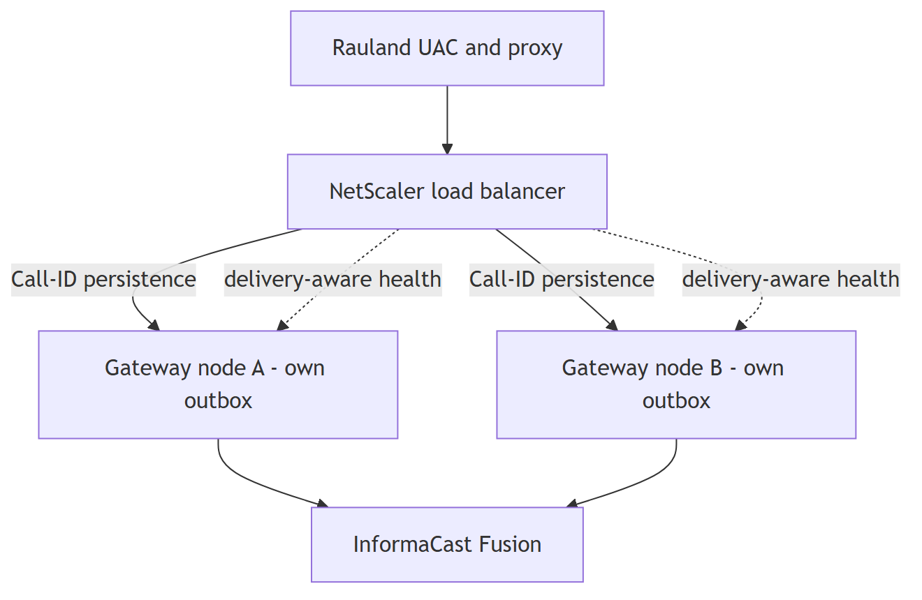
Prerequisites already in place. Two design decisions in the shipped build exist specifically to enable this epic: the persisted upstream event_id (the cross-node merge key that lets two nodes recognize the same clinical event), and the shared-nothing node design (each node’s outbox is already fully independent). #17 builds on those; it does not require rearchitecting them.

#13 — Dashboard-v2 remaining phases (incremental)
The dashboard-v2 core shipped (date-picker log viewer, 90-day stacked call-type chart, /call/{id} correlated detail view, per-call diagnostic bundle, verify-lookups). The remaining phases are the incremental tail of that epic — further correlation, filtering, and reporting refinements. Dashboard-only work: it deploys by restarting only sipgw-dashboard.service, with zero SIP-path impact.

#5 — Dedupe tail (cleanup)
Enforcing clinical duplicate suppression shipped (signed off, enabled in production: 2 s window, bed-level, purpose-keyed, record-first, fail-safe toward delivery). The #5 tail is follow-up hardening and telemetry on top of the live feature — e.g. tightening the event-id keying and continued monitoring of the suppress/deliver split — not the core capability, which is done.

#11 — Logging-hygiene tail (cleanup)
The load-bearing logging-hygiene work shipped: full client_id / client_secret / bearer-token redaction, UTC RFC3339 stamps across all four streams, the ACK-gated / spec-correct BYE. The #11 tail is the residual cleanup on top — minor formatter and log-content polish, no behavior change to the call path.

3. Upstream asks (dependencies on our vendors)
Two items are not ours to build — they depend on Singlewire and Rauland. We are pursuing both; neither blocks the current build, which already compensates for both defensively.

Singlewire — idempotency key on the scenario trigger
Ask. An idempotency key on the InformaCast Fusion scenario-trigger API, so a retried POST that Fusion actually received (but whose response we lost) cannot fan out a second overhead page.
Why. Our delivery model is deliberately at-least-once (“duplicate OK, missed never”), so on an ambiguous failure we retry — and a retry can produce a duplicate page. A server-side idempotency key would let Fusion collapse a retried-but-already-accepted request, giving us effectively-once delivery without ever weakening the retry that guarantees we never miss a page. Until Singlewire offers this, our own record-first + clinical dedupe reduce (but cannot fully eliminate) duplicate fan-out on retry.

Rauland — duplicate-origination investigation
Ask. Investigation of why the Rauland source double-emits — roughly one in three events arrives as two INVITEs — and, ideally, a fix at origin.
Why. We already suppress these downstream (enforcing dedupe, 2 s window, event-id keyed). That is robust, but it is a compensating control: it collapses duplicates after they cross the wire. Fixing the double-emission at the Rauland origin would remove the duplicate class entirely and reduce the load our dedupe path carries. Our suppression stays in place regardless — it is fail-safe and clinically signed off — so this ask is an improvement at the source, not a dependency for correct operation.

4. Guiding principles (how the roadmap is prioritized)
Every item above is weighed against the product’s one non-negotiable rule:
It is acceptable to deliver a page twice. It is never acceptable to miss one.
That ordering explains the roadmap’s shape: durability and delivery guarantees shipped first (a missed page is the unacceptable failure), availability of the node (#20, #19, #17) comes next (a down node delays but — thanks to durability — does not silently lose pages), and the duplicate-reduction asks (Singlewire idempotency, Rauland origination) come as refinements — because a duplicate is the tolerable side of that trade, never the dangerous one. No roadmap item will be accepted if it trades away the “never miss” guarantee to reduce duplicates.

See the Reliability section for the delivery guarantees and known limitations these roadmap items address, and the Architecture and Operations sections for the current single-node build the roadmap builds upon.

Troubleshooting Guide
This guide is symptom-first. Find the symptom, read the likely cause, apply the resolution. Everything here describes the current production build (c23f3eb, the v1.7 line) as deployed on host sip2apibridge. Where behavior changed from earlier builds, the change is called out so you are not chasing a bug that a current release already fixed.
Two facts frame almost every diagnosis:
- The paging path and the dashboard are two independent services. A dead or blank dashboard does not mean paging is down, and restarting the dashboard never interrupts a page. See Service map.
- A page is durably recorded before it is delivered. Once the SIP INVITE is accepted, the call is written to SQLite (WAL) as state='pending' and then delivered by a background worker with bounded retries. A transient Fusion failure no longer loses the page — it retries, and if it can never be delivered it escalates to a human channel. See Page did not arrive.

Service map
Service | Type | What it does | Restart impact
sipgw.service | Type=notify, WatchdogSec=30 | SIP ingress + parse + TTS + durable delivery (the call path) | Restarting this interrupts paging briefly. Coordinate.
sipgw-dashboard.service | Type=simple | Read-only web UI on :8080 (dashboard_app.py) | Safe to restart any time. Does not touch paging.
Both processes open the same SQLite database at /var/lib/sipgw/calls.db (WAL mode). The writer (sipgw.service) stamps a heartbeat row; the dashboard reads it to answer /health. This is why /health can report the writer’s liveness even though it is served by the dashboard process.
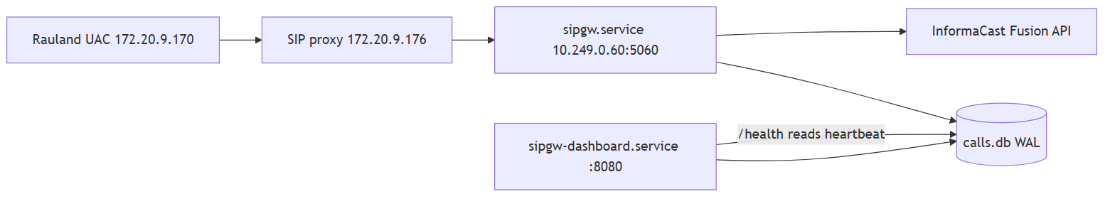

Where to look — files and ports
Thing | Location
Install root | /opt/sipgw
Virtualenv | /opt/sipgw/venv
Database (WAL) | /var/lib/sipgw/calls.db
Logs | /var/log/sipgw/
Main service log | /var/log/sipgw/sipgw.log
Fusion/API debug (full HTTP) | /var/log/sipgw/sipgw_api_debug.log
SIP wire debug | /var/log/sipgw/sipgw_sip_debug.log
Dashboard log | /var/log/sipgw/sipgw_dashboard.log
SIP port | 5060/udp and 5060/tcp
Dashboard port | 8080/tcp
Health endpoint | http://10.249.0.60:8080/health
Log retention is 90 days. All timestamps are UTC (the host clock is Etc/UTC; note logging.timezone: America/New_York is declared in config but is not applied — do not expect Eastern time in the log files).

First-response triage (run these three)
# 1. Are both services up?
systemctl status sipgw.service sipgw-dashboard.service --no-pager
# 2. Is the writer alive and is Rauland reaching us? (JSON)
curl -s http://10.249.0.60:8080/health | python3 -m json.tool
# 3. What has the call path logged in the last few minutes?
tail -n 100 /var/log/sipgw/sipgw.log

Symptom: a page was expected but did not come over the overhead
This is the highest-stakes symptom. Work it in this order; the goal is to find which stage the event reached: never arrived (SIP), arrived but rejected (allowlist / parse), or arrived and is stuck/failed in delivery (Fusion).

Step 1 — Did the call reach the gateway at all?
Open the dashboard call table (http://10.249.0.60:8080/) or query the DB. If there is no row for the expected time, the INVITE never reached us or was rejected before it was recorded. Go to No calls appearing at all.
If there is a row, click the timestamp to open the /call/{id} detail view. That page correlates, for this one call, the SIP wire block, the main service log lines, and the Fusion API exchange. It is the fastest way to see where the event stopped.

Step 2 — Read the call’s delivery state
Every recorded call carries a state. The states you will see:
state | Meaning | What it tells you
pending | Recorded, not yet delivered (or between retry attempts) | Delivery is in flight or waiting on a backoff cooldown. Momentary is normal.
delivering | A delivery attempt is in progress right now | Transient. If a row is stuck here after a crash, startup recovery returns it to pending.
delivered | Fusion returned 2xx — the page fired | Success.
failed | Retries exhausted (max_attempts) — permanently not delivered | Escalation fired. See Fusion errors.
expired | Undelivered past max_age_seconds and given up | Escalation fired. The page was too old to still be clinically useful.
legacy | Row predates the durable-delivery state machine | Classified by its fusion_status, not by state. Old rows only.
duplicate | Recorded but suppressed by clinical dedupe | Not seen in production today — clinical dedupe ships inert. See Duplicate pages.
Important — “retrying” is a behavior, not a stored state. When an attempt fails retryably, the worker records the error and returns the row to pending, then holds an in-memory cooldown before the next attempt. So a call that is mid-retry shows state='pending' with a non-empty last_error and attempts > 0. Do not expect a literal retrying value in the DB.
Quick DB reads (read-only; safe while the service runs):
# State breakdown of recent, real (non-test) calls
sqlite3 /var/lib/sipgw/calls.db \
"SELECT state, COUNT(*) FROM calls WHERE is_test=0 GROUP BY state;"
# Anything not yet delivered, newest first
sqlite3 -header -column /var/lib/sipgw/calls.db \
"SELECT id, datetime(created_at,'unixepoch') AS created_utc, state, attempts, \
fusion_status, substr(last_error,1,60) AS last_error \
FROM calls WHERE state IN ('pending','delivering','failed','expired') \
ORDER BY created_at DESC LIMIT 20;"

Step 3 — Interpret and act
- state='delivered' but staff say they heard nothing. The gateway did its job — Fusion accepted the notification (2xx). The problem is downstream of this gateway: InformaCast scenario/audience configuration, speaker zones, or volume. Confirm the TTS text was correct on the /call/{id} view, then hand off to the InformaCast/overhead side. (If the TTS text is wrong, see Wrong or garbled TTS.)
- state='pending' and it is not moving. Either delivery is actively retrying (check last_error/attempts) or the delivery worker is not running. Confirm the worker started:
- grep "delivery worker started" /var/log/sipgw/sipgw.log | tail -1
grep -E "call [0-9]+ (DELIVERED|retry|FAILED|EXPIRED)" /var/log/sipgw/sipgw.log | tail -20
- A healthy retry looks like: call 4213 retry #2 in 4.0s (status 503, Retry-After=4). If you see repeated retries, this is Fusion-side — go to Fusion errors.
- state='failed' or state='expired'. The page was not delivered and the system escalated (posted to the configured escalation channel, or — if no channel is configured — logged a loud ESCALATION line). This is the designed loud-failure path, not a silent loss. Grep the escalation trail:
- grep -E "ESCALATION|call [0-9]+ (FAILED|EXPIRED)" /var/log/sipgw/sipgw.log | tail -20
- Then treat the underlying cause as a Fusion problem (below), fix it, and note that expired/failed pages are not auto-resent — the clinical event is over.

The June 2026 loss is now prevented
On 2026-06-12 a Code Blue was lost to a transient httpx.ConnectTimeout during an inline OAuth token fetch (recorded as fusion_status=-1, with no retry). That failure mode is now structurally prevented in this build:
- Durable outbox + bounded retries — a connect timeout returns status=-1, the worker reschedules with backoff instead of dropping the page, and escalates only after max_attempts.
- Background OAuth token refresh — the token is renewed off the critical path (webhook.py refresh loop), so a page almost never blocks on a fresh token fetch in the first place.
If you ever see a modern row at fusion_status=-1 that is not retrying, that is a real incident — capture the diagnostic bundle (below) and escalate.

Capture a diagnostic bundle for any hard case
Every call detail page offers a plain-text diagnostic bundle:
http://10.249.0.60:8080/call/<id>/bundle.txt
It assembles, for that one call, the correlated SIP block, main-log lines, and Fusion API exchange into copy/paste text for a ticket. Grab this before you restart anything — it is the single best artifact for RedEye support.

Symptom: no calls appearing at all (dashboard table empty or not growing)
No new rows for a stretch where you expected activity. The question is whether Rauland is reaching us or our services are down. Do not assume a dead gateway — a genuinely quiet period looks identical in the table.

Step 1 — Check inbound liveness on /health
curl -s http://10.249.0.60:8080/health | python3 -m json.tool
Look at last_inbound_sip_age_s — the seconds since the last allowlisted SIP datagram from Rauland was seen. This is your Rauland-reachability signal.
- Small / recently updated age → Rauland is reaching the gateway. A quiet table just means no clinical events fired. This is normal and not a fault.
- Large / growing age (hours where you expected traffic) → the upstream SIP path is the suspect: Rauland UAC 172.20.9.170, the proxy 172.20.9.176, network/VLAN, or the far side simply not emitting. Escalate to the Rauland / network side.
- Field is null → no allowlisted inbound SIP has been seen since the last writer start. Combined with a fresh service start, that is expected; combined with a long-running service, it points to an upstream break.
last_inbound_sip_age_s is informational — it never changes the /health status code. A long quiet Rauland stretch must not make an external monitor think the node is unhealthy, so a silent Rauland does not return 503. Optionally, silence-escalation can be enabled (health.inbound_escalate_after_seconds > 0) to alert a human once per silence episode; it is off by default.

Step 2 — Confirm the services are actually up
systemctl status sipgw.service --no-pager
systemctl is-active sipgw.service sipgw-dashboard.service
If /health itself returns 503:
/health body | Meaning | Action
{"status":"no-heartbeat"} | The writer has never stamped a heartbeat | sipgw.service is not running or failed at startup. systemctl status, check sipgw.log.
{"status":"stale","heartbeat_age_s":N} | Writer heartbeat is older than the stale bound (~30s) | The call-path process is hung or dead. This is a real paging outage — restart sipgw.service and investigate the hang.
{"status":"fusion-unreachable"} | (Only if opt-in fusion-degrade is enabled) heartbeat is fine but Fusion probe is failing | Paging ingress is fine; Fusion is unreachable. Go to Fusion errors.

Step 3 — Watch the SIP wire
If liveness is stale but you believe Rauland is sending, watch the SIP debug log live while a test is placed:
tail -f /var/log/sipgw/sipgw_sip_debug.log
You should see INVITE fingerprint=... call_id=... from=<ip>:<port> lines as INVITEs land. If nothing appears here even though the far side claims to be sending, the traffic is not reaching the socket — suspect network/firewall/VLAN between the proxy and 10.249.0.60:5060.
Firewall note. There is currently no host firewall (nftables is empty) on sip2apibridge. Ingress protection relies entirely on the application allowlist (172.16.0.0/12, 127.0.0.0/8, 10.0.0.0/8). This means a missing /health or blank table is not caused by a host firewall rule — but it also means adding nftables for :5060/:8080 is a recommended hardening step (and the dashboard has no authentication). See the Security section of this manual.

Symptom: SIP requests are rejected with 403 Forbidden
The gateway answered the far side with 403 Forbidden and the log shows:
Rejected INVITE from unauthorized IP 203.0.113.9
Cause. The source IP is not inside the SIP allowlist (sip.allowed_networks = 172.16.0.0/12, 127.0.0.0/8, 10.0.0.0/8). Every request from outside those ranges is rejected before it is parsed or recorded, and the source clock (inbound-liveness) is not reset by it — so internet scan noise on UDP 5060 cannot mask a real Rauland outage.
Resolution.
- If the rejected IP is internet noise / a scanner, this is working as intended. No action beyond the recommended nftables hardening.
- If the rejected IP is a legitimate Rauland/proxy source that changed (re-IP, new proxy, added leg), add its network to sip.allowed_networks in config.yaml and restart sipgw.service. Confirm the current expected path is 172.20.9.170 → 172.20.9.176 → gateway.
# Who is being rejected, and how often?
grep "Rejected" /var/log/sipgw/sipgw.log | tail -30

Symptom: SIP 481 Call Leg/Transaction Does Not Exist
This should no longer occur in the current build. The old race — the gateway sending BYE before the caller’s ACK, drawing a 481 — is fixed. In immediate-BYE mode the gateway now waits for the ACK before sending BYE (sip_server.py, ACK-gated teardown), guaranteeing INVITE → 200 OK → ACK → BYE ordering. A lost ACK is covered by a per-call fallback timer that tears the dialog down cleanly instead of racing.
Critically, the page never depends on ACK/BYE/teardown — the durable page is recorded when the INVITE is answered, so even a messy teardown cannot cost you a page.
If you still see 481 in the wire log: you are almost certainly looking at historical lines, or a peer is sending BYE/requests for a dialog the gateway already tore down (benign). Confirm the timestamp and confirm you are on build c23f3eb+. If a new 481 correlates with a missing page, capture the diagnostic bundle and escalate — that would be a regression.
grep -i "481\|awaiting ACK\|ACK-timeout fallback" /var/log/sipgw/sipgw_sip_debug.log | tail -20

Symptom: the same Code Blue paged twice (duplicate overhead announcements)
Rauland is known to emit two INVITEs per event for roughly a third of events. There are two different de-duplication mechanisms in this codebase, and only one of them is active in production today. Getting this distinction right is essential to a correct diagnosis.

What IS active: SIP transaction de-duplication (re-INVITE handling)
If the second INVITE is a retransmit of the same SIP dialog — same Call-ID — the gateway recognizes it as a re-INVITE, simply re-sends the 200 OK, and does not fire a second page. The on_call page callback is invoked only for the first INVITE of a Call-ID. Every INVITE (including retransmits) still gets a #15 correlation fingerprint line for audit:
INVITE fingerprint=v1:abcd1234 call_id=... from=172.20.9.170:5060
Re-INVITE for existing call <call_id>
So: true SIP retransmits do not double-page.

What is NOT active: clinical dedupe (dedupe.py)
Clinical dedupe collapses two INVITEs that are the same clinical event but different SIP dialogs (different Call-IDs), keyed on the normalized clinical identity (area, room, bed, purpose). In the current production build this ships inert / shadow-disabled:
- dedupe.enforce: false and dedupe.window_seconds: 0 — with these shipped defaults evaluate() does not even query the database and never suppresses a page.
- Setting enforce: true is a fatal config error (fail-fast validation refuses it) because suppression requires clinical sign-off.
Consequence to state plainly: if Rauland double-emits an event as two separate SIP dialogs (two Call-IDs), the current build will page twice — that is expected behavior today, not a bug. The clinical-dedupe machinery is present and can run in shadow mode (window_seconds > 0, enforce still false) to measure duplicates — it logs WOULD suppress ... and delivers anyway — but it does not drop pages.
# Shadow evidence (only present if a shadow window was enabled for measurement)
grep "WOULD suppress" /var/log/sipgw/sipgw.log | tail -20
# Confirm the deployed dedupe posture
grep -A3 "^dedupe:" /opt/sipgw/config.yaml

Resolution / tuning
- If duplicate pages are true SIP retransmits (same Call-ID) and you still see two pages, that is a real defect — capture bundles for both call rows and escalate.
- If duplicates are distinct dialogs (two Call-IDs for one event), collapsing them requires enabling enforcing clinical dedupe, which is a clinical decision (a legitimate second same-bed page within the window would also be suppressed) and is currently out of policy. Until then, the double-page is expected. Tuning parameters, when clinically approved, are window_seconds (how close in time), match_bed, and match_purpose (RRT vs Code Blue never merge regardless).
Note: the state='duplicate' value and the duplicate_of column exist in the schema for the enforcing path, but because enforcement is off, you will not see duplicate rows in production.

Symptom: Fusion rejects or cannot be reached (4xx / 5xx / 401 / connect timeout)
The gateway accepted the SIP call and recorded the page, but delivery to InformaCast Fusion is failing. All of this surfaces in state, fusion_status, last_error, and the sipgw_api_debug.log (which logs the full HTTP exchange, with client_id/client_secret/tokens masked).
Symptom / status | Cause | What the build does | Your action
401 Unauthorized | Access token expired or rejected | The client clears the token cache and retries once automatically. Background refresh normally prevents this. | Persistent 401s → the Fusion credentials (<CLIENT_ID>/<CLIENT_SECRET>) or audience are wrong/revoked. Verify in config; check token-exchange lines in api_debug.
4xx (e.g. 400/403/404) | Bad request, wrong scenario/field/audience ID, or Fusion-side permission | Non-2xx → counts as a failed attempt; worker retries with backoff up to max_attempts, then failed + escalate. | Check scenario_id, variable_name/scenario_field_id, audience, base_url against Fusion. Read the response body in api_debug.
5xx (500/502/503) | Fusion transient/server-side outage | Retries with exponential backoff; honors a numeric Retry-After (delta-seconds) when present. | Usually self-heals. If sustained, Fusion is down — the page will expire and escalate if the outage outlasts max_age_seconds.
fusion_status=-1 | Client-side exception (e.g. ConnectTimeout, DNS, TLS) — no HTTP response | Treated as a retryable failure and rescheduled (this is exactly the 2026-06-12 failure mode, now retried instead of dropped). | Check network path to api.icmobile.singlewire.com, DNS, and TLS. Inspect the exception in api_debug.
Log recipes:
# Every Fusion delivery outcome from the call path
grep -E "Fusion webhook (response|retry|error)" /var/log/sipgw/sipgw.log | tail -30
# 401 auto-retry trail
grep -i "Got 401" /var/log/sipgw/sipgw_api_debug.log | tail
# Full, masked HTTP exchanges (token exchange + scenario trigger)
tail -n 200 /var/log/sipgw/sipgw_api_debug.log

Is Fusion reachable at all right now?
/health carries informational Fusion fields from a periodic read-only reachability probe (a short GET of the scenario definition — it never triggers a page):
curl -s http://10.249.0.60:8080/health | python3 -m json.tool
# fusion_reachable: true|false|null fusion_detail: "HTTP 200" | "<exc>"
# fusion_checked_age_s: seconds since the probe ran
By default a failing probe does not flip /health to 503 (a Fusion blip must not make an external monitor pull the only node). If the opt-in health.fail_on_fusion_unreachable is enabled, a fresh false probe returns {"status":"fusion-unreachable"} — but only after the writer-heartbeat gate passes, so a dead writer is never mislabeled as a Fusion problem.

Symptom: the page played but said the wrong thing (wrong TTS)
Fusion delivered (state='delivered') but the spoken announcement named the wrong area/room or the wrong code type.
Cause. The TTS string is built from the SIP INVITE fields resolved through lookups.yaml:
- Area — areas map (with default_area = Unknown Area. when unmatched).
- Room — resolved in priority order: area_rooms combo override ("<area>*<room>") → rooms room-only map → default_room_format (Room {room}.). The combo override exists precisely because the same room number can mean different rooms in different areas.
- Purpose — call_purposes keyword match on the SIP display name (e.g. Blue → Code Blue, RRT → Rapid Response Team), else default_purpose.
Common failure shapes:
You hear | Likely cause | Fix
“Unknown Area” | Area ID has no areas entry | Add the area to lookups.yaml.
“Room 2201” instead of a name | No rooms/area_rooms mapping for that room | Add the mapping (use area_rooms if the number collides across areas).
Wrong / generic code (“Code”) | Display name didn’t match a call_purposes keyword | Add/adjust the keyword. Check the actual display name in the SIP block on /call/{id}.
Right name, wrong room | An area_rooms combo override is masking (or missing) | Reconcile the combo key "<area>*<room>".
lookups.yaml reloads without a restart. The gateway watches the file’s mtime and reloads on change — no service bounce needed. A malformed edit is not applied destructively: on a load error the previous good table is kept and the failure is logged.
Validate before trusting an edit using the dashboard’s built-in checker:
- Click “Verify lookups.yaml” on the dashboard, or hit GET /api/verify-lookups.
- Confirm the correct area/room in the /call/{id} detail view, which shows the raw SIP fields next to the resolved TTS.
# Confirm the reload actually happened after you saved the file
grep -E "lookups.yaml changed|Loaded .* area" /var/log/sipgw/sipgw.log | tail

Symptom: the dashboard is blank, won’t load, or /health won’t answer
First, confirm this is a dashboard problem, not a paging problem. They are separate services. Paging can be perfectly healthy while the dashboard is down.
systemctl status sipgw-dashboard.service --no-pager
curl -sI http://10.249.0.60:8080/ # dashboard root
tail -n 50 /var/log/sipgw/sipgw_dashboard.log
Symptom | Cause | Resolution
Connection refused on :8080 | Dashboard service down | systemctl restart sipgw-dashboard.service — safe, does not interrupt paging.
Page loads but table empty | No non-test calls in range, or DB read issue | Check the date filter; confirm calls.db is readable; check dashboard log. Remember test rows are hidden by design.
/health 503 but dashboard HTML loads | Dashboard is up; the writer heartbeat is stale/absent | This is a paging problem surfaced by the dashboard — go to No calls appearing. Do not just restart the dashboard.
A recent test doesn’t show | Test traffic is intentionally hidden | Test/dry-run calls are marked is_test=1, never fire a real page, and are excluded from the table and stats. This is correct.
Because the dashboard is read-only and decoupled, when in doubt you can restart it freely to clear a transient UI issue without any paging risk.

Symptom: paging blipped after an unexpected service restart (the #20 pattern)
You see a short paging interruption that lines up with an OS/package activity window rather than a crash or a deliberate restart.
Cause. On 2026-07-07, an unattended-upgrades / needrestart auto-restart bounced sipgw.service uncoordinated (tracked as issue #20, remediated). An OS patch cycle decided a dependent library changed and restarted the service on its own schedule — with no coordination with clinical timing.
How to recognize it in the logs. Look for a service stop/start that is adjacent to apt/dpkg/needrestart activity and is not preceded by a crash trace or an operator command:
# Service lifecycle around the event
journalctl -u sipgw.service --since "-1 day" --no-pager | grep -Ei "Stopped|Started|Stopping|Starting"
# Correlate with unattended-upgrades / needrestart
journalctl --since "-1 day" --no-pager | grep -Ei "unattended-upgrade|needrestart|dpkg|systemd.*sipgw"
# The clean shutdown/startup markers from the app itself
grep -E "delivery worker (started|stopped)|writer .*heartbeat" /var/log/sipgw/sipgw.log | tail
Why it did not lose a page (usually). Durability is designed to survive a hard stop: pages are recorded before delivery, a graceful stop drains the queue best-effort, and on the next startup recovery returns any crash-orphaned delivering rows to pending so they are retried (at-least-once). The risk is a page arriving in the exact restart window, which is why coordination matters.
Resolution / prevention.
- Operationally: coordinate OS patching — do not let unattended-upgrades restart the paging service on its own. Schedule patch windows and drain first.
- The engineering fix is roadmap #19 (zero-downtime writer restarts via systemd socket activation) and #20 (OS auto-restart coordination). Both are in the Roadmap section, labeled planned — not yet in this build.

Symptom: the watchdog restarted the service / WatchdogSec trips
sipgw.service runs Type=notify with WatchdogSec=30. If the process stops sending its watchdog keepalive to systemd within the window, systemd restarts it.
Cause. The event loop stalled long enough that the watchdog notify (watchdog.py) missed its deadline — typically a hang or a pathological block, not a normal Fusion slowdown (delivery is off the SIP hot path).
What to check.
journalctl -u sipgw.service --no-pager | grep -Ei "watchdog|WATCHDOG|Killing|restart" | tail
grep -Ei "watchdog" /var/log/sipgw/sipgw.log | tail
If watchdog restarts recur, capture the logs around each restart and escalate to RedEye — a recurring watchdog trip indicates a real stall to diagnose, not something to paper over by widening WatchdogSec.

Quick reference — grep cheat sheet
# --- Paging path (sipgw.log) ---
grep -E "call [0-9]+ (DELIVERED|retry|FAILED|EXPIRED)" /var/log/sipgw/sipgw.log
grep "ESCALATION" /var/log/sipgw/sipgw.log
grep "delivery worker started" /var/log/sipgw/sipgw.log
grep -E "Fusion webhook (response|retry|error)" /var/log/sipgw/sipgw.log
grep "Rejected" /var/log/sipgw/sipgw.log # 403 allowlist rejects
grep -E "lookups.yaml changed|Loaded .* area" /var/log/sipgw/sipgw.log
# --- SIP wire (sipgw_sip_debug.log) ---
grep "INVITE fingerprint=" /var/log/sipgw/sipgw_sip_debug.log
grep -i "481\|awaiting ACK\|ACK-timeout" /var/log/sipgw/sipgw_sip_debug.log
# --- Fusion/API (sipgw_api_debug.log; secrets masked) ---
grep -i "Got 401" /var/log/sipgw/sipgw_api_debug.log
tail -n 200 /var/log/sipgw/sipgw_api_debug.log
# --- Dashboard (sipgw_dashboard.log) ---
tail -n 50 /var/log/sipgw/sipgw_dashboard.log
# --- Health + state ---
curl -s http://10.249.0.60:8080/health | python3 -m json.tool
sqlite3 /var/lib/sipgw/calls.db \
"SELECT state, COUNT(*) FROM calls WHERE is_test=0 GROUP BY state;"

When to escalate to RedEye support
Open a ticket (attach the /call/{id}/bundle.txt diagnostic bundle) when:
- A modern call is failed/expired, or shows fusion_status=-1 without retries, and staff report a missed page.
- A true SIP retransmit (same Call-ID) double-pages.
- A 481 correlates with a missing page (possible regression of the ACK-gated fix).
- Watchdog restarts recur, or you see uncoordinated auto-restarts (the #20 pattern) affecting paging.
- /health is persistently stale/no-heartbeat and a restart does not clear it.
Always grab the bundle before restarting anything — it is the highest-value artifact for diagnosis.

FAQ & Support / Escalation
This section answers the questions RedEye support and Tift Regional staff ask most often about the RedEye sip2api Gateway as it runs in production today (build c23f3eb, the v1.7 line), then explains how to open a support case, how severities are triaged, and — most importantly — what to collect before you call so the first response is a fix and not a request for more data.
The one-line escalation rule: if a real Code Blue or RRT did not result in an overhead page, treat it as Severity 1 and contact RedEye immediately (see Contacting RedEye Support). Grab the per-call diagnostic bundle on the way — it is one click and it is exactly what support needs.

Frequently Asked Questions

1. We saw two identical pages (or two rows) for one event. Is something broken?
Almost certainly not — and in the current build you should rarely see a duplicate page at all. Rauland emits two SIP INVITEs for a single event (this is a source-side behavior, observed on roughly one third of events). The gateway now runs enforcing duplicate suppression (dedupe.py): the second INVITE that arrives within a 2-second window for the same bed and same purpose is recorded as a duplicate audit row and is not delivered a second time. You will see the original page fire once and a duplicate row on the dashboard pointing back at the original.
What is deliberately not suppressed:
- A re-page for the same room/bed more than 2 seconds later — that is treated as a legitimate new event and is always delivered.
- A different bed in the same room (two patients coding at once are never merged — match_bed: true).
- A different purpose (an RRT and a Code Blue never collapse into each other).
If you see two delivered pages seconds apart for the same bed, that is worth a ticket. Two rows where one is marked duplicate is the system working as designed. See Q5 for the state column.

2. Why are the log and database timestamps in UTC, not Eastern time?
The stored call timestamp is canonical UTC, RFC3339 milliseconds (...Z). The host clock (sip2apibridge) is set to Etc/UTC, and although the config declares logging.timezone: America/New_York, that setting is not currently applied to the log files — so the four log streams and the DB are UTC. The dashboard renders wall-clock times for readability, but when you read a raw log line or a diagnostic bundle, read it as UTC (Eastern is UTC minus 4 hours during daylight time, minus 5 in winter). This is called out here because correlating a clinical timeline against the logs is the single most common source of confusion — the log is not “an hour off,” it is a different zone.

3. What happens now if Singlewire / InformaCast Fusion is unreachable when a page fires?
The page is not lost. This is the central reliability guarantee of the current build and the direct fix for the 2026-06-12 incident (Q10). The flow is record-first:
- The call is written durably to the database (SQLite WAL) in state received before any delivery is attempted.
- A background delivery worker (delivery.py) attempts the Fusion webhook. If Fusion is unreachable, returns an error, or times out, the worker retries with exponential backoff (starting ~2s, doubling to a 60s cap, honoring a Retry-After header if Fusion sends one).
- Retries continue up to 6 attempts. A page still undelivered after 15 minutes is marked expired.
- If a page ends in failed (attempts exhausted) or expired, the gateway escalates to a human alert channel (escalation.py → Teams/Slack/PagerDuty/NOC webhook), so a human is notified rather than the failure being silent.
Separately, the OAuth token is refreshed in the background (webhook.py), ~5 minutes before it expires, so a page never blocks on a token round-trip — the exact failure mode that dropped the 2026-06-12 page.
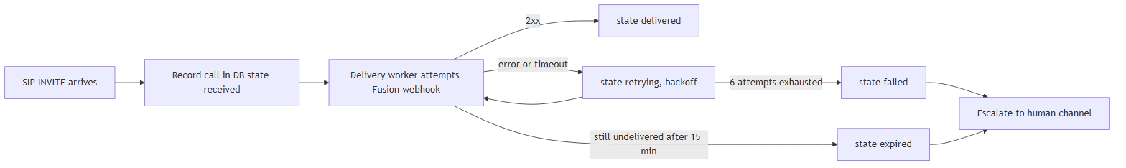

4. Does a retry or an escalation mean a page was missed?
Not by itself. A retrying state means the first attempt did not succeed and the worker is trying again — most transient blips deliver on a later attempt and end as delivered. An escalation is different: it fires only when a page ended failed or expired, meaning it was not delivered to Fusion after all retries. An escalation is a real signal — treat it as Severity 1 and confirm whether the clinical event still needs a manual overhead announcement.

5. What do the call “states” mean (received, delivered, retrying, failed, expired, duplicate, legacy)?
The state column tracks each call through the durable delivery pipeline:
State | Meaning
received | Recorded durably, delivery not yet completed (the record-first insert).
retrying | An attempt failed; the worker is backing off and will try again.
delivered | Fusion accepted the page (HTTP 2xx). This is the success state.
failed | All retry attempts exhausted without a 2xx. Escalated.
expired | Still undelivered past the 15-minute age limit. Escalated.
duplicate | Suppressed as a same-bed/same-purpose duplicate within the 2s window; points at the original via duplicate_of. Never delivered (by design).
legacy | A row that predates the durable pipeline; migrated in place, no data loss. It was handled by the older best-effort path.
A healthy day is almost entirely delivered (plus some duplicate rows from Rauland’s double-emit). Any failed or expired row warrants a look.

6. Can we change the TTS voice, the announcement wording, or the dedupe window?
- Wording / repetition: yes. The announcement is assembled from lookup tables plus tts.message_preamble (currently “Attention! Attention!”) and tts.play_count (currently 3 repeats) in config.yaml. Changing wording is a config edit plus a coordinated writer restart.
- Voice: the spoken voice is chosen by InformaCast Fusion, not by the gateway — the gateway sends text (the customTTS field). Voice changes are made on the Fusion side.
- Dedupe window: yes, dedupe.window_seconds (currently 2) is configurable, as are match_bed and match_purpose. Do not widen this without clinical sign-off — a wider window risks suppressing a legitimate re-page. validate_config will warn loudly if the window is set inert (<= 0) or wide (> 10s).
All of the above are config changes on the writer and take effect on a coordinated restart. RedEye should make dedupe/wording changes with you, not around you.

7. How do we add a new area, unit, or room so it announces correctly?
Room/area/purpose text comes from the lookup tables (lookups.yaml) — this maps the numbers Rauland sends into the human-readable location and call-type the page speaks. Adding a unit or fixing a room name is a lookups edit followed by a writer restart. The dashboard has a Verify Lookups view so you can confirm a given area/room resolves the way you expect before it is needed in an emergency. RedEye maintains lookups jointly with Tift telecom; send the Rauland-side identifier and the exact spoken text you want and it will be added and verified.

8. Is the dashboard password-protected?
No. The dashboard (sipgw-dashboard.service on port 8080) currently has no authentication and is read-only. It exposes call history, logs, and diagnostics to anyone who can reach the port. Today the only protection is network reach — and note the host currently has no active firewall (empty nftables), so ingress relies on the application-level SIP allowlist, which does not cover the dashboard port. Recommendation: restrict :8080 (and :5060) with nftables and/or place the dashboard behind an authenticated reverse proxy. Treat the dashboard URL as sensitive until that is in place. (Dashboard authentication is a known gap, not a shipped feature.)

9. Can we restart the dashboard without interrupting paging? What about restarting the paging service?
Restarting the dashboard is safe and does not affect paging. The two are independent systemd services:
- sipgw.service — the call path (SIP ingress, parsing, TTS, durable delivery). This is the life-safety service.
- sipgw-dashboard.service — the read-only web UI. It opens the database read-only and can be restarted, upgraded, or crash without touching the paging path.
So sudo systemctl restart sipgw-dashboard is a routine, no-page-impact operation. Restarting sipgw.service, by contrast, is a brief SIP blip (~0.3s) and should be coordinated — see Q11. Durability protects you across a writer restart (record-first plus crash recovery re-queues anything in flight), but you still want to avoid restarting during a known event.

10. What was the 2026-06-12 incident, and is it actually fixed?
Yes, it is fixed. On 2026-06-12 a Code Blue was lost: the page fired an inline OAuth token fetch on the critical path, that fetch hit a transient httpx.ConnectTimeout, the delivery recorded fusion_status=-1, and — in the old best-effort design — there was no retry. The page silently did not go out.
The current build removes every leg of that failure:
- Record-first durability: the call is persisted before delivery, so a failure after recording cannot erase it.
- Bounded retries with backoff: a transient timeout is retried, not dropped.
- Background token refresh: the OAuth token is kept warm off the page path, so a page never blocks on — or fails because of — a token fetch.
- Escalation: if delivery genuinely cannot complete, a human is paged.
That specific incident’s root cause is now structurally impossible to lose silently.

11. A patch (or auto-restart) bounced the service. How do we avoid that?
On 2026-07-07, an unattended-upgrades / needrestart auto-restart bounced the paging service uncoordinated (issue #20, since remediated). The lesson: coordinate OS patching with paging, and prefer maintenance windows. The durable design means an unplanned bounce does not lose recorded pages, but an uncoordinated restart is still an availability risk during a live event. Zero-downtime writer restarts via systemd socket activation (#19) are on the roadmap; until then, patch on a schedule and confirm /health after any restart.

12. How do we know the Rauland link is actually up, versus just quiet?
Rauland only sends SIP on a real event — there are no keepalives — so a quiet gateway could mean “no emergencies” or “the link is down.” The gateway stamps the time of the last inbound SIP from an allowed network and surfaces it as “Last inbound from Rauland” on the dashboard and as last_inbound_sip_age_s in /health. The card turns amber after ~5 days of silence. This is informational — a normal quiet stretch does not flip /health to 503, and optional silence-escalation is off by default. If the card is amber and you expected traffic, that is worth investigating with RedEye.

13. What does /health actually check, and when does it go red (503)?
/health returns 503 only when the writer heartbeat is stale (the writer stamps a heartbeat every 10s; /health goes stale after 30s) or missing — i.e. the call-path process is not alive. It additionally reports (as informational fields, not as 503 triggers by default) Fusion reachability, delivery backlog, last delivered/failed, and the last-inbound-SIP age. By design a Fusion blip does not 503 the node (that default protects a single node behind a monitor from being pulled for a transient upstream hiccup). So: red /health = the pager process itself is in trouble — that is a page-now condition.

14. Is any test traffic mixed into our stats or pages?
No. The gateway has a safety layer (safety.py): dry-run / test-mode traffic is marked is_test=1, never fires a real page, and is excluded from dashboard stats, charts, and the call table. When you read the dashboard you are seeing real clinical traffic only.

Support & Escalation

Contacting RedEye Support
Contact details are environment-specific — fill these in for your deployment.
Channel | Detail
Support email | <REDEYE_SUPPORT_EMAIL>
Support phone / on-call | <REDEYE_SUPPORT_PHONE>
After-hours / Sev-1 escalation | <REDEYE_ONCALL_ESCALATION>
Ticket portal | <REDEYE_TICKET_PORTAL_URL>
Escalation webhook (auto-alert) | configured in escalation.webhook_url
Provider | RedEye Network Solutions LLC, in conjunction with Claude Code
For a missed real page (Severity 1), use the phone / on-call path — do not wait on email.

Severity levels
Severity | Definition | Examples | Target first response
Sev 1 — Critical | A real Code Blue / RRT did not page, or the call path is down. Life-safety impact. | An escalation alert for a failed/expired page; a clinical event with no overhead page; /health red (heartbeat stale/missing); sipgw.service down. | <SEV1_RESPONSE_TARGET> (immediate / on-call)
Sev 2 — Major | Paging works but is degraded or at risk. | Repeated retrying then delivered; Fusion intermittently unreachable; dashboard down (paging unaffected); “Last inbound from Rauland” unexpectedly amber. | <SEV2_RESPONSE_TARGET>
Sev 3 — Minor | Cosmetic, informational, or config request. | Wrong room/area spoken text (lookups fix); wording/repetition change; a duplicate-row question. | <SEV3_RESPONSE_TARGET>
Sev 4 — Request | Planned change or enhancement. | Add a unit, adjust dedupe window (with sign-off), roadmap questions. | <SEV4_RESPONSE_TARGET>
A duplicate row by itself is not an incident (see Q1). A missed delivery always is.

What to collect first (before you call)
Collecting these three things up front turns most cases into a single round-trip.
- The per-call diagnostic bundle — this is the single most useful artifact. On the dashboard, open the call (/call/{id}) and use Export diagnostic bundle, or fetch it directly:
- http://<dashboard-host>:8080/call/<CALL_ID>/bundle.txt
- The bundle is a plain-text, copy/paste-friendly file that correlates, for that one call:
  - the call record (id, timestamps, caller/display name, area/room, the exact tts_string, fusion_status, response time, state, attempts, last_error, sip_call_id, event_id);
  - the SIP messages joined by exact Call-ID;
  - the application-log lines referencing that Call-ID;
  - the best-match Fusion API exchange (marked provisional/heuristic).
- Attach the .txt to the ticket verbatim. It contains no secrets (credentials are never logged), so it is safe to send.
- The As-Built / host inventory — the deployment facts for sip2apibridge (host, IPs, ports, paths, Fusion scenario/audience, allowlist). This lets support reason about your specific environment without a discovery round-trip. Reference: <AS_BUILT_DOC_LOCATION>.
- The relevant log window — from /var/log/sipgw, the slice around the event, remembering the logs are UTC (Q2). There are four streams:
  - sipgw.log — main application log (start here);
  - sipgw_sip_debug.log — raw SIP messages;
  - sipgw_api_debug.log — Fusion API exchange;
  - sipgw_dashboard.log — dashboard process (only for dashboard issues).
- The dashboard’s date-picker log viewer can pull the right day directly if you cannot reach the host.
Also state, in one line: the clinical time of the event (wall clock), what was expected (e.g. “Code Blue, 3 West, room 312”), and what happened (no page / wrong text / late page).

What to expect
- Sev 1: immediate triage on the on-call path. Support will confirm the call path is alive (/health), locate the call by state, determine whether it was failed/expired/never-recorded, and advise whether a manual overhead announcement is needed now while the root cause is worked.
- Sev 2–4: worked to the response target above. Config/lookups changes are applied by RedEye with Tift telecom and, for dedupe or wording, only with the appropriate sign-off, on a coordinated writer restart.

Quick self-triage before escalating
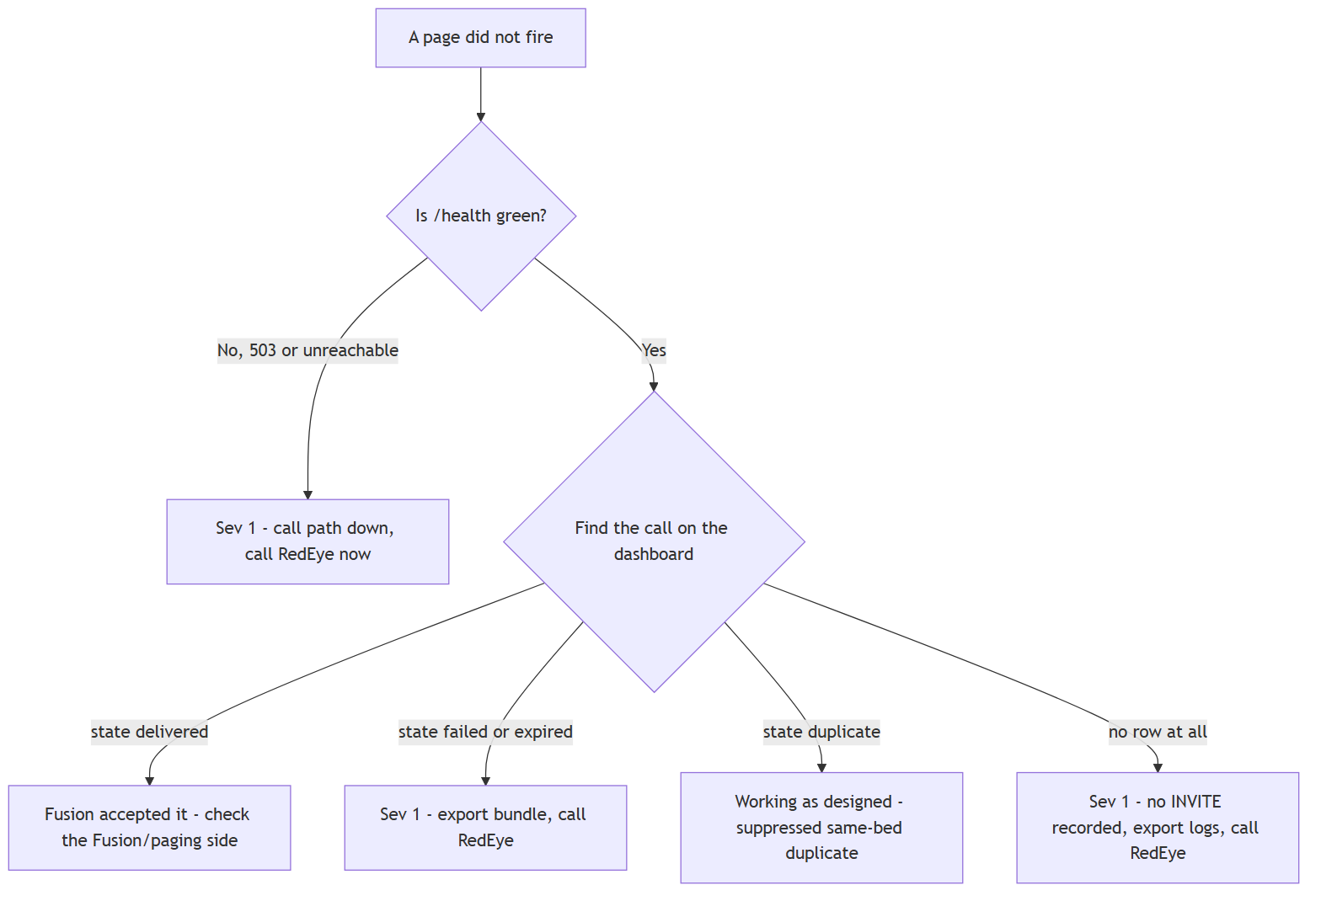
For anything in a red box, grab the diagnostic bundle and the log window first, then escalate — you will have handed support everything it needs.

Appendix A — README

sip2apigw — SIP-to-Webhook Gateway for Nurse Call Systems
A production Python asyncio service that bridges Rauland nurse call systems with Informacast Fusion mass notification. When a Code Blue, Rapid Response Team, or Code Pink alert is initiated, the system receives the inbound SIP call, parses caller information from SIP headers, builds a text-to-speech announcement, and triggers a Fusion scenario that broadcasts the alert to IP speakers.
v1.6.0 is the reliability + observability release. A page is now recorded before it is sent (record-first), delivered by a durable retry worker that survives a Fusion outage or a process crash, escalated to a human channel if it can never be delivered, and observed through a real heartbeat-backed /health. The dashboard runs as a separate read-only process, and the whole system is designed around a set of hard life-safety invariants (see Safety Model).
Status: v1.6.0 has been running in production since 2026-07-01, validated on a live Code Blue (call #303: record-first → Fusion HTTP 200 in 795 ms → 12 IP speakers). See the CHANGELOG.

How It Works
Rauland Nurse Call sipgw (writer) Informacast Fusion
───────────────── ────────────────────────────── ─────────────────────
┌──────────────────────────┐
SIP INVITE ────────> │ 1. Receive INVITE │
│ 2. 100 Trying │
<──────── │ 3. 200 OK │
│ 4. Send BYE (immediate) │
│ 5. Parse caller │
│ 6. Build TTS │
│ 7. RECORD-FIRST: │
│ persist PENDING row │ ── record-first, then dedupe (shadow)
└───────────┬──────────────┘
│ (durable outbox)
┌───────────▼──────────────┐
│ Delivery worker (#2) │ ──────> OAuth2 Token (kept warm, #4)
│ retry + backoff │ ──────> POST /scenario-notifications
│ escalate on fail (#3) │ <────── 200 OK + TTS Audio
│ expire if too old │
└──────────────────────────┘ Speakers announce:
"Attention! Code Blue!
sipgw-dashboard (read-only process, #14) 1st Floor. E.D.
┌───────────────────────────────┐ Room 201."
│ Call history + state-aware │
│ stats, CSV export, log viewers │
│ /health ◄── writer heartbeat │
└───────────────────────────────┘ :8080 (read-only DB)

Two-service topology (#14)
v1.6.0 splits the single process into two systemd units that share one config.yaml and one SQLite database:
Service | Unit | Role
Writer | sipgw.service | SIP listener + record-first + durable delivery worker + escalation + heartbeat + systemd watchdog. Owns all writes to the DB and the shared log files.
Dashboard | sipgw-dashboard.service | Read-only web UI + /health. Opens the DB query_only=ON so it can never mutate a page or the heartbeat, and writes only its own sipgw_dashboard.log.
Both processes bootstrap identically: load_config → effective-dry-run → prod-DB barrier → validate_config. A misconfigured or unsafe dashboard refuses to start exactly like the writer does. Both services must run for a healthy system.

Example
SIP call from "Code Blue" <sip:a730r201@172.16.1.100> with default config produces:
Attention! Attention! Code Blue! 1st Floor. E.D. Room 201. Code Blue! 1st Floor.
E.D. Room 201. Code Blue! 1st Floor. E.D. Room 201.
This is delivered as TTS audio to all IP speakers in the configured Fusion device group.

What’s New in v1.6.0

Reliability
- #2 Durable, record-first delivery — On call answer, the page is written to the calls outbox as a pending row before any send is attempted (create_pending_call). A background DeliveryWorker then delivers it asynchronously with exponential backoff (honoring Retry-After delta-seconds), so a Fusion outage or a crash between “answered” and “sent” cannot drop a Code Blue. The state machine is pending → delivering → delivered | failed | expired (plus legacy for pre-v1.6.0 rows). On startup, recover_inflight() returns any crash-orphaned delivering rows to pending — at-least-once delivery. The DB runs in WAL mode so the read-only dashboard can read while the writer commits.
- #3 Escalation on failure/expiry — When a page exhausts delivery.max_attempts (failed) or ages past delivery.max_age_seconds (expired), the Escalator POSTs a JSON alert to a human channel (escalation.webhook_url — Teams/Slack/PagerDuty/NOC). Escalation failures are logged, never raised, and never disrupt delivery. Empty URL still logs the failure loudly at ERROR.
- #4 Background OAuth2 token refresh — A background task keeps the Fusion token warm, renewing it token_refresh_margin_seconds (default 300s) before expiry, so a real page never blocks on a token round-trip on the critical path.
- #8 systemd Type=notify watchdog — The writer sends READY=1 before running crash-recovery (a large recover must not delay READY and trip the restart loop), then pings WATCHDOG=1 on a cadence (WATCHDOG_USEC/2). Watchdog pings prove event-loop liveness only — decoupled from DB writes, so transient DB slowness never restarts the life-safety pager. Completely inert without systemd (NOTIFY_SOCKET/WATCHDOG_USEC unset): tests, dry-run, and non-systemd runs behave exactly as before.
- #9 Startup config validation — validate_config runs before the service starts and is fatal on invalid production config: Fusion credentials, scenario_id, and a preset scenario_field_id are required in prod so the first real Code Blue does not fail auth or trigger a live field-id lookup. CIDR ranges, ports, and retry tuning are validated too. Non-fatal issues surface as warnings.

Observability
- #7 Heartbeat-backed /health — The writer stamps a heartbeat row every health.heartbeat_interval_seconds; the dashboard reads it and returns 200 {"status":"ok"} only if the beat is fresh, 503 if it is stale (health.stale_after_seconds, default 30s) or absent. /health now reflects real writer liveness, not just “the web server answered”.
- #10 State-aware, test-excluding stats — Dashboard cards derive success/failed/pending from the delivery state (get_today_stats), exclude all is_test=1 rows, and classify legacy rows by their stored fusion_status for continuity across the cutover boundary.
- #12 Canonical UTC timestamps, host-local display — Every row’s timestamp is written as canonical UTC RFC3339 millis-Z. Bucketing and the “today” boundary key off the numeric created_at epoch (uniform across old local-format and new UTC rows), while the dashboard and CSV render host-local wall-clock. logging.timezone: "" reads the host’s local zone; an IANA name overrides per install.
- #13-P1 Dashboard view toggle + CSV export — A Summary / Advanced view toggle, plus GET /export.csv which exports today’s real calls (invalid view falls back to summary, never a 500). CSV always appends AND is_test=0, so dry-run/test rows can never leak into an exported file.
- #6 Async logging — File writes, daily rotation, and .tgz compression happen on a background QueueListener thread (via QueueHandler), so the event loop never blocks on disk I/O. The dashboard uses a dashboard-safe logging setup that never attaches the rotating handler to the writer’s shared log files (two processes racing midnight doRollover() would corrupt them).
- #11 Logging hygiene — client_id + client_secret and bearer tokens masked in all debug logs, exception types logged, BYE Via transport corrected.
- #15 INVITE fingerprint — invite_fingerprint(msg) computes a stable transaction identity (v1:<hex> from Call-ID + From user + From tag + CSeq) so a UDP retransmission of the same INVITE is recognizable. This is deliberately distinct from #5’s clinical identity (see below).

Dedupe (#5) — ships SHADOW / DISABLED
Clinical dedupe computes a stable clinical identity for a page — normalized (area, room, bed, purpose) as cf-v1:<hex> — to measure how often true duplicates arrive. It ships inert and never drops a page:
- Two OFF switches, both default off:
  - dedupe.enforce: false — never suppresses. Setting it true is a fatal config error (validate_config forbids it in all modes; suppression requires clinical sign-off).
  - dedupe.window_seconds: 0 — the shadow duplicate lookup never even runs; evaluate returns a fingerprint-only, no-suppress decision without touching the DB. A test-only window_seconds > 0 turns on WOULD suppress … telemetry, and even then the page is still delivered.
- Record-first is sacred. Dedupe runs after create_pending_call, purely as telemetry (it may annotate duplicate_of and log). It never gates, delays, or skips delivery. A real second Code Blue for the same room is always sent.
- The clinical fingerprint (cf-v1:) is intentionally not the same as #15’s transaction fingerprint (v1:). The two are separate, clearly named functions and must never be conflated.

Safety Model
These invariants are load-bearing and enforced in code and tests:
- No real send in dev/test — NoSendGuardTransport (sipgw/safety.py) backs every outbound HTTP client (Fusion webhook and escalation) when dry-run is active. Effective dry-run = fusion.dry_run OR env SIPGW_DRY_RUN=1; the environment can only enable dry-run, never disable it.
- [TEST] marking — In dry-run, the [TEST] marker is installed on the loggers first, so every log line (including init lines) is marked, and every DB row is written is_test=1.
- Prod-DB hard barrier — assert_safe_database_path runs on every DB open — including the read-only dashboard reader — so dry-run/test can never attach to the production database.
- Never weakened — SIP IP allowlist, credential masking, and Jinja autoescape=True.

Features
- SIP UA — Listens on UDP/TCP port 5060. Handles INVITE, ACK, BYE, CANCEL, OPTIONS.
- Immediate BYE mode — Answer and hang up instantly without RTP (mirrors existing systems).
- Caller parsing — Extracts area, room, bed from SIP username format a{area}r{room}[b{bed}]. Leading zeros preserved (e.g., r01196 stays 01196).
- Configurable TTS — Play count (default 3x), message preamble, iteration preamble.
- Area+Room combo overrides — Same room number, different name per area.
- Fusion integration — OAuth2 client credentials with token caching + background refresh, field-based scenario trigger, auto field-id resolution.
- Hot-reload lookups — lookups.yaml changes detected on next SIP call or page load, no restart needed.
- Durable record-first delivery — retry/backoff, crash recovery, expiry, escalation.
- Read-only web dashboard — dark-themed, auto-refreshing history, state-aware stats, view toggle, CSV export, log viewers, heartbeat-backed /health.
- 3 debug logs — application, SIP messages, API — async-written, daily rotation with .tgz compression, 90-day retention.
- 266 tests — unit, functional, and system-level.

Quick Start
## Install (as root) — installs BOTH services
sudo bash install.sh
## Configure (one file, shared by both services)
sudo vi /opt/sipgw/config.yaml # Set fusion credentials + preset scenario_field_id
sudo vi /opt/sipgw/lookups.yaml # Review area/room mappings (hot-reloaded)
## Start both services
sudo systemctl start sipgw # writer (SIP + delivery)
sudo systemctl start sipgw-dashboard # read-only dashboard + /health
## Verify
systemctl status sipgw sipgw-dashboard
curl http://localhost:8080/health # 200 only if the writer heartbeat is fresh

Configuration
All settings are in a single config.yaml, loaded by both services. Full reference in docs/CONFIGURATION.md and docs/SIPGW_SERVICE_MANUAL.md.

SIP
Parameter | Default | Description
sip.bind_ip | 0.0.0.0 | IP to bind SIP listener
sip.bind_port | 5060 | SIP port (UDP + TCP)
sip.allowed_networks | ["172.16.0.0/12"] | CIDR ranges allowed to send SIP
sip.call_timeout_seconds | 600 | Max call duration before auto-BYE
sip.immediate_bye | false | Answer then immediately BYE (no RTP)
sip.rtp_port_range_start / _end | 10000 / 20000 | RTP port range

Fusion API
Parameter | Default | Description
fusion.base_url | https://api.icmobile.singlewire.com/api | Fusion API base URL
fusion.token_url | .../api/token | OAuth2 token endpoint
fusion.audience |  | Provider ID (required in prod)
fusion.scenario_id |  | Scenario UUID (required in prod)
fusion.variable_name | customTTS | Scenario field variable name
fusion.scenario_field_id |  | Field UUID (must be preset in prod; auto-resolved only in dry-run)
fusion.client_id / client_secret |  | OAuth2 credentials (required in prod)
fusion.token_refresh_margin_seconds | 300 | Refresh the token this long before expiry (#4)
fusion.dry_run | false | Force no-send guard on all outbound HTTP (env SIPGW_DRY_RUN=1 can also enable)

Delivery (#2 retry worker)
Parameter | Default | Description
delivery.max_attempts | 6 | Attempts before a page is marked failed + escalated
delivery.base_backoff_seconds | 2.0 | Base for exponential backoff
delivery.max_backoff_seconds | 60.0 | Backoff cap (also caps honored Retry-After)
delivery.max_age_seconds | 900.0 | Undelivered longer than this → expired + escalate
delivery.poll_interval_seconds | 1.0 | Worker poll cadence
delivery.batch_size | 20 | Rows processed per pass

Escalation (#3) / Health (#7) / Dedupe (#5)
Parameter | Default | Description
escalation.webhook_url | "" | Human alert channel; empty logs failures at ERROR only
escalation.timeout_seconds | 10.0 | Escalation POST timeout
health.heartbeat_interval_seconds | 10.0 | Writer heartbeat cadence
health.stale_after_seconds | 30.0 | /health returns 503 once the heartbeat is older than this
dedupe.enforce | false | Must stay false — true is a fatal config error
dedupe.window_seconds | 0 | 0 = shadow lookup never runs; >0 = test-only WOULD suppress telemetry

Logging / Dashboard / Database
Parameter | Default | Description
logging.log_dir | /var/log/sipgw | Log directory
logging.retention_days | 90 | Days to keep rotated .tgz logs
logging.timezone | "" | Display/day-boundary zone; "" = host local, or an IANA name (#12)
logging.api_debug_log / sip_debug_log | true | Enable detailed API / SIP logs
dashboard.port / bind_ip | 8080 / 0.0.0.0 | Dashboard listener
dashboard.auto_refresh_seconds | 30 | Default page auto-refresh interval
dashboard.page_size | 20 | Rows per page
database.path | /var/lib/sipgw/calls.db | Shared SQLite DB (writer RW, dashboard read-only)

Lookup Tables
lookups.yaml maps SIP caller data to speech-ready names. Changes are hot-reloaded automatically — the file’s mtime is checked on every lookup (SIP call or dashboard page load); no restart needed. Use the “Verify lookups.yaml” dashboard button to validate after editing.
areas:
730: "1st Floor... E.D..."
731: "4th Floor... I.C.U..."
default_area: "Unknown Area."
call_purposes: # display-name keyword → call purpose (first match wins)
"Blue": "Code Blue"
"RRT": "Rapid Response Team"
"Pink": "Code Pink"
default_purpose: "Code Blue"
rooms: {} # room-only fallback
area_rooms: # "area*room" → spoken name (handles duplicate room numbers)
"797*2201": "Prepost 1"
"730*01196": "B 15" # leading zeros preserved
default_room_format: "Room {room}."
Lookup priority: area_rooms combo match → rooms fallback → "Room {N}."

Fusion API Integration
- Token: POST {base_url}/token with client_credentials grant + audience (provider ID), kept warm by the background refresher (#4).
- Trigger: POST {base_url}/v1/scenario-notifications?scenarioId={id}
- Body: {"fields": [{"fieldId": "<uuid>", "answer": "<assembled TTS>"}]}
In production scenario_field_id must be preset; auto-resolution runs only in dry-run.

Required Fusion Setup
- Create + enable an OAuth2 application; note the client ID/secret.
- Add scope urn:singlewire:scenario-notifications:write.
- Create a scenario with a text field variable (e.g., customTTS) and a message template using {{customTTS}}.

Dashboard
Read-only web UI at http://<host>:8080 — no authentication required. Served by the separate sipgw-dashboard process against a read-only DB connection.
- Call table — Summary / Advanced view toggle; timestamps shown in host-local time.
- State-aware stats cards — total, successful, failed, pending; test rows excluded; legacy rows classified by stored status.
- CSV export — GET /export.csv (today’s real calls; test rows never leak).
- Log viewers — sipgw.log, SIP messages, API debug, each with a Copy button.
- Lookup verification — GET /api/verify-lookups, GET /api/sample-lookups, plus the Verify button.
- JSON API — GET /api/calls?limit=100.
- Health check — GET /health returns 200 {"status":"ok","heartbeat_age_s":…} only when the writer heartbeat is fresh; 503 (stale / no-heartbeat) otherwise.

Logging
Log File | Content | Written by
/var/log/sipgw/sipgw.log | Application events, call processing, errors | writer
/var/log/sipgw/sipgw_sip_debug.log | Raw SIP messages (both directions) | writer
/var/log/sipgw/sipgw_api_debug.log | Full HTTP request/response traces to Fusion | writer
/var/log/sipgw/sipgw_dashboard.log | Dashboard process log (separate file — never the writer’s) | dashboard
All writer logs are written off the event loop (#6), rotate daily at midnight, compress to .tgz, and are retained 90 days. In dry-run every line is [TEST]-marked.

SIP Implementation
Lightweight custom SIP UA (not pjsua2/sipsimple), purpose-built for narrow requirements:
Method | Handling
INVITE | 100 Trying → 200 OK (with SDP) → optional RTP → optional immediate BYE
ACK | Acknowledged silently
BYE | 200 OK → terminate call + cleanup
CANCEL | 200 OK + 487 Request Terminated
OPTIONS | 200 OK with capabilities
RTP silence: 12-byte header + 160 bytes of 0xFF (u-law silence), 20ms intervals, PCMU/8000. invite_fingerprint(msg) (#15) provides a stable transaction identity for correlating retransmissions.

Testing
266 tests pass across the suite:
cd /opt/sipgw && SIPGW_LOOKUPS=/opt/sipgw/lookups.yaml \
./venv/bin/python -m pytest -q
Coverage includes the new v1.6.0 subsystems: test_delivery, test_escalation, test_token_refresh, test_dedupe, test_health, test_watchdog, test_migration, test_readonly_db, test_stats, test_timestamps, test_startup_safety, test_no_send, test_safety_barrier_marker, test_logging_hygiene, test_async_logging, test_invite_fingerprint, test_dashboard_app, test_config_validation, alongside the original parser/lookups/TTS/SIP/RTP/webhook/dashboard/functional/system tests.

Service Management
## Writer (SIP + durable delivery)
sudo systemctl {start|stop|restart|status} sipgw
## Read-only dashboard + /health
sudo systemctl {start|stop|restart|status} sipgw-dashboard
journalctl -u sipgw -f
journalctl -u sipgw-dashboard -f

Security
- IP filtering — sip.allowed_networks CIDR ranges (empty = reject all).
- No-send guard — NoSendGuardTransport blocks all outbound HTTP in dry-run.
- Prod-DB barrier — enforced on every DB open, writer and reader alike.
- systemd hardening — NoNewPrivileges, ProtectSystem=strict, ProtectHome, PrivateTmp; writer uses CAP_NET_BIND_SERVICE for port 5060; dashboard has its own MemoryMax=256M / CPUQuota=50% envelope so a runaway UI request can’t starve the life-safety writer.
- Read-only dashboard — query_only=ON; cannot mutate pages or the heartbeat.
- Token lock — asyncio.Lock + double-check prevents concurrent token refresh races.
- XSS protection — Jinja2 autoescape=True on all dashboard output.
- Secret masking — client_id/client_secret and bearer tokens truncated in debug logs.

Project Structure
/opt/sipgw/
├── config.yaml # Single config, shared by both services
├── lookups.yaml # Area/purpose/room lookup tables
├── sipgw.service # systemd unit — writer (Type=notify watchdog)
├── sipgw-dashboard.service # systemd unit — read-only dashboard
├── install.sh / uninstall.sh
├── sipgw/
│ ├── main.py # Writer entry point + SIPGateway orchestrator
│ ├── dashboard_app.py # Dashboard entry point (read-only, #14)
│ ├── sip_server.py # SIP UA (UDP+TCP)
│ ├── sip_message.py # SIP parser + response builder + invite_fingerprint (#15)
│ ├── rtp_handler.py # RTP silence stream (u-law PCMU/8000)
│ ├── parser.py # Caller info parser
│ ├── lookups.py # Lookup table loader (hot-reload)
│ ├── tts_builder.py # TTS builder + assembler
│ ├── webhook.py # Fusion client (OAuth2, background refresh #4)
│ ├── delivery.py # Durable delivery worker (#2)
│ ├── escalation.py # Human-channel escalation (#3)
│ ├── dedupe.py # Clinical dedupe — SHADOW/DISABLED (#5)
│ ├── watchdog.py # systemd Type=notify + watchdog (#8)
│ ├── database.py # SQLite state machine, heartbeat, stats, timestamps
│ ├── dashboard.py # FastAPI UI (view toggle, CSV, /health)
│ ├── config.py # Typed config loader + validate_config (#9)
│ ├── logging_config.py # Async logging + dashboard-safe setup (#6)
│ └── safety.py # No-send guard, [TEST] marker, prod-DB barrier
├── tests/ # 266 tests
└── docs/
├── ARCHITECTURE.md ASSUMPTIONS.md CONFIGURATION.md
├── TESTING.md SIPGW_SERVICE_MANUAL.md
└── RUNBOOK-cutover-2026-07-01.md
/var/log/sipgw/ sipgw.log · sipgw_sip_debug.log · sipgw_api_debug.log · sipgw_dashboard.log
/var/lib/sipgw/ calls.db (+ -wal / -shm sidecars)

Environment Variables
Variable | Default | Description
SIPGW_CONFIG | /opt/sipgw/config.yaml | Path to configuration file
SIPGW_LOOKUPS | /opt/sipgw/lookups.yaml | Path to lookup tables
SIPGW_DRY_RUN | unset | 1 forces effective dry-run (can only enable, never disable)

Troubleshooting
Problem | Solution
Writer won’t start | journalctl -u sipgw — validate_config is fatal on missing prod credentials / scenario_field_id, bad CIDR, port conflict
/health returns 503 | Writer heartbeat stale/absent — check sipgw.service is running; the dashboard alone cannot be healthy
Pages stuck pending | Check Fusion reachability / credentials; the worker retries with backoff and escalates on exhaustion
Pages expired | Undelivered past delivery.max_age_seconds — inspect escalation channel + Fusion outage window
401/403 from Fusion | Verify credentials + scope urn:singlewire:scenario-notifications:write
Service refuses to start in dry-run | Prod-DB barrier — dry-run/test cannot open the production database.path

Deferred / Host-Gated Items
These require real hardware, a live capture, or clinical sign-off and are not exercised by the test suite:
- Real-systemd watchdog + OOM isolation drills — Type=notify READY/WATCHDOG=1 behavior, and the dashboard MemoryMax/CPUQuota isolation, only take effect under real systemd with the relevant cgroup controllers. Validate on the target host, not in CI/containers.
- #5 dedupe enforcement — remains SHADOW/DISABLED. Turning suppression on requires clinical sign-off and validation against a real Rauland INVITE capture; enforce=true is a fatal config error until then.
- Production cutover — see docs/RUNBOOK-cutover-2026-07-01.md for the no-data-loss lookups/config preservation gate and cutover steps.

Documentation
- Architecture: docs/ARCHITECTURE.md
- Configuration reference: docs/CONFIGURATION.md
- Assumptions: docs/ASSUMPTIONS.md
- Testing: docs/TESTING.md
- Service manual: docs/SIPGW_SERVICE_MANUAL.md
- Cutover runbook: docs/RUNBOOK-cutover-2026-07-01.md
- Changelog: CHANGELOG.md

Prerequisites
- Ubuntu 22.04+ / Debian 12+
- Python 3.11+
- Network access to Informacast Fusion API (api.icmobile.singlewire.com)
- SIP traffic from the nurse call system on port 5060

Uninstall
sudo bash uninstall.sh

Appendix B — CHANGELOG

Changelog
All notable changes to the sipgw project are documented in this file.

[Unreleased] — v1.7 (writer)
Behavioral SIP change — writer restart (brief ~0.3s SIP blip); no dashboard impact.
- #11 immediate-BYE is now ACK-gated (closes the 481 race). In immediate_bye mode the gateway used to send its BYE in the same tick as the 200 OK, which could outrun the caller’s ACK and draw a 481 Call Leg/Transaction Does Not Exist. The gateway now answers, keeps the call, fires the page immediately (fully decoupled from teardown), and defers the gateway BYE until the ACK confirms the dialog. A new per-call lost-ACK fallback (sip.immediate_bye_ack_timeout_seconds, default 2.0s) tears the dialog down and frees the RTP port if the ACK is lost, so a dropped ACK can never strand the dialog or leak a port. The teardown funnel is single-fire (atomic answered → terminating), so a duplicate ACK or an ACK/fallback race can never double-send the BYE or double-free the port. A retransmitted INVITE during the ACK-wait now hits the re-INVITE 200-resend branch instead of re-paging.
- #11 spec-correct BYE (additive). The BYE request-URI now targets the caller’s Contact (falling back to From-user@remote when absent) and carries the reversed Record-Route as its Route set. Packet routing is unchanged — the datagram still goes to remote_addr; only the request-URI / Route header content changed.
- New knob sip.immediate_bye_ack_timeout_seconds (default 2.0). Staging now mirrors production (immediate_bye: true) and a new host drill M7 gates the deploy: INVITE→200→ACK→BYE with zero 481 / zero “ACK for unknown call”, plus the lost-ACK fallback path.
- #5 clinical dedupe SUPPRESSION enabled (closes #5). After clinical sign-off, dedupe.enforce is no longer a fatal config — it is enabled in production with the safest parameters: window_seconds: 2 (only near-instant duplicates; a re-page >2s later is treated as legitimate and always delivered), bed-level (match_bed: true, so two patients coding in one room are never merged), and purpose in the key (RRT and Code Blue never merge). A suppressed page is still recorded (record-first: it becomes a durable duplicate audit row pointing at the original), it is simply not delivered. Suppression is fail-safe: it is guarded on state='pending', so if the delivery worker has already picked the page up, the page is delivered rather than dropped — every race resolves toward delivery, never a wrongful drop. validate_config now WARNS loudly (*** DEDUPE SUPPRESSION ACTIVE ***) instead of refusing to start, and flags an inert (window<=0) or wide (window>10s) window. Kill-switch: dedupe.enforce=false + restart. A new host drill M8 gates the deploy (two same-bed pages <2s → one suppressed; >2s → both delivered).

[v1.6.5] — 2026-07-03
Dashboard-only (zero SIP impact).
- #13 date picker is now a most-recent-first dropdown. Replaced the native date input with a <select> whose options are descending (Today first, then yesterday, …), so looking back a day or two is at the top of the list rather than starting months ago. Works consistently across browsers. Today and the current selection are always present.

[v1.6.4] — 2026-07-03
Dashboard-only (zero SIP impact) — date-picker UX.
- #13 the date picker now defaults to the current date (was: the last day that happened to have logs, which could show a stale month) and moved to a prominent labelled bar at the top of the page (📅 “Viewing date (zone)” + a Today/Historical badge + “Back to today”), since it drives the whole page (call table + stats + logs), not just the log panel. The redundant in-log picker was removed. Today/live keeps the existing today-only query; a historical pick uses the local-day window.

[v1.6.3] — 2026-07-03
Backlog burn-down batch. Dashboard parts deploy with zero SIP impact (restart only sipgw-dashboard); the two writer parts activate on a coordinated writer restart (additive/idempotent, safe even on an unplanned one).

Dashboard (zero SIP impact)
- #7 opt-in Fusion-unreachable /health signal (closes #7). New health.fail_on_fusion_unreachable (default false) + fusion_unreachable_max_age_seconds; when off (default), /health behavior is byte-for-byte unchanged (status stays heartbeat-only). When an operator opts in, a stale/failed Fusion probe can degrade /health — never a transient blip.
- #13 F1 — the date picker now also drives the call table + stats, not just the log viewer: selecting a day filters the table/stats/logs to that local day (one _local_day_window source of truth).
- #13 F2 — 90-day stacked “calls by type” chart. A self-contained inline SVG stacked bar chart over the last 90 local days, stacked by call type/purpose (Code Blue / RRT / Code Pink / any future type — derived from display_name via lookups, so all legacy rows count). No external JS/CDN; excludes is_test=1.
- #13 Phase-2 — /call/{id} correlated call-detail view. Joins the call row with its exact SIP + main-log lines by Call-ID (read-only, autoescaped; test rows 404 to keep the UI-wide is_test=0 discipline).

Writer (coordinated restart)
- #15 persist the upstream event_id. Idempotent nullable event_id column + index (legacy rows stay NULL), threaded from the INVITE through record-first create_pending_call and surfaced read-only on the dashboard. The extraction shipped in v1.6.1; this stores it (and is the merge-key prerequisite for #17 HA and #5’s event-id dedupe).
- Inbound-liveness / Rauland-reachability monitor (new). An additive stamp of the last inbound SIP receive time (after the IP allowlist — no behavior change to INVITE/ACK/BYE), persisted like the heartbeat and surfaced as last_inbound_sip_age_s in /health + a dashboard card. Answers “is the Rauland link up, or just quiet?”. Optional silence escalation is default OFF (inbound_escalate_after_seconds=0); the age never flips the /health status code.

[v1.6.2] — 2026-07-03
Dashboard-only (zero SIP-path impact).
- #13 timezone-aware date-picker log viewer. The log viewer gains a date picker across all three streams. “A day” is the viewer’s day, defined in the configured display zone (logging.timezone, labelled in the UI). Because logs are UTC-stamped and rotate at UTC midnight, a local day is gathered across the overlapping UTC archive(s) and filtered by each entry’s timestamp (DST-correct; multi-line entries kept as a unit). Avoids re-decompressing: the day list is built from archive filenames, and reads decompress at most the 1–2 relevant archives, cached by (path, mtime). UTC rotation is unchanged.

[v1.6.1] — 2026-07-02
Backlog burn-down: a batch of safe, additive, outage-free observability + diagnostics improvements (no SIP/delivery behavior change, no dedupe enforcement). Closes #9 and #12; advances #5, #7, #11, #13, #15.
- #12 log timestamps → UTC RFC3339 millis-Z. All log streams (sipgw.log, sipgw_api_debug.log, sipgw_sip_debug.log, and the dashboard’s own sipgw_dashboard.log) now emit a canonical YYYY-MM-DDTHH:MM:SS.mmmZ stamp via the new ISO8601Formatter, replacing the ambiguous space-separated host-local YYYY-MM-DD HH:MM:SS. All streams are byte-for-byte zone-consistent, UTC-sortable, and string-matchable against the Singlewire Date/createdAt fields. This completes the log half of #12 (the DB/dashboard half shipped in v1.6.0).
- The dashboard and CSV export are unchanged — they still render host-local wall-clock and compute the “today” boundary from logging.timezone. Log stamps are hard-coded UTC-Z and are not driven by that knob.
- The host runs UTC, so the #6 when="midnight" rotation continues to roll at 00:00 UTC; each day-file and the UTC-Z stamps inside it now share the same UTC calendar day (self-consistent). No rotation/compression/retention behavior changed. No SIP/delivery/call-path change — purely additive observability.
- Operators: log scrapers expecting the old local stamp must adjust to ...T...Z.
- #9 unknown-key startup warnings (final acceptance criterion). Misspelled config keys (e.g. sip.imediate_bye) and unknown top-level sections are now surfaced as non-fatal startup warnings naming the offending key (unknown key 'sip.imediate_bye' ignored (typo?)) instead of being silently dropped. Unknown keys are still not applied (the real field keeps its default), and this is warning-only — an unexpected/forward-compat key never refuses to start prod. Warnings ride the existing validate_config warning loop, so both the gateway and the dashboard log them with no caller change. Completes #9 (the fatal-validation half shipped in v1.6.0).
- #11 full credential redaction (closes the masking sub-item). client_secret and client_id are now fully redacted in api_debug request logs (the prior 4-char prefix leak is gone). The BYE-before-ACK (481) teardown items remain open as a separate SIP-state-machine change.
- #15 structured INVITE fingerprint line + upstream event-id extraction. Each inbound INVITE now logs a structured, greppable line carrying the retransmit-stable transaction fp= plus a best-effort upstream event_id (Call-ID segment) — purely additive telemetry, never touching routing/answer/BYE or the on_call callback.
- #5 richer SHADOW dedupe audit trail. The (still-disabled) shadow detector’s WOULD suppress line now records the inter-page gap, bed_match/purpose_match, and both Call-IDs, so the live duplicate-rate/gap evidence needed for the clinical window decision is captured. Enforcement stays validate_config-forbidden; a real second Code Blue is still always delivered.
- #7 enriched /health + additive Fusion reachability keepalive. /health gains informational fields (backlog, last_delivered_at, fusion_reachable, fusion_checked_age_s); the 200/503 status stays driven solely by the writer heartbeat (no new failure flips it, so external monitors are unaffected). A writer-side keepalive stamps Fusion reachability off the page path and is routed through the no-send guard in dry-run (reaches no real host).
- #13 dashboard v2 Phase-1 remainder. Time toggle (Local/UTC/Both), plain-language
  - glyph + aria-label delivery status (WCAG, no colour-only signalling), a friendly Fusion Result CSV column + UTC timestamp, and a read-only get_calls_between range export. Dashboard-only (isolated read-only process); the epic’s Phases 2–5 stay open.

[v1.6.0] — 2026-07-01
Reliability + observability release. The gateway moves from best-effort, single-process paging to a durable, record-first delivery pipeline with retry, escalation, and a decoupled read-only dashboard. Every change here preserves the life-safety invariants: no real outbound send in dev/test (NoSendGuardTransport), [TEST]-marked logs and is_test=1 rows under dry-run, the prod-DB path barrier on every DB open, and — above all — a real page is never dropped, duplicated, or gated by any new machinery.
Validated in production (2026-07-01). Cut over on the live host after all six real-systemd drills passed there (Type=notify READY, watchdog kill+restart, dashboard crash isolation, WAL -shm under ProtectSystem=strict, two-process no-send, restart-recovery). Confirmed on a live Code Blue — call #303: INVITE → fingerprint v1:c621e265… → record-first PENDING row → Fusion HTTP 200 in 795 ms → overhead page fanned to 12 IP speakers, delivered on attempt 1, is_test=0, no duplicate, no escalation. lookups.yaml preserved byte-identical and all 302 prior rows migrated losslessly.

Added
- Durable, record-first delivery (#2) — on_call now writes the page to the DB in state pending before any delivery is attempted (main.py record-first path). A background DeliveryWorker (delivery.py) drives the state machine pending → delivering → delivered | failed | expired (database.py, WAL mode, idempotent schema migration; legacy rows carry state legacy). If the process restarts, recover() re-queues in-flight pages so nothing is lost.
- Retry with exponential backoff (#2) — failed attempts retry with base_backoff_seconds (default 2.0s) doubling up to max_backoff_seconds (default 60s), honoring an upstream Retry-After delta-seconds when present. After delivery.max_attempts (default 6) a page is marked failed; a page undelivered past delivery.max_age_seconds (default 900s) is marked expired. Poll cadence is poll_interval_seconds (default 1.0s).
- Escalation on failed/expired pages (#3) — escalation.py posts to a human alert channel (escalation.webhook_url — Teams/Slack/PagerDuty/NOC) when a page ends in failed or expired. Empty URL disables escalation (failures still logged at ERROR). In dry-run the escalation HTTP client is routed through the no-send guard like every other client.
- Background OAuth2 token refresh (#4) — the token is refreshed proactively fusion.token_refresh_margin_seconds (default 300s) before expiry (webhook.py), so a page never blocks on a token round-trip on the hot path.
- Clinical dedupe in SHADOW / DISABLED (#5) — dedupe.py computes a stable clinical fingerprint cf-v1:<hex> over the normalized (area, room, bed, purpose) tuple — deliberately distinct from #15’s SIP transaction fingerprint. It ships inert behind two OFF switches: dedupe.enforce=false (never suppresses) and dedupe.window_seconds=0 (the shadow duplicate lookup never even queries the DB). Setting window_seconds>0 is test-only telemetry that logs WOULD suppress … but still returns no-suppress; enforce=true is out-of-policy and made fatal by validate_config. The deduper runs after create_pending_call and never gates the insert — a real second Code Blue for the same room is always delivered.
- Async logging (#6) — a non-blocking QueueHandler moves all file writes, rotation, and gzip compression off the event loop (logging_config.py; CompressingTimedRotatingFileHandler on sipgw.log, sipgw_api_debug.log, sipgw_sip_debug.log).
- Real /health backed by a writer heartbeat (#7) — the writer stamps a heartbeat row every dashboard.heartbeat_interval_seconds (default 10s; database.write_heartbeat); the dashboard’s /health reads it (read_heartbeat) and reports unhealthy if older than dashboard.stale_after_seconds (default 30s) — a single source of truth, no duplicate dashboard key.
- systemd Type=notify watchdog (#8) — watchdog.py; main sends READY=1 once listeners are up (before recover()) and pings WATCHDOG on a cadence, so a hung event loop is detected and the writer restarted. Fully inert without real systemd (containers/CI). StartLimitIntervalSec=0 keeps start-rate limiting from ever wedging the life-safety pager in failed.
- Startup config validation (#9) — validate_config fails fatally on invalid production config (e.g. max_attempts < 1, poll_interval_seconds <= 0, dedupe.enforce=true) and warns on soft issues (e.g. empty escalation.webhook_url).
- State-aware, test-excluding dashboard stats (#10) — stats derive from the delivery state machine and exclude is_test=1 rows; a Pending card was added alongside Successful/Failed.
- Canonical UTC RFC3339-Z timestamps (#12) — the writer stamps atomic …Z UTC timestamps (database._utc_rfc3339); day-boundary bucketing keys off the numeric created_at epoch (_day_start_epoch), and the dashboard renders host-local time (“Time (local)”, display_local). logging.timezone="" means host-local (hosts are UTC); an IANA name overrides.
- Two-service split: writer + read-only dashboard (#14) — the dashboard is now a separate process (dashboard_app.py, sipgw-dashboard.service) that opens the DB read-only (query_only) and only reads the writer’s heartbeat. The sd_notify watchdog stays exclusively on the life-safety writer (sipgw.service). The dashboard runs under its own MemoryMax=256M / CPUQuota=50% envelope so a runaway UI request cannot starve the writer (enforced only under real systemd cgroups; inert in CI/containers).
- Dashboard view toggle + CSV export (#13-P1) — Summary/Advanced view toggle (invalid view values fall back to summary, never a 500) and an /export.csv endpoint.
- Stable INVITE fingerprint (#15) — invite_fingerprint(msg) (sip_message.py) yields a v1:<hex> SIP transaction identity (Call-ID/From/CSeq) for correlation and as the basis for #5. Kept clearly separate from #5’s cf-v1: clinical identity.

Changed
- on_call is now record-first: the DB insert precedes delivery and is never gated by dedupe or any downstream check.
- Dashboard is decoupled from the writer and can be restarted independently without affecting paging.

Safety / invariants
- Dry-run can only be enabled, never disabled; any new HTTP client (escalation) uses the NoSendGuardTransport. All test logs are [TEST]-marked and all test rows are is_test=1. The prod-DB path barrier (assert_safe_database_path) runs on every DB open, including the dashboard’s read-only connection. SIP IP allowlist, credential masking, and Jinja autoescape=True are unchanged.

Deferred to future releases (tracked as open issues)
v1.6.0 ships some issues partially by design; the remainder stays tracked and open: - #5 dedupe enforcement stays SHADOW/DISABLED (suppression is validate_config-forbidden) until clinical sign-off and a real Rauland INVITE capture validate the clinical fingerprint; adopting the upstream event-id as the primary key is part of that follow-up. - #7 Fusion-reachability keepalive probe — /health reports the writer heartbeat (dead-writer detection); an active Fusion-reachability / component-level probe is not yet implemented. - #12 log-line timezone offset — stored DB timestamps and dashboard display are now unambiguous (UTC stored, host-local shown), but the log formatters (logging_config.py) still emit local time without an explicit offset. - #15 upstream event-id extraction — the retransmit-stable transaction fingerprint shipped; parsing an upstream event-id header for cross-system correlation is open. - #11 BYE-before-ACK (481) teardown race, #9 residual config-validation coverage, and #13 dashboard Phases 2–4 remain open with exact scope documented on each issue. - #17 Shared-nothing HA (active/active, fail-open) is a separate future epic.

[v1.5.1] — 2026-03-24

Fixed
- Dashboard stats capped at page size — “Successful” and “Failed” counts were computed from the current page (max 20 rows) instead of all today’s calls. Now uses a dedicated SQL query (get_today_stats()) that counts across all of today’s records.
- Copy buttons not working over HTTP — navigator.clipboard.writeText() requires HTTPS or localhost. Added document.execCommand('copy') fallback for plain HTTP connections over LAN.

[v1.5] — 2026-03-24

Added
- Area+Room combo overrides (area_rooms: in lookups.yaml) — maps "area*room" keys to spoken room names, handling duplicate room numbers across areas. 211 authoritative overrides. Lookup priority: area_rooms combo → rooms fallback → default format.
- Hot-reload of lookups.yaml — file changes detected automatically via mtime check on every lookup call. No service restart needed. Failed reloads logged with full traceback; previous data preserved.
- Verify lookups.yaml button on dashboard — validates YAML syntax, required sections, key formats, value types, and cross-references. Shows detailed per-entry error messages and warnings.
- Sample lookups download (/api/sample-lookups) — downloadable lookups-sample.yaml with extensive commentary documenting all mapping types.
- /api/verify-lookups JSON endpoint for programmatic validation.
- 120 tests across 9 test files.

Changed
- Room naming now uses get_room_name(room, area) — area parameter enables combo lookups.
- Removed all 305 room-only entries from lookups.yaml — all overrides now use area_rooms combos.
- tts_builder.py passes area_number to get_room_name() for combo lookup support.

[v1.4] — 2026-03-24

Fixed
- Leading zeros stripped from room/area numbers — a730*r01196*b1 was parsed as room 1196 instead of 01196. Area, room, and bed numbers are now stored as strings throughout the entire pipeline (parser, lookups, database, TTS builder, dashboard) to preserve the original format from SIP headers.

Changed
- CallerInfo.area_number, room_number, bed_number types changed from Optional[int] to Optional[str].
- Lookup table keys (areas, rooms) changed from int to str internally.
- Database schema: area_number and room_number columns changed from INTEGER to TEXT.
- All 112 tests updated to use string values for area/room/bed assertions.

Added
- Leading-zero preservation tests in parser, TTS builder, and lookups test suites.
- Updated lookups.yaml with expanded room mappings (~500 entries) and ellipsis-style TTS pauses in area names.

[v1.3] — 2026-03-04

Added
- Dashboard pagination — calls displayed 20 per page (configurable dashboard.page_size), today’s calls only.
- Auto-refresh toggle — disabled by default, with dropdown for 10s/30s/60s/120s/300s intervals.
- Default refresh interval configurable via dashboard.auto_refresh_seconds (default 30s).
- Client-side JS manages refresh timer; state preserved in URL query params.

Changed
- Stats cards now show today’s totals instead of all-time.
- Removed server-side <meta http-equiv="refresh"> tag in favor of client-controlled timer.

[v1.2] — 2026-03-04

Added
- Immediate BYE mode (sip.immediate_bye) — answer and immediately hang up without RTP stream, mirroring the existing nurse call receiver’s SIP behavior.
- SIP messages debug log (sipgw_sip_debug.log) — full raw inbound/outbound SIP message capture with <<< RECV / >>> SEND markers.
- SIP Messages Log panel on dashboard (light blue theme) with Copy button.
- logging.sip_debug_log config toggle.

Fixed
- Token refresh race condition — added asyncio.Lock with double-check pattern to prevent concurrent coroutines from duplicating token requests.
- RTP port leak — ports are now freed if INVITE setup fails after allocation.
- XSS vulnerability — dashboard switched from Jinja2.Template() to Environment(autoescape=True).
- Token JSON validation — explicit JSONDecodeError handling and access_token key check with clear error messages.

[v1.1] — 2026-02-19

Added
- TTS assembly — configurable play_count (default 3), message_preamble, and iteration_preamble in new tts: config section.
- Room number mapping — rooms: section in lookups.yaml for overriding “Room N” with custom names.
- get_room_name() lookup function with fallback to default_room_format.
- Fusion fieldId-based payload — scenario trigger now sends {"fields": [{"fieldId": "...", "answer": "..."}]} for proper TTS delivery.
- Auto field resolution — scenario_field_id discovered automatically from Fusion API on first call.
- API debug log (sipgw_api_debug.log) — full HTTP request/response traces for northbound API.
- Dashboard log panels — Recent Logs, API Debug Log with Copy buttons.
- Comprehensive service manual (docs/SIPGW_SERVICE_MANUAL.md).
- Automated backups — daily at 2:00 AM with 30-day retention.
- 105+ tests across 9 test files.

[v1.0] — 2026-02-19

Initial Release
- SIP UA on UDP/TCP port 5060 with IP filtering.
- SIP INVITE/ACK/BYE/CANCEL/OPTIONS handling.
- RTP silence stream (u-law PCMU/8000, 20ms intervals).
- Caller info parsing from SIP From header (a{area}r{room}[b{bed}]).
- TTS string builder with area/purpose lookups from lookups.yaml.
- Informacast Fusion webhook client with OAuth2 client credentials.
- SQLite call history via aiosqlite.
- FastAPI web dashboard on port 8080 (dark theme, auto-refresh).
- Daily log rotation with .tgz compression, 90-day retention.
- systemd service with security hardening.
- Install/uninstall scripts.

Appendix C — Sample Configuration Files

config.yaml (example)
# =============================================================================
# sipgw config.yaml — shared by BOTH services in the #14 two-service topology:
# * sipgw.service — the WRITER: SIP listener + durable delivery
# worker + heartbeat + systemd watchdog. Owns ALL
# writes to database.path and to the log files.
# * sipgw-dashboard.service — the DASHBOARD: read-only web UI + /health.
# Opens database.path READ-ONLY (query_only=ON),
# only READS the writer's heartbeat row for
# /health, and logs to its OWN sipgw_dashboard.log
# (never the writer's rotating log files).
# Both processes load THIS file. `dashboard:` and `health:` are consumed by the
# dashboard process; `sip:`, `delivery:`, `escalation:` by the writer; the rest
# (fusion/logging/database/dedupe) by both. Run `python -m sipgw.dashboard_app
# <config>` for the dashboard and `python -m sipgw.main <config>` for the writer.
# =============================================================================
sip:
bind_ip: "0.0.0.0"
bind_port: 5060
allowed_networks:
- "172.16.0.0/12"
- "127.0.0.0/8"
- "10.0.0.0/8"
call_timeout_seconds: 600
immediate_bye: true
# #11 In immediate_bye mode the gateway answers (200 OK), keeps the call, and
# sends the deferred gateway BYE only once the caller's ACK confirms the dialog
# — so the BYE never outruns the three-way handshake (kills the 481 race). If
# the ACK is lost, this per-call fallback fires the BYE and frees the RTP port
# after this many seconds so a dropped ACK can never strand the dialog.
immediate_bye_ack_timeout_seconds: 2.0
rtp_port_range_start: 10000
rtp_port_range_end: 20000
fusion:
base_url: "https://api.icmobile.singlewire.com/api"
token_url: "https://api.icmobile.singlewire.com/api/token"
audience: "YOUR_PROVIDER_ID"
scenario_id: "YOUR_SCENARIO_ID"
scenario_endpoint: "/v1/scenario-notifications"
variable_name: "customTTS"
scenario_field_id: ""
client_id: "YOUR_CLIENT_ID"
client_secret: "YOUR_CLIENT_SECRET"
tts:
play_count: 3
message_preamble: "Attention! Attention! "
iteration_preamble: ""
logging:
log_dir: "/var/log/sipgw"
retention_days: 90
rotation_time: "midnight"
timezone: "" # empty = host local tz (hosts are UTC); set an IANA name to override
api_debug_log: true
sip_debug_log: true
dashboard:
port: 8080
bind_ip: "0.0.0.0"
auto_refresh_seconds: 30
page_size: 20
health:
# The writer stamps a heartbeat every heartbeat_interval_seconds; the
# dashboard process reads it and reports /health 503 once it is older than
# stale_after_seconds (a single source of truth — no duplicate dashboard key).
heartbeat_interval_seconds: 10.0
stale_after_seconds: 30.0
# #7 Fusion reachability keepalive: the writer runs a bounded, READ-ONLY GET
# of the scenario every keepalive_interval_seconds (a reachability probe — it
# NEVER triggers a scenario / sends a page, and in dry-run the no-send guard
# blocks the real host). The ok/checked_at/detail result is stamped to the DB
# and surfaced in /health as INFORMATIONAL fields (fusion_reachable,
# fusion_checked_age_s, backlog, last delivered/failed). These are for humans
# and monitors ONLY — a Fusion blip is deliberately NOT allowed to flip
# /health to 503; the status code stays keyed solely on heartbeat freshness.
keepalive_interval_seconds: 300.0
# #7 OPT-IN degraded /health signal for the Fusion-unreachable probe above.
# Default false: /health stays heartbeat-only (fusion_reachable stays purely
# informational, exactly as today). Set true ONLY if you deliberately want a
# Fusion outage to make /health return 503 status='fusion-unreachable'.
# TRADEOFF (read carefully): with a single node behind an LB/monitor, a
# transient Fusion blip CAN then 503 the node and get it pulled or restarted —
# the exact scenario the default-off protects against. Keep it FALSE outside
# production (dry-run/test probes reach no real host). Only a PRESENT + FRESH
# ok=False probe degrades; a never-run or stale check stays 200 (fail-safe).
fail_on_fusion_unreachable: false
# Freshness bound for the degrade above (seconds). 0.0 = auto: derived from the
# probe cadence (keepalive_interval_seconds * 2 + stale_after_seconds) so a
# normally-aged check is never mistaken for stale. Only a check newer than this
# can degrade /health.
fusion_unreachable_max_age_seconds: 0.0
# inbound-liveness (sibling of the #7 checks, for the INBOUND / Rauland
# direction). Rauland sends SIP only on real Code Blue events — no keepalives —
# so the gateway cannot by itself tell "Rauland idle" from "Rauland link down".
# The writer stamps the time of the last inbound SIP from an ALLOWED network and
# flushes it to the DB every inbound_flush_interval_seconds; the dashboard shows
# "Last inbound from Rauland" (amber once older than inbound_stale_after_seconds)
# and /health surfaces last_inbound_sip_age_s. These are INFORMATIONAL only — a
# normal quiet stretch is NOT allowed to flip /health to 503.
inbound_flush_interval_seconds: 30.0
inbound_stale_after_seconds: 432000.0 # 5 days -> dashboard turns amber
# OPT-IN silence escalation via the escalation webhook below. 0 = OFF (default).
# If enabled, keep it ABOVE the historical ~4.27-day (368,837 s) max quiet gap —
# recommend >= 432000 (5 days) — or a normal idle stretch will false-alarm. It
# fires at most once per silence episode and resets when inbound resumes.
inbound_escalate_after_seconds: 0.0 # 0 = OFF
path: "/var/lib/sipgw/calls.db"
escalation:
# Human alert channel for pages that fail delivery or expire
# (Teams/Slack/PagerDuty/NOC webhook). Empty disables escalation
# (failures are still logged at ERROR). In dry-run the escalation client
# carries the no-send guard, so this URL is blocked in testing.
webhook_url: ""
timeout_seconds: 10.0
# --- #5 clinical dedupe (SHADOW / DISABLED) --------------------------------
# SAFETY: a real second Code Blue for the same room must NEVER be dropped.
# This ships inert (safe-by-default): enforce=false (never suppresses) and
# window_seconds=0 (the shadow duplicate lookup never even runs), so a fresh or
# misconfigured deploy stays completely inert.
#
# Setting enforce=true is a FATAL config error — suppression requires clinical
# sign-off and is not approved.
#
# window_seconds > 0 with enforce:false is SHADOW-ONLY TELEMETRY, never
# suppression: it turns on the duplicate lookup so each clinical duplicate is
# logged ('WOULD suppress ... gap=<inter-page seconds> ... this_call_id=..
# dup_call_id=..') and annotated (duplicate_of) to measure the real duplicate
# rate and gap distribution. Every page is STILL delivered. Operators enable
# this (e.g. window_seconds: 60) on the live deploy to gather evidence; the
# example stays 0 so nothing is measured until deliberately turned on.
dedupe:
enforce: false
window_seconds: 0
# --- #12 timestamps note ---------------------------------------------------
# Stored call `timestamp` is canonical UTC RFC3339 millis-Z. The dashboard
# displays LOCAL wall-clock (and the "today" boundary is computed) using
# `logging.timezone` above. Bucketing keys off the numeric created_at epoch, so
# legacy local-format rows and new UTC rows both classify correctly.

lookups.yaml (excerpt)
# not found

