https://virtualassistancestudio.com/
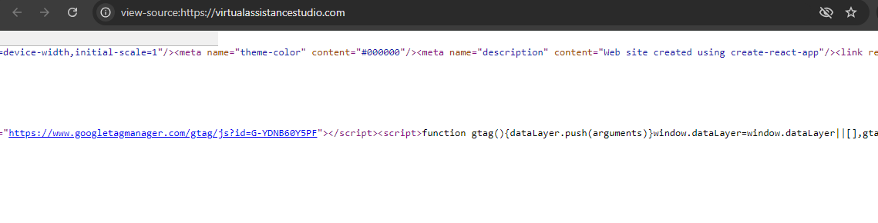
Wrong Title Description
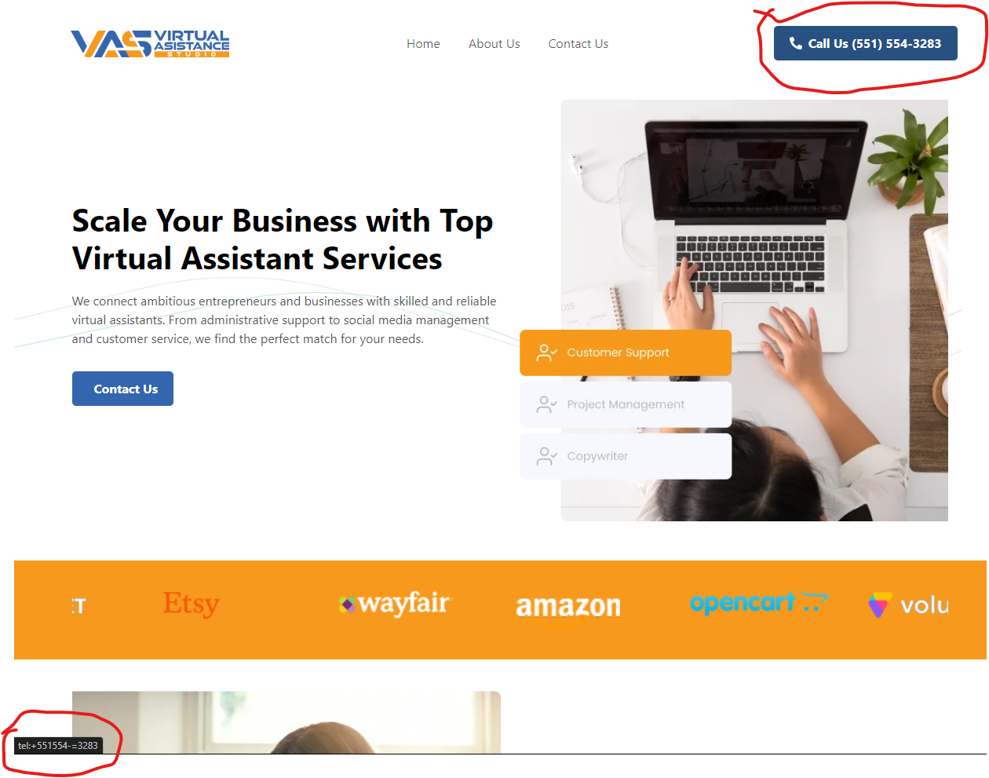
When I hover on call us it shows wron number kindly add right number
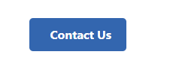
Add “Call Now” label
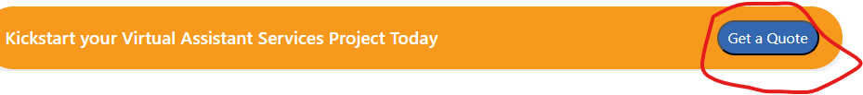
Not working
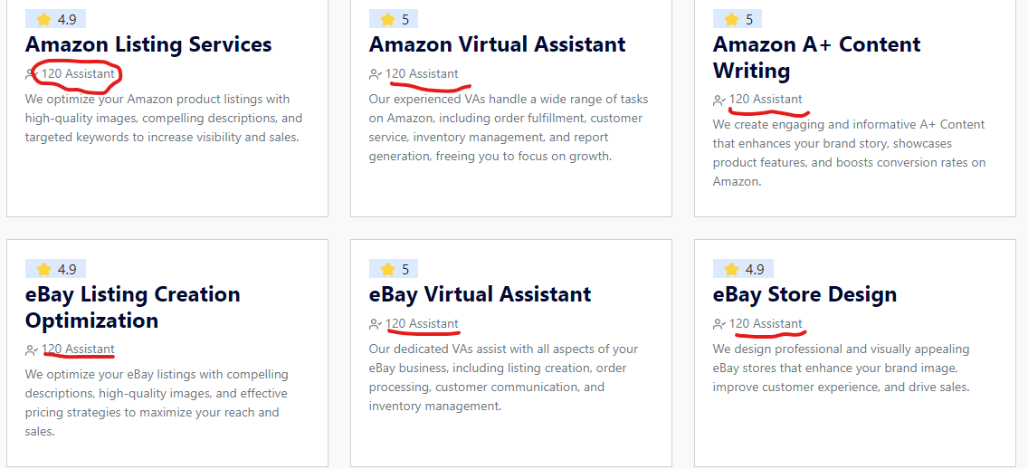
Need to add 1200+ Assistant
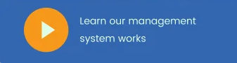
Use this “Learn our Virtual Assistance Studio works”
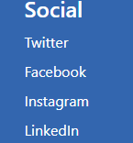
Use these links
https://www.facebook.com/virtualassistancestudio/
https://www.instagram.com/vasvirtualassistancestudio/
https://www.linkedin.com/company/vas-virtual-assistance
And remove twitter

Use “2024 Virtual Assistance Studio” instead of this “2022 Virtual Assistant”

Add link on footer logo https://virtualassistancestudio.com/

https://virtualassistancestudio.com/about-us
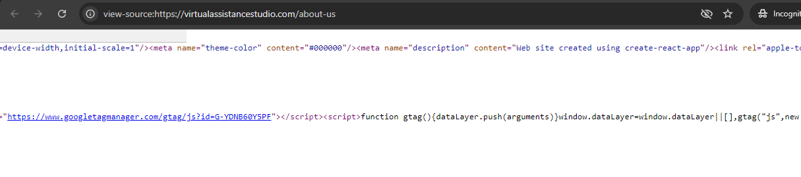
Wrong Title Description
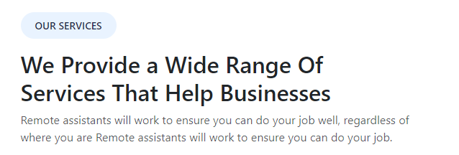
Wrong content, kindly add proper content that was given in the doc
Use different names and designations

https://virtualassistancestudio.com/contact-us
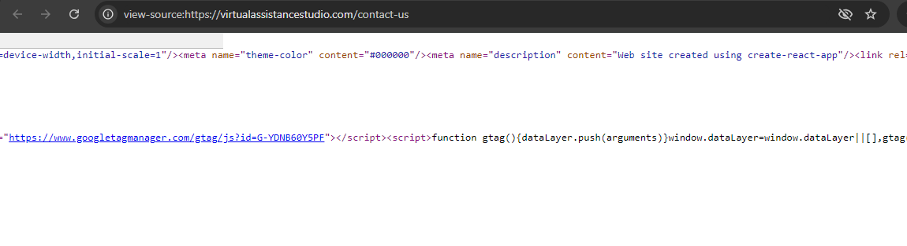
Wrong Title Description

Use this info@virtualassistancestudio.com

Use these links
https://www.facebook.com/virtualassistancestudio/
https://www.instagram.com/vasvirtualassistancestudio/
https://www.linkedin.com/company/vas-virtual-assistance

https://virtualassistancestudio.com/privacy-policy
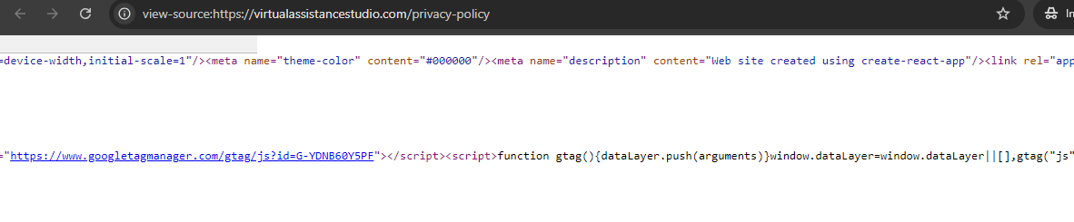
Wrong Title Description
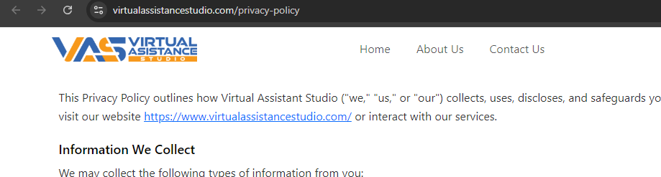
Need Privacy Policy Heading before content or Add Banner Heading
Need Virtual Assistance Studio instead of this “Virtual Assistant Studio”

https://virtualassistancestudio.com/terms-and-conditions
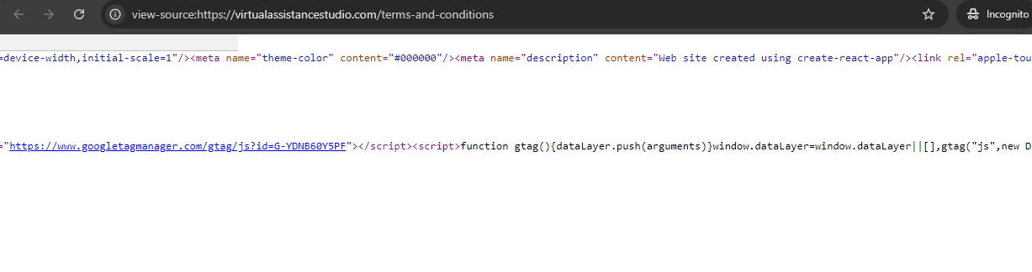
Wrong Title Description
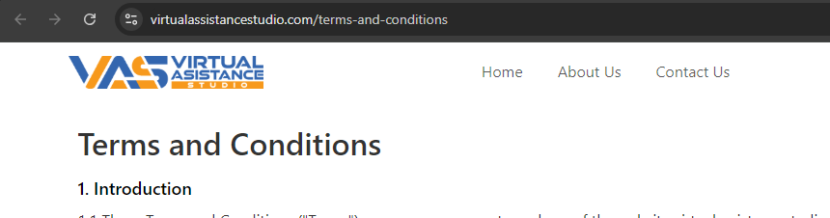
Need Banner Heading of Terms and Conditions

