Table of Contents
Overview 1
Main Screen 1
Image View 2
View Selected Area Window 2
Choose Specific Time Range Screen 2
Security 2

Overview

Main Screen

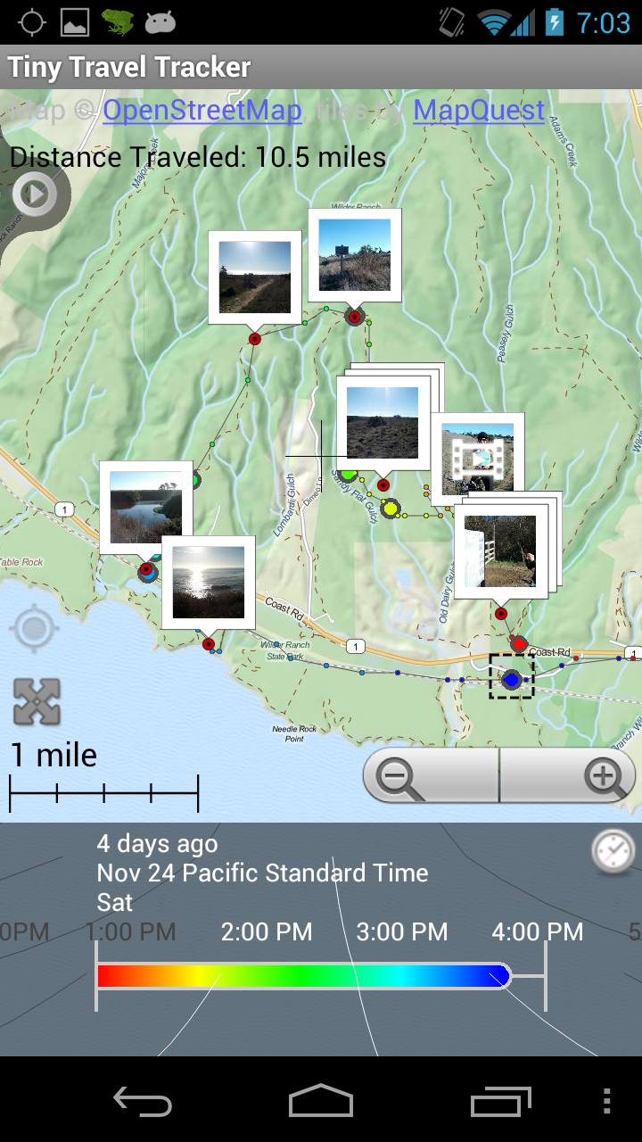
1
2
3
6
5
7
9
4
8

Gps Trail (1) | This is the trail of collected GPS points  The color corresponds to the time you were there, and by default goes from red → orange → yellow → green → blue. This can be changed in the Settings menu, under “Change Trail Colors”. The colors correspond to the color bar in the Time View (3). So in the picture above, red corresponds to 1:00 PM, green to around 2:15 PM and blue to 3:45 PM on November 24th  Only the range displayed in the Time View (3) is shown on the screen.  You can drag the map around using your finger. To zoom in or out press the zoom buttons (5). Also, to fit the screen to the points within the range of the Time View (3), press the Auto Zoom button (6).
Pictures (2) | These are the pictures you took with the phone along with the trail. They can be turned on or off by selecting the menu button (???) and pressing “Turn off photos” or ”Show Photos”. Only photos taken within the time specified by the Time View are shown.  Tap on a photo or set of photos to view, share or delete them as described in the section Image View.
Time View (3) | This is used to select the time range to view on the map. Only points within the time range will be shown. The Time View can be moved by dragging your finger side to side, or up and down. Dragging side to side will move backwards and forwards in time. Dragging up and down will increase or decrease the Time View size.  Note that the map will always show the same area regardless of the Time View. So if you select a time range where you are not in the area show on the map, the Gps Trail will not be displayed. Either zoom out using the zoom buttons (5) or press the Auto Zoom button (6) to fit the map to the current time range displayed.
Choose Specific Time Range button (4) | This will display the Choose Specific Time Range Screen where you can choose a specific time range by selecting dates rather than using the Time View (3)
Zoom Buttons (5) | These buttons will the map zoom in and out. You may also pinch the screen to zoom.
Auto Zoom (6) | This button moves the map so that all the points in the range specified by the Time View (3) are displayed on screen. For instance, if you had November 24th in the Time View range and you were in San Francisco all day that day, tapping the Auto Zoom button would cause the map screen to move to San Francisco.
Move to Gps Location button (7) | This will center the map on your current location if known. If your current location is not known, this button will be grayed out.
Selected Area (8) | By tapping on a point in the Gps Trail, a screen will appear showing the exact time(s) you entered and left the area, as well as the time you spent there and distance traveled. However, only the times that are also within the Time View (3) time range are shown.  You can also create a custom sized selected area by pressing and holding on an empty part of the screen until the phone vibrates for a second, and then dragging to select the area you are interested in.  You may want to turn off the photos displayed as mentioned in “Pictures 2”, above.  See View Selected Area Window for more details on the window that appears.
Distance Traveled (9) | This shows the distance traveled within the time range specified in the Time View (3). The distance is calculated based on the total time range, regardless of what the map is displaying. For instance, if you had the map zoomed in on San Francisco, but you traveled outside of San Francisco, the distance of your entire trip will be displayed.  To view the distance traveled while you were in a particular area, see the View Selected Area Window section.  Note that the distance traveled accuracy may fluctuate depending on the number of GPS points taken and the inaccuracy of the GPS readings themselves.

Image View

View Selected Area Window

Choose Specific Time Range Screen

Security

