**Лабораторное занятие №17.**

**Тема:** Разработка игры Puzzle Plumber.

**Цель работы:** Разработать игру Puzzle Plumber.

**Ход работы:**

1.Создание Background

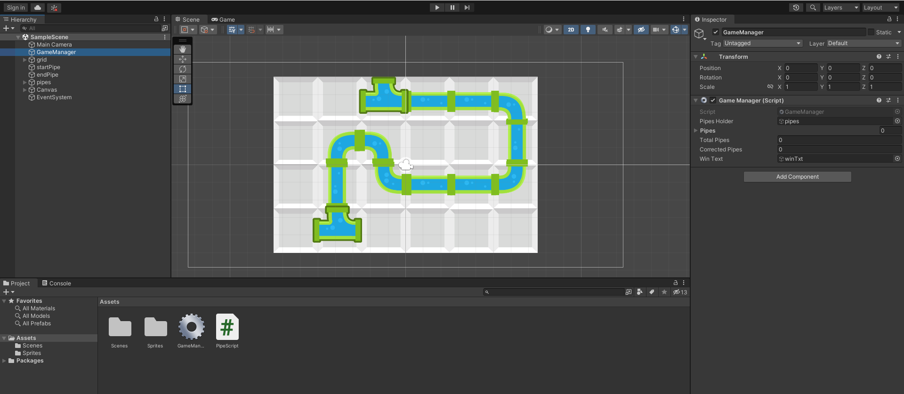

**Рис.17.1** – Background.

2.Создание объектов.

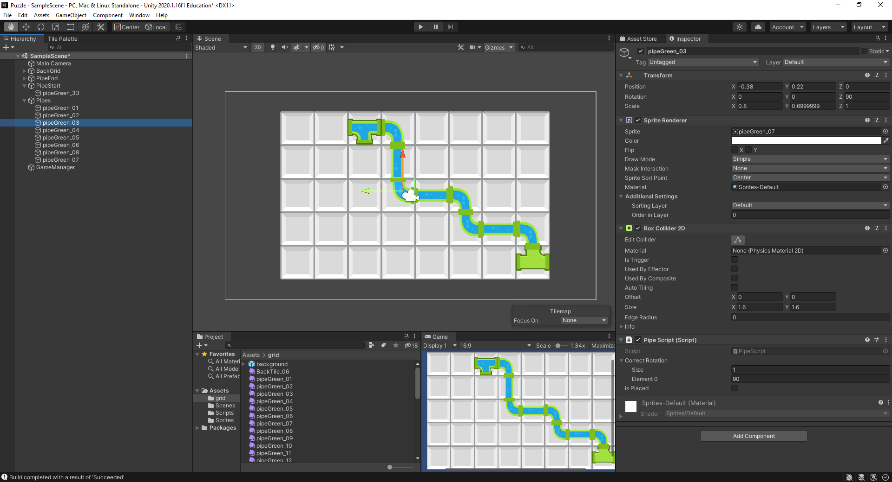

**Рис.17.2** - GameObject

**Листинг** **PipeScript**

using System.Collections;

using System.Collections.Generic;

using UnityEngine;

public class PipeScript : MonoBehaviour

{

float[] rotations = { 0, 90, 180, 270 };

public float[] correctRotation;

[SerializeField]

bool isPlaced = false;

int PossibleRots = 1;

GameManager gameManager;

private void Awake()

{

gameManager = GameObject.Find("GameManager").GetComponent<GameManager>();

}

private void Start()

{

PossibleRots = correctRotation.Length;

int rand = Random.Range(0, rotations.Length);

transform.eulerAngles = new Vector3(0, 0, rotations[rand]);

if (PossibleRots > 1)

{

if (transform.eulerAngles.z == correctRotation[0] || transform.eulerAngles.z == correctRotation[1])

{

isPlaced = true;

gameManager.correctMove();

}

}

else

{

if (transform.eulerAngles.z == correctRotation[0])

{

isPlaced = true;

gameManager.correctMove();

}

}

}

private void OnMouseDown()

{

transform.Rotate(new Vector3(0, 0, 90));

if (PossibleRots > 1)

{

if (transform.eulerAngles.z == correctRotation[0] || transform.eulerAngles.z == correctRotation[1] && isPlaced == false)

{

isPlaced = true;

gameManager.correctMove();

}

else if (isPlaced == true)

{

isPlaced = false;

gameManager.wrongMove();

}

}

else

{

if (transform.eulerAngles.z == correctRotation[0] && isPlaced == false)

{

isPlaced = true;

gameManager.correctMove();

}

else if (isPlaced == true)

{

isPlaced = false;

gameManager.wrongMove();

}

}

}

}

**Листинг GameManager**

using System.Collections;

using System.Collections.Generic;

using UnityEngine;

public class GameManager : MonoBehaviour

{

public GameObject PipesHolder;

public GameObject[] Pipes;

[SerializeField]

int totalPipes = 0;

[SerializeField]

int correctePipes = 0;

void Start()

{

totalPipes = PipesHolder.transform.childCount;

Pipes = new GameObject[totalPipes];

for (int i = 0; i < Pipes.Length; i++)

{

Pipes[i] = PipesHolder.transform.GetChild(i).gameObject;

}

}

public void correctMove()

{

correctePipes += 1;

Debug.Log("correct Move");

if (correctePipes == totalPipes)

{

Debug.Log("OuuuuMyYooouWon!");

}

}

public void wrongMove()

{

correctePipes -= 1;

}

}