Лабораторная работа № 25

**Тема:** разработка игрового проекта “ Bounce”

**Цель:** приобрести навыки в разработке игрового проекта “ Bounce”

**Ход работы:**

Выполнение работы

Импортирование ресурсов игры

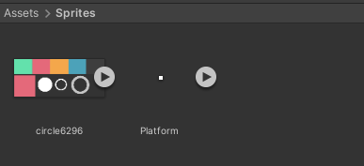

Рис.25.1 – Папка Sprites

Создаем объект Ball с компонентами Rigidbody2D и CircleCollider2D.

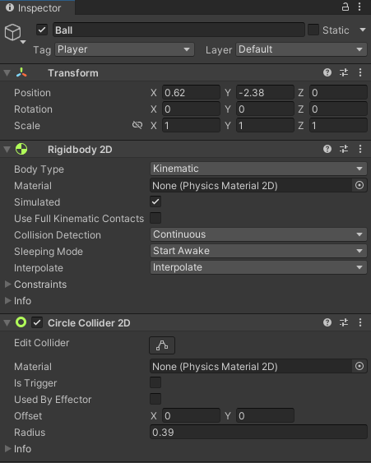

Рис.25.2 –Ball

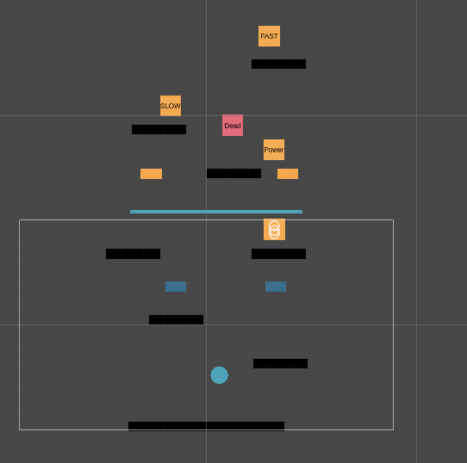

Рис.25.3– Окно Scene

Организация UI

Создаем объекты UI Button, Panel, Text, Canvas, Image настраиваем и раставляем

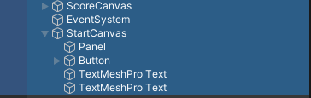

Рис.25.4– объекты UI

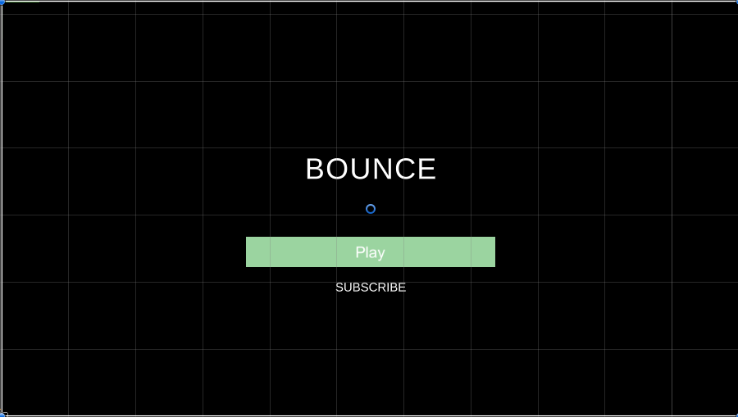

Рис.25.5– Окно Game

Разработка геймплея игры

Листинг 25.1 Ball.cs

|  |
| --- |
| using System.Collections;  using System.Collections.Generic;  using UnityEngine;  public class Ball : MonoBehaviour  { Rigidbody2D rgbd;  public Vector2 maxForce;    public float forceAppliedInSidewaysDirection;  public bool moving;    float sidewaysMovement;  BallFuctionality ballFuctionality;  // Start is called before the first frame update  void Start()  {  rgbd = GetComponent<Rigidbody2D>();  ballFuctionality = GetComponent<BallFuctionality>();  }  void Update()  {  // clampVeclocity();  // Debug.Log(rgbd.velocity);  movement();  }  public void FixedUpdate()  {  if (!moving)  {  Vector2 vel = rgbd.velocity;  vel.x = Mathf.Lerp(vel.x, 0, 0.2f);  rgbd.velocity = vel;  }  }  void clampVeclocity()  {  Vector2 vel = rgbd.velocity;  if (Mathf.Abs(vel.x) >= maxForce.x)  {  vel.x = maxForce.x * Mathf.Sign(rgbd.velocity.x);  }  if ((vel.y) >= maxForce.y)  { if (ballFuctionality.jumpHigher) return;  vel.y = maxForce.y;  }  rgbd.velocity = vel;  }  void movement()  {  if (Input.GetKey(KeyCode.LeftArrow))  {  rgbd.AddForce(new Vector2(-forceAppliedInSidewaysDirection, 0));  }  if (Input.GetKey(KeyCode.RightArrow))  {  rgbd.AddForce(new Vector2(forceAppliedInSidewaysDirection, 0));  }  if (Input.GetKeyDown(KeyCode.RightArrow) || Input.GetKeyDown(KeyCode.LeftArrow))  {  moving = true;  }  if (Input.GetKeyUp(KeyCode.RightArrow) || Input.GetKeyUp(KeyCode.LeftArrow))  {  moving = false;  }  }  } |

Листинг 25.2 BallFuctionality.cs

|  |
| --- |
| using System.Collections;  using System.Collections.Generic;  using UnityEngine;  public class BallFuctionality : MonoBehaviour  {  Rigidbody2D rgbd;  public float forceAppliedInUpwardDirection, higherForceAppliedInUpwardDirection;  public bool jumpHigher;  Manager manager;  public bool hasElectricity;  SpriteRenderer sr;  public Color electricitySprite;  Color originalColor;  Score score;  // Start is called before the first frame update  void Start()  {  rgbd = GetComponent<Rigidbody2D>();  sr = GetComponentInChildren<SpriteRenderer>();  score = FindObjectOfType<Score>();  originalColor = sr.color;  manager = FindObjectOfType<Manager>();  }  public void OnCollisionEnter2D(Collision2D collision)  { if (!manager.startGame) return;  if (collision.collider.tag == "JumpingBlock")  {  if (jumpHigher)  {  Debug.Log("Applying higher force");  rgbd.AddForce(new Vector2(0, higherForceAppliedInUpwardDirection));  jumpHigher = false;  }  else  {  rgbd.AddForce(new Vector2(0, forceAppliedInUpwardDirection));  }  }  if (collision.collider.tag == "ElectricityBlock")  { //gameover  if (hasElectricity) {  rgbd.AddForce(new Vector2(0, forceAppliedInUpwardDirection)); return; }  else  {  Debug.Log("Dead");  manager.RestartTheGame();  }  }  }  public void OnTriggerEnter2D(Collider2D collision)  {  if (!manager.startGame) return;  if (collision.tag == "spring")  {  jumpHigher = true;  Destroy(collision.gameObject);  }  if (collision.tag == "TimeSlower")  {  //call function to slow the game  manager.slowTimerStart();  Destroy(collision.gameObject);  }if (collision.tag == "TimeFaster")  {  //call function to slow the game  manager.FastTimerStart();  Destroy(collision.gameObject);  }if (collision.tag == "ElectricityPower")  {  //change the sprite to charge sprite  //screen flashes  Destroy(collision.gameObject);  StartCoroutine(electricity());  }  if (collision.tag == "PointObject")  {  //add point  if (!collision.GetComponent<PointsObject>().hasBroke)  {  score.AddScore();  }  collision.GetComponent<PointsObject>().Explode();  }  }  IEnumerator electricity()  {  hasElectricity = true;  sr.color = electricitySprite;  yield return new WaitForSeconds(2f);  hasElectricity = false;  sr.color = originalColor;  }  } |

Листинг 25.3 BlockScript.cs

|  |
| --- |
| using System.Collections;  using System.Collections.Generic;  using UnityEngine;  public class BlockScript : MonoBehaviour  {  public bool moveBlock, fallingBlock;  bool startMovingBlock, startFallingBlock;  Rigidbody2D rgbd;  bool moveLeft;  // Start is called before the first frame update  void Start()  {  rgbd = GetComponent<Rigidbody2D>();  if (Random.value > 0.5)  {  moveLeft = true;  }  }  // Update is called once per frame  void Update()  {  if (startMovingBlock && moveBlock)  {  if (moveLeft)  {  rgbd.velocity = new Vector2(-3, 0);  }  else  {  rgbd.velocity = new Vector2(3, 0);  }  }  }  public void OnCollisionEnter2D(Collision2D collision)  { if(collision.collider.tag == "Player") {  if (moveBlock)  {  startMovingBlock = true;  }  else if (fallingBlock)  {  rgbd.bodyType = RigidbodyType2D.Dynamic;  }  }  }  } |

Листинг 25.4 CameraController.cs

|  |
| --- |
| using System.Collections;  using System.Collections.Generic;  using UnityEngine;  public class CameraController : MonoBehaviour  {  public Transform player;  // Update is called once per frame  void Update()  {  if (player.position.y > transform.position.y)  {  transform.position = new Vector3(transform.position.x, player.position.y, -10);  }  }  } |

Листинг 25.5 Manager.cs

|  |
| --- |
| using System.Collections;  using UnityEngine.SceneManagement;  using UnityEngine;  public class Manager : MonoBehaviour  {  public bool slowTime, fastTime;    public float slow;  public bool startGame;  public void slowTimerStart()  {  StartCoroutine(slowTheTime());  }  IEnumerator slowTheTime()  {  slowTime = true;  Time.timeScale = 1 / slow;  Time.fixedDeltaTime = Time.fixedDeltaTime / slow;  FindObjectOfType<BallFuctionality>().forceAppliedInUpwardDirection *= 2;  yield return new WaitForSeconds(2 * slow);  Time.timeScale = 1;  Time.fixedDeltaTime = Time.fixedDeltaTime * slow;  FindObjectOfType<BallFuctionality>().forceAppliedInUpwardDirection /= 2;  slowTime = false;  }  public void FastTimerStart()  {  StartCoroutine(fastTheTime());  }  IEnumerator fastTheTime()  {  fastTime = true;  Time.timeScale = 1 * slow;  Time.fixedDeltaTime = Time.fixedDeltaTime * slow;  FindObjectOfType<BallFuctionality>().forceAppliedInUpwardDirection /= 2;  yield return new WaitForSeconds(2 * slow);  Time.timeScale = 1;  Time.fixedDeltaTime = Time.fixedDeltaTime / slow;  FindObjectOfType<BallFuctionality>().forceAppliedInUpwardDirection *= 2;  fastTime = false;  }  public void StartTheGame()  {  startGame = true;  FindObjectOfType<BallFuctionality>().GetComponent<Rigidbody2D>().bodyType = RigidbodyType2D.Dynamic;  }  public void RestartTheGame()  {  SceneManager.LoadScene(SceneManager.GetActiveScene().buildIndex);  }  } |

Листинг 25.6 PointsObject.cs

|  |
| --- |
| using System.Collections;  using System.Collections.Generic;  using UnityEngine;  public class PointsObject : MonoBehaviour  {  Transform[] childObj;  public GameObject Points1;  public int force;  public bool hasBroke;  public void Explode()  {  hasBroke = true;  Points1.SetActive(true);  Points1.GetComponent<Rigidbody2D>().bodyType = RigidbodyType2D.Dynamic;  Points1.GetComponent<Rigidbody2D>().AddForceAtPosition(Vector2.up * force * 3 / 2, Points1.transform.position);  foreach (Transform t in transform)  {  Rigidbody2D rgbd = t.GetComponent<Rigidbody2D>();  if (rgbd != null)  {  //shake camera  rgbd.bodyType = RigidbodyType2D.Dynamic;  rgbd.AddForceAtPosition(Vector2.up * force,  new Vector2(Random.Range(t.position.x - 2, t.position.x + 2), t.position.y));  //play sound  }  }  }  } |

Листинг 25.7 Score.cs

|  |
| --- |
| using System.Collections;  using System.Collections.Generic;  using UnityEngine;  public class Score : MonoBehaviour  {  public TMPro.TextMeshProUGUI scoreText;  public int ScoreValue;    public void AddScore()  {  ScoreValue++;  scoreText.text = ScoreValue.ToString();  }    } |

Вывод: Приобрел навыки разработки игры “ Bounce”