**Лабораторное занятие № 28-29.**

**Тема:** Разработка игры “ Ants”

**Цель:** Разработать игру“ Ants”

**Ход работы:**

1.Cпрайты

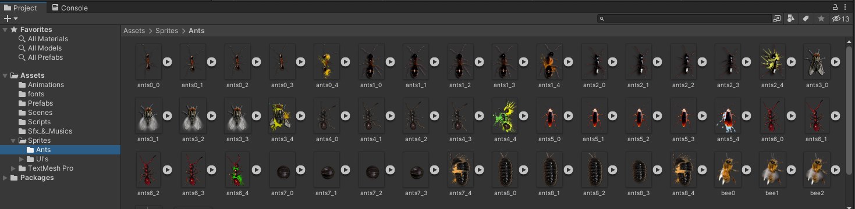

**Рис.28.1** – Папка Sprites

2. Background

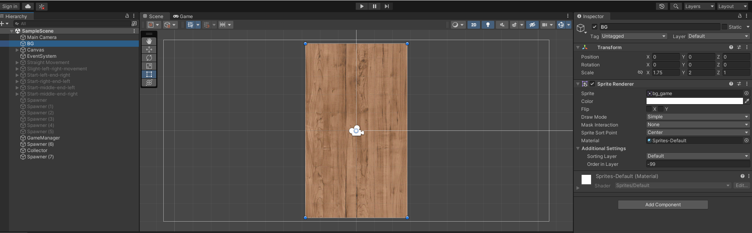

**Рис.28.2** – Background

3. Menu

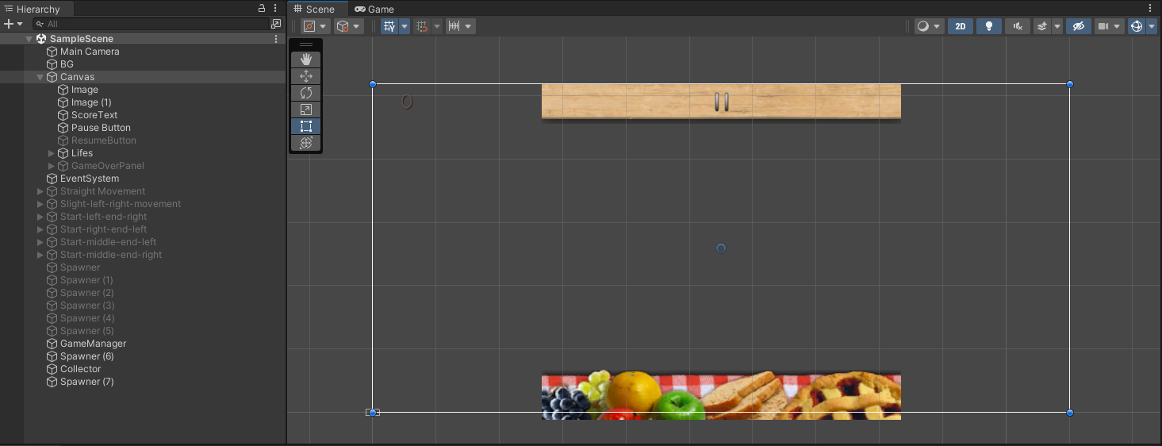

**Рис.28.3** – Menu

4. Граница поля.

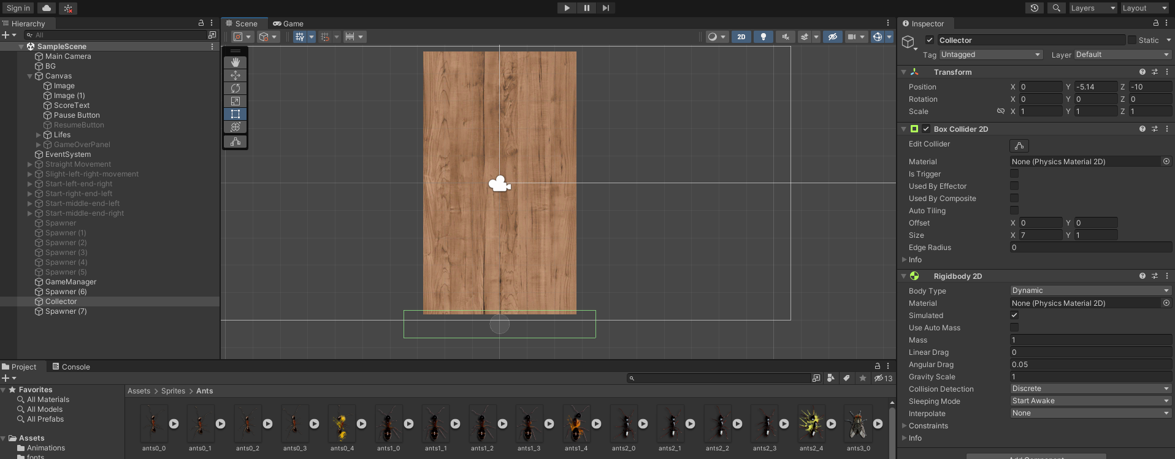

**Рис.28.4** – Collector.

6.Создание мест для движения насекомых.

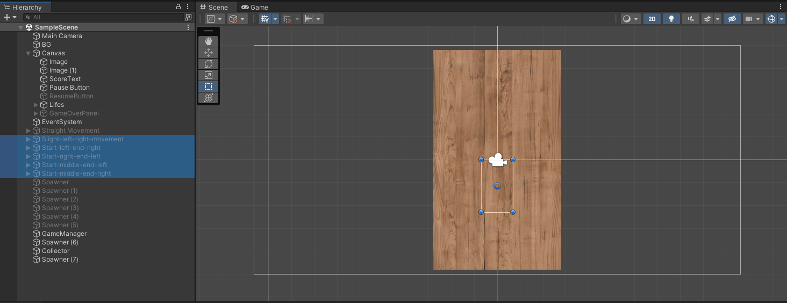

**Рис.28.5** – Движение насекомых.

7.Спавнер насекомых.

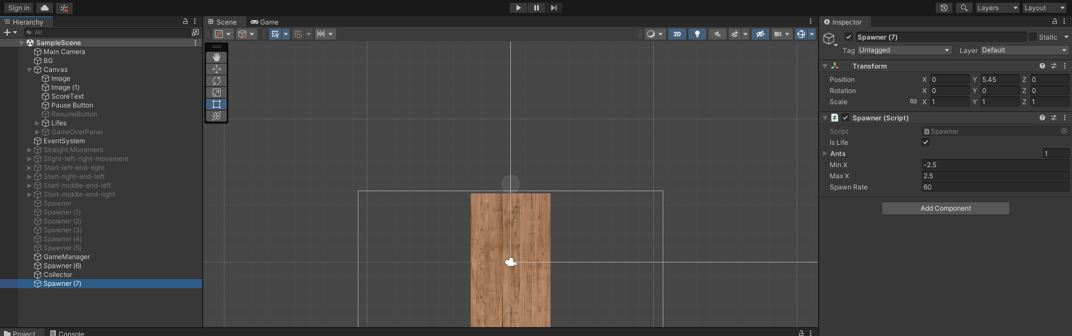

**Рис.28.6** – Spawner.

9.Создание cкриптов.

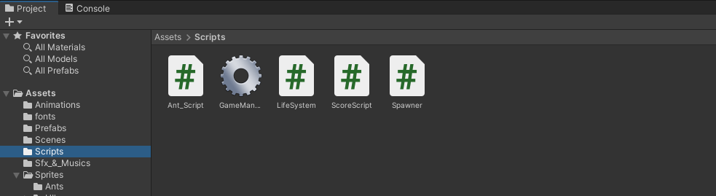

**Рис.28.7**– Scripts.

**Скрипты:**

Ant_Script.cs

using System.Collections;

using System.Collections.Generic;

using UnityEngine;

public class Ant_Script : MonoBehaviour

{

private GameObject AliveAnt;

private Transform DeadAnt;

private Transform parent;

public bool isBee;

public bool isLife;

private GameManager gameManager;

void Start()

{

gameManager = FindObjectOfType<GameManager>().GetComponent<GameManager>();

if(!isLife)

{

AliveAnt = this.gameObject;

DeadAnt = transform.GetChild(0);

parent = transform.parent;

}

}

private void OnMouseUpAsButton()

{

if(isBee)

{

gameManager.GameOver();

}

if(isLife)

{

Destroy(gameObject);

LifeSystem.lifeCount += 1;

}

if (!isLife)

{

AliveAnt.GetComponent<SpriteRenderer>().enabled = false;

AliveAnt.GetComponent<BoxCollider2D>().enabled = false;

DeadAnt.gameObject.SetActive(true);

parent.GetComponent<Animator>().enabled = false;

if (!isBee)

{

ScoreScript.score += 1;

}

Destroy(parent.gameObject, 5);

}

}

private void OnCollisionEnter2D(Collision2D other)

{

if(!isBee)

{

LifeSystem.lifeCount -= 1;

if(LifeSystem.lifeCount==0)

{

gameManager.GameOver();

}

}

Destroy(parent.gameObject);

}

void Update()

{

if(isLife)

{

Vector2 pos = transform.position;

pos.y -= 0.4f * Time.deltaTime;

transform.position = pos;

}

}

}

GameManager.cs

using System.Collections;

using System.Collections.Generic;

using UnityEngine;

using TMPro;

public class GameManager : MonoBehaviour

{

public TextMeshProUGUI ScoreText, BestScoreText, PlayTimeText;

public GameObject GameOverPanel;

public GameObject[] spawner;

private float NextSpawnerTime;

// Start is called before the first frame update

void Start()

{

NextSpawnerTime = Time.time;

}

// Update is called once per frame

void Update()

{

SpawnerManagement();

}

public void GameOver()

{

Time.timeScale = 0;

GameOverPanel.SetActive(true);

ScoreText.text = ScoreScript.score.ToString();

BestScoreText.text = PlayerPrefs.GetInt("Best").ToString();

PlayTimeText.text = Time.time.ToString();

}

public void Pause()

{

Time.timeScale = 0;

}

public void Resume()

{

Time.timeScale = 1;

}

void SpawnerManagement()

{

if(Time.time > NextSpawnerTime)

{

int spr = Random.Range(0, 6);

if (spr==0)

{

spawner[0].SetActive(true);

}

if (spr == 1)

{

spawner[1].SetActive(true);

}

if (spr == 2)

{

spawner[2].SetActive(true);

}

if (spr == 3)

{

spawner[3].SetActive(true);

}

if (spr == 4)

{

spawner[4].SetActive(true);

}

if (spr == 5)

{

spawner[5].SetActive(true);

}

NextSpawnerTime = Time.time + 2;

Invoke("DeactivateAllSpawners", 2);

}

}

void DeactivateAllSpawners()

{

spawner[0].SetActive(false);

spawner[1].SetActive(false);

spawner[2].SetActive(false);

spawner[3].SetActive(false);

spawner[4].SetActive(false);

spawner[5].SetActive(false);

}

}

LifeSystem.cs

using System.Collections;

using System.Collections.Generic;

using UnityEngine;

public class LifeSystem : MonoBehaviour

{

public GameObject[] lifes;

public static int lifeCount;

// Start is called before the first frame update

void Start()

{

lifeCount = 2;

}

// Update is called once per frame

void Update()

{

if(lifeCount == 5)

{

lifes[0].SetActive(true);

lifes[1].SetActive(true);

lifes[2].SetActive(true);

lifes[3].SetActive(true);

lifes[4].SetActive(true);

}

if(lifeCount == 4)

{

lifes[0].SetActive(true);

lifes[1].SetActive(true);

lifes[2].SetActive(true);

lifes[3].SetActive(true);

lifes[4].SetActive(false);

}

if(lifeCount == 3)

{

lifes[0].SetActive(true);

lifes[1].SetActive(true);

lifes[2].SetActive(true);

lifes[3].SetActive(false);

lifes[4].SetActive(false);

}

if(lifeCount == 2)

{

lifes[0].SetActive(true);

lifes[1].SetActive(true);

lifes[2].SetActive(false);

lifes[3].SetActive(false);

lifes[4].SetActive(false);

}

if(lifeCount == 1)

{

lifes[0].SetActive(true);

lifes[1].SetActive(false);

lifes[2].SetActive(false);

lifes[3].SetActive(false);

lifes[4].SetActive(false);

}

if (lifeCount == 0)

{

lifes[0].SetActive(false);

lifes[1].SetActive(false);

lifes[2].SetActive(false);

lifes[3].SetActive(false);

lifes[4].SetActive(false);

}

}

}

ScoreScript.cs

using System.Collections;

using System.Collections.Generic;

using UnityEngine;

public class LifeSystem : MonoBehaviour

{

public GameObject[] lifes;

public static int lifeCount;

// Start is called before the first frame update

void Start()

{

lifeCount = 2;

}

// Update is called once per frame

void Update()

{

if(lifeCount == 5)

{

lifes[0].SetActive(true);

lifes[1].SetActive(true);

lifes[2].SetActive(true);

lifes[3].SetActive(true);

lifes[4].SetActive(true);

}

if(lifeCount == 4)

{

lifes[0].SetActive(true);

lifes[1].SetActive(true);

lifes[2].SetActive(true);

lifes[3].SetActive(true);

lifes[4].SetActive(false);

}

if(lifeCount == 3)

{

lifes[0].SetActive(true);

lifes[1].SetActive(true);

lifes[2].SetActive(true);

lifes[3].SetActive(false);

lifes[4].SetActive(false);

}

if(lifeCount == 2)

{

lifes[0].SetActive(true);

lifes[1].SetActive(true);

lifes[2].SetActive(false);

lifes[3].SetActive(false);

lifes[4].SetActive(false);

}

if(lifeCount == 1)

{

lifes[0].SetActive(true);

lifes[1].SetActive(false);

lifes[2].SetActive(false);

lifes[3].SetActive(false);

lifes[4].SetActive(false);

}

if (lifeCount == 0)

{

lifes[0].SetActive(false);

lifes[1].SetActive(false);

lifes[2].SetActive(false);

lifes[3].SetActive(false);

lifes[4].SetActive(false);

}

}

}

Spawner.cs

using System.Collections;

using System.Collections.Generic;

using UnityEngine;

public class Spawner : MonoBehaviour

{

public bool isLife;

public GameObject[] ants;

public float minX, maxX, SpawnRate;

private float NextSpawn;

void Start()

{

if(!isLife)

{

NextSpawn = Time.time;

}

if(isLife)

{

NextSpawn = 60;

}

}

void Update()

{

Spawn();

}

void Spawn()

{

if (Time.time > NextSpawn)

{

Vector2 position = new Vector2(Random.Range(minX, maxX), transform.position.y);

Instantiate(ants[Random.Range(0, ants.Length)], new Vector2(position.x, position.y), transform.rotation);

NextSpawn = Time.time + SpawnRate;

}

}

}