**Title: Culture Associated Global DNA Methylation changes in Human Intestinal Epithelial Organoids**

Organoids are a powerful tool to model aspects of development, health and disease. A necessary aspect of organoid models is the expansion of cultures *in-vitro* through several rounds of passaging. This is of potential concern as high passaging of cell cultures has been shown to affect cellular function. We have generated genome wide DNA methylation (DNAm) profiles from 80 human intestinal organoids. Our analyses revealed major effects of passage on DNAm with significant changes at 61,337 CpGs. High passage organoids were globally hypomethylated and locally hypermethylated, with greater variability in DNAm with increasing passage. Importantly, we were able to validate observed passage effects in 76 publicly available organoids, including healthy gut organoids and organoids generated from malignant tissues including pancreas, rectum, stomach, and lung. Together, our findings suggest a major impact of prolonged culturing on global organoid DNAm profiles, highlighting the importance of considering passage in organoid experiments.

**Highlights**

* Prolonged culturing affects organoid DNA methylation genome-wide
* DNA methylation is globally decreased with passage, but increased at specific loci
* Globally DNA methylation becomes more variable with prolonged culturing
* Similar culturing effects on are seen in multiple tissues and disease states

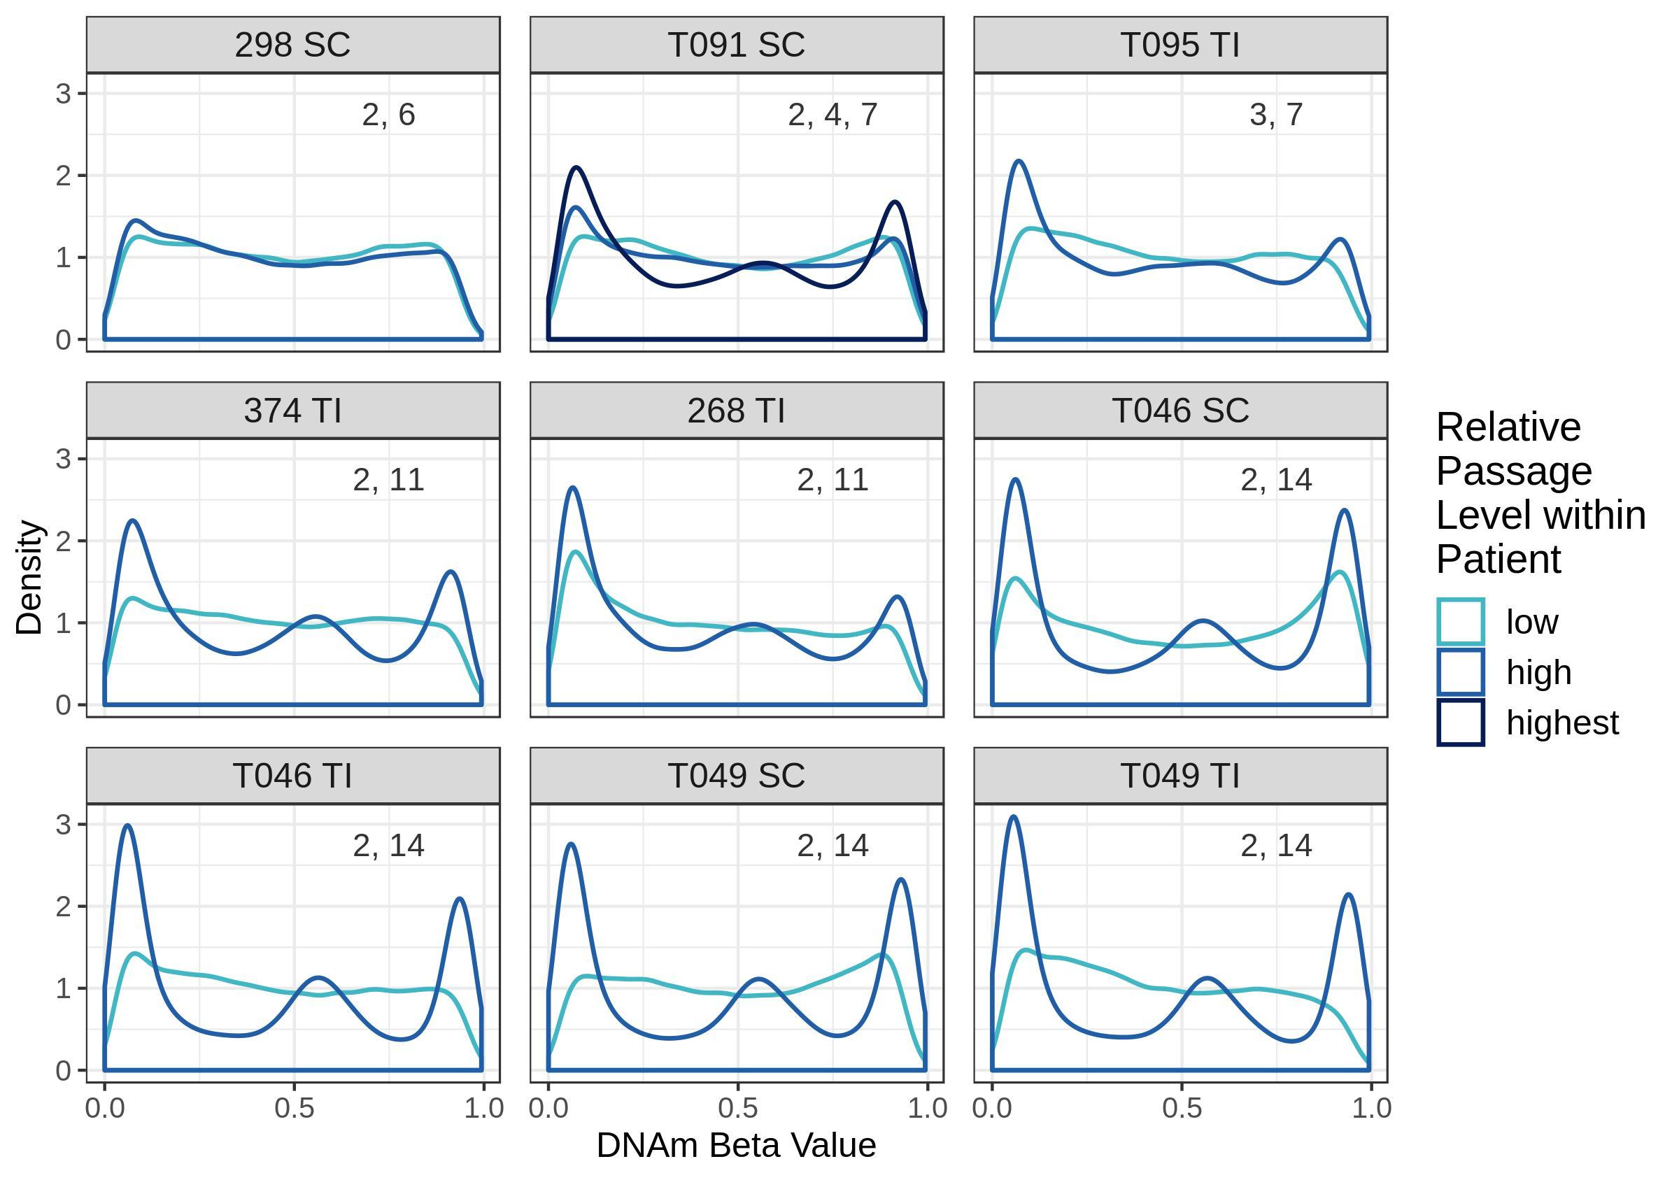

**Figure 1. DNAm beta value distributions are trimodal for high passage samples but bimodal for low passage samples, even within an individual.** DNAm beta value distributions for samples derived from the same patient but cultured to a different number of passages. Distributions displayed are for the 51,545 most variable CpGs. Plots are labelled with the patient ID number, sampling site of origin (TI:terminal ileum, SC:sigmoid colon) and the passage number of each organoid derived from that patient and sampling site. Curves are coloured by high or low passage relative to the other sample(s).